**Student Name:** **Weight: 3%**

**Student ID:** **Marks: /**

# Instructions

In software development, a security framework is an integral part of the software’s life cycle. It is important to ensure that security requirements are well defined and well implemented, and that integrity is preserved throughout the various stages.

Provide one example of how security is involved in each phase of the SDLC.

# SDLC Phases

1. Project initiation and planning

A customer wants to have an application which involves money transactions. In this case, the requirement has to be clear like what kind of transactions will be done, how it will be done, in which currency it will be done

1. Functional requirements and definition

Systems analysis is vital in determining what a business"s needs are, as well as how they can be met, who will be responsible for individual pieces of the project, and what sort of timeline should be expected.

1. System design specifications

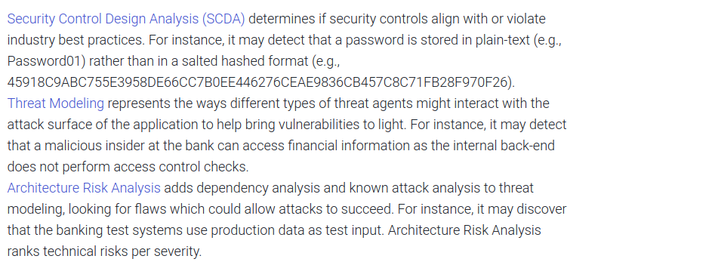

1. Development and implementation

Code reviews verify whether developers made such security mistakes. Tools that automate such code reviews are called static application security testing (SAST) tools. These tools can offer comprehensive and preventative solutions depending on your needs. These tools also integrate into standard development environments (such as Eclipse) so that developers are informed about security mistakes as soon as they create them. It works similarly to a spellchecker that detects misspelled words as soon as they’re typed.

1. Documentation and common program controls

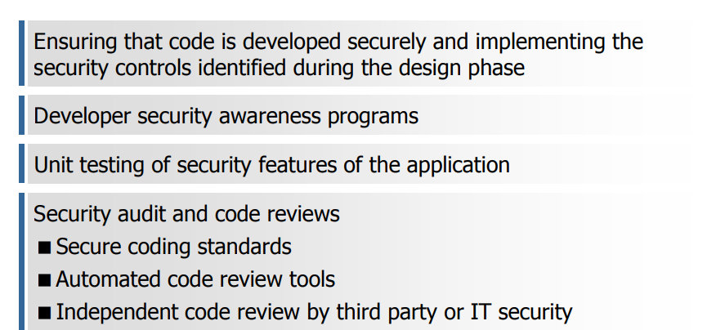

1. User acceptance

It is best advised to use live data for UAT. Data should be scrambled for privacy and security reasons. Tester should be familiar with the database flow.

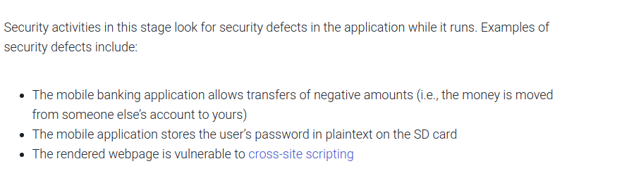

1. Testing and evaluation control
2. Production implementation

After sign-off, the product is good to go for production. Deliverables for UAT testing are Test Plan, UAT Scenarios and Test Cases, Test Results and Defect Log

No critical defects open

Business process works satisfactorily

UAT Sign off meeting with all stakeholders