**Student Name: Ahmed Almass Weight: 5%**

**Student ID: 651096 Marks:**

Assignment 2

Complete the challenge in WebGoat. Type your answers below and then submit this document using the Assignment tool in Brightspace by the due date (see your Course Schedule).

1. List all the vulnerabilities you find.
2. Briefly describe the method you used to bypass and/or exploit.

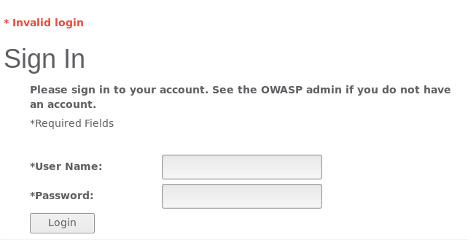Stage1.

Finding source page that included username and password

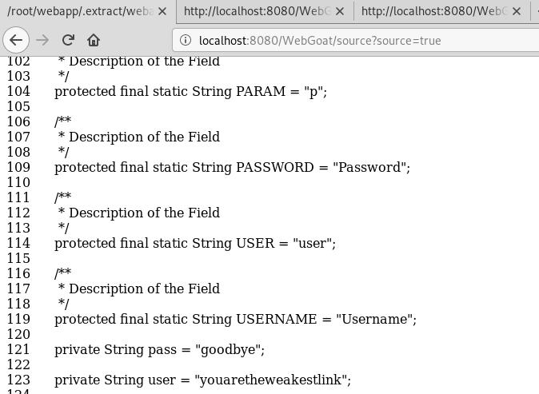

stage 2

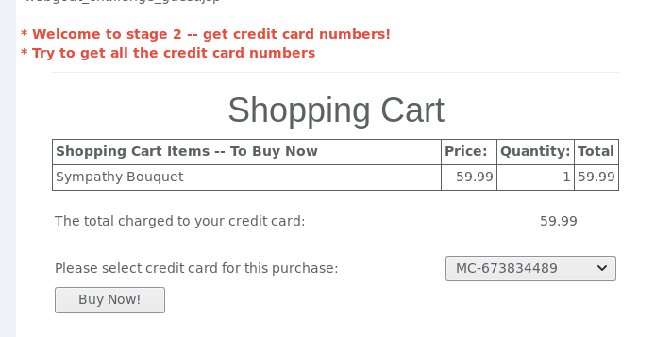

intercepting with burp

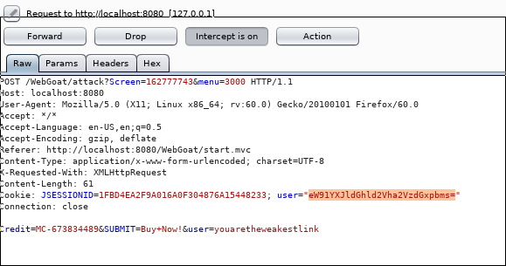

Copying the user encription to decoder

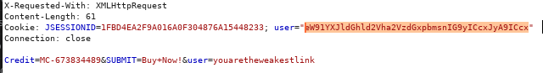

than i included “ ’ or ‘1’ = 1 than encoded it again and placeing it under user .

finished

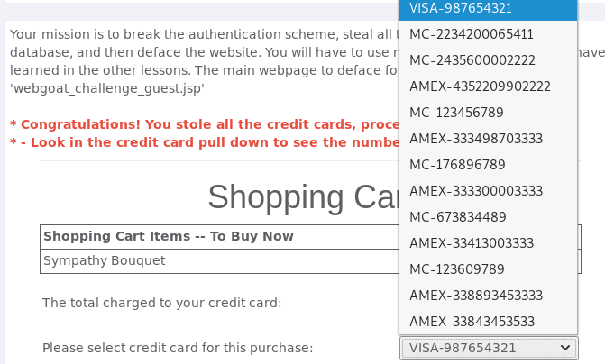

3rd stage (the end didnt work for me showing how far i went)

Intercepted with burp

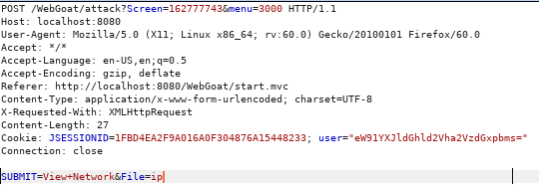

File command to linux commands

