Name:Ahmed Almass

Lab 2: Bypassing ClientSide Controls

Web Application Security

Table of Contents

Lab Outcome 2

Background Reading 2

Required Hardware/Software 2

Introduction 2

1.0 Hidden Fields 2

2.0 Restrictions in HTML Fields 2

3.0 Script-Based Validations 2

4.0 Looking at HTML Code 2

5.0 Sign-Off – Lab 2: Bypassing Client-Side Controls 3

Web Application Security

Lab 2: Bypassing Client-Side Controls

# Lab Outcome

Find and exploit client-side controls.

Background Reading

Read the textbook sections listed in the Course Schedule.

Required Hardware/Software

* WebGoat v7.1
* Burp

# Introduction

Many web applications rely on validation on the client side to control the data that is submitted to the server. If these measures aren’t replicated on the server side, the server can easily be bypassed and a user can gain access to private or sensitive information on the server.

# 1.0 Hidden Fields

In WebGoat, complete the **Parameter Tampering > Exploit Hidden Fields** lesson.

After Intercepting with burp, i was able to find and modify hiden field to obtain a the product for a price other the priced specified.

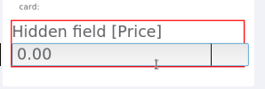

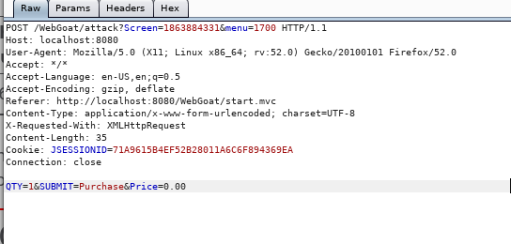

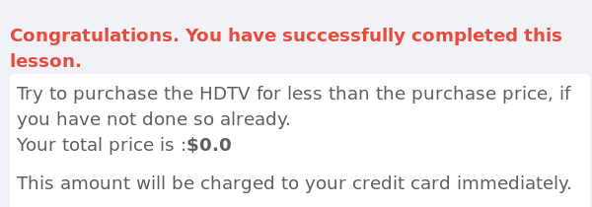

# 2.0 Restrictions in HTML Fields

In WebGoat, complete the **Parameter Tampering > Bypass HTML Field Restrictions** lesson.

First the i downloaded a tool extension for webdevolopers to enable field form.

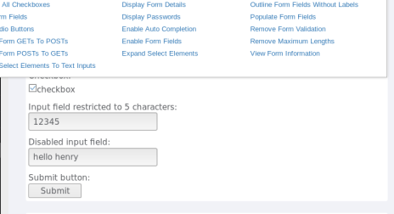

Than I intercepted with burp and change the parameters that was resricted.

# 3.0 Script-Based Validations

In WebGoat, complete the **Parameter Tampering > Bypass Client Side JavaScript Validation** lesson.

 Intercepting with brup i was able to bypass the restrictions.

# 4.0 Looking at HTML Code

In WebGoat, complete the **Code Quality > Discover Clues in the HTML** lesson.

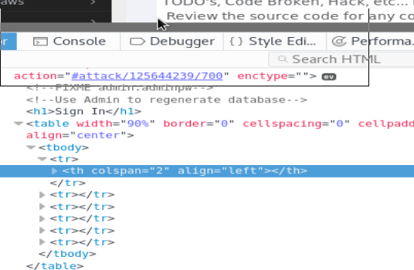

# 5.0 Sign-Off – Lab 2: Bypassing Client-Side Controls

Detach this page and submit it to your instructor to show you have completed each of the sections.

Name:

Student ID:

|  |  |
| --- | --- |
| **Section** | **Instructor Initials** |
| 1.0 Hidden Fields |  |
| 2.0 Restrictions in HTML Fields |  |
| 3.0 Script-Based Validations |  |
| 4.0 Looking at HTML Code |  |