Nikhil Anand

Aalok Borkar

**PROJECT URL:** <http://web.engr.oregonstate.edu/~borkaraa/yelp>

**Entity-Relationship Diagram:**

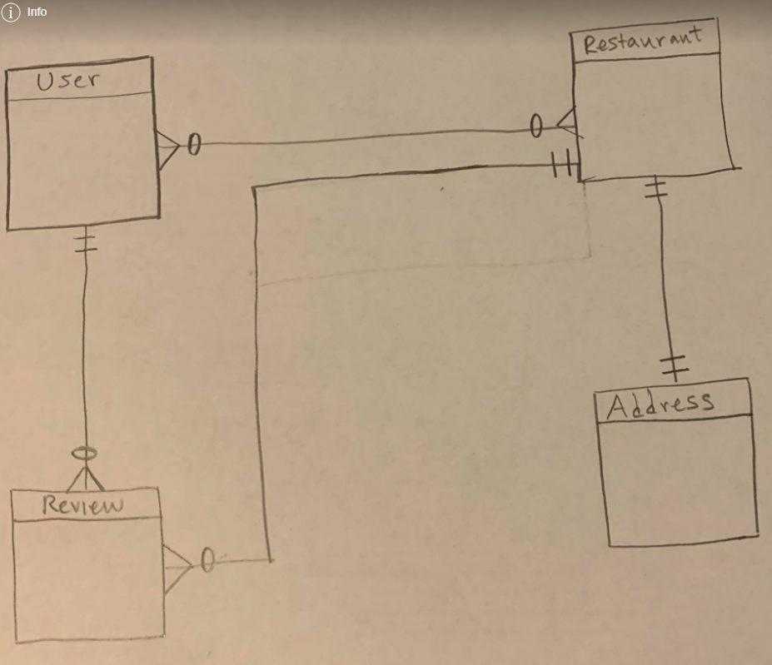

**Schema:**

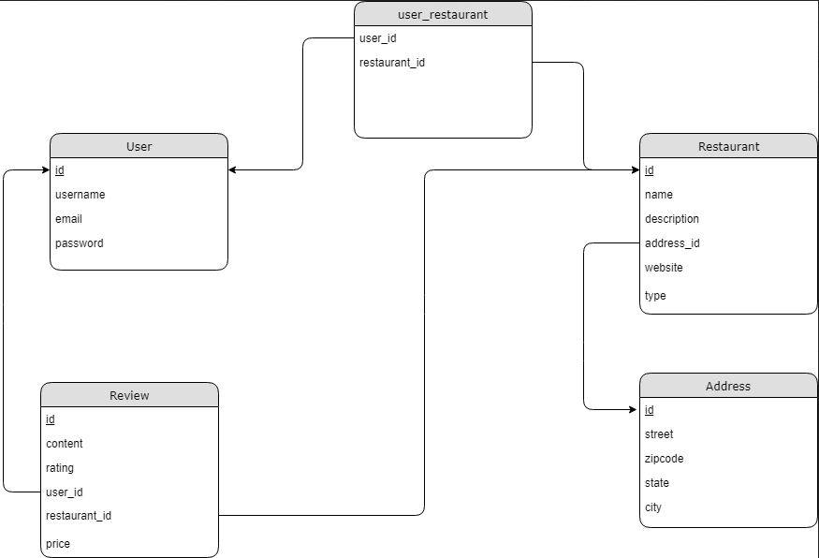

**Reviews:**

1. “OK so I don't see your project step two here so I can't really do much other then guess at how you are going to impediment this. Your schema makes sense and has a good layout which is easy to read and understand what you are going for. It might make sense to also include a customer base to the restaurant that shows how popular the place is by how many people go to it. As well as a style of food that they are serving. You may already be doing this but again I can tell sense I can see your written outline, but a main point of restaurants is the kind of food they are serving and I do not see that as a point. You may be planning on including that in the description but I think I should be a point that can be polled up so that you can do a search for restaurants with specific styles of food. As well as the level of service they are going for is this fine dining or is it take out, Missional star (sic) or family, it helps to show who the restaurant is for and what they are going for. Something you could add to the review is how many times they have put a review up, it is a way to show there credibility of there review. Not sure if review is the just the review it's self or if it is the reviewer and what he wrote. Similarly is the person reviewing them going to be in this database or is it just going to be the reviews themselves. Also does the user have any experience or does he have training in different types of food, such as Japanese, Vietnamese, French, Italian, American southern, etc, or does he run the business side of things. Also does the address have to be fixed or are you not including food trucks or are you only doing brick and mortar restaurant in this database. Something as well you can add is how long the restaurant has been open for.”
2. I reviewed your draft and had two comments/concerns. I'm not quite sure what the relationship between User and Restaurant represents?  What is the purpose of it? Secondly, I would argue that a restaurant can have multiple addresses (chain restaurants like McDonalds). This would then require a relationship table between Restaurant and Address and an update to the ERD.  A grader might let you work with a simplified version where every restaurant has exactly one address but I don't really know. Those are the only two things that really stuck out to me otherwise everything seemed good.
3. The only question i was going to ask about the diagrams was the relationship between users and restaurants, but that was cleared up in your post above.  The ERD and the schema both match each other, so i don't see any technical changes to either of your diagrams. So rather than just say "looks good" i would like to provide some input, even though its really minuscule. Looking at restaurants, i would add "price" and "type", just so they can be sorted by the users if they are looking for specific prices or type of food.  If you add a "price" attribute, it could be something like and integer from 1 to 4 with general prices. "Type" would be a little more difficult, because it would probably be a many to many relationship and require a separate table, since a restaurant could be Asian and Japanese, or American and Buffet, etc, and many restaurants can be of the same type. Under review you could add an attribute called "anonymous" in case a user wanted to leave an anonymous review.  I'm not a yelper, so I’m not sure if that is really a thing, but it might help get more reviews. Anyway, all that being said, this is only a one quarter class, and you could keep adding attributes forever, but you would never be able to finish the project in the short amount of time we have. I think it is fine as it is.

**Changes:**

1. Based off of this review we ultimately decided not to make any changes to our database schema diagram or overall database structure. The reviewer mentioned that it might be beneficial to include a customer base or ‘cuisine’ attribute to the restaurant table, but after deep considering we realized that this additional data would be unnecessary given the true, bigger, purpose of the application we are creating. Additionally the reviewer stated that we should consider adding the restaurant dining standard. While this suggestion makes sense for an application that focuses primarily on the numerous specific details of restaurants, it does not, however, provide any benefit to assessing the true rating of a restaurant, especially in regards to other user on our application. The rest of the review seemed to be questions that the author had, which we were able to answer on the original Piazza post. At this point in time the structure and attributes our database contains seem to keep a normalized structure, while also providing enough specificity and information to facilitate a successful application.
2. Based off this review we decided to take no action because it was primarily a misunderstanding rather than a suggested change to our database. I replied to this review on piazza with the following response: Hey so the relationship between Users and Restaurants, it shows how users can own many restaurants and restaurants can be co-owned by many owners! But yes I can see how that wasn't clear without our step 1 description. As for addresses, in a Yelp app the way it works is each establishment (unique location) has its own entry on yelp, so we would imitate this on our app by only allowing one address per establishment.
3. The first part of this review was answered by my response to the earlier review. The next suggestion was to add a type and price attribute to the restaurants table. The price attribute we have decided to add to the reviews table and this will be an integer value between 1-3 representing the dollar sign symbols that you would see in a yelp review (3= $$$ meaning expensive), and the type attribute we will add to the restaurant category and this will be a varchar of size (100) and we will use it to categorize the restaurants by a certain type which we could use to provide search functionality in our application. This was a great review and a thoughtful response which resulted in us making changes to our database design.  We decided not to go with their idea for an anonymous response because that usually leads to lower quality reviews which we do not want to promote.

**Upgrades:**

We are not making any other changes to our database besides adding the type attribute to the restaurant table and the price attribute to the review table. We also will not be altering the format of our table since we have properly done our many to many table and don’t have dependencies that violate 3NF form.