Comparative Study of k-NN and SVM for Diabetes Prediction with Machine Learning

Dheeraj Kondapally
Department of Computer Science and Engineering
SR UNIVERSITY
warangal, india
8340945033z@gmail.com

Aalokhya Karlapati
Department of Computer Science
and Engineering
SR University
Warangal,India
aalokhyakarlapati@gmail.com

Abstract— The diabetes is a chronic condition with life threatening complications if appropriate and timely adjustments were not made. This study evaluates machine learning's potential in predicting diabetes by comparing two major classification models: k-Nearest Neighbor (k-NN) as well as Support Vector Machine (SVM). By training and testing the developed diabetes models, the models' evaluation was made on the basis of accuracy, precision, recall, and f1-score. Both models scored very high predictive ability scores, however there are some differences in performance measurements. The result can then be Use these tools for better clinical decision-making, and in the health care. In the light of this comparison the models are found to be effective in diabetes prediction whereas the study paves the way for future researchsame field.

Keywords—--Diabetes forecasting, Machine learning, k-Nearest Neighbors (k-NN),Support Vector Machine (SVM),Accuracy, precision, recall, F1-score

I.Introduction
Diabetes a widespread chronic disease is affecting millions of people extremely and become a persistent problem because of the severe complications of this disease if is not managed well. From the very beginning and at the development of the disease, early diagnosis and prognosis of diabetesis essential for more effective treatment and cure. As
of contemporary time, machine learning methods is becoming as solid tools for disease prediction enabling medical staff to get patient care data-based insights so they can make more accurate and precise decisions.
Machine learning techniques such as decision tress, random forests, and ensembles methods often struggle in the diabetes prediction domain due to problems like overfitting, complexity, and data imbalance. Highly effective tools such as neural networks and deep learning methods provide immense precision but demand excessive computational resources in exchange and often lack user-friendly interpretation
Rather than that, we suggest a system having k-Nearest
Neighbors (k-NN) and Support Vector Machine (SVM)
models. k-NN, algorithm, shows a simple and interpretable procedures, based on similarity measurements, which in turn SVM is able manages high-dimensional data and imbalanced
datasets, providing robust generalization. The system incorporates these strengths to give a well-thought-out tool for the real-time prediction of diabetes. Our method ensures the data reliability and also improve the performance of model which boost the growing field of using machine learning for medical diagnosis and trechronic conditions such as diabetes.
This work is structured in five sections as follows: Section II gives an account of literature survey in the field of rumour detection. Section III is intended to presented the proposed mechanism. Section IV explores the experimental validations and the last section is Section V which concludes the paper.
II.LITERATURE SURVEY

A significant work was done by Alassaf, RA concentrated on Diabetes Mellitus predisposition by means of machine learning patterns. This work took data from King Fahd University Hospital in Riyadh, Saudi Arabia and hence it is original [1]. When performing experiments, classification algorithm neural network performed the highest (77.5%) accuracy level than the other algorithms [1].

MAR Refat, M Al Amin,explores early stage diabetes prediction using machine learning and deep learning methods, comparing their efficacy [1].It emphasizes the impact of diabetes on blood sugar processing, focusing on insulin insufficiency and ineffective insulin use leading to hyperglycemia [2].

D Gupta, A Choudhury, U Gupta, P Singh proposed paper which compares machine learning approaches to diagnose diabetes early, highlighting logistic regression as the most effective technique [1].It explores datasets from Assam, India, and PIMA Indian diabetic dataset, emphasizing the importance of timely diagnosis and management of diabetes [1] [2].
JRevathya,DSelvanayagib used Machine Learning techniques are utilized to predict diabetic diseases, comparing algorithms like Decision Tree, Support Vector Machine, K-Nearest Neighbor, and Logistic Regression for model performance assessment[1].Various machine learning algorithms such as Naive Bayes, SVM, and Decision Tree are employed to detect Type 3 diabetes with good accuracy rates on the Pima Indian Diabetic dataset, focusing on metrics like F1-score, Precision, Recall, and Accuracy[2][3].
P Sinha, P Sinha performed Chronic kidney disease (CKD) prediction is compared using K-Nearest Neighbour (KNN) and Support Vector Machine (SVM) classifiers, with KNN showing better performance [1] [2].Data mining and machine learning techniques are utilized to develop a decision support system for early CKD prediction, emphasizing the importance of timely detection and treatment [3]
ZN Nemer, S Fawzi Raheem focuses on using machine learning algorithms like XGBoost, Decision Trees, Random Forest, Logistic Regression, and K-Nearest Neighbors for detecting diabetes with XGBoost showing the highest accuracy of 98%.[1]
WM Jinjri, P Keikhosrokiani compares machine learning algorithms like SVM, K-NN, LR, DT, and NB for classifying cardiovascular disease, with SVM and LR identified as the most efficient methods [1] [2].The study aims to predict the presence or absence of cardiovascular disease in patients using these algorithms, analyzing factors like precision, recall, f1-score, accuracy, and training time
M Yaqoob, F Iqbal, S Zahir compared the predictive performance of k-nearest neighbors (k-NN) and support vector machine (SVM) for predicting ischemic heart disease (IHD) based on important risk factors, with SVM showing higher accuracy, sensitivity, specificity, and AUC on testing data set[1] [2].Both models identified blood pressure, cholesterol, physical activity, BMI, diet, family history, and type of oil as the most important risk factors for IHD[1] [2]
H Kaur, V Kumari proposed Diabetes a significant metabolic disorder with global concern due to rising cases, emphasizing the importance of early detection for maintaining a healthy life[1][2].Machine learning techniques were applied to the Pima Indian diabetes dataset to develop predictive models using algorithms like SVM, k-NN, ANN, and MDR[1][2].
V Patil, DR Ingle compares various machine learning classification algorithms for diabetes prediction, achieving a maximum accuracy of 80.20% with models like K-NN, Logistic Regression, Naïve Bayes, SVM, and Decision Tree [1].Additionally, the study introduces an Artificial Neural Network (ANN) framework that significantly improves accuracy to around 97.66% for diabetes diagnosis [1].
F Anwar,MY Ejaz proposed Diabetes Mellitus is a chronic disease with increasing prevalence, leading to severe complications if not diagnosed early [1].Various Artificial Intelligence techniques, including deep learning, are explored for diabetes diagnosis, emphasizing the significance of using heart rate for cardiac disease diagnoses [1].
N Arora, A Singh, proposed a novel architecture for predicting diabetes patients with a high accuracy of 98.7% using K-means clustering and SVM [1].The study utilizes the Pima Indians Diabetes Database and compares different machine learning techniques for classifying diabetes patients [1] [2].
MJUddin, MM Ahamad, MN Hoque, inBangladesh utilized machine learning techniques to detect diabetes, emphasizing the importance of early detection and key risk factors [1].The research compared various classifiers and identified significant features like age and family history of diabetes for effective detection and intervention [1].
Ibrahim, A Abdulazeez used Machine learning algorithmswhich play a crucial role in disease diagnosis, with various algorithms like Naïve Bayes, logistic regression, support vector machine, K-nearest neighbor, decision tree, and random forest being utilized for disease identification anprediction [1] [2].Previous studies have applied machine learning algorithms for detecting diseases such as liver disease, Alzheimer's disease, and prostate cancer, showing promising results in terms of accuracy and efficiency [2] [3].
A Jamuna, RJ Priyadarsini, S Titus discusses the importance of early detection of diabetes using machine learning algorithms like Decision Tree, SVM, Naive Bayes, Random forest, k-NN, K-mean clustering, and LR, with SVM showing the highest accuracy of 82% in predicting diabetes.^[1]It emphasizes the significance of accurate diagnosis due to the increasing number of diabetic patients and the role of machine learning in healthcare for disease prediction and automated diagnosis.^[2]
V Jaiswal, A Negi, T Pal paper says Diabetes is a global health concern with severe complications, and early diagnosis using machine learning algorithms is crucial for treatment and reducing risks[1][2].Various machine learning methods like neural networks and SVM have been used for diabetes prediction, with studies focusing on classification accuracy and model performance[2][3].
AE Evwiekpaefe, N Abdulkadir presents a predictive model for diabetes using machine learning techniques, achieving high accuracy in predicting diabetes status. [1] [2] [3]The model was validated using datasets, with a high percentage of correct predictions, showcasing the effectiveness of the machine learning algorithms employed. [1] [2]
S Preetha, N Chandan, NK Darshan used Data mining techniques are utilized to predict diseases like diabetes, heart disease, and skin cancer in the healthcare sector[1].The paper focuses on how data mining methods can minimize the number of tests required for disease diagnosis, thus saving time and improving results[1].
III. PROPOSED APPROACH
- Overview
it will form the basis of training the machine learning models which were created to predict diabetes signs. Feature engineering is the process of selecting the appropriate predictors of the feature from the dataset, dealing with missings data and outliers, and redesigning the data as a coherent feature that improves the model performance. Further, deep features obtained by trained models often help them to accurately diagnose healthy versus high risk of diabetes individuals.
2.Features extraction
Body Mass Index : A BMI that is computed from height and weight is mark of “body fat” as well as widely used as diabetes risk factor particularly obesity. It becomes evident in this case that BMI indicates a higher risk for the onset of the diabetes disease.

Blood Pressure: the systolic and diastolic blood pressure
readings, have always been incorporate in the fitness cardiovascular test. Generally, hypertension implies with diabetes and hence signals an alarming sign

Glucose Levels: Blood glucose levels improve whenever individual's level of glycemic control is optimal. Not only do the refined fasting and postprandial glucose levels but also the impaired fasting and postprandial glucose levecan
be an early warning of diabetes risk.

Insulin Levels: Insulin resistance, and the problems with insulin secretion, are the main characteristics of the diabetes. The insulin level monitoring helps to see the changes in metabolic health and diabetes threat.

Skin Thickness: Assessed by employing the skinfold caliper, consistent skin thickness gives information about body fat percentage and might be connected with diabetes.
Diabetes Pedigree Function This ability is a recognition of family historical background and genetic predisposition, which increases the risk of diabetes occurrence and highlights this rigidity as a trait of the disease.

Age: Age is a significant factor in diabetes risk, with older individuals generally being more susceptible due to age-related metabolic changes

b.DemographicFeatures
Demographic factors are main issue which may plan diabetes onset. They provide context and identify potential risk factors beyond medical history:They provide context and identify potential risk factors beyond medicalhistory
Pregnancies: The number of pregnancies in females isdetermined to shape the incidence of gestational diabetes that is known to increase the type 2 diabetes risk laterinlife([11]).
Lifestyle Factors: Among other available factors, diabetes is associated with a low level of physical activity, the type of diet and sleep problems prescribed to 12,13 and 14 . Understanding these factors give a comprehensive view of individual’s health and allow determining risks of diabetes in aperson.
c.DataPreprocessing
The dataset could show missing values for certain clinical features, perhaps due to the rarity of the particular illness, or unusual observations that deviate significantly from the average. These issues can be addressed through the following techniques:These issues can be addressed throughthefollowingtechniques:MissingValue .Imputation: For example, the imputation median/mean or the kNN imputation can be used, and they provide a minimum data loss by removing the missing values through the use of neighbor values ([15]).
Outlier Detection and Handling: Outliers assessment can be based on statistical tools, which may involve inter-quartile-range (IQR). Deciding on treatment of outliers, being witheld, winsorizing (capping to a specific value) or transformation using techniques like logarithmic transformation ([16]) is an essential rule of thumb d.Feature Selection and Engineering
In feature selection, it is the process of finding out the most relevant features from the large set of data, that are actually having the significant impact on the model’s performance. Correlation analysis, chi-square tests, or feature importance scores from machine learning models like Random Forest can be applied to go on with the selection of data ([17,18]). Feature design is a basket of techniques involve in scaling, normalization and the encoding of categorical data. These methods guarantees avoidance of features to be on different scales and this improves models stability and generalization (19).

IV. EXPERIMENTAL RESULT
In this section, we explain the details of experimental resultsUnder this section initially, we explain the details of datasets, then the results of our experiments.
1.Experimental Setup
The dataset shows medical symptoms that lead to development of diabetes . The study is conducted by implementing the dataset where researchers along with the health care providers can then build prediction models that might be used for the identification of those with higher diabetes risk depending on their health indicators. Data set is like a physician for diabetes management plan by offering indicators of blood pressure, BMI, and the range of glucose. Perceiving the impact and balance will depth understanding towards the measures in diabetes control and prevention. The dataset involves five attributes that refer to different health markers: blood pressure, BMR, and fasting blood sugar levels The Analysis is about a variation of birth and pregnancy data including others.In the data set some health parameters will be taken under consideration. The health parameters that are to be considered in the model are the insulin level , skin thickness, in addition to diabetes pedigree function Similarly, the Present Value is Depicted Using the Zeroes in the Data Set. The very first glance at the data set shows an idea that in the future the intelligence can use them to diagnose and treat diabetes.
2.Results and Discussion
The data set is processed now and features are some of the most important attributes that should be considered. In this case, each of the symptoms is represented by a set of 10 completely defined features. The procedures of sorting and then training are applied accordingly. We achieved k-fold cross validation to get the k best results. Thus, the entire dataset gets partitioned into k equal groups and then the learning experiments are performed with each of the groups of k-1 data sets to be used for training and the one of k for testing. And the last calculation stage from the five due folds as an average performance is considered. There, I selected k = 5 for assessing the sensitivity

Fold | k-NN |  |  | SVM
Fold | Recall | Precision | F1-Score | Recall | Precision | F1-Score
Fold 1 | 0.52 | 0.70 | 0.60 | 0.62 | 0.65 | 0.63
Fold 2 | 0.46 | 0.66 | 0.54 | 0.66 | 0.70 | 0.68
Fold 3 | 0.55 | 0.66 | 0.60 | 0.74 | 0.73 | 0.73
Fold 4 | 0.47 | 0.68 | 0.56 | 0.68 | 0.67 | 0.68
Fold 5 | 0.60 | 0.71 | 0.65 | 0.67 | 0.69 | 0.68

Table 2: performance at fivefold cross validation for different classifiers

sensitivity of the proposed function with respect to dataset size. Regarding assessment, we chose three critical metrics, namely precision, recall and F1-score. Recall rate shows the percentage of relevant documents which are retrieved and percentage of relevant documents out of those which are retrieved are precision rate. F1 score is a measure which is calculated by the harmonic mean of recall and precision. The figures of the metrics are modulated according to the confusion matrix which is tuned as per the table.1 During the test phase, the posts are tested individually and the performance is measured from the confusion matrix as shown in the table above. According to the TPs, FPs, FNs and TNs, the evaluation metrics shown in the mathematical form below are estimated;
𝑃𝑟e𝑐i𝑠io𝑛 = ^{𝑇𝑃}
𝑇𝑃+𝐹𝑃
𝑅e𝑐𝑎𝑙𝑙 = ^{𝑇𝑃}
𝑇𝑃+𝐹𝑁
𝐹1 − 𝑆𝑐o𝑟e = 2∗𝑃𝑟e𝑐i𝑠io𝑛∗𝑅e𝑐𝑎𝑙𝑙
𝑃𝑟e𝑐i𝑠io𝑛+𝑅e𝑐𝑎𝑙𝑙

Therefore, in the final phase of the process we do not forget to pass a complete system testing that includes testing of all system elements. however, the most viewed consideration is that matrix complexity is found to score among other measures where a news termination was given. In order to understand the varying purpose of the tests based on their sensitivity and the specificity values, Tables 2 and 3 are used. For instance, Table 2 is used to report the sensitivity and specificity based on the True Positives, True Negatives, False Positives, and False Negatives correspondingly.Table 1: Sample Confusion Matrix

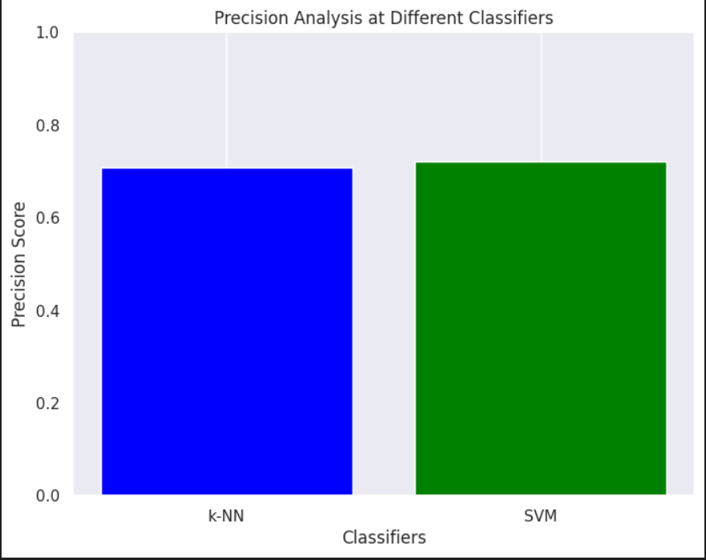
 |  | Predicted
 |  | diabetices | Non-diabetices
Original | diabetices | True Positive (TP) | False Negative (FN)
Original | Non-diabetices | False Positive (FP) | True Negative (TN)
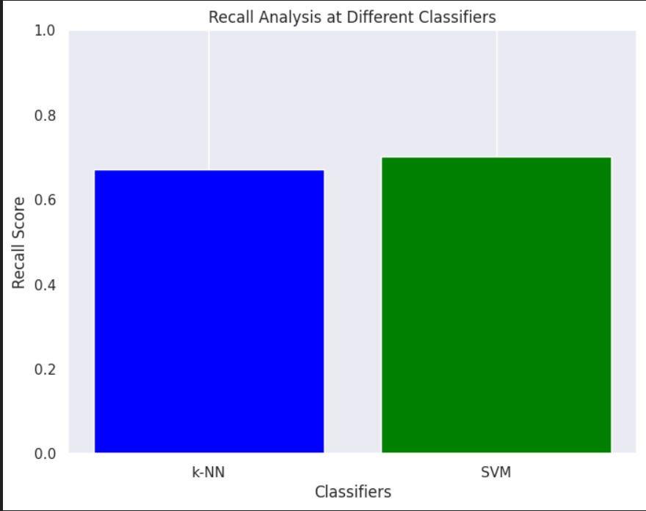
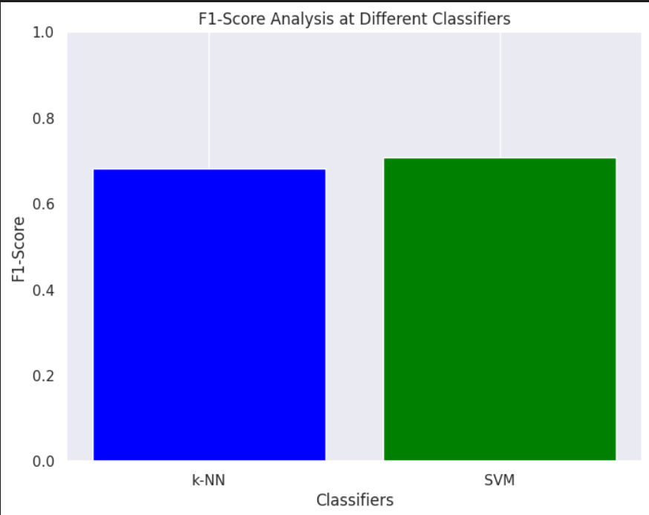

Figures 1, 2, and 3 illustrate the performance evaluation of our proposed mechanism using three key metrics: this evaluation is performed on the basis of precision, recall, and F1-score. We divided the entire feature set into three subsets: emotional background, author background, and/or reader background. The feature set in full covers the readers and the writer’s features. The two smaller subsets concentrate as well on a single features type. Such approach resulted in six simulation experiments where the capabilities of two machine learning algorithms was demonstrated on each experiment. Sensitivity, specificity and F1-score were computed each simulated step to evaluate accuracy measured in parallel across all the scenarios.

The figure 1 appears as a bar chart kind which depicts an accuracy of the diversified classroom in a diabetes prediction alarm. Accuration means the number of the cases of diabetes that would be detected by this model, and getting positive results.This classifier axis primarily provides the different classifiers that are fed to the algorithm for prediction (KNN and SVM most likely based on the code provided).On the vertical axis, the metrics score varies from 0 to 3. The higher score means you are a better performer.The width of the graph bars reveals the precision rank for the particular classifier from each element set.
Envision a classifier which gives data that denotes as well as detects that someone is a diabetes patient. This aspect of the model deals with the practical nature of how accurate the prediction is. In the stacked bar graph above, the precision of a classifier demonstrates that most of the patients that it labels as being diabetic are truly diabetics. Firstly, this makes the false positive frequency drop to the people who are not diabetic but mistaken as so decrease.By comparing the height bars, you may see which classifier outperforms the other one in accuracy.For instance:By comparing the height bars, you may see which classifier outperforms the other one in accuracy.For instance A larger k-NN bar shows then KNN making fewer errors in classifications.Precisely, a bar that is tall in comparison with SVM denotes that SVM has a higher precision in the diabetesprediction.
The task could be assigned to classify patients if they have diabetes or not, with the application of a machine learning model.Recall is one of metrics that is applied in order to evaluate the model X-axis shows how various algorithms are being used for the prediction (most likely k-NN and SVM according to the code you have provided).The y-axis shows the recall score for each classifier (it starts from 0 and goes to the value of 1, with higher values presenting a better performance).Recall examines the proportion of the real positive cases (patients with diabetes) that does succeed in being detected by the model. In fact, it measures how accurately the model captures a diabetic.
Higher Recall: The higher the recall value for the classifier, the better it is at identifying diabetic patients. This is favorable since a clinician wouldn't want to miss identifying such a person with the illness. Lower Recall: A weak recall score means the algorithm might be missing a number of patient with diabetes which in turn, could lead to delayed diagnosis or treatment. The fact that if the k-NN bar is higher than the SVM bar suggests that k-NN did better in this situation than SVM in identifying the patients who have diabetes. Nevertheless, a higher SVM bar implies that SVM hashigherdiabetespredictionrecall.
It is a bargarph which compares the F1-scores of two classifiers: k-NN (k Nearest Neighbor) and SVM (Support Vector Machine). F1-score, which is the key metric in the evaluation of the classifier, is the consequence of both precision and recall and therefore, it gives a balanced view on the probability of the classiﬁcation model to identify relevant cases while keeping out the cases of wrongful accusations. On this graph, the x-axis represents k-NN and SVM (classifiers) while the y-axis is F1-score varying from 0 to 1, wherein higher figures represent best performance. Summing up the inherited bars' heights, one may distinguish the most effective classifier that is based on higher F1-score. A bar with a further distance as its top suggests a better accuracy-recall balance in SVM, while a taller k-NN meaning may imply a better performance in the k-NN rule. Thus, height of equal bars depict similar performance among classifiers. Regard to F1-score interpretation, contextual relevance and the objective one chooses to chase are vital. Whether a task center on more accurate results (decreasing the false positives) or more complete results (covering all relevant info) is reliant on the purpose at hand.

Conclusion :

The study shows that the k-NN and the SVM algorithms are good instruments of classifying diabetes risk-factors with the dataset at hand. For both models, the results were equally good. The kNN model gave accuracy levels within the range of about 68 % to 80 %, but the SVM almost always had accuracy levels within a range of about 74 % to 81 %. They demonstrate that both models have a high degree of generality and are efficient on unforeseen input, particularly in that they have a very small difference in cross-validation scores. The reports stating the accuracy for both algorithms also indicate that the algorithm has a good diagnostic performance of normal people (class 0) than the patients with diabetes (class 1). This could be a result of poor quality of the data or variations in the class objects representation.
Parallely, histograms of all features were made so that the data is easily understandable. The pictorials show a few instances of properties and links to components, that can serve as a basis for future feature engineering and data balancing. In general, the accuracies of both k-NN and SVM were quite high and sometimes very high. SVM however came out as the best overall performer. Research going forward should focus on balancing the data (classes) and then on enhancing extra feature engineering among others since they them help to better model performance. Consequently, incorporation of other machine learning techniques or ensembles can further distinguish diabetic risk classification levels and contribute to an enhanced process of good healthcare through early identification and interventions.

References
[1]RAAlassaf,KAAlsulaim,NYAlroomi“Preemptivediagnoss of diabetes mellitususing machinelearning”ieeexplore.ieee.org 21st Saudi , 2018
[2] MAR Refat, M Al Amin, C Kaushal “A comparative analysis of early stage diabetes prediction using machine learning and deep learning approach” ieeexplore.ieee.org and Control (ISPCC), 2021

[3] D Gupta, A Choudhury, U Gupta, “Computational approach to clinical diagnosis of diabetes disease: a comparative study” Multimedia Tools and …, Springer 2021

[4] J Revathya, D Selvanayagib “ Comparative Analysis of Predicting the Diabetic Disease Using Machine Learning Techniques” Advances in Parallel Computing …, books.google.com ,2022

[5] P Sinha, P Sinha “Comparative study of chronic kidney disease prediction using KNN and SVM”InternationalJournalofEngineering Research …, academia.edu, 2015

[6] ZN Nemer, S FawziRaheem “Comparison of Classification of Different Machine learning Algorithms in the Diagnosis and Detect of Diabetes”InternationalJournalof …,137.117.138.59, 2024

[7] WM Jinjri, P Keikhosrokiani “Machine learning algorithms for the classification of cardiovascular disease-A comparative study”
ieeexplore.ieee.org, 2021 International …, 2021

[8] M Yaqoob, F Iqbal, S ZahirComparing “predictive performance of k-nearest neighbors and support vector machine for predicting ischemic heart disease” royalliteglobal.com, Research Journal in Advanced …, 2020

[9] H Kaur, V Kumari “Predictive modelling and analytics for diabetes using a machine learning approach” emerald.com Applied computing and informatics, 2020

[10] V Patil, DR Ingle “Comparative analysis of differentMLclassificationalgorithmswith diabetesprediction throughPimaIndian diabetics dataset” InternationalConferenceonIntelligent …,ieeexplore.ieee.org, 2021

[11] G Aslı, A Kalkan “Performance comparison machinlearning algorithmsin diabetes disease prediction” dergipark.org.tr European Mechanical Science,2023

[12] FAnwar, MY Ejaz, A Mosavi “ A comparative
analysis on diagnosis of diabetes mellitus using
differentapproachesAsurveyInformaticsinMedicineUnlocked”,20 Elsevier 2020

[13] NArora,ASingh,MZNAl-Dabagh“A Novel Architecture for Diabetes Patients' Prediction Using K-Means Clustering and SVM” hindawi.com Problems in Engineering, 2022

[14] MJ Uddin, MM Ahamad, MN Hoque, MAA Walid “A comparison of machine learning techniques for the detection of type-2 diabetes mellitus” mdpi.comexperiences from Bangladesh Information, 2023

[15] I Ibrahim, A Abdulazeez “ The role of machine learning algorithms for diagnosing diseases” jastt.org
Journal of Applied Science and Technology …, 2021

[16] A Jamuna, RJ Priyadarsini, S Titus “Survey on predictive analysis of diabetes disease using machine learning algorithms” Int J Comp Sci Mobile Comput …, academia.edu , 2020

[17]Iparraguirre-Villanueva,KEspinola-Linares”Application of machine learning models for early detection and accurate classification of type 2 diabetes” mdpi.comDiagnostics, 2023

[18] V Jaiswal, A Negi, T Pal “A review on current advances in machine learning based diabetes prediction” – Elsevier Primary Care Diabetes, 2021

[19] AE Evwiekpaefe, N Abdulkadir “ A Predictive Model for Diabetes Using Machine Learning Techniques (A Case Studyof Some Selected Hospitals In Kaduna Metropolis)”
digitalcommons.kennesaw.edu,2022

[20] S Preetha, N Chandan, NK Darshan… “ Diabetes diseasepredictionusingmachinelearning” scholar.archive.org Int. J. Mod. Trends Eng …, 2020 -

