Sales Trend Forecasting and Visualization
Week 3 Project – eCommerce Sales Forecasting
Prepair by :- Aalok pandey

1. Introduction
This project analyzes monthly eCommerce sales trends and forecasts sales for the next 12 months. A synthetic but realistic sales dataset was created because the task permits simulated data when necessary. The dataset contains 60 months of historical observations from January 2020 to December 2024.

2. Objective
The objectives are to prepare time-based sales data, identify trend and seasonal patterns, apply forecasting techniques, evaluate prediction accuracy, visualize historical and future sales, and translate the forecast into useful business insights.

3. Dataset Description
The dataset contains Date, Sales, Orders, and Average Order Value. Sales are the primary target variable. The data is monthly, which makes it suitable for identifying long-term trend and recurring monthly seasonality.
Important: this is a simulated dataset created specifically for this academic project. It should not be presented as real company sales.

4. Data Preparation
- Converted the Date field into monthly datetime format.
- Checked the dataset structure and kept one observation per month.
- Created supporting business measures: Orders and Average Order Value.
- Created a chronological train/test split to avoid using future information during training.
- Used the first 48 months for training and the final 12 months for model evaluation.

5. Exploratory Sales Trend Analysis
The highest historical monthly sales occur in December 2024 at approximately 203,181 units, while the lowest occur in February 2020 at approximately 78,781. The data was intentionally constructed with a gradual upward trend and stronger sales toward the end of the year to represent typical seasonal eCommerce behavior.
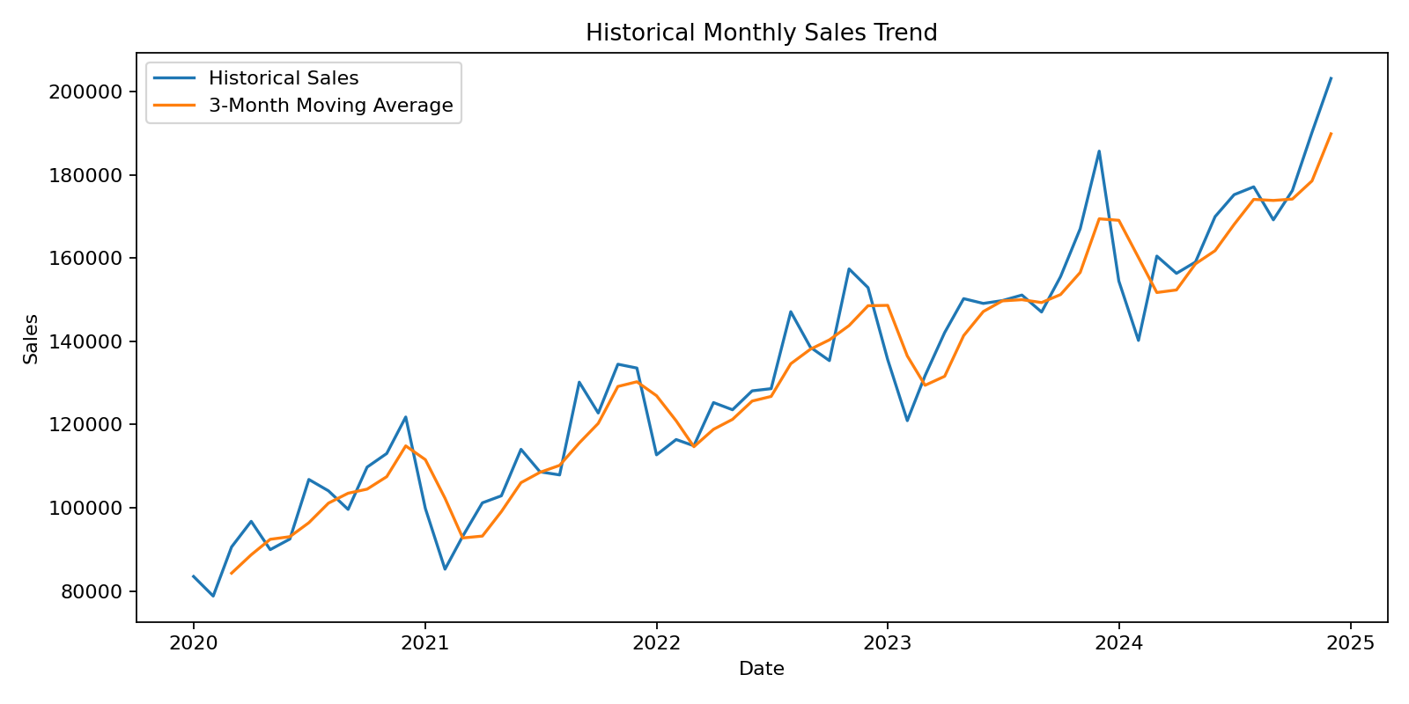

6. Forecasting Methodology

Seasonal Linear Regression
The primary forecasting model is linear regression using three predictors: a time trend, a sine seasonal component, and a cosine seasonal component. The trend captures gradual growth or decline, while the sine and cosine terms capture recurring 12-month seasonality.
This approach was selected because the dataset has a clear time trend and repeating monthly pattern, while remaining simple enough to explain and reproduce.

3-Month Moving Average
A 3-month moving average was also calculated as a simple baseline. It smooths short-term fluctuations and provides a reference point for judging the regression model.

7. Model Evaluation
The final 12 historical months were kept as an unseen test period. Accuracy was measured using MAE, RMSE and MAPE.
Metric | Value | Interpretation
MAE | 7,635.44 | Sales currency units
RMSE | 9,911.74 | Sales currency units
MAPE | 4.44 | %
3-Month Moving Average MAE | 11,438.31 | Sales currency units
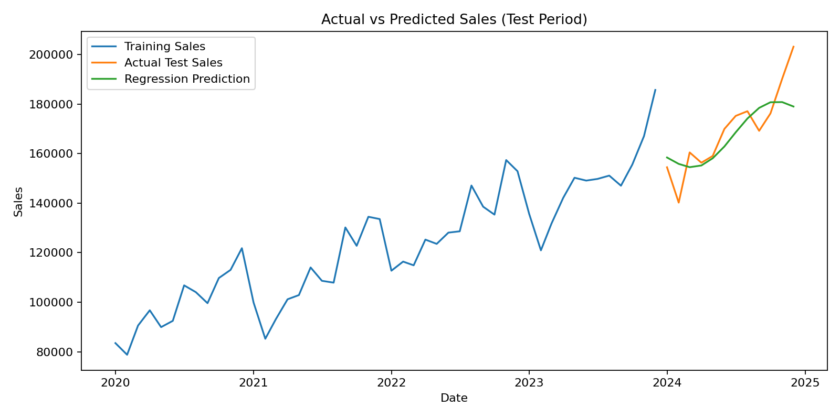

8. Future Sales Forecast
The model produces a 12-month forecast for January–December 2025. The average forecasted monthly sales level is approximately 185,068. From January to December 2025, the forecast changes by approximately 11.7%.
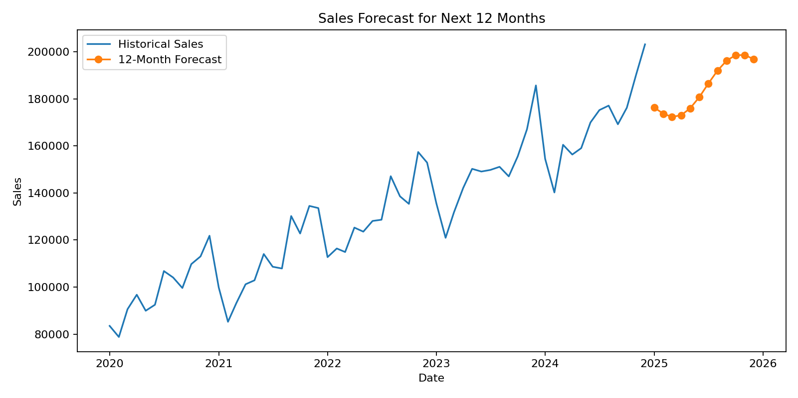

9. Business Insights
- The forecast can support inventory and procurement planning by giving an expected sales level for each future month.
- Seasonal peaks can be used to plan marketing campaigns, staffing, and stock availability.
- The monthly forecast can help management set realistic sales targets and budgets.
- The forecast should be refreshed when new actual sales data becomes available.

10. Assumptions
- The historical trend continues into the forecast period.
- The 12-month seasonal pattern remains reasonably stable.
- No major external shock causes a sudden structural change in demand.
- The synthetic data represents a simplified eCommerce sales environment.

11. Limitations
- The dataset is simulated rather than actual company data.
- The model uses time and seasonality but does not include price, promotions, advertising, economic conditions, holidays, or competitor activity.
- Forecast uncertainty increases as the prediction horizon becomes longer.
- A more advanced project could compare this model with exponential smoothing, ARIMA/SARIMA, Prophet, or machine-learning models.

12. Conclusion
The project demonstrates a complete sales forecasting workflow: dataset preparation, trend analysis, seasonal regression, moving-average benchmarking, model evaluation, visualization, future forecasting, and business interpretation. The resulting workbook contains the historical data, test predictions, forecast values, and evaluation metrics.

