WEEK 1 TASK
Developing an eCommerce
Data Analytics Strategy
A structured strategy for using public and business data to understand performance, customer behavior, and market trends

Project Detail | Information
Task | Week 1 – eCommerce Data Analytics Strategy
Domain | eCommerce / Retail Analytics
Primary Focus | Business performance, customer behavior, acquisition, retention and market growth
Approach | Descriptive → Diagnostic → Predictive → Prescriptive analytics
Deliverable | Detailed strategy plan with research, metrics, methodology, implementation and recommendations
Prepared by | ____________________________
Date | 30 September 2026

Note: This is a strategy document, not a claim about the performance of a specific eCommerce company.

Table of Contents
1. Executive Summary
2. Project Objective and Scope
3. Research Background and Market Context
4. Analytics Goals and Business Questions
5. Data Strategy and Public Data Sources
6. Data Collection and Data Quality Framework
7. Core KPI Framework
8. Customer Journey and Funnel Analytics
9. Market Segmentation Strategy
10. Hypothesis Development and Testing
11. Predictive Analytics and Decision-Making
12. Multi-Phase Analytics Implementation Plan
13. Dashboard and Reporting Design
14. Governance, Privacy, Risks and Mitigation
15. Expected Outcomes and Evaluation Criteria
16. Conclusion and Next Steps
17. References

The structure follows the assignment requirements: research, metrics, strategy formulation, segmentation, hypotheses, predictive analytics, implementation, visual process documentation, challenges, mitigation and recommendations.

1. Executive Summary
This project develops a practical data analytics strategy for an eCommerce environment. The purpose is to create a repeatable framework through which an online retailer can collect, clean, analyze and communicate data to support decisions about sales, customers, products, marketing and growth. The strategy is designed to work with internal transaction and website data as well as publicly available market information.
The proposed framework begins with clearly defined business objectives and then connects those objectives to measurable KPIs. Data is collected from order systems, web/app analytics, customer records, marketing platforms, product catalogs, support systems and external market sources. After quality checks, the data is transformed into analysis-ready datasets. Descriptive analytics explains what happened, diagnostic analytics investigates why it happened, predictive analytics estimates what may happen next, and prescriptive analytics supports action selection.
The strategy gives particular attention to customer acquisition, conversion, retention and market growth. Customer segmentation uses demographic, behavioral and value-based attributes, including an RFM-style framework where suitable. Hypothesis testing is used to move from assumptions to evidence, while predictive models can support demand forecasting, churn-risk identification and customer-value estimation.
The final outcome is a management-ready analytics system: standardized data definitions, KPI dashboards, recurring reports, documented hypotheses, model outputs and a feedback loop that connects insights to business experiments.

Key Principles
- Start with business questions rather than tools.
- Use consistent KPI definitions and a single source of truth.
- Separate descriptive facts from interpretation and recommendations.
- Validate data quality before modeling.
- Use experiments where possible to test whether an action caused a measurable change.
- Protect customer privacy and limit access to sensitive data.
- Automate recurring reporting so analysts can spend more time on decision support.

2. Project Objective and Scope

2.1 Objective
The main objective is to design a comprehensive eCommerce data analytics strategy that uses available data to generate actionable insights into business performance, customer behavior and market trends.

2.2 Specific Objectives
- Define business goals and translate them into measurable analytics questions.
- Identify internal and public data sources relevant to sales, customers, products, marketing and market conditions.
- Establish a KPI framework covering revenue, profitability, acquisition, conversion, retention and customer value.
- Design a customer segmentation approach for targeted analysis and marketing.
- Create a hypothesis-development process for investigating business problems.
- Define appropriate descriptive, diagnostic, predictive and prescriptive techniques.
- Design dashboards and reporting routines for different stakeholder groups.
- Identify implementation risks and propose mitigation controls.
- Create a phased roadmap from foundational reporting to advanced analytics.

2.3 Scope
Included | Not Included
Sales and order analytics | Operating a real eCommerce store
Customer acquisition and retention analytics | Actual advertising spend or campaign execution
Product/category performance | Accessing private customer data
Market and public-data analysis | Making financial or investment recommendations
Segmentation and predictive analytics framework | Guaranteeing a specific business result
Dashboard and reporting design | Production deployment of a complete data platform

3. Research Background and Market Context
eCommerce is a data-rich business environment because customer interactions can be recorded across multiple digital touchpoints: product views, searches, cart activity, checkout, purchases, refunds, reviews and repeat visits. This creates an opportunity to connect customer behavior with commercial outcomes, provided that events and business definitions are consistently captured.
As a current market reference, the U.S. Census Bureau reported that seasonally adjusted U.S. retail e-commerce sales in Q2 2026 were estimated at $340.2 billion, up 3.8% from Q1 2026 and 12.2% from Q2 2025; e-commerce represented 17.1% of total retail sales in that quarter. These figures describe the U.S. market and should not be treated as a direct measure of an individual company's performance or of India's eCommerce market.
For measurement design, Google Analytics documentation provides standardized eCommerce events such as view_item, add_to_cart, view_cart and purchase. Standardized event names help analytics systems distinguish common retail interactions and support consistent reporting.
The OECD's Digital Economy Outlook notes that adoption of data-dependent technologies such as big data analytics and AI varies substantially across firms and is influenced by firm characteristics. This supports a phased strategy in which organizations first establish data quality and reporting foundations before moving to advanced modeling.

Research Implications for This Project
- Use a funnel-based event model to connect browsing behavior to purchase outcomes.
- Track both absolute performance and rates, such as conversion rate and repeat-purchase rate.
- Separate market-level trends from company-specific performance.
- Treat advanced analytics as an extension of a reliable data foundation rather than a substitute for it.

Public Research Sources
Source | How it can be used
U.S. Census Bureau – Quarterly Retail E-Commerce Sales | Market-size and trend context for U.S. retail eCommerce.
Google Analytics – eCommerce measurement documentation | Design of standardized digital interaction events.
OECD Digital Economy Outlook 2024 | Context on digital technology, data and analytics adoption.
Government statistical portals / open-data catalogs | Population, economic, geographic or category-level context.
Public company reports and investor disclosures | Benchmarking business models, product categories and reported operating metrics.

4. Analytics Goals and Business Questions
The strategy should convert broad business goals into questions that can be answered with data. The following question bank can be used as the initial analytics backlog.
Business Area | Key Questions | Example Metrics
Business performance | How are sales changing? Which categories contribute most? | Revenue, orders, AOV, gross margin
Acquisition | Which channels bring qualified customers? | CAC, conversion rate, new customers
Conversion | Where do users leave the purchase journey? | View-to-cart, cart-to-checkout, checkout-to-purchase
Customer retention | Which customers return and how often? | Repeat rate, retention, churn-risk
Customer value | Which segments create long-term value? | CLV, AOV, frequency, monetary value
Products | Which products grow, decline or create returns? | Units, revenue, margin, return rate
Marketing | Which campaigns or channels generate incremental outcomes? | ROAS, CPA, conversion, revenue
Market | Which geographies/categories show growth opportunities? | Growth rate, market share proxy, demand trend
Operations | Where do delivery or stock issues affect customer experience? | Cancellation, stock-out, delivery time

Decision Hierarchy
- Strategic: Which customer segments, categories or markets deserve investment?
- Tactical: Which campaigns, offers, products or channels should be tested?
- Operational: Where are immediate conversion, stock, service or data-quality issues?
- Analytical: Which hypotheses and models should be prioritized based on expected decision value?

5. Data Strategy and Public Data Sources
A useful eCommerce analytics strategy combines first-party operational data with carefully selected external data. The objective is not to collect every available variable; it is to collect data that answers defined business questions.

5.1 Internal / First-Party Data
Dataset | Typical Fields | Primary Uses
Orders | order_id, customer_id, date, value, discount, status | Sales, AOV, trends, cohort analysis
Order Items | order_id, product_id, quantity, price | Product and basket analysis
Customers | customer_id, signup_date, location, channel | Segmentation and retention
Products | product_id, category, brand, cost, price | Product profitability and assortment
Web/App Events | session_id, event_name, timestamp, product_id | Funnel and behavior analysis
Marketing | campaign, channel, cost, clicks, conversions | Acquisition and campaign analysis
Returns/Support | order_id, reason, ticket type, resolution | Experience and product-quality analysis
Inventory/Delivery | SKU, stock, fulfillment date, delivery date | Availability and operations

5.2 Public / External Data
- Government retail and economic statistics.
- Population, demographic and geographic datasets where legally usable.
- Public search/trend indicators where methodology and access terms permit.
- Public company annual reports and investor disclosures.
- Industry association reports and research publications.
- Public holiday calendars, weather or event datasets when relevant to demand analysis.
External datasets should be documented with source, publication date, geographic scope, update frequency, methodology, license/terms and known limitations. A public dataset is not automatically suitable for direct business comparison.

6. Data Collection and Data Quality Framework
The analytics lifecycle begins before analysis. Data collection should be designed around a common event and entity model so that customer, order, product and session identifiers can be joined consistently.
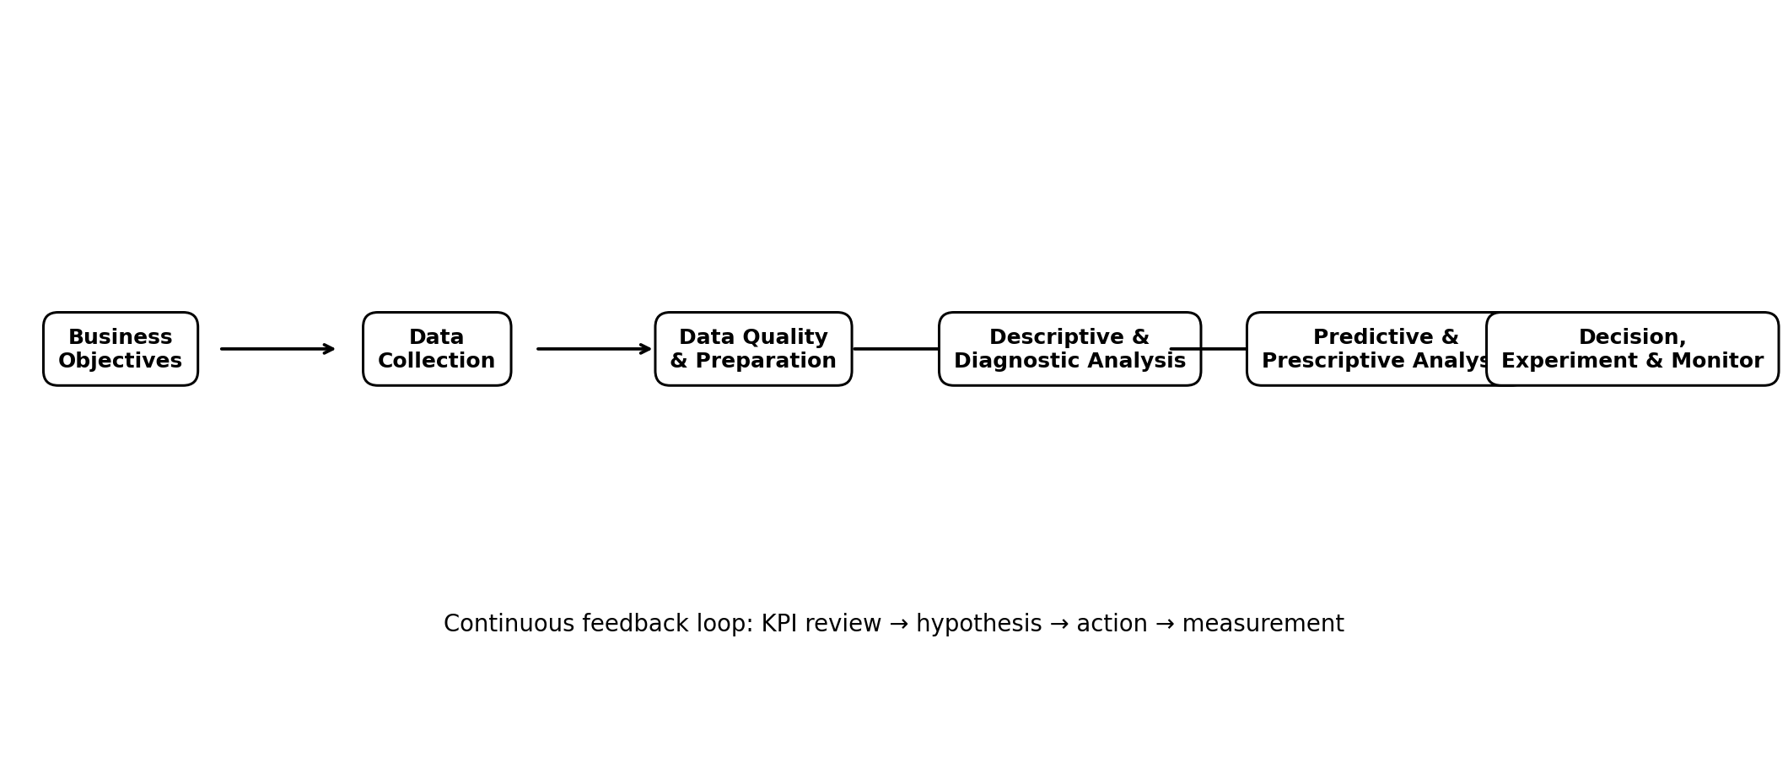
Figure 1. Proposed eCommerce analytics lifecycle

6.1 Data Quality Checks
Quality Dimension | Checks | Example Control
Completeness | Missing IDs, dates, prices, quantities | Track null rate by field
Validity | Negative/invalid values, impossible dates | Range and rule validation
Uniqueness | Duplicate orders or transaction IDs | Unique-key test
Consistency | Different category/channel names | Reference/master tables
Timeliness | Delayed or missing daily data | Freshness SLA
Accuracy | Mismatch between order system and analytics | Reconciliation totals

6.2 Event Tracking Standard
For digital behavior, the implementation should use a controlled event dictionary. Example events include view_item, add_to_cart, view_cart, begin_checkout and purchase. For each event, define required parameters such as product identifier, quantity, price/value, currency, session/user identifier and timestamp.
Google's documentation specifically recommends standardized retail eCommerce event names and parameters. It also notes that implementation should be validated to avoid duplicate events and incorrect transaction tracking.

7. Core KPI Framework
KPIs should be grouped by business purpose. A KPI dictionary should define the formula, data source, time grain, owner and interpretation for every metric.
KPI | Formula / Definition | Purpose
Revenue | Sum of completed-order sales value | Measure sales performance
Orders | Count of completed orders | Measure transaction volume
AOV | Revenue ÷ Orders | Measure average order value
Conversion Rate | Purchases ÷ relevant sessions/users | Measure purchase efficiency
Cart-to-Purchase Rate | Purchases ÷ carts | Identify checkout friction
CAC | Acquisition spend ÷ new customers | Measure acquisition cost
ROAS | Attributed revenue ÷ advertising spend | Evaluate paid-media efficiency
Repeat Purchase Rate | Customers with repeat orders ÷ eligible customers | Measure retention
CLV | Estimated future contribution/value per customer | Support long-term customer decisions
Return Rate | Returned units/orders ÷ sold units/orders | Monitor product/customer issues
Gross Margin | Revenue − cost of goods sold | Measure economic contribution

KPI Governance
- Define one official formula for each executive KPI.
- Specify whether the metric uses gross sales, net sales or recognized revenue.
- Document treatment of cancellations, refunds, taxes, shipping and discounts.
- Keep numerator and denominator populations consistent.
- Record data refresh time and source system.
- Review KPI definitions when business processes change.

8. Customer Journey and Funnel Analytics
Funnel analytics identifies where users progress or drop out between discovery and purchase. The funnel should be analyzed overall and by segment, device, channel, product category, geography and campaign.
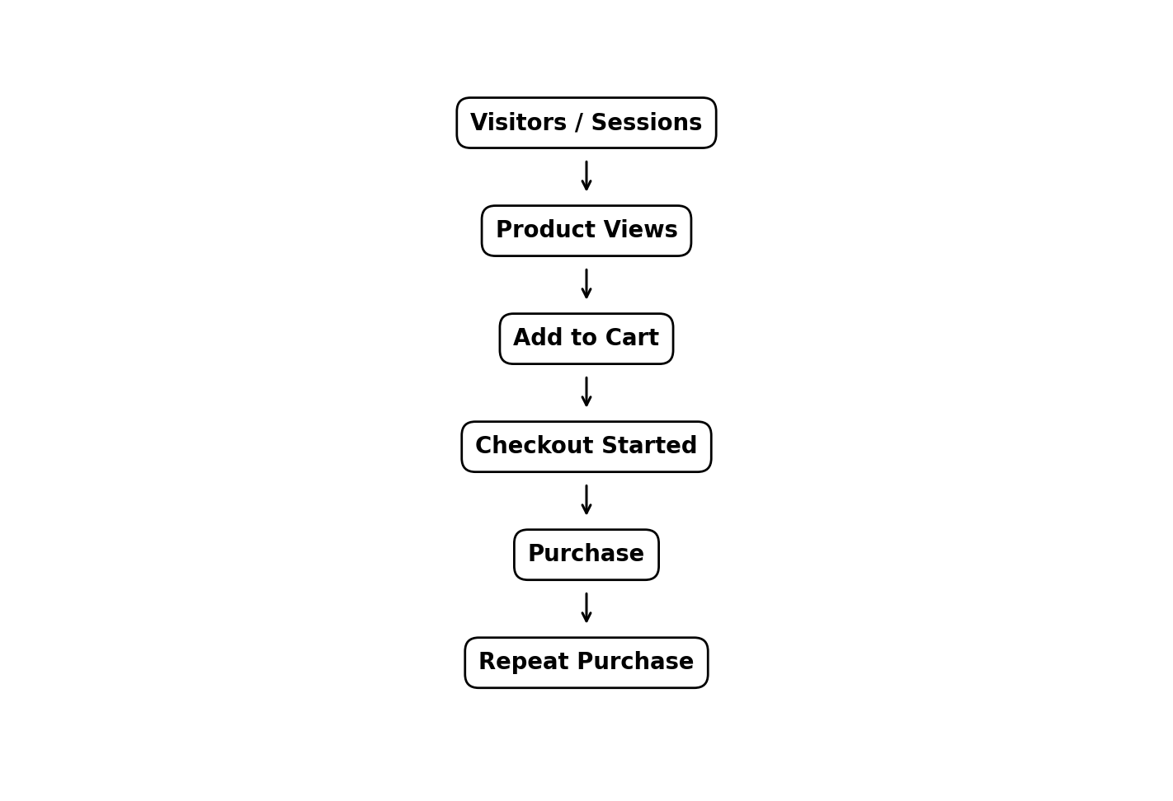
Figure 2. Example customer journey funnel

Diagnostic Questions by Funnel Stage
Stage | Diagnostic Questions
Visitors → Product View | Is traffic relevant? Are landing pages and search results useful?
Product View → Cart | Are price, reviews, availability and product information sufficient?
Cart → Checkout | Are shipping costs, delivery dates or account requirements causing exits?
Checkout → Purchase | Are payment errors, trust issues or technical failures occurring?
Purchase → Repeat | Does product quality, service, value or communication influence return behavior?

Cohort Analysis
Customers can be grouped by acquisition month or first-purchase period. Retention and revenue can then be tracked across subsequent periods. Cohort analysis helps distinguish a temporary sales spike from sustainable customer behavior.

9. Market Segmentation Strategy
Segmentation divides customers or markets into groups with meaningful differences in behavior or value. Segments should be actionable: each segment should support a distinct analytical question, business action or experiment.
Segmentation Dimension | Examples | Use
Behavioral | Browsing frequency, categories viewed, cart behavior | Personalization and journey analysis
Value-based | Revenue, margin, CLV, order frequency | Prioritization and retention
RFM | Recency, Frequency, Monetary | Customer value/engagement grouping
Acquisition | Organic, paid search, social, referral | Channel comparison
Geographic | Country, state, city, delivery zone | Market and logistics planning
Product affinity | Category/brand/basket patterns | Cross-sell and assortment
Lifecycle | New, active, at-risk, lapsed | Lifecycle communication

Example RFM Framework
Recency measures how recently a customer purchased; Frequency measures how often they purchased during the chosen observation window; Monetary measures the amount of value associated with their purchases. The observation window and treatment of refunds/cancellations should be documented before scoring.
RFM scores can be combined with customer lifecycle and acquisition-channel information. The goal is not simply to label customers, but to connect segments to measurable actions such as retention experiments, cross-sell analysis or service interventions.

10. Hypothesis Development and Testing
A hypothesis converts an observation or business assumption into a testable statement. This prevents analysis from becoming a collection of charts without a decision purpose.
Hypothesis | Variables | Method | Decision Use
Free shipping may increase checkout completion. | Shipping offer, checkout completion | A/B test or controlled comparison | Evaluate offer design
Customers with higher product engagement may have higher conversion. | Engagement events, purchase | Cohort/regression analysis | Improve product discovery
Repeat customers may have different basket composition from new customers. | Lifecycle, category mix, AOV | Group comparison | Cross-sell and retention planning
Certain acquisition channels may have higher long-term value. | Channel, CAC, repeat revenue/CLV | Cohort analysis | Budget allocation evidence
Delivery delays may be associated with higher return/contact rates. | Delivery time, returns/tickets | Correlation/regression | Operations improvement

Testing Workflow
- State the business problem.
- Define the null and alternative hypotheses where statistical testing is appropriate.
- Specify the population, observation period and exclusion criteria.
- Select the metric and method before inspecting results where practical.
- Check sample size, missingness, bias and confounding factors.
- Report effect size and uncertainty, not only statistical significance.
- Translate the result into a business action or a decision to collect more evidence.

11. Predictive Analytics and Decision-Making
Predictive analytics estimates future outcomes using historical and current data. It should be introduced only after data quality, feature definitions and baseline reporting are stable.
Use Case | Target | Possible Features | Model Examples
Demand forecasting | Future units/orders | History, seasonality, price, promotions | Time-series models, gradient boosting
Churn / lapse risk | Probability of inactivity | Recency, frequency, support, engagement | Logistic regression, tree-based models
Customer value | Future revenue/contribution | Past value, frequency, lifecycle | Regression, probabilistic CLV models
Product recommendation | Next likely product | Past purchases, views, category affinity | Collaborative/filtering approaches
Return-risk analysis | Return probability | Product, customer, delivery, price | Classification models

Model Evaluation
- Use a time-aware train/validation/test split for time-dependent problems.
- Compare advanced models against simple baselines.
- Use business-relevant metrics such as MAE/MAPE for forecasting or precision/recall/AUC for classification, depending on the use case.
- Check model drift and performance after deployment.
- Document features, assumptions, limitations and intended use.
- Do not treat model probability as certainty; use it as decision-support evidence.

From Prediction to Action
The value of a model comes from the decision it improves. For example, a churn-risk model could trigger an experiment for selected customers, while a demand forecast could inform inventory planning. The resulting business action must then be measured so the organization can determine whether the intervention produced a useful incremental outcome.

12. Multi-Phase Analytics Implementation Plan
Phase | Duration | Main Activities | Outputs
Phase 1 – Discovery | Week 1 | Business questions, stakeholders, KPI definitions, source inventory | Analytics strategy and KPI dictionary
Phase 2 – Data Foundation | Weeks 2–3 | Data extraction, cleaning, joins, validation, event dictionary | Clean analytical datasets
Phase 3 – Descriptive Analytics | Weeks 4–5 | Trend, product, customer, channel and funnel analysis | Dashboard v1 and insight report
Phase 4 – Segmentation & Hypotheses | Weeks 6–7 | RFM, cohorts, hypothesis backlog, testing design | Segments and test plan
Phase 5 – Predictive Analytics | Weeks 8–10 | Feature engineering, model development and validation | Validated model prototypes
Phase 6 – Decision & Automation | Weeks 11–12 | Dashboard automation, alerts, experiments, monitoring | Operational analytics workflow

Suggested Technology Stack
Layer | Tools / Options
Data storage | MySQL / PostgreSQL / cloud warehouse
Data cleaning | Power Query / Python pandas / SQL
Analysis | Python, SQL, Excel
Visualization | Power BI / Tableau / Excel
Modeling | scikit-learn / statsmodels
Tracking | GA4 or equivalent event analytics platform
Documentation | GitHub / shared documentation / version-controlled notebooks

For a student project, the stack can be simplified to Excel + Power Query + SQL + Python + Power BI. The same analytical logic can later be migrated to cloud infrastructure.

13. Dashboard and Reporting Design
The reporting layer should serve different audiences. Executives need a small set of decision KPIs; analysts need drill-down capability; marketing and operations teams need action-oriented views.
Dashboard | Main Content | Refresh
Executive Overview | Revenue, orders, AOV, margin, conversion, repeat rate | Daily / weekly
Customer Analytics | New vs repeat, cohorts, RFM, CLV, retention | Weekly
Marketing Performance | Spend, CAC, ROAS, channel conversion | Daily / weekly
Product Analytics | Category, SKU, margin, returns, basket affinity | Daily
Funnel Analytics | Traffic → product → cart → checkout → purchase | Daily
Operations | Stock-outs, fulfillment, delivery, cancellations | Daily

Dashboard Design Principles
- Show KPI value, comparison period and direction of change.
- Allow filtering by time, channel, category, geography and customer lifecycle.
- Use consistent definitions across pages.
- Show exceptions and drivers, not only totals.
- Keep detailed diagnostic views separate from executive summaries.
- Include data-refresh timestamp and metric definitions.

14. Governance, Privacy, Risks and Mitigation
Analytics systems can create business value only when data is trustworthy, appropriately protected and used for legitimate purposes. Governance should be designed into the project rather than added after deployment.
Risk | Potential Impact | Mitigation
Poor data quality | Incorrect insights and decisions | Automated validation, reconciliation and data-quality dashboard
Duplicate events | Inflated sessions/orders/revenue | Unique transaction IDs and event validation
Metric inconsistency | Different teams report different numbers | Central KPI dictionary
Privacy exposure | Unauthorized access or misuse | Minimize personal data, access controls, retention rules
Model bias | Uneven or misleading predictions | Segment checks, fairness review and human oversight
Overfitting | Poor performance on new data | Validation, baseline models, time-aware testing
Attribution error | Misallocation of marketing credit | Document attribution rules and use experiments where possible
Dashboard overload | Low adoption and unclear priorities | Role-based dashboards and limited executive KPIs

Privacy and Ethical Principles
- Collect only data needed for defined analytical purposes.
- Use appropriate access controls and protect customer identifiers.
- Avoid exposing individual customer information in general dashboards.
- Document consent, retention and data-use requirements applicable to the organization and jurisdiction.
- Use aggregated or anonymized data for public reporting where possible.
- Provide human review for high-impact decisions supported by models.

15. Expected Outcomes and Evaluation Criteria
The assignment requires clarity, depth, completeness, logical structure and quality of insights. The following deliverables map directly to those criteria.
Expected Outcome | Evidence in the Project
Clear business strategy | Objectives, scope, business questions and decision hierarchy
Research foundation | Market context and documented public data sources
Defined metrics | KPI framework and KPI governance
Practical methodology | Data collection, quality, analysis and modeling workflows
Customer understanding | Funnel, cohorts and segmentation/RFM strategy
Analytical depth | Hypotheses, statistical testing and predictive use cases
Implementation readiness | Multi-phase roadmap and technology stack
Professional communication | Dashboards, flowcharts, tables and structured headings
Risk awareness | Governance, privacy and mitigation plan

Success Measures for the Analytics Program
- Higher trust in reported KPIs.
- Reduced manual effort in recurring reports.
- Faster identification of conversion or retention issues.
- More consistent experimentation and hypothesis tracking.
- Improved visibility into customer and product segments.
- Measurable business actions linked to analytics outputs.

16. Conclusion and Next Steps
This eCommerce data analytics strategy establishes a complete path from business questions to data collection, quality assurance, KPI reporting, customer segmentation, hypothesis testing, predictive modeling and decision support. The central principle is that analytics should be connected to decisions: every important metric should have a definition, every major analysis should answer a question, and every recommended action should be measurable.
The first implementation priority is to establish a reliable data foundation and a common KPI dictionary. Once that foundation is stable, the organization can expand into funnel diagnostics, customer cohorts, RFM segmentation and structured experimentation. Predictive models should be introduced progressively, with clear evaluation criteria and monitoring.

Recommended Next Steps
- Confirm stakeholders and top 10 business questions.
- Create the source-data inventory and data dictionary.
- Define official KPI formulas and ownership.
- Implement/validate core eCommerce events.
- Build the cleaned analytical dataset.
- Create the first Power BI/Excel dashboard.
- Perform customer funnel and cohort analysis.
- Build RFM segments and an experiment backlog.
- Develop one predictive prototype after establishing a baseline.
- Set up a recurring review cycle to measure actions and update the analytics strategy.

Final Recommendation for the Project Structure
For the academic submission, the document should be accompanied by a small demonstration dataset, one cleaned-data workbook or notebook, and a dashboard mock-up. These artifacts are not required to claim real company results; they demonstrate how the proposed strategy would be implemented.

17. References
- U.S. Census Bureau. Quarterly Retail E-Commerce Sales. Current report and historical releases. https://www.census.gov/retail/ecommerce.html
- U.S. Census Bureau. About the Quarterly E-Commerce Report and survey methodology. https://www.census.gov/retail/ecommerce/about_the_surveys.html
- Google for Developers. Measure eCommerce with Google Analytics. https://developers.google.com/analytics/devguides/collection/ga4/ecommerce
- Google for Developers. Recommended events by business vertical – Retail and ecommerce. https://developers.google.com/analytics/devguides/collection/ga4/reference/recommended-events
- Google for Developers. Validate your ecommerce setup. https://developers.google.com/analytics/devguides/collection/ga4/validate-ecommerce
- OECD. Digital Economy Outlook 2024, Volume 1 – Digital technology diffusion and data. https://www.oecd.org/en/publications/oecd-digital-economy-outlook-2024-volume-1_a1689dc5-en/full-report/component-7.html

Appendix A – Suggested Data Dictionary
Field | Type | Example | Description
order_id | String | ORD10025 | Unique order identifier
customer_id | String | CUS4021 | Customer identifier
order_date | DateTime | 2026-09-01 | Order timestamp
product_id | String | SKU501 | Product identifier
category | String | Electronics | Product category
quantity | Integer | 2 | Units purchased
unit_price | Decimal | 799.00 | Selling price per unit
discount | Decimal | 50.00 | Discount amount
channel | String | Organic Search | Acquisition channel
order_status | String | Completed | Order state
return_flag | Boolean | False | Whether the order/item was returned

Appendix B – Example Analytics Questions for Future Weeks
- Which 10 products generate the highest net revenue?
- Which customer segments have the highest repeat-purchase rate?
- Which acquisition channels have the strongest conversion after controlling for device and geography?
- Where is the largest funnel drop-off?
- Which categories have high revenue but low margin?
- Which customers are approaching inactivity based on recency and engagement?
- What factors are associated with returns?
- Can demand be forecast accurately enough to support inventory planning?
- Which experiments should be prioritized for measurable incremental impact?

