WEEK 6 TASK

Comprehensive Retail eCommerce
Data Analysis Report
An end-to-end analytical study of customer behaviour, sales, website acquisition, forecasting and pricing

Project details | Description
Project type | Retail eCommerce analytics — simulated end-to-end case study
Methods | Data quality review, KPI analysis, RFM segmentation, channel/category analysis, trend forecasting, pricing evaluation
Tools recommended | Python, pandas, NumPy, Matplotlib, Jupyter Notebook; Word for final report
Reporting period | January–December 2025 (simulated)
Prepared by | [Aalok pandey]

1. Executive Summary
This report demonstrates an end-to-end retail eCommerce analytics workflow, integrating data strategy, customer segmentation, sales performance, acquisition-channel analysis, product-category performance, website/device insights, revenue forecasting and pricing strategy. The objective is to translate transaction-level data into practical recommendations for revenue growth, customer retention and better marketing efficiency.
The simulated dataset contains 2,400 orders from 589 unique customers across six countries, five product categories and six acquisition channels. Total revenue is 253,361 illustrative currency units, average order value (AOV) is 106, estimated profit is 92,088, and estimated profit margin is 36.3%. The repeat-customer rate is 92.9% and the recorded return rate is 6.3%.
These values are demonstration outputs, not verified business results. The strongest final submission will rerun the same analysis on the provided course dataset, include evidence of data cleaning, and explain the business meaning and limitations of each result.

Key questions answered
- Which products, countries and acquisition channels contribute the most revenue?
- Which customer groups deserve retention campaigns or reactivation?
- How can recent sales trends support short-term planning without overstating forecast certainty?
- How should discounts be evaluated alongside revenue, estimated profit and return behaviour?
- What additional website funnel data is needed to measure conversion and customer experience?

Headline KPIs (simulated)
Metric | Illustrative result | Business interpretation
Total revenue | 253,361 | Top-line sales value after applied discounts
Orders | 2,400 | Transaction volume during the study period
Unique customers | 589 | Customer reach in the sample
Average order value | 106 | Average revenue per order
Estimated profit | 92,088 | Revenue less simulated estimated cost
Estimated profit margin | 36.3% | Estimated profit divided by revenue
Repeat-customer rate | 92.9% | Share of customers with more than one order
Recorded return rate | 6.3% | Share of orders marked as returned

2. Business Problem and Objectives
Retail eCommerce teams often collect order, customer, marketing and product data in separate systems. Without a consistent analytical process, decisions can rely on isolated metrics—for example, increasing discounts because sales rose, even when profit declined. This project creates a unified reporting structure and connects customer behaviour to commercial outcomes.

Project objectives
- Define a reproducible data strategy, data dictionary and quality-control process.
- Measure core sales and profitability indicators and compare performance by month, channel, country and category.
- Use recency, frequency and monetary value (RFM) to identify actionable customer groups.
- Build a simple, transparent baseline forecast and describe how it should be validated.
- Evaluate pricing and discount patterns against revenue and estimated profit.
- Document website analytics requirements and identify the funnel metrics needed for a production-grade analysis.
- Convert findings into prioritised, measurable business recommendations.

3. Data Strategy and Project Lifecycle
The analytical lifecycle begins with defining business questions, collecting data, profiling fields, cleaning errors, engineering features, exploring patterns, modelling trends, validating results and communicating decisions. In a real project, transaction data should be joined to customer, product, web-session, campaign and returns tables using stable identifiers.
Stage | Work performed | Quality gate / output
1. Define | Confirm objectives, KPIs, reporting period and decision owners | KPI dictionary and analysis plan
2. Collect | Orders, customer profiles, products, sessions, campaign spend, returns | Source inventory and access approval
3. Profile | Check shape, types, missingness, duplicates, ranges and category consistency | Data-quality report
4. Clean | Standardise dates/countries, remove exact duplicates, handle missing values and investigate outliers | Documented cleaning log
5. Engineer | Month, AOV, discount band, profit, RFM values, channel/device summaries | Reusable analytical table
6. Analyse | Descriptive, segment, cohort, channel, category and pricing analysis | Tables and visualisations
7. Forecast | Compare naïve and trend baselines; use time-based holdout validation | Forecast with error metrics
8. Recommend | Translate results into owners, actions, KPIs and test plans | Action roadmap and final report

Recommended data model
A production-ready model should use an orders fact table at order-line or order grain, plus customer, product, date, campaign and website-session dimensions. Confirm the grain before calculating totals: if each order has multiple line items, count distinct order_id for orders and sum line revenue for sales. Never join session-level and order-line-level tables without controlling duplication.

Core fields and definitions
Field | Definition / rule
order_id | Unique transaction identifier; count distinct values for order count
order_date | Order timestamp; standardise timezone and parse as datetime
customer_id | Pseudonymous customer key; investigate missing IDs
revenue | Net item sales after discounts; define tax/shipping treatment consistently
estimated_cost | Product/fulfilment cost estimate; validate source and currency
profit | Revenue minus estimated cost; does not include all overhead unless supplied
discount_pct | Discount fraction, stored consistently as 0–1 or 0–100
channel | Acquisition attribution; document attribution window and precedence
device | Device category for session/order attribution; not a substitute for funnel data
is_returned | Order/line return flag; specify whether partial returns are supported

4. Data Quality and Preparation
The synthetic dataset was generated for demonstration and contains a consistent schema. The following checks should be repeated on the real course dataset and documented with before/after counts.
- Missingness: calculate missing percentage per column and determine whether to impute, exclude or flag records based on business meaning.
- Duplicates: distinguish exact duplicate rows from legitimate repeat orders; remove only confirmed duplicates.
- Validity: reject or investigate negative quantity, negative price, discounts outside the allowed range, impossible dates and revenue-cost inconsistencies.
- Consistency: standardise country names, channel labels, product categories and device names using a mapping table rather than ad hoc replacements.
- Outliers: inspect unusually high order values and quantities; correct source errors but retain genuine high-value orders.
- Reconciliation: compare record counts and revenue totals before and after cleaning, and explain every material change.
- Privacy: use pseudonymous customer IDs and avoid exporting names, email addresses, phone numbers or payment details.
A useful quality table should include: check, number of affected rows, treatment, reason, and impact on totals. This makes the analysis auditable and improves the report's credibility.

5. Sales Performance Analysis
The simulated sample generated 253,361 in revenue across 2,400 orders, with an AOV of 106. Estimated profit is 92,088 and estimated margin is 36.3%. These are calculated from generated values; actual business reporting must define whether revenue includes taxes, shipping, cancellations and refunds.
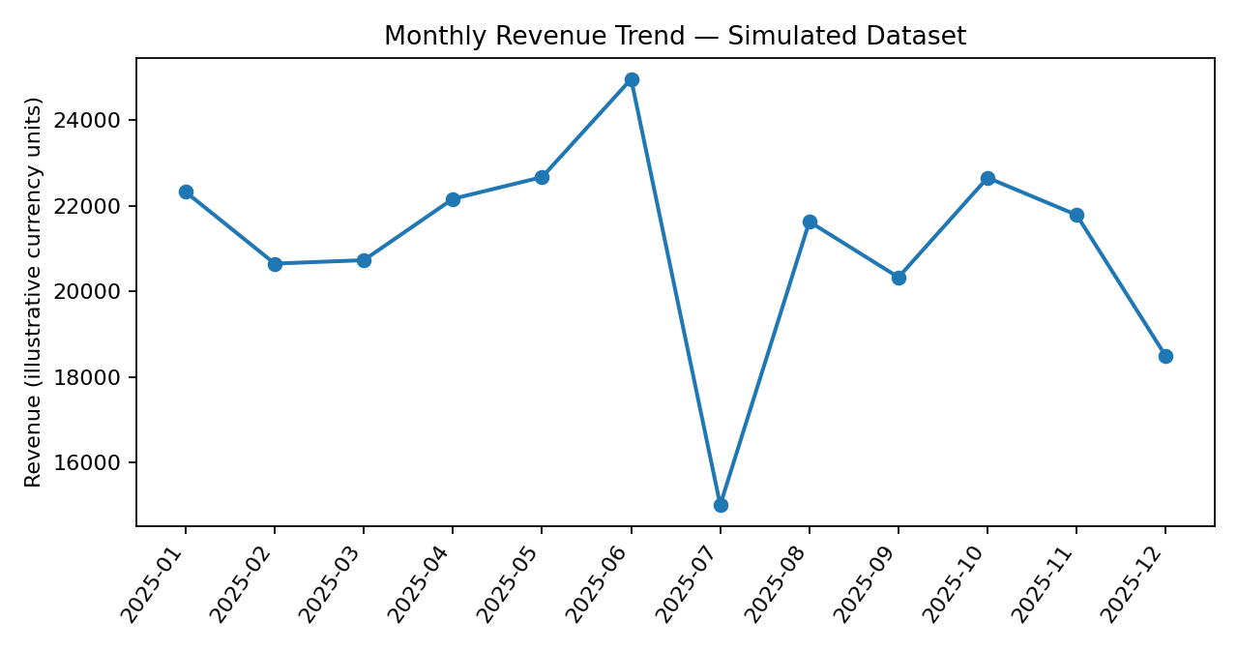
Figure 1. Monthly revenue trend. Use this chart to identify seasonality, spikes and weaker periods; validate anomalies against promotions and stock availability.
Interpretation approach: compare month-on-month revenue growth, order growth and AOV together. Revenue growth driven by more orders has a different operational implication from growth driven by higher basket value. Annotate campaign dates, holidays, stockouts and price changes before claiming causality.

Recommended sales KPIs
KPI | Formula | Why it matters
Revenue | Sum of net order/line revenue | Measures sales value
Orders | Count distinct order_id | Measures transaction volume
AOV | Revenue ÷ distinct orders | Tracks basket value
Gross/estimated profit | Revenue − product cost | Measures value after direct cost
Profit margin | Profit ÷ revenue | Prevents revenue-only decisions
MoM growth | (Current month − prior month) ÷ prior month | Tracks momentum
Return rate | Returned orders ÷ eligible orders | Signals product/fulfilment issues

6. Customer Behaviour and RFM Segmentation
RFM groups customers by Recency (days since the most recent order), Frequency (number of orders) and Monetary value (total revenue). It is a practical prioritisation method, not a prediction of future behaviour. The demonstration uses transparent rule-based groups so that a reviewer can reproduce the logic.
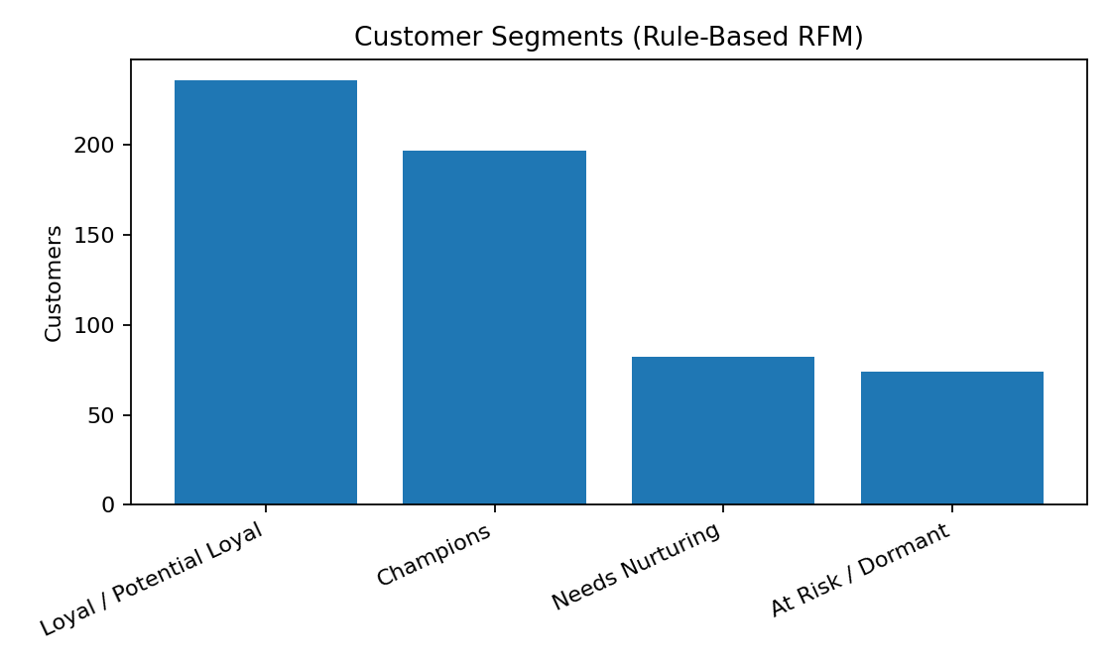
Figure 2. Number of customers in rule-based RFM segments.
Segment | Illustrative rule | Recommended action
Champions | Recent purchase (≤60 days) and 4+ orders | Early access, loyalty benefits, referral offers; avoid unnecessary blanket discounts
Loyal / Potential Loyal | Recent (≤120 days) and 2+ orders | Cross-sell relevant products and encourage the next purchase
At Risk / Dormant | No purchase for >180 days | Win-back test, personalised recommendations and controlled incentive
Needs Nurturing | All remaining customers | Relevant onboarding, replenishment reminders and content based on category interest
RFM thresholds should be adapted to purchase frequency and business model. A grocery retailer may use much shorter recency windows than a furniture retailer. Before deployment, compare segment revenue, margin, churn and campaign response; test offers with a control group to measure incremental lift.

Customer analysis extensions
- Cohort retention: group customers by first-purchase month and measure the share returning in later months.
- Customer lifetime value: estimate contribution margin over a defined horizon, and state assumptions clearly.
- Basket analysis: identify products commonly purchased together after ensuring order-line data is available.
- Retention drivers: compare repeat rates by first channel, category, discount band and geography while controlling for confounding factors.

7. Acquisition Channel and Website Analytics
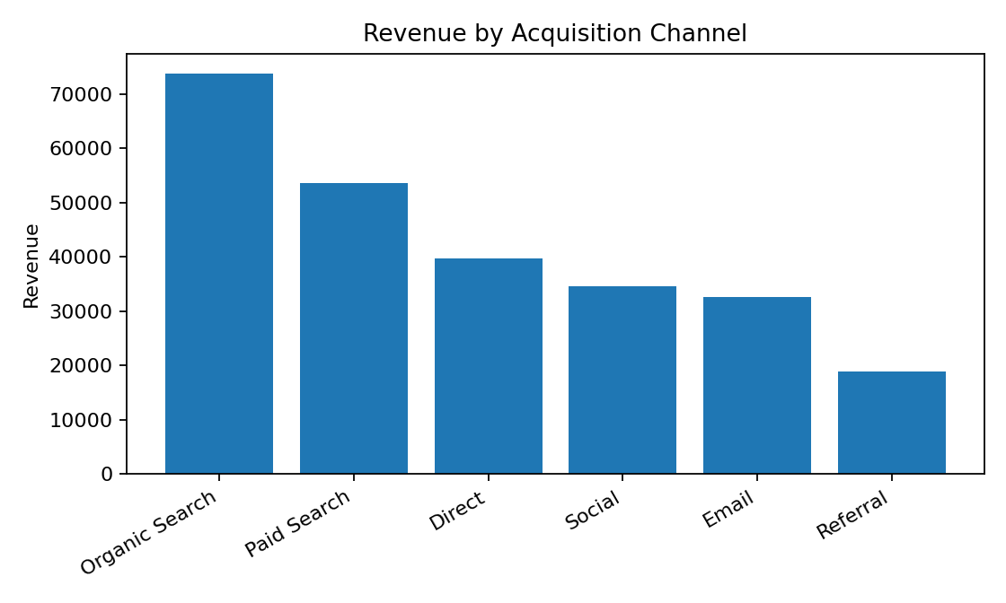
Figure 3. Revenue by acquisition channel in the simulated sample.
Channel revenue alone cannot determine marketing efficiency. A channel may generate high sales because it receives more budget or traffic, while a smaller channel may generate more profit per visit. A defensible channel scorecard should combine sessions, conversion rate, orders, revenue, spend, customer acquisition cost (CAC), return on ad spend (ROAS), new-customer share and contribution margin.
Website / marketing metric | Formula / requirement | Decision use
Sessions | Count sessions using a consistent session definition | Traffic volume
Conversion rate | Orders ÷ sessions (define session/order attribution) | Landing page and checkout optimisation
Cart abandonment | (Carts − completed orders) ÷ carts | Checkout friction diagnosis
CAC | Acquisition spend ÷ new customers acquired | Cost to acquire customers
ROAS | Attributed revenue ÷ ad spend | Paid campaign efficiency; not profit
Revenue per session | Attributed revenue ÷ sessions | Connects traffic quality with sales
Bounce/engagement | Use analytics platform's documented definition | Landing page relevance and content quality
Device conversion | Orders or conversions ÷ sessions by device | Mobile UX prioritisation
Important limitation: the demonstration data has channel and device labels attached to orders but does not contain web sessions, cart events, campaign spend or attribution paths. Therefore, it can compare order revenue by channel/device, but it cannot calculate a true website conversion rate, CAC, ROAS or cart-abandonment rate. These should be reported as unavailable until session-level data is provided.

Device analysis
In this sample, mobile-labelled orders account for the largest revenue share, reflecting the generated order mix. This is not proof that mobile traffic converts best; traffic denominators are required. The practical next step is to audit mobile page speed, product detail clarity, payment errors and checkout completion using session and event data.

8. Product Category and Geographic Performance
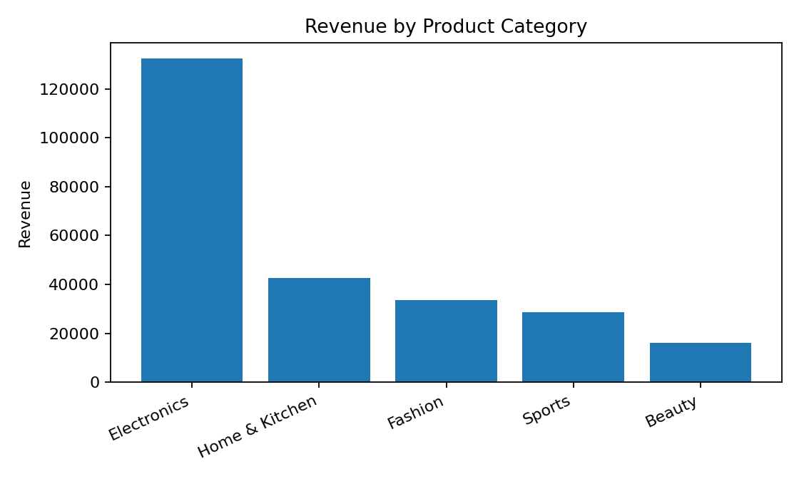
Figure 4. Revenue by product category.
Category | Revenue | Orders | Estimated profit
Electronics | 132,337 | 505 | 47,900
Home & Kitchen | 42,756 | 578 | 15,679
Fashion | 33,518 | 591 | 12,316
Sports | 28,628 | 330 | 10,435
Beauty | 16,122 | 396 | 5,759
Category leaders should be assessed on revenue, estimated margin, return rate, stock availability and repeat purchase—not revenue alone. A high-revenue category with weak margin or high returns may require assortment, supplier or product-page changes rather than more advertising.

Geographic comparison
Country | Revenue | Orders | Estimated profit
India | 105,538 | 995 | 38,040
United States | 53,906 | 533 | 19,468
United Kingdom | 32,773 | 294 | 11,989
Germany | 23,749 | 228 | 8,460
Canada | 23,532 | 187 | 8,886
Australia | 13,862 | 163 | 5,245
Country comparisons need currency normalisation, local tax/shipping treatment, exchange-rate dates and market-size context. If the source dataset combines currencies, do not sum raw amounts until values are converted to a common reporting currency.

9. Sales Forecasting
A forecast should be a planning aid, not a promise. The demonstration fits a straight-line trend to 12 monthly revenue observations and extends it three months. This is a deliberately simple baseline: it does not model holidays, promotions, seasonality, stockouts or uncertainty.
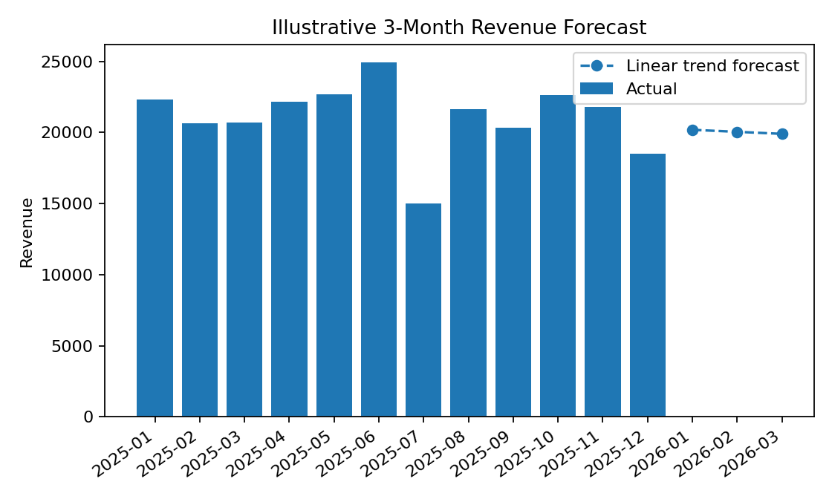
Figure 5. Illustrative trend-based forecast for the first three months after the observed year.
Forecast month | Illustrative trend forecast
2026-01 | 20,189
2026-02 | 20,046
2026-03 | 19,904
For a high-quality submission, compare at least two baselines (last-month/seasonal-naïve and linear trend) and evaluate them using a chronological holdout period. Report MAE and/or MAPE, noting that MAPE is unstable when actual values are zero or very small. Never randomly shuffle a time series before forecasting. With only one year of data, seasonal conclusions remain weak.

Forecast improvement plan
- Use 24–36 months of monthly history if available.
- Add calendar features, promotion flags, price changes, inventory/stockout signals and major holidays.
- Compare a seasonal-naïve baseline with suitable statistical or machine-learning models.
- Back-test using rolling-origin validation and report errors for each holdout period.
- Provide prediction intervals or low/base/high scenarios for inventory and staffing decisions.

10. Pricing and Discount Strategy
Pricing evaluation should distinguish higher order volume from profitable growth. For each discount band, compare order count, revenue, AOV, estimated profit, margin and return rate. Discount effectiveness should ideally be measured through controlled experiments because customers receiving discounts may differ systematically from customers who do not.
Discount | Orders | Revenue | Estimated profit | AOV
0% | 501 | 58,294 | 20,918 | 116
5% | 362 | 41,253 | 14,977 | 114
10% | 554 | 57,576 | 21,553 | 104
15% | 477 | 48,526 | 17,459 | 102
20% | 314 | 29,707 | 10,577 | 95
25% | 192 | 18,005 | 6,605 | 94
Interpret the discount table carefully: this simulated data does not establish that discounts caused a change in demand. Price bands may contain different products and customer types. Before recommending a discount, compare like-for-like SKUs and calculate contribution margin after fulfilment, returns and marketing costs.

Pricing recommendations
- Set a minimum contribution-margin guardrail for promotional offers.
- Use targeted, time-limited offers for at-risk customers rather than broad discounts to everyone.
- Test free-shipping thresholds or bundles where unit economics support them.
- Run A/B tests with a holdout group; compare incremental profit, not only conversion or revenue.
- Monitor post-promotion pull-forward effects and return rates.

11. Integrated Findings and Business Recommendations
Priority | Recommendation | Owner | Success metric | Time horizon
1 — High | Create one trusted KPI layer and reconcile orders/revenue before every report | Data analyst + finance | Revenue reconciliation variance; missing/duplicate rate | Weeks 1–2
2 — High | Launch a controlled win-back test for dormant customers | CRM / marketing | Incremental reactivation and contribution profit vs control | Weeks 3–6
3 — High | Evaluate channels using sessions, spend, CAC, ROAS and contribution margin | Performance marketing | CAC, contribution profit per acquired customer | Weeks 2–5
4 — Medium | Review top categories using margin, return rate and stock availability | Merchandising + operations | Category margin; return rate; stockout rate | Weeks 3–6
5 — Medium | Build a mobile checkout funnel and fix the largest observed drop-off | Product / UX | Mobile conversion rate; checkout error rate | Weeks 2–8
6 — Medium | Back-test a baseline forecast before using it for replenishment | Analytics + supply chain | MAE vs naïve baseline; forecast bias | Weeks 4–8
7 — Medium | Test discount policies with margin guardrails and holdout groups | Pricing + finance | Incremental contribution profit | Weeks 4–8
These priorities are framed as proposed actions. The data supports descriptive comparisons only; causal claims require experiments or a suitable causal design.

12. Limitations, Risks and Ethics
- Data limitation: all values in this demonstration are synthetic; they must not be represented as observed company performance.
- Coverage limitation: no sessions, carts, campaign spend, product inventory, refunds, shipping cost or full customer profile is included.
- Attribution risk: order channel may not represent the true influence of marketing touchpoints.
- Forecast risk: one year of simulated monthly observations is insufficient to establish robust seasonality.
- Profit limitation: estimated profit subtracts a simulated direct cost only and is not equivalent to net profit.
- Segmentation risk: rule-based RFM thresholds are arbitrary until calibrated to the business model.
- Privacy and fairness: minimise personal data, control access, document retention and avoid discriminatory targeting.

13. Future Scope
- Integrate web analytics events, campaign costs, refunds and inventory snapshots.
- Develop customer-level retention/churn models with temporal validation and interpretable features.
- Estimate customer lifetime value using contribution margin and survival/retention methods.
- Use product-level demand forecasting and promotion-aware inventory optimisation.
- Introduce experimentation standards for pricing, recommendations and win-back campaigns.
- Automate a monthly report with data-quality checks, KPI alerts and version-controlled notebooks.

14. Conclusion
This project presents a coherent end-to-end framework for retail eCommerce analysis, from data strategy and quality controls to customer segmentation, commercial performance, website analytics requirements, forecasting and pricing decisions. Its main strength is integration: each analysis is tied to a business question, a measurable KPI and a practical next action.
For final submission, replace the synthetic dataset with the actual course data, rerun the analysis in Jupyter Notebook, paste verified outputs into the report, and preserve the limitations section. A high-scoring report should be transparent about what the data can and cannot prove, explain every visualisation, and make recommendations that are measurable and feasible.

Appendix A. Reproducibility Checklist
- Dataset source, extraction date and reporting period documented.
- Data dictionary and metric definitions included.
- Missing values, duplicates, invalid values and outliers assessed.
- Cleaning decisions and before/after row counts recorded.
- Revenue and order totals reconciled to source.
- Charts have clear titles, axes, units and captions.
- Forecast baseline and chronological validation documented.
- RFM thresholds and segment actions explained.
- Website metrics without denominators explicitly marked unavailable.
- Recommendations have owners, KPIs and time horizons.
- All simulated results replaced or clearly labelled before submission.

Appendix B. Suggested Jupyter Notebook Structure
- 00_project_setup.ipynb — imports, paths, project objective
- 01_data_audit_cleaning.ipynb — schema, missing values, duplicates, cleaning log
- 02_eda_sales_kpis.ipynb — sales, category, country, channel and device analysis
- 03_customer_rfm.ipynb — RFM table, segment chart and campaign suggestions
- 04_forecasting.ipynb — monthly aggregation, baseline models and time-based validation
- 05_pricing_strategy.ipynb — discount bands, margin checks and experiment design
- 06_final_summary.ipynb — export final tables and chart assets for the report

