WEEK 4 PROJECT REPORT
WEBSITE ANALYTICS AND
CONVERSION RATE OPTIMIZATION
E-Commerce Website Performance Analysis
Prepared By
AALOK PANDEY
B.Tech Final Year Academic Project
Week 4 Internship / Analytics Task
Submission Year: 2026

1. Executive Summary
This report presents a structured website analytics and conversion-rate optimization (CRO) study for a hypothetical retail eCommerce website. The project follows the Week 4 task requirements: research key website analytics metrics, develop an analysis framework, simulate realistic trends, identify high-impact funnel opportunities, and provide actionable recommendations.
Because no first-party Google Analytics or website database was supplied with the task, all numerical values in this report are explicitly simulated for academic demonstration. The purpose is to show how a data analyst can transform website events into measurable insights rather than to claim that these figures belong to a real company.

Executive Findings
- The simulated website records 100,000 sessions over 90 days and an overall conversion rate of approximately 3.1%.
- Email has the highest simulated conversion rate (5.0%), while Social has the lowest (1.4%) and the highest bounce rate (58%).
- Mobile represents 62% of sessions but has a lower simulated conversion rate than desktop and tablet traffic.
- The funnel indicates substantial leakage between product views, cart creation, checkout, and completed purchase.
- The recommended CRO program focuses on mobile checkout, landing-page relevance, cart transparency, product-page quality, performance, and controlled A/B testing.

Project Deliverable
A professional DOCX website analytics report containing methodology, KPI definitions, simulated analysis, charts, findings, recommendations, implementation plan, limitations, conclusion, and references.

2. Introduction and Project Objectives

2.1 Background
An eCommerce website generates a large number of digital signals: sessions, page views, clicks, product interactions, cart additions, checkout starts, purchases, and repeat visits. Website analytics converts these events into indicators that help a business understand customer behavior. CRO then uses those insights to reduce friction and improve the percentage of visitors who complete a desired action.

2.2 Problem Statement
The main analytical problem is to determine where users lose interest or encounter friction during the digital buying journey. Looking only at total traffic is insufficient because a website can receive many visitors without producing proportionate purchases. The analysis therefore connects acquisition, engagement, funnel behavior, and conversion.

2.3 Objectives
- Measure and explain important website KPIs.
- Compare simulated performance across acquisition channels and devices.
- Build a conversion funnel from session to purchase.
- Identify possible high-impact areas for optimization.
- Connect website performance to customer acquisition and retention.
- Recommend measurable actions that can be tested and monitored.
- Create a clear professional report suitable for academic submission.

2.4 Scope
The project covers an illustrative retail eCommerce website, with emphasis on acquisition channels, user engagement, device behavior, funnel progression, conversion rate, and CRO. Technical implementation of a live website is outside the scope.

3. Methodology and Analysis Framework

3.1 Research Approach
The project uses a combination of documented analytics concepts, benchmark-oriented reference ranges, and a simulated 90-day dataset. The simulation is intentionally transparent so that the reader can distinguish project assumptions from real company measurements.

3.2 Analysis Framework
Stage | Questions | Key Metrics
Acquisition | Where does traffic come from? | Sessions, CTR, channel share
Engagement | Do visitors interact with the site? | Bounce/engagement rate, session duration
Product Interest | Do visitors explore products? | Product views, add-to-cart rate
Checkout | Where does purchase friction occur? | Checkout starts, completion rate
Conversion | Does traffic generate business outcomes? | Orders, conversion rate, revenue/session
Retention | Do customers return? | Returning users, repeat purchase rate, cohort metrics

3.3 Data Preparation Assumptions
- Analysis period: 90 days.
- Total simulated sessions: 100,000.
- Traffic is segmented into Organic Search, Paid Search, Direct, Email, Social, and Referral.
- Device segments are Mobile, Desktop, and Tablet.
- Conversion rate is calculated as orders divided by sessions.
- Figures are rounded for readability.

3.4 Why Segmentation Matters
Overall averages can hide important differences. Segmenting by source and device can reveal that one channel creates high-quality traffic while another creates volume with weak post-click behavior. This is why the report evaluates both channel-level and device-level metrics.

4. KPI Definitions and Benchmark Context
KPIs should be selected according to business objectives. A click or session is an intermediate signal; a completed purchase is a direct outcome. The following metrics form the core measurement framework for this project.
KPI | Formula / Definition | Analytical Purpose
Sessions | Count of visits / sessions | Measures traffic volume.
Bounce Rate | Single-engagement sessions ÷ sessions | Signals landing-page and traffic-quality issues.
Avg. Session Duration | Engaged time ÷ sessions | Provides directional engagement context.
CTR | Clicks ÷ impressions × 100 | Measures response to ads/search listings.
Add-to-Cart Rate | Add-to-cart sessions ÷ sessions × 100 | Measures product purchase intent.
Checkout Completion | Orders ÷ checkout starts × 100 | Measures checkout effectiveness.
Conversion Rate | Orders ÷ sessions × 100 | Measures the final website outcome.
Revenue / Session | Revenue ÷ sessions | Connects traffic with monetization.

4.1 Illustrative Benchmark Ranges
Metric | Illustrative range for this academic exercise | Important caveat
eCommerce Conversion Rate | ~2–4% | Varies by category, traffic source, price and geography.
Bounce Rate | ~30–60% | Definition and page type strongly affect the figure.
Avg. Session Duration | ~2–4 minutes | More time is not necessarily better if users complete tasks quickly.
CTR | ~1–5% | Platform, keyword, placement and brand influence CTR.
Cart Abandonment | Often substantial | Shipping, cost, trust and checkout friction can contribute.
These ranges are not universal pass/fail standards. For an actual business, the strongest comparison is normally a like-for-like historical baseline plus an appropriate peer benchmark.

5. Simulated Acquisition Analysis
The following table represents the simulated 90-day acquisition dataset. It is designed to support the task's requirement to analyze theoretical data trends expected on a retail eCommerce site.
Channel | Sessions | CTR | Bounce | Avg. Duration | CVR | Orders
Organic Search | 30,000 | 3.8% | 43% | 3m 05s | 3.0% | 900
Paid Search | 22,000 | 4.6% | 47% | 2m 42s | 2.5% | 550
Direct | 18,000 | — | 32% | 3m 48s | 4.2% | 756
Email | 10,000 | 5.9% | 27% | 4m 12s | 5.0% | 500
Social | 12,000 | 1.9% | 58% | 1m 54s | 1.4% | 168
Referral | 8,000 | 2.7% | 39% | 3m 10s | 2.8% | 224
Total | 100,000 | — | — | — | 3.10% | 3,098
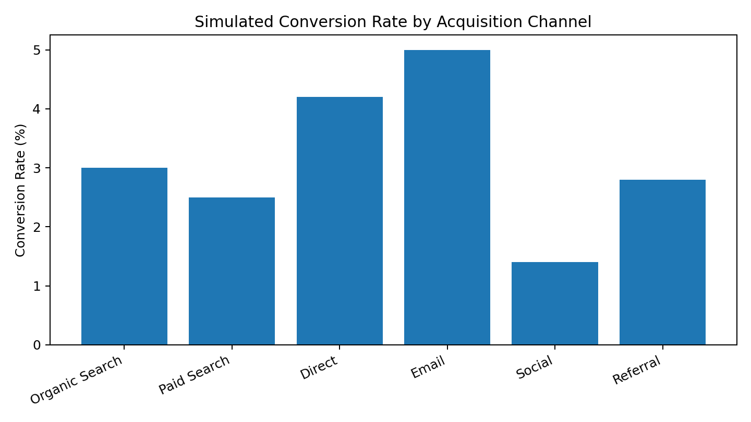
Figure 1. Simulated conversion rate by acquisition channel.

5.1 Interpretation
The simulated results show different levels of post-click quality. Email has the highest conversion rate, while Social has the lowest. Organic Search provides the largest traffic volume. Paid Search generates a comparatively strong CTR, but its conversion rate is lower than the higher-intent Direct and Email segments.

6. Engagement and Traffic Quality Analysis
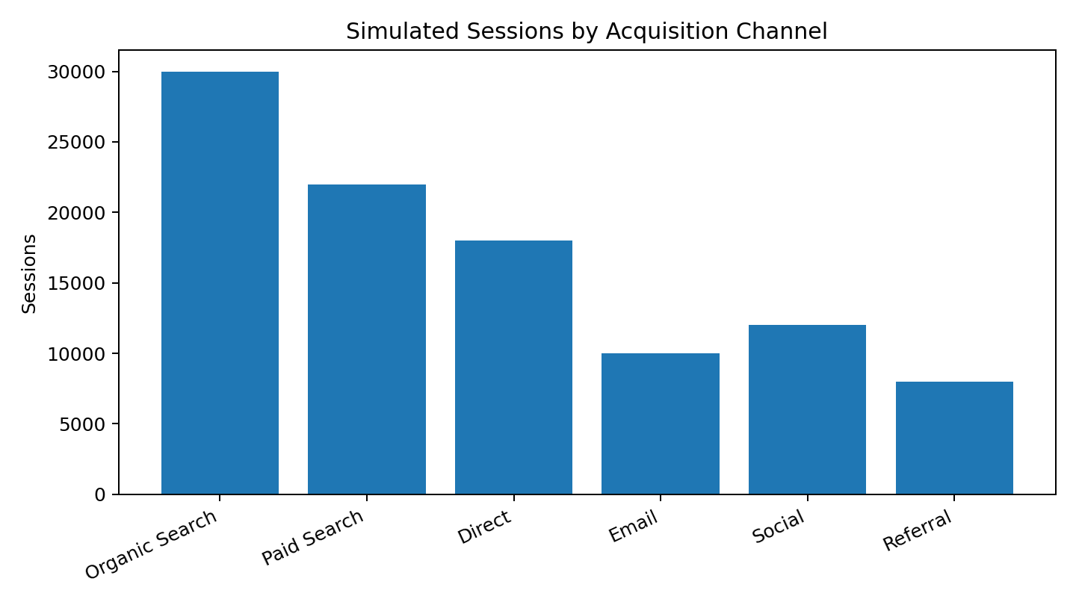
Figure 2. Simulated sessions contributed by acquisition channel.
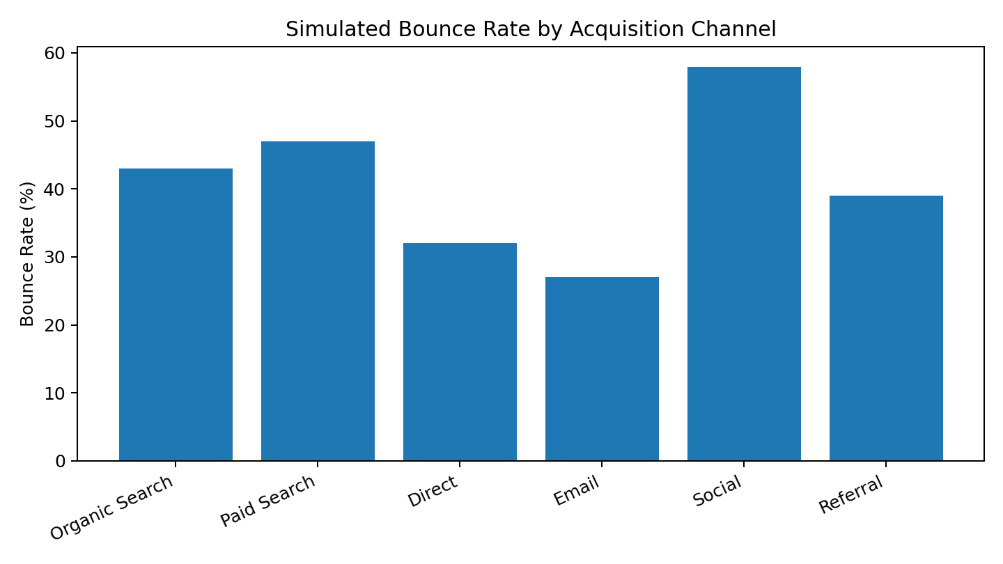
Figure 3. Simulated bounce rate by acquisition channel.

6.1 Insights
- Organic Search is the largest traffic source in the simulation, so improving SEO landing pages can influence a large user population.
- Social traffic has a high bounce rate and short session duration, suggesting that campaign-to-landing-page alignment should be investigated.
- Email combines high engagement with strong conversion, which is consistent with a more intentional audience segment.
- Paid Search should be evaluated using both CTR and downstream conversion rather than CTR alone.
- Direct traffic has low simulated bounce and relatively high conversion, which may indicate stronger existing brand familiarity.

6.2 Acquisition vs. Quality
A key data-analyst principle is that traffic volume and traffic quality are different dimensions. A channel can be large but inefficient, or smaller but highly productive. The correct business question is therefore not simply 'Which channel gets the most clicks?' but 'Which traffic produces meaningful customer outcomes at an acceptable cost?'

7. Device and Conversion Funnel Analysis

7.1 Device Analysis
Device | Sessions | Share | Bounce Rate | Conversion Rate | Orders
Mobile | 62,000 | 62% | 49% | 2.5% | 1,550
Desktop | 30,000 | 30% | 34% | 4.0% | 1,200
Tablet | 8,000 | 8% | 41% | 4.4% | 352
Total | 100,000 | 100% | — | 3.10% | 3,102*
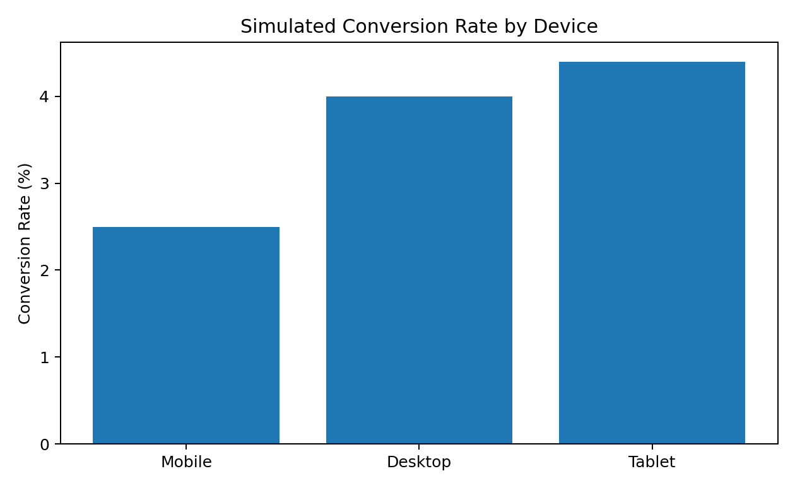
Figure 4. Simulated conversion rate by device.
*Small order-count difference versus the channel table results from rounded assumptions.

7.2 Device Insight
Mobile contributes most sessions but has the lowest simulated conversion rate among the three device groups. This makes mobile usability an important investigation area. Potential checks include page speed, responsive layout, product-image behavior, sticky/add-to-cart controls, form length, payment options, and mobile-specific technical errors.

7.3 Funnel Data
Funnel Stage | Users / Events | Step Conversion | Drop-off
Sessions | 100,000 | 100% | —
Product Views | 72,000 | 72% of sessions | 28%
Add to Cart | 18,000 | 25% of product viewers | 75%
Checkout Started | 9,000 | 50% of carts | 50%
Purchase | 3,100 | 34.4% of checkouts | 65.6%

8. Conversion Funnel Insights
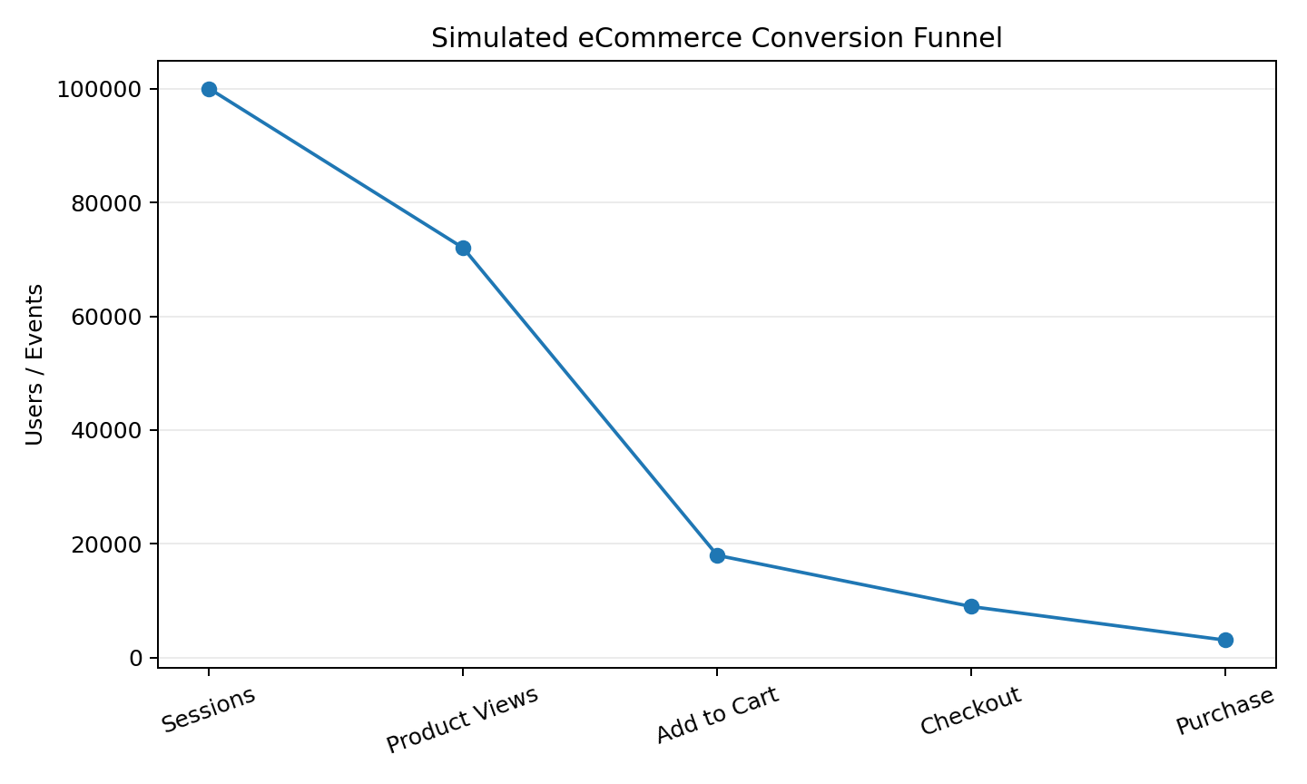
Figure 5. Simulated eCommerce conversion funnel.

8.1 Funnel Interpretation
The funnel shows that 100,000 simulated sessions become 3,100 purchases. The largest early-stage leakage occurs before product exploration, while substantial leakage also occurs between cart and checkout and between checkout and purchase.
Funnel Area | Possible Causes to Investigate | Evidence Needed
Session → Product View | Weak landing-page relevance, unclear navigation, low-intent traffic | Landing-page analysis, search terms, recordings
Product View → Cart | Pricing, product information, weak CTA, unavailable products | Product analytics, heatmaps, stock data
Cart → Checkout | Unexpected cost, shipping information, comparison behavior | Cart exits, shipping visibility, user feedback
Checkout → Purchase | Payment errors, long forms, trust concerns, technical issues | Error logs, payment reports, checkout recordings

8.2 Important Analytical Principle
An aggregate drop-off does not identify its cause by itself. Each hypothesis must be tested with additional evidence. For example, a high checkout abandonment rate could be caused by payment failures rather than poor design. A data analyst should therefore combine quantitative funnel data with technical logs and qualitative user research.

9. CRO Recommendations

9.1 Mobile-First Checkout
Review mobile checkout for unnecessary fields, confusing validation, slow-loading payment elements, and difficult form entry. Test a simplified flow and monitor mobile conversion, checkout errors, refunds, and support contacts.

9.2 Landing-Page and Message Alignment
Create landing pages that closely match the promise of each advertising or campaign message. The page should make the value proposition, product relevance, trust information, and primary CTA clear.

9.3 Product-Page Improvement
Strengthen product pages with clear images, specifications, authentic reviews, availability, delivery expectations, returns information, and a visible add-to-cart action.

9.4 Cart Transparency
Make shipping charges, taxes where applicable, delivery timing, total cost, and return information visible before the user reaches final payment. This reduces uncertainty and provides a clearer purchase decision.

9.5 Trust and Payment Experience
Test whether users need clearer payment choices, reassurance, support access, security messaging, or simpler forms. Changes should be validated experimentally rather than assumed to improve conversion.

9.6 Website Performance
Monitor page performance, particularly on mobile networks. Prioritize high-traffic pages where performance problems coincide with funnel leakage.

9.7 Experimentation
Use controlled A/B tests. Each test should have a clear hypothesis, primary KPI, guardrail metrics, test duration/sample requirements, and a documented decision rule.

10. Customer Acquisition, Retention and Dashboard Design

10.1 Customer Acquisition
Acquisition analytics evaluates how users arrive and whether the resulting traffic produces meaningful actions. CTR is useful for understanding ad or listing response, but it should be connected to post-click engagement and conversion.

10.2 Customer Retention
Retention should be evaluated after acquisition and purchase. Useful measures include returning-user rate, repeat purchase rate, cohort retention, customer lifetime value, email engagement, and time between purchases. These measures help distinguish one-time conversion improvements from sustainable customer value.

10.3 Recommended Analytics Dashboard
Dashboard Area | Recommended KPI / Visual
Executive Summary | Sessions, orders, conversion rate, revenue/session
Acquisition | Sessions, CTR, CVR by channel
Engagement | Bounce/engagement rate, session duration
Funnel | Session → view → cart → checkout → purchase
Device | Conversion and drop-off by device
Trend | Daily/weekly sessions, orders and CVR
Retention | Returning users, repeat purchases, cohort metrics
CRO Testing | Hypothesis, variant, primary KPI, result, decision

10.4 Data Analyst Workflow
- Collect and validate tracking data.
- Clean and standardize event definitions.
- Segment users by source, device, geography and customer status where appropriate.
- Calculate KPIs and compare with historical baselines.
- Identify abnormal drop-offs and formulate hypotheses.
- Validate hypotheses with additional evidence.
- Recommend and test changes.
- Monitor results and document learnings.

11. Action Plan, Limitations and Conclusion

11.1 30-Day Action Plan
Week | Activity | Output
Week 1 | Audit tracking, events, UTM/campaign tagging and funnel definitions. | Validated analytics foundation
Week 2 | Review mobile UX, landing pages, performance and checkout errors. | Prioritized problem list
Week 3 | Launch controlled CRO experiments on validated friction points. | Experiment results
Week 4 | Evaluate primary and guardrail KPIs; document decisions. | CRO learning report

11.2 Limitations
- The dataset is simulated and does not represent a real company's internal analytics.
- Benchmark ranges are illustrative and can differ considerably across industries and traffic sources.
- Correlation between a KPI and conversion does not prove causation.
- Seasonality, pricing, promotions, product mix, inventory and external events can influence conversion.
- Real-world A/B testing requires appropriate statistical design and reliable event tracking.

11.3 Conclusion
This project demonstrates how a data analyst can evaluate an eCommerce website using a KPI framework, segmented analysis, funnel analysis, and CRO experimentation. The simulated data highlights mobile conversion, social traffic quality, cart/checkout leakage, and landing-page relevance as areas that deserve investigation. The recommended process is to validate each issue with evidence, prioritize changes by impact and effort, and use controlled experiments to measure outcomes.
The central lesson is that website analytics is not only about reporting numbers. Its value comes from connecting metrics to customer behavior, identifying measurable problems, forming testable hypotheses, and tracking whether changes produce better business outcomes.

11.4 Final Deliverable Checklist
- ☑ Introduction and objectives
- ☑ Research and benchmark context
- ☑ KPI definitions and rationale
- ☑ Simulated dataset and analysis
- ☑ Charts and graphs
- ☑ Conversion funnel analysis
- ☑ Customer acquisition and retention
- ☑ Actionable CRO recommendations
- ☑ 30-day implementation plan
- ☑ Limitations and conclusion
- ☑ References

12. References and Appendix

12.1 Reference Sources
- Google Analytics Help — Analytics documentation and measurement concepts: https://support.google.com/analytics/
- Google Analytics 4 — Ecommerce measurement guidance: https://developers.google.com/analytics/devguides/collection/ga4/ecommerce
- Google Search Central — Core Web Vitals and page experience guidance: https://developers.google.com/search/docs/appearance/core-web-vitals
- Baymard Institute — Ecommerce checkout usability and cart-abandonment research: https://baymard.com/lists/cart-abandonment-rate
- Google Ads Help — Click-through rate and advertising measurement concepts: https://support.google.com/google-ads/

12.2 Appendix: Simulated Data Notes
The numbers used in this report were created for academic simulation. They are intentionally consistent enough to demonstrate calculations and comparisons, but they should not be interpreted as audited industry statistics. In a real project, the analyst would export data from an analytics platform, validate event definitions, remove or investigate tracking anomalies, and document the exact calculation logic.

12.3 Example Calculation
Overall conversion rate = Total orders ÷ Total sessions × 100. Using the simulated values: 3,100 ÷ 100,000 × 100 = 3.10%.
Channel conversion rate = Channel orders ÷ Channel sessions × 100. For Email: 500 ÷ 10,000 × 100 = 5.0%.
These calculations demonstrate how a data analyst can move from raw website events to interpretable KPIs.

