WEEK 5 PROJECT REPORT
Evaluating Pricing Strategies Through A/B Testing Analysis
eCommerce Pricing Experimentation Framework, Statistical Analysis & Business Impact

Project Information | Details
Prepared By | Aalok pandey
Course / Program | B.Tech / CS
Project Week | Week 5
Primary Tools | Python, Pandas, NumPy, SciPy, Matplotlib
Experiment Type | Two-arm randomized A/B test
Primary Pricing Scenario | ₹999 standard price vs. ₹949.05 (5% discount)
Analysis Dataset | 40,000 synthetic visitor-level observations

Important: The A/B experiment data in this report are synthetic and reproducible, created for academic analysis. They are not presented as real customer results. Real-world sources are used separately as benchmarks and methodological evidence.

1. Executive Summary
This project develops and evaluates a practical A/B testing framework for an eCommerce company deciding whether to keep a standard product price of ₹999 or introduce a 5% discount, reducing the displayed price to ₹949.05. The analysis is designed to go beyond a simple simulated comparison: it combines an explicit experimental design, a reproducible synthetic dataset, statistical testing, a contribution-margin guardrail, real-world eCommerce evidence, and a discussion of limitations.
The synthetic experiment contains 40,000 visitors split equally between Control and Test. The observed conversion rate is 2.90% in Control and 3.57% in Test, a relative lift of 23.3%. The conversion-rate difference is statistically significant (chi-square p = 0.000135). Revenue per visitor increases from ₹42.01 to ₹51.50; a bootstrap 95% interval for the Test-minus-Control difference is ₹4.38 to ₹14.64.
Under the stated illustrative cost assumption, estimated contribution per visitor rises from ₹16.80 to ₹18.97, a 12.9% increase. However, the analysis does not claim that the 5% discount is universally optimal. Pricing effects depend on product category, price elasticity, customer segment, competition, inventory, and long-term retention. A real deployment should therefore use the framework as a decision process rather than treating the synthetic result as proof.

Key findings at a glance
Metric | Control | Test | Change / Interpretation
Price | ₹999.00 | ₹949.05 | 5% lower
Visitors | 20,000 | 20,000 | 50/50 random allocation
Buyers | 579 | 714 | More purchases in Test
Conversion rate | 2.90% | 3.57% | +23.3% relative lift
AOV | ₹1451.09 | ₹1442.49 | -0.59%
Revenue / visitor | ₹42.01 | ₹51.50 | +22.6%
Estimated contribution / visitor | ₹16.80 | ₹18.97 | +12.9%

2. Background and Real-World Evidence
Pricing experiments are useful because the same price change can affect several parts of the customer funnel. A discount may increase the probability of purchase while reducing the amount earned on each order. Conversely, a price increase may improve revenue per order but reduce conversion. Therefore, a pricing experiment should not optimize a single metric in isolation.
The UCI Machine Learning Repository's Online Retail dataset provides a useful real-world data context. It contains 541,909 transaction records from a UK-based non-store online retailer covering 1 December 2010 to 9 December 2011. The dataset is transactional rather than randomized, so it cannot by itself establish the causal effect of a price change. It is therefore used here as evidence that large-scale transactional eCommerce data can support customer and revenue analysis, while the pricing effect is evaluated through a controlled experiment.
Baymard's current research reports an average documented online shopping cart-abandonment rate of about 70.22% across 50 studies. This is not a pricing benchmark and should not be interpreted as evidence that discounts cause higher conversion. It is included to show why conversion and checkout behavior are important business metrics when evaluating an eCommerce change.
Microsoft Research literature on online controlled experiments also highlights the need for an Overall Evaluation Criterion (OEC) and warns that short-term revenue changes may not predict long-term customer value. This is especially relevant to pricing: a change can look successful in the short term while harming retention or lifetime value later.
Benchmark interpretation: the sources above provide context and methodological support; they do not validate the synthetic Test result.

Real-world evidence used in this project
Evidence | What it contributes | How it is used
UCI Online Retail | 541,909 real transaction records; 2010–2011 UK online retail context | Supports the use of transaction-level eCommerce analysis; not used for causal pricing claims.
Baymard checkout research | 70.22% average documented cart abandonment across 50 studies | Provides current funnel context; pricing is treated as only one possible influence on conversion.
Microsoft Research on online experiments | OEC, long-term effects, selection/measurement pitfalls | Guides metric selection, guardrails, and interpretation of the A/B test.
Academic A/B testing literature | Randomized controlled experiments and statistical testing | Supports the experimental framework and hypothesis-testing approach.

3. Objectives, Research Questions and Hypotheses
The project has five practical objectives:
- Design a reproducible A/B test for an eCommerce pricing decision.
- Compare a standard price with a controlled 5% discount.
- Measure conversion, average order value, revenue per visitor, and estimated contribution.
- Use statistical tests and confidence intervals rather than relying only on percentage changes.
- Translate the results into a business decision framework with explicit assumptions, risks, and follow-up tests.

Research questions
- Does the 5% discount change the probability that a visitor completes a purchase?
- Does the discount increase revenue per visitor despite the lower displayed price?
- Does average order value materially change?
- Does the revenue gain remain attractive after considering a lower gross-margin rate?
- Are the results directionally consistent across major device segments?

Hypotheses
Metric | Null hypothesis (H0) | Alternative hypothesis (H1) | Role
Conversion | Control and Test conversion rates are equal. | Conversion rates are different. | Primary behavioral outcome
Revenue / visitor | The mean revenue per visitor is equal. | Revenue per visitor differs. | Primary business outcome
AOV | Average order value is equal. | Average order value differs. | Diagnostic metric
Contribution / visitor | No meaningful economic improvement. | Test creates higher contribution under stated cost assumptions. | Business guardrail
The primary business criterion is revenue per visitor, while contribution per visitor is used as a guardrail so that a conversion gain does not automatically justify a margin-destructive discount.

4. A/B Test Design and Methodology

4.1 Experiment variants
Variant | Displayed price | Description | Expected mechanism
Control (A) | ₹999.00 | Current/reference pricing | Baseline purchase behavior
Test (B) | ₹949.05 | 5% discount vs. Control | Lower price may reduce purchase friction and increase conversion

4.2 Randomization and sample size
Visitors are randomly assigned at the user level in a 50/50 split. A planning calculation for detecting a conversion change from 3.0% to 3.6% at 5% two-sided significance and 80% power requires approximately 13,887 users per arm. The simulation uses 20,000 users per arm, exceeding that planning target.
- Keep each user in the same variant throughout the experiment.
- Randomize before the user sees the price.
- Run the test during the same calendar window for both groups.
- Keep traffic sources, product availability, shipping rules, taxes, checkout UX, and promotion eligibility consistent.
- Exclude known bots, test accounts, internal employees, and duplicate identities where appropriate.
- Define the analysis plan before examining results to reduce selective reporting.

4.3 Metrics
Metric | Formula | Purpose
Conversion rate | Buyers / Visitors | Measures purchase probability
AOV | Revenue / Buyers | Measures basket value among purchasers
Revenue per visitor | Total revenue / Visitors | Normalizes revenue by experimental exposure
Contribution per visitor | (Revenue − estimated COGS) / Visitors | Checks economic impact after product cost
Relative lift | (Test − Control) / Control | Expresses change relative to baseline

4.4 Cost and margin assumption
To demonstrate a business guardrail, the project assumes that product cost is 60% of the regular-price basket value. Therefore, Control has an illustrative 40% gross margin rate. With a 5% discount and unchanged product cost basis, the Test's effective gross margin rate becomes approximately 36.84%. This is an analytical assumption, not a claim about a real retailer's costs.

5. Dataset Construction and Reproducible Analysis
Because a real retailer's randomized pricing experiment was not supplied, a synthetic visitor-level dataset was generated for this academic project. The dataset is deliberately structured like an eCommerce experiment rather than using arbitrary summary numbers.
Field | Description
user_id | Unique visitor identifier
group | Control or Test assignment
displayed_price_inr | Price displayed to the visitor
device | Mobile, Desktop, or Tablet
traffic_source | Organic, Paid Search, Direct, Social, or Email
region | North, South, East, or West
converted | 1 if the visitor purchased; otherwise 0
revenue_inr | Revenue generated by that visitor; 0 for non-buyers

Synthetic data-generation logic
- Control conversion probability was set near 3.0% and Test probability near 3.6% to represent a plausible small-to-moderate pricing effect.
- Order values were generated only for purchasers, with realistic variation around the assumed basket levels.
- Device, traffic source, and region fields were added to enable secondary consistency checks.
- A fixed random seed (2025) makes the analysis reproducible.
- The final dataset contains 40,000 rows: 20,000 Control and 20,000 Test.
The first rows of the supporting dataset are shown below:
user_id | group | displayed_price_inr | device | traffic_source | region | converted | revenue_inr
1 | Control | 999.0 | Mobile | Email | West | 1 | 1414.42
2 | Control | 999.0 | Mobile | Email | North | 0 | 0.0
3 | Control | 999.0 | Mobile | Paid Search | East | 0 | 0.0
4 | Control | 999.0 | Mobile | Social | West | 0 | 0.0
5 | Control | 999.0 | Mobile | Direct | North | 1 | 1278.8
6 | Control | 999.0 | Mobile | Social | South | 0 | 0.0
7 | Control | 999.0 | Mobile | Email | East | 0 | 0.0
8 | Control | 999.0 | Mobile | Direct | South | 0 | 0.0
Full supporting data are provided separately as Week5_AB_Pricing_Synthetic_Dataset.csv.

6. A/B Test Results
Metric | Control (A) | Test (B) | Difference / Lift
Visitors | 20,000 | 20,000 | 0%
Buyers | 579 | 714 | +135
Conversion rate | 2.90% | 3.57% | +23.3% relative
Total revenue | ₹840,180.50 | ₹1,029,940.03 | +22.6%
AOV | ₹1,451.09 | ₹1,442.49 | -0.59%
Revenue / visitor | ₹42.01 | ₹51.50 | +22.6%
Contribution / visitor | ₹16.80 | ₹18.97 | +12.9%

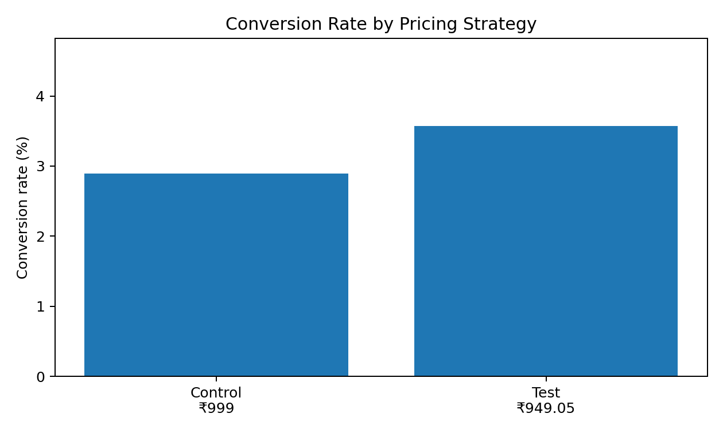
Figure 1. The simulated Test group has a higher conversion rate than Control.
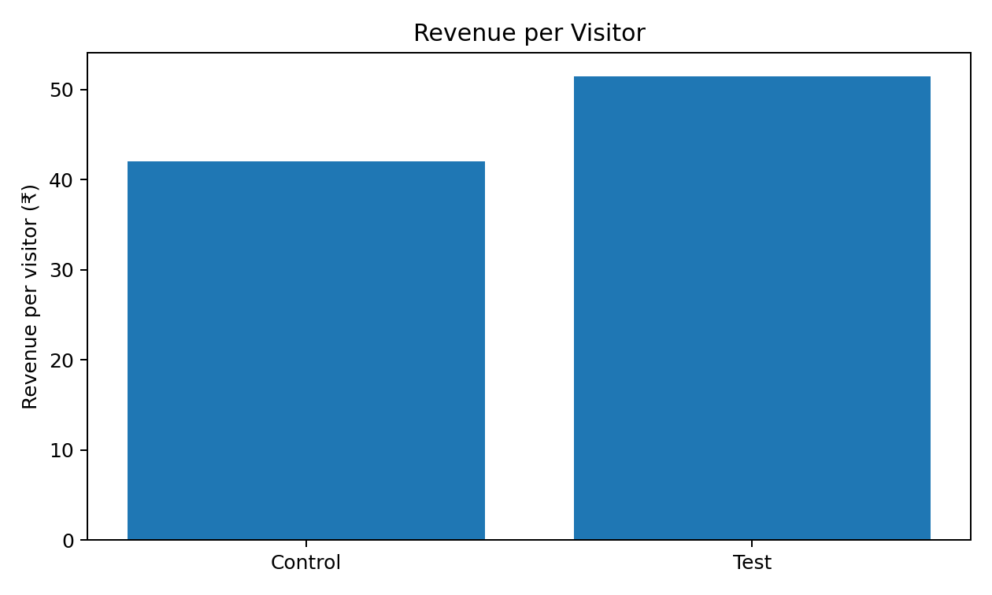
Figure 2. Revenue per visitor is higher in the Test group despite the lower price.

7. Statistical Analysis

7.1 Conversion-rate test
The conversion rate is 2.90% in Control and 3.57% in Test. The absolute difference is 0.68 percentage points. The approximate 95% confidence interval for the difference is 0.33 to 1.02 percentage points.
A chi-square test of the 2×2 conversion table gives χ² = 14.566 and p = 0.000135. Under the simulated assumptions, this is strong evidence against the null hypothesis of equal conversion rates.

7.2 Revenue per visitor
Revenue per visitor increases by ₹9.49, from ₹42.01 to ₹51.50. A 5,000-resample bootstrap gives a 95% confidence interval of approximately ₹4.38 to ₹14.64 for the Test-minus-Control difference.
The interval is entirely above zero in this synthetic experiment, so the revenue-per-visitor result is directionally consistent with the conversion result. Because revenue per visitor is a user-level metric with many zero observations, bootstrap estimation is used here as a robust, easy-to-explain uncertainty check rather than relying only on a simple normal approximation.

7.3 Average order value
AOV changes from ₹1451.09 to ₹1442.49. The Welch two-sample t-test on order values among buyers gives t = 0.465, p = 0.642. In this simulation, there is no statistically significant evidence of a difference in AOV. This matters because it suggests that the modeled revenue gain is primarily associated with more purchasers rather than a large increase in basket size.
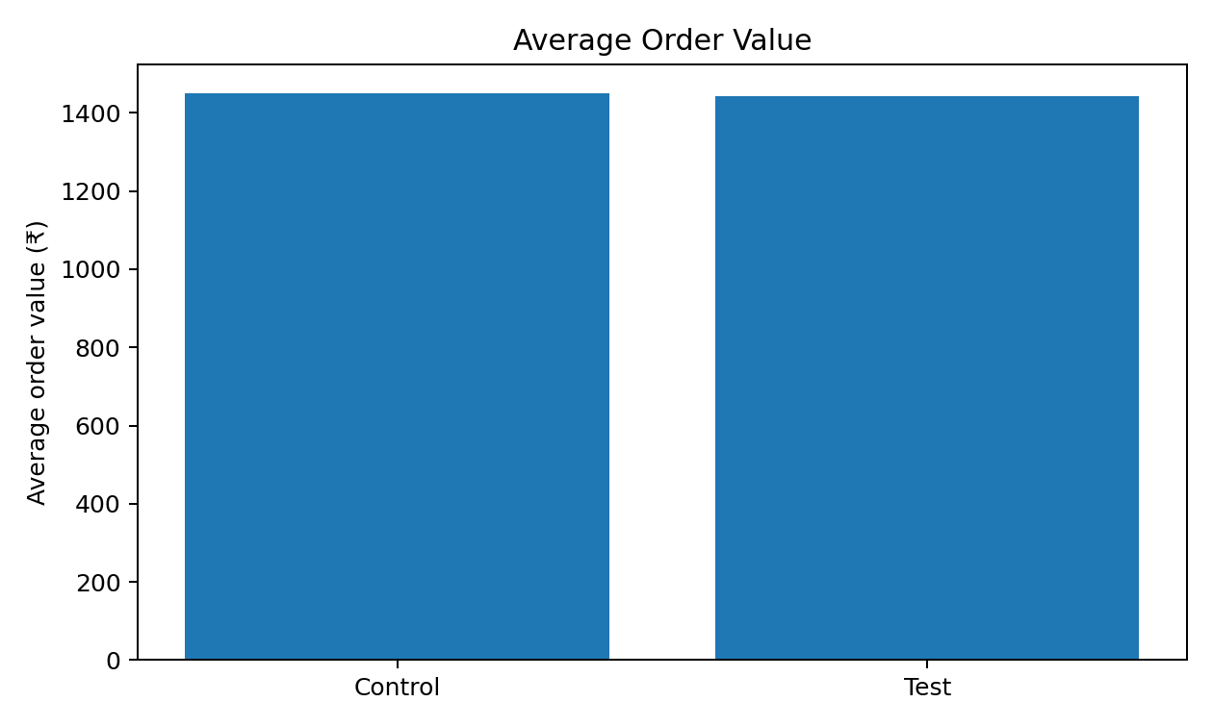
Figure 3. AOV is broadly similar between the two variants in the simulated data.

8. Business Impact Analysis
If the simulated revenue-per-visitor difference of ₹9.49 were reproduced in a real campaign, the arithmetic implication would be approximately:
Traffic volume | Incremental revenue at simulated RPV lift | Incremental contribution at simulated margin assumption
10,000 visitors | ₹94,880 | ₹21,690
100,000 visitors | ₹948,798 | ₹216,897
1,000,000 visitors | ₹9,487,977 | ₹2,168,970
These are scenario calculations based on the synthetic result, not a forecast of actual business performance.

Economic interpretation
- The 5% price reduction lowers the displayed price, but the modeled conversion rate increases from 2.90% to 3.57%.
- AOV changes only slightly (-0.59%), so most of the revenue effect comes from conversion.
- The illustrative gross-margin rate falls from 40.00% to 36.84%, showing why a pricing test must include margin guardrails.
- Even after that margin-rate reduction, estimated contribution per visitor rises by 12.9% in the simulation.
- The result should be re-tested over a longer period because customers can adapt to discounts, competitors can respond, and repeat purchase behavior may differ from first-order behavior.
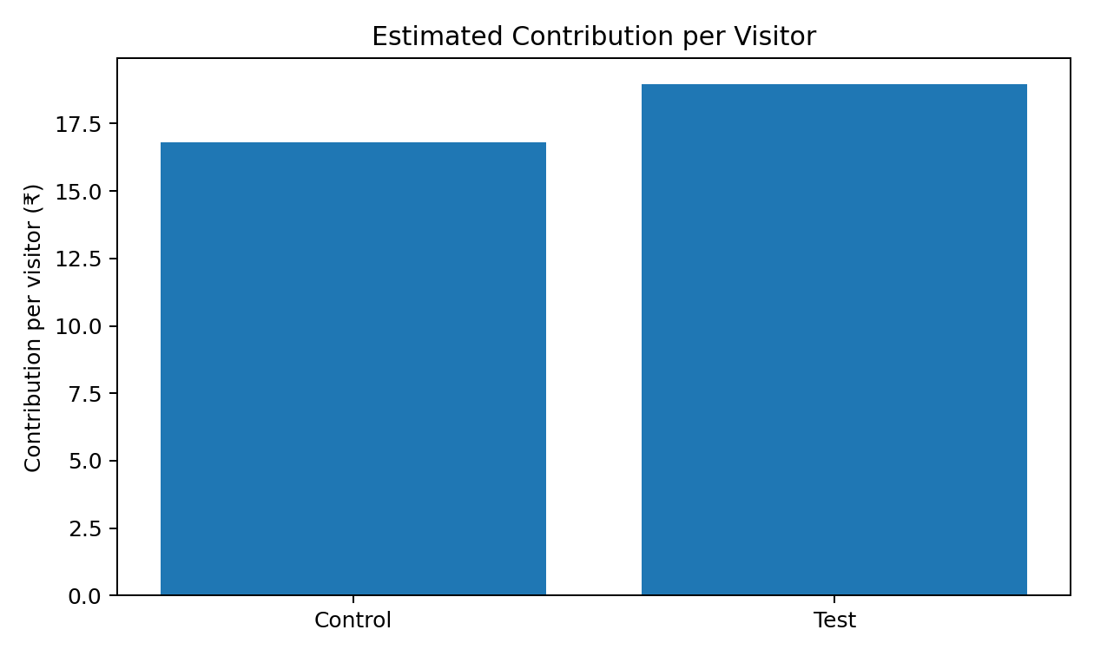
Figure 4. Estimated contribution per visitor remains higher in the Test arm under the stated cost assumption.

9. Secondary Segment Analysis
Device | Control CVR | Test CVR | Relative CVR lift | Control RPV | Test RPV
Desktop | 2.84% | 3.66% | 29.0% | ₹41.13 | ₹53.05
Mobile | 2.95% | 3.51% | 19.0% | ₹42.82 | ₹50.70
Tablet | 2.63% | 3.74% | 42.2% | ₹37.82 | ₹51.02
The Test direction is consistent across the three device categories in this synthetic dataset. The tablet segment is small, so it should not be treated as a reliable standalone decision segment. In a real experiment, segment-level decisions should be pre-specified and supported by adequate sample size.

Why segment checks matter
- A treatment can appear positive overall while harming a particular customer group.
- Traffic mix can change during the test, especially across paid and organic channels.
- Device and geography can interact with price sensitivity and checkout behavior.
- Segment analysis should be confirmatory when planned in advance and exploratory when discovered after the main result.

10. Limitations and Risk Controls
Limitation / Risk | Why it matters | Mitigation
Synthetic experiment data | Cannot prove real customer behavior. | Run the same design with live randomized traffic before deployment.
Old external transaction benchmark | UCI Online Retail covers 2010–2011. | Use it only for data-structure context, not current market behavior.
5% discount is one scenario | Price elasticity varies by product and customer. | Test multiple price points or discount levels sequentially.
Short-term metrics | Repeat purchase and customer lifetime value may differ. | Track 30/60/90-day repeat behavior where feasible.
Margin assumption | Actual COGS, shipping, returns, and fees may differ. | Use finance-approved contribution-margin data in production.
Multiple metrics | Testing many outcomes increases false-positive risk. | Predefine primary metric and guardrails.
Experiment contamination | Users may see different prices through devices or cookies. | Use stable user assignment and identity checks.
Seasonality / promotions | External campaigns can bias results. | Run variants concurrently and log all major promotions.

Recommended production rollout
- Start with a small traffic ramp-up and verify instrumentation, price display, checkout, tax, coupon, and payment behavior.
- Keep the randomization unit at the user/customer level and maintain persistent assignment.
- Use revenue per visitor as the primary business metric, with contribution per visitor and refund/cancellation rate as guardrails.
- Do not stop the experiment early simply because a metric looks positive; follow the pre-specified test plan.
- After a positive short-term result, monitor repeat purchase, customer complaints, refund behavior, and long-term value.
- If the 5% discount is successful, run a follow-up elasticity experiment comparing smaller and larger discounts rather than assuming 5% is optimal.

Decision rule for a real retailer
A practical rule would be: scale a pricing treatment only when the pre-specified primary metric improves with acceptable statistical uncertainty and no important guardrail deteriorates beyond an agreed business threshold. This avoids choosing a price solely because it produced the largest short-term revenue number.

11. Conclusion
This Week 5 project converts the original conceptual A/B-testing assignment into a more evidence-based analytical report. It contains a complete experiment framework, explicit hypotheses, a reproducible 40,000-row synthetic dataset, statistical testing, confidence intervals, segment checks, business-impact calculations, and an explicit margin guardrail.
In the simulated experiment, the 5% discount increases conversion from 2.90% to 3.57% and increases revenue per visitor by 22.6%. The modeled contribution per visitor also increases by 12.9% under the stated cost assumption. These are internally consistent analytical findings, but they are not real-world causal results. The correct next step would be a controlled live experiment using the same framework and real cost, refund, retention, and customer-value data.

12. References and Evidence Base
[1] UCI Machine Learning Repository. Online Retail dataset. 541,909 transactions from a UK-based online retailer, 2010–2011. https://archive.ics.uci.edu/dataset/352/online%2Bretail
[2] Baymard Institute. 50 Cart Abandonment Rate Statistics 2026; average documented cart abandonment rate reported as 70.22%. https://baymard.com/lists/cart-abandonment-rate
[3] Kohavi, R., Longbotham, R., Sommerfield, D., & Henne, R.. Controlled experiments on the web: survey and practical guide. Data Mining and Knowledge Discovery, 18, 140–181. https://link.springer.com/article/10.1007/s10618-008-0114-1
[4] Dmitriev, P., Frasca, B., Gupta, S., Kohavi, R., & Vaz, G.. Pitfalls of Long-Term Online Controlled Experiments. IEEE Big Data, 2016. https://www.microsoft.com/en-us/research/publication/pitfalls-of-long-term-online-controlled-experiments/
[5] Crook, T., Frasca, B., Kohavi, R., & Longbotham, R.. Seven pitfalls to avoid when running controlled experiments on the web. KDD 2009. https://doi.org/10.1145/1557019.1557139

Appendix A — Reproducibility Notes
- Random seed for the primary synthetic dataset: 2025.
- Bootstrap seed: 7; 5,000 resamples.
- Sample size: 20,000 users per arm.
- Primary analysis software: Python with Pandas, NumPy, SciPy, Statsmodels, Matplotlib, and python-docx.
- Supporting CSV file: Week5_AB_Pricing_Synthetic_Dataset.csv.
- All numerical results in this report can be regenerated from the supporting dataset and the formulas described in the report.

Appendix B — Formula Sheet
Metric | Formula
Conversion rate | Number of buyers / Number of visitors
AOV | Total revenue / Number of buyers
Revenue per visitor | Total revenue / Number of visitors
Relative lift | (Test metric − Control metric) / Control metric
Contribution | Revenue − COGS
Contribution per visitor | Contribution / Number of visitors
Effective Test margin rate | 1 − (0.60 / 0.95) = 36.84% under the stated assumption

