WEEK 6 • FINAL INTEGRATED PROJECT

Comprehensive Retail
E-Commerce Data Analysis
An evidence-led integration of customer behaviour, sales forecasting, website analytics and pricing experimentation

Project detail | Information
Prepared by | Aalok Pandey
Programme | B.Tech / Data Science — eCommerce Analytics Project
Core transaction source | OnlineRetail.xlsx • worksheet: Online Retail Data Set
Transaction coverage | 1 December 2010 – 9 December 2011
Analysis tools | Python, Pandas, NumPy, Matplotlib, scikit-learn metrics, SciPy / Statsmodels, Microsoft Word
Evidence classification | Transaction findings are calculated from supplied historical data; Week 4 website metrics and Week 5 pricing experiment are synthetic/illustrative.
Submission package | DOCX report, reproducible analysis notebook/script, summary CSVs, customer RFM table and charts

Final submission report • October 2026

Evidence and Interpretation Note
This report deliberately separates three evidence types. (1) Observed transaction records: calculations are recomputed from the supplied OnlineRetail.xlsx workbook. (2) Synthetic website analytics: Week 4 contains an aggregate channel-level demonstration table, not event-level logs from the same retailer. (3) Synthetic pricing experiment: Week 5 contains 40,000 generated visitor records split between Control and Test. These synthetic datasets are useful for demonstrating methods but cannot establish actual company performance or real-world causal effects.
No first-party website event export, marketing-cost file, product cost ledger, refund-cost table, or live randomized pricing experiment was provided. Therefore, website conversion and A/B outcomes are reported as illustrative only. The transaction dataset is historical and ends on 9 December 2011; it should not be treated as a current market forecast.

Contents
- 1. Executive Summary
- 2. Business Problem and Objectives
- 3. Project Lifecycle and Data Strategy
- 4. Data Quality and Preparation
- 5. KPI Definitions and Reproducibility
- 6. Customer Behaviour and RFM Segmentation
- 7. Sales Trend and Forecast Validation
- 8. Product and Geographic Analysis
- 9. Website Analytics (Synthetic Demonstration)
- 10. Pricing A/B Test (Synthetic Demonstration)
- 11. Cross-Analysis: What the Evidence Connects
- 12. Recommendations and Implementation Roadmap
- 13. Limitations, Ethics and Future Directions
- 14. Conclusion
- Appendix A. Worked Calculations
- Appendix B. Supporting Files and Reproduction

1. Executive Summary
The objective of this final-week project is to integrate earlier retail analytics tasks into one transparent, reproducible workflow. The core empirical analysis uses the supplied Online Retail transaction workbook. The raw sheet contains 406,829 transaction lines. Applying a documented positive-sales rule—Quantity > 0 and UnitPrice > 0—retains 397,884 lines and excludes 8,945 lines associated primarily with negative-quantity cancellation/return activity or invalid non-positive unit prices. The retained data contain 4,338 customers, 18,532 invoices, 3,665 stock codes and 37 countries.
Recomputed positive-sales revenue is £8,911,407.90. Mean invoice value is £480.87 and median invoice value is £303.04, showing a right-skewed order-value distribution. Using a 10 December 2011 RFM snapshot, 65.58% of customers have more than one distinct invoice. A reproducible five-segment RFM rule identifies 946 Champions (21.8% of customers) who contribute £5.76 million, or 64.6% of positive-sales revenue. Conversely, 1,735 Dormant/Low-Value customers represent 40.0% of customers but contribute 9.3% of revenue.
Sales increased from £569,445 in January 2011 to £1,161,817 in November 2011 (104.0%). December 2011 is incomplete and is excluded from the Jan–Nov growth comparison. A final-eight-week holdout compares a naïve baseline, a recursive four-week moving average and Holt’s linear trend. Holt has the lowest RMSE (£54,658), while the moving average has the lowest MAPE (10.02%); model choice depends on the error measure and operating cost of over/under-forecasting.
The separate Week 4 synthetic website table totals 100,000 sessions and 3,098 orders, a weighted conversion rate of 3.10%; email has the highest channel conversion (5.0%) and social the lowest (1.4%). In the separate Week 5 synthetic A/B dataset, conversion is 2.895% for Control and 3.570% for Test, a 0.675 percentage-point difference and 23.3% relative lift (two-proportion test p ≈ 0.000135). These results demonstrate analysis methods only; they are not evidence that a real discount would produce the same effect.

Executive Summary: Decision-Relevant Findings
Finding supported by supplied data | Implication | Confidence / boundary
Champions: 21.8% of customers; 64.6% of positive-sales revenue | Protect high-value relationships; monitor retention and service issues. | Historical transactions; RFM is rule-based.
Dormant/Low-Value: 40.0% of customers; 9.3% of revenue | Use low-cost reactivation tests; do not spend equally on every dormant customer. | Segment is broad; validate campaign economics.
UK contributes 82.0% of positive-sales revenue | Maintain UK service and inventory reliability; investigate diversification carefully. | Historical and geographically concentrated sample.
Nov 2011 revenue is £1.162m vs Jan £0.569m | Investigate growth drivers and seasonal/event effects before extrapolation. | One partial annual cycle; no promotion/inventory features.
Synthetic website and pricing results show methods, not actual retailer performance | Replace with first-party analytics and a live controlled experiment before deployment. | Illustrative only; no cross-source causal linkage.

2. Business Problem and Objectives
Retail e-commerce teams need to understand who buys, which products and markets contribute revenue, how demand changes over time, where website journeys may lose visitors, and whether a pricing change improves business outcomes rather than only conversion. The project combines these questions while preserving the boundary between directly observed transaction data and synthetic teaching examples.

Objectives
- Create a traceable data-preparation pipeline and document exclusions.
- Measure customer purchasing behaviour using invoice-level frequency, revenue and RFM recency.
- Describe monthly sales patterns and compare forecasting baselines on a chronological holdout.
- Identify revenue concentration by country and product without claiming causality.
- Recalculate the Week 4 aggregate website KPIs and Week 5 synthetic A/B outcomes.
- Connect findings into practical recommendations, limitations and future data requirements.

Questions Answered
- How much positive-sales revenue is represented in the supplied transaction sheet?
- How concentrated are revenue and repeat purchases across customer segments and countries?
- How well do simple forecasting methods perform on the final eight weeks held out from training?
- What do the separate synthetic website and pricing datasets demonstrate, and what can they not prove?
- What additional data would be needed to make current, causal business decisions?

3. Project Lifecycle and Data Strategy
Stage | Work performed | Output / control
1. Source inspection | Read the named transaction worksheet and identify field names, dates and row counts. | Source and worksheet recorded.
2. Data quality review | Check missing values, quantity and unit-price validity, invoice patterns and date range. | Documented cleaning rule and exclusions.
3. Transformation | Calculate line revenue as Quantity × UnitPrice; derive month and invoice-level summaries. | Reconciled sales table.
4. Customer analysis | Aggregate by CustomerID; calculate Recency, Frequency and Monetary; apply explicit scoring rules. | Customer RFM CSV and segment summary.
5. Forecast validation | Aggregate revenue to week-ending Sunday; hold out the last eight observations; compare baselines. | Forecast metrics and actual-vs-predicted chart.
6. Separate method demonstrations | Recalculate Week 4 aggregate channel rates and Week 5 synthetic visitor A/B metrics. | Clearly labelled synthetic tables/charts.
7. Synthesis | Compare customer concentration, sales trend, geography and method boundaries. | Recommendations, limitations and future roadmap.

Primary transaction fields: InvoiceNo, StockCode, Description, CustomerID, Country, InvoiceDate, UnitPrice, Quantity and Total price. The transaction file has no session ID, traffic source, device, product category, discount percentage, advertising spend, product cost or customer demographics. Those variables are not inferred from the transaction data.

Data lineage and evidence boundary
OnlineRetail.xlsx → positive-sales cleaning → monthly / weekly sales, product and country summaries → customer-level RFM. Separately: Week 4 aggregate synthetic website table → channel conversion summary; Week 5 synthetic visitor table → two-arm A/B summary. The two synthetic sources are not joined to the historical transaction records because they do not share a validated customer or session key.

4. Data Quality and Preparation
Quality check | Recomputed result | Treatment / interpretation
Raw transaction rows | 406,829 | Source worksheet row count.
Missing CustomerID | 0 | No missing IDs in the supplied worksheet; this does not establish broader data accuracy.
Negative Quantity rows | 8,905 | Likely cancellation/return activity; excluded from positive-sales analysis.
UnitPrice ≤ 0 rows | 40 | Excluded from positive-sales analysis.
Rows retained | 397,884 | Quantity > 0 and UnitPrice > 0.
Rows excluded by rule | 8,945 | Difference between raw and retained counts; excluded rows are not treated as positive sales.
Distinct customers | 4,338 | Counted after filtering.
Distinct invoices | 18,532 | Counted after filtering.
Distinct StockCodes | 3,665 | Product-code count, not necessarily a count of unique product descriptions.
Distinct countries | 37 | Country field as supplied; no geographic normalization was needed for these summaries.
Date range | 2010-12-01 to 2011-12-09 | December 2011 is partial.

Reconciliation check: line revenue is recomputed as Quantity × UnitPrice. In the retained data, the maximum absolute difference between this calculated value and the supplied Total price field is £0.00 at the stored precision. The resulting sum is £8,911,407.904, reported as £8,911,407.90 after currency rounding.
The filter is intentionally simple and reproducible. It creates a positive-sales view, not a complete accounting view: returned/cancelled transactions are excluded rather than netted against original purchases. Therefore, this report labels the metric positive-sales revenue and does not call it audited net revenue or profit.

5. KPI Definitions and Reproducibility
KPI | Definition used | Important note
Positive-sales revenue | Sum of Quantity × UnitPrice for rows where Quantity > 0 and UnitPrice > 0. | Returns/cancellations are excluded, not netted.
Invoice value | Sum of line revenue by InvoiceNo; report mean and median across retained invoices. | Invoice-level, not line-level average.
Repeat-purchase rate | Customers with more than one distinct retained InvoiceNo ÷ all retained customers. | Based on observed sample period only.
Recency | Days from each customer’s last purchase to 10 December 2011. | Snapshot is one day after last transaction date.
Frequency | Number of distinct retained invoices per customer. | One invoice can contain multiple line items.
Monetary | Sum of positive-sales revenue per customer. | Not profit or lifetime value.
Forecast MAE | Mean absolute error between holdout actual and forecast. | Lower is better.
Forecast RMSE | Square root of mean squared holdout error. | Penalizes large misses more heavily.
Forecast MAPE | Mean absolute percentage error on holdout weeks. | Can be unstable when actual values are near zero.
Website conversion | Orders ÷ Sessions in the synthetic aggregate table. | Synthetic; not first-party website evidence.
A/B conversion | Converted visitors ÷ visitors in each synthetic arm. | Synthetic; statistical significance is not external validity.

6. Customer Behaviour and RFM Segmentation
RFM uses three transaction-derived measures: Recency (how recently a customer purchased), Frequency (how many distinct invoices they placed) and Monetary (positive-sales revenue). A snapshot date of 10 December 2011 is used so the most recent purchase receives a recency of one day rather than zero. Quintile scores are assigned using ranked values to make ties deterministic: lower recency receives a higher R score, while higher frequency and monetary values receive higher scores.
For reproducibility, segment labels follow these rules in order: Champions = R≥4, F≥4 and M≥4; Loyal Customers = F≥4 and R≥3; Potential Loyalists = R≥3 and F≥3; At-Risk Customers = R≤2 and F≥3; all remaining customers = Dormant / Low-Value. These are project-defined analytical segments, not universal industry definitions.
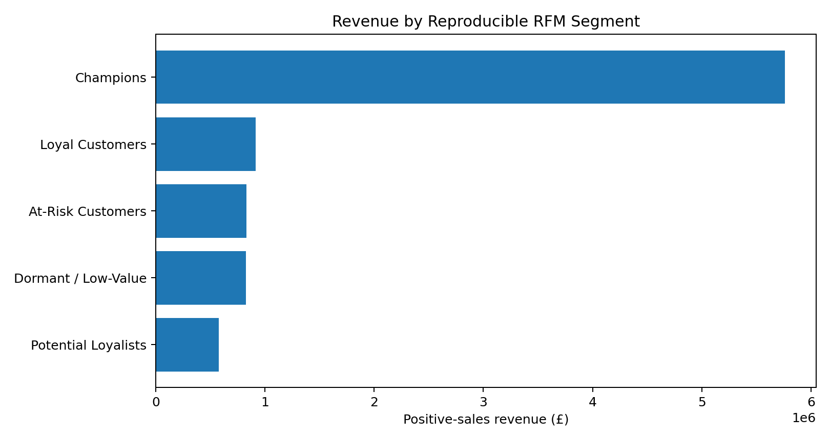
Figure 1. Positive-sales revenue by rule-based RFM segment; amounts are calculated from the retained transaction rows.
RFM segment | Customers | Customer share | Revenue (£) | Revenue share | Mean recency (days)
Champions | 946 | 21.8% | £5,759,478.91 | 64.6% | 13.0
Loyal Customers | 499 | 11.5% | £916,738.34 | 10.3% | 37.5
At-Risk Customers | 663 | 15.3% | £829,962.10 | 9.3% | 150.9
Dormant / Low-Value | 1,735 | 40.0% | £827,407.73 | 9.3% | 148.5
Potential Loyalists | 495 | 11.4% | £577,820.82 | 6.5% | 30.1

Interpretation: Champions account for 21.8% of customers but 64.6% of positive-sales revenue. Their average observed positive-sales spend is about £6,088 per customer, compared with about £477 for the Dormant / Low-Value segment. The 40.0% Dormant / Low-Value share contributes 9.3% of revenue. This concentration suggests differentiated retention and reactivation strategies rather than one uniform campaign.
Caution: RFM scores are relative to this historical sample and snapshot date. A customer classified as dormant may simply have purchased earlier in the observation window; the dataset does not contain later follow-up outcomes. RFM does not establish why a customer stopped buying and should not be interpreted as churn prediction.

Customer-level worked example
Illustrative calculation using the published rules: if a customer has a last purchase on 1 December 2011, their recency at the 10 December 2011 snapshot is 9 days. If that customer has 4 distinct invoices and £1,200 in retained positive-sales revenue, Frequency = 4 and Monetary = £1,200. Their R/F/M quintile scores are determined against all 4,338 customers, after which the segment rules are applied. This example explains the calculation; it is not a claim about a named customer in the source file.

7. Sales Trend and Forecast Validation
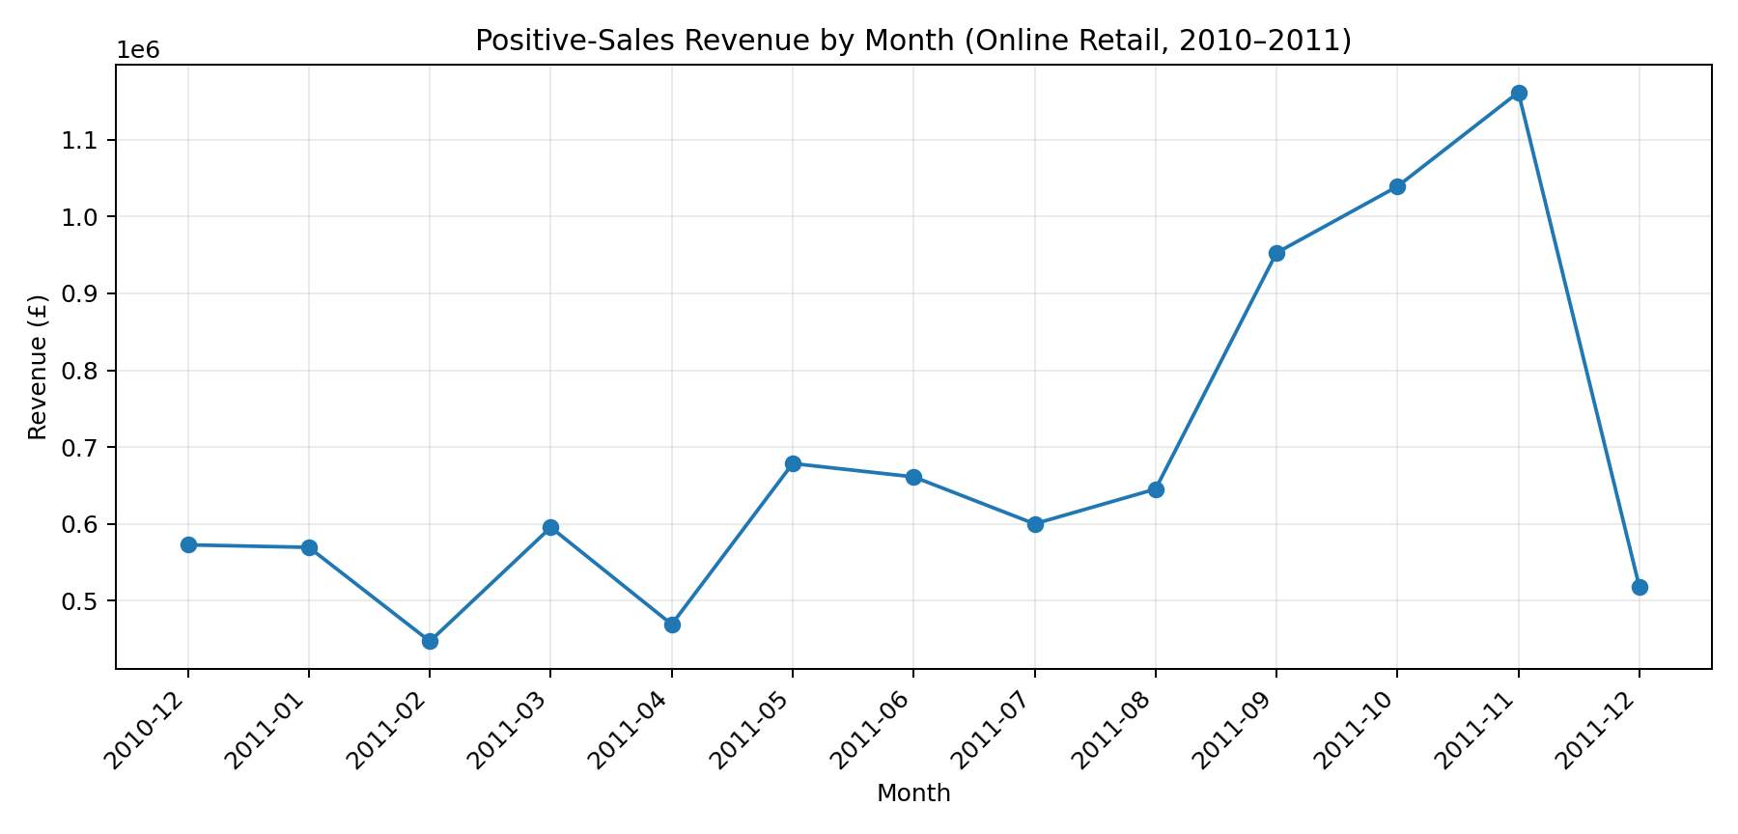
Figure 2. Monthly positive-sales revenue. December 2011 is incomplete (data end on 9 December).
Monthly revenue rises from £569,445.04 in January 2011 to £1,161,817.38 in November 2011, a 104.03% increase. The increase is not smooth: February declines 21.5% month over month, March rebounds 33.2%, May increases 44.6%, and September increases 47.7%. November is the highest complete month in this period. These are descriptive patterns; without campaign, stock availability, price or holiday fields, the analysis cannot attribute the increases to a specific cause.
Forecast setup: retained positive-sales revenue is aggregated into 54 week-ending-Sunday observations. The final eight weeks are held out; models are fitted only on earlier observations. The recursive four-week moving average uses the last four available values, appending each forecast when producing the next horizon. Holt’s linear trend is fitted using the training series only. This avoids using holdout actuals during prediction.
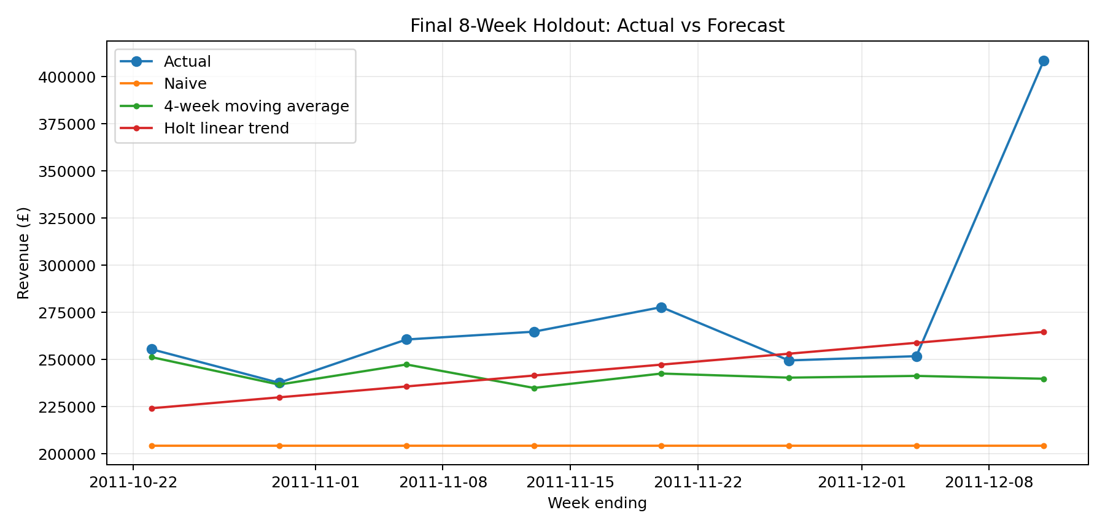
Figure 3. Final eight-week holdout. Models differ in how they respond to the sharp final-week increase.
Model | MAE (£) | RMSE (£) | MAPE
Naive | £71,352 | £87,924 | 23.95%
4-week moving average | £33,971 | £62,242 | 10.02%
Holt linear trend | £34,021 | £54,658 | 10.53%

Interpretation: Holt’s linear trend produces the lowest RMSE (£54,658), meaning it has the smallest squared-error penalty on this holdout. The four-week moving average has the lowest MAPE (10.02%) and MAE (£33,971 is slightly below Holt’s £34,021). The naïve baseline performs worst across all three metrics. Since the moving average and Holt trade off error measures, the final operational choice should reflect whether percentage error or large absolute misses matter more.
The final holdout includes a final week with unusually high revenue relative to preceding weeks. The models do not include calendar events, promotions, stockouts, price changes or inventory constraints. The series contains only about one annual cycle, so this is a baseline demonstration rather than a dependable long-range forecast.

8. Product and Geographic Analysis
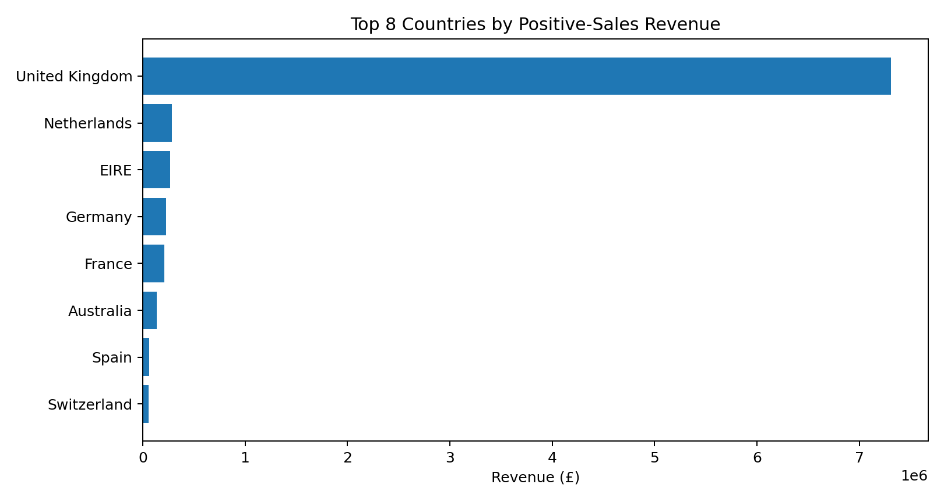
Figure 4. Top eight countries by positive-sales revenue.
The United Kingdom contributes £7,308,391.55, or 82.0% of positive-sales revenue. The next largest country by revenue is the Netherlands at £285,446.34 (3.2%), followed by EIRE at £265,545.90 (3.0%). This concentration means overall trends are strongly influenced by UK transactions; country comparisons should consider different customer counts and order frequencies, not revenue alone.

Highest-revenue product codes
Stock code | Description | Units | Positive-sales revenue | Invoices
23843 | PAPER CRAFT , LITTLE BIRDIE | 80,995 | £168,469.60 | 1
22423 | REGENCY CAKESTAND 3 TIER | 12,402 | £142,592.95 | 1,703
85123A | WHITE HANGING HEART T-LIGHT HOLDER | 36,725 | £100,448.15 | 1,971
85099B | JUMBO BAG RED RETROSPOT | 46,181 | £85,220.78 | 1,600
23166 | MEDIUM CERAMIC TOP STORAGE JAR | 77,916 | £81,416.73 | 195
POST | POSTAGE | 3,120 | £77,803.96 | 1,099
47566 | PARTY BUNTING | 15,291 | £68,844.33 | 1,379
84879 | ASSORTED COLOUR BIRD ORNAMENT | 35,362 | £56,580.34 | 1,375

A data-quality caution is visible in the top product table: stock code 23843 (“PAPER CRAFT , LITTLE BIRDIE”) has 80,995 units but appears in only one retained invoice. This could be a bulk order or an unusual transaction; it should be validated before using unit volume as a replenishment signal. Revenue ranking and unit-volume ranking answer different questions.

9. Website Analytics — Synthetic Demonstration
The supplied Week 4 workbook contains an aggregate table of six acquisition channels, totalling 100,000 sessions and 3,098 orders. The channel metrics are explicitly treated as synthetic/illustrative because there is no event-level website export and no validated join key to the historical Online Retail transactions.
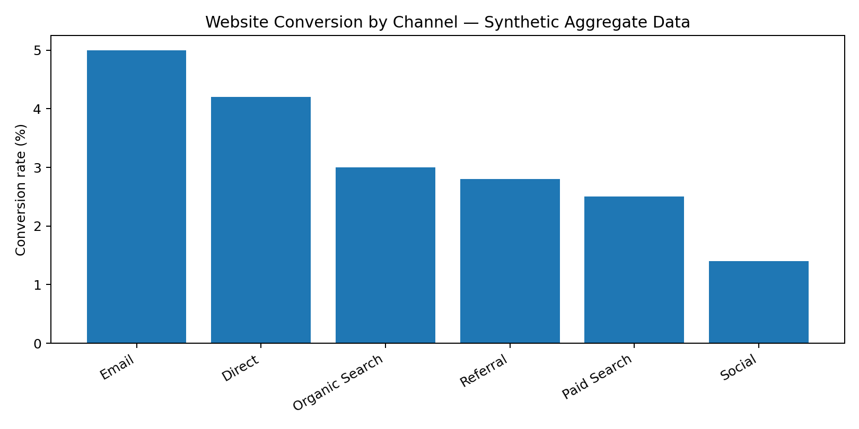
Figure 5. Channel conversion calculated as orders divided by sessions in the Week 4 synthetic aggregate table.
Channel | Sessions | Orders | Calculated conversion | Bounce rate (supplied)
Email | 10,000 | 500 | 5.00% | 27%
Direct | 18,000 | 756 | 4.20% | 32%
Organic Search | 30,000 | 900 | 3.00% | 43%
Referral | 8,000 | 224 | 2.80% | 39%
Paid Search | 22,000 | 550 | 2.50% | 47%
Social | 12,000 | 168 | 1.40% | 58%

Email has the highest illustrative conversion rate (5.0%; 500 orders from 10,000 sessions), followed by Direct at 4.2%. Social is lowest at 1.4% (168 orders from 12,000 sessions) and has the highest supplied bounce rate (58%). A reasonable test hypothesis is to inspect landing-page relevance and checkout friction for social traffic while checking whether email orders are incremental rather than merely capturing customers who would have purchased anyway.
These channel differences are not causal evidence. The table does not contain randomized assignment, acquisition cost, customer lifetime value, event-level funnel stages or a time dimension. The supplied impression/click fields are incomplete for some channels, so no overall click-through-rate claim is made.

10. Pricing A/B Test — Synthetic Demonstration
The Week 5 visitor-level dataset contains 40,000 rows: 20,000 Control visitors shown a ₹999 price and 20,000 Test visitors shown ₹949.05 (a 5% lower displayed price). This is a synthetic academic dataset, not a live randomized test run by a real retailer.
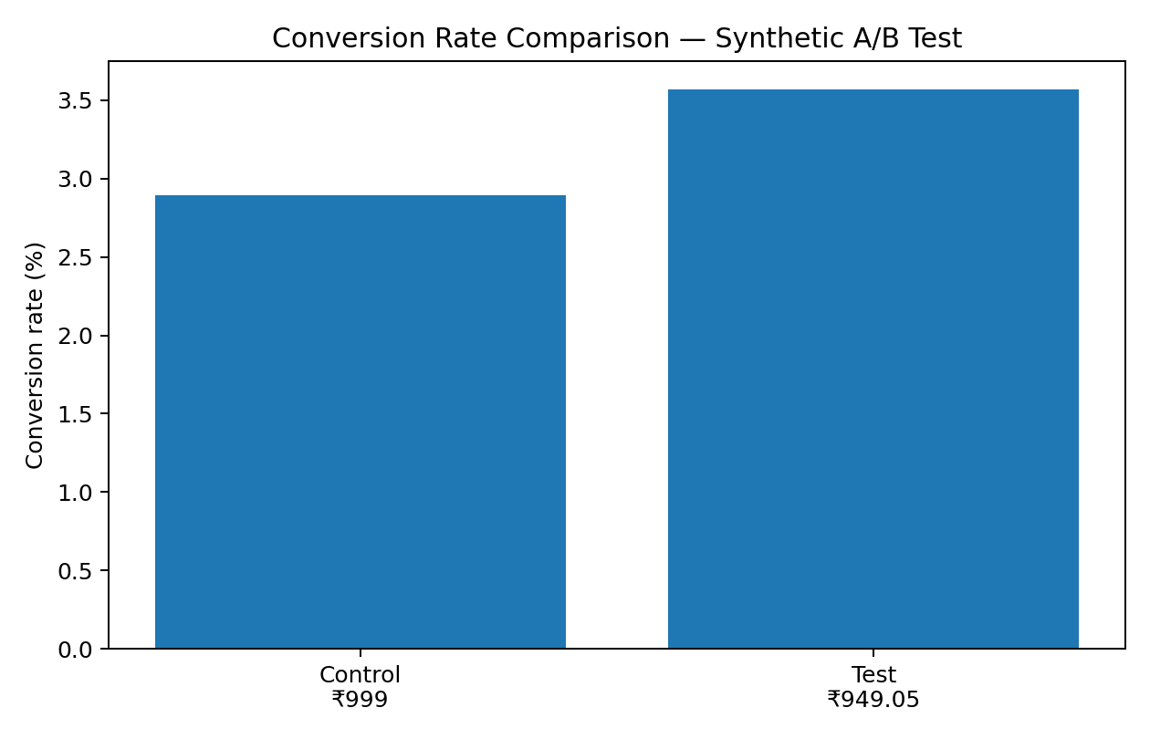
Figure 6. Conversion rates in the synthetic two-arm experiment.
Metric | Control | Test | Difference / change
Visitors | 20,000 | 20,000 | Equal sample size
Buyers | 579 | 714 | +135 buyers in generated sample
Conversion rate | 2.895% | 3.570% | +0.675 percentage points; +23.3% relative
Revenue | ₹840,180.50 | ₹1,029,940.03 | +₹189,759.53 in generated sample
Revenue per visitor | ₹42.01 | ₹51.50 | +₹9.49; +22.6% relative
Average revenue per buyer | ₹1,451.09 | ₹1,442.49 | −0.59%

A two-proportion z-test gives p = 0.000135. The approximate 95% confidence interval for the Test-minus-Control conversion difference is 0.328 to 1.022 percentage points. Under the generated data, the conversion difference is statistically distinguishable from zero. However, statistical significance does not fix the key limitation: the records were generated to represent a plausible effect, so the p-value does not establish that a real 5% discount causes a 23.3% conversion lift.
Revenue per visitor also rises in this synthetic sample from ₹42.01 to ₹51.50. Contribution profit is not claimed because the dataset does not provide observed cost of goods, shipping, payment fees, refunds or customer acquisition cost. A real test should predefine revenue or contribution per visitor as the primary metric, track returns and repeat purchasing, maintain stable user assignment, and run with actual traffic.

11. Cross-Analysis: What the Evidence Connects
A cross-analysis is useful only when the measures share a valid data source or a clearly justified key. The transaction file supports customer segment × revenue, country × revenue, product × revenue and time × revenue comparisons. The Week 4 and Week 5 tables are independent synthetic exercises, so their results are not merged with the transaction file.
Pattern | Numerical evidence | What it suggests | What it does not prove
Customer concentration | Champions: 21.8% of customers / 64.6% of revenue; Dormant/Low-Value: 40.0% / 9.3%. | Retention efforts for high-value customers and economical reactivation tests may be worthwhile. | Does not prove a particular retention campaign will work.
Geographic concentration | UK contributes 82.0% of positive-sales revenue. | UK performance dominates the historical total; market-specific monitoring matters. | Does not establish why UK revenue is higher or whether it will remain so.
Revenue trajectory | Jan 2011 £569,445; Nov 2011 £1,161,817; +104.0%. | Investigate the September–November increase and compare against calendar/promotion/inventory records if available. | Does not prove seasonality or a campaign effect.
Product anomaly | Stock code 23843 has 80,995 units in one invoice. | Flag for transaction validation before inventory planning. | Does not mean the record is necessarily erroneous.
Synthetic website funnel | Email 5.0% conversion; Social 1.4% with 58% bounce. | Generate hypotheses for landing-page and channel-quality tests. | Not linked to the historical sales customers; not observed retailer performance.
Synthetic pricing experiment | 2.895% vs 3.570% conversion; p≈0.000135. | Demonstrates how to calculate a treatment-control difference and test uncertainty. | Generated effect is not causal evidence for a real pricing decision.

12. Recommendations and Implementation Roadmap
Priority / timing | Action | Success measures | Decision guardrail
1. Data controls (Days 1–7) | Keep source file immutable; version cleaning logic; reconcile positive-sales and return views; add automated row-count and revenue checks. | Row-count reconciliation; missing/invalid-value checks; reproducible totals. | Never label positive-sales revenue as net revenue.
2. Retention pilot (Days 8–21) | Create a Champions retention cohort and a separate at-risk reactivation cohort; test one treatment against a holdout. | Repeat purchase, incremental revenue/customer, unsubscribe/complaint rate. | Use a holdout; compare incremental outcomes rather than campaign-attributed totals.
3. Revenue planning (Weeks 2–4) | Monitor weekly actuals against both moving-average and Holt baselines; annotate promotions, stockouts and holidays. | MAE, RMSE, MAPE, forecast bias. | Re-select model only after repeated chronological validation.
4. Product and country checks (Weeks 2–4) | Validate unusually large quantities; compare revenue with invoice counts, unique customers and return activity by market. | Outlier resolution, stockout rate, return rate, revenue/customer. | Do not make inventory decisions from revenue alone.
5. Website instrumentation (Weeks 3–5) | Obtain real sessions, landing pages, device, checkout steps, orders, source costs and consent-compliant identifiers. | Funnel completion, conversion, revenue/session, acquisition cost. | Confirm event definitions and attribution before channel comparisons.
6. Pricing experiment (Weeks 4–6) | Run a live randomized test only after margin data and test design are approved. | Conversion, revenue/visitor, contribution/visitor, refund and repeat rate. | Predefine primary metric, sample size, duration and stop rule.

30-Day Operating Plan
- Days 1–7: approve metric definitions, validate data cleaning and create an exception log for bulk orders and returns.
- Days 8–14: refresh RFM scores; design customer holdouts; begin weekly forecast tracking.
- Days 15–21: obtain first-party website event exports and test funnel data completeness.
- Days 22–30: prepare a pricing-test protocol with finance-approved costs, primary metric, guardrails and sample-size calculation.

13. Limitations, Ethics and Future Directions
Limitation | Why it matters | Future improvement
Historical transaction period (2010–2011) | Customer preferences, channel mix and prices may have changed substantially. | Use recent transaction history and compare periods with stable definitions.
Positive-sales filter excludes returns/cancellations | Reported revenue is not net of refunds and may overstate retained sales value. | Build a separate cancellation/return ledger and reconcile net revenue.
One annual cycle / partial December | Seasonality is weakly identified; December is incomplete. | Collect multiple years and use seasonal-naïve / seasonal models.
No cost or margin fields in core transaction data | Revenue is not profit; product economics cannot be established. | Join validated COGS, fulfilment, payment, discount and refund costs.
No customer demographics or website events | Cannot explain motivations, sessions, device behavior or funnel drop-off. | Use privacy-compliant first-party event and CRM data.
RFM rules are analyst-defined | Segment thresholds influence segment sizes and labels. | Compare alternative thresholds and validate actionability through controlled tests.
Website and pricing datasets are synthetic | They do not represent measured performance or prove causal effects. | Replace with production event exports and a real randomized experiment.
Potential outliers / bulk orders | Extreme quantities can distort unit rankings and forecasts. | Review source documents and robustly report sensitivity with/without flagged records.
Multiple exploratory comparisons | Testing many segments and metrics can produce chance findings. | Pre-register primary hypotheses and treat post-hoc results as exploratory.

Future Directions
- Extend the transaction window to at least two or three years and compare forecast models using rolling-origin evaluation.
- Build a return-adjusted customer and product profitability view using validated costs and refunds.
- Measure customer cohort retention at 30/60/90 days and estimate lifetime value only when observation windows and margin data support it.
- Join channel and website data only through governed, consent-compliant identifiers and consistent attribution windows.
- Run randomized pricing tests with persistent assignment, predefined metrics and post-purchase guardrails.
- Investigate product-level outliers and compare revenue concentration with units, invoices, customer counts and return rates.
Ethical reporting principle: distinguish observations, derived metrics, assumptions and recommendations. Customer identifiers are included only in the supporting analytical table for reproducibility; they should not be published in public-facing dashboards. Synthetic outputs must remain labelled as synthetic in any future reuse.

14. Conclusion
The integrated analysis demonstrates a complete analytical path from raw transaction inspection to data cleaning, customer segmentation, descriptive sales analysis, chronological forecast validation and business recommendations. Its strongest findings are grounded in the supplied Online Retail transactions: £8.91 million positive-sales revenue, a 65.58% repeat-purchase rate, revenue concentration in the Champions segment, and a UK share of approximately 82.0%.
The report also incorporates website analytics and pricing experimentation as method demonstrations while explicitly marking them synthetic. This distinction is essential: a high-quality report should not make synthetic data appear like real company performance. The practical next step is to replace those examples with first-party web analytics, approved cost data and a live randomized pricing test before making operational decisions.

Appendix A. Worked Calculations

A1. Positive-sales revenue
Rule: retain rows where Quantity > 0 and UnitPrice > 0. Recompute line revenue = Quantity × UnitPrice. Sum retained line revenue = £8,911,407.904, rounded to £8,911,407.90. The filtered count is 397,884 lines out of 406,829 raw lines; excluded count = 406,829 − 397,884 = 8,945.

A2. Repeat-purchase rate
Repeat customers = customers with more than one distinct retained invoice. Repeat-purchase rate = repeat customers ÷ 4,338 × 100 = 65.58%.

A3. RFM segment revenue share
Champions revenue share = £5,759,478.91 ÷ £8,911,407.90 × 100 = 64.63%. Customer share = 946 ÷ 4,338 × 100 = 21.81%.

A4. Monthly growth
Jan–Nov growth = (November revenue − January revenue) ÷ January revenue × 100 = (£1,161,817.38 − £569,445.04) ÷ £569,445.04 × 100 = 104.03%.

A5. A/B conversion difference
Control = 579 ÷ 20,000 = 2.895%; Test = 714 ÷ 20,000 = 3.570%. Absolute difference = 3.570% − 2.895% = 0.675 percentage points. Relative lift = (3.570% − 2.895%) ÷ 2.895% × 100 = 23.32%. This calculation is based on generated data and is not a real-world treatment effect.

Appendix B. Supporting Files and Reproduction
The accompanying package contains: a reproducible Jupyter notebook and Python script; source dataset copy; CSV summaries for monthly revenue, RFM segments, customer-level RFM, country performance, top products, forecast holdout metrics, Week 4 synthetic channel metrics and Week 5 synthetic A/B results; and all figures used in this report.
Reproduction requirements: Python 3.10+ with pandas, numpy, matplotlib, openpyxl, scipy, statsmodels, scikit-learn and python-docx. Run the notebook top-to-bottom from the package root. The notebook uses explicit paths and prints the core row-count, revenue, segment, forecast and A/B checks.
Primary transaction source is the supplied OnlineRetail.xlsx, worksheet “Online Retail Data Set”. Week 4 metrics come from the supplied aggregate website workbook; Week 5 metrics come from Week5_AB_Pricing_Synthetic_Dataset.csv. Neither synthetic source should be described as real company telemetry.

