WEEK 6 PROJECT REPORT
Comprehensive Retail
E-Commerce Data Analysis
An End-to-End Analytical Framework for Customer, Sales,
Website Performance, Forecasting, and Pricing

Assignment | Week 6 – Comprehensive Retail eCommerce Data Analysis Report
Prepared by | Aalok pandey
Tools and methods | Python, Pandas, NumPy, Matplotlib, descriptive statistics, RFM, forecasting
Data status | Illustrative simulated data for demonstration; replace with project dataset before submission
Academic / Internship Project | Final Integrated Report

Important Data and Interpretation Note
This report is a complete analytical project template built around a clearly labelled simulated retail dataset because no Week 1–5 datasets or analysis files were attached with the task images. The values, charts, segment sizes, channel conversion rates, and forecast shown here are illustrative—not claims about a real company. This distinction is important for academic integrity. Before final submission, replace the simulated values with the actual data and rerun the calculations, or attach your earlier task files so the report can be integrated accurately.
The report demonstrates the full project lifecycle requested in the assignment: data strategy, quality checks, customer behaviour and RFM segmentation, sales patterns and baseline forecasting, website acquisition analysis, pricing evaluation, findings, recommendations, limitations, and future work.

Table of Contents
- 1. Executive Summary
- 2. Business Problem and Objectives
- 3. Data Strategy and Project Lifecycle
- 4. Data Quality and Preparation
- 5. Analytical Framework and KPIs
- 6. Customer Behaviour and RFM Segmentation
- 7. Sales Analysis and Forecasting
- 8. Website and Acquisition Analytics
- 9. Pricing Strategy Evaluation
- 10. Cross-Analysis, Patterns, and Limitations
- 11. Recommendations and Implementation Roadmap
- 12. Future Directions
- 13. Conclusion
- Appendix A: KPI Definitions
- Appendix B: Reproducibility and Validation Checklist

1. Executive Summary
Retail e-commerce businesses generate data at every stage of the customer journey—from acquisition and browsing to ordering, payment, fulfilment, and repeat purchase. Looking at only one metric can hide the reason behind a performance change. This project combines customer segmentation, sales trend analysis, a simple order forecast, acquisition-channel conversion analysis, and price-band evaluation into one decision-oriented report.
In the illustrative dataset, monthly orders generally rise over the 18-month period, with a visible seasonal peak in the final quarter of 2025 and a subsequent reset in early 2026. The baseline forecast suggests gradual order growth over the next six months, but it should be treated as a planning reference rather than a guaranteed prediction. The example channel analysis shows email and direct traffic converting more efficiently than social traffic, while the pricing example shows stronger conversion in mid-range price bands than at the lowest or highest band.
The RFM framework divides customers by recency, frequency, and monetary value so that retention, reactivation, and acquisition efforts can be differentiated. The most important management implication is to connect customer value with channel quality, product pricing, and sales planning instead of optimising each area independently.

Illustrative headline indicators
Area | Illustrative observation | Business interpretation
Sales | Orders trend upward over the period, with a seasonal spike | Plan inventory and campaign capacity around seasonal peaks.
Customers | Champions and loyal customers form valuable retention groups | Protect high-value customers with relevant service and loyalty benefits.
Website | Email/direct channels show higher conversion in the example | Investigate channel intent and test budget shifts using controlled experiments.
Pricing | Mid-range price band has the strongest example conversion | Test price, discount, and value messaging by category.
Forecast | Baseline order forecast increases over six months | Use forecast ranges and monitor error monthly, not a single point estimate.

2. Business Problem and Objectives
Business problem: an e-commerce team may have sales, customer, marketing, website, and pricing information stored in separate files. Without a joined-up analytical approach, it is difficult to know which customers deserve retention investment, which channels bring converting visitors, how demand may change, and whether price changes are improving outcomes.

Project objectives
- Define a data strategy and a repeatable end-to-end analysis process.
- Identify quality issues such as missing values, duplicates, invalid dates, inconsistent categories, and impossible quantities or prices.
- Analyse customer value through recency, frequency, monetary value, and actionable segments.
- Describe order and revenue trends and develop a transparent baseline forecast.
- Compare acquisition channels using sessions, orders, and conversion rate.
- Evaluate price bands alongside conversion and revenue, avoiding unsupported causal claims.
- Convert findings into prioritised, measurable business recommendations.

Key business questions
- Which customers are most valuable and which may be lapsing?
- When does demand rise or fall, and how should inventory and staffing respond?
- Which acquisition channels produce visitors who complete purchases?
- Does conversion vary across price bands, and what should be tested next?
- What data limitations could mislead a decision-maker?

3. Data Strategy and Project Lifecycle

3.1 Data sources and proposed data model
A production analysis should combine records using stable keys and documented definitions. Customer IDs connect customer and order records; order IDs connect order headers and line items; session IDs connect web events and attribution data; product IDs connect sales to catalogue and pricing information.
Dataset | Typical fields | Purpose
Customers | customer_id, signup_date, region, acquisition_source | Customer cohort and profile analysis
Orders | order_id, customer_id, order_date, order_status, discount, shipping | Order trend and customer purchase history
Order items | order_id, product_id, quantity, unit_price, return_flag | Revenue, units, product mix, returns
Web sessions | session_id, channel, landing_page, device, session_date | Traffic and conversion analysis
Product catalogue | product_id, category, list_price, cost, stock | Pricing, margin, and inventory analysis
Campaigns | campaign_id, spend, impressions, clicks, campaign_date | CAC, ROAS, and campaign optimisation

3.2 Project lifecycle
- Define the business questions, decision owners, time period, and KPI definitions.
- Collect files or database extracts and record source, extraction date, and row counts.
- Profile the data: schema, types, missingness, duplicates, ranges, and category consistency.
- Clean data using documented rules while preserving raw copies and logging exclusions.
- Create analytical tables at a consistent grain (order, order line, customer, or session).
- Perform exploratory analysis and calculate KPIs and customer segments.
- Validate calculations against totals and known business rules.
- Communicate findings with charts, assumptions, limitations, and recommended actions.
- Monitor KPIs and refresh the analysis on a scheduled basis.

3.3 Analytical tools
Python is suitable for a reproducible workflow: Pandas for data manipulation, NumPy for numerical operations, Matplotlib for charts, and scikit-learn or statsmodels for more advanced modelling if the data supports it. A spreadsheet can be used for source review, but transformations and final calculations should be scripted where possible so that they can be repeated.

3.4 Data governance
Use only the customer fields required for the stated purpose, restrict access to identifiable data, avoid exposing personal information in charts, and define retention rules. Marketing consent and privacy requirements must be respected. Document who owns each dataset and which version of a KPI definition is in use.

4. Data Quality and Preparation
Analysis quality depends on whether the input data is complete, valid, consistent, and correctly joined. Cleaning should be evidence-based: do not delete a row only because it looks unusual. First determine whether it is a valid refund, cancelled order, bulk purchase, test transaction, or genuine error.

4.1 Quality checks
Issue | Detection method | Recommended treatment
Missing identifiers | Count null customer_id/order_id/product_id | Exclude from customer-level joins only when the identifier is essential; report the excluded share.
Duplicate rows | Check duplicated primary keys and duplicate line signatures | Remove only confirmed duplicates; repeated products within an order may be legitimate.
Invalid dates | Parse dates and inspect failures/future dates | Correct from source if possible; otherwise quarantine invalid records.
Negative quantity/price | Range checks and business-rule review | Determine whether records represent returns/credits before exclusion.
Inconsistent categories | Trim whitespace, standardise case, map known aliases | Maintain a mapping table and preserve the original field.
Join inflation | Compare row counts and revenue before/after joins | Check key uniqueness and join cardinality; aggregate at the correct grain.
Outliers | IQR/percentile review and business context | Validate extreme values; do not automatically remove valid high-value orders.

4.2 Suggested preparation sequence
- Keep an untouched raw copy and create a dated cleaned version.
- Standardise column names, data types, whitespace, and category labels.
- Separate completed, cancelled, refunded, and pending orders before calculating sales.
- Calculate line revenue as quantity × unit price, then account for discounts and refunds according to a written rule.
- Create order-level and customer-level tables separately to avoid counting order lines as orders.
- Check that revenue and order counts reconcile to source totals within documented tolerances.
- Record every rule, row count before/after, and reason for exclusions.

4.3 Validation controls
At minimum, validate that each order belongs to one customer, order dates fall within the analysis window, quantities and prices follow known rules, and the sum of line revenue agrees with order totals after discounts and returns. Recompute a small sample manually. If an aggregation changes the number of orders unexpectedly, investigate before interpreting results.

5. Analytical Framework and KPIs
KPI | Definition | Decision supported
Gross sales | Sum of quantity × unit price before deductions | Demand and product mix
Net revenue | Gross sales − discounts − refunds/returns, based on documented policy | Commercial performance
Orders | Count of distinct completed order IDs | Demand volume
Average order value (AOV) | Net revenue ÷ completed orders | Basket-building and promotion evaluation
Repeat purchase rate | Customers with 2+ completed orders ÷ purchasing customers | Retention effectiveness
Conversion rate | Completed orders ÷ eligible sessions × 100 | Website and channel efficiency
Average order frequency | Completed orders ÷ purchasing customers | Purchase intensity
Customer monetary value | Net customer spend during the selected window | Customer prioritisation
Gross margin | (Net revenue − cost of goods sold) ÷ net revenue | Pricing and profitability
CAC | Acquisition spend ÷ new customers attributed to that spend | Acquisition efficiency
ROAS | Attributed revenue ÷ advertising spend | Campaign return, subject to attribution caveats

Metric definitions must remain consistent across the report. For example, conversion rate should specify whether the denominator is sessions, users, or add-to-cart events. Revenue should specify whether taxes, shipping, discounts, and refunds are included. The chosen definition should be documented in the project code and repeated in dashboard labels.

5.1 Descriptive, diagnostic, predictive, and prescriptive analysis
Analysis type | Question | Method used here
Descriptive | What happened? | Monthly trends, segment counts, channel conversion
Diagnostic | What may explain it? | Compare seasonality, channel mix, customer segments, and price bands
Predictive | What may happen next? | Transparent baseline order forecast
Prescriptive | What should we do? | Prioritised tests and operational actions

6. Customer Behaviour and RFM Segmentation
RFM is a practical customer segmentation method based on three behavioural signals. Recency measures how recently a customer purchased; frequency measures how often they purchased; monetary value measures how much they spent. RFM is useful for prioritising communication, but it does not by itself prove customer loyalty or predict future value with certainty.

6.1 RFM calculation
- Choose a snapshot date after the final transaction date.
- Recency = snapshot date − date of the customer's most recent completed purchase, measured in days.
- Frequency = count of distinct completed orders per customer in the analysis window.
- Monetary = sum of net revenue attributed to the customer in the analysis window.
- Score each measure using documented quantiles or business-defined thresholds; ensure that lower recency days receive a better recency score.
- Combine scores into interpretable groups and review segment sizes and spend before activating campaigns.

6.2 Example segment interpretation
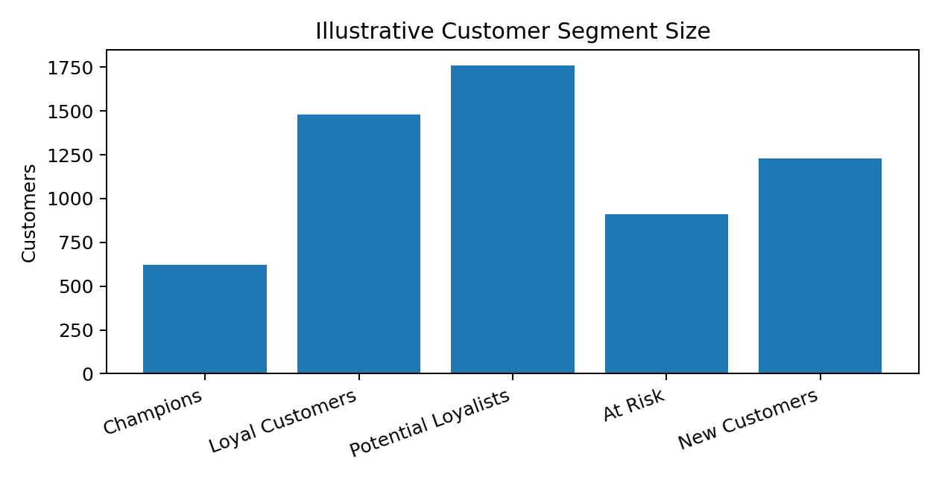
Segment | Typical behaviour | Suggested action
Champions | Recent, frequent, high spend | Early access, VIP support, referral invitations; avoid unnecessary blanket discounts.
Loyal Customers | Repeat buyers with steady spend | Cross-sell relevant products, loyalty benefits, replenishment reminders.
Potential Loyalists | Recent customers with room to build repeat behaviour | Onboarding, recommendations, second-purchase incentive tests.
At Risk | Previously valuable but not recently active | Targeted win-back messaging and service-recovery checks.
New Customers | Recent first-time or low-frequency buyers | Post-purchase education, delivery updates, and a clear next-best offer.

The chart uses illustrative segment counts, not observed customer records. In a real submission, the segments must be generated from customer-level transactions and the counts should reconcile to the number of eligible customers.

6.3 Avoiding common RFM errors
- Count distinct orders, not order-line rows, for frequency.
- Use net spend consistently and decide how refunds are treated.
- Do not compare customers with very different observation windows without adjusting the method.
- Check whether one-off bulk purchases distort monetary quantiles.
- Validate the segment rules with later-period repeat purchase or campaign response when possible.

7. Sales Analysis and Forecasting

7.1 Historical trend
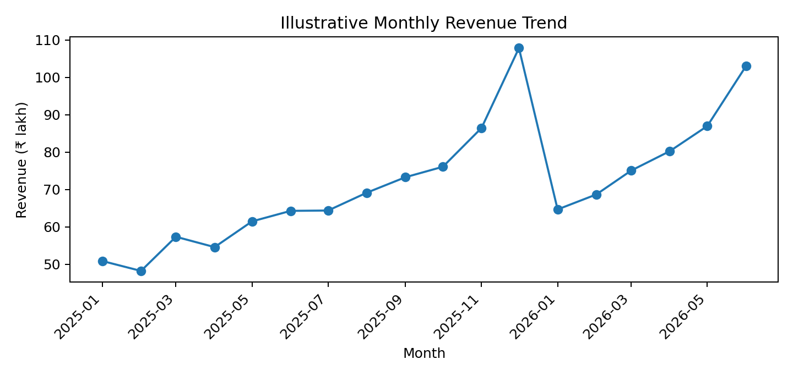
The illustrative revenue trend broadly rises over the selected period, with a pronounced late-year peak. Such a pattern may reflect seasonal demand, promotional activity, higher order volume, higher basket value, or a combination. The chart alone cannot identify the cause. A real analysis should annotate campaign dates, stockouts, price changes, and holiday periods to test explanations.

7.2 Order volume and baseline forecast
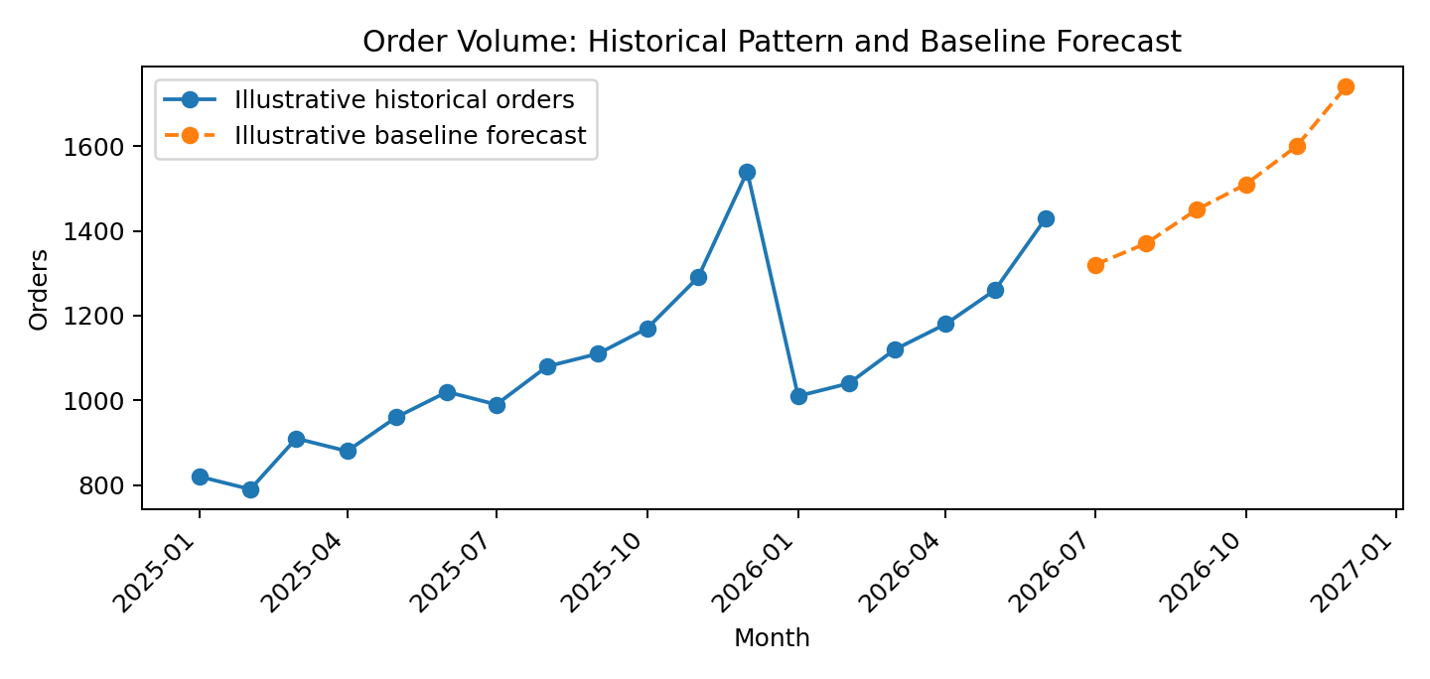
The dashed line is an illustrative baseline forecast for six future months. It is intentionally simple and should be treated as a planning benchmark. Before operational use, compare at least a seasonal-naïve baseline with a moving average or an appropriate time-series model. Use a time-based holdout period and report MAE or RMSE. Randomly splitting monthly time series is inappropriate because it can leak future information into training.

7.3 Forecasting procedure
- Aggregate completed orders by day or month, depending on business planning needs.
- Plot the series and inspect missing periods, seasonality, trend, campaign spikes, and structural changes.
- Create a baseline such as last year's same month where sufficient history exists, or a moving average where it does not.
- Split train and test chronologically; never train on future periods.
- Compare forecast errors against a simple baseline and show prediction intervals where the method supports them.
- Review forecast bias and error monthly; retrain after major business changes.

7.4 Operational implications
- Use demand forecasts as ranges for inventory and staffing, not as exact promises.
- Separate organic demand from promotion-driven spikes where possible.
- Track stockouts and cancellations because observed sales can understate true demand.
- Use category-level forecasts if product-level demand differs materially.

8. Website and Acquisition Analytics
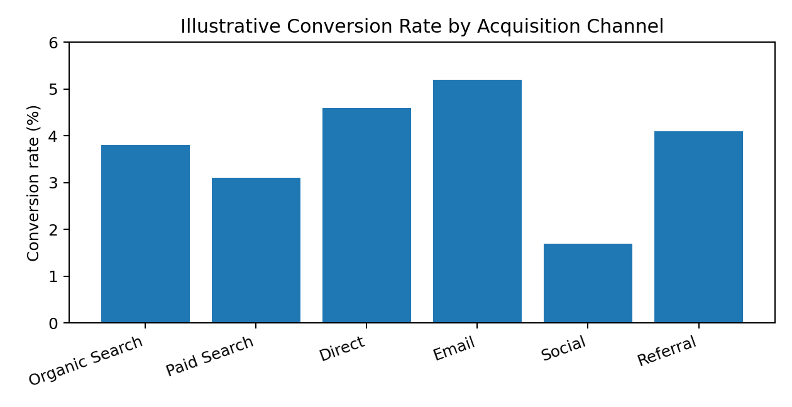
The example channel chart compares conversion rate, not channel profitability. Email and direct traffic appear stronger in this illustrative scenario, while social traffic is lower. A low conversion rate does not automatically mean a channel should be stopped: social may introduce new customers who convert later, and attribution windows may shift credit between channels.

8.1 Metrics to evaluate together
Metric | Why it matters | Caution
Sessions and users | Measures reach | Bot traffic and repeat sessions may distort totals.
Conversion rate | Measures purchase completion | Use a consistent denominator and attribution window.
Revenue per session | Connects traffic to commercial outcome | Can be skewed by a few large orders.
CAC / ROAS | Relates marketing cost to acquired customers/revenue | Attribution is not necessarily incremental impact.
Landing-page exit / bounce | Can flag friction or mismatched intent | A high bounce rate can be normal for some page types.
Device and page speed | May reveal user-experience barriers | Compare similar traffic sources and page types.

8.2 Recommended diagnostic workflow
- Segment conversion by channel, device, landing page, new/returning visitor, and campaign.
- Check tracking consistency and consent-related measurement gaps.
- Review landing-page promise against product availability, price, shipping, and checkout experience.
- Investigate checkout abandonment, payment failures, page speed, and mobile usability.
- Run controlled A/B tests with a defined primary metric and guardrail metrics.
Do not reallocate a large budget solely from the chart. Validate channel performance with adequate sample size, contribution margin, new-customer quality, and incrementality tests where feasible.

9. Pricing Strategy Evaluation
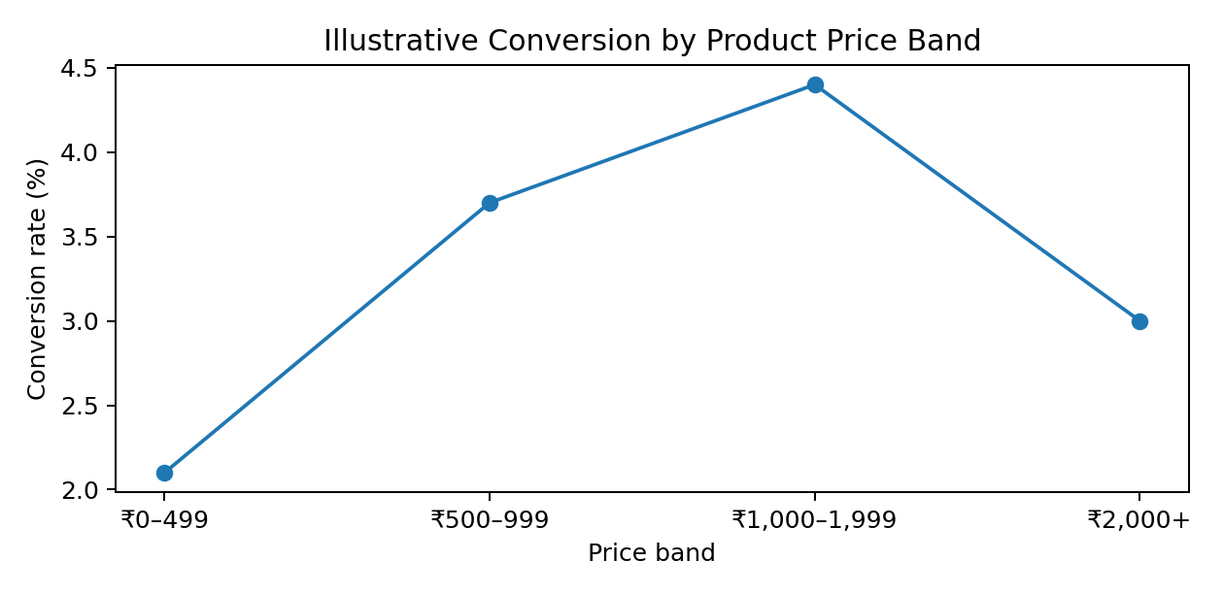
The illustrative curve suggests conversion is strongest in the middle price band. This pattern is not proof that the middle band causes better conversion: product category, brand, availability, shipping costs, customer intent, and promotion depth may all differ by price band.

9.1 Pricing analysis framework
- Compare price bands within the same product category where possible.
- Measure conversion, units per order, net revenue, gross margin, returns, and discount rate together.
- Separate list price from realised price after discounts and coupons.
- Check whether price changes overlap with campaigns, stockouts, or changes in traffic quality.
- Test price or offer changes using controlled experiments and protect margin as a guardrail.

9.2 Practical pricing recommendations
- Use bundles and complementary recommendations to increase basket value without discounting every item.
- Test free-shipping thresholds only after estimating their effect on contribution margin.
- Avoid blanket discounts for high-value customers who may purchase without them.
- For high-traffic, low-conversion products, review value messaging, reviews, delivery promises, and total checkout cost before reducing price.
- Track returns and cancellations after a price or promotion change to avoid mistaking low-quality orders for success.

10. Cross-Analysis, Patterns, and Limitations

10.1 How the analyses connect
Customer, sales, website, and pricing analysis should be interpreted as a connected system. For example, a channel may have a high conversion rate but attract low-value orders; a promotion may increase orders while reducing margin; a customer segment may spend heavily but also return a high share of purchases. The strongest decision uses multiple measures rather than a single headline KPI.
Observed pattern to test | Possible explanation | Validation needed
Revenue rises while orders stay flat | Higher AOV, product mix, or price changes | Decompose revenue into orders × AOV and compare margin.
Traffic rises but conversion falls | Lower-intent acquisition, UX friction, or tracking change | Compare channel/device mix and funnel stages.
Discounted orders increase but profit falls | Discount cost exceeds incremental demand | Measure contribution margin and use a control group.
RFM high spend but low frequency | One unusually large order | Inspect order history and later-period repeat behaviour.
Forecast misses seasonal peaks | Model lacks seasonal features or promotion calendar | Compare seasonal baselines and annotate events.

10.2 Correlation is not causation
Correlations between discounts, channel, price, and conversion may be confounded by campaign targeting, customer intent, product category, or seasonality. A correlation coefficient describes association in the observed data; it does not show that changing one variable will cause the outcome to change. Use experiments, quasi-experimental methods, or careful controls for causal questions.

10.3 Limitations
- The example figures in this draft are simulated and cannot support factual claims about a real retailer.
- No transaction-level files, prior-week reports, or website event logs were provided with the screenshots.
- The example forecast is a baseline illustration and has not been validated against a held-out real dataset.
- Attribution may over-credit channels that appear late in the customer journey.
- Pricing comparisons may be affected by product mix, margin, promotions, and customer selection.
- Customer segmentation quality depends on the observation window and business-specific thresholds.

10.4 How to make the report evidence-based
Replace all illustrative charts and figures with outputs from the actual dataset. Add the date range, row counts, excluded-record counts, and metric definitions. Include at least one validation table, one real example of a data-quality issue and its treatment, and a short explanation of how each finding was calculated. If a result cannot be reproduced from the source data, do not present it as a finding.

11. Recommendations and Implementation Roadmap
Priority | Action | Success measure | Timing
1 – Data foundation | Create a documented clean-data pipeline and KPI dictionary | Reconciliation pass rate; missing-ID rate; refresh success | Weeks 1–2
2 – Customer retention | Pilot separate campaigns for champions, potential loyalists, and at-risk customers | Repeat purchase rate; incremental margin; unsubscribe rate | Weeks 2–4
3 – Website optimisation | Investigate mobile checkout and channel-specific landing pages | Conversion rate; checkout completion; payment failure rate | Weeks 3–6
4 – Pricing tests | Test targeted offers or bundles by category with margin guardrails | Contribution margin per visitor; AOV; return rate | Weeks 4–8
5 – Forecasting | Compare seasonal-naïve and moving-average forecasts | MAE/RMSE; forecast bias; stockout rate | Monthly
6 – Measurement | Create a recurring review of segment, channel, pricing, and sales KPIs | Action completion and KPI movement | Monthly

11.1 First 30 days
- Days 1–7: confirm data access, KPI definitions, privacy requirements, and source reconciliation.
- Days 8–14: build clean customer/order/session tables and publish data-quality checks.
- Days 15–21: validate RFM segments, channel metrics, and baseline forecast; agree on one experiment.
- Days 22–30: launch a small pilot, define a control group, and establish a monthly review cadence.

11.2 Decision principles
- Prioritise actions with a clear owner, measurable outcome, and review date.
- Use profit or contribution margin as a guardrail when optimising revenue or conversion.
- Prefer small controlled tests to large unverified changes.
- Document decisions that depend on incomplete data and revisit them when data improves.

12. Future Directions
- Customer lifetime value (CLV): estimate future contribution from repeat behaviour, not revenue alone.
- Churn prediction: train and validate a classification model only after defining churn and preventing target leakage.
- Product recommendation: test complementary or similar-product recommendations and evaluate incremental basket value.
- Inventory optimisation: combine demand forecasts, supplier lead times, service levels, and stockout costs.
- Experimentation platform: standardise A/B-test design, sample-size planning, guardrails, and post-test reporting.
- Marketing incrementality: use holdout groups or geo experiments to estimate whether spend creates additional demand.
- Real-time monitoring: track data freshness, checkout errors, conversion anomalies, and forecast drift.
- Responsible analytics: minimise personal data, document model limitations, and audit outcomes across customer groups.

13. Conclusion
This integrated project demonstrates how retail e-commerce data can support decisions across customer retention, sales planning, website performance, and pricing. Its central lesson is that the analysis must be connected: customer value should be considered alongside acquisition cost, conversion should be considered alongside margin, and forecasts should be evaluated against transparent baselines.
The final report should be submitted only after the illustrative figures are replaced with reproducible results from the actual project data. With validated metrics, clear visual explanations, explicit limitations, and a practical implementation roadmap, the analysis can move beyond a collection of charts and become a coherent business recommendation.

Appendix A: KPI Definitions
Term | Definition / note
RFM | Recency, Frequency, Monetary value; customer-level behavioural segmentation.
AOV | Net revenue divided by completed orders, with revenue policy documented.
Conversion rate | Completed orders divided by eligible sessions, multiplied by 100.
MAE | Mean absolute error; average absolute difference between actual and forecast values.
RMSE | Root mean squared error; penalises larger forecast errors more heavily.
CAC | Acquisition spend divided by new customers attributed to that spend.
ROAS | Attributed revenue divided by advertising spend; attribution limitations apply.
Contribution margin | Revenue after variable costs relevant to the decision, defined consistently.
RFM snapshot date | Reference date used to calculate recency for all customers.

Appendix B: Reproducibility and Validation Checklist
- ☐ Raw files preserved and data sources documented.
- ☐ Analysis period and business timezone stated.
- ☐ Order status and refund treatment documented.
- ☐ Duplicate and missing-value checks completed and reported.
- ☐ Join keys and expected table grain verified.
- ☐ Distinct order counts reconcile before and after transformation.
- ☐ Revenue reconciles to source totals within documented tolerance.
- ☐ RFM snapshot date, thresholds, and segment rules documented.
- ☐ Forecast uses chronological train/test separation and a baseline comparison.
- ☐ Channel conversion denominator and attribution window documented.
- ☐ Pricing analysis includes margin and product-mix caveats.
- ☐ Every chart has a title, axis labels, and a plain-language interpretation.
- ☐ All illustrative values replaced by actual computed values before submission.
- ☐ Recommendations have owners, success metrics, and review dates.

Appendix C: Suggested project folder structure
Week6_Retail_Ecommerce_Analysis/
├── data/
│ ├── raw/ # Original source files; do not overwrite
│ └── processed/ # Cleaned analytical tables
├── notebooks/
│ └── retail_ecommerce_analysis.ipynb
├── outputs/
│ ├── charts/
│ └── validation_tables/
├── report/
│ └── Week6_Retail_Ecommerce_Analysis_Report.docx
└── README.md
Recommended README sections: project objective, data dictionary, setup instructions, analysis workflow, KPI definitions, key findings, limitations, and how to reproduce charts.

