# Introduction

Think about some of the different ways that people use computers. In school, students use computers for tasks such as writing papers, searching for articles, sending email, and participating in online classes. At work, people use computers to analyze data, make presentations, conduct business transactions, communicate with customers and coworkers, control machines in manufacturing facilities, and do many other things. At home, people use computers for tasks such as paying bills, shopping online, communicating with friends and family, and playing games. And don’t forget that cell phones, tablets, smart phones, car navigation systems, and many other devices are computers too. The uses of computers are almost limitless in our everyday lives.

Computers can perform such a wide variety of tasks because they can be programmed. This means that computers are not designed to do just one job, but to do any job that their programs tell them to do. A [**program**](https://revel-ise.pearson.com/courses/66313f88392f34239b83b04a/pages/urn:pearson:entity:c470fdb5-0c94-4a3f-a2cf-36b374e4d128?source=dashboard) is a set of instructions that a computer follows to perform a task. For example, **Figure 1-1** shows screens using Microsoft Word and PowerPoint, two commonly used programs.

#### Figure 1-1

#### **A word processing program and a presentation program**

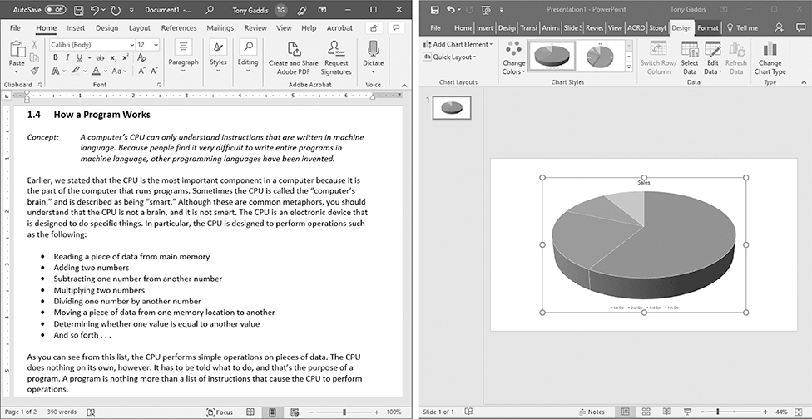

Programs are commonly referred to as [**software**](https://revel-ise.pearson.com/courses/66313f88392f34239b83b04a/pages/urn:pearson:entity:c470fdb5-0c94-4a3f-a2cf-36b374e4d128?source=dashboard). Software is essential to a computer because it controls everything the computer does. All of the software that we use to make our computers useful is created by individuals working as programmers or software developers. A [**programmer**](https://revel-ise.pearson.com/courses/66313f88392f34239b83b04a/pages/urn:pearson:entity:c470fdb5-0c94-4a3f-a2cf-36b374e4d128?source=dashboard), or [**software developer**](https://revel-ise.pearson.com/courses/66313f88392f34239b83b04a/pages/urn:pearson:entity:c470fdb5-0c94-4a3f-a2cf-36b374e4d128?source=dashboard), is a person with the training and skills necessary to design, create, and test computer programs. Computer programming is an exciting and rewarding career. Today, you will find programmers’ work used in business, medicine, government, law enforcement, agriculture, academics, entertainment, and many other fields.

This book introduces you to the fundamental concepts of computer programming using the Python language. The Python language is a good choice for beginners because it is easy to learn and programs can be written quickly using it. Python is also a powerful language, popular with professional software developers. In fact, it has been reported that Python is used by Google, NASA, YouTube, various game companies, the New York Stock Exchange, and many others.

Before we begin exploring the concepts of programming, you need to understand a few basic things about computers and how they work. This chapter will build a solid foundation of knowledge that you will continually rely on as you study computer science. First, we will discuss the physical components of which computers are commonly made. Next, we will look at how computers store data and execute programs. Finally, you will get a quick introduction to the software that you will use to write Python programs.

# Hardware and Software

**CONCEPT:** The physical devices of which a computer is made are referred to as the computer’s hardware. The programs that run on a computer are referred to as software.

## **Hardware**

The term [**hardware**](https://revel-ise.pearson.com/courses/66313f88392f34239b83b04a/pages/urn:pearson:entity:378371f2-3c7e-4e97-9eeb-94ab410a86aa?source=dashboard) refers to all of the physical devices, or [**components**](https://revel-ise.pearson.com/courses/66313f88392f34239b83b04a/pages/urn:pearson:entity:378371f2-3c7e-4e97-9eeb-94ab410a86aa?source=dashboard), of which a computer is made. A computer is not one single device, but a system of devices that all work together. Like the different instruments in a symphony orchestra, each device in a computer plays its own part.

If you have ever shopped for a computer, you’ve probably seen sales literature listing components such as microprocessors, memory, disk drives, video displays, graphics cards, and so on. Unless you already know a lot about computers, or at least have a friend that does, understanding what these different components do might be challenging. As shown in **Figure 1-2**, a typical computer system consists of the following major components:

* The central processing unit (CPU)
* Main memory
* Secondary storage devices
* Input devices
* Output devices

#### Figure 1-2

#### **Typical components of a computer system**

Let’s take a closer look at each of these components.

## **The CPU**

When a computer is performing the tasks that a program tells it to do, we say that the computer is [**running**](https://revel-ise.pearson.com/courses/66313f88392f34239b83b04a/pages/urn:pearson:entity:378371f2-3c7e-4e97-9eeb-94ab410a86aa?source=dashboard) or [**executing**](https://revel-ise.pearson.com/courses/66313f88392f34239b83b04a/pages/urn:pearson:entity:378371f2-3c7e-4e97-9eeb-94ab410a86aa?source=dashboard) the program. The [**central processing unit**](https://revel-ise.pearson.com/courses/66313f88392f34239b83b04a/pages/urn:pearson:entity:378371f2-3c7e-4e97-9eeb-94ab410a86aa?source=dashboard), or [**CPU**](https://revel-ise.pearson.com/courses/66313f88392f34239b83b04a/pages/urn:pearson:entity:378371f2-3c7e-4e97-9eeb-94ab410a86aa?source=dashboard), is the part of a computer that actually runs programs. The CPU is the most important component in a computer because without it, the computer could not run software.

In the earliest computers, CPUs were huge devices made of electrical and mechanical components such as vacuum tubes and switches. **Figure 1-3** shows such a device. The two women in the photo are working with the historic ENIAC computer. The [**ENIAC**](https://revel-ise.pearson.com/courses/66313f88392f34239b83b04a/pages/urn:pearson:entity:378371f2-3c7e-4e97-9eeb-94ab410a86aa?source=dashboard), which is considered by many to be the world’s first programmable electronic computer, was built in 1945 to calculate artillery ballistic tables for the U.S. Army. This machine, which was primarily one big CPU, was 8 feet tall, 100 feet long, and weighed 30 tons

Figure 1-3

#### **The ENIAC computer**

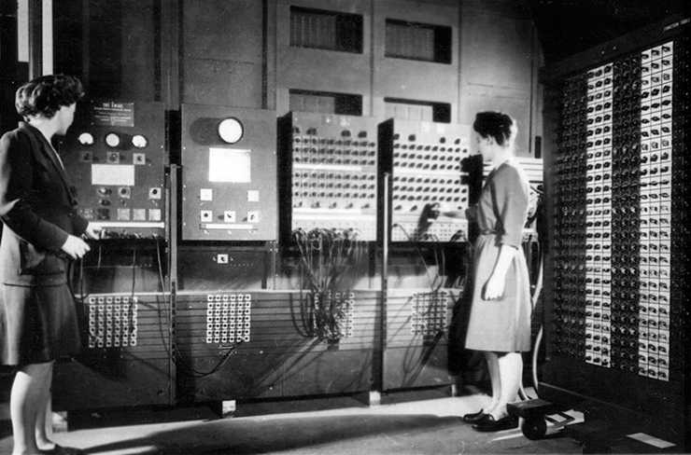

Today, CPUs are small chips known as [**microprocessors**](https://revel-ise.pearson.com/courses/66313f88392f34239b83b04a/pages/urn:pearson:entity:378371f2-3c7e-4e97-9eeb-94ab410a86aa?source=dashboard). **Figure 1-4** shows a photo of a lab technician holding a modern microprocessor. In addition to being much smaller than the old electromechanical CPUs in early computers, microprocessors are also much more powerful.

#### Figure 1-4

#### **A lab technician holds a modern microprocessor**

## **Main Memory**

You can think of [**main memory**](https://revel-ise.pearson.com/courses/66313f88392f34239b83b04a/pages/urn:pearson:entity:8728032a-1e59-4eef-af5d-061d19cfc9d7?source=dashboard) as the computer’s work area. This is where the computer stores a program while the program is running, as well as the data that the program is working with. For example, suppose you are using a word processing program to write an essay for one of your classes. While you do this, both the word processing program and the essay are stored in main memory.

Main memory is commonly known as [**random-access memory**](https://revel-ise.pearson.com/courses/66313f88392f34239b83b04a/pages/urn:pearson:entity:8728032a-1e59-4eef-af5d-061d19cfc9d7?source=dashboard), or [**RAM**](https://revel-ise.pearson.com/courses/66313f88392f34239b83b04a/pages/urn:pearson:entity:8728032a-1e59-4eef-af5d-061d19cfc9d7?source=dashboard). It is called this because the CPU is able to quickly access data stored at any random location in RAM. RAM is usually a [**volatile**](https://revel-ise.pearson.com/courses/66313f88392f34239b83b04a/pages/urn:pearson:entity:8728032a-1e59-4eef-af5d-061d19cfc9d7?source=dashboard) type of memory that is used only for temporary storage while a program is running. When the computer is turned off, the contents of RAM are erased. Inside your computer, RAM is stored in chips, similar to the ones shown in **Figure 1-5**.

#### Figure 1-5

#### **Memory chips**

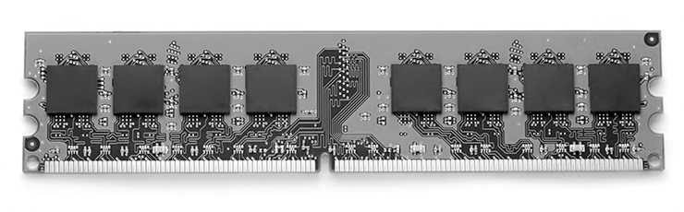

## **Secondary Storage Devices**

[**Secondary storage**](https://revel-ise.pearson.com/courses/66313f88392f34239b83b04a/pages/urn:pearson:entity:8728032a-1e59-4eef-af5d-061d19cfc9d7?source=dashboard) is a type of memory that can hold data for long periods of time, even when there is no power to the computer. Programs are normally stored in secondary memory and loaded into main memory as needed. Important data, such as word processing documents, payroll data, and inventory records, is saved to secondary storage as well.

The most common type of secondary storage device is the [**disk drive**](https://revel-ise.pearson.com/courses/66313f88392f34239b83b04a/pages/urn:pearson:entity:8728032a-1e59-4eef-af5d-061d19cfc9d7?source=dashboard). A traditional disk drive stores data by magnetically encoding it onto a spinning circular disk. [**Solid-state drives**](https://revel-ise.pearson.com/courses/66313f88392f34239b83b04a/pages/urn:pearson:entity:8728032a-1e59-4eef-af5d-061d19cfc9d7?source=dashboard), which store data in solid-state memory, are increasingly becoming popular. A solid-state drive has no moving parts and operates faster than a traditional disk drive. Most computers have some sort of secondary storage device, either a traditional disk drive or a solid-state drive, mounted inside their case. External storage devices, which connect to one of the computer’s communication ports, are also available. External storage devices can be used to create backup copies of important data or to move data to another computer.

In addition to external storage devices, many types of devices have been created for copying data and for moving it to other computers. For example, [**USB drives**](https://revel-ise.pearson.com/courses/66313f88392f34239b83b04a/pages/urn:pearson:entity:8728032a-1e59-4eef-af5d-061d19cfc9d7?source=dashboard) are small devices that plug into the computer’s USB (universal serial bus) port and appear to the system as a disk drive. These drives do not actually contain a disk, however. They store data in a special type of memory known as [**flash memory**](https://revel-ise.pearson.com/courses/66313f88392f34239b83b04a/pages/urn:pearson:entity:8728032a-1e59-4eef-af5d-061d19cfc9d7?source=dashboard). USB drives, which are also known as [**memory sticks**](https://revel-ise.pearson.com/courses/66313f88392f34239b83b04a/pages/urn:pearson:entity:8728032a-1e59-4eef-af5d-061d19cfc9d7?source=dashboard) and [**flash drives**](https://revel-ise.pearson.com/courses/66313f88392f34239b83b04a/pages/urn:pearson:entity:8728032a-1e59-4eef-af5d-061d19cfc9d7?source=dashboard), are inexpensive, reliable, and small enough to be carried in your pocket.

## **Input Devices**

[**Input**](https://revel-ise.pearson.com/courses/66313f88392f34239b83b04a/pages/urn:pearson:entity:8728032a-1e59-4eef-af5d-061d19cfc9d7?source=dashboard) is any data the computer collects from people and from other devices. The component that collects the data and sends it to the computer is called an [**input device**](https://revel-ise.pearson.com/courses/66313f88392f34239b83b04a/pages/urn:pearson:entity:8728032a-1e59-4eef-af5d-061d19cfc9d7?source=dashboard). Common input devices are the keyboard, mouse, touchscreen, scanner, microphone, and digital camera. Disk drives and optical drives can also be considered input devices, because programs and data are retrieved from them and loaded into the computer’s memory.

## **Output Devices**

[**Output**](https://revel-ise.pearson.com/courses/66313f88392f34239b83b04a/pages/urn:pearson:entity:8728032a-1e59-4eef-af5d-061d19cfc9d7?source=dashboard) is any data the computer produces for people or for other devices. It might be a sales report, a list of names, or a graphic image. The data is sent to an [**output device**](https://revel-ise.pearson.com/courses/66313f88392f34239b83b04a/pages/urn:pearson:entity:8728032a-1e59-4eef-af5d-061d19cfc9d7?source=dashboard), which formats and presents it. Common output devices are video displays and printers. Disk drives can also be considered output devices because the system sends data to them in order to be saved.

## **Software**

If a computer is to function, software is not optional. Everything computer does, from the time you turn the power switch on until you shut the system down, is under the control of software. There are two general categories of software: system software and application software. Most computer programs clearly fit into one of these two categories. Let’s take a closer look at each.

## **System Software**

The programs that control and manage the basic operations of a computer are generally referred to as [**system software**](https://revel-ise.pearson.com/courses/66313f88392f34239b83b04a/pages/urn:pearson:entity:cda8d7a3-df60-4736-92a5-5964571d69e2?source=dashboard). System software typically includes the following types of programs:

1. ***Operating Systems*** An [**operating system**](https://revel-ise.pearson.com/courses/66313f88392f34239b83b04a/pages/urn:pearson:entity:cda8d7a3-df60-4736-92a5-5964571d69e2?source=dashboard) is the most fundamental set of programs on a computer. The operating system controls the internal operations of the computer’s hardware, manages all of the devices connected to the computer, allows data to be saved to and retrieved from storage devices, and allows other programs to run on the computer. Popular operating systems for laptop and desktop computers include Windows, macOS, and Linux. Popular operating systems for mobile devices include Android and iOS.
2. ***Utility Programs*** A [**utility program**](https://revel-ise.pearson.com/courses/66313f88392f34239b83b04a/pages/urn:pearson:entity:cda8d7a3-df60-4736-92a5-5964571d69e2?source=dashboard) performs a specialized task that enhances the computer’s operation or safeguards data. Examples of utility programs are virus scanners, file compression programs, and data backup programs.
3. ***Software Development Tools***[**Software development tools**](https://revel-ise.pearson.com/courses/66313f88392f34239b83b04a/pages/urn:pearson:entity:cda8d7a3-df60-4736-92a5-5964571d69e2?source=dashboard) are the programs that programmers use to create, modify, and test software. Assemblers, compilers, and interpreters are examples of programs that fall into this category.

## **Application Software**

Programs that make a computer useful for everyday tasks are known as [**application software**](https://revel-ise.pearson.com/courses/66313f88392f34239b83b04a/pages/urn:pearson:entity:cda8d7a3-df60-4736-92a5-5964571d69e2?source=dashboard). These are the programs that people normally spend most of their time running on their computers. **Figure 1-1**, at the beginning of this chapter, shows screens from two commonly used applications: Microsoft Word, a word processing program, and PowerPoint, a presentation program. Some other examples of application software are spreadsheet programs, email programs, web browsers, and game programs.

# How Computers Store Data

**CONCEPT:** All data that is stored in a computer is converted to sequences of 0s and 1s.

A computer’s memory is divided into tiny storage locations known as [**bytes**](https://revel-ise.pearson.com/courses/66313f88392f34239b83b04a/pages/urn:pearson:entity:6b77196a-1a2f-431a-8e49-1eefb310291e?source=dashboard). One byte is only enough memory to store a letter of the alphabet or a small number. In order to do anything meaningful, a computer has to have lots of bytes. Most computers today have millions, or even billions, of bytes of memory.

Each byte is divided into eight smaller storage locations known as bits. The term [**bit**](https://revel-ise.pearson.com/courses/66313f88392f34239b83b04a/pages/urn:pearson:entity:6b77196a-1a2f-431a-8e49-1eefb310291e?source=dashboard) stands for [**binary digit**](https://revel-ise.pearson.com/courses/66313f88392f34239b83b04a/pages/urn:pearson:entity:6b77196a-1a2f-431a-8e49-1eefb310291e?source=dashboard). Computer scientists usually think of bits as tiny switches that can be either on or off. Bits aren’t actual “switches,” however, at least not in the conventional sense. In most computer systems, bits are tiny electrical components that can hold either a positive or a negative charge. Computer scientists think of a positive charge as a switch in the on position, and a negative charge as a switch in the off position. **Figure 1-6** shows the way that a computer scientist might think of a byte of memory: as a collection of switches that are each flipped to either the on or off position.