Important Note. Please read.

This box contains a delicate Robot made by Quark Robotics Company (Spain/Europe), that will be showed in a conference at the Robotics Group of the University of Bremen (Germany). You could contact there with Dirk Spenneberg (:+49 [421] 218 - 64102)

It is a 6 legs robot with no harmful parts. It contains normal batteries of 6 volts in the middle and the bottom of the robot, that have been conveniently disconnected in order to prevent accidental activations.
There are no pressurized parts. The robot is not affected by normal X-Rays exposure. The robot is used for research on walking methods. This robot only walks. Nothing else.

Please treat it with most care as it is extremely fragile. If it is needed to fully open the robot for in deep check, please follow the next instructions:

- The top part could be taken out by cutting the three small black plastic clamps existing at the corners (“A” part in the picture) and moving up the shell with care.
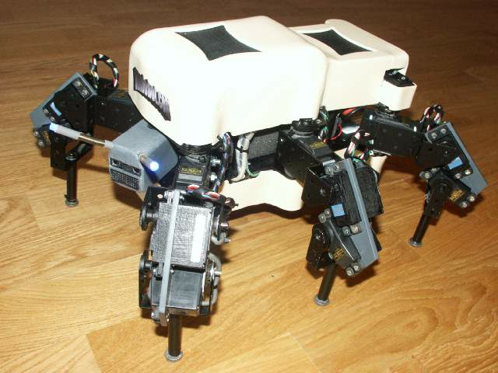

- The bottom part could be opened by putting the robot upside down and unscrewing the four screws at the center of the transparent plastic part.
A

For additional clarification please contact me (Alejandro Alonso. General Manager of Quark Robotics) at cell phone +34-600912305.

Please pack again the robot as secure as possible. It is extremely delicate. Thank you very much.
If it is not possible to contact me via cell phone, please mail me at aap@quarkrobotics.com

