BOUNDARY LAYERS: TRANSITION TO TURBULENCE

3A1b Short Lab Report  
  
Aalok Patwardhan  
Emmanuel College

# Abstract

A hot-wire anemometer was used to measure the velocity and its fluctuations throughout the boundary layer perpendicular to the surface of a flat pate. The anemometer was towards the trailing edge of the plate, allowing the boundary layers to be fully formed whilst taking measurements. Transition of the boundary layer from laminar to turbulent was observed for the smooth plate, then with the addition of a small roughness element, and finally with a leading-edge trip wire. The non-dimensional boundary layer velocity profiles were obtained and plotted, as well as using the provided Causer plot to estimate the skin friction coefficient. The difficulties in measuring velocity fluctuations was noted due to the instrumentation error and randomness.

# Objectives

* Using a hot-wire anemometer and a stethoscope observe the transition from laminar flow to turbulence in a boundary layer on a flat plate in three scenarios: smooth, behind a centre-line isolated roughness element, and behind a two-dimensional roughness trip wire.
* Obtain transition Reynolds numbers for these conditions.
* Measure the turbulent wedge angle forming downstream of the roughness element.
* Measuring mean and turbulent boundary layer profiles at full turbulence.
* Using the mean flow velocity profile to estimate skin friction coefficient.

# Experimental Method

## Hot-wire Calibration

Initially the hot-wire anemometer was calibrated by positioning it in the free stream and running the tunnel at various speeds. For each speed test the corresponding free stream velocity was calculated and the values of the calibration constants A and B were obtained from King's Law which relates measured voltage to the flow speed as in equation 1.

$E^{2}=A+BU^{0.5}$ (1)

The values for A and B were found to be 0.1037 and 0.8126 respectively.

## Observation of Transition

It is to be noted that for each test (smooth plate, roughness element, trip wire) the Reynolds number was calculated based on air at standard atmospheric conditions and the length parameter D set to be the distance from the leading edge to the anemometer (1.14m).

### Smooth Plate

From Appendix B it is seen that transition occurred at a critical Reynolds number of 5.02x105. Below this critical number the boundary layer was fully laminar, and at this Re turbulent spots started to form. The duration of these turbulent patches was around 30ms from the corresponding figure in Appendix B and by multiplying this time by the boundary layer velocity obtained from King's Law (6.43ms-1) a length of 19.3cm was calculated as the length of the spots. It must be noted that due to the random nature of the turbulent spots and the element of chance in capturing these spots with the data logger the result from the figure is not very reliable on its own.

Full turbulence as shown in Appendix B was achieved at a Reynolds number of 8.19x105.

### Roughness Element

A small screw roughness element was placed near the leading edge on the centre-line, and the hot-wire anemometer signal at various flow speeds was again recorded. The boundary layer was observed to start transitioning into turbulence at Re = 2.79x105 and full turbulence was seen at Re = 4.03x105. This is shown in Appendix C .It must be noted that during these tests the manometer was fluctuating greatly at the low pressures, and a 10% error from the manometer readings should be taken into account.

Using the method in section 2.2.1, the approximate turbulent patch length was calculated to be (80ms * 3.57ms-1 =) 28.6cm - a higher value than for the smooth plate.

A stethoscope was moved span wise across the plate, and by listening to the sound of the flow approximate regions could be deduced for laminar-transition, and transition-turbulent region boundaries. This measurement was carried out 212mm from the leading edge, and again at 603mm. This is more clearly shown in figure 1. The more reliable results for calculating the half wedge angle was at the second measurement location as the span wise length of the regions was larger. Half wedge angles of 6º and 8º were calculated for the laminar-transition and transition-turbulent regions respectively. Due to the measuring device having a resolution of 1cm, the calculated angles are left here to the nearest degree.

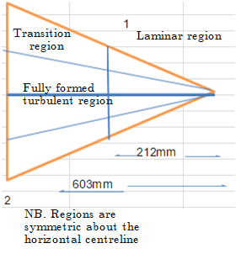

Figure 1

### Trip Wire

The screw element was removed and a trip wire was placed span wise near the leading edge, and the experiment repeated. Appendix D shows the anemometer measurements.

It can be seen that even at low speeds (Re = 2.78x105) the boundary layer was almost fully turbulent. This shows that the trip wire is working effectively, tripping the oncoming flow into turbulence close to the leading edge. The flow is therefore fully developed by the time it reaches the anemometer at the trailing edge.

# Discussion

## Velocity Profile

The mean velocity was non-dimensionalised into a mean velocity ratio $\frac{\overline{U(y)}}{\overline{U_{1}}}$ where $\overline{U\left(y\right)}$ is the velocity at height y, and $\overline{U_{1}}$ is the free stream velocity. This can be seen in figure 2. The profile is as expected for a turbulent boundary layer, with a steep velocity gradient near the surface reflecting on the no-slip condition.

The points were also plotted on the Causer plot given in the handout and in Appendix A, and the linear region provided an estimate of the skin friction coefficient Cf to be 0.0045. From this a friction velocity U* was calculated to be 1.993ms-1 where U* = $\sqrt{\frac{1}{2}C_{f}{\overline{U_{1}}}^{2}}$.

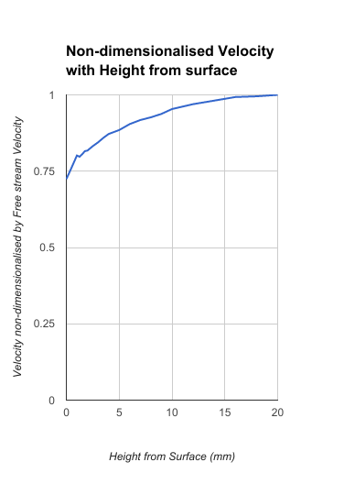

Figure 2

## Velocity Fluctuation

RMS values of the velocity fluctuations were plotted against height from the plate surface, and plotted. The fluctuation velocities $\overline{U^{'2}}$ were non-dimensionalised by $\overline{U}$ and $\overline{U_{*}}$ as shown in figure 3. The RMS values fluctuated greatly and it was difficult to get reliable values. This procedure could be improved by incorporating some type of time-averaging. The velocity was seen to fluctuate the most closer to the surface of the plate. This was due to the creation of small eddies and turbulent spots which is a random phenomenon.

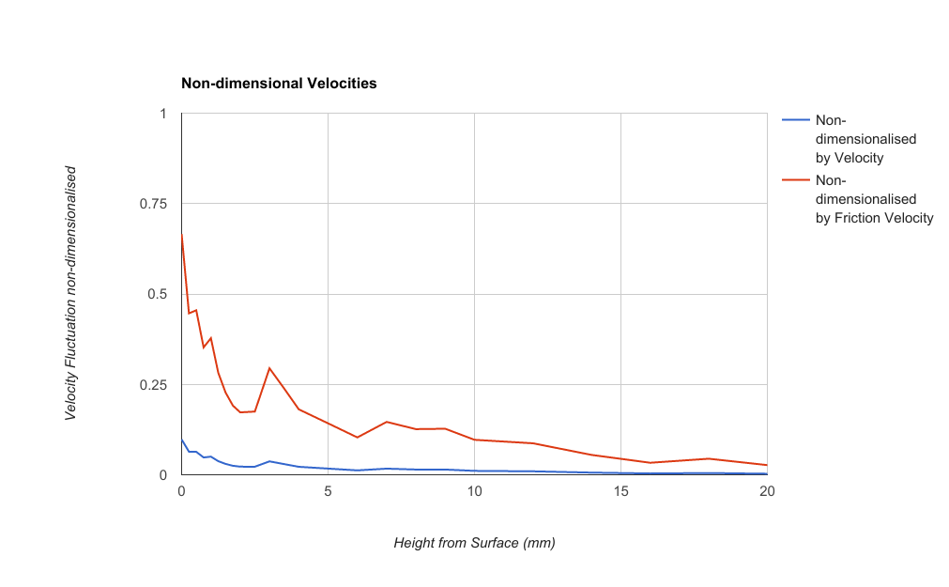

Figure 3

# Conclusion

Small roughness elements can greatly alter the critical Reynolds number at which boundary layers transition from. These roughness elements cause turbulent wedge shapes to form on the surface in which regions of laminar, transitioning and turbulent flow can be empirically observed.

The use of a trip wire causes the boundary layer over the whole plate to become turbulent for a large range of flow velocities.

A turbulent boundary layer has a fuller velocity profile than a laminar boundary layer due to the formation of eddies in the turbulent flow. This profile can be used to calculate the friction coefficient using a Causer plot.

It is difficult to measure velocity fluctuations accurately due to the randomness of the fluctuations, but there is a peak in velocity fluctuation at a point in the boundary layer.

The velocity was observed to fluctuate greatly closer to the surface.