FULL TECHNICAL REPORT:  
3A3 PUMP EXPERIMENT

Aalok Patwardhan  
Emmanuel College

# Abstract

In this experiment two identical pumps were tested with two operating liquids: water and a glycerine solution. For each pump, using a throttle at inlet and outlet to the pump the flow rate was varied and the resulting pressure rise across the pump was measured. Cavitation was seen to occur for the water test at full speed whilst throttling at the inlet. This phenomenon and its importance in the engineering world is investigated further in this report. Performance factors were non-dimensionalised to summarise results in the form of pressure rise and cavitation number. Pumps were seen to perform better at lower flow rates and Reynolds numbers. Finally the merits of axial versus centrifugal compressors were discussed.

# Introduction

Two nominally identical pumps were tested. One used pure water as its operating fluid and the other used a 60%-40% Glycerine-Water solution. The glycerine solution pump was kept running at a constant rotational speed whereas for the water pump the impeller speed and throttle opening was varied throughout the experiment.

## Method

For the water pump, the fluid was throttled at the outlet at full speed (roughly 49.5Hz) and then the process was repeated for half speed. The experiment was performed again but this time the inlet to the pump was throttled. Finally the glycerine pump was tested keeping the speed at roughly 49.5Hz whilst throttling the outlet.

Using equation 1 calibrated mass flow rate was obtained. The flow rates Q and the pressure rises across the pump were calculated and measured, and non-dimensionalised as in equations 2 and 3 where N and D are the rotational speed and diameter of the impeller respectively. Graphs for all five tests are given in Appendix A.

$\dot{m}=0.193\sqrt{Δp_{vent}}$ (1)

$C_{Q}=\frac{Q}{ND^{3}}$ (2)

$C_{p}=\frac{Δp}{ρN^{2}D^{2}}$ (3)

## Determination of Viscosity ratio

Dynamic viscosity is proportional to 𝑇𝜌/L where T is the time taken for a given volume to pass down the tube, 𝜌 is the density of the liquid and L is the length of the tube. The ratio $\frac{ρ_{Glycerine}}{ρ_{Water}}$

was calculated to be 12.94, and is tabulated in Table 1.

|  |  |  |  |  |
| --- | --- | --- | --- | --- |
|  | **Time to drop 4cm, T (s)** | **Length of Tube L (m)** | **Fluid Density (kg/m3)** | **Ratio of viscosities** |
| **Water** | 33 | 10 | 1000 |  |
| **Glycerine Solution** | 73 | 2 | 1170 | **12.94** |

Table 1: Calculating ratio of densities

# Analysis

## Impeller vanes

Table 2 shows the measured values for inlet and outlet angles and radii of the impeller vanes, as well as the height of the blades. The angles were estimated using a protractor and this could be a source of errors.

|  |  |  |  |
| --- | --- | --- | --- |
|  | **Radius (m)** | **Angle (⁰)** | **Height (m)** |
| **Inlet Vane** | 0.013 | 59 | 0.0045 |
| **Outlet Vane** | 0.039 | 46 | 0.0045 |

Table 2: Impeller dimensions

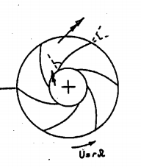The rotor rotates anti-clockwise, doing work on the fluid so that its angular momentum about the centre of the rotor increases. The convex surface of each vane exerts a torque on the fluid and so the fluid exerts a torque on this surface too due to Newton's third law. High pressure thus results on the convex surface. This is shown in Figure 1.

Pressure surface

Outlet flow direction

Inlet flow direction

Suction surface

Figure 1: Impeller sketch

## Pump Reynolds Number

The radial velocity at inlet to the vane at maximum flow condition was found by using a mass flow rate of 1.0969kgm-3 and impeller dimensions, and had a value of Vr,in=2.98ms-1. Since the tangential velocity was U = N x rin = 3.99ms-1, the velocity triangle in figure 2 shows that the relative velocity at the inlet to the vane is Vrel = 4.98ms-1. Thus the Reynolds number based on this velocity and the impeller inlet diameter was calculated to be:

$Re=1.29×{10}^{5}$.

Utangential

Vr,in Wrel

Figure 2: Velocity triangle

# Cavitation

## Dimensionless Cavitation Number

When the local static pressure Pin decreases to below the saturation vapour pressure Pv cavitation can be seen to occur. The cavitation pressure can be non-dimensionalised as in equation 4.

$C_{cav}=\frac{p_{in}- p_{v}}{ρN^{2}D^{2}}$ (4)

Cavitation should occur when the above value falls below zero but our measured values of Pin are larger than Pv because other factors such as pressure losses due to friction are not taken into account. We have also assumed that the temperature and therefore Pv,sat has stayed the same throughout the experiment which is not the case.

An estimate for the inlet pressure Pin was obtained and with the knowledge that the discharge was at atmospheric pressure, and taking into consideration the loss in pressure head between the discharge and the pump delivery, dimensionless cavitation pressure was plotted. This is shown in Appendix A.

For the full speed cases Ccav was much lower than for the half speed experiments. This is because the rotational speed N is much larger for the same Pin. In general the inlet cases had a lower PCav than the outlet throttling cases.

There was a drop in pressure as the inlet was throttled, and cavitation started roughly when the pressure drop was around 67kPa, corresponding to a Ccav less than 0.058. Small vapour bubbles were forming and then bursting quickly initially. As the pressure drop decreased further, large bubbles and splashing was observed near the leading edge of the impeller blades. This is shown in figure 3.

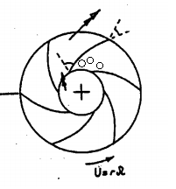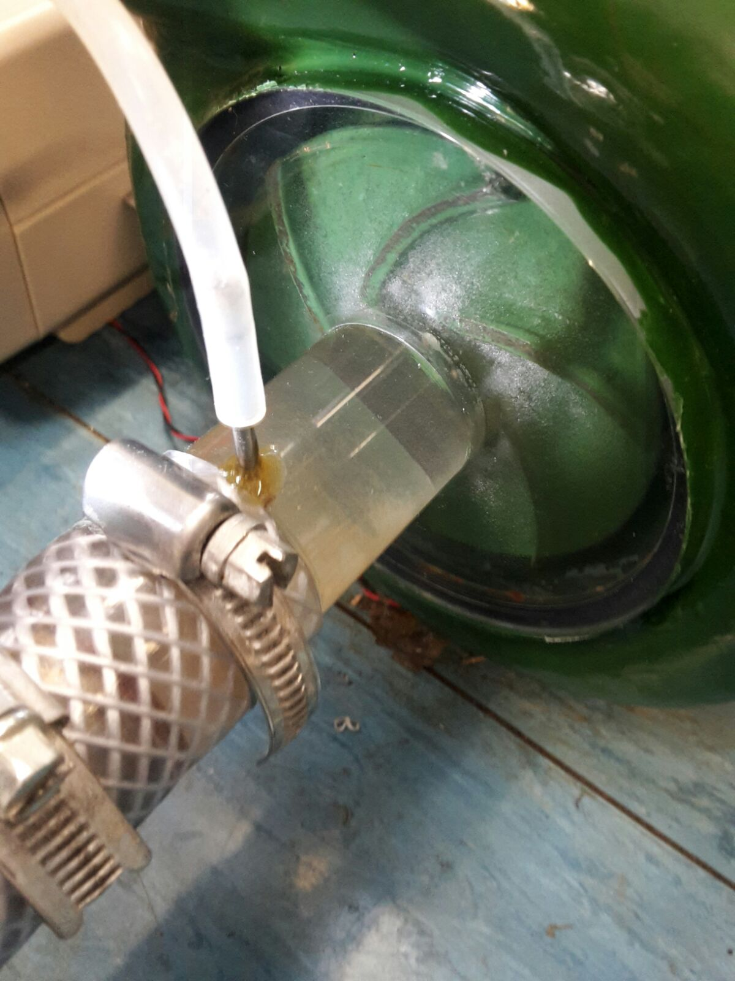

Figure 3: Cavitation observed and sketched

Static pressure increases as the flow diverges from inlet to exit because the velocity relative to the impeller decreases. This is discussed in section 4.3. However the pressure also increases as the flow moves through the rotating impeller and the radius increases, therefore the lowest pressure must be at the impeller blade leading edge. This is corroborated by the streamline curvature as the flow goes from axial to radial sharply.

## Practical Issues with Cavitation

There are many types of cavitation that exist and some of the main types will be discussed here.[1]

### Suction cavitation in pumps

If the pump is operating under low pressure, vaporisation of liquid occurs at the impeller inlet. The bubbles move with the fluid to the discharge side of the pump where the bubbles are compressed back into liquid. This happens relatively fast and violently, and material is sometimes removed from the surface and can also lead to bearing failure. This can be seen for example in power steering where clogged hydraulic filters can cause suction cavitation.

### Discharge cavitation in pumps

If the pressure at pump discharge is very high, most of the fluid circulates inside the pump without flowing out. The high velocities of fluid at the pump housing-wall surface create a vaccuum at the housing wall, forming bubbles. Material can be removed around the impeller vane tips due to erosion. It is thought that the sound of cracking your knuckles is due to this type of cavitation.[2]

### Sheet cavitation

This is a region of vapour which remains attached in roughly the same position to the impeller blade. It can be seen on ship propellers as in figure 4.

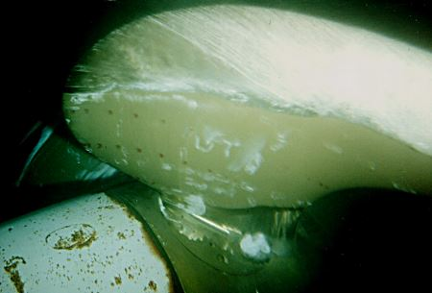

Figure 4: Sheet caviation on a ship propeller[3]

### Vortex cavitation

Although this type of cavitation is not relatively corrosive, it is a source of noise which has a lot of importance in defence applications for detecting ships. Figure 5 shows an example of this form of cavitation.[4]

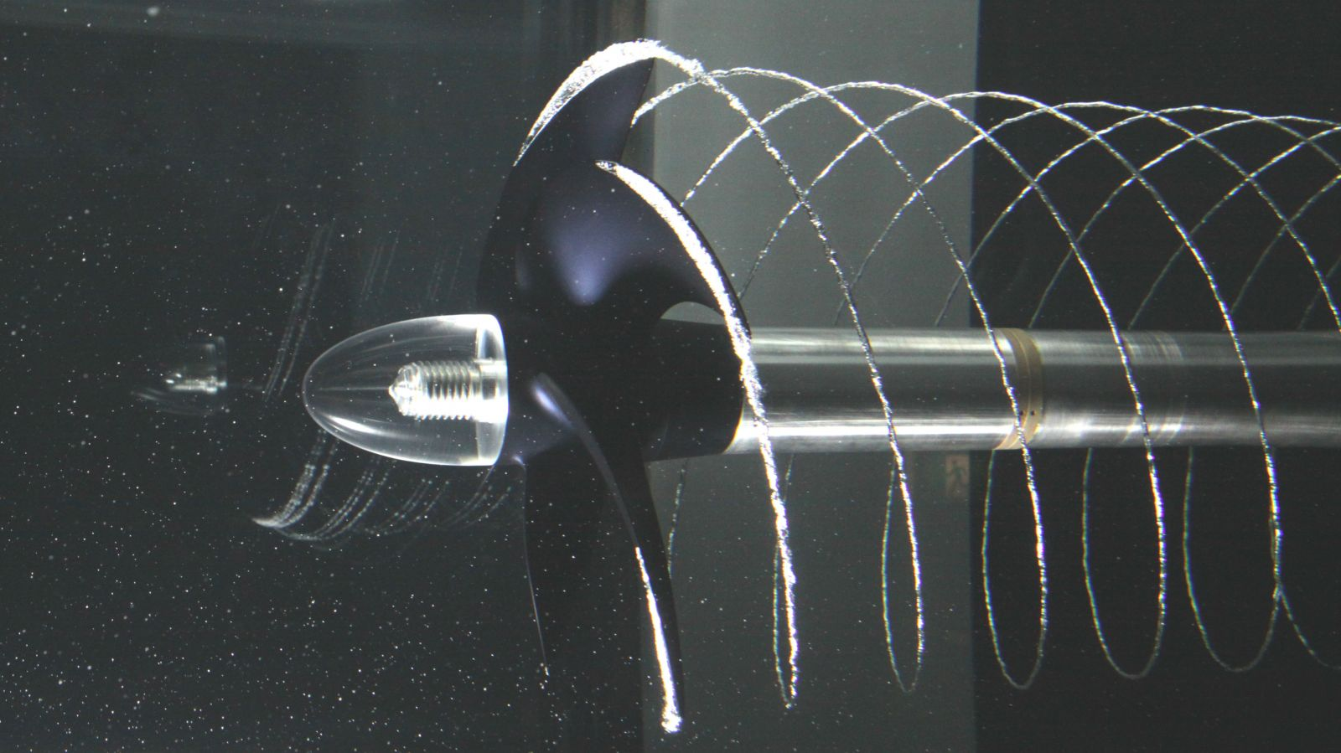

Figure 5: Vortex Cavitation from a propeller[5]

### 

In this experiment the most likely form of cavitation is predominantly suction cavitation. One possible way of veryfing this would be to run the pump continuously for an extended period of time, and then test the impeller through a non-invasive method such as ultrasonic testing. Suction cavitation would show symptoms of erosion present near the inlet (eye) of the impeller. The presence of erosion evenly distributed along the impeller blades would indicate the presence of sheet cavitation.

### 

If the pump is throttled at inlet and cavitation is observed in the throttling tap, this can have adverse implications for the cavitation in the pump as the flow rate is effectively reduced further. From the graph in Appendix B generally cavitation number decreases with a decreasing flow rate and so cavitation is more likely. However it is possible to throttle the pump at inlet without cavitation occurring at the throttle by ensuring the pressure at pump inlet is as large as possible. The pipe length between throttling tap and pump inlet could be made as short and diametrically wide as possible to reduce pressure losses, or the inlet water reservoir could be pressurised. Alternatively the temperature of the water could be increased so as to increase the saturation vapour pressure of the fluid.

# Discussion

## Performance Curves

The graphs for the five tests are presented in Appendix B. It can be seen that the pressure rise increases as the flow rate decreases. For all four operating conditions, the pump exhibited similar behaviour. Cavitation can be inferred from the full speed inlet throttled experiment, as the non-dimensional pressure decreases significantly.

## Differences in Results (Inlet v Outlet Throttling)

Since the pressure rises across the pump, the inlet pressure is much lower than the outlet pressure. Throttling the inlet can therefore cause cavitation because the local static pressure reduces to less than the saturation vapour pressure.

Although throttling the outlet also causes decreases in pressure, cavitation should not occur due to the increase in pressure across the pump.

## Comparison of Results with Expectations

The pump increases the pressure of the fluid by doing work on it by using the rotational kinetic energy of the impeller. If flow rate increases keeping all else equal, the pressure rise is less, since there is less work done per unit volume.

Cavitation increased with increasing rotation speed. Pin was decreased when inlet flow velocity was increased leading to cavitation. If the flow rate reduces, then all else being equal, only the radial flow velocity component decreases - the tangential component is unchanged. This leads to the inlet angle of the flow to be decreased, as is shown in figure 6.

Utangential Utangential

Vr,in Vr,in

Wrel Wrel

Figure 6: Velocity triangles for nominal operation (left) and for reduced flow rate (right)

Figure 7 taken from the lab experiment handout shows friction factor against Reynolds number Re for different values of roughness. To estimate roughness, a crude measurement was taken by ruler and a relative roughness factor of $\frac{k}{d}=0.05$ was calculated. The figure only shows a maximum roughness factor of 0.0333, and this is the value used for dicussion here. The Reynolds number for the Glycerine solution was $\sim 1.0×{10}^{4}$. This is in the transition region of figure 7 and the friction factor varies with Re. For the water experiment Re was determined to be $\sim 1.3×{10}^{5}$ corresponding to well within the rough region. Here friction factor was entirely independent of Re. If the friction factor is large for some flow then more energy is dissipated resulting in a smaller pressure rise. This matches with the results where the pressure rise for Glycerine was larger than that of water.

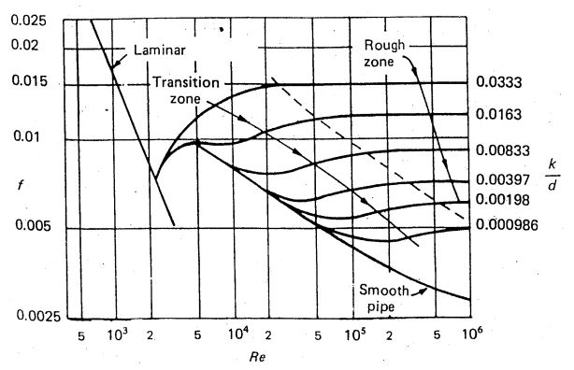

Figure 7: Graph comparing friction factor, Re, and roughness number[6]

## Venturi

A venturi constricts flow and thus accelerates it, and the resulting change in pressure can be used to determine mass flow rate. The Reynolds number for the glycerine solution is much lower than that of water due to the higher viscosity of the solution. Calculations for mass flow rate assume inviscid fluid, but this is not the case for the Glycerine solution. From the momentum integral equation it can be induced that the friction factor for glycerine solution is therefore smaller than for water. This leads to the solution having a greater pressure rise for a given fluid flow rate than water.

# Centrifugal v Axial Compessors

There are advantages and disadvantages to using either type of compressor, and the selection must be made based on the requirements of the application.

In the manufacturing industry, centrifugal compressors are preferred over axial compressors in pneumatic tools. For this application, the desired rotational speed may vary and a relatively large change in pressure per stage may be required. Centrifugal compressors have good efficiency over a large range of rotational speeds and are simple to manufacture. This means that the cost of production is relatively small too. These compressors are also preferred over axials due to their attribute of having a low starting power.

Some disadvantages of centrifugal compressors are that they have a large frontal area[7] which may be unwanted in some applications and they are impractical if more than two stages are used due to some losses in turns between the stages.

In the jet industry, axial compressors are preferred over centrifugals.[8] As well as having a high peak efficiency, axial compressors can have more stages giving increased pressure rise without significant losses. They are preferred in aircraft applications as they have a smaller frontal area than an equivalent centrifugal compressor producing the same thrust and this is essential due to the face that if the engine is too close to the ground then debris will get ingested.  
However axial compressors are heavy, more complex in terms of manufacturing and only maintain good efficiency over a small range of rotational speeds. Although production costs are higher for axial than for centrifugal compressors, this is fine in the applications they are found in.

# Conclusion

In a centrifugal pump there is a pressure difference across the two sides of each impeller vane. The phenomenon of suction cavitation can occur in these pumps, and was seen when the local pressure falls below the saturation vapour pressure. In general the pump operates better in terms of producing a greater pressure rise at lower flow rates and also at lower Reynolds numbers. This was seen with the glycerine solution. Venturis although useful for measuring flow rate of inviscid fluids are not suitable for viscous cases. Cavitation occurs in many engineering applications and care must be taken to avoid its harmful consequences. Finally both axial and centrifugal compressors have merits and disadvantages, and are suited to different applications.

# Appendix APlot 3 (1).pngAppendix B

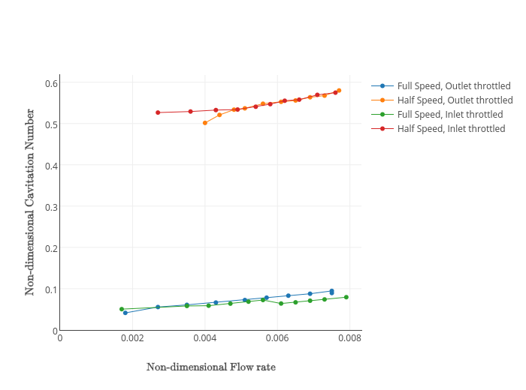

1. https://neutrium.net/equipment/pump-cavitation/
2. Kawchuk et al. (2015). "Real-Time Visualization of Joint Cavitation"
3. https://ocw.tudelft.nl/wp-content/uploads/Chapter_6.pdf
4. R.K.Turton. Principles of Turbomachinery. CUED Reading List
5. http://maritime-executive.com/media/images/article/Photos/Machinery
6. 3A3 Pump Experiment handout
7. KING, W. (1945), "AXIAL vs CENTRIFUGAL SUPERCHARGERS for Aircraft Engines,"
8. https://www.grc.nasa.gov/www/k-12/airplane/caxial.html