Derivation of Von Karman Integral Momentum Equation

We start with continuity: 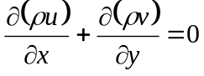
Multiply this by edge velocity u_{e}(x). Integrate by parts.

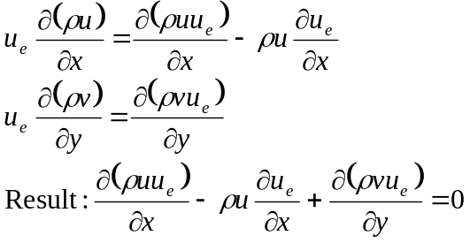
(1)
Subtract from this the u-momentum equation:
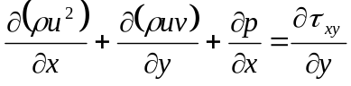
(2)
Use also the Euler equation: ρVdV+dp=0 which gives at boundary layer edge
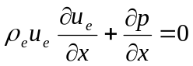
(3)
Result after some minor rearranging:
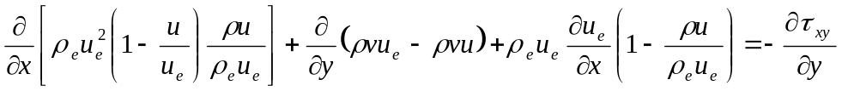
(4)
Integrate equation (4) from y=0 to y=δ.

Use definitions of displacement thickness and momentum thickness. Second term goes to zero, since v=- at wall, and u=u_{e} at the edge. We get:
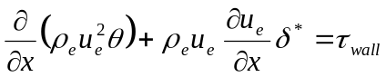
(5)
Equation (5) works for laminar and turbulent, compressible and incompressible flows.
Expand first term. Simplify this for incompressible flows, by assuming ρ=ρ_{e} is constant.
We use ordinary derivatives from now on, since there are no derivatives with respect to y left.
We get:
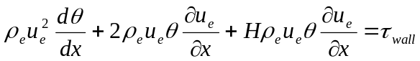

Divide thru’ by 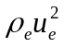 We get
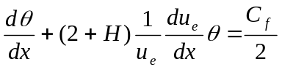 (6)

