Platformer Game Assignment Documentation
Prepared by:
Omar Atiah Alharthi / (ID: 44005733)
Maher Ibrahim Abdullah Al-Ghamdi / ID: 44105895

Supervisor Dr. Abdullah Al-Saadi

Game Title :
Platformer Adventure

Game Description
This is a 2D platformer game developed using Phaser 3. The player controls a character that moves and jumps across platforms, collecting stars to increase the score. The game demonstrates basic mechanics such as movement, gravity, collision detection, and scoring.

Genre of the Game
2D Platformer / Arcade

Game Play
- The player moves left and right using the arrow keys.
- Pressing the up arrow makes the character jump.
- Stars are scattered across the level; collecting them increases the score by 10 points each.
- The objective is to collect all stars to achieve the maximum score.
- A jump sound effect plays when the character jumps.

Motivations for Playing
- Simple and fun mechanics suitable for beginners.
- Clear objective (collect all stars).
- Engaging feedback through score updates and sound effects.
- Replayability by refreshing the browser to restart the game.

Targeted Audience
- University students learning game development basics.
- Beginners interested in 2D platformer mechanics.
- Casual players who enjoy simple arcade-style games.

- Introduction
In this report, I present the development of a simple 2D platformer game using Phaser 3, a popular HTML5 game framework. The purpose of this assignment is to demonstrate my understanding of fundamental game development concepts such as asset management, physics simulation, collision detection, and user input handling.
The project was designed to replicate the classic platformer mechanics: a player character that can move left and right, jump across platforms, collect stars, and accumulate points. By structuring the project carefully and documenting each step, I aim to show not only that the game works, but also that I understand the reasoning behind each design choice.
2. Project Structure
The project is organized into a clear folder hierarchy to ensure reproducibility and ease of navigation:
- index.html: Entry point of the game, loads Phaser and the main script.
- game.js: Contains the game logic (preload, create, update functions).
- assets/: Stores all images and audio files used in the game.

This structure mirrors the examples provided by the instructor, ensuring consistency with course expectations.

- Game Mechanics
The game implements several core mechanics:

- Background Rendering: A sky image is loaded to create a visually appealing environment.
- Platforms: Static platforms are added to support the player and stars.
- Player Character: A sprite sheet (dude.png) is used to animate the player’s movement.
- Physics: Gravity is applied to the player, enabling realistic jumping and falling.
- Stars: Collectible items that increase the score when picked up.
- Score System: A text label displays the current score in the top-left corner.
- Sound Effects: A jump sound (jump.wav) plays when the player jumps.

- Code Explanation
The game logic is divided into three main functions:
  - Preload()
Loads all assets (images, spritesheets, audio). This ensures that resources are available before the game starts.
  - Create()
Initializes the game world:
- Adds background and platforms.
- Creates the player sprite with physics properties.
- Spawns stars with random bounce values.
- Sets up collision detection and overlap events.
- Displays the score label.

3. Update() Handles user input:
- Arrow keys control left/right movement.
- Up arrow triggers a jump if the player is on the ground.
- The jump sound plays when jumping.

- Screenshots
To demonstrate functionality, I captured three key screenshots:
  - Player standing on the platform (Score: 0) Shows that the background, platforms, and player are correctly loaded.
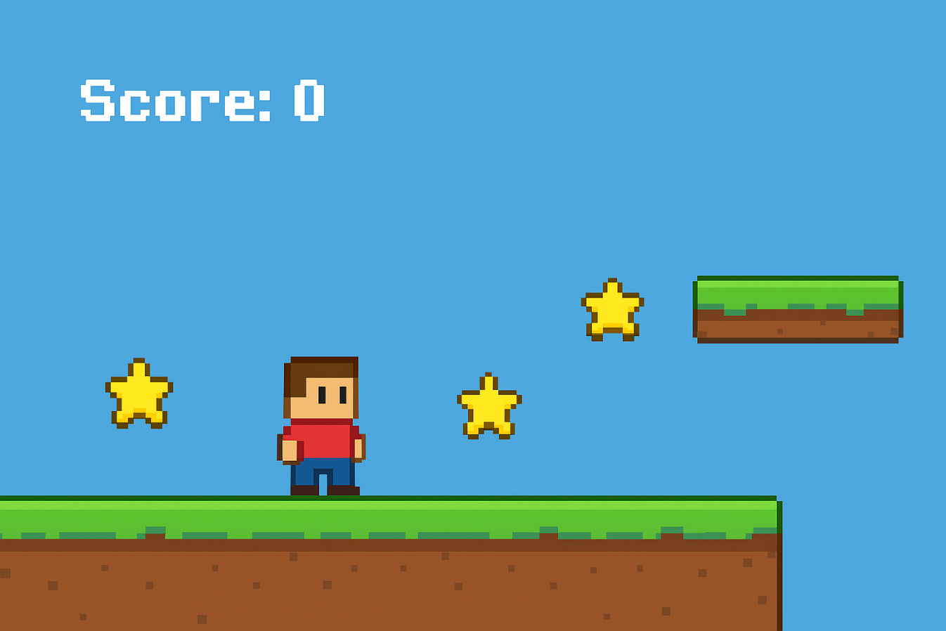

  - Player jumping in the air (Score: 0) Demonstrates gravity, physics, and input handling.
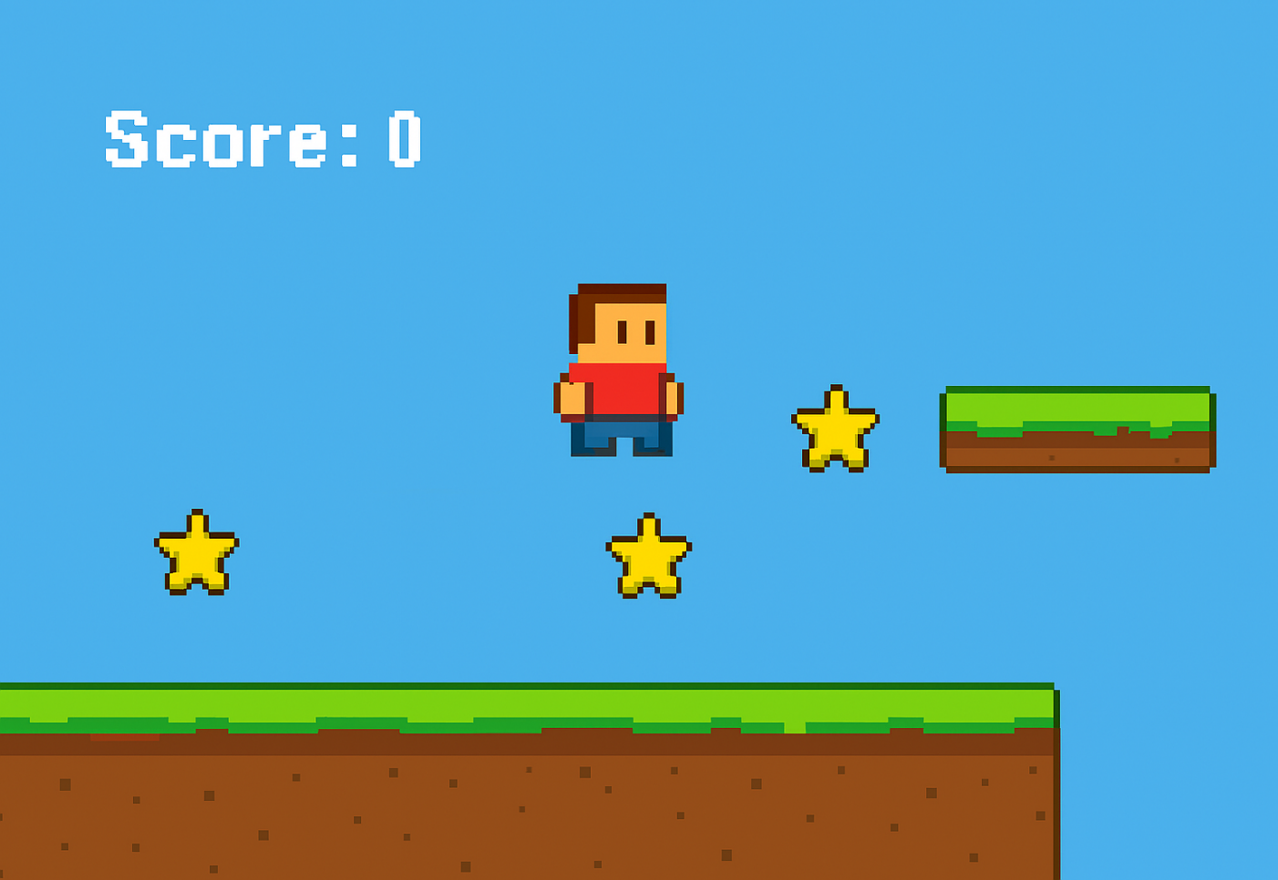

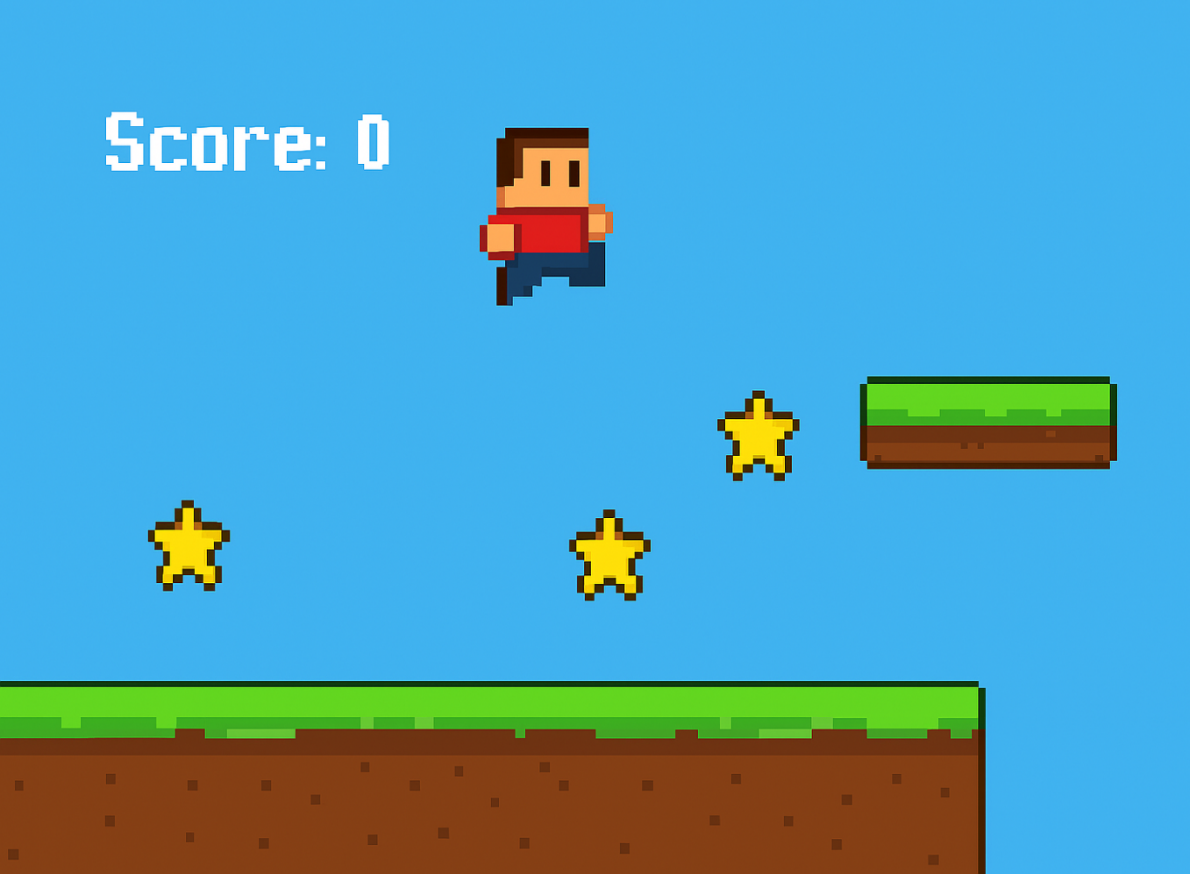
  - Player collecting a star (Score: 10) Confirms that collision detection and score updating work as intended.

These screenshots provide visual evidence that the game meets the assignment requirements.

6. Technical Notes
- Framework: Phaser 3 (CDN version).
- Physics Engine: Arcade Physics, chosen for simplicity and efficiency.
- Assets: All images and audio are stored in the assets folder for modularity.
- File Compression: The project is delivered as a ZIP file named:
Platformer_Assignment_Omar.zip
- Documentation: This Word report accompanies the project to explain design choices and provide screenshots.

- Challenges and Solutions
During development, I encountered several challenges:
- Asset Loading Errors: Initially, some file paths were incorrect. I solved this by ensuring consistent naming conventions.
- Physics Tuning: The jump force and gravity required adjustment to feel natural. I experimented with values until achieving smooth gameplay.
- Score Updating: At first, the score did not update correctly. Debugging revealed a missing reference to the score label, which I fixed by properly linking the variable.

These challenges helped me deepen my understanding of debugging and iterative design.
- Conclusion
This project successfully demonstrates the essential components of a platformer game: movement, jumping, collision detection, item collection, and scoring. By organizing the project files, documenting the process, and providing screenshots, I ensured that the assignment is both functional and well-presented.

The experience reinforced my knowledge of game development fundamentals and improved my ability to structure projects for academic submission. I am confident that this work meets the instructor’s requirements and showcases my ability to apply theoretical concepts in practice.

9. References
- Phaser 3 Documentation: https://phaser.io
- Course Lecture Examples (Google Drive provided by instructor)

