**University Of Engineering And Technology**



**Weather Forecast Project in Python**

**Group Members:**

1. Altamash Zaheer 2021-CE-49
2. Abdul Basit 2021-CE-50
3. Mohsin Qais 2021-CE-96
4. Talal Muzammal 2021-CE-47

**Submitted To*:***

Raja Muzammal Muneer

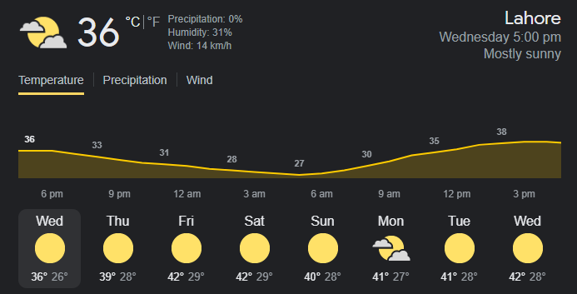

## **Abstract:**

This weather forecast project is a basic python project that aims to predict weather’s details of a region in order to show.

* Wind (it gives the blowing rate of air in KPH)
* Temperature (it will show temperature in Centigrade)
* Humidity (a quantity representing the amount of water vapors in the atmosphere or in a gas)
* Pressure
* Description (overcast clouds)

## **Objective:**

1. This project will provide us with the critical knowledge of python programing.
2. This is a fully functional GUI base project developed in python that covers all of the features that an IT student needs to make a weather forecasting application
3. We will become familiar to interact with Graphical interface within python
4. It will provide practical experience and understanding by working on different projects.

## **Socio and Economic Benefits:**

1. It provides information to the people and organization to reduce weather related loses and to ensure health, safety and quality of life.
2. Aircraft and shipping rely heavily on accurate weather forecasting.
3. People can make smart choices about when and where to go on vacation.
4. Sensors will be placed in two different places in river so that pollution comparison can be made.
5. Farmers can be known when to plant or harvest crops.
6. Regions can be evacuated if typhons and floods are excepted.

## **Tools and Software:**

Visual Studio Code (VS Code)

**References:**

* Code with Harry (You Tube)
* Parvat Computer Technology (You Tube)
* Towards Data Science (Website)