- Welcome to Virtual Maint System for Rigging of Main Rotor of ALH.
- Project By Maj AS Yadav, Maj Siddhesh Kumbhar, Capt Premlata
- Directing Staff Maj Rahul Samyal

- Introduction :
Rigging in ALH means correlating the cockpit control travels to the actuator strokes and further to the blades angle.
It consists of lower and upper control rigging.

- Requirement of Rigging
- Change of any major component (e.g. MGB, MR blades, actuators, etc.)
- When vibration out of control
- On recommendation of EO/OC

- Applicable documents
Maintenance Manual WCs 08.00.00.201 and 67.10.00.508

- Tools Required

a. Hydraulic Trolley ALH 13501
b. Rigging Fixture ALH-SK-TP-110 (for adjusting the swinging arm with clinometer)
c. Rigging Tool ALH—9504
d. Rigging Fixture ALH-T-2368-Pilot/ALH-T-2358-Co-Pilot (Fixture for measuring the Pilot's & Co-Pilot's collective stick angular travel)
e. Rigging Fixture ALH-9702 (To set Cyclic stick fore and aft and left and right positions).
f. Tool No. ALH-1244 ( Tool to locate the dial guage near main rotor actuators on the cabin roof)
g. Rigging Tools ALH-FCS-129 -2 nos. & ALH-FCS-130 - 2 nos. (Tools to adjust the control rods eye and fork end orientation)
h. ALH-SK-H-507 (To facilitate measurement of Main Rotor Actuator Piston travel)
j. ALH-SK-H-493 (To set Lever orientation of the Vibration Isolation System)
k. Clinometer 015-Plus-XG 45
l. Dial gauge
m. Depth gauge
n. Force Guage LG 100N (Range 0-100 N)

- Rigging of Lower Flight Control System

  - Tools on side table with caption
  - Procedure
  - Pre-condition
    - Helicopter to be levelled.
    - Place the jacks at the designated position
    - Place clinometer at designated position
    - Press ‘LEVEL’ to level the aircraft
    - Ladder and platform appears
    - Engage the rigging pin tool on to the lever assy as depicted to make swinging arm perpendicular to helicopter floor to the required accuracy by adjusting the fwd control rod.

- Procedure

  - Adjustment of collective and cyclic stick travel.
  - Pre-condition – Disconnect the trim actuator & control rod from the CSAS actuator.

  - For collective stick

    - Place the tool No ALH 9504 at the designated loc to set the pilot stick ref at the lower most position (i.e. 314 +/- 2 mm from floor ref line) by adjusting the low pitch stop nut.
    - Place clinometer fixture on collective stick. With the help of clinometer ensure the uppermost position of collective 27.7 degree +/- by adjusting high pitch stop nut.

  - For Cyclic Stick

    - Place the clinometer fixture on cyclic stick at designated loc to place in neutral position also check CNI indicator.
    - By using clinometer ensure the cyclic stick lateral & longitudinal travel as shown in fig by adjusting the stopper nuts.

  - Measurement of Piston Stroke

    - Pre-condition - Disconnect trim actuator & control rod from actuator input lever end.
    - Measure the piston stroke with the help of depth gauge on all three actuators and ensure the piston stroke as shown.
    - Now connect the control rods to the actuator input lever and again measure the stroke of three actuators to ensure the values as shown.

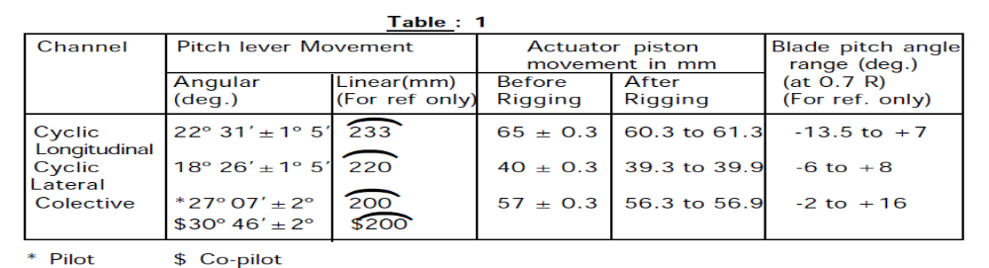

  - Now measure of the piston cushion.

    - Disconnect control rods.
    - Measure the piston strokes at fully fwd posn & full rearward posn.
    - Connect the control rod.
    - Measure the piston stroke at fully fwd posn & full rearward posn for piston cushion = Fully fwd / rearward posn with control rods – Fully fwd / rearward posn without control rods.
    - Piston cushion should be between 0.2 to 0.4 mm.

- Rigging of Upper Controls

- Tools required

- Pre-conditions
  - Main rotor head levelling with the help of jacks.
  - Cyclic locked with tool ALH 9646.

- Procedure
  - Place protractor on MGB casing and insert pointer in main bolt of yellow blade and set blade at zero degrees.
  - Place ‘L’ plate near spoon and clinometer near collar of all four blades.
  - Measured angle at both the places to be same.
  - If not, adjust by placing paper shims under clinometer fixtures.
  - Move collective fully down and measure blade angle of each blade at 0, 90, 180 and 270 degrees for all four blades.
  - Similar procedure to be followed for collective fully up.
  - Take maen value of all readings at each angle.
    - Collective lever max down = - 8 degrees 50’ to 9 degrees
    - Collective lever max up = + 9 degrees to +/- 10 degrees
  - If readings out of range, adjust by moving eye ends of booster rods.
  - Operate the cyclic and collective at different angles as shoen in table to get desired readings.
  - For example, move yellow blade at 10 degree
  - Collective fully down, cyclic longitudinal neutral, lateral cyclic left (2 degrees 50’ to 3 degrees 20’)
  - If readings out of range, adjust by moving tie ends of booster rods and track links.

- Final Settings
  - Wire lock all nuts
  - Recharge hyd package
  - Check all connections
  - Check for any FOD
  - Deliver aircraft for next vibration checks.

