Our topic

Suspension is an important system for automotive vehicles since it provides ride comfort, steering stability and better handling in different road conditions. Among vast of different automotive suspension systems, semi-active suspension systems provide best compromise between cost and performance. This is due the fact that semi-active suspension systems require minimum amount of energy in order to adjust damping coefficient of the suspension system. [1] Semi-active suspension systems typically have a shock absorber or an adjustable damper which damping coefficient is controller with relatively small actuator. For example, in semi-active hydraulic adjustable dampers the desired damping force can be obtained by adjusting the spool displacement of an electro-hydraulic proportional valve. The adjustable damper is usually parallelly connected to suspension springs of an automotive suspension system. [2] A simplified 2D-visual representation of a typical semi-active automotive suspension system is displayed in figure below.

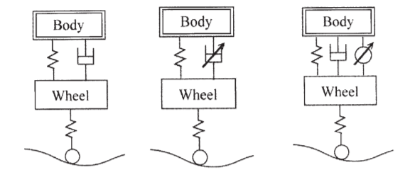

Suspension springs

Adjustable damper

Figure 1. Semi-active suspension system [2]

In this paper, the focus is on suspension systems in automobiles which run primarily on roads. Thus, suspension system of vehicles responses directly to road profile as main load input. Therefore, accurate information of force excitation from road unevenness is essential for optimizing controllable suspension systems. In order to achieve superior performance, statistical road profile is applied to damping control strategies such as “skyhook” method or hybrid control strategies. [3] According to research report [3], the control strategies which were proven to be more efficacious had road profile known in advance.

Describe the random variable associated with your engineering problem (case, location) based on related and relevant journal or conference articles.

* Matti

Describe how you could define it (measurements/sensors, references/literature, simulations/method) and required engineering tools and in which courses you learn to use these.

One of the main goals for satisfactory controllable semi-active suspension system is to get information about the road profile. There are three widely used road estimation and reproduction methods, according to [3].

* *Direct measurement* uses mechanisms which are kept in contact with the road surface, thus directly measure road profile irregularities. Although this method can provide precise profile measurements, structure of the measuring mechanism restricts application in ordinary cars, also the mechanism is going to get worn out quickly compare to non-contact measurement. Possible structure of measuring mechanism [4] is in figure 2 below

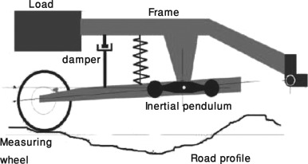

Figure 2. Device for direct measurement of the road profile [4]

* *Non-contact measurement* utilizes vehicles equipped non-contact transceivers to measure the road profile. The transceiver can be an optic displacement sensor or ultrasound sensor. However, these non-contact sensors are much more expensive than another two previous methods, thus non-contact measurement is not commonly used in commercial application.
* *Road estimation based on vehicle response* uses sensors, for example accelerometers, displacement sensors, and tilt angle sensor. These sensors collect response data and for estimation of road profile use some methods, for example sliding mode observer, transform function method or adaptive neural network. These methods based on vehicle response are the most practical for commercial applications because they do not require any specific instruments designs.

As said in the previous part, the best option for measuring the road profile is to estimate it from vehicle response to the road. For estimation and for possibility of controlling the whole process we need information about some variables included in the process and we aim to measure them precisely. Firstly, we can use displacement sensor, such as linear variable differential transformer (LVDT), for measuring displacement of body mass, wheel mass and displacement of tyre related to the road profile. Almost the same variable we can measure using accelerometers, specifically we can measure acceleration of body mass and wheel mass. We should also place in a force sensor in order to get feedback from the semi-active feedback and to get an option to control that damping force by changing the level of electrical voltage in the damper.

Our aim is to use these measured dynamic responses to the road profile as inputs in the control law. In that case, we are going to have a random variable (displacement of tyre due to random profile) and we can create a dynamic model of damping system with the random variable as an input. If we know parameters of that model, we can simulate a behaviour of the dynamic system and also create a satisfactory control law.

Describe the expected probability distribution (both short and long term) and give reasoning for the selection. What are the probability distributions closely related?

* Yu

When we start considering cumulative forces due vertical accelerations over a long time period on our vehicle, we start talking about long term analysis. This is often assessed as a set of short-term responses and a practical approach to it. Therefore the long term expected probability distribution would be the Weibull distribution, used for fatigue analysis, related to extreme value analysis and its reliability.

This probability distribution form is normally applied in reliability engineering to treat stochastic processes and forecasting of failure, when the distribution is proportional to power of time unit. The probability density function would be

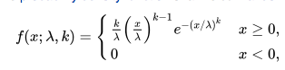

(1)

Where k > 0 is the shape parameter and λ > 0 is the scale parameter.

Related distributions could be, amongst others, interpolation between exponential distribution (k=1) and the Rayleigh distribution (k = 2 )[6].

Due to the fact that in the paper of *A Study of Semi-Active Vibration Control for Vehicle Suspension System Using an Adjustable Shock Absorber,* the displacement with semi-active with PID controller in random road profile along the time has been given. Actually,

For the topic of semi-active vibration control, the displacement function can be defined as follows [2],



Where Zmax is the maximum displacement, w is the frequenze, n is the random number, and u(t) is the step signal.

When we get the different data of their displacement, from the paper [2], there are a graph to show the result along the time.

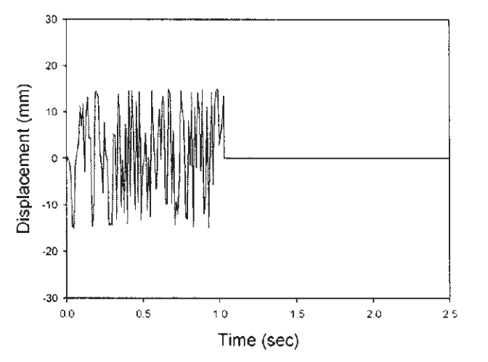

Figure 1

Without detailed data value, we cannot fit the curve to conclude the corresponding probability distribution, but from the graph with the method of elimination of other probability distribution. So a decision can be made, just Weibull probability distribution.

Additionally, mean value, variance, skewness and kurtosis which is discussed above with fatigue analysis and extreme value analysis are more related to the distribution.

For mean value of Weibull distribution, it is

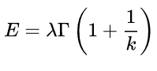

Where Г is the function of gamma.

For variance, it is

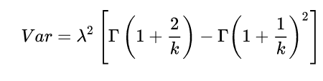

For skewness, it is

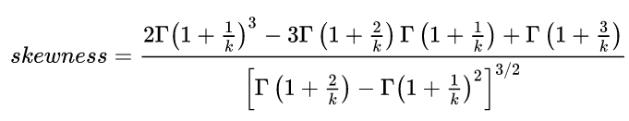

For kurtosis, it is

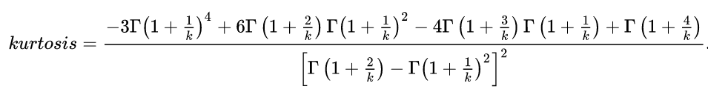

How is the selected case related to your former and future studies (learning diary)?

The team members are currently taking the mechatronics study path from the master program in mechanical engineering from Aalto University. Courses related to this path include learning about designing mechatronic machines, understanding the theoretical and practical principles that must be taken into consideration when developing this designing and ideating processes, and applying them.

The reason for selecting, in first place, the course, is to widen the team´s knowledge about how to deal with random successes and loads that can have an effect on mechatronic machines, and how this can be dealt with, or if predicted on time, contribute to a more optimized design output from an earlier stage.

A common application of mechatronics is of course vehicles. They are not only machines that are strongly presents in our everyday life, but the field is constantly open to innovation and improvement. This is why, the triggering of road profile as a random load, and the study of its impact, is relevant for the team member´s study paths since it will provide understanding about the extension and relevance this phenomena actually has on the mechatronic machine development, not only when it comes to the designing and optimizing of manufacturing and industrial resources, but the impact goes all the way to ensuring of the safety of the potential passengers on board the vehicle.

We also foresee that the knowledge gathered through this project, even though in this case applied to one topic, can be applied to any kind of statistical and prediction practices, which will contribute to a valuable development of our engineering careers, and be indeed a useful tool no matter in what direction this process goes.

1. Savaresi, S. M., and Spelta, C. (November 20, 2006). "Mixed Sky-Hook and ADD: Approaching the Filtering Limits of a Semi-Active Suspension." ASME. J. Dyn. Sys., Meas., Control. July 2007; 129(4): 382–392. <https://doi-org.libproxy.aalto.fi/10.1115/1.2745846\>
2. Wu, J & Lin, Chih-Jer & Kuo, K. (2008). A Study of Semi-Active Vibration Control for Vehicle Suspension System Using an Adjustable Shock Absorber. Journal of Low Frequency Noise Vibration and Active Control. 27. 219-235.
3. Y. Qin, M. Dong, F. Zhao, R. Langari and L. Gu, "Road profile classification for vehicle semi-active suspension system based on Adaptive Neuro-Fuzzy Inference System," 2015 54th IEEE Conference on Decision and Control (CDC), Osaka, 2015, pp. 1533-1538, doi: 10.1109/CDC.2015.7402428
4. M. Doumiati, A. Victorino and A. Charara. "Estimation of road profile for vehicle dynamics motion: experimental validation ". *Proc. of American Control Conference*. San Francisco, CA, June 29 -July 1, 2011.
5. Qin Y, Xiang C, Wang Z, et al. " Road excitation classification for semi-active suspension system based on system response. *J Vib Control* 2018; 24: 2732–2748. DOI: 10.1177/1077546317693432.
6. Papoulis, Athanasios Papoulis; Pillai, S. Unnikrishna (2002). *Probability, Random Variables, and Stochastic Processes* (4th ed.). Boston: McGraw-Hill. [ISBN](https://en.wikipedia.org/wiki/ISBN_(identifier)) [0-07-366011-6](https://en.wikipedia.org/wiki/Special:BookSources/0-07-366011-6).