Part A
Name:- Aditya Mishra
Roll No:- S046
Subject:- Data Structures and Algorithms
Program: MBA TECH (DS)
Aim:
Implementation of various array operations like traversal, insertion and deletion using any real life application.
Prerequisite: C++ Programming
Outcome: To implement arrays and its operations.
Theory: An array is defined as the collection of similar type of data items stored at contiguous memory locations. The array is the simplest data structure where each data element can be randomly accessed by using its index number. Arrays are the derived data type which can store the primitive type of data such as int, char, double, float, etc.
Declaration of C++ Array
data_type array_name[array_size];
int marks[5];
int marks[5]={20,30,40,50,60};
OPERATIONS ON ARRAY
- Traversing an array
- Inserting an element in an array
- Searching an element in an array
- Deleting an element from an array

Traversing an array

Algorithm for array traversal
Step 1: [INITIALIZATION] SET I= lower_bound
Step 2: Repeat Steps 3 to 4 while I<= upper_bound
Step 3: Apply Process to A[I]
Step 4: SET I=I+1
[END OF LOOP]
Step 5: EXIT

Inserting an Element in an Array
- Algorithm to insert at the end
Step 1: Set upper_bound = upper_bound+1
Step 2: Set A[upper_bound] = VAL
Step 3: EXIT
- Algorithm to Insert an Element in the Middle of an Array
Step 1: [INITIALIZATION] SET I=N
Step 2: Repeat Steps 3 and 4 while I>= POS
Step 3: SET A[I + 1] = A[I]
Step 4: SET I=I–1
[END OF LOOP]
Step 5: SET N=N+1
Step 6: SET A[POS] = VAL
Step 7: EXIT
Deleting an Element from an Array
- Algorithm
- Step 1: [INITIALIZATION] SET I= POS
- Step 2: Repeat Steps 3 and 4 while I<=N–1
- Step 3: SET A[I] = A[I+1]
- Step 4: SET I=I+1
- [END OF LOOP]
- Step 5: SET N=N–1
- Step 6: EXIT

Procedure:
- Open CodeBlock editor or visual studio editor and write the code in C++.
- Complile and run the code
Task:
- Insert an element in an array
- Delete an element in an array
- Find the smallest element in an array
- Find highest and lowest element in an array.
- Find the second largest element in an array.

Part B
Code:
/*
Task:

1. Insert an element in an array
2. Delete an element in an array
3. Find the smallest element in an array
4. Find highest and lowest element in an array
5. Find the second largest element in an array
6. Linear Search
*/

#include <iostream>
using namespace std;

// Function Prototypes
void insert(int arr[], int &n, int capacity, int pos, int item);
void disp(int arr[], int n);
void del(int arr[], int &n, int pos);
void smallest(int arr[], int n);
void range(int arr[], int n);
void secondLargest(int arr[], int n);
int linearSearch(int arr[], int n, int key);

int main()
{
int arr[10] = {2, 3, 1, 8, 0, 4, 56, 34, 90};

int n = 9; // Number of elements
int capacity = 10; // Maximum size of array

int pos = 3;
int item = 10000;

cout << "Original Array:\n";
disp(arr, n);

// Insert
cout << "\nInserting " << item << " at position " << pos << endl;
insert(arr, n, capacity, pos, item);
disp(arr, n);

// Delete
pos = 5;
cout << "\nDeleting element at position " << pos << endl;
del(arr, n, pos);
disp(arr, n);

// Smallest
cout << endl;
smallest(arr, n);

// Highest & Lowest
range(arr, n);

// Second Largest
secondLargest(arr, n);

// Linear Search
int key;
cout << "\nEnter element to search: ";
cin >> key;

int index = linearSearch(arr, n, key);

if (index != -1)
cout << key << " found at position " << index << endl;
else
cout << key << " not found in the array." << endl;

return 0;
}

// Display Array
void disp(int arr[], int n)
{
cout << "[ ";
for (int k = 0; k < n; k++)
cout << arr[k] << " ";
cout << "]\n";
}

// Insert Element
void insert(int arr[], int &n, int capacity, int pos, int item)
{
if (n == capacity)
{
cout << "Overflow!\n";
return;
}

if (pos < 0 || pos > n)
{
cout << "Invalid Position!\n";
return;
}

for (int k = n; k > pos; k--)
arr[k] = arr[k - 1];

arr[pos] = item;
n++;
}

// Delete Element
void del(int arr[], int &n, int pos)
{
if (pos < 0 || pos >= n)
{
cout << "Invalid Position!\n";
return;
}

for (int k = pos; k < n - 1; k++)
arr[k] = arr[k + 1];

n--;
}

// Find Smallest Element
void smallest(int arr[], int n)
{
int small = arr[0];

for (int k = 1; k < n; k++)
{
if (arr[k] < small)
small = arr[k];
}

cout << "Smallest element = " << small << endl;
}

// Find Highest and Lowest Element
void range(int arr[], int n)
{
int low = arr[0];
int high = arr[0];

for (int k = 1; k < n; k++)
{
if (arr[k] < low)
low = arr[k];

if (arr[k] > high)
high = arr[k];
}

cout << "Lowest element = " << low << endl;
cout << "Highest element = " << high << endl;
}

// Find Second Largest Element
void secondLargest(int arr[], int n)
{
if (n < 2)
{
cout << "Second largest does not exist.\n";
return;
}

// Initialize with first element instead of INT_MIN
int largest = arr[0];
int second = arr[0];

// Find the largest element
for (int k = 1; k < n; k++)
{
if (arr[k] > largest)
largest = arr[k];
}

// Find the second largest element
bool found = false;
for (int k = 0; k < n; k++)
{
if (arr[k] != largest)
{
if (!found || arr[k] > second)
{
second = arr[k];
found = true;
}
}
}

if (found)
cout << "Second largest element = " << second << endl;
else
cout << "No second largest element.\n";
}

// Linear Search
int linearSearch(int arr[], int n, int key)
{
for (int k = 0; k < n; k++)
{
if (arr[k] == key)
return k;
}

return -1;
}

Output: 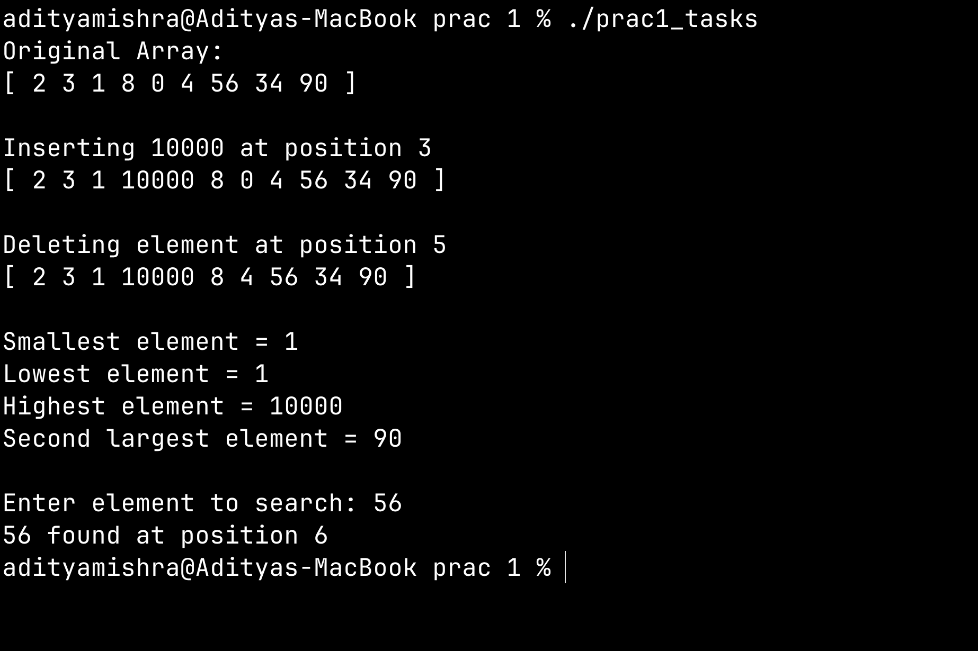
Observation & Learning:
Write your Observations & Learning after performing task
Answer Following Question
- How is the array stored in memory?
Ans: Stored in a linear fashion.
- What are the advantages and disadvantages of an array?
Ans: Advantage: easy to implement
Disadvantage: not applicable on large scale

Conclusion:
We successfully implemented C++ program on arrays and its operations.

