Part A
Name:- Aditya Misha
Roll No:- S046
Subject:- Data Structures and Algorithms
Program: B Tech/MBA Tech CE 2nd Year
Aim:
To study and implement concept of Stack data structure
Prerequisite: C++ Programming
Outcome: To implement stack and its operations.
Theory: Stack is a linear data structure which stores the elements in an ordered manner.
The elements in a stack are added and removed only from one end which is called top.
The policy is LIFO, the element that was inserted last is the first one to be taken out.
Operations-
Push(element)- inserts an element at top of the stack
Pop() – removes the topmost element
Peek()- returns the topmost element without removing
isEmpty() – checks if stack is empty
isFull()- checks if stack is full

Push operation
Step 1: IF TOP == MAX-1
PRINT OVERFLOW
Goto step 4
[END OF IF]
Step 2: SET TOP = TOP + 1
Step 3: SET STACK[TOP] = VALUE
Step 4: END
Pop operation
Step 1: IF TOP = -1
PRINT UNDERFLOW
Go to step 4
[END OF IF]
Step 2: SET VAL = STACK[TOP]
Step 3: SET TOP = TOP - 1
Step 4: END
Peek operation
Step 1: IF TOP = -1
PRINT UNDERFLOW
Go to step 4
[END OF IF]
Step 2: SET VAL = STACK[TOP]
Step 3: SET TOP = TOP - 1
Step 4: END

Procedure:
Open CodeBlock editor or visual studio editor and write the code in C++.
Complile and run the code
Instructions:

Copy code & paste in code section and output of Part B.
Part B
Code: /*
Operations-
Push(element)- inserts an element at top of the stack
Pop() – removes the topmost element
Peek()- returns the topmost element without removing
isEmpty() – checks if stack is empty
isFull()- checks if stack is full
*/

#include <iostream>

namespace NonPrimitiveDS {

const int MAX{100};

struct Stack {
int arr[MAX];
int top{-1};
};

bool isFull(const Stack& s) {
return s.top == MAX - 1;
}

bool isEmpty(const Stack& s) {
return s.top == -1;
}

void push(Stack& s, int item) {
if (isFull(s)) {
std::cout << "Stack is full!\n";
return;
}

s.arr[++s.top] = item;
}

int pop(Stack& s) {
if (isEmpty(s)) {
std::cout << "Stack is empty!\n";
return -1;
}

return s.arr[s.top--];
}

int peek(const Stack& s) {
if (isEmpty(s)) {
std::cout << "Stack is empty!\n";
return -1;
}

return s.arr[s.top];
}

void disp(const Stack& s) {
if (isEmpty(s)) {
std::cout << "Stack is empty.\n";
return;
}

std::cout << "Top ->\n";
for (int i = s.top; i >= 0; --i) {
std::cout << s.arr[i] << '\n';
}
}

}

int main() {

NonPrimitiveDS::Stack s;
int choice, item;

while (true) {

std::cout << "\nSTACK MENU\n";
std::cout << "1. Push\n";
std::cout << "2. Pop\n";
std::cout << "3. Peek\n";
std::cout << "4. Check if Empty\n";
std::cout << "5. Check if Full\n";
std::cout << "6. Display\n";
std::cout << "7. Exit\n";
std::cout << "Enter your choice: ";
std::cin >> choice;

switch (choice) {

case 1:
std::cout << "Enter value to push: ";
std::cin >> item;
NonPrimitiveDS::push(s, item);
NonPrimitiveDS::disp(s);
break;

case 2: {
int popped = NonPrimitiveDS::pop(s);
if (popped != -1)
std::cout << "Popped element: " << popped << '\n';
NonPrimitiveDS::disp(s);
break;
}

case 3:
if (!NonPrimitiveDS::isEmpty(s))
std::cout << "Top element: "
<< NonPrimitiveDS::peek(s) << '\n';
break;

case 4:
if (NonPrimitiveDS::isEmpty(s))
std::cout << "Stack is empty.\n";
else
std::cout << "Stack is not empty.\n";
break;

case 5:
if (NonPrimitiveDS::isFull(s))
std::cout << "Stack is full.\n";
else
std::cout << "Stack is not full.\n";
break;

case 6:
NonPrimitiveDS::disp(s);
break;

case 7:
std::cout << "Exiting...\n";
return 0;

default:
std::cout << "Invalid choice.\n";
}
}
}
Output: 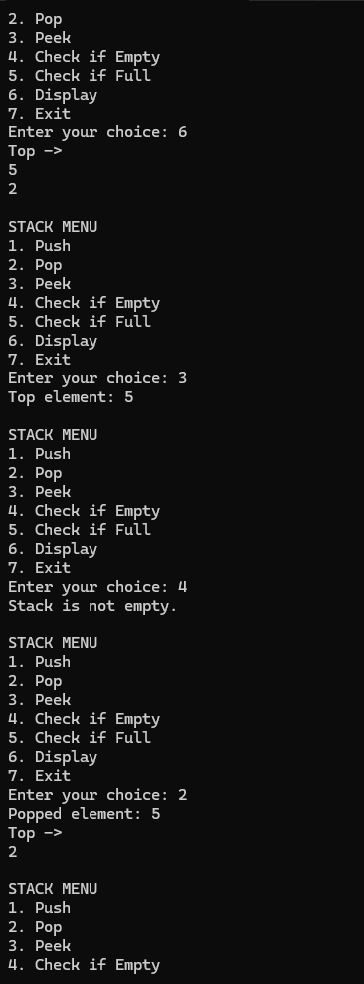
Observation & Learning:
Successfully implemented and tested a stack using an array, understanding LIFO behavior and the working of push, pop, peek, isEmpty, and isFull operations with overflow and underflow handling.
Answer Following Question
List applications of stack data structures.
After following operations are performed on stack, which element is at the top
Push(3), push(2), pop(), push (4), push(10), pop()

A stack is used for function call management, expression evaluation, parentheses matching, undo/redo operations, browser backtracking, depth-first search (DFS), and reversing data such as strings.
After performing the operations Push(3), Push(2), Pop(), Push(4), Push(10), Pop(), the top element is 4.

Conclusion:
We successfully implemented C++ program on arrays and its operations.

