Name: Aditya Mishra
Roll no.: S046
Sub NAME: OOPs
Date: 29/07/2026

Q.1
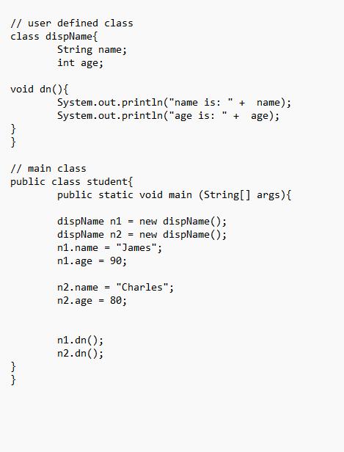
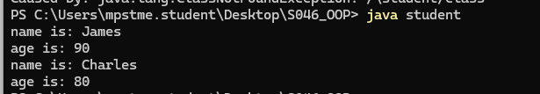
--------------------------------------------------------------------------------------------------------------------------------------

Q.2
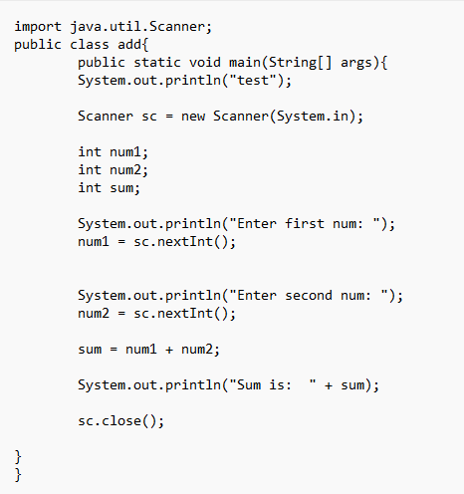
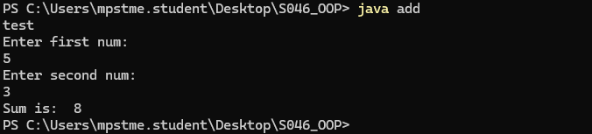

--------------------------------------------------------------------------------------------------------------------------------------

Q.3
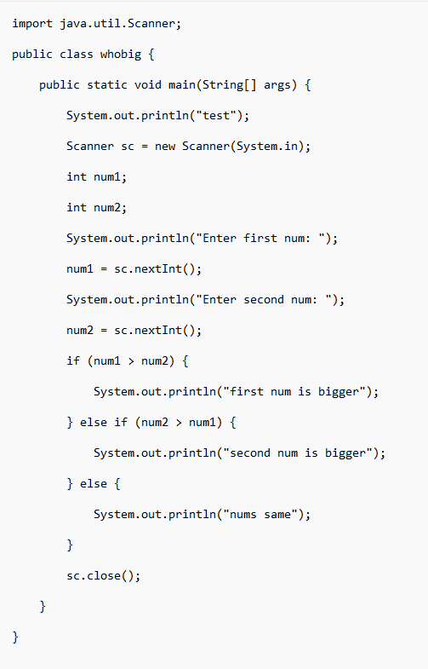

--------------------------------------------------------------------------------------------------------------------------------------

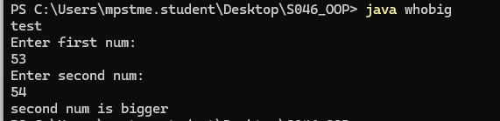

--------------------------------------------------------------------------------------------------------------------------------------
Q.4
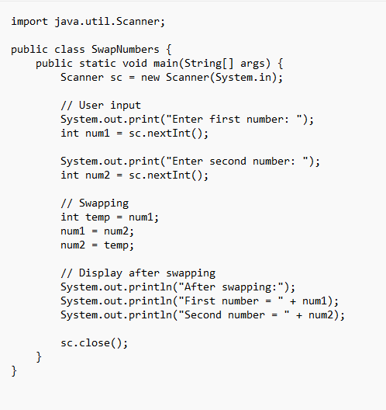
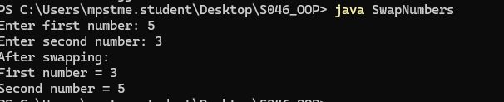

Q.5
