PERSONAL INFORMATION | Md Abdullah al Mahi
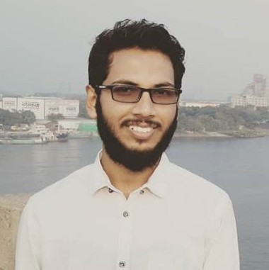
 | Hazi Road, Ranimohol, Demra, 1360 Dhaka.
 | +8801751989173
 | amahi.wp@gmail.com

https://www.linkedin.com/in/abdullahalmahi/

https://github.com/aamahi

PERSONAL STATEMENT | I am passionate develoaper interest in Web application Develoapment. Doing creative work is my passion. I love to do hard work for successful output. My hobby is traveling and learning about new technology. I like to find a solution to a complex issue. I am a PHP lover and continuously trying to help other PHP users.  I love to travel, take photographs and attending conferences, workshops, and seminars.

PERSONAL SKILLS

TECHNOLOGY SKILLS | Backend | PHP 7, Laravel, Lumen, REST API.
TECHNOLOGY SKILLS | Frontend | Javascript, Vue.js, jQuery, Ajax, Bootstrap, HTML 5, CSS 3.
TECHNOLOGY SKILLS | Database | MySQL
TECHNOLOGY SKILLS | Tools | Git, Github, Phpstrom, Visual studio code, Passport, JWT.
TECHNOLOGY SKILLS | API Integration | Facebook, Google, Twitter.
OTHERS | - Fluent in Unix Terminal (bash)  - Flexible, adaptable and both willing and able to learn quickly.  - Able to generate innovative ideas.  - Constructive and diplomatic team player with strong communication skills.  - Capable of working efficiently under high pressure
LANGUAGES | Bangla | Understanding, Speaking, Writing.
LANGUAGES | English | Understanding, Speaking, Writing.

PROJECTS

KUFA | Dynamic website /
KUFA | - PHP , MySQL
KUFA | - https://github.com/aamahi/kufa

MASTER ELECTRONICS | Inventory management system
MASTER ELECTRONICS | - Laravel , PHP, MySQL.
MASTER ELECTRONICS | - Developed couple of REST API services for mobile app using Lumen serving 100K users.  - Worked on an audio/video calling web app using WebRTC, Vue.js and Redux.  - Worked on an audio/video calling web app using WebRTC, Vue.js and Redux.  - Worked on an audio/video calling web app using WebRTC, Vue.js and Redux.  - Worked on an audio/video calling web app using WebRTC, Vue.js and Redux.
MASTER ELECTRONICS | - https://github.com/aamahi/master_electronics

EDUCATION

DIPLOMA IN ENGINEERING | Computer Technology
DIPLOMA IN ENGINEERING | - Habigonj Polytechnic Institute, Habigonj.
DIPLOMA IN ENGINEERING | - 8th Semester Runing.

TRAINING

INDUSTRIAL TRAINING | Web Develoapment (Laravel)
INDUSTRIAL TRAINING | - Creative it Institute.

EXTRA COURSE | Mastering PHP7
EXTRA COURSE | - Learn with Hasin Hayder

REFERENCE

Suhan Hossin Ean
- Department Head (web) and Softwear engineer
- Creative it Institute

