VALIDATION · TRACK 2 (FINANCIAL RESULTS)
Range validation — method & worked example
How we validate the per-asset dollar output when no competitor number exists at this granularity: reverse-engineer a credible range from renewable-specific reference numbers, normalized to a common basis using our own per-asset financial breakdown. Worked for solar × hail.
Where to find more
Benchmark source library: renewable_loss_benchmark_source_library (source pathways + benchmark-number matrix)
Value / damage crosswalk: 02_crosswalks/solar_hail_value_damage_crosswalk.md
Damage curve (GitHub): hail_solar dossier v1.3
Slide deck: How We Validate (Google Slides)

§1 Why range validation
The per-asset dollar figure (EAL / PML / return-period loss) is the output that matters most to a client — and the hardest to validate. At this granularity a comparable competitor number rarely exists. No source publishes “US solar-hail loss is $X–$Y.” So instead of matching a single “true” number, we check that our output lands inside a credible range assembled from renewable-specific reference numbers.
A defensible band is honest; a false-precision match is not. Range validation is a plausibility check and a defense against silent 10× errors — not calibration.

§2 The method — reverse-engineer a range
Reports give losses for a specific asset or asset type — not a national range. We turn those into a comparable envelope in four steps:
- Collect what reports actually give — per-asset / per-type event losses ($/MW, $/claim, event totals).
- Classify the loss basis — what does “loss” mean here: physical damage, overall, or business interruption? Strip to a like-for-like basis before comparing (see §3).
- Recast to a common denominator — use our per-asset financial breakdown (component × $ + capacity) to convert each number into %TIV, % module value, and an implied damage ratio (see §4).
- Assemble the envelope and check — the normalized anchors define a credible band; confirm our per-asset output lands inside it.

Our engine — the per-asset financial breakdown
For every U.S. solar asset we hold capacity (MW) plus a component-level dollar breakdown. That yields the value buckets (TIV, physical, module, module + fieldwork) that let us convert any raw dollar number into %TIV — and it is the same breakdown that drives our per-asset output, so both sides of the comparison share a denominator.

§3 Compare orange to orange — loss-basis normalization
The single most important caveat: the word “loss” means different things in different reports. Comparing across bases silently corrupts the range. Classify every reference number first:
Loss basis | What it includes | Use for our M3 physical check?
Physical damage | repair/replacement of damaged hardware only | Yes — the like-for-like basis
Gross claim / repair cost | physical + fieldwork + claim-handling; often > module value | Yes — after recast to module+fieldwork
Overall / insured loss | net of deductible & sublimit, insurer basis | Caution — insurance-layer, not ground-up physical
Business interruption | downtime / lost generation / revenue | No — exclude (separate from physical)
Only once two numbers are on the same basis can they share a range. A gross claim that exceeds pure module value is not a curve error — it usually carries fieldwork / claim costs (see §4).

§4 The value / damage crosswalk
We recast both sides onto our value buckets, so a raw $/MW becomes a comparable %TIV and maps to the grain the M3 hail curve actually damages (PV module / PV array).

Value buckets (solar, project default basis)
Bucket | $ / MWdc | % TIV | Role
Installed TIV | $1,120,000 | 100% | project denominator
Physical replaceable value | $877,796 | 78% | physical-damage denominator
PV_ARRAY module hardware | $291,215 | 26% | the M3 hail failure-unit
PV_ARRAY + replacement fieldwork | $398,084 | 36% | gross physical repair bucket

AXIS severity, recast onto the buckets
Benchmark | $ / MW | % TIV | Comparison grain
Successful stow | $150,000 | 13% | fits the module-hardware bucket
Fixed-tilt | $340,000 | 30% | needs fieldwork / claim-cost allocation
Failed stow | $380,000 | 34% | needs fieldwork / claim-cost allocation
The crosswalk classifies comparability — it does not tune the curve. Fixed-tilt / failed-stow severities exceed pure module value; that is coherent once replacement fieldwork is included, not evidence that the curve needs max_DR > 1.

§5 Worked example — solar × hail
Normalized to %TIV, an illustrative fixed-tilt / no-stow per-asset severity (≈27% of installed TIV) sits inside the envelope set by AXIS's five-year solar-hail claims — so it passes the range check.
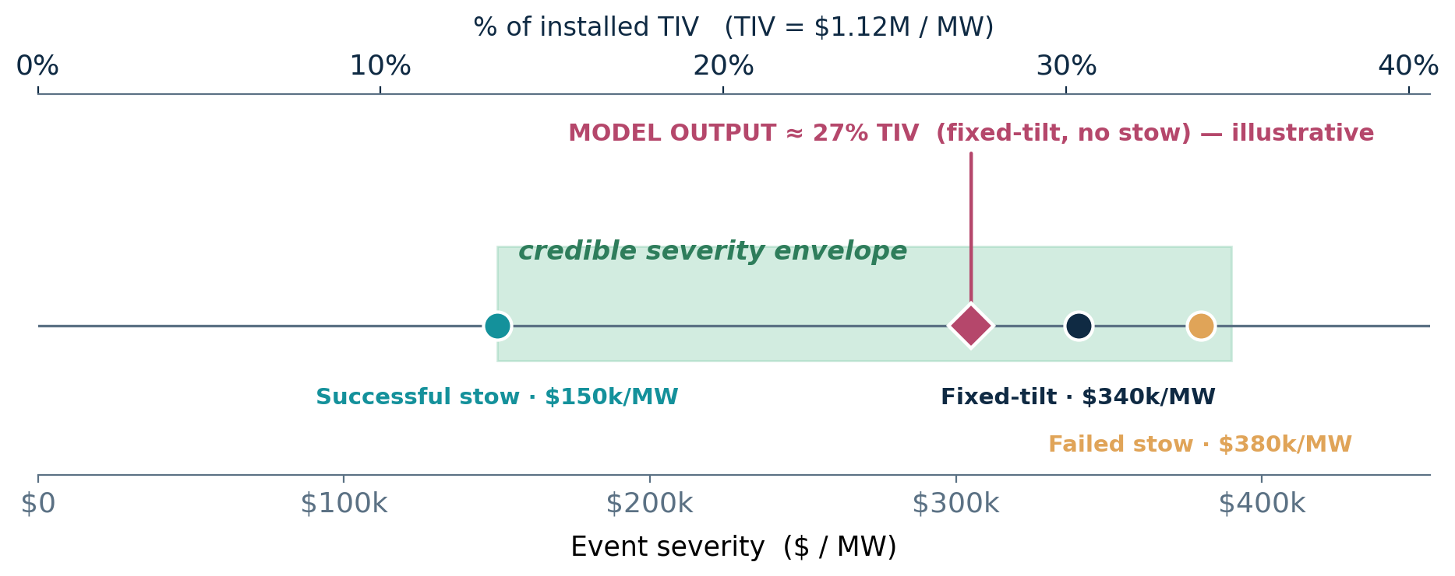

Corroborating anchors
Number | What it says | Source · tier
73% | hail = share of solar loss $ (6% of incidents) | kWh SRA 2025 · R1
$58.4M | avg hail claim; 54% of hail loss cost | GCube · R1
$150/340/380k/MW | event severity by stow state (5-yr claims) | AXIS 2025 · R1
$70–80M | Midway Solar event (178 MW, 2019) | case study · R3
$50M | Fighting Jays hail sublimit (2024) | case study · R3
PML / AAL | engineered hail loss, per site & return period | VDE Hail Risk · R2

§6 What range validation is — and is not
- IS a plausibility envelope — does the number sit where credible evidence says it should?
- IS basis-aware — normalized to %TIV before comparison, and honest about gross vs net, BI inclusion, portfolio bias.
- IS NOT calibration — it does not fit curve parameters to the references.
- IS NOT a claim that competitor / commercial numbers are ground truth (most are gated and portfolio-biased).
- IS NOT a substitute for claims calibration once real per-asset loss data arrives.

§7 Sources
Source | Reference number | Tier | Link
kWh Analytics SRA 2025/26 | hail loss share; 1-in-100 >10% asset value | R1 | open ↗
AXIS Global Energy (solar hail) | $/MW severity by stow; downtime days | R1 | open ↗
GCube / TMHCC (Hail No!) | avg hail claim; % of hail loss cost | R1 | open ↗
J.S. Held (Midway) | event severity $70–80M | R3 | open ↗
Descartes / VDE (Fighting Jays) | $50M hail sublimit; stow contrast | R3 | open ↗
VDE Hail Risk Intelligence | engineered PML / AAL per site | R2 | open ↗
Full source registry, tags, and the benchmark-number matrix live in the renewable_loss_benchmark_source_library (data/ + 01_pairs/solar_hail).

