DAMAGE CURVE BUILD METHODOLOGY
The strict-order pipeline from curated evidence to a shippable damage callable — EVIDENCE → GRAIN → AXIS → FORM → ADJUSTMENTS → EMIT → SHIP — with the cell-package layout, worked example, and staged roadmap.

Author: InfraSure
Audience: Internal modeling team building damage cells; reviewers auditing how a curve was constructed.
Folder: Methodology & Implementation
Companions: Damage Modeling Terminology (the words); Damage Curve Evidence Reference (the inputs).
Reads: End-to-end once to absorb the pipeline; then as a manual — every stage is self-contained, with its own decisive question and own failure mode.

How to read this document
This is the longest document in the set. Each stage takes a defined input from the previous stage, makes a defined decision, and hands a defined output to the next.
Sections 1–3 are orientation: how this document relates to the others, what the reader needs to know going in, and the seven-stage pipeline at a glance. Sections 4–10 are the seven stages, one section each. Sections 11–14 cover the cell-package layout, the worked example end-to-end, validation and the staged roadmap, and the cross-reference index.
Each stage section has the same internal structure: decisive question (what this stage decides), inputs (what arrives from upstream), outputs (what leaves to downstream), doctrine (the rules that constrain the decision), worked moves (concrete examples), and failure modes (the mistakes the stage is designed to prevent).

1. How this document relates to the others
The damage foundation set is three documents. This is the third — the one that does the transforming. The Terminology document supplies the vocabulary. The Evidence Reference document supplies the inputs. This document is where the inputs become a curve.

The three-document map
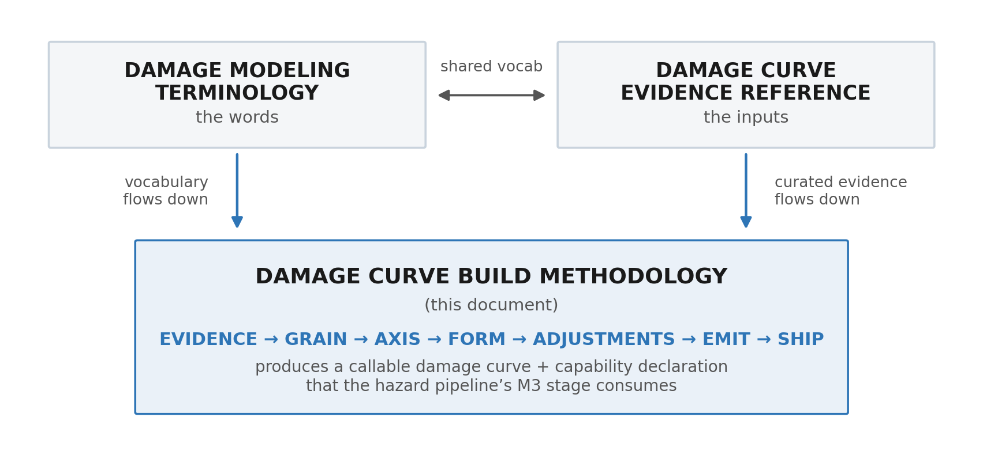

The boundary with the hazard pipeline
The damage callable is the deliverable. It plugs into a hazard pipeline at the M3 stage (the per-event loss generation stage). Everything downstream of M3 — annual aggregation, financial application, tail metrics — is the hazard side, not the damage side. The damage side’s job is finished when the callable is shipped with its capability declaration.
The clean boundary, stated once: damage delivers D(intensity, selectors, conditioners, exposure) → emit_object and an associated capability declaration. The hazard pipeline binds to that callable at M3 by passing per-event intensities and binding values from the exposure dataset. The damage side does not own loss aggregation or financial application; those are downstream.
This document stops at SHIP. It does not specify how M3 invokes the callable — that is hazard’s methodology. But it specifies what M3 is entitled to assume about the callable, because that is the consumer contract.

2. What you need to know before reading this document
Three things, all carried from the companion documents. They are restated here briefly so this document reads end-to-end without forcing a context switch.

2.1 — Vocabulary baseline
From the Terminology document. The terms the rest of this document assumes:
- Damage curve = a callable. A parameterized function with a capability declaration. Not a chart.
- Failure-unit = the level at which a curve is written. A cell typically has multiple failure-units (panel glass, mounting frame, inverter, racking for a solar farm).
- Cell = a (hazard × asset class) pair. A cell ships a family of curves, one per failure-unit that has one, composed by capex-weighted summation.
- Selector = fixed asset attribute that picks a curve variant (e.g. mono-Si vs bifacial panel).
- Conditioner = event-time state that adjusts parameters (e.g. stow angle, wind direction).
- Exposure = the value-share touched by this failure-unit (used to aggregate damage ratios into capex-weighted losses).
- Emit object = what the curve returns per event: scalar mean DR, mean+spread, state vector, or a damage distribution.
- Capability declaration = the metadata that ships with the callable saying which downstream metrics it honestly supports.

2.2 — Evidence baseline
From the Evidence Reference document:
- Four tiers: T1 direct empirical (loss observed on the actual asset × hazard with intensity recorded — e.g. attributed claims, field campaigns, realistic test stands); T2 engineering standards (consensus standards and lab tests — e.g. IEC, IBHS, ASCE, HAZUS); T3 inferred/proxy (a related-but-not-identical asset, hazard, or scale — e.g. coupon tests, cross-event transfer); T4 expert judgment (documented credentialed opinion or OEM notes that are not test reports). A tier grades an artifact for the specific claim being made, not in the abstract.
- Curated, not fitted: parameters are attributed to specific artifacts; the optimizer does not override the curation.
- Tier × claim matrix: the weakest-tier parameter in a curve gates which downstream metrics are honest. Metrics not supported are withheld, not caveated.
- Source-to-parameter map: every parameter row has a tier and a source artifact named.

2.3 — Where this document defers
Three things this document does not specify, because they live elsewhere:
1. How M3 binds to the callable. That is the hazard pipeline’s methodology — not damage’s.
2. The per-cell catalog. Cells live in their own repo folders; this document specifies the layout a cell must have, not the inventory of cells.
3. Annual aggregation, financial application, tail metric derivation. All downstream of M3; the damage side does not own them.

3. The seven-stage pipeline at a glance
Damage curve construction is a strict-order pipeline. Seven stages, each with one decisive question, one defined input, one defined output. The order is not arbitrary — it is the order in which decisions become forced by upstream choices. You cannot choose the functional form before you know the axis; you cannot choose the axis before you know the failure-unit (the grain).

The pipeline
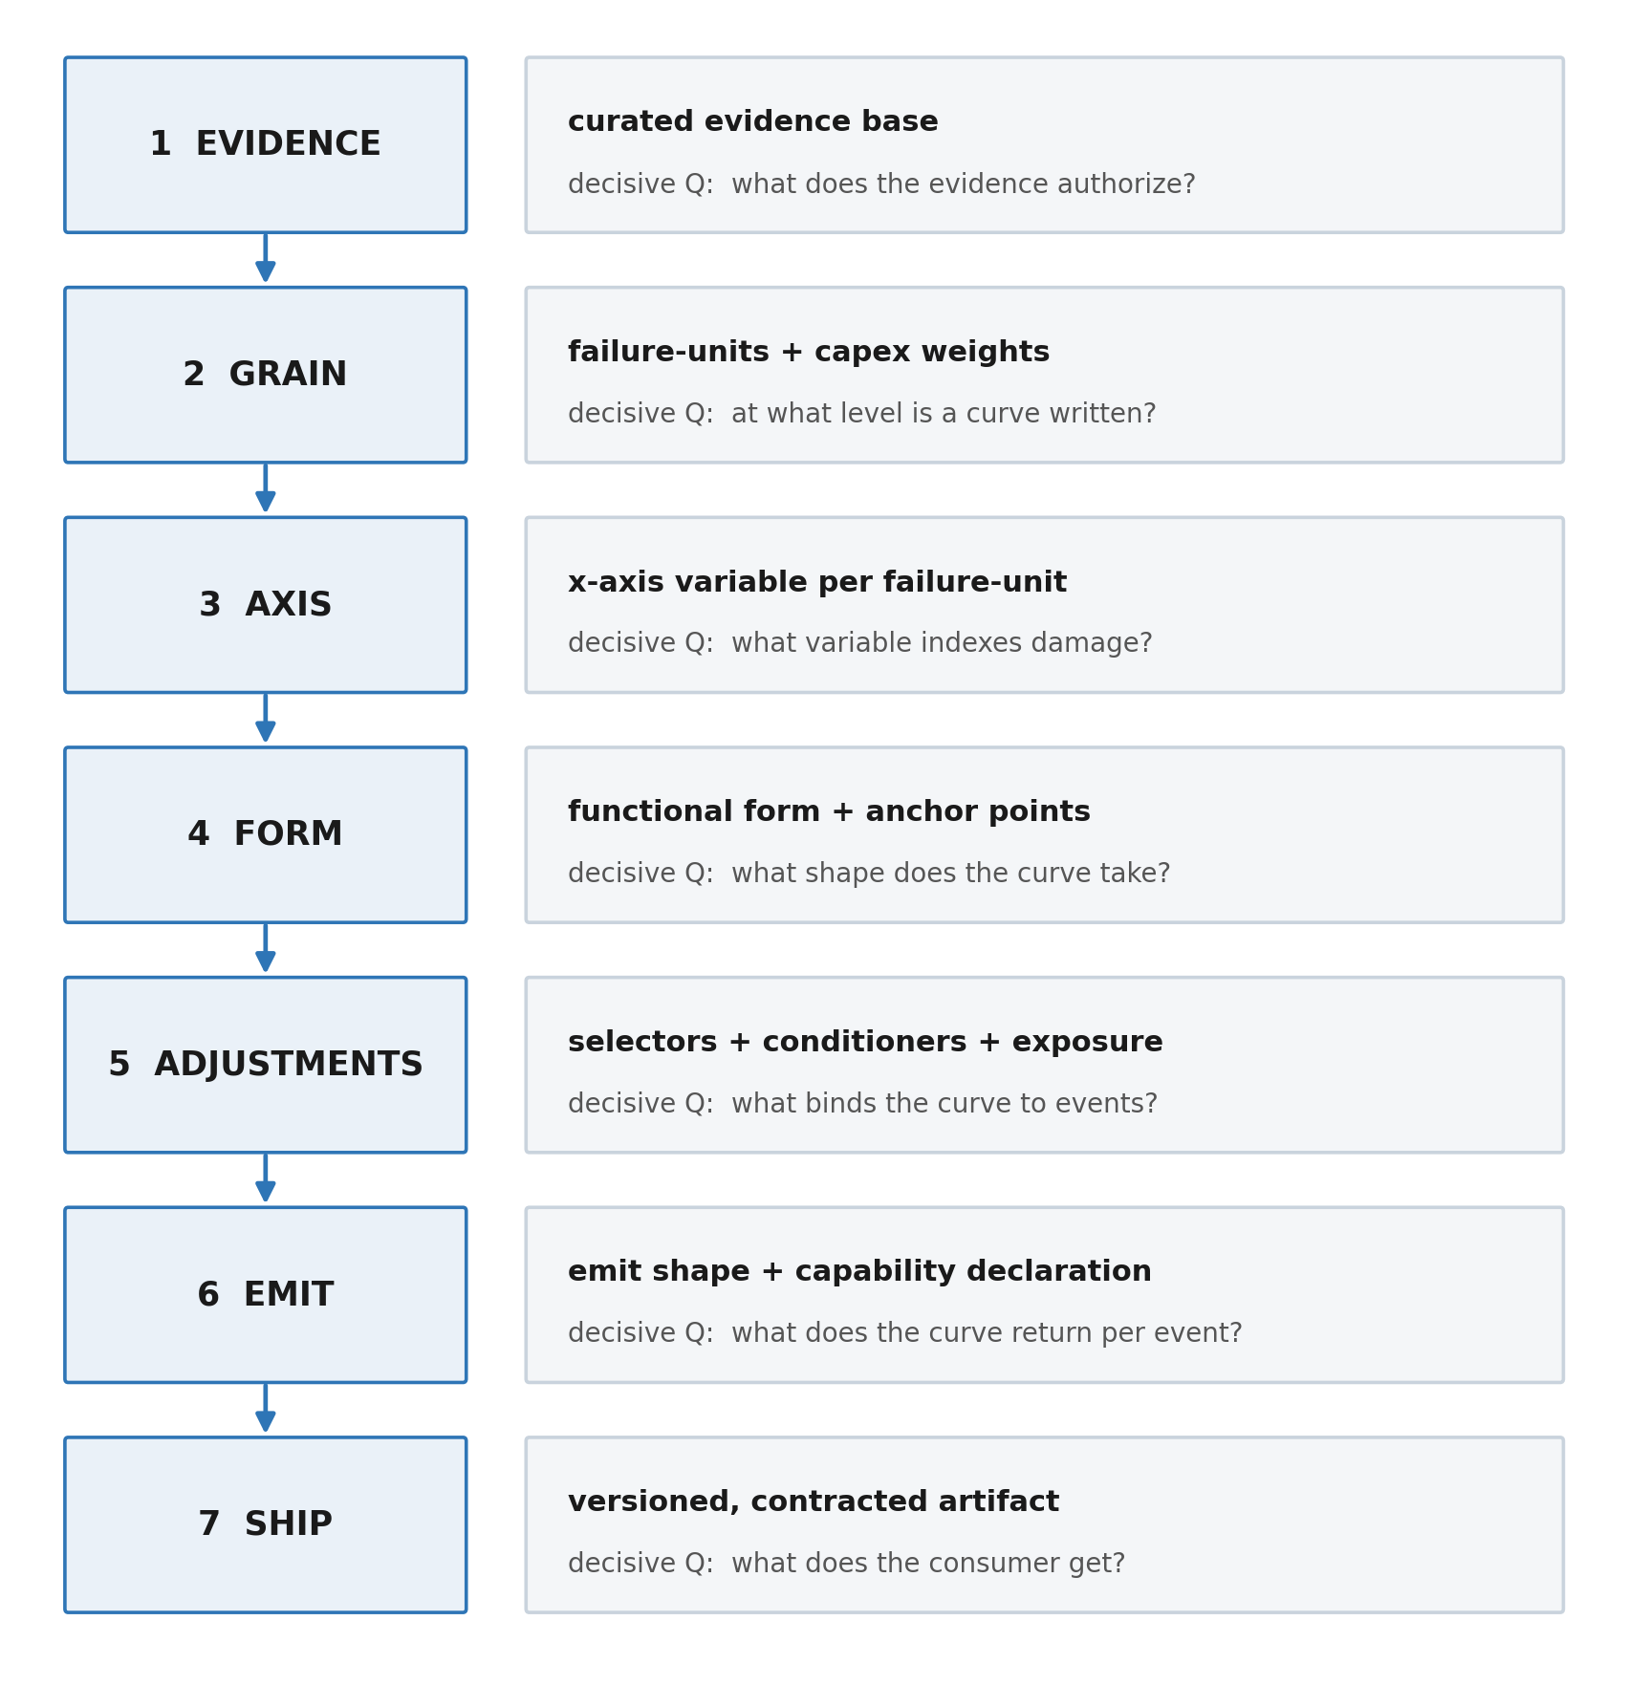

Why seven and not five or eight
Seven is the minimal set such that every stage has its own decisive question, its own evidence input, and its own failure mode. Collapsing stages hides decisions; splitting stages creates sub-stages that share doctrine with their parent.
Alternative carving | What it does | Why rejected
Five stages (collapse GRAIN+AXIS, ADJUSTMENTS+EMIT) | Reduces the spine to: evidence → shape → interface → ship. | Hides two of the highest-stakes decisions: grain (which determines the entire downstream structure) and emit (which determines what metrics are honest). A composite "shape" stage swallows two independent choices.
Eight stages (split EVIDENCE into collection + tiering) | Adds an "evidence-tiering" stage between EVIDENCE and GRAIN. | Tiering is the doctrine of EVIDENCE, not a separate decision. A stage with no independent answer is a section, not a stage.
Eight stages (split ADJUSTMENTS into selector + conditioner + exposure) | Splits the binding logic into three stages. | The three binding kinds share the same decisive question (what does the curve depend on that is not intensity?). They are facets of one stage, not three.

The discipline of strict order
Stages are strict-order: do not skip and do not loop without rewinding.
A team that has reached FORM and discovers it needs a new selector does not patch FORM. It rewinds to ADJUSTMENTS, declares the selector, regenerates the curve variants, and re-enters FORM with the variant population now defined. The discipline avoids the silent failure mode where a selector is grafted onto a finished curve and the curve’s tier story no longer matches its parameters.
Strict order also means: every stage has the right to demand that an earlier stage be redone. EMIT is allowed to say "the evidence base does not support the distribution emit shape that GRAIN implied; rewind to EVIDENCE." This is the protocol’s safety valve.

4. Stage 1 — EVIDENCE

Decisive question
What does the curated evidence base authorize the curve to claim?

Inputs
The asset class, the hazard, and the artifacts on the desk — papers, claims summaries, vendor reports, standards, forensic studies, expert input. Anything that might inform a damage parameter for this cell.

Outputs
A curated evidence package: a source list with tiers assigned per claim (tiers T1–T4 are introduced in §2.2 and defined in full in the Evidence Reference), the source-to-parameter pre-map, the assumption register, the evidence backlog, and a derivation rationale — a short narrative, per failure-unit, of how the curve was reasoned into existence: which source set each parameter, how any ready-made curve was decomposed rather than adopted, which conflicting sources were chosen over others and why, and what was rejected. The quantitative table records the result; the rationale records the reasoning. This is the package that downstream stages consume. The package is a deliverable in itself — even before any curve is built.

Doctrine
From the Evidence Reference document, the rules that bind this stage:
1. Curated, not fitted. Every parameter is attributed to an artifact. The optimizer does not override the curation.
2. Tier per claim, not per artifact. A 2024 paper is T1 for what it directly tested and T3 for adjacent claims.
3. No silent demotion. Mixing a T1 paper with a T3 proxy in a single fit silently demotes the T1 to T3. Do not.
4. Backlog the gaps. Where evidence is missing, write a backlog item that names the artifact that would fill it. Do not invent.
5. Provenance is per-parameter. Every parameter that will exist in any downstream stage gets a row in the source-to-parameter table — even the ones that will end up at T4 with a backlog flag.
6. A found curve is an artifact like any other. A ready-made curve from a paper or a library is never copied as a black box. It is tiered for the claim, then decomposed into its evidence — anchor points, threshold, cap — and re-derived. A similar-asset library curve enters as a T3 proxy; a paper’s curve is T1 for its own specimen and T3 when transferred to a different asset or hazard.

Worked moves
Concrete examples of what doing this stage looks like, drawn from the hail × solar example continued in §12:
Move 1 — Assemble. Pull every artifact that might inform a hail × solar damage parameter: a panel hail-impact study, a solar-impact engineering specification, a mechanical-load standard, regional hail-loss screening values, a vendor engineering note on stow effects, and several claim-adjuster reports from prior storms.
Move 2 — Tier each artifact against the parameters it might inform. The impact study is T1 for k and x₀ on the panel type it tested (its specimen); T3 when transferred to a different module. The engineering specification is T2 for L (saturation cap from the impact-resistance rating) and x_threshold (onset of glass damage). The mechanical-load standard is T2 corroboration of L. The hail-loss screening values are T3, used for calibration only — not parameter-setting. The vendor note is T4 for the stow conditioner, with a backlog flag. The claim-adjuster reports are T3 because they lack engineering attribution.
Move 3 — Write the pre-map. Populate the source-to-parameter table per parameter; mark T4 rows with backlog items; write the assumption register (e.g. "no consideration of accumulated panel age effects").
Move 4 — Declare backlog. What is not yet in the package: secondary uncertainty for panel_glass; paired field observations for the stow conditioner; bifacial-specific anchor data. Each backlog item names the evidence that would close it and the tier it would carry once closed.

Failure modes the stage prevents
Failure | How EVIDENCE prevents it
Silent fit-over-everything | Curation forces per-parameter attribution; an optimizer cannot run over the union of tiers without naming itself a tier-mixing operation, which the doctrine forbids.
Hidden backlog (a curve that cannot be built but appears built) | Backlog items are first-class outputs. A cell whose backlog implies the curve cannot honestly support metrics is one whose capability declaration will read empty downstream.
Provenance drift | Source-to-parameter map is built before any parameter value is fixed; later stages cannot add a parameter without a row in the map.

5. Stage 2 — GRAIN

Decisive question
At what level is a curve written — and how are those levels composed?

Inputs
From EVIDENCE: the curated package, including which failure modes the evidence describes. Plus the asset’s capex breakdown (how the value is distributed across subsystems).

Outputs
A failure-unit list with capex weights and roles. Each failure-unit is one of:
Role | Meaning | Example (solar farm)
primary-nonzero | Owns a curve; the main damaged value bucket — drives most of the cell’s damage signal under typical events. | panel_glass under hail.
secondary-conditional | Owns a curve; a smaller co-event contributor. Built when capex-share × expected DR is non-negligible. | a static racking structure under severe hail (own curve, smaller share than the module).
conditioner-only | No curve of its own; hosts a conditioner that shifts another unit’s curve (changes vulnerability). | MOUNTING/TRACKER under hail — no curve of its own; hosts the stow_state conditioner that shifts the module curve.
exposure-protection-modifier | Changes the affected amount or removes the hazard pathway — not the unit’s vulnerability. (Contrast the conditioner, which changes vulnerability.) | a flood wall or raised elevation (removes the hazard pathway to the equipment; the equipment’s own curve is unchanged).
DR≈0-reviewed | Reviewed and found negligible across the intensity range, so no curve is built. The finding is documented, not silently dropped. | racking under hail.

Doctrine
Five rules that govern grain decisions:
1. Subsystem-default. Write curves at the subsystem level by default. Panel glass, mounting frame, inverter, racking — not at the panel-as-monolith level.
2. Finer where mechanism concentrates. Go finer than subsystem only where the damage mechanism concentrates evidence and decision. If hail damage to a panel is dominated by glass fracture, that is the failure-unit. Do not split into "anti-reflective coating," "front glass," "cell," "back sheet" without evidence that supports separate curves.
3. Cap-and-sum composition. Failure-unit damage ratios compose into cell-level damage via capex-weighted summation, with each unit’s DR capped at its own saturation. The cell’s aggregate damage cannot exceed the sum of weighted unit caps. No grouping primitive that hides the composition.
4. No grouping primitive. The system does not have a "group of failure-units" abstraction. Composition is always explicit: cell_DR = Σ (capex_share_i × unit_DR_i). The transparency is the protection against silent double-counting.
5. Role assigns the build effort. Primaries get the most evidence and the most parameter care; secondaries get standards-derived shapes; conditioner-only and exposure-protection-modifier units carry no curve of their own.

Worked moves (hail × solar continued)
Capex breakdown for a utility-scale solar farm:
panel_glass 0.65 (largest single share; primary)
mounting/tracker 0.20 (conditioner-only; hosts stow_state, no curve of its own)
inverter 0.10 (secondary; capex too small for v1 prioritization)
racking 0.05 (DR ≈ 0 under hail)
Grain decisions:
- panel_glass: primary; gets the most evidence-curated curve.
- mounting/tracker: conditioner-only; hosts the stow_state conditioner that shifts the module curve.
- inverter: secondary; not built in v1 because capex-share × expected DR ≪ panel_glass.
- racking: DR ≈ 0; no curve.
- inverter, substation: reviewed and found negligible for hail (DR≈0-reviewed); documented, not silently dropped.
Composition formula for the cell in v1.0:
cell_DR = 0.65 × panel_glass_DR(intensity) (the other units are DR ≈ 0 or not-built in v1)

Failure modes the stage prevents
Failure | How GRAIN prevents it
Monolithic-cell curve | Subsystem default forces explicit failure-unit decomposition. A cell with only one curve has to defend why the others are DR ≈ 0 or not-built.
Over-fragmentation | Finer-where-mechanism-concentrates limits the splitting to evidence-supported boundaries. Splitting front glass from back sheet without evidence is forbidden.
Hidden double-counting | No grouping primitive; composition is always the capex-weighted explicit sum. A failure-unit cannot appear in two groups.

6. Stage 3 — AXIS

Decisive question
What variable indexes damage for each failure-unit?

Inputs
From GRAIN: the failure-unit list with roles. From EVIDENCE: the evidence package — specifically the intensity variables the evidence reports against.

Outputs
For each failure-unit that gets a curve, a single x-axis variable in physical units, with a documented valid range. Failures-unit × axis is one-to-one in v1; multivariate axes are a deliberate later-version move with a documented justification.

Doctrine
Five rules that govern axis decisions:
1. Univariate v1. One x-axis per failure-unit by default. The axis is the variable the damage evidence indexes; if the evidence indexes a different variable than the hazard catalog reports, the cell’s consumer contract must declare the conversion required.
2. Chain-position rule. The axis is the variable that hits the failure-unit, not the variable the hazard reports. Hail damage to panel glass is indexed by hailstone diameter (the thing that hits the panel), not by storm radar reflectivity (a hazard catalog input). When the two differ, the hazard pipeline’s M3 stage is responsible for the chain conversion; the damage callable receives the axis variable directly.
3. Physical units, always. Wind speed in m/s, hail diameter in mm, ground motion in g (or PGV in cm/s), inundation depth in m, fire radiant flux in kW/m². Never normalized; never dimensionless.
4. Valid range, declared. Every axis carries a valid-intensity range. Outside the range the curve does not extrapolate; the emit object is undefined, not "best guess."
5. One curve per (failure-unit × axis). If a failure-unit appears to depend on two intensity variables (e.g. hailstone size and wind speed jointly), the v1 move is to pick the dominant one and conditioner-adjust on the other. Moving to a multivariate axis is a major version event.

Worked moves (hail × solar continued)
panel_glass axis decision:
- The damage evidence indexes against hailstone diameter (mm). T1 for axis choice.
- Standards (IBHS, IEC) index against the same: hailstone diameter equivalents. T2 corroboration.
- Wind speed and angle of impact also affect damage but are conditioner candidates (see ADJUSTMENTS), not axis candidates: not enough evidence to support a multivariate axis.
Axis:
variable: hailstone diameter
units: mm
valid range: [10, 90] mm
outside range: emit_object is undefined; hazard pipeline must not query.
Consumer note for hazard pipeline:
Hazard catalog reports hail as MESH (maximum estimated size of hail) from radar. M3 must convert MESH → hailstone diameter before invoking D(). The conversion is M3’s responsibility; documented in the consumer contract.

Failure modes the stage prevents
Failure | How AXIS prevents it
Wrong variable on x | Chain-position rule forces selection of the variable that hits the failure-unit, not the variable the hazard catalog happens to report.
Silent extrapolation | Valid range is declared; outside the range the emit object is undefined. The consumer cannot query the curve at an out-of-range intensity and get a number back.
Hidden multivariate dependence treated as univariate | Variables beyond the axis must be conditioners in ADJUSTMENTS or the axis is wrong; multivariate axes are an explicit move, never a quiet one.

7. Stage 4 — FORM

Decisive question
What functional shape does the curve take, and where are its anchor points?

Inputs
From EVIDENCE: anchor points (intensity → damage state or DR), each at a tier. From GRAIN: the failure-unit. From AXIS: the variable and valid range.

Outputs
A parameterized curve over the axis, with: a functional form (logistic, piecewise, state-based, PCHIP, or other documented form); parameter values; anchor points the parameters are pinned against; an explicit no-extrapolation boundary at the valid range edges; and the derivation rationale carried forward from EVIDENCE, now extended to record why this form was chosen and how each parameter was pinned.

Doctrine
Five rules that govern form decisions:
1. Logistic by parsimony. Default to the four-parameter logistic: DR(x) = L / (1 + exp(-k × (x - x₀))). Three parameters do the heavy lifting; the threshold (x_threshold) appears as anchoring (see rule 4).
2. Documented alternatives, with reasons. Piecewise-linear when the evidence reports damage-state transitions sharply; state-based (fragility form) when the evidence is in damage states and the consumer expects state probabilities; PCHIP (monotone cubic) when the evidence anchors are dense and a smooth interpolation is preferred; linear when the evidence supports only a slope between two anchors. Each non-logistic choice is documented with a reason.
3. Anchoring rule. Where the evidence supports a non-zero damage onset, the curve is anchored: shifted such that DR(x_threshold) ≈ 0, not L × sigmoid(threshold - x₀). Anchoring is explicit and stated in the parameter table.
4. Saturation cap (L) is the binding constant. L is the asymptote and the maximum value the curve can return. The consumer is entitled to assume DR ≤ L for all x in the valid range.
5. No extrapolation. Outside the valid intensity range, the curve does not return a value; the emit object is undefined. Extrapolating logistic asymptotes into ranges where no evidence exists is forbidden.

Form selection card
Form | Choose when | Do not choose when
Logistic (default) | Evidence supports a smooth S-shape with onset, mid, and saturation regions all anchored or constrained. | Evidence reports discrete damage states (use state-based) or the curve must be locally non-monotone over a sub-interval (use piecewise).
Piecewise-linear | Two or three anchor points with little reason to commit to a smooth form; the slope changes sharply between anchors. | Anchors are dense and a smooth interpolation is preferred (use PCHIP); a true sigmoidal shape is supported (use logistic).
State-based (fragility) | Evidence is in damage states (HAZUS-style) and consumer wants P(state) per intensity, not mean DR. | Consumer expects scalar mean DR (logistic is more natural).
PCHIP (monotone cubic) | Anchors are dense, smooth interpolation desired, and monotonicity must be guaranteed. | Anchors are sparse (overfits); the underlying shape is fundamentally sigmoidal (logistic is more interpretable).
Linear | Two anchors only and the evidence does not support more. | Anchors span a region with obvious curvature.

Worked moves (hail × solar continued)
panel_glass form and anchors:
- The impact study reports several anchor points spanning roughly 30–70 mm hail diameter with mean DR.
- IBHS spec gives threshold (~25 mm onset) and saturation behavior at high intensity.
- IEC 61215 corroborates L.
Decision: logistic with anchoring.
form: logistic with anchoring at x_threshold = 25 mm
parameters (pinned against the study’s anchors + the spec’s threshold + the standard’s L):
L = 0.85
k = 0.062 / mm
x_0 = 46 mm
x_threshold = 25 mm (anchoring)
valid range: [10, 90] mm
fit method: curated. Anchor points pinned; (L, k, x_0) chosen to minimize squared residuals against the study’s anchors, subject to the standard-set L and curve(threshold) ≈ 0 (anchoring).

A visual of the shape
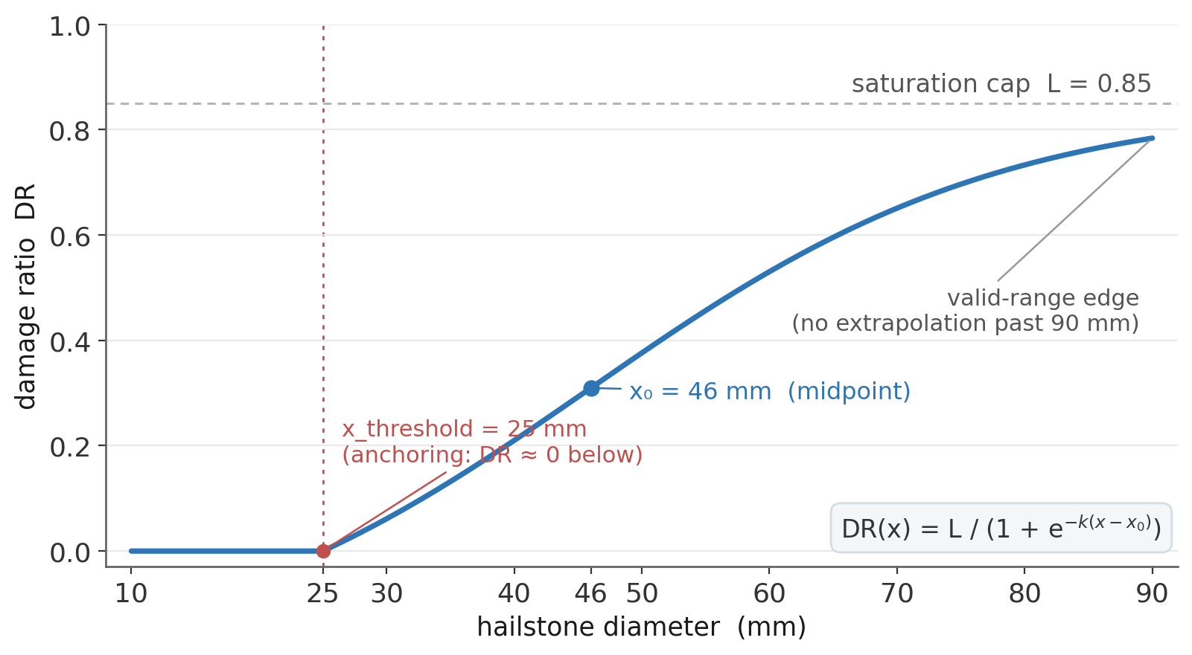
Illustrative anchored logistic for the module failure-unit under hail: L = 0.85, k = 0.062/mm, x₀ = 46 mm, anchored to DR ≈ 0 at x_threshold = 25 mm; no extrapolation past the valid-range edge at 90 mm. Values shown to illustrate the shape, not a specific cell’s calibration.

Failure modes the stage prevents
Failure | How FORM prevents it
Overfit on sparse anchors | Form selection card biases toward simpler forms (linear, piecewise) when anchors are sparse; PCHIP and state-based are reserved for dense or state-encoded evidence.
Sigmoid extrapolation past evidence | No-extrapolation rule cuts the curve at valid-range edges; the asymptote L is not used to imply values for intensities the curve does not cover.
Onset misrepresented (small but non-zero DR at low intensity) | Anchoring forces the curve to ≈ 0 at x_threshold; the consumer does not receive a tiny non-zero DR at 5 mm hail.
Saturation overshoot | L is the binding asymptote; emit object guarantees DR ≤ L.

8. Stage 5 — ADJUSTMENTS

Decisive question
What does the curve depend on that is not intensity, and how does each dependency enter?

Inputs
From FORM: the baseline curve for each failure-unit. From EVIDENCE: artifacts that suggest binding dependencies — fixed asset attributes (selectors), event-time states (conditioners), and value-share (exposure).

Outputs
A bound curve: D(intensity, selectors, conditioners, exposure) with each binding kind defined and parameterized.
These are three roles, not one undifferentiated “parameters” bucket, because they answer different questions at different times. A selector picks the curve; a conditioner adjusts it; an exposure scales it to dollars. Keeping them separate keeps event-time state out of curve choice and keeps the audit trail clean — a fixed asset attribute can never quietly act as an event-time adjustment, and vice versa. Two timing terms run through the stage: a binding is set at bind-time if it is fixed once, when the cell is loaded for a specific asset, and stays stable across that asset’s events; it is set at event-time if it is recomputed on each event call. Selectors and exposure are bind-time; conditioners are event-time.

The three binding kinds
Binding | When evaluated | What it does | Example (hail × solar)
Selector | Bind-time (when the cell is loaded for an asset) | Picks a curve variant from a discrete set keyed on a fixed asset attribute. | panel_type ∈ { mono-Si, bifacial } selects between two curves.
Conditioner | Event-time (each event call) | Adjusts curve parameters (typically k or x₀) based on event-time state. | stow_state at event-time shifts k by a multiplier (vendor-noted, T4).
Exposure | Bind-time (per asset) | Specifies the value-share of the asset touched by this failure-unit; the multiplier in capex-weighted aggregation. | panel_glass exposure = 0.65 of the asset capex.

Doctrine
Five rules that govern adjustment decisions:
1. Selectors are fixed at bind-time. A selector’s value does not change during a simulation. The selector partitions assets at the point of model invocation. Examples: panel type, building code era, foundation class.
2. Conditioners are event-time. A conditioner’s value is event-state, not asset-state. Examples: stow angle when storm arrives, wind direction relative to building axis, ground saturation when shake arrives. Conditioners enter as parameter multipliers, not as new x-axis variables.
3. Exposure is the value-share contract. Exposure determines how a unit’s DR scales into cell-level damage. Exposure values come from asset-level capex breakdowns and must sum to ≤ 1 across the cell’s failure-units.
4. Each binding has its own tier. A selector inferred from T2 standards is T2; a conditioner from a T4 vendor note is T4. The capability declaration weakens to the weakest binding’s tier — adjustments do not get a pass on the tier × claim matrix. Provenance covers the adjustment’s form as well as its magnitude: a conditioner records the transformation it applies (for example, a multiplier on k) and the source that motivates that form, not only the number and the tier. The reasoning for the chosen form folds into the derivation rationale.
5. Audit signature. Every binding in the curve’s signature is logged at invocation. A consumer asking "why did this asset get DR = 0.4?" can read the selector value, conditioner state, and exposure share that produced the answer.

Worked moves (hail × solar continued)
Selectors in v1.0: none yet. Bifacial selector deferred to v1.2 (per backlog).
Conditioners in v1.0: one — stow_state (T4, vendor note).
conditioner: stow_state (parameterized by stow angle ∈ {0°, 30°, 60°, 90°})
effect: k ← k × (1 + 0.15 × cos(stow_angle)) [stow_angle = the stow_state's angle; vendor-noted, T4]
backlog: paired field observations would promote to T2 or T3
Exposure:
panel_glass exposure = 0.65 (the capex share of panel glass in a panel + module assembly)
Full signature:
D(diameter, selectors={}, conditioners={stow_state}, exposure=0.65) → emit_object

Failure modes the stage prevents
Failure | How ADJUSTMENTS prevents it
Selector treated as conditioner (or vice versa) | Bind-time vs event-time rule disambiguates. A fixed attribute that varies between assets but not within an event is a selector, period.
Exposure values that sum to > 1 | Cell-level constraint: exposures must sum to ≤ 1. Enforced in the cell-package metadata.
Conditioner without provenance | Tier-per-binding rule. A conditioner with no source is a T4 item with a backlog flag, not a quiet parameter.
"Why this DR?" unanswerable | Audit signature requirement. Every invocation logs the binding values used; consumer can interrogate.

9. Stage 6 — EMIT

Decisive question
What does the curve return per event, and what is the capability declaration that ships with it?

Inputs
From ADJUSTMENTS: the bound curve. From EVIDENCE: the tier mix, the secondary uncertainty curation status, the evidence-tier × claim matrix.

Outputs
The emit shape (the object returned per event) and the capability declaration (which downstream metrics the curve supports). These two outputs are coupled — the emit shape constrains what metrics are mathematically possible; the capability declaration says which of those possible metrics are honest given the evidence.

The emit shapes
Emit shape | What it is | When to choose
Scalar mean DR | The curve returns a single number per event: mean(DR | intensity). | Evidence supports the mean but not a spread; downstream consumer (M3) only needs the mean (e.g. EAL by integrating mean over hazard).
Mean + spread | The curve returns mean and a measure of dispersion (e.g. coefficient of variation). | Evidence supports a curated spread (secondary uncertainty); downstream consumer wants per-event variance for variance-based metrics.
State vector | The curve returns P(damage_state) for a defined set of states (none, slight, moderate, extensive, complete). | Evidence is in damage states (fragility form); downstream consumer wants state-conditioned downstream actions (e.g. repair logic).
Damage distribution | The curve returns a parametrized distribution of DR conditional on intensity (e.g. Beta(a(x), b(x))). | Evidence supports a full conditional distribution; downstream consumer needs tail metrics directly from per-event variability.

What a scalar curve does and does not carry
A scalar curve is often described as having “no tail.” That is imprecise, and the distinction matters. There are two sources of variability, and a scalar curve treats them differently. Event variability — the spread in how often events happen and how severe they are — is preserved whenever the curve is applied per event across the event set. A scalar curve run over many events produces a real loss distribution and an honest expected loss. What a scalar curve drops is within-event spread — the secondary uncertainty around the mean DR at a given intensity, and the spatial variation within a single event’s footprint. That within-event spread contributes little to the expected loss but dominates the deep tail. Collapsing it to a mean upstream of a tail metric can understate a high quantile by an order of magnitude. So the rule is not “a scalar curve has no tail”; it is that a scalar tail would be understated, so the curve withholds it rather than shipping it understated. The final risk statistics come from applying the curve to the event set and reading the per-event loss distribution — which is why a scalar curve still supports an honest expected loss while withholding the quantile metrics.

Doctrine
Four rules that govern emit decisions:
1. Emit-shape selection rule. The shape is chosen by the first nonlinearity downstream that the curve must honor. If the consumer integrates over a linear functional of DR (EAL), scalar mean is sufficient. If the consumer applies a deductible (nonlinear), mean + spread or full distribution is required. If the consumer applies state-conditioned repair logic, state vector is required. The downstream nonlinearity dictates the upstream emit shape.
2. Capability declaration is the contract. The declaration is part of what ships. It names, per metric, whether the curve supports it, conditionally supports it, or withholds it; whether secondary uncertainty (spread) is carried; the cap-binding preflight that gates a scalar EAL; the valid intensity range; the weakest tier the curve depends on; and the selectors and conditioners the consumer must supply. A curve without a capability declaration is not a damage callable; it is a chart.
3. Tier × claim matrix gates the declaration. From the Evidence Reference document: the weakest-tier parameter sets the ceiling on metrics_supportable. EMIT does not negotiate this — it reads the matrix and writes the declaration.
4. Withhold, not caveat. Metrics the tier mix does not support are marked withheld in the declaration, with the reason (no secondary uncertainty curated; a T3 parameter anywhere). The consumer cannot accidentally produce a withheld metric — the callable does not emit the shape required for it.

The capability declaration schema
capability_declaration:
cell_id: <id>
cell_damage_model_version: <semver>
spread_carried: true | false (is secondary uncertainty curated?)
emit_modes_populated: [ scalar_mean | discrete_state_table |
parametric_distribution | state_ensemble ]

metrics_supportable: (per metric, not a flat list)
failure_unit_scalar_dr: supported | conditional | withheld
scenario_loss: supported | conditional | withheld
scalar_eal: supported | conditional_on_cap_binding | withheld
pml: supported | withheld
var: supported | withheld
tvar: supported | withheld

cap_binding: (a fail-closed preflight, not a flag)
policy: pass_required | fail_closed | not_applicable
preflight_status: pass | fail | not_executed
required_before_eal: true | false
tolerance_pct: <number> (default 2.5)
action_if_fail: require_mean_plus_spread_emit

valid_intensity_range: [low, high] (physical units)
source_tier: T1 | T2 | T3 | T4 (the weakest tier the curve depends on)
selectors_required: [name: domain] (supplied at bind-time)
conditioners_optional: [name: domain, tier] (event-time; tier visible to consumer)
exposure_share: <0..1>
last_recurated: YYYY-MM-DD

Worked moves (hail × solar continued)
Evidence tier mix: weakest tier in panel_glass = T2 mixed with T1. Secondary uncertainty NOT curated in v1.0.
Reading the tier × claim matrix: "T2 mixed with T1, no secondary uncertainty" → mean honest; metrics_supportable = { EAL }.
Emit shape selection: downstream M3 integrates mean DR against hail intensity hazard; first nonlinearity is annual aggregation, not per-event. → scalar mean DR is sufficient.
Capability declaration shipped:
spread_carried: false
emit_modes_populated: [ scalar_mean ]
metrics_supportable: failure_unit_scalar_dr: supported
scalar_eal: conditional_on_cap_binding
pml / var / tvar: withheld
cap_binding: policy: pass_required; preflight_status: pass
valid_intensity_range: [low, high] (physical units)
source_tier: T2 (weakest tier the curve depends on)

Failure modes the stage prevents
Failure | How EMIT prevents it
Caveated tail metric | Withhold-not-caveat rule. A VaR with weak evidence is not produced with a caveat; it is not produced at all.
Mismatch between emit shape and downstream nonlinearity | First-nonlinearity-downstream rule forces the emit shape to be sufficient for what the consumer does with it.
Quiet over-claim | Capability declaration is part of what ships. Consumers inspect it; reviewers audit it.
Dossier-declaration drift | Declaration is derived from the dossier (last_recurated, source_to_parameter). Stale dossier with current declaration is caught by the §13 validation checks.

10. Stage 7 — SHIP

Decisive question
What does the consumer receive, and on what terms?

Inputs
From EMIT: the curve, the emit shape, the capability declaration. From the entire upstream pipeline: the dossier, the source_context folder, the workbook, the cell metadata.

Outputs
A versioned, contracted cell — the complete shippable artifact described in §11 — registered for the hazard pipeline’s M3 stage to bind against.

Doctrine
Five rules that govern ship decisions:
1. Version pin. Every cell carries a semantic version. Patch increments for parameter-row revisions; minor for selector/conditioner/assumption changes; major for axis or form changes. Consumers bind to a specific version, not "latest."
2. Consumer contract. The contract names the inputs the consumer must provide (selectors, conditioners, intensity in declared units), the outputs the consumer receives (emit object per the capability declaration), and the chain conversions the consumer is responsible for (e.g. MESH → hail diameter).
3. Deviation-from-standard documentation rule. If the cell deviates from a referenced standard (a T2 source) — e.g. uses a different saturation cap than the IBHS spec recommends — the deviation is named in the dossier with the artifact that justifies it. Quiet deviation is forbidden.
4. Withheld set is enforced. The callable cannot be invoked in a way that produces a withheld metric. The runtime constraint is part of the contract.
5. Dossier ships. The dossier and source_context folder ship with the cell. Removing the dossier and shipping only the callable is forbidden — it breaks provenance and breaks the contract.

The shippable artifact
shippable cell = {
readme: cell description, version pin, capability declaration
callable: the parameterized function D(...)
source_to_parameter: the §4 table from the Evidence Reference
dossier: the §9 template from the Evidence Reference
source_context/: the durable artifacts (papers, standards, etc.)
workbook: reproducible derivation from anchors to parameters
metadata_spec: machine-readable capability declaration (YAML/JSON)
preview_renders: the curve visualized at v1, v1.1, v1.2 across variants
archive_pointer: previous versions, pinned and queryable
freshness_card: §8 of Evidence Reference
changelog: every version with the branch (B1–B6) of the change
}

Worked moves (hail × solar continued)
Shipped v1.0:
version: 1.0.0
pinned to: the hazard pipeline’s M3 stage interface
deviations from standard: none in v1.0 (curve aligns with IBHS + IEC saturation cap)
withheld: { VaR, AEP-PML, OEP-PML, TVaR } — runtime-enforced
artifact: cells/hail_x_solar/ at the repo commit hash
backlog: v1.1 secondary uncertainty; v1.1 mounting_frame curve; v1.2 bifacial selector
Consumer contract excerpt:
- M3 supplies hail diameter in mm (MESH → diameter conversion is M3’s).
- M3 supplies the stow state (by angle, an integer in {0, 30, 60, 90}) or null (defaults to unstowed).
- M3 supplies exposure_share or accepts the cell default 0.65.
- Damage cell returns scalar mean DR per event; metrics_supportable = { EAL }.
- Damage cell does NOT return spread; VaR/AEP-PML cannot be computed from this cell in v1.0.

Failure modes the stage prevents
Failure | How SHIP prevents it
Floating version (consumer pulls "latest" and silently breaks) | Version pin in the consumer contract. Consumers bind to a specific version; an upgrade is a deliberate move.
Provenance loss in transit | Dossier and source_context ship with the cell. The callable alone is not a valid shipped artifact.
Withheld-metric leakage | Runtime enforcement of the withheld set. The callable does not emit the shape required for a withheld metric.
Quiet deviation from a referenced standard | Deviation-documentation rule. A T2 standard is either matched, deviated-with-reason, or replaced — never silently overridden.

11. The cell-package layout
Every cell — every (hazard × asset) pair built using this methodology — produces a directory with a fixed layout. The layout is the same for every cell, regardless of the hazard or asset, so that a reader can navigate a new cell with no orientation.

The directory
cells/<hazard>_x_<asset>/
├── README.md ── what this cell is, version, capability summary
├── callable.py ── the function D(intensity, selectors, ...) → emit
├── parameters.yaml ── per-failure-unit parameter values
├── capability_declaration.yaml ── machine-readable contract
├── source_to_parameter.md ── the §4 table (Evidence Ref)
├── dossier.md ── the §9 dossier (Evidence Ref)
├── source_context/
│ ├── INDEX.md ── artifact ↔ parameter map
│ ├── <paper>.pdf ── T1 artifacts
│ ├── <standard>.pdf ── T2 artifacts
│ ├── <vendor_note>.pdf ── T3/T4 artifacts
│ └── <calibration_check>.md ── cross-checks not used as parameter sources
├── workbook.ipynb ── reproducible derivation: anchors → params
├── preview_renders/
│ ├── baseline.png ── DR(intensity) with no conditioners
│ ├── <selector_variants>.png ── per-variant curves
│ └── <conditioner_sweep>.png ── parameter shift across conditioner range
├── freshness_card.md ── §8 (Evidence Ref)
├── changelog.md ── every version, branch B1-B6, reviewer
└── archive/
├── v0.9/ ── prior versions pinned and queryable
└── v1.0/ ── (the version before the current one)

The minimum cell
A cell that ships at T4-everywhere with metrics_supportable = { } is still a valid cell. The minimum contents:
- README.md — states version, capability declaration (which will read empty), and what this cell does and does not yet do.
- callable.py — exists and runs; returns the declared emit shape (likely a scalar with a wide spread and a "do-not-use-for-sized-claims" flag).
- parameters.yaml — populated; T4 rows have backlog items.
- capability_declaration.yaml — metrics_supportable: empty; withheld: every metric with reason.
- source_to_parameter.md and dossier.md — populated even when T4 everywhere; backlog items name the path forward.
A cell with fewer than this is not in the system; the rest accumulates with successive versions.

12. Worked example — hail × utility-scale solar, end-to-end
A complete walk through the seven stages for one cell. The earlier sections show pieces of this example; here it is shown as a single coherent flow, the way it happens during a build. The hazard–asset pairing is real, but the parameter values, sources, and tiers below are illustrative — they show how the stages connect, not a specific cell’s live calibration. A built cell’s numbers live in its own dossier.

Stage 1 — EVIDENCE
Artifacts assembled (illustrative): a panel hail-impact study (T1 for k, x₀ on the tested module), a solar-impact specification (T2 for L, x_threshold), a mechanical-load standard (T2 corroboration of L), regional hail-loss screening values (T3, calibration only), a vendor engineering note (T4 for the stow conditioner), and several claim-adjuster reports (T3, no engineering attribution).
Source-to-parameter pre-map for the dominant failure-unit (panel_glass):
Parameter | Value (target) | Tier | Source
L | ~0.85 | T2 | solar-impact spec + mechanical-load standard
k | ~0.06 | T1 | panel hail-impact study (anchors)
x₀ | ~46 mm | T1 | impact study, midpoint of fit
x_threshold | ~25 mm | T2 | solar-impact spec, impact threshold
cond_stow | ~-0.15 k | T4 | Vendor engineering note (backlog: paired field obs)
secondary uncertainty | — | absent | BACKLOG v1.1

Stage 2 — GRAIN
Capex breakdown: panel_glass 0.65, mounting/tracker 0.20, inverter 0.10, racking 0.05.
Role assignment: panel_glass primary-nonzero; mounting/tracker conditioner-only (hosts stow_state); inverter and substation reviewed as DR≈0 for hail; racking DR≈0.
Composition: cell_DR = 0.65 × panel_glass_DR(diameter) for v1.0.

Stage 3 — AXIS
panel_glass axis: hailstone diameter (mm), valid range [10, 90] mm, no extrapolation. Hazard pipeline’s M3 stage performs MESH → diameter conversion before invoking D().

Stage 4 — FORM
Form: logistic with anchoring at x_threshold = 25 mm.
panel_glass_DR(d) = L / (1 + exp(-k × (d - x₀))) for d ≥ x_threshold
= 0 for d < x_threshold
= undefined for d ∉ [10, 90]

L = 0.85, k = 0.062 / mm, x₀ = 46 mm, x_threshold = 25 mm

Stage 5 — ADJUSTMENTS
Selectors: none in this version. Conditioners: stow_state (T4). Exposure: 0.65.
Bound callable:
D(diameter, selectors={}, conditioners={stow_state}, exposure=0.65)

internally:
k_effective = k × (1 + 0.15 × cos(stow_angle)) [vendor-noted; T4]
unit_DR = L / (1 + exp(-k_effective × (d - x₀))) if d ≥ x_threshold
= 0 if 10 ≤ d < x_threshold
= undefined otherwise
emit = unit_DR × exposure = scalar mean DR contribution

Stage 6 — EMIT
Tier mix weakest: T2 (with T1). Secondary uncertainty absent. Tier × claim matrix → metrics_supportable = { EAL } only.
Emit shape: scalar mean DR (sufficient given the downstream M3 nonlinearity is annual aggregation, not per-event deductible).

Stage 7 — SHIP
Version: 1.0.0. Consumer contract specifies M3 inputs and the withheld set. Backlog drives v1.1 and v1.2 planning. Dossier and source_context fold in.

What the consumer sees
From M3’s perspective:
D = damage_cell.load("hail_x_solar", version="1.0.0")
capability = D.capability_declaration
capability.metrics_supportable → { "EAL" }
capability.emit_shape → "scalar_mean_DR"
capability.valid_intensity_range → [10, 90]
capability.selectors_required → [ ]
capability.conditioners_optional → [ "stow_state" ]
capability.exposure_share → 0.65
for each event in catalog:
diameter_mm = M3.mesh_to_diameter(event.mesh)
if not (10 ≤ diameter_mm ≤ 90):
emit = undefined # M3 must handle this honestly
else:
emit = D(diameter_mm,
conditioners={"stow_state": asset.stow_state_at(event.t)},
exposure=asset.exposure_share or 0.65)
# M3 may compute EAL by integrating emit.mean over event probabilities
# M3 may NOT compute VaR or AEP-PML; the curve withholds the shape

13. Validation and the staged roadmap
A built cell passes validation; the cell catalog grows in a staged order. This section defines what passes and what the staging looks like.

Validation — what counts as a passing cell
A cell is shippable when every check below passes. Each check is auditable from the cell’s contents alone.
# | Check | What it verifies
1 | Capability matches dossier | metrics_supportable matches what the weakest-tier rule in the source-to-parameter table implies.
2 | No parameter without source | Every row in parameters.yaml has a row in source_to_parameter with a tier and a named artifact.
3 | Source artifacts present | Every artifact named in source_to_parameter has a file in source_context/, plus an INDEX entry.
4 | Valid range enforced | The callable returns undefined (not zero, not extrapolated) outside the declared valid_intensity_range.
5 | Withheld set enforced | The callable cannot be invoked in a way that produces a metric in the withheld set.
6 | Cap binding honored | For all in-range intensities and all conditioner values, the emit’s DR ≤ L.
7 | Exposure sums | Sum of exposure_share across the cell’s built failure-units ≤ 1.
8 | NRI calibration check (where applicable) | When applied at FEMA NRI county scale with average exposure, the cell’s implied losses are within the NRI’s expected range — used as sanity, not as fit target.
9 | Workbook reproduces | workbook.ipynb runs end-to-end and reproduces the parameter values in parameters.yaml from the anchors in source_to_parameter.
10 | Freshness card valid | last_recurated date is real; next-review date is set; staleness triggers are populated.
11 | Changelog complete | Every parameter row visible in source_to_parameter has a corresponding changelog entry (creation event minimum).
12 | Claims back-test (where data permits) | Where claim-level losses exist with engineering attribution, the cell’s mean DR predictions are compared against observed within a documented tolerance — used as evidence, not as fit target.
13 | Derivation rationale present | A derivation rationale is present for each built failure-unit: every parameter conflict between sources is named and resolved, and any ready-made curve is shown decomposed to its evidence rather than adopted wholesale.

The staged roadmap
Cells are built in a deliberate order — not opportunistically. The order optimizes for two things: (a) early cells should be in regions where evidence is dense enough to produce honest tier-1 capability declarations (otherwise the whole system reads as T4 placeholders); (b) later cells should leverage selectors and conditioners learned from earlier cells.
Stage A (foundation): high-evidence cells across mature hazard-asset pairs
- hail × solar (this document’s worked example)
- wind × wind-turbine
- flood × commercial-building
- shake × residential
→ each builds toward metrics_supportable = { EAL } baseline
→ establishes the selector/conditioner vocabulary across hazards

Stage B (depth): second-version of stage-A cells with curated secondary uncertainty
- hail × solar v1.1 (unlocks VaR)
- wind × wind-turbine v1.1
- flood × commercial-building v1.1
→ metrics_supportable expands to { EAL, VaR, AEP-PML }
→ builds the secondary-uncertainty curation playbook

Stage C (breadth): adjacent cells leveraging stage-A vocabulary
- hail × wind-turbine, hail × residential
- wind × commercial-building, wind × residential
- flood × residential, flood × industrial
→ reuses selector/conditioner patterns from stage A
→ cells start at metrics_supportable = { EAL } and grow

Stage D (frontier): novel hazard-asset pairs with thin evidence
- wildfire × structure
- shake × novel structures
- compound (e.g. surge + wind)
→ ships with metrics_supportable possibly = { } in v1.0
→ evidence backlog drives staged upgrades

Discipline of the roadmap
Three things the staged roadmap protects against.
First, opportunistic cell creation. Without a roadmap, cells get built where data is at hand — which is correlated with what the team happens to be working on, not with what produces the most informative early system. The roadmap forces a deliberate sequencing.
Second, selector/conditioner vocabulary fragmentation. Stage A cells establish a vocabulary; later cells reuse it. Without staging, every cell invents its own selectors and the system loses cross-cell coherence.
Third, illusion of coverage. A system with 30 cells all at T4 is not 30 cells of coverage; it is 30 cells with empty metrics_supportable. Staging makes the coverage story honest: stage A produces fewer cells but each cell ships meaningful metrics.

14. Cross-reference index
Every concept in this document maps to one or both of the companion documents.

Into the Terminology document
Concept here | Defined in Terminology
Damage curve as callable | §1 Orientation; §2 Curve family
Failure-unit and roles | §3 Grain terms
Axis, valid range, no extrapolation | §4 Shape terms
Logistic form parameters (L, k, x₀, threshold) | §4 Shape terms
Selector / conditioner / exposure | §5 Binding terms
Emit shapes; capability declaration | §7 Emit terms
Tier × claim; curated-not-fitted; provenance | §6 Evidence terms

Into the Evidence Reference document
Concept here | Defined in Evidence Reference
Tier taxonomy (T1–T4) | §2 Tier taxonomy
Source classes (papers, claims, standards, etc.) | §3 Sources by class
Source-to-parameter mapping | §4 Source-to-parameter mapping
Provenance and source_context folder | §5 Provenance and source-context
Evidence-tier × curve-claim matrix | §6 The matrix
Six-branch ingestion protocol (used in changelog branch column) | §7 Ingestion protocol
Freshness card and staleness triggers | §8 Freshness and staleness
Dossier template | §9 Cell evidence dossier template

Reader’s walkthrough across all three documents
A new teammate.
Reads Terminology end-to-end (one pass) to absorb the vocabulary. Reads Evidence Reference §1–6 to understand how evidence is tiered and what it authorizes. Reads this document end-to-end. Reads the worked example in §12 last to see the seven stages collapsed into one cell.
An engineer building a new cell.
Starts at stage 1 of this document. Pulls the §4 source-to-parameter pre-map template from Evidence Reference. Iterates through stages 2–7. Validates against §13. Ships via §10 and the §11 layout.
A reviewer auditing an existing cell.
Opens the cell’s dossier. Cross-checks the capability declaration against the Evidence Reference §6 matrix. Walks the seven stages of this document against the cell’s contents — looking specifically for the failure modes named in each stage’s "Failure modes the stage prevents" table.
A consumer (M3 engineer) integrating a cell.
Reads the cell’s README and capability declaration. Confirms M3’s nonlinearity matches what the emit shape supports. Implements the chain conversions named in the consumer contract. Pins to a version; does not pull "latest."

Closing
The pipeline is strict-order because the dependencies are: evidence authorizes; grain decomposes; axis indexes; form parameterizes; adjustments bind; emit declares; ship contracts.
A curve built this way carries its evidence inside, its capability declaration on the outside, and its consumer contract at the boundary. The combination is what makes the callable defensible, composable, and updatable — the three properties the damage layer exists to deliver.
What ships at the end is not a chart and not a number. It is a callable artifact, versioned, with a contract that names what it can and cannot honestly support — the input the hazard pipeline’s M3 stage binds against.

