DAMAGE MODELING TERMINOLOGY
The vocabulary the rest of the damage layer assumes — input terms, shape terms, binding terms, evidence terms, emit terms.

Author: InfraSure
Audience: Internal modeling team; consumers of the damage callable
Folder: Reference
Companions: Damage Curve Build Methodology (the build pipeline that uses these terms)
Reads: Dictionary-style — read end-to-end once to absorb the family resemblances, then refer back as needed.

How to read this document
Each section names a family of terms (e.g. the curve family, the grain family, the binding family). A term appears under exactly one family — the family it belongs to. Where a term is commonly confused with one in another family, the confusion is flagged inline and again in §8.
Read the families in order on a first pass; on later passes, jump straight to the family you need. The final index in §9 lets you find any term in one hop.
Terms are written in the form term — definition. Where a term has a tight technical pair (e.g. damage ratio vs damage state), the pair is laid out as a small table that makes the distinction explicit. Where a term lives outside this document — defined in the methodology — the section says so and points there.

1. Orientation
Damage modeling translates a hazard intensity at an asset into a damage outcome — typically a fraction of value lost. Five terms recur from the first page: a cell is one hazard × asset pair; a failure-unit is the atom at which one curve is written; a damage callable is that curve as a callable function; DR (damage ratio) is its output, a fraction of value lost; and a curve maps intensity to DR. This document defines the words the rest of the damage layer uses; it does not build curves (that is the Build Methodology) and it does not catalog individual cells (those live in the per-cell folders).
Two ideas anchor everything below. First, a damage curve is a callable, not a chart. When we say "the hail × solar curve," we mean a parameterized function that returns a damage outcome for a given intensity, with metadata describing what it can honestly support downstream. The plot is just one rendering of that callable. Keeping the callable framing in mind avoids most of the vocabulary confusions in the rest of the document.
Second, damage is plural per cell. A single hazard × asset pair almost always involves multiple curves (one per failure-unit; e.g. blade, tower, nacelle, foundation for wind × wind-farm). The word "the damage curve for X" is shorthand; the precise thing is a family of curves indexed by failure-unit and composed by capex-weighted summation.
Both ideas recur throughout the families below.

The damage callable in one box
Before the words, the shape:
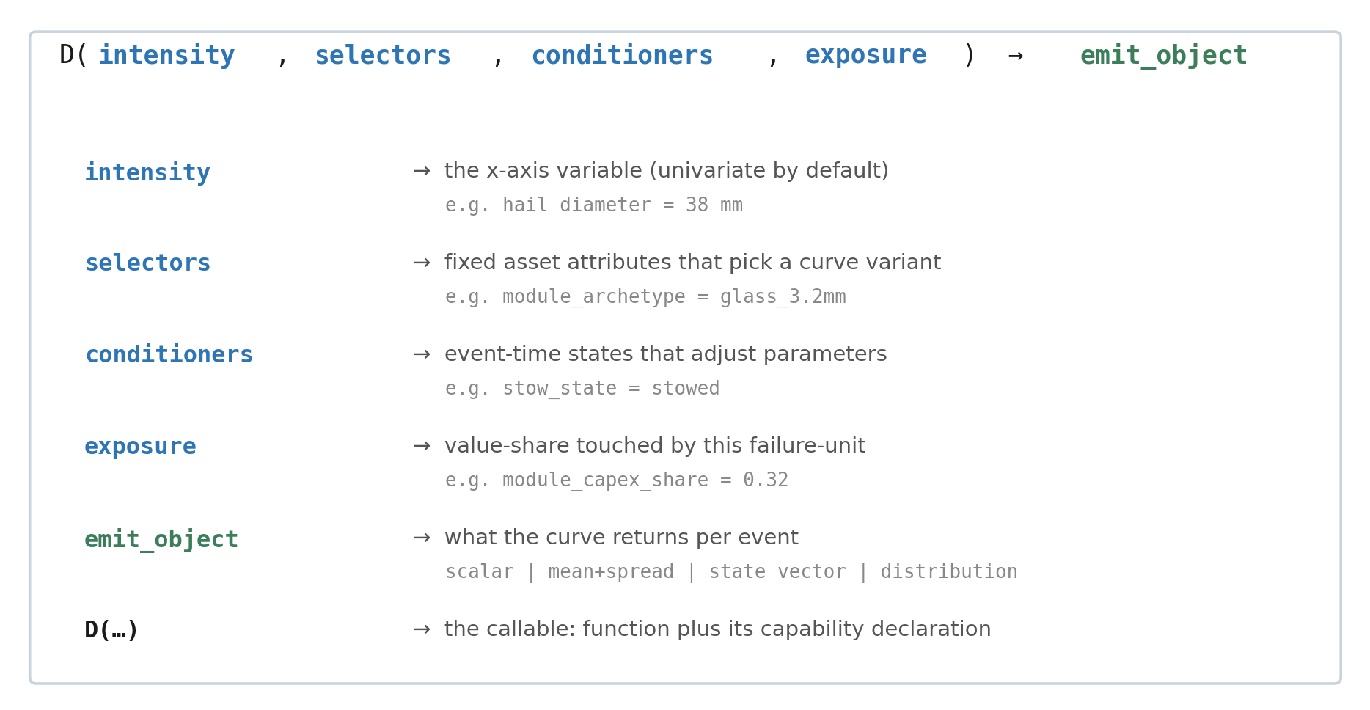
The damage callable in one box: every term in this document is a piece of this signature, a fact about how it was built, or a fact about what it can honestly support.

Every term in the rest of this document is either a piece of that signature or a fact about how the callable was built or a fact about what the callable can honestly support downstream. Each family below groups terms of one kind.

2. The curve family
These terms name nearby but distinct objects, and the field uses them inconsistently. The table below fixes what each one is, what it returns, and the confusion it resolves.
Family map — what each term is, what it returns, the confusion it kills.
Term | What it is | Returns | The confusion it kills
Vulnerability function | Intensity → mean damage ratio. A single-value function of intensity. Hail × solar: 60 mm hail → DR ≈ 0.5. | a number in [0, 1] | Synonym with damage function and loss function. "Fragility" is not a synonym.
Damage function | Same object as vulnerability function. Different field, same math. | a number in [0, 1] | See above — synonym with vulnerability function.
Loss function | Same object again, in the actuarial dialect. | a number in [0, 1] | See above — synonym with vulnerability and damage function.
Fragility function | Intensity → P(reach each damage state). A vector of probabilities. Hail × solar: 60 mm hail → P(none, slight, moderate, extensive, complete). | a probability distribution over discrete states | NOT a synonym for vulnerability. A fragility function is an input that you aggregate into a vulnerability function — not a substitute for it.
Severity distribution | The distribution of loss sizes pooled across events. Hail × solar: the per-event DRs from many storms, gathered into one distribution — no calendar. | a probability distribution over dollars | Not an AEP and not an OEP. No calendar. Per-event, not annual.
Derating curve | Non-damaging stress → output forgone (MWh). Solar: a heat-derate curtailing inverter output — MWh lost, no physical damage. | forgone production | Not a damage function. Revenue, no physical damage. Lives in the disruption track, not the damage callable.

Vulnerability and fragility — the genuine distinction
A fragility function is the richer object; a vulnerability function is its costed expectation. The conversion is mechanical when you have a cost ratio per damage state:
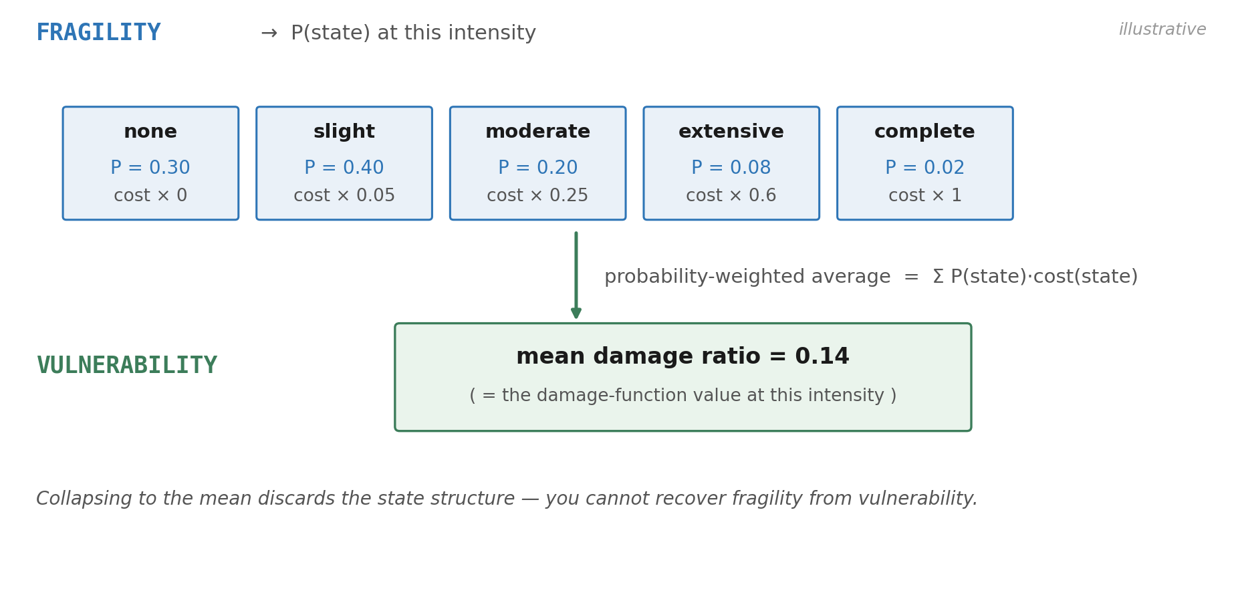
A fragility function (probabilities over discrete states) collapses into a vulnerability function (one mean damage ratio) via a cost-weighted average. The reverse is not possible.

Two practical consequences. First, a fragility function "becomes" a vulnerability function the moment you attach a cost-per-state vector — but you lose information in the process (the state probabilities collapse into one number). Second, a vulnerability function does not become a fragility function. The state structure is gone; you cannot recover it from the mean.

Damage ratio (MDR) versus damage state
Two different answers to "how damaged is this asset," at different resolutions.
Term | What it is | Resolution
Damage ratio | Repair cost ÷ replacement value. A continuous fraction. Sometimes written DR, sometimes mean damage ratio (MDR) when the context is "expectation of." | continuous, [0, 1] (sometimes [0, 1+] when repair > replace)
Mean damage ratio (MDR) | The expected value of the damage ratio at a given intensity. What a vulnerability function returns. | continuous scalar
Damage state | A discrete bin — typically none / slight / moderate / extensive / complete (HAZUS conventions). What a fragility function distributes over. | discrete, 4-5 bins

The ratio between them: MDR = Σ_s p(state_s) · cost_ratio(state_s) — a scalar collapse of the discrete distribution.

Severity distribution
A damage curve emits per-event outcomes; pool those outcomes across many events and you get a severity distribution. It is per-event, not annual. It has no calendar. It is one of the building blocks the hazard pipeline uses to construct annual aggregates (AEP and OEP); those live downstream of the damage callable, in the hazard methodology, not here.

Derating curve — what it is not
A derating curve maps a non-damaging operating stress (e.g. ambient temperature) to lost output (MWh). It is a revenue-side object: no physical damage occurs, no repair cost is incurred. Damage modeling excludes derating from the curve — that channel belongs to the disruption track, which is an additive stage downstream of damage. Conflating the two is the most common scope-creep error: a damage estimate quietly read as if it covered derating, business interruption, curtailment, or deductibles.

3. The grain family
Grain is the resolution at which we write curves and compose losses. Get the grain wrong and every downstream choice is contaminated. We use a four-level vocabulary, and which level a damage curve is written at is a deliberate choice.
Level | What it is | Example
Cell | A project-management unit. One (hazard × asset) pair. Each cell ships independently with its own version, dossier, and metadata. | hail × solar; flood × solar; wind/tornado × wind-farm
Failure-unit | The curve-record unit. The atom at which one damage curve is written. A cell typically contains multiple failure-units. | PV_MODULE_GLASS_CELL; INVERTER_ELECTRICAL_INGRESS; BLADE_STRUCTURAL
Subsystem | The value-link and reconciliation unit. Used to assign a capex weight to losses. A subsystem can contain one or many failure-units. | PV_ARRAY; INVERTER_SYSTEM; TURBINE_ROTOR
Component | The procurement / asset-register unit. Lives in the asset model, not the damage model. | PV module; central inverter; blade

Two rules govern how curves are written at this grain:
- Subsystem-default. Write a curve at the subsystem grain unless one mechanism concentrates damage in a sub-part of the subsystem, in which case go finer (typically to a failure-unit inside that subsystem).
- Cap-and-sum, no grouping primitive. Compose losses across failure-units by capping each at its at-risk fraction of value and summing. We do not group failure-units into a synthetic "unit" object, because summation already composes losses across the asset tree. Grouping is only justified when joint ≠ sum — i.e. parts interact — and no in-scope hazard currently does that.

Coverage roles within a cell
Inside a cell, each failure-unit carries a coverage role telling the consumer how the curve participates in the cell-level result.
Role | What it means | Treatment
primary-nonzero | Owns a curve; the main damaged value bucket. Its emit value drives the cell-level damage ratio. | Returned by the cell callable.
secondary-conditional | Owns a curve; a smaller co-event contributor at the same event. | Returned alongside primary; summed.
conditioner-only | No curve of its own; hosts a conditioner that shifts another unit's curve, changing its vulnerability (e.g. stow_state adjusting a hail curve). | Not summed. Used as a conditioner input.
exposure-protection-modifier | Changes the affected amount or removes the hazard pathway — not the unit's vulnerability (e.g. a flood wall or raised elevation). | Applied to exposure / hazard reaching the unit, not to the curve.
DR≈0-reviewed | Reviewed and explicitly judged to contribute negligible damage. Documented, not silently dropped. | Documented but not modeled. Not silent.

A cell's coverage taxonomy is not optional documentation. "DR ≈ 0" is a positive claim, not an omission — it says we looked and judged the contribution negligible. An unreviewed failure-unit is a different (and worse) thing: a known unknown.

4. The shape family
Once a failure-unit and an x-axis are chosen, the curve has a shape. The shape vocabulary names both the functional form and the geometric features that make a curve honest.

Functional forms
Form | Defining shape | When to use
Logistic (sigmoid) | S-curve with threshold, midpoint, and saturation. DR(x) = L / (1 + exp(−k·(x − x₀))). | Default. Used for all built cells. Three physically meaningful parameters.
Piecewise / state-based | Step-like; damage ratio jumps at thresholds tied to discrete event states (e.g. inundation reaches threshold T). | Flood electricals; any failure where a state change drives the damage, not a continuous response.
Linear | DR = m · x + b within a bounded range, with saturation at the cap. | When evidence supports only a slope and no curvature; rare.
PCHIP / interpolation | Shape-preserving interpolation between knots; no parametric form. | When evidence gives a clean knot set and a parametric fit would impose unjustified shape.

The default of logistic is not a habit — it is a parsimony rule. Three parameters, all physical, each interpretable. Use a different form only when evidence shape demands it; document the deviation. Reflexive lognormal fits are explicitly avoided: they obscure the threshold-and-saturation shape that damage curves actually have.

Geometric features
The features that make a curve honest about what it represents. They divide into two groups. Threshold, saturation cap, and anchoring are form-agnostic — every damage curve has them, whatever its functional form. Midpoint x₀ and steepness k are logistic-only — they are the logistic’s shape parameters; a piecewise or state-based curve has different ones. Keeping the two groups distinct is what lets a non-logistic curve still declare a threshold and a cap.
Feature | What it is | Why it matters
Threshold | The intensity below which damage is effectively zero. | A real physical property. A curve with no threshold (DR(0) > 0) is suspect unless explicitly anchored.
Midpoint (x₀) | The intensity at which DR reaches half its cap (50%-damage point). | The natural reporting axis for "how vulnerable is this asset?"
Steepness (k) | The slope of the logistic at x₀; controls the width of the transition band. | Distinguishes brittle (high k) from graceful (low k) failure modes.
Saturation cap (L) | The asymptotic upper bound on DR. Equals the at-risk fraction of value for this failure-unit. | Caps the curve at physical reality. No extrapolation past it.
Anchoring | A correction that removes a non-physical floor DR(0) > 0 by subtracting it from the curve. | Selectively applied: yes wildfire, yes wind; no hail (IBHS curve already sharp).
Saturation rule | The composition rule: cell-level cap = Σ wᵢ Lᵢ, no extrapolation past it. | Replaces older "ran to 100%" curves that lied about full-replacement intensities.

The shape these features produce
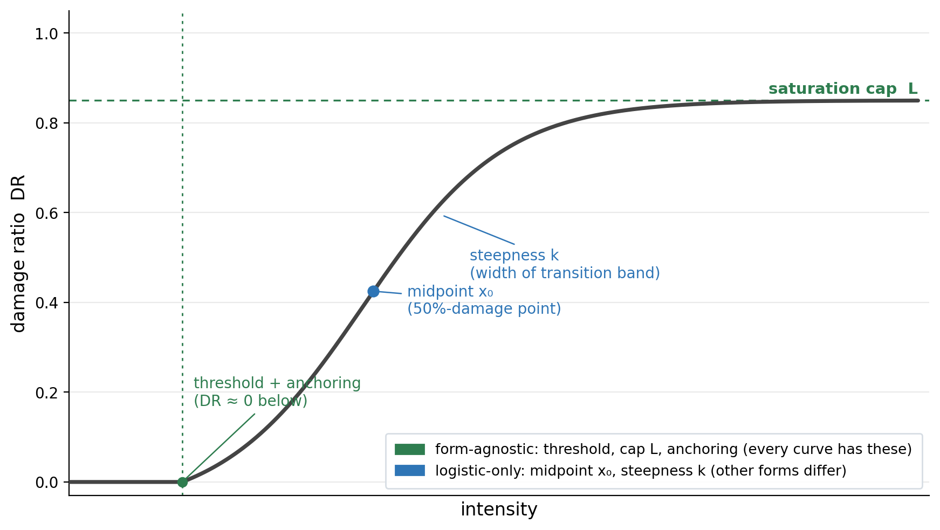
The anchored logistic and its features, split by which ones every curve has. Form-agnostic features — threshold, saturation cap L, and anchoring — belong to any damage curve, whatever its functional form. Logistic-only features — midpoint x₀ and steepness k — are specific to the logistic; a piecewise or state-based form has different shape parameters.

5. The binding family
A curve is parameterized once. It is called many times — once per event — across many different asset configurations. The binding family names the three kinds of context that turn a parameterized curve into an actual damage outcome at a specific asset, in a specific event.
Term | What it is | Set when
Selector | A fixed asset attribute that picks a curve variant from a family. Examples: tracker_type, panel_glass_type, transformer_type. | Once per asset. Stable across events.
Conditioner | An event-time state that adjusts a curve's parameters before it is evaluated. Examples: stow_state, water_residence_time, yaw_error. | Per event. Varies by event.
Exposure variable | The value-share or count that the curve's emit applies to. Examples: panel_count, BoS_fraction, tower_height. | Once per asset (typically). Used to convert DR into a loss.

Selector and conditioner are siblings, not parent and child. Two axes tell them apart: when it is set (bind-time vs event-time) and what it changes (a selector picks which curve; a conditioner adjusts that curve’s parameters). Exposure is the third role: it translates the result into dollars. Keeping the axes straight is what prevents the classic trap of using an event-time state like stow_state as a selector — that smuggles event-time information into curve choice and breaks the audit trail. The three answer different questions: selectors pick the right curve; conditioners adjust how it is read this time; exposure variables translate the result into dollars. Mixing them — e.g. using stow_state as a selector — would smuggle event-time information into the curve choice and break the audit trail.

How they combine in one call
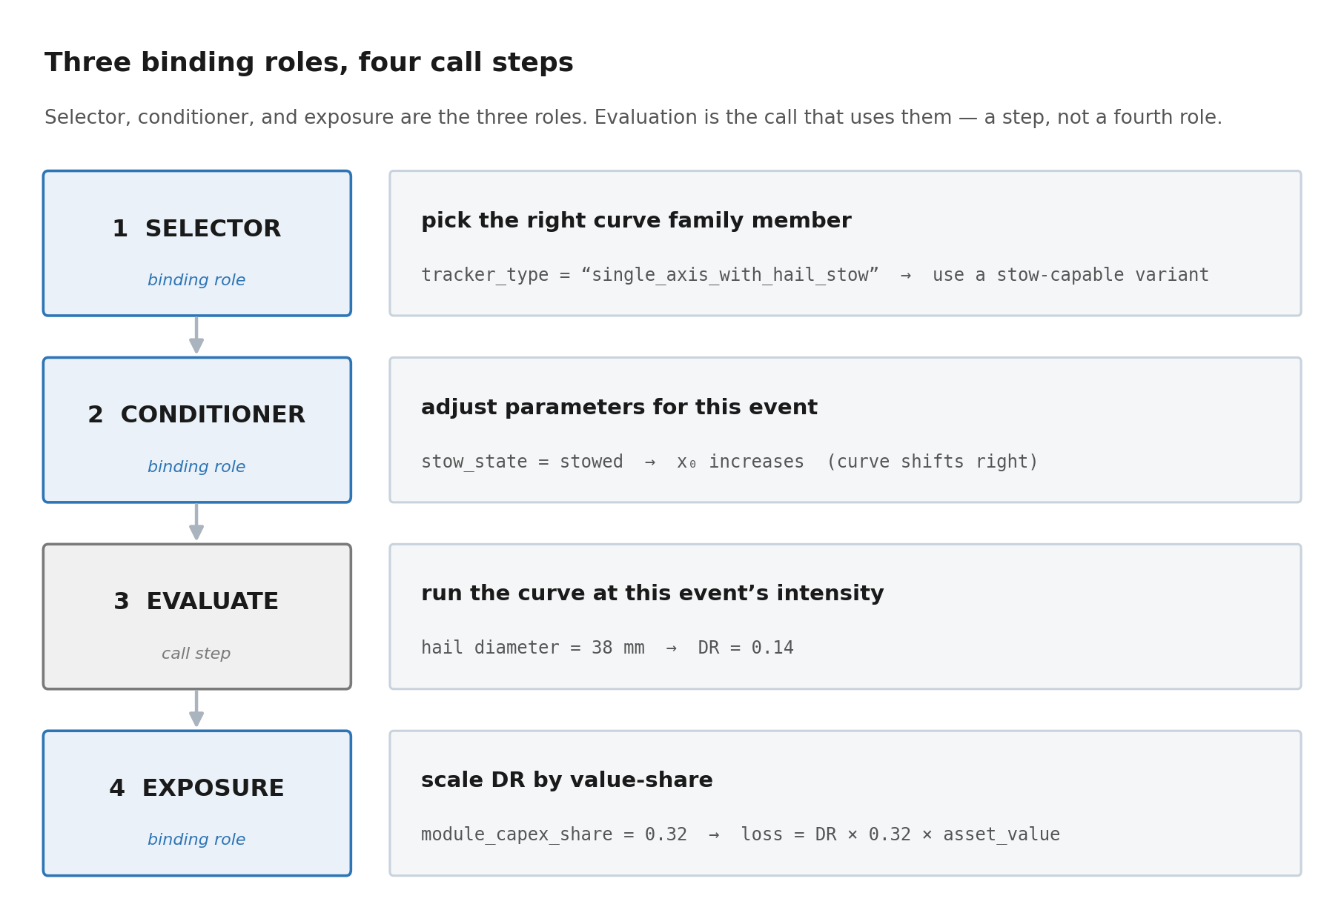
The three binding roles (selector, conditioner, exposure) and the evaluation step that uses them, composed in one call: the selector picks the curve, the conditioner adjusts it, evaluation runs it, and exposure scales the result to dollars.

In the methodology, this four-step sequence is the inside of every damage callable. The vocabulary here is what each step does; the methodology says how each step is built.

Resiliency and adaptation reuse the same three knobs
A resiliency or adaptation measure does not need a fourth binding role. Each one maps onto a knob that already exists: hardening the asset (a hail-rated module) is a selector that picks a tougher curve; an operational response during the event (stowing a tracker) is a conditioner; protecting or relocating value (a flood wall, raised siting) changes the exposure the curve applies to. Naming the knob each measure uses keeps the model from growing a special case for every intervention.

6. The evidence family
Damage curves are built from a curated stack of evidence rather than fitted to a single pooled dataset. The evidence vocabulary names the kinds of evidence, the discipline that distinguishes them, and the trail that proves which piece supports which parameter.

The evidence tiers
Not all evidence is equal. We use a four-tier hierarchy, and the tier authorizes what the curve is allowed to claim downstream. A tier grades an artifact for the specific claim being made, not in the abstract: the same forensic study is T1 for the event it covers and T3 when transferred to a different asset or hazard. Five T3 sources do not make a T1 — only a more confident T3. Tiers are re-examined at every curve update.
Tier | What it is | What it authorizes
T1 — direct empirical | Loss observed on the actual asset × hazard, intensity recorded or reconstructible. Examples: attributed claims, field campaigns, realistic test stands, and forensic studies for the event they cover. | Anchors and mean shape in-range; tail metrics too, if secondary uncertainty is curated.
T2 — engineering standards | Consensus standards and lab tests (IEC, IEEE, IBHS, UL, ASCE, HAZUS). Designed to characterize failure modes, not to estimate loss. | Thresholds, saturation caps, damage-state cutoffs; cross-asset calibration. Informs midpoint and steepness with care.
T3 — inferred / proxy | A related-but-not-identical asset, hazard, or scale: coupon tests, analogous assets, cross-event transfer, or a forensic study applied elsewhere than the event it covers. | Order-of-magnitude shape and documented variant selectors. Backs no sized metric on its own — a T3-dependent curve renders and informs but supports no EAL, PML, VaR, or TVaR.
T4 — expert judgment | Documented credentialed opinion or elicitation; OEM notes that are not test reports. | A provisional curve’s existence plus selector / conditioner short-lists. No sized metrics. Carries an explicit flag.

Curation discipline
Three terms describe how evidence becomes a curve. They are the operating mode of the damage layer.
- Curated, not fitted. Which evidence is admissible, and the axis, form, and anchors, are decided by reasoning about what each source authorizes — the objection is to fitting one pooled, heterogeneous dataset, not to fitting at all. Curation sets the frame; fitting is allowed inside it. An optimizer may fit to source-pinned anchor points and report residuals, but it never overrides the anchors or pools evidence across tiers. The balance slides with the data: sparse, non-jointly-observed evidence is curated heavily; rich, jointly-observed, homogeneous data lets fitting carry more weight, still inside the frame.
- Source-to-parameter mapping. Every parameter (L, k, x₀, or knot values for non-parametric forms) is mapped to the specific source that pins it. The dossier carries this mapping; without it, the curve is unprovable.
- Provenance travels. When a curve is consumed downstream — e.g. when the hazard M3 stage binds to a damage callable — the source tier and provenance flags travel with the call. The consumer sees what the curve is built on, not just the number it returns.

Source-context and the evidence backlog
Two operational terms.
- Source context. The artifact every parameter points back to — a paper, a standard, a claims extract, a vendor report — stored in a citable, version-pinned form. The cell's dossier links to these.
- Evidence backlog. Sources known to exist but not yet ingested into the curve. A documented backlog is part of the curve's honesty: it says "this is what would update the curve if we ingested it next."

7. The emit family
A curve emits something each time it is called. The emit family names what the callable returns and what it formally promises about that return. The shape is not a matter of risk appetite; it is forced by the first nonlinearity downstream. A scalar mean is correct — not a compromise — when everything downstream is linear in DR: integrate the mean over the event set and the expected loss is exact. The moment a downstream step is nonlinear in DR (a deductible, a tail quantile, state-conditioned repair logic), the mean is no longer sufficient and the curve must emit a spread, a distribution, or a state vector. Shape follows the consumer’s math, not the modeler’s preference.

Emit object shapes
Shape | What it is | When the curve emits this
Scalar mean DR | Just the mean damage ratio. A single number. | When everything downstream is linear in DR (e.g. EAL by integrating the mean) and the cap rarely binds.
Mean + spread | Mean DR plus a measure of secondary uncertainty (variance, CV, or 5/95 band). | When evidence supports a spread and downstream wants to propagate uncertainty into tail metrics.
State vector | A probability distribution over discrete damage states. | When the underlying evidence is a fragility function and collapsing to a mean discards information the consumer needs.
Damage distribution | A full continuous distribution over DR (or a parameterized one). | When tail metrics need to be honest and the cap may bind. Highest fidelity, highest cost.

Capability declaration
Every emit object ships with a capability declaration — metadata that tells the consumer what the callable can honestly support. This is the central honesty mechanism of the damage layer.
capability_declaration:
spread_carried: true | false (is secondary uncertainty curated?)
emit_modes_populated: [ scalar_mean | discrete_state_table |
parametric_distribution | state_ensemble ]

metrics_supportable: (per metric, not a flat list)
failure_unit_scalar_dr: supported | conditional | withheld
scenario_loss: supported | conditional | withheld
scalar_eal: supported | conditional_on_cap_binding | withheld
pml | var | tvar: supported | withheld

cap_binding: (a fail-closed preflight, not a flag)
policy: pass_required | fail_closed | not_applicable
preflight_status: pass | fail | not_executed
required_before_eal: true | false

valid_intensity_range: [low, high]
source_tier: T1 | T2 | T3 | T4 (the weakest tier the curve depends on)
cell_damage_model_version: <semver>

The capability declaration is what makes the curve auditable. A downstream consumer who asks for a tail metric (TVaR, AEP-PML at long return periods) must check metrics_supportable. If the requested metric is not listed, the metric is withheld, not caveated. "Withheld, not caveated" is doctrine: the curve does not return a number with a footnote — it returns no number, and the consumer must either upgrade the curve (richer emit, richer evidence) or accept the absence.

Version pin
Two terms that often get confused.
- Cell damage-model version. A semantic version (v1.0, v1.1, v2.0) attached to the cell's damage callable. Changes when the callable's behavior changes — new evidence, new failure-unit, recalibrated parameters.
- Package release version. The version of the documentation/library release containing many cells. A documentation refresh that does not change any callable is a documentation revision, not a model version bump.
A consumer of the damage callable pins the cell damage-model version it is using, so that downstream results are reproducible even when the cell evolves.

8. Confusions at a glance
The high-leverage confusions, in one place. Each row names the two terms, the place the confusion lives, and the rule that resolves it.
Term A | Term B | The rule that distinguishes them
Vulnerability | Fragility | Vulnerability is a costed expectation (a number). Fragility is a probability distribution over discrete states (a vector). Vulnerability is derived from fragility + cost-per-state; the reverse is not possible.
Damage ratio | Damage state | Damage ratio is a continuous fraction. Damage state is a discrete bin. DR = Σ_s p(state_s) · cost_ratio(state_s).
Damage | Loss | Damage is physical (a fraction of value impaired). Loss is the dollar consequence after value, terms, and downstream stages. Damage is the damage layer's output; loss is what the hazard pipeline computes from it.
Damage | Derating | Damage is physical impairment requiring repair. Derating is non-damaging output forgone (e.g. heat curtailment). Derating belongs to the disruption track, not the damage callable.
Cell | Failure-unit | A cell is a project-management unit (one hazard × asset pair). A failure-unit is a curve-record atom (e.g. PV_MODULE_GLASS_CELL). One cell contains multiple failure-units.
Failure-unit | Subsystem | A failure-unit is the curve grain. A subsystem is the value-link grain. Multiple failure-units can share one subsystem (and thus its capex weight).
Selector | Conditioner | A selector is a fixed asset attribute that picks a curve variant. A conditioner is an event-time state that adjusts an already-picked curve. The selector is stable; the conditioner varies event-to-event.
Curated | Fitted | A curated curve is framed by reasoning about what each source authorizes — which evidence is admissible, the axis, the form, the anchors. A fit is the residual of an objective function. The two are not opposites: curation sets the frame, and an optimizer may fit to source-pinned anchors inside it. What is ruled out is fitting one pooled, heterogeneous dataset and letting it override the frame.
Threshold | Saturation cap | Threshold is the low-intensity edge (below which DR ≈ 0). Saturation cap is the high-intensity edge (above which DR does not grow). Both can be inferred from evidence; neither is a fitted artifact.
Scalar mean DR | Mean + spread | Scalar emits one number. Mean+spread emits a number plus a measure of secondary uncertainty. The downstream consequence is whether tail metrics are honest.
Withheld | Caveated | Withheld = the curve does not return a value for this metric (it is not in metrics_supportable). Caveated = the curve returns a value with a footnote. We do the first; we do not do the second.

9. Cross-reference index
Every term defined in this document, alphabetical, with its section and (where applicable) the doc that uses it operationally.
Term | Section here | First operational use
Anchoring | §4 geometric features | Methodology — FORM (anchoring rule, applied selectively)
Capability declaration | §7 capability | Evidence Reference — what each evidence tier authorizes
Cap-and-sum | §3 grain rules | Methodology — GRAIN (composition rule)
Cell | §3 grain levels | Methodology — the cell package layout
Cell damage-model version | §7 version pin | Methodology — SHIP (consumer pin)
Component | §3 grain levels | (Asset model; outside damage layer)
Conditioner | §5 binding | Methodology — ADJUSTMENTS (event-time state)
Coverage role | §3 coverage roles | Methodology — GRAIN (primary / secondary / DR≈0)
Curated, not fitted | §6 curation discipline | Methodology — EVIDENCE (the operating mode)
Damage callable | §1 orientation | Methodology — the deliverable
Damage distribution | §7 emit shapes | Methodology — EMIT (highest-fidelity shape)
Damage function | §2 curve family | Methodology — FORM (the curve being parameterized)
Damage ratio (DR / MDR) | §2 curve family | Methodology — EMIT (the scalar mean shape)
Damage state | §2 curve family | Methodology — EMIT (state vector shape)
Derating curve | §2 curve family | (Disruption track; outside damage layer)
DR≈0-reviewed | §3 coverage roles | Methodology — GRAIN (positive claim, not omission)
Evidence backlog | §6 source-context | Methodology — EVIDENCE (deferred ingestion)
Evidence tiers | §6 tiers | Methodology — EVIDENCE (authorization rule)
Exposure variable | §5 binding | Methodology — ADJUSTMENTS (value-share)
Failure-unit | §3 grain levels | Methodology — GRAIN (the curve atom)
Fragility function | §2 curve family | Methodology — EMIT (state vector emit)
Functional form | §4 forms | Methodology — FORM (logistic default; alternatives)
Inferred / proxy (T3) | §6 tiers | Methodology — EVIDENCE
Loss function | §2 curve family | (Actuarial dialect; synonym)
Mean + spread | §7 emit shapes | Methodology — EMIT (when tail honesty needed)
Mean damage ratio (MDR) | §2 curve family | Methodology — EMIT (the scalar shape)
Metrics_supportable | §7 capability | Methodology — SHIP (consumer contract)
Midpoint (x₀) | §4 geometric features | Methodology — FORM (the 50%-damage point)
Exposure-protection-modifier | §3 coverage roles | Methodology — GRAIN (exposure / protection role)
Package release version | §7 version pin | Methodology — SHIP (vs cell version)
PCHIP | §4 functional forms | Methodology — FORM (non-parametric option)
Piecewise / state-based | §4 functional forms | Methodology — FORM (flood electricals)
Primary / secondary | §3 coverage roles | Methodology — GRAIN (the role taxonomy)
Provenance | §6 curation discipline | Methodology — EVIDENCE (travels with the call)
Expert judgment (T4) | §6 tiers | Methodology — EVIDENCE
Saturation cap (L) | §4 geometric features | Methodology — FORM (no-extrapolation rule)
Scalar mean DR | §7 emit shapes | Methodology — EMIT (default shape)
Secondary uncertainty | §7 emit shapes (mean+spread) | Methodology — EMIT (the spread)
Selector | §5 binding | Methodology — ADJUSTMENTS (fixed attribute)
Severity distribution | §2 curve family | (Hazard pipeline; downstream of damage)
Source context | §6 source-context | Methodology — EVIDENCE (the citable artifact)
Source-to-parameter mapping | §6 curation discipline | Methodology — EVIDENCE (the audit trail)
State vector | §7 emit shapes | Methodology — EMIT (fragility-grade emit)
Steepness (k) | §4 geometric features | Methodology — FORM (transition width)
Subsystem | §3 grain levels | Methodology — GRAIN (value-link grain)
Threshold | §4 geometric features | Methodology — FORM (low-intensity edge)
Vulnerability function | §2 curve family | Methodology — FORM (the curve as a function)
Withheld, not caveated | §7 capability + §8 confusions | Methodology — SHIP (the honesty mechanism)

A note on scope. This document defines vocabulary. It does not build curves (that is the Damage Curve Build Methodology) and it does not catalog cells (those live in the per-cell folders inside the repository, organized by the cell-package layout described in the methodology). If a term you need is not here, it is either downstream of the damage callable (hazard pipeline) or asset-model-side (procurement vocabulary). The cross-references in §9 say which.

