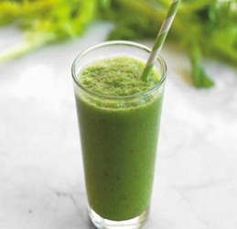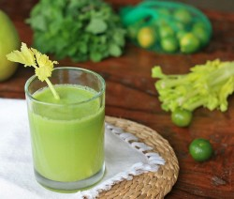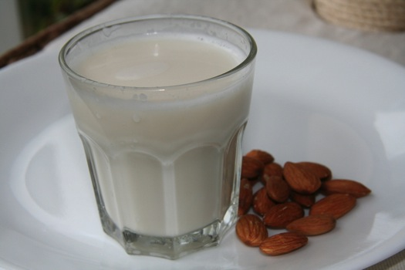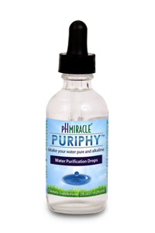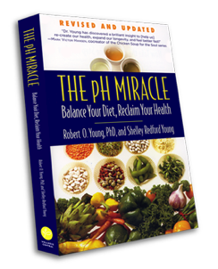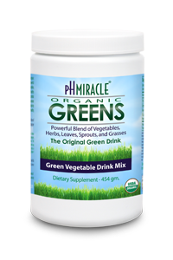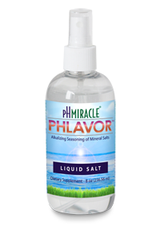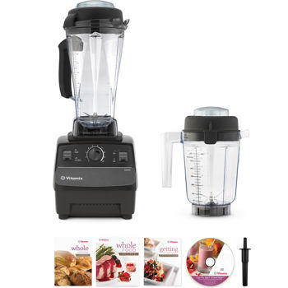

* Cathy Maxwell’s

$97 Value

http://www.healthyhabitsutah.com

**FREE**

**REPORT**

**5 Secrets to a Healthier,  
Sexier Spring Body**

# Health & Wellness Seekers,

# I’m Cathy Maxwell, founder of [HealthyHabitsUtah.com](http://www.healthyhabitsutah.com) which offers weekly articles from moi about alkalized living, health, happiness, spirituality and all things good. I tend to lean on the vegan side and call this ‘plant passionate living’.

My physical health journey began in 1990 when I was in an awful snow skiing accident. Surgeries have put me back together, however my body was so crippled and acidic, I was diagnosed with both Fibromyalgia and Chronic Fatigue. Both conditions are a direct result of a high level of acidosis- although I didn’t have that information at the time.

I learned of Dr Robert O Young and his “New Biology” about five and a half years ago. It made sense. I have since had the privilege to study with Dr. Young and have received a Coaching and Microscopy certification from him. Following his protocol and keeping my body alkaline has allowed me to regain my health: gives me healthy blood cells, high energy levels, keeps me lean, has cleared up brain fog, gives me a clear complexion and has cleared my femoral artery blockage. There are so many more benefits I could go on and on.

Two years ago my neck was rebuilt with three new disks, a metal plate and eight screws. My healing from this surgery was very successful. What I am facing now is Deep Brain Stimulation Surgery. I have had an Essential Tremor for twenty five years.

My first of three surgeries is scheduled for early June. This will be my twenty sixth surgery. Needless to say my body has been through more than most can imagine. Yet through alkalizing, my body is in better shape than most.

I have been revving up the alkalinity train so that my body is fully prepared and has alkaline reserves ready. My goal is to be in the best health possible walking into the hospital so that my body will be at its peak state to fight off hospital infections and to more easily recover from the drugs and anesthesia. You can follow my journey by following my blog at [blog.healthyhabitsutah.com](http://blog.healthyhabitsutah.com).

I have learned to take personal responsibility for my well-being at the deepest level imaginable. Now I want to show you how to take charge of your own health and radiance with some plant passionate living: green juicing, alkalizing and a little sassiness!

Each and every one of us has the power to change the wellness in our families and in our kitchens. By making these five simple changes consistently, you can see improvements in the quality of your life. It is up to you. I can tell you about them, but only you can do them. Learn to live like you really mean it. No one can take better care of you than wise, brilliant, capable and STRONG you...

Make these five simple Healthy Habits stick. Get inspired – print it out, hang it on your fridge and read it daily! This step alone will have a big impact on your life. Remember you are the change you’ve been waiting for.

Juice Up!

***Cathy Maxwell***

PH Miracle Certified Coach & Microscopist

Column 2

**Energy Filled Green Drink**

It’s my favorite morning beverage. This recipe makes about 32 ounces after processing through a juicer.

2 large cucumbers (peeled if not organic)

A colander full of spinach (or kale, chard etc)

6 stalks of celery

**Green Avocado Smoothie**

Mix these ingredients in a blender. Adjust the lime according to your taste buds!

2 avocados

Juice of 2 limes

1 cucumber

Handfuls of spinach

Few ice cubes

Ionized water (or filtered water)

RECIPES

Acidosis

Our bodies become full of acid or reach a high level of acidosis very easily through unhealthy eating and living. This includes toxic effects of external sources such as: exposure to air pollution, second hand smoke, and stress to name a few.

Our bodies can’t tolerate extended acid imbalances. When this happens we are set up for sickness and disease. Needless to say, when we test the pH of a person with disease, their reading is very low. It is also very surprising to my clients how low their pH readings are when tested. (Not so surprising to me, because I understand the average American diet)

You may remember from Chemistry the relationship between acid and base is quantified on a scale of 0 to 14 known as pH. On that scale 7 is neutral. Below 7 is acidic and above is basic or “alkaline”. Our blood should ideally be maintained at 7.365 pH. This is slightly alkaline and is critical for good health.

Cutting back or avoiding food in a box: frozen or fast-food and eating mostly real, live food will help you to increase your alkalinity. My clients test their alkalinity by using a pH strip dipped in urine. It takes twenty parts alkalinity to neutralize one part acidity.

The five secrets that I am giving you is a big step in the right alkalizing direction. Do yourself and your health a huge favor and implement them today. Your body will thank you, your family and friends will ask what you’ve done differently. *You will be amazed*!

Alkalinity

Copyright **©** HealthyHabitsUtah 2013 | www.healthyhabitsutah.com

**Secret 1 – The Right Water:**

Fully hydrating the body with lots of good quality water is the quickest and easiest way to reach and maintain good health. I encourage all of my clients to drink at least four liters (about one gallon) of water each day. Yes, I said four liters a day, but don’t worry I will tell you how to do it!

I drink one liter of water when I wake up in the morning. I drink another liter by noon, one by three and my last one by six pm. Just make sure you stop drinking water in this quantity by six pm so that you can get a good night sleep with no bathroom interruptions. And guys, to get four liters of water in my body every day, I need to gulp my water, not sip, but gulp my water. If I just sipped my water all day there is no way I would get the necessary water into my body that it needs. That doesn’t mean you have to gulp water so that it’s running down your face in front of your new boss or, on a hot date. After increasing your water up to four liters, challenger yourself to add two additional liters in the mix for a total of six liters and you’re on your way to excellent hydration!

Our body cells are only as healthy as the fluids they are bathed in. Unfortunately, the water you need is not flowing from your tap and it’s not in your bottled water either. Those water sources are acidic. Ionized water is the best choice. This is water that is highly alkaline, highly charged and full of potential energy. The next best source is filtered water.

**5 Secrets to a Healthier,**

**Sexier Spring Body**

5 Secrets to a Healthier, Sexier Spring Body

Copyright **©** HealthyHabitsUtah 2013 | www.healthyhabitsutah.com

**Secret 2 – Deep Breathing:**

The body releases acidic toxins from deep breathing because it increasing your lymphatic flow. I recommend that you take long deep breaths through the nose and then release the air slowly back out through the mouth - making a loud noise. You may be thinking, “seriously, this is a secret?” But how often do you consciously sit and do deep breathing throughout the day? Chances are never.

I recommend that you start with 3 sets of 10 deep breaths a day. And I mean actually taking a deep belly breath, holding it for at least 10 seconds, blowing it out and doing it again 10 times. You will be surprised how this will make you feel! You will have more energy than you can remember having in years.

There’s no mistake that this resembles many popular mediation practices. Conscious breathing helps center the mind as well as the body.

When you’re thinking you need a cup of coffee or an energy drink, do this instead. It is amazing and free too!

5 Secrets to a Healthier, Sexier Spring Body

Copyright **©** HealthyHabitsUtah 2013 | www.healthyhabitsutah.com

**Secret 3 – Green Juice:**

When you drink your vegetables your body is receiving a greater concentrations of rapidly usable alkaline salts, vitamins, minerals, chlorophyll, electrons, and can assimilate them more easily and rapidly.

Juicing also has a very cleansing effect on our intestines. Use organic vegetables whenever you can. I even grow a lot of my own vegies so that I can have them fresh daily! If you don’t already have a juicer, look for a good one that is easy to clean. Mine also has a grinder option. This allows me to grind soaked almonds so that I can make my own almond milk. Most juicers do not offer this option. I love it. I add a touch of fresh almond milk on top of my fresh green juice. I start every day with a green juice or smoothie. For added alkalinity have two or three throughout the day!

5 Secrets to a Healthier, Sexier Spring Body

Copyright **©** HealthyHabitsUtah 2013 | www.healthyhabitsutah.com

**Secret 4 – Avoid Dairy:**

Dairy products contain acidic hormones, pesticide residues, microforms, mycotoxins, and saturated acid fats. Milk sugar also causes the biological transformation of healthy body cells into bacteria, yeast, and mold.

Dairy is known to be the leader of all foods in forming sticky mucus. If you have to have a glass of milk, the only good choice is unprocessed goats milk from organically grown and grazing goats.

I drink almond milk when I am missing a glass of milk. This way I still get my protein and calcium and the creamy sensation of a milky drink. I make sure to get the unsweetened version. There are other varieties out there to allow you to avoid dairy – give them a try too.

As mentioned in the green juice section, my juicer also comes with a grinder feature allowing me to make almond milk fresh. This is the best ever and a real treat! You will notice that by leaving dairy out of your menus, unwanted pounds will shed away more easily and you will be less congested in your throat.

5 Secrets to a Healthier, Sexier Spring Body

Copyright **©** HealthyHabitsUtah 2013 | www.healthyhabitsutah.com

**Fruits**: Eat high-sugar acidic fruit on their own-and only in moderation. They are not a friend to alkalinity. The exceptions are Alkalizing Fruits-lemon, lime, grapefruit, raw tomato, avocado, red, yellow, green and orange peppers. Enjoy as many as you would like.

**Vegetables**: Eat all the vegetables you would like. Get creative with green salads and finger foods. I often carry cucumber and red bell pepper sticks in my purse – yum! Vegetables may be eaten with either Protein meals or Starch meals or alone.

**Healthy Alkalizing Mono and Polyunsaturated Oils**: Use these with alkaline vegetables, alkalizing fruit, starches, seeds, nuts and avocados. I use Omega 3-6-9 Essential Oil Blend.

**Protein Meal**: Eat protein with all the vegetables you would like and/or all the alkalizing fruits you would like. . ie- a piece of grass fed beef or organic chicken with a big green salad with broccoli and green beans.

**Starch Meal**: Eat starch with all the vegetables you would like and/or all the alkalizing fruits you would like..ie- quinoa with tomato, cucumber, avocado, salsa, red onion, hemp seeds, broccoli, red bell pepper, squeeze of lime, and omega oil (one of my fav meals!)

* **Secret 5 – Food Combining:**

To ensure proper alkalization of food in your stomach, food combining is an important consideration. You will find extra pounds –acidic weight – will also drop off pretty easily when you follow these guidelines. Here are the basics:

5 Secrets to a Healthier, Sexier Spring Body

**About the Author**

Cathy is a passionate woman, wife, mom, yogi, entrepreneur, and adventurer. After spending decades climbing the corporate ladder in the airline and mortgage business, Cathy jumped off the proverbial cliff and returned to her long rooted desires and love as a health and lifestyle coach to gutsy Women and Men.

Cathy is an expert who inspires others to take their health to the next level and to align their lives so that they may "Thrive".

She is a certified pH Miracle Health Coach and combines Nutritional Live Blood Analysis (one who studies blood under a high powered microscope) with her health practice. She has studied at Anthony Robbins Master University and has been trained in the Art of Reiki and the Oneness Blessing.

5 Secrets to a Healthier, Sexier Spring Body

Copyright **©** HealthyHabitsUtah 2013 | www.healthyhabitsutah.com

With these five steps, I know that you can advance your health to the next level if you are conscientious and consistent. I know that if you slip, you can plug yourself back into the five steps to get back on the journey, just as I have over the years. I have unwavering faith in this process.

Right On! Now that you are at the end of this report, I believe you will have dreamed a powerful new vision for yourself, learned a new breathing technique and realized the importance of food combining. It now makes sense for you to avoid dairy products and drink the best quality water in large quantities. Look forward to starting your day with green vegetable juice and smoothies. ***You’re on your way to a Healthier, Sexier Spring Body!***

What’s Next?...

Are you ready for more support on your body and soul journey?  I have success tools and the motivation to get you to the next level!!

Lets Fly Together!

Copyright **©** HealthyHabitsUtah 2013 | www.healthyhabitsutah.com

5 Secrets to a Healthier, Sexier Spring Body

**The PH Miracle Book** – **Revised and Updated by Dr Robert O Young and Shelley Redford Young**. This incredible book is one everyone should own. It talks about the benefits of living an alkaline life and teaches you how to do it. It talks about alkaline exercises, has a great recipe section from Chef Shelley, and introduces you to amazing new concepts. You can order the Alkalizing Bible for just $16.95

**PuriPhy™** – This product actually ionizes your water and increases the alkalinity from a 7pH up to a 10-11 pH. PuripHy is water purification in a bottle. Adding five drops per liter of water it neutralizesalgae, bacteria, yeast, molds, parasites, exotoxins and mycotoxins in your water. It also helps your blood absorb more oxygen from the water you drink. One bottle has 180 servings. $49.95 2oz

THAT’S ONLY 27 CENTS FOR AN IONIZED, PURE LITER OF WATER!

This is a no brainer for your health.

**How to get started:** To further help you in integrating the “5 secrets to a Healthier Sexier Spring Body” I have recommended a book, written by my mentor, Dr Robert O Young, and a few alkalizing products that I use daily. I have also given you some direction on juicers and blenders.

5 Secrets to a Healthier, Sexier Spring Body

Copyright **©** HealthyHabitsUtah 2013 | www.healthyhabitsutah.com

Copyright **©** HealthyHabitsUtah 2013 | www.healthyhabitsutah.com

**Phlavor™** – Health is energy and to have sustainable energy, Dr Young believes we need salt. Not just any salt, but nature’s salt. This is natural saline from the North Shore of the Great Salt Lake and is used to replace lost electrolytes in our bodies. Did you also know that when you are craving sugar, it is actually your body’s desire for the proper kind of salt? (this is all explained in The PH Miracle Book above ) These sprays are purse size. I always have one in my purse, one on my desk and one beside my bed. This spray helps to keep me alkalized, energized and to keep cravings at bay. A 2 0z bottle is $9.95

**pH Miracle® Greens™** – In my opinion, the very best green drink on the planet! This organic powder has 36 ingredients made up of vegetables, fruits, grasses, roots and leaves. It is electronically charged and ionized. The only one I know of on the market that can make that claim. Dr Young has made this super concentrated. He has taken 28 pounds of greens to make 1 pound of product. There is no way I could get this amount of greens into me in a day. Drinking my greens helps me raise my alkalinity and fight off sickness and disease. These greens are also chlorophyll rich and help me to build my blood. Currently on Sale for $71.20

5 Secrets to a Healthier, Sexier Spring Body

**Juicers** – You can buy juicers starting at $30 and up. They are going to be harder to clean, louder and may not last as long as a more expensive one. That’s ok. It’s your 1st juicer. If you’re like me you are going to do what you need to do to get healthy: borrow a juicer, ask your Mom or significant other to buy one for your upcoming birthday, or just because you’re a good person! Just get a juicer! The juicer pictured to the left is the model I’ve grown into. It grinds nuts so that I can make my own fresh nut milk which is important to me. It is a PowerGrind Pro and retails for $342.98 (It’s also possible to find good products at discounts on sites like eBay, Craigslist or local classified ad sites.

**Blender –** I am hoping that most everyone already has a blender. Ideally you want something a little bit stronger than the average $20 blender so that it will chop up the cucumber in the smoothie. When I started making my smoothies I had the average low-end blender. I chopped up my cucumber into tiny little cubes by hand and just took the time with the blender to make the smoothies with what I had. It worked. It just took extra time. I wanted to get healthy bad enough to be patient. I tell you this because I know you do too. You don’t need a big fancy blender (but it’s really nice).

The blender pictured to the left is a Vitamix 5200 that retails for $499 and is the one I use now.

5 Secrets to a Healthier, Sexier Spring Body

Copyright **©** HealthyHabitsUtah 2013 | www.healthyhabitsutah.com

Take and implement these “5 secrets” my friends and make them Healthy Habits! I look forward to giving you more information in the future about my Healing 14 Day Group Cleanses and about the Individualized Coaching I offer. Keep an eye out for my next ezine publication of “Thrive”.

My web site is new and is a work in progress. As of today, you cannot order the products I recommended directly on my site, however, you can shoot me an email at [healthyhabitsutah@gmail.com](mailto:healthyhabitsutah@gmail.com)and I will return your call for your order. Please include your phone number and the best time of day to reach you. A shopping cart is in the works, so this should not be an issue very long.

Create a Radiant and Alkaline Day

– and remember to Laugh...its Alkalinzing!! (true)

5 Secrets to a Healthier, Sexier Spring Body

Copyright **©** HealthyHabitsUtah 2013 | www.healthyhabitsutah.com

[](https://twitter.com/healthyhabitsut)[](https://www.facebook.com/HealthyHabitsUtah)[](http://blog.healthyhabitsutah.com)

For my weekly blogs and videos about alkaline living, health, happiness, sassiness, spirituality, compassion and all things good; visit <http://www.healthyhabitsutah.com>.

To chat with me online, follow me on twitter, read my blog and sign up for my eZine, and like my Facebook fanpage.

Stay Connected:

Cathy Maxwell

Draper, Utah 840202  
(801) 651-3452

www.healthyhabitsutah.com

##### Healthy Habits Utah