Crazy Squares

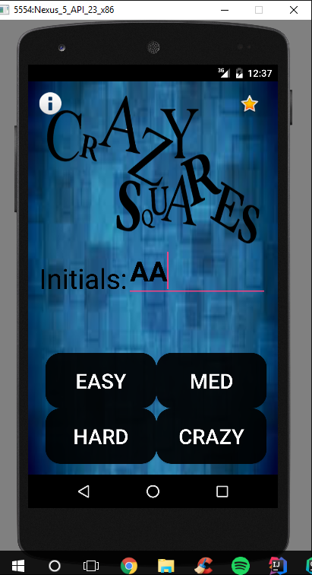

Match together 3 colors in a row.

**3 levels**

Easy – Match together 3 of the same colors in a row. You can never get rid of black squares. Black squares come 5% of the time. The region is a 4x4 square. The colors that pop up are blue, green, pink, yellow, red, and black.

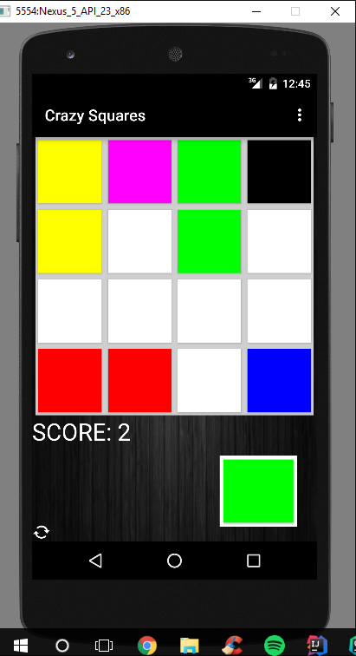

Medium – Match together 3 of the same colors in a row. You can never get rid of black squares. Black squares come10 % of the time. The region is a 4x4 square. The colors that pop up are blue, green, pink, yellow, red, and black.

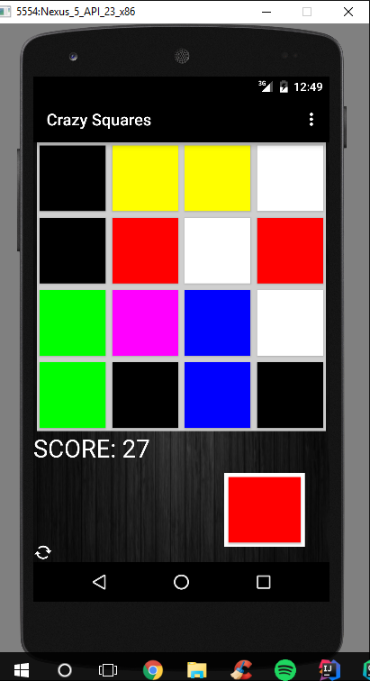

Hard – Match together 3 of the same colors in a row. You can never get rid of black squares. Black squares come 11% of the time. The region is a 5x5 square. The colors that pop up are blue, red, green, pink, yellow, baby blue, orange, purple , and , black

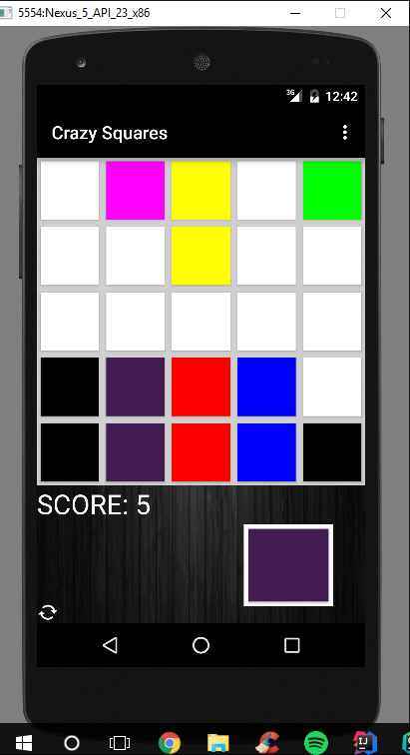

High Scores – Save High Scores locally to your phone. Coming soon: Log in with Facebook and check leaderboard against your Facebook friends.

