**UNIT II FREQUENCY TRANSFORMATIONS  
2.1 INTRODUCTION TO DFT –2.2 PROPERTIES OF DFT – 2.3FILTERING METHODS BASED ON DFT – 2.4FFT ALGORITHMS DECIMATION – IN – TIME ALGORITHMS, 2.5DECIMATION – IN – FREQUENCY ALGORITHMS – 2.6USE OF FFT IN LINEAR FILTERING – DCT.**

**2.1 Introduction to DFT:**





**DFT is useful in transformation of signal from one domain (time) to another domain(frequency).**

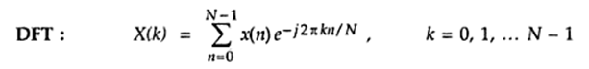

**Here “k” indicates the index of frequency& “N” is the length of input sequence x(n).**

**The IDFT is defined as,**

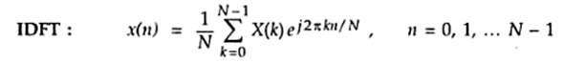

**DFT interms of Twiddle factor:**

**Twiddle factor**

**Thus DFT equation can be written as, &**

**IDFT can be written as**

**1.Determine the 4-point DFT of,**

** ; N=4;**

** **

**Let k=0,**



**For k=1,**

**  Thus ;**

**For k=2,**

**  Thus **

**For k=3,**



** Thus **

**Thus the DFT of X(n) is **

**2.Find the IDFT of X(k)= { 4,0,0,0}**

** Here N=4;**

**For n=0,**

**  Thus **

**For n=1,**

** **

**For n=2,**

** **



**For n=3,**

** **

**Thus IDFT of X(k) is **

**3.Practice:Find 8-point DFT of x(n)={1,2,3,4}**

**Here N=4; But we have to find for 8 point;So append zeros,such that,**

**x(n)={1,2,3,4,0,0,0,0}; Hence N=8;**

**4.Practice: Find the IDFT of**



**5.** Compute DFT of x(n)={0,2,3,-1}. Sketch magnitude & phase spectrum.













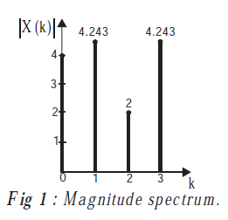 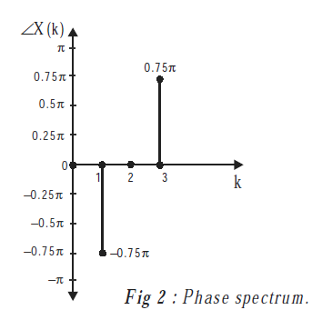

**2.2 Properties of DFT:**





**Statement:**







**Proof:**













**Proof:**



















**Proof:**







** **

** (or) **



**Proof:**



**  **





**Proof:**

** Since **

**Thus **











**Proof:**

**   **







**Proof:**



**8.**





**Proof:**













**9.Complex conjugate property:**





**Proof:**



**Note:**





**Similarly by using IDFT formula, next equation can be proved.**

**6.Find the DFT of x(n)={1,2,3,4} by using twiddle factor.**

**=]**

**Here N=4; =];]=**

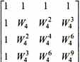

**Twiddle factor**



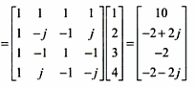

**Note: Similarly IDFT in terms of twiddle factor,=]**

**7.Practice:Find IDFT of X(k)={10,-2+2j,-2,-2-2j}**

**8.Find the circular convolution of **

**by DFT-IDFT method.**

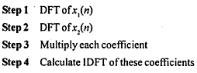



** **



**Similarly,**

** **





** ;**



**;**



** **





** thus,**

**FFT: (Fast Fourier Transform)**

**FFT is an algorithm that efficiently computes the DFT of a sequence x(n) with reduced number of calculations.**

**Steps involved:**

**1.Divide the dataset into two or more sub-data sets.**

**2.Solve each recursively & terminate the recursion when the data-set is small.**

**3.Obtain the solution to the original data-set by combining the solutions to each sub data-sets.**

**Commonly used FFTs:**

**The solution to the given data set can be obtained either in**

**(i)time-domain (Decimation-in-time FFT)or**

**(ii) in frequency-domain(Decimation-in-frequency FFT)**

**2.4 Decimation In Time (DIT) Algorithm:**

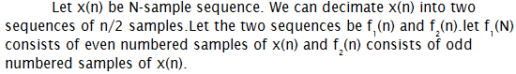

** **



** **





























** **









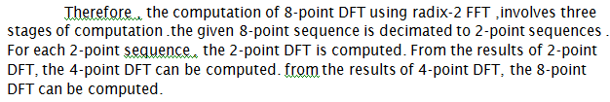



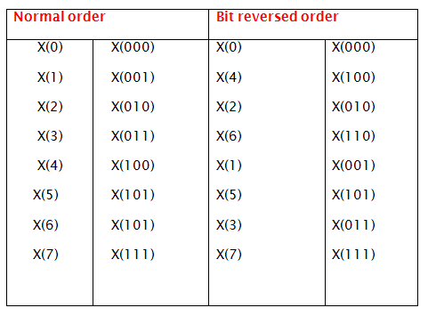







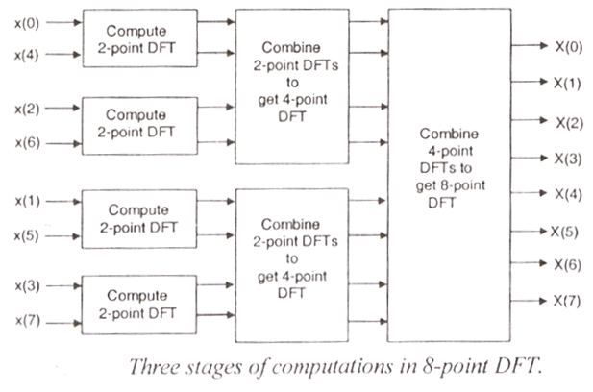



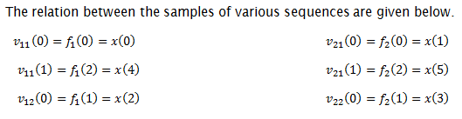













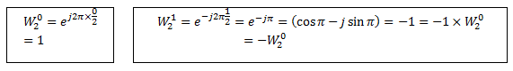



























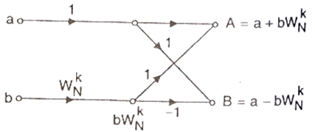

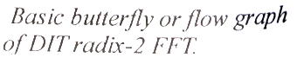



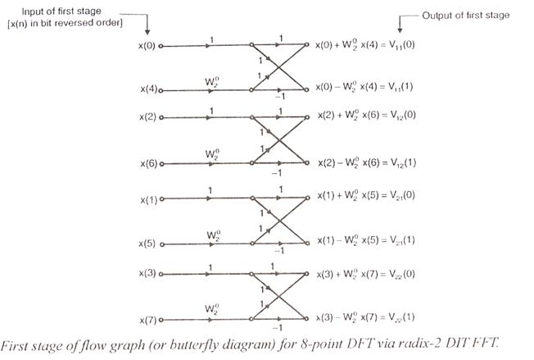

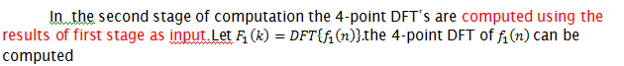



** **

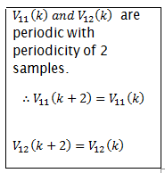

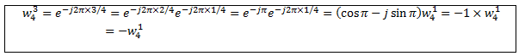









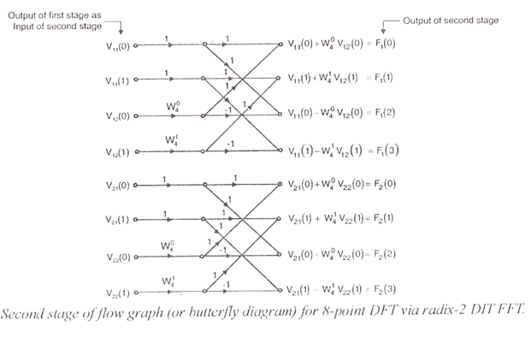















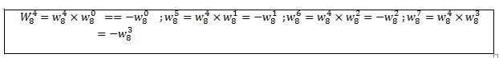

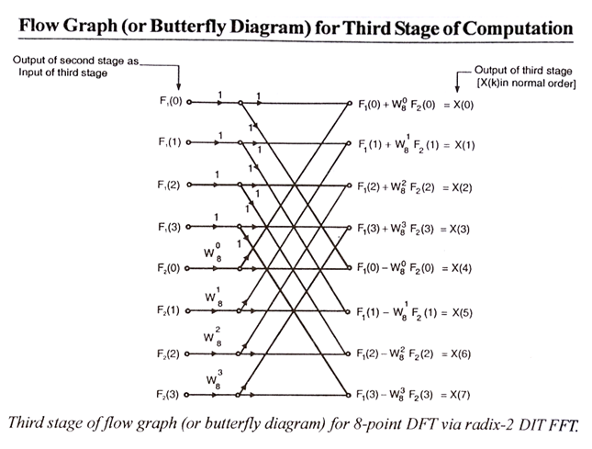

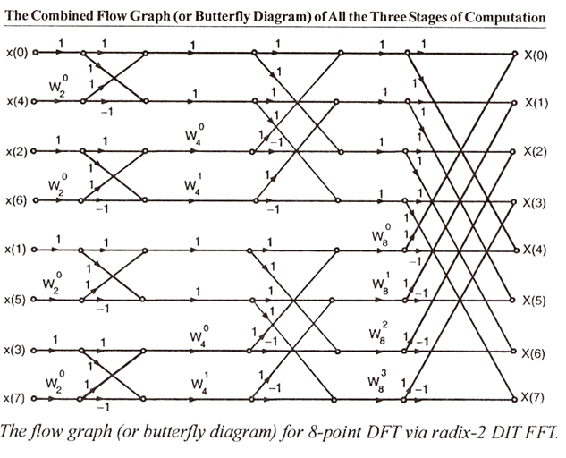

**9.**

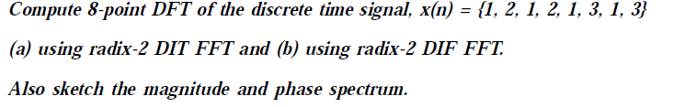

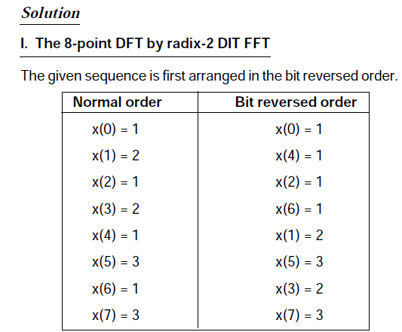



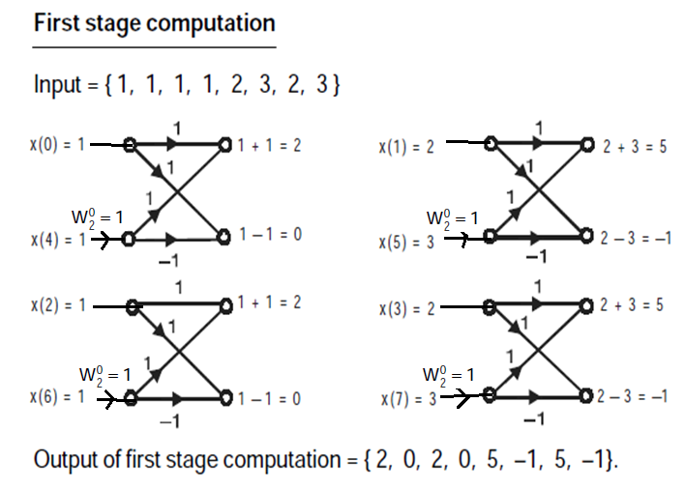

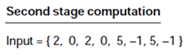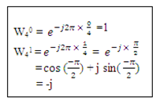

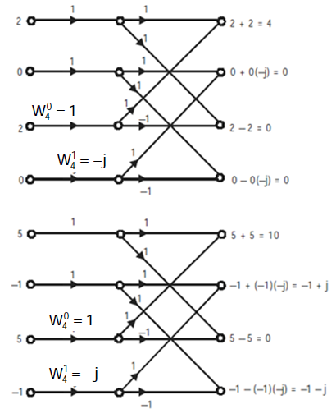



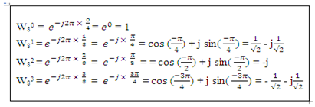

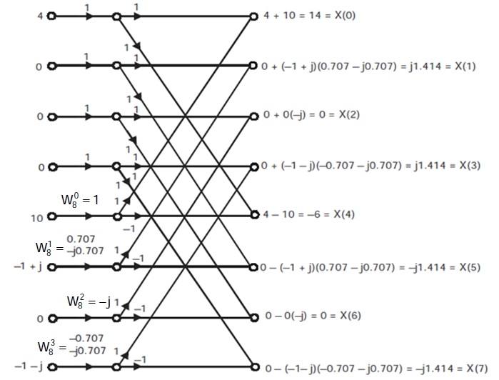

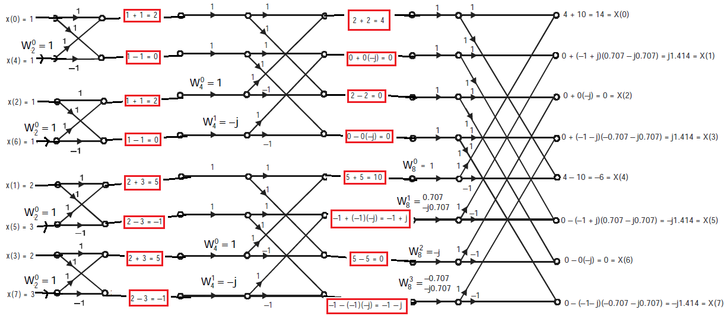

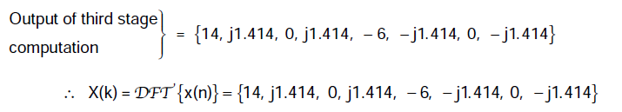



**Here in DIF algorithm,the frequency domain sequence X(K) is decimated.**



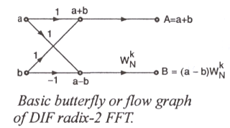

**Differences between DIT & DIF:**

1. **In DIT time domain sequence is decimated,whereas in DIF the frequency domain sequence is decimated.**
2. **In DIT the input should be in bit-reversed order & the output will be in normal order.For DIF,input is in normal order while output is bit reversed.**
3. **In butterfly diagram,in DIT the complex multiplication takes place before the add-subtract operation whereas in DIF,the complex multiplication takes place after the add-subtract operation.**

**Similarities in DIT & DIF:**

**1.In both the algorithms the value of N should be such that, N= ,& there will be m stages of butterfly computations,with N/2 butterfly per stage.**

**2.Both algorithms involve same number of operations.The total no.of complex additions are N & total no.of complex multiplications are (N/2).**

**3.Both require bit reversal at same place during computations.**

**DIF Algorithm:**

















** **

**(or)**





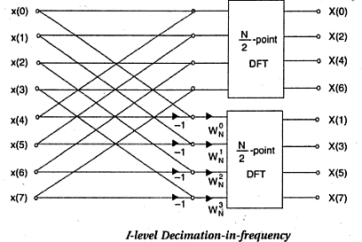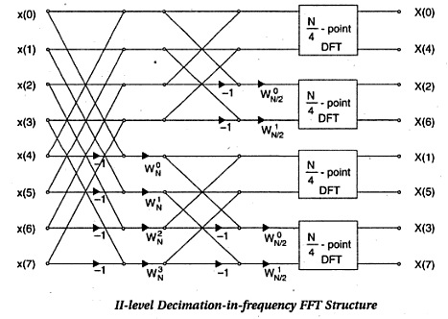

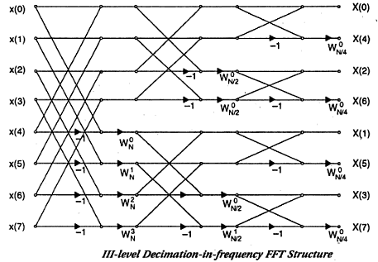

**10.**

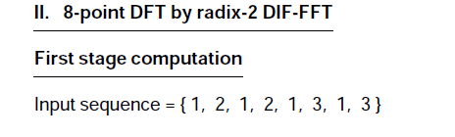

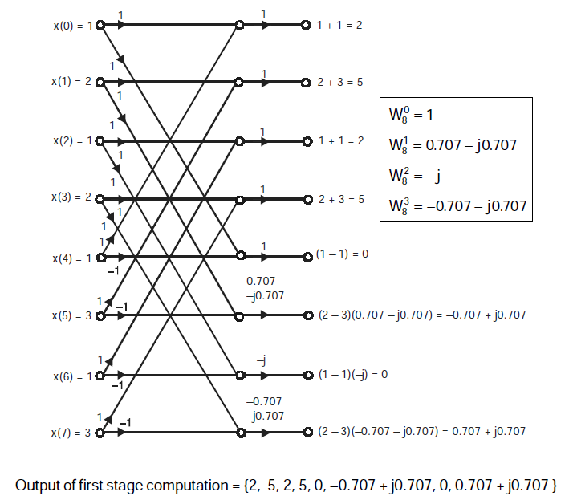

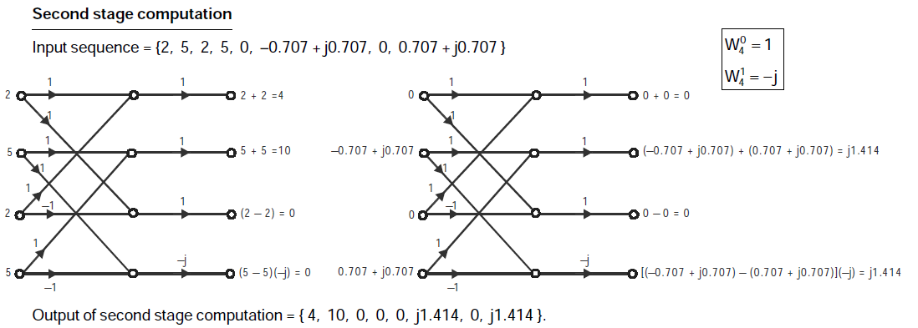



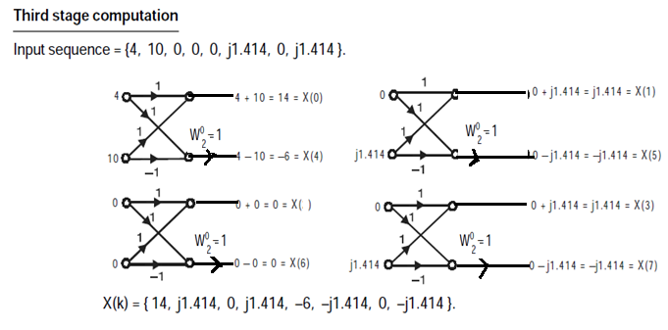

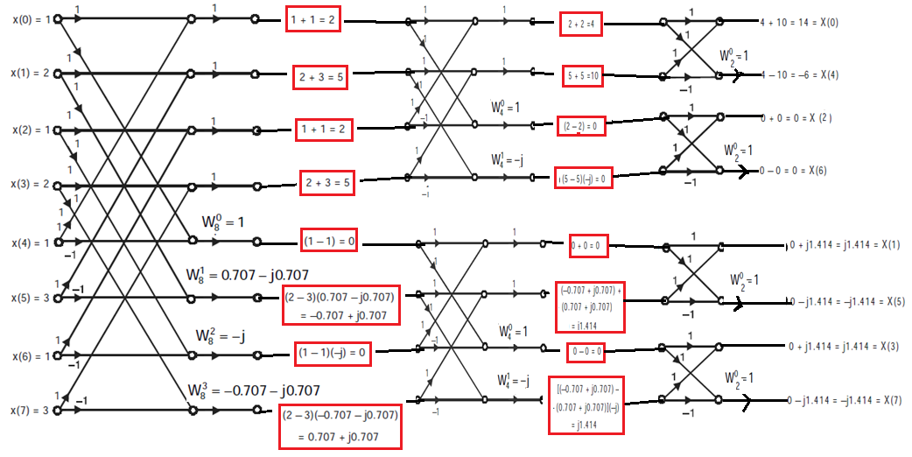



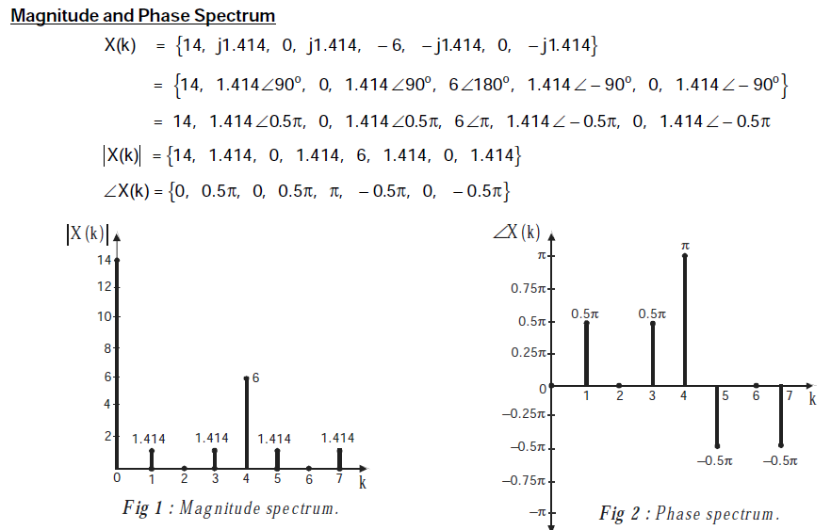

**11.** & 1**2.**



 

13. 





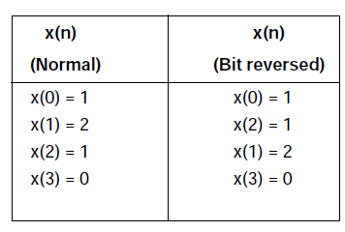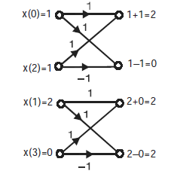



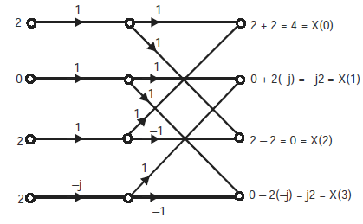

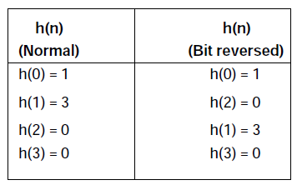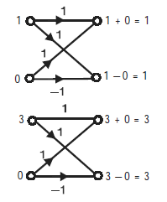



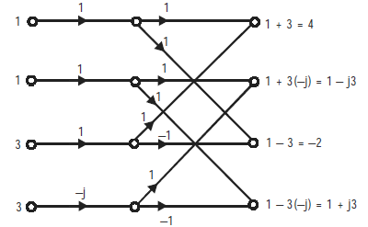 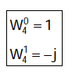







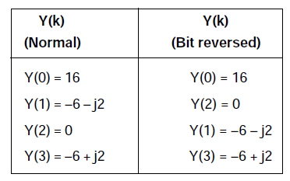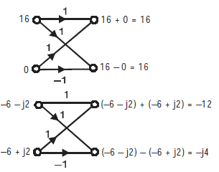



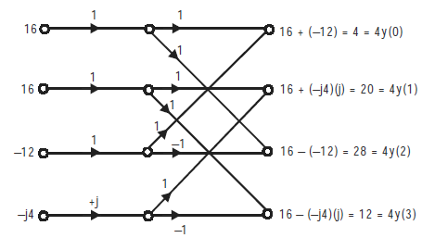 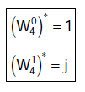

**2.6 Use of FFT in linear filtering:**

**One of the application of FFT isin Linear filtering of long sequence by 2 methods.**

**1.Overlap-save method**

**2.Overlap-add method**

**14.Determine the output of a linear FIR filter whose impulse response is h(n)={1,2,3} & x(n)={1,2,3,4,5,6,7,8,9} using overlap-save method.**

**Solution: The given input data sequence, x(n)= {1,2,3,4,5,6,7,8,9}.**

**Divide the x(n) into L=3 data subblock. The length of h(n) is M=3; Add M-1 =2 zeros to first sub-data block.**





** **

**Similarly **



**Inorder to perform circular convolution,the length of impulse response must be equal to length of the data subblock.Therfore,add 2 zeros to impulse response.**



**   **



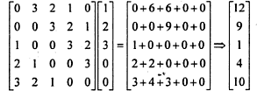



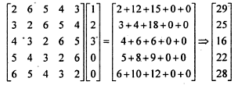



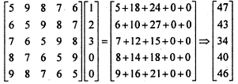



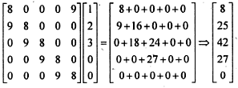

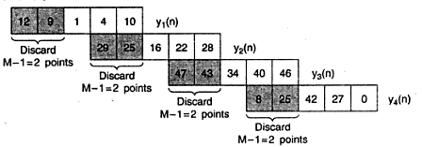

**By using section convolution,aliasing of data points are completely removed when compared to conventional circular convolution techniques.**



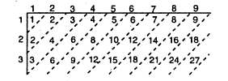



**15.Determine the output of linear FIR filter whose impulse response is h(n)={1,2,3} 7 x(n)={1,2,3,4,5,6,7,8,9} using overlap-add method.**

**Solution: The given input data sequence, x(n)= {1,2,3,4,5,6,7,8,9}.**

**Divide the x(n) into L=3 data subblock. The length of h(n) is M=3; Add M-1 =2 zeros to first sub-data block.**







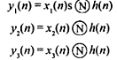



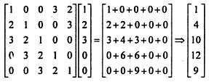



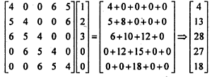



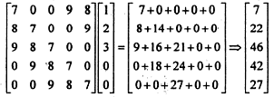

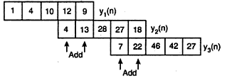





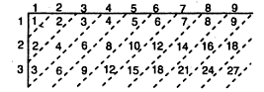



**16.Practice:Determine the output of a linear FIR filter whose h(n)={1,-3,5} &x(n)={-1,4,7,3,-2,9,10,12,-5,8} using overlap-save & overlap-add method.**

