 | Anjalai Ammal - Mahalingam Engineering College,  Department of E.C.E. | 

CS2403 DIGITAL SIGNAL PROCESSING

S.KAVITHA
AP/ECE

SYLLABUS:
UNIT I SIGNALS AND SYSTEMS
BASIC ELEMENTS OF DSP – CONCEPTS OF FREQUENCY IN ANALOG AND DIGITAL SIGNALS – SAMPLING THEOREM – DISCRETE – TIME SIGNALS, SYSTEMS – ANALYSIS OF DISCRETE TIME LTI SYSTEMS – Z TRANSFORM – CONVOLUTION (LINEAR AND CIRCULAR) – CORRELATION.
UNIT II FREQUENCY TRANSFORMATIONS
INTRODUCTION TO DFT – PROPERTIES OF DFT – FILTERING METHODS BASED ON DFT – FFT ALGORITHMS DECIMATION – IN – TIME ALGORITHMS, DECIMATION – IN – FREQUENCY ALGORITHMS – USE OF FFT IN LINEAR FILTERING – DCT.
UNIT III IIR FILTER DESIGN
STRUCTURES OF IIR – ANALOG FILTER DESIGN – DISCRETE TIME IIR FILTER FROM ANALOG FILTER – IIR FILTER DESIGN BY IMPULSE INVARIANCE, BILINEAR TRANSFORMATION, APPROXIMATION OF DERIVATIVES – (HPF, BPF, BRF) FILTER DESIGN USING FREQUENCY TRANSLATION
UNIT IV FIR FILTER DESIGN
STRUCTURES OF FIR – LINEAR PHASE FIR FILTER – FILTER DESIGN USING WINDOWING TECHNIQUES, FREQUENCY SAMPLING TECHNIQUES – FINITE WORD LENGTH EFFECTS IN DIGITAL FILTERS
UNIT V APPLICATIONS
MULTIRATE SIGNAL PROCESSING – SPEECH COMPRESSION – ADAPTIVE FILTER – MUSICAL SOUND PROCESSING – IMAGE ENHANCEMENT.
TEXT BOOKS:
1. John G. Proakis & Dimitris G.Manolakis, “Digital Signal Processing – Principles, Algorithms & Applications”, Fourth edition, Pearson education / Prentice Hall, 2007.
2. Emmanuel C..Ifeachor, & Barrie.W.Jervis, “Digital Signal Processing”, Second edition, Pearson Education / Prentice Hall, 2002.
REFERENCES:
1. Alan V.Oppenheim, Ronald W. Schafer & Hohn. R.Back, “Discrete Time Signal Processing”, Pearson Education, 2nd edition, 2005.
2. Andreas Antoniou, “Digital Signal Processing”, Tata McGraw Hill, 2001

UNIT:1
SIGNALS&SYSTEMS
Basic elements of DSP – concepts of frequency in Analog and Digital Signals – sampling theorem – Discrete – time signals, systems – Analysis of discrete time LTI systems – Z transform – Convolution (linear and circular) – Correlation.
Signals,Systems and Signal Processing
SIGNAL?= Anything that carries INFORMATION…

Ex: 1 ECG(ElectroCardioGram) == Gives Information about the Health of Person’s Heart.
Ex: 2EEG(ElectroEncephaloGram)== Gives Information about the Brain Activity of a Person.
Actual Definition of a Signal:
- Signal is defined as any physical quantity that varies with one or more independent variables.

1-Dimensional Signal:
- If the signal is a function of a single independent variable, then it is called as a one-dimensional signal.Ex: S(t) = 7t
Multi-Dimensional Signal:
- If the signal is a function of a 2 or more independent variables, then it is called as Multi-dimensional signal.
Ex: 2-D signal(depends on 2 independent variables)
S(x,y)=6x+5y, I(x,y) which tells the Intensity or Brightness at each point of a photo.

3-D signal(depends on 3 independent variables)
I(x,y,t) which tells the Intensity or brightness at each point of the motion picture .
Multi-Channel Signal:(Vector)
- Signals that are genereted by multiple sources or multiple sensors are called Multi-Channel Signals.Such signals can be represented by Vector form.
Ex: EEG(8 channel) :is obtained from 8 different places of Human Body.
Broad Classification of Signals:
1.Continuous Time Signals(CT) :Which is defined at all instants of time,represented by x(t).

x(t)

2.Discrete Time Signals(DT) :Which is defined at specific instants of time,represented by x(n).
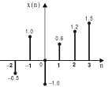
Continuous-Valued versus Discrete-Valued Signals:The values of a CT or DT Signal can be continuous or discrete.
- If a signal takes on all possible values of a finite or an infinite range, it is CONTINUOUS-VALUED Signal.
- If the signal takes on values from a finite set of possible values, it is DISCRETE-VALUED Signal. Also called Digital Signal because of the discrete values.
SYSTEM?
Interconnection of Components.
Operates on an input signal and produces an output signal
Ex:Amplifier is a system where it operates on weak input signal and produces strong output signal.
Broad Classification of Systems:
1.CT System operates only on CT input & CT output Signals.Ex: Amplifier,Filter.
2.DT Systems operates on DT input & DT output Signals.Ex: Population Chart,Salary Deposited in Savings Account.
Represented by:
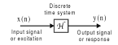
SIGNAL PROCESSING:
- It is the operation on signal to extract useful information from it.
- Which changes the characteristics of signal such as Amplitude,Shape,Phase and Frequency.
Classification of Signal Processing:
- Analog Signal Processing(ASP) deals with analog input and analog output signals.
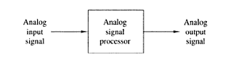
Analog Signal Processor may be an Amplifier or Filter.
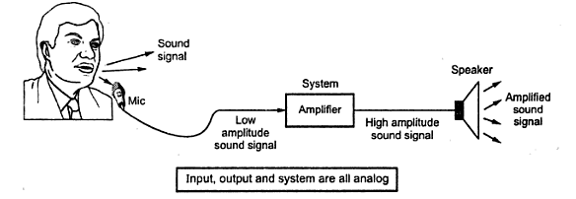

- Digital Signal Processing (DSP)Here processing is done with Digital Computer or Special Purpose Digital hardware.
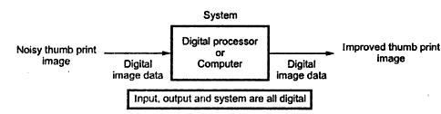

  - BASIC ELEMENTS OF DSP
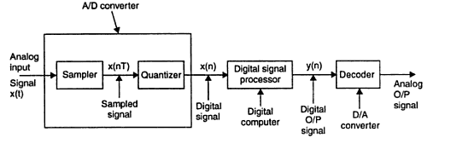
- Analog input signal may be ECG or EEG or any CT signal which is defined at all instants of time.
- An Anti-Aliasing Filter may be included which performs 2 functions.
- Acts as a LPF to remove high frequency noise and also band limits the signal.
- Acts as a 50Hz Notch filter to remove the power frequency components which is the larger part of external noise.
3. An Amplifier may be included which is used to bring the signal upto the voltage range for the requirement of A/D Unit.
4.A/D converter comprises of
- Sampler : Used to convert the input signal x(t) into Discrete Time Continuous Valued Signal x(nT),where T is said to be Sampling interval.
- Quantizer : Used to convert the DT-Continuous valued Signal x(nT) into DT-Discrete Valued Signal represented by x(n).Thus A/D converter provides N-bit binary number.
5. DSP which is a large programmable Digital Computer or a Microprocessor.May be a
(i)Hardware(ii) Software(iii)Firmware(Implementing S/W in a Special purpose H/W)
DSP performs amplification,attenuation,filteringetc operations on digital data.It consists of ALU,Shifter,address generators etc for its fast functioning.
6.D/A Converter:
Some of the processed signals are required back in their analog form.For ex,sound,image,video signals are required back in analog form.Hence DSP processor output is given to D/A Converter.It converts Digital output of DSP into its analog equivalent.Here the output is CT but not smooth which contains unwanted high frequency components.
7. An Reconstruction filter may be included where it eliminates high frequency components and provides smooth CT signal.
Advantages of DSP over ASP:
- Flexibility: in reconfiguring DSP operations simply by changing the program.But in the case of ASP,redesign of Hardware followed by testing & verification.
- Accuracy:Provides a better control of accuracy requirements in ADC,DSP interms of word length,floating point vs fixed point arithmetic etc.,But in the case of ASP,tolerance in analog circuit components make it extremely difficult.
- Easy Storage:On magnetic media such as tape or disk without loss of signal.Hence easily transportable.
- Sophisticated Algorithms:Which uses software and can be routinely implemented.But in ASP,it is very difficult to perform Mathematical operations in analog form.
- Cheaper Cost:The lower cost may be due to the fact that the digital hardware is cheaper,or perhaps it is the result of the flexibility for modifications provided by the digital implementation.
Limitations:
  - System Complexity:Because of A/D & D/A Converters and its associated filters
  - Power Consumption:In Analog, the circuit elements like R,L,C do not need much power.But a DSP Chip which contains 4 Lakh transistors dissipates more power.
  - Bandwidth limited by sampling rate:When the analog signals have wide bandwidth,then high speed A/D converters are required.Such high speeds of A/D conversion are difficult to achieve for same signals.For such applications,analog systems must be used.
1.4 DISCRETE TIME SIGNALS,SYSTEMS:
D-T Signals:
Defined at specific instant of time & not defined at instants between 2 successive samples.
Representation of DT Signals:
There are 4 ways of representing DT Signals: They are
- Graphical representation 2.Functional representation 3. Tabular representation 4.Sequence representation

1.Graphical Representation
Consider a signal $x(n)$ with values $x\left(-2\right)=-3,x\left(-1\right)=2,x\left(0\right)=0,x(1)=3,x\left(2\right)=1 \& x(3)=2$
This DT signal can be represented graphically as shown in fig.1.1
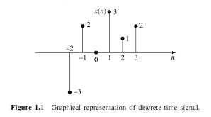
- Functional Representation
In this, the amplitude of the signal is written against the values of n.
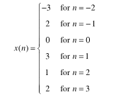
3.Tabular Representation
In this, the sampling instant n & the magnitude of the signal at the sampling instant are represented in tabular form.
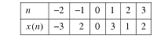
4.Sequence Representation
A finite duration sequence given in 1.1 can be represented as:
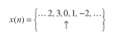
The arrow mark denotes the n=0 term. When no arrow is indicated, the first term corresponds to n=0.
Standard D-T Signals:
1.Digital impulse signal (or) Unit sample sequence
$$δ\left(n\right)=1 ;n=0$$
$$=0 ;n ≠0;$$
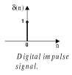
2.unit step signal:
$$u\left(n\right)=1;n ≥0$$
$$=0 ;n <0$$
3.Ramp signal: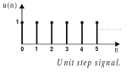
$$r\left(n\right)=n ;n ≥0$$
$$=0 ;n <0$$
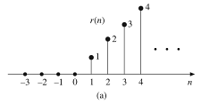
4.Exponential signal:
$$g\left(n\right)= a^{n } ;n ≥0$$
$$=0 ;n <0$$
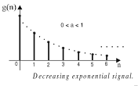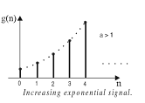

5.Discrete time sinusoidal signal:
The discrete-time sinusoidal sequence is given by $x\left(n\right)=A sin⁡(ωn+ ∅$)
where A is the amplitude, ω is angular frequency, $∅$ is phase angle in radians & n is an integer.
The period of the DT sinusoidal sequence is: N = $\frac{2π}{ω}$ m
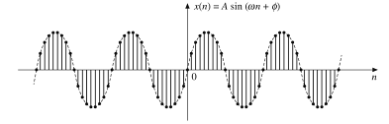
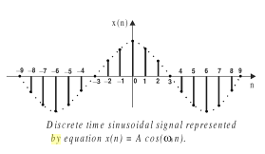
6.DT complex exponential signal:
is defined as, $x\left(n\right)= a^{n }e^{j(ω_{0}n+ ∅ )}$
= $a^{n }$cos$(ω_{0}n+ ∅ )$ + j $a^{n }sin(ω_{0}n+ ∅ )$
For $\left|a\right|$ = 1, the real & imaginary parts of complex exponential sequence are sinusoidal.
For $\left|a\right|>$ 1, the amplitude of the sinusoidal sequence exponentially grows.
For $\left|a\right|<$ 1, the amplitude of the sinusoidal sequence exponentially decays.
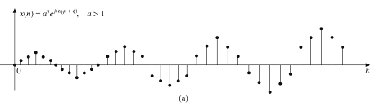
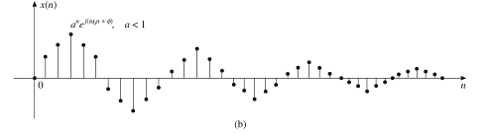
Classification DT Signals:
- Deterministic & nondeterministic signals
- Periodic &aperiodic signals
- Symmetric & antisymmetric signals
- Energy & Power signals
1.Deterministic & nondeterministic signals
The signals that can be completely specified by mathematical equations are called Deterministic signals.
Ex: step, ramp, sine wave,cos wave etc.
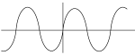

The signals whose characteristics are random in nature are called nondeterministic signals.
Ex:Noise
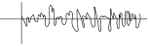
2.Periodic & Aperiodic signals:
A signal which has a definite pattern & which repeats itself at regular intervals of time is called a periodic signal.
For periodicity, x(n) should satisfy $x\left(n\right)=x(n+N)$for integer values of N.
Where N is no.of samples of a period, $N=\frac{2π}{ω}$ . m
Where “m” should be 1.integer 2.positive 3. Small for making “N” to be an integer.
The smallest value of N for which the above equation is true is called “Fundamental Period”.
Ex for periodic signal:
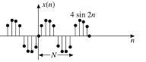
Ex for Aperiodic signal:
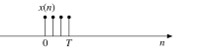
3.Symmetric & antisymmetric signals
The DT signals may exhibit aymmetry or antisymmetry with respect to n=0.
Even(Symmetric) signal: condition: $x\left(n\right)=x(-n)$ for all n.
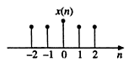
Odd (Antisymmetric) signal: condition: $x\left(-n\right)= -x(n)$ for all n.
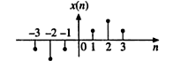
A DT signal x(n) which is neither even nor odd can be expressed as a sum of even & odd signal.
ie., $x\left(n\right)= x_{e }$(n) + $x_{o}$ (n) where ${x }_{e }$(n) = Even part of x(n) &$x_{o}$ (n) = Odd part of x(n)
and ${ x}_{e }$(n) = $\frac{1}{2}$[ $x\left(n\right)+ x(-n)$ ], $x_{o}$ (n) = $\frac{1}{2}$ [ $x\left(n\right)-x(-n)$ ]
4.Energy & Power signals
The Energy E of a DT signal x(n) is defined as,
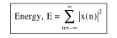
If energy E of a DT signal is finite & non-zero, then it is called as Energy signal.
The average power of a DT signal x(n) is defined as,
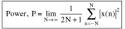
If power P of a DT signal is finite & non-zero, then it is called as Power signal.
Note: For energy signals, the energy will be finite& avg power will be zero.For power signals, the average power will be finite & energy will be zero.
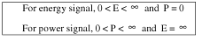
Basic operation on signals:
1.Time shifting 2.Time reversal 3. Time Scaling 4.Amplitude Scaling 5.Signal Addition 6.Signal Multiplication
- Time Shifting:
y(n) = x(n-k)
Thus y(n) is obtained by time shifting x(n) by “k” units.
If ‘k’ is positive, it is called delay & the shift is to the right.
if ‘k’ is negative ,called advance where the shift is to the left.
EX: Given Signal x(n)
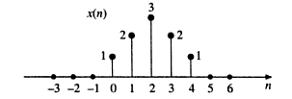
To draw:x(n-3)
Here k is positive.hence delay by 3 units.that is shifting towards right by 3 units.
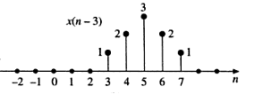
To draw: x(n+2)
Here k is negative.hence advance by 2 units.that is shifting towards leftby 2 units.
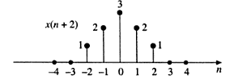
2.Time Reversal:
The time reversal of a DT signal x (n) is obtained by folding the sequence about n=0;
Given x(n):
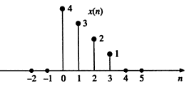
x(-n): folding about the origin n=0
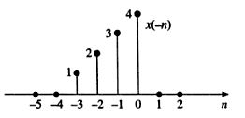
x(-n+3): Delay x(-n) by 3 units
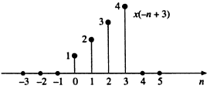
x(-n-3):Advance x(-n) by 3 units
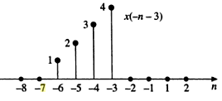
3.Amplitude Scaling:
The Amplitude scaling of a DT signal is represented by, $y\left(n\right)=ax(n)$ where ‘a’ is a constant.
Ex:Given x(n)
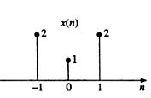
To draw: 2x(n)
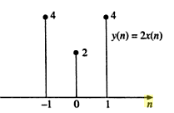
4.Time Scaling:
Time scaling is represented as,$y\left(n\right)=x(an)$;
When a>1,it’s called time compression & if a<1 it’s called time expansion.
EX:Given x(n)
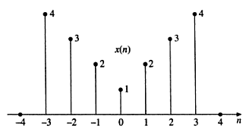
To draw x(2n): here a=2>1,so compress x(n) by a factor of 1/a,that is 1/2.
That is multiply all “n” by ½, and take only integer values of “n”
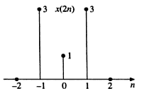
To draw x(n/2):here a=1/2 <1, so expand x(n) by a factor of 1/a,that is 1/(1/2),that is 2.
So multiply all “n” by 2 and take all integer values.
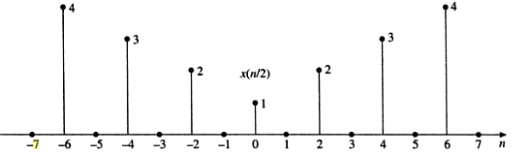
5.Signal Addition:
EX:Given:$x_{1}$ (n) ={1,2,3,1,5} &$x_{2}$ (n) = {2,3,4,1,-2}
To find: $x_{1 }$(n) + $x_{2}$ (n)
6.Signal Multiplication:
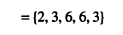
1.4 DT-Systems:
A DT system is one which transforms DT input signals into DT output signals.
That is $y\left(n\right)=T [ x\left(n\right)]$
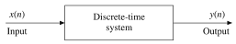
Classification of DT systems:
1.Linear& Non-linear systems 2. Time variant & invariant 3.Causal & non-causal 4. Stable &unstable 5.Static & Dynamic 6.Invertible & Non-invertible systems.
1.Linear & Non-linear systems:
A Linear system is one which satisfies the superposition principle.That is, the weighted sum of inputs is equal to the weighted sum of outputs.
A relaxed system ‘H’ is linear if
$H\{a_{1 }x_{1}$(n) + $a_{2}x_{2}$ (n)} = $a_{1}$ H { $x_{1}$(n)} + $a_{2}$H { $x_{2}$ (n)} , where $a_{1}$,$a_{2}$ are constants.
If a system doesn’t satisfy this principle, then it’s called Non-Linear systems.
Diagrammatic explanation:
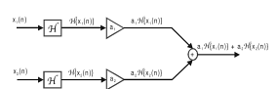
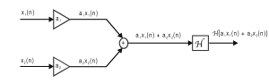
2.Time variant & Time Invariant systems:
A system is said tobe time invariant if its input-output characteristic do not change with time.
A relaxed system H is time invariant or shift invariant
if H { x(n) } = y(n) then, H{ x(n-m)} = y(n-m).Otherwise the system is time variant.
Diagrammatic explanation:
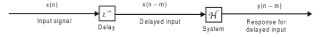
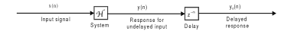
If y(n-m) = $y_{d }$(n), then Time invariant.
3.Causal & Anticausal systems:
A system is said to be causal if the output of the system at any time depends only on present input, past input & past output & not on future input & output.
If the system depends on future input & output, then it’s Anti causal system. That is,
y(n) = F { x(n) , x(n-1) , x(n-2),…….,y(n-1),y(n-2)…..}
Where x(n) is present input,x(n-1) is past input and y(n-1) is past output.
Ex: y(n) = x(n-2) + x(n-1) +x(n)
For non-causal: y(n)= x(n) + x(n+2)
4.Stable &unstable systems:
A system is said to be stable if it satisfies BIBO stability criteria.That is , Bounded Input Bounded Output.Bounded means finite.That is,If x(n)<infinite (that is finite),Then y(n)<infinite (that is finite).
5.Static & Dynamic systems:
A system is said to be static or memoryless if its output at any instant depends on present samples & not on past or future samples of the input.
If it depends on past or future, then it’s dynamic system.
Ex: y(n) =x(n)
for dynamic, y(n) = x(n) + x(n-2)
6.Invertible & Non-Invertible systems:
A system is said to be invertible if the input signal given to the system can be recovered.
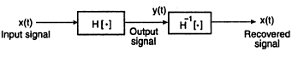
If the input is not recovered means, Non-Invertible system.
1.5 ANALYSIS OF DT-LTI SYSTEM:
DT-LTI:
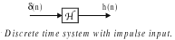
= function on input signal
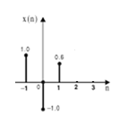
Here x(0)=-1; which can be expressed as x(0)$δ$(0)=-1;x(1)=0.6; can be expressed as x(1)$δ$(n-1)=0.6;
x(-1)=1.0; can be expressed as x(-1)$δ$(n+1)=1.0;thus in general,x(n) can be expresses as
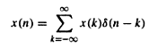----- (1)
We know that output y(n)=T{x(n)} --- (2)
Substituting the value of x(n)from (1) in (2),we get,
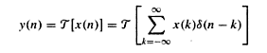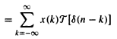--- (3)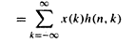
Thus, equation (3) becomes,
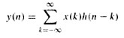--- (4)
Where equation (4) is called convolution sum (or) superposition sum.
Thus equation (4) can also be expressed as,convolution of x(n) and h(n) as
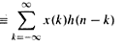
Properties of DT-LTI System:
1.Commutative property 2.Distributive property 3.Associative property 4. Causality 5.Stability
6.Step Response 7.Invertibility 8.LTI systems with & without memory
1.Commutative property:
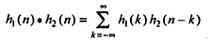
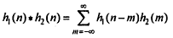,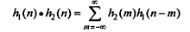
(or)
2.Distributive property:
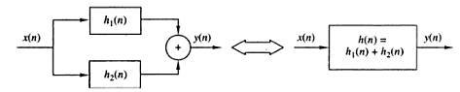
L.H.S:Here y(n)=x(n)*h(n)Where h(n)=${ h}_{1}$(n)+$h_{2}$(n)
Thus y(n)=x(n)*{${ h}_{1}$(n)+$h_{2}$(n)}
R.H.S:Here y(n)=x(n)*h(n)=x(n)*{${ h}_{1}$(n)+$h_{2}$(n)} =x(n)*$h_{1}$(n) + x(n)*$h_{2}$(n)

Thus the proof of Distributive property.
- Associative property
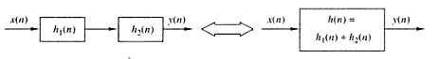
L.H.S:
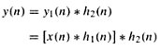
(by commutative property)
R.H.S:
Where h(n)= $h_{2}$(n) * $h_{1}$(n) Therefore, by substituting,y(n)=x(n)*$\{ h_{2}$(n) * $h_{1}$(n)}(by commutative property)
y(n)=
Which is the proof for Associative law of DT-LTI Systems.
4.Causality:h(k)=0, k<0;
Consider,

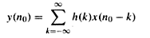
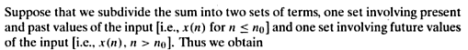
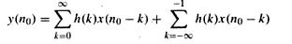
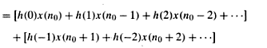
(future values)
h(k)=0, k<0;
hence,
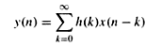
5.Stability:
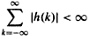
w.k.t
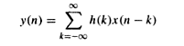
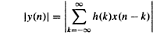
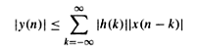
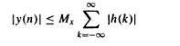
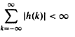
6. Step Response
W.K.T
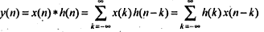
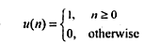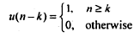Or u(n-k)=1,k$≤$ n
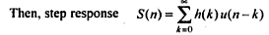
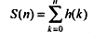
7.Invertibility of LTI systems:
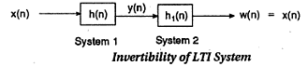
This is possible only if,
8. LTI system with & without memory
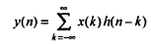
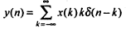
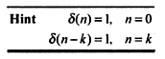
Condition for LTI system without memory is:
With memory:
Identity property of DT-LTI System:Statement:
The Convolution of any sequence with unit sample sequence results in the same sequence.
Proof:L.H.S:x(n)*$δ$(n)=
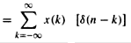
$δ$ (n-k) =1 at n=k
the equation becomes
= x(n) $δ$(0) {where $δ$(0)=1} and
{since $δ$(k-k) = $δ$ (0)}
=x(n)
=R.H.S
Thus proved.
Problems:
Note: Fundamental period =N = (2π/ω) m
For a DT signal to be periodic, N should be an integer.

1. Find the fundamental period of $x\left(n\right)=\sin\left(2π/3\right)$ n& check for periodicity.
W.K.T Fundamental period N= (2π/ω) m
Here ω = 2π/3; Thus N= (2π/(2π/3)).m= 3. m (Let m=1)
Hence N = 3 samples.
Since N is an integer, is periodic with 3 samples.
2. Find the fundamental period of $x\left(n\right)= e^{j7πn}$& check for periodicity.
Here ω = 7π; Thus, N= (2π/7π).m = (2/7).m. (let m=7)
Hence N=2 samples.Since N is an integer, is periodic with 2 samples.
3. Find the fundamental period of $x\left(n\right)= e^{j \frac{3}{5}(n+\frac{1}{2})}$& check for periodicity.
Here ω = 3/5; Thus N = $\frac{2π}{(\frac{3}{5})}$.m=$\frac{10π}{3}$ .m ; For any value of ‘m’, N cannot be an integer.Thus x(n) is Aperiodic.
4.$x\left(n\right)=\cos\left(\frac{π}{3}\right)$ n + $\cos\left(\frac{3π}{4}\right)$ n
Let $ω_{1}$ = π/3; $ω_{2}$ = 3π/4;$N_{1}$= 2π$\left(\frac{m}{ω1}\right)$= 2π$\left(\frac{m}{\frac{π}{3}}\right)$ =6.m (let m=1)
Thus $N_{1}$ = 6 samples.
$N_{2}$ = 2π$\left(\frac{m}{ω2}\right)$ = 2π$\left(\frac{m}{\frac{3π}{4}}\right)$ =$\left(\frac{8}{3}\right)$.m (Let m= 3)
Thus $N_{2}$ =8 samples.
For x(n) to be periodic, $\left(\frac{N_{1}}{N_{2}}\right)$ should be a rational number.
Thus $\left(\frac{N_{1}}{N_{2}}\right)$ = $\left(\frac{6}{8}\right)$= $\left(\frac{3}{4}\right)$;Since ¾ is a rational number, given signal x(n) is periodic.
Hence common time period= N = 4$N_{1}$ (or) 3$N_{2}$ = 4x6 = 24 samples.

Practice problem: 5. x(n) = sin$\left(\frac{πn}{4}\right)$6.$x\left(n\right)=e^{j2n}$7.$x\left(n\right)=\cos\left(\frac{π}{4}\right)$n + cos2n
8. Check for Energy or Power signals.
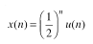
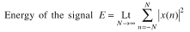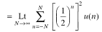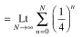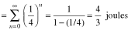
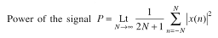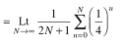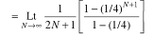
Here the Energy is finite & Power is Zero.Hence it is a Energy Signal.
9.Check for E or P
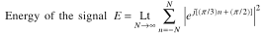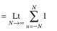
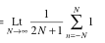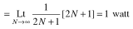
Here the energy is infinite & power is finite.Hence Power signal.
10. Check for E or P
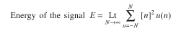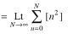

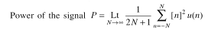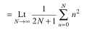= 0
Here both E is infinite & P is zero..Hence it is neither Energy nor Power signal.
Practice problem: 11. $x\left(n\right)=cos\left(\frac{π}{4}\right)$n 12. $x\left(n\right)= e^{j(\frac{π}{2}n+\frac{π}{}}8$) 13.Find the energy of the signal x(n) which has taken a value of 2 @ n= 0,1,2.
13.Find the even & odd components of $x\left(n\right)=8 e^{-j \frac{π }{6}n}$
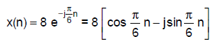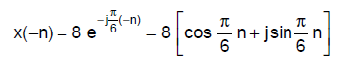
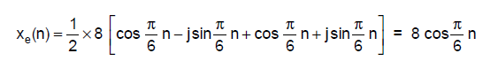
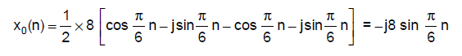
14.
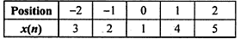
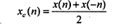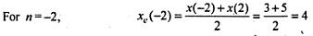
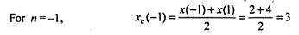
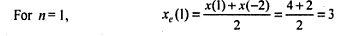
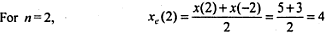
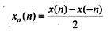
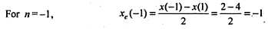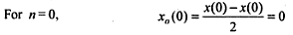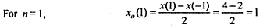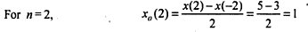
15.
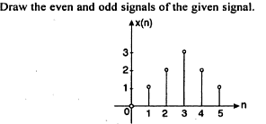
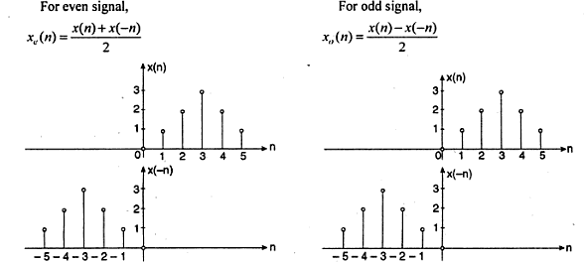

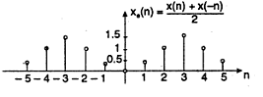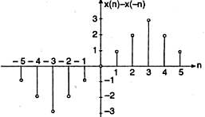
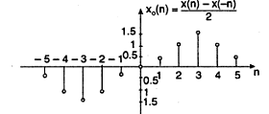
16.Practice problem: Find the odd & even components of $x\left(n\right)=\left(-2,1,2,-1,3\right)$
$$↑$$
17.Check for linearity.y(n)=5 x(n)
For input $x_{1}(n)$, output will be $y_{1}\left(n\right)=5x_{1}(n)$, for input $x_{2}(n)$,output will be $y_{2}\left(n\right)=5x_{2}(n)$;
For a$x_{1}(n)$+b$x_{2}(n)$,output will be a$y_{1}(n)$+b$y_{2}(n)$;
W.K.T, H[a$x_{1}(n)$+b$x_{2}(n)$] = aH[$x_{1}(n)$] + bH[$x_{2}(n)$]
Or $y_{3}(n)$ = a $y_{1}(n)$ + $by_{2}(n)$
R.H.S: a $y_{1}(n)$ + $by_{2}(n)$= a[5$x_{1}(n)]+$ b ${[5x}_{2}\left(n\right) ] →$ (1)
L.H.S: $y_{3}\left(n\right)$ = H[a$x_{1}\left(n\right)$+b$x_{2}\left(n\right)$]= 5[a$x_{1}\left(n\right)$+b$x_{2}\left(n\right)$]=a[5$x_{1}(n)]+$ b[5 $x_{2}\left(n\right)$ ] $→\left(2\right)$
Thus (1) =(2). Hence the given system is linear.
18. Check for linearity.y(n)=7 x(n) + 5
For input $x_{1}(n)$, output will be $y_{1}\left(n\right)=7x_{1}\left(n\right)+5$,for $x_{2}(n)$,output will be $y_{2}\left(n\right)=7x_{2}\left(n\right)+5$;
For a$x_{1}(n)$+b$x_{2}(n)$,output will be a$y_{1}(n)$+b$y_{2}(n)$;
W.K.T, H[a$x_{1}(n)$+b$x_{2}(n)$] = aH[$x_{1}(n)$] + bH[$x_{2}(n)$]
Or $y_{3}(n)$ = a $y_{1}(n)$ + $by_{2}(n)$
R.H.S: a $y_{1}\left(n\right)$ + $by_{2}\left(n\right)$=
a[7$x_{1}\left(n\right)+5]+$ b ${[7x}_{2}\left(n\right)+5]=7(a x_{1}\left(n\right)+bx_{2}\left(n\right))+5(a+b) →$ (1)
L.H.S: $y_{3}\left(n\right)$ = H[a$x_{1}\left(n\right)$+b$x_{2}\left(n\right)$]= 7[a$x_{1}\left(n\right)$+b$x_{2}\left(n\right)$]+5
=7a$x_{1}(n)+$ 7b $x_{2}\left(n\right)$+5 $→\left(2\right)$
Thus (1) $≠$(2). Hence the given system is non-linear.
Practice problem 19. Check for linearity: $y\left(n\right)= x^{2}$(n) 20. y(n) = n x(n)
21.Check for Time invariancy: y(n)= x(2n)$→(A)$
For input $x_{1}(n)$, output will be $y_{1}\left(n\right)=x_{1}(2n)$, $→(1)$
for input $x_{2}(n)$,output will be $y_{2}\left(n\right)=x_{2}(2n)$;$→(2)$
Let $x_{2}(n)$= $x_{1}(n-n_{0})$,$→(3)$
Substituting (3) in (2), we get
Delay input:
$y_{2}\left(n\right)=x_{1}[2\left(n-n_{0}\right)]$,$→(4)$
Delay output: substitute $n=\left(n-n_{0}\right)$ in (A),
$y\left(n\right)=x[2\left(n-n_{0}\right)]$,$→(5)$
$T_{(4)}$= $T_{(5)}$,Hence the given system is Time In Variant(TIV)
22. y(n)=g(n)x(n)$→$(A)
For input $x_{1}(n)$, output will be $y_{1}\left(n\right)=g(n)x_{1}(n)$, $→(1)$
for input $x_{2}(n)$,output will be $y_{2}\left(n\right)=g(n)x_{2}(n)→(2)$
Let $x_{2}(n)$= $x_{1}(n-n_{0})$,$→(3)$
Substituting (3) in (2), we get
Delay input:
$y_{2}\left(n\right)={g(n)x}_{1}\left(n-n_{0}\right)$,$→(4)$
Delay output: substitute $n=\left(n-n_{0}\right)$ in (A),
$y\left(n\right)=g(n-n_{0})x\left(n-n_{0}\right)$,$→(5)$
$T_{(4)}≠T_{(5)}$,Hence the given system is Time Variant(TV)
23.Practice: y(n)=nx(n) 24. y(n) = x(n) –x(n-1)
25.Check for causality: y(n)=x(n)+x(n-1)
For n=0, y(0) = x(0) +x(-1)—here output depends on present & past input
For n=1, y(1) = x(1) +x(0) —here output depends on present & past input
For n=-1, y(-1) = x(-1) +x(-2)—here output depends on present & past input
Hence the given system is Causal.
26.y(n)=x(n+4) + x(n)
Here output depends on future & present.hence non-causal.
Practice:27. y(n)= (n+3)+$x^{2}$(n) 28. Y(n)= x(2n)
29.Check for static or dynamic: y(n)= 10x(n)+5
For n=0,y(0)=10x(0)+5
For n=1, y(1)= 10x(1)+5
For n=-1, y(-1)=10x(-1)+5
Here at all values of n,ouput depends on present input. Hence the given system is static.
30. y(n)= x(-n+2)
n=0 , y(0)= x(2)
n=1 , y(1) = x(1)
n=-1, y(-1)=x(3)
Her ethe output depends on present & future.Hence the given system is dynamic.
Practice 31. Y(n)= x(n)a(n) 32. Y(n)= $\sum_{-∞}^{n+1}{x(n)}$
33. Check for stability: y(n)=x(n)$→(A)$
A system is said to be stable if $\left|x(n)\right|< ∞$, then $\left|y(n)\right|< ∞$;(BIBO)
Let x(n) = B,a finite constant;$→(1)$
Substituting (1) in (A), y(n)=(B)
Here when B=0, y(n) =0 ,<$∞$
when B=1, y(n) =1 ,<$∞$
when B=-1, y(n) =-1 ,<$∞$
Hence the given system is stable.
34.y(n)=nx(n) )$→(A)$
A system is said to be stable if $\left|x(n)\right|< ∞$, then $\left|y(n)\right|< ∞$;(BIBO)
Let x(n) = B,a finite constant;$→(1)$
Substituting (1) in (A), y(n)=n(B)
Here when B=0, y(n) =n.(0)
when B=1, y(n) =n.(1)
when B=-1, y(n) =n,(-1)
Hence stability of the system depends on the value of “n”. n may be finite or infinite. If n =$∞$, then y(n)=$∞$.
Hence the given system is unstable.
Practice:35. Y(n)=x(n)-x(n-1)-$\frac{1}{3}$x(n+3) 36.y(n)= $e^{x\left(n\right)}$
37.Check for invertibility: y(n)=x(n-4)
If x(n) is input, then y(n)=x(n-4)
Then the inverse system could be, y1(n)= y(n+4)=x(n-4+4)=x(n)
Thus the same input x(n) can be recovered.Hence the given system is invertible system.
Practice:38. Y(n)=2x(n)
39.Problems related to DT-LTI Systems:
Express the given signal sequence as a time-shifted impulse.
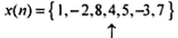
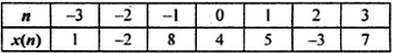
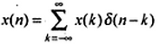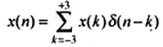
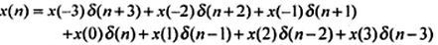
40.Practice:
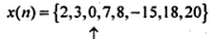
41.Test for stability: $h\left(n\right)={\left(\frac{1}{2}\right)}^{n}$u(n)
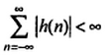$=\sum_{n=0}^{∞}{{\left(\frac{1}{2}\right)}^{n}}$ =1+$\left(\frac{1}{2}\right)$+${\left(\frac{1}{2}\right)}^{2}$+….+$∞$= $\frac{1}{1-\frac{1}{2}}$ =2 <$∞$
Hence the given system is stable.
42.Find whether the system with impulse response $h\left(n\right)=e^{2n}$u(n) is stable or not.
The condition for stability is:
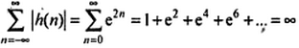
Hence the given system is unstable.
43.Practice: $h\left(n\right)=e^{2n}δ(n-2)$
44.Find the step responseof the system $h\left(n\right)=α^{n}$u(n)
$=S\left(n\right)= \sum_{k=0}^{n}{α^{k}}$=$\frac{1-α^{n+1}}{1-α}$
45. Check for Causality: $h\left(n\right)=e^{2n}u(n-2)$
h(k)=0, k<0;
or h(n)=0,n<0;
Here $h\left(n\right)=e^{2n}u(n-2)$,where u(n-2)=1, n>2&
=0, n<0;
hence it is defined only for n>2; When this u(n-2) is multiplied with any signal $e^{2n}$ it will yield the answer for only n>2; Hence the given system is causal.
46.$h\left(n\right)=e^{2n}δ(n+2)$
h(k)=0, k<0;
or h(n)=0,n<0;
here : $h\left(n\right)=e^{2n}δ(n+2)$,where $δ(n+2)$=1, at n=-2;that is not equal to zero for n<0;
Hence non-causal.
47.practice:$h\left(n\right)=e^{2n}u(n+2)$
48.$h\left(n\right)=e^{2n}δ(n-2)$
49.Find the response of the system $h\left(n\right)=a^{n}$u(n)excited by unit step sequence.
so here x(n)=u(n);
=$\sum_{k=-∞}^{∞}{u\left(k\right)}a^{n-k}$u(n-k)
{u(n-k) =1 ,n$≥$k or k$≤n$}
=$\sum_{k=0}^{n}{(1)}a^{n-k}$
= $a^{n }$+ $a^{n-1 }$+$a^{n-2 }$=….+1
50.Two LTI systems are connected in cascade.Find the unit sample response of this cascade connection.
$h_{1}\left(n\right)={\left(\frac{1}{2}\right)}^{n}$u(n) ; $h_{2}\left(n\right)={\left(\frac{1}{4}\right)}^{n}$u(n)
Since it is in cascade connection $h\left(n\right)=h_{1}$(n) * $h_{2}$(n)
Unit sample response means $x(n)= δ(n)$
W.K.T the convolution of any sequence with unit sample sequence results in same sequence.
Thus $δ\left(n\right)*h\left(n\right)=h\left(n\right)$
Hence our aim is to find $h\left(n\right)$:
$h\left(n\right)=h_{1}$(n) * $h_{2}$(n)
= $\sum_{k=-∞}^{∞}{h_{1}}$(k) $h_{2}$(n-k)
=$\sum_{k=-∞}^{∞}{{{\left(\frac{1}{2}\right)}^{k}u(k)}_{}}{{\left(\frac{1}{4}\right)}^{n-k}u(n-k)}_{}$
here u(k) forms the lower limit &u(n-k) forms the upper limit;
u(k)=1, n$≥0$&
u(n-k)=1,n$≥k$ or k$≤$ n
Hence lower limit is 0 and upper limit is n;
=$\sum_{k=0}^{n}{{{\left(\frac{1}{2}\right)}^{k}}_{}}{{\left(\frac{1}{4}\right)}^{n-k}}_{}$=${\left(\frac{1}{4}\right)}^{n}\sum_{k=0}^{n}{{{\left(\frac{1}{2}\right)}^{k}}_{}}{{\left(\frac{1}{4}\right)}^{-k}}_{}$=${\left(\frac{1}{4}\right)}^{n}\sum_{k=0}^{n}{{{\left(\frac{1}{2}\right)}^{k}}_{}}4^{k}$=${\left(\frac{1}{4}\right)}^{n}\sum_{k=0}^{n}{{{\left(\frac{4}{2}\right)}^{k}}_{}}$ =${\left(\frac{1}{4}\right)}^{n}\sum_{k=0}^{n}{{{\left(2\right)}^{k}}_{}}$=${\left(\frac{1}{4}\right)}^{n}\frac{1-2^{k+1}}{1-2}$=${\left(\frac{1}{4}\right)}^{n}\frac{1-2^{k+1}}{-1}$
y(n)=${\left(\frac{1}{4}\right)}^{n}{(2}^{k+1}$ -1 )

(a) LINEAR CONVOLUTION:
Procedure:
- Convert the given values x(n) & h(n) to temporary variable ‘k” as x(k) & h(k).
- Folding: Here the sequence h(k) is folded at k=0 to get h(-k).
- Shifting: Here h(-k) is shifted depending upon the value of “n” in y(n).
- Multiplication: Here x(k) & h(n-k) are multiplied on sample to sample basis.
- Summation: The product sequence obtained by multiplication of x(k) & h(n-k) is added over all the values of “k” to get the value of y(n).
- If $N_{1}$ is the no.of samples in x(n) &$N_{2}$ is the no.of samples in h(n), then the total no.of samples is N=$N_{1}$+$N_{2}$-1.
- To calculate the starting sequence of y(n),the following formula is used.
Starting sequence of y(n)=starting sequence of x(n) + starting sequence of h(n).
- To find the last sequence of y(n):= last seq.of x(n) + last seq.of h(n).
- Convert the given values x(n) & h(n) to temporary variable ‘k” as x(k) & h(k).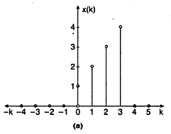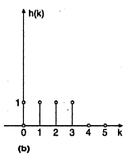
- Folding: Here the sequence h(k) is folded at k=0 to get h(-k).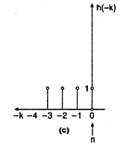
- If $N_{1}$ is the no.of samples in x(n) &$N_{2}$ is the no.of samples in h(n), then the total no.of samples is N=$N_{1}$+$N_{2}$-1=4+4-1=7To calculate the starting sequence of y(n),the following formula is used.
Starting sequence of y(n)=starting sequence of x(n) + starting sequence of of h(n).
=0+0=y(0)
- To find the last sequence of y(n):= last seq.of x(n) + last seq.of h(n).=3+3=y(6)So we have to find from y(0) to y(6)
- To find y(0):
- If n=0, then we have to find x (k) h (-k)
Hence,y(0)=1;
If n=1,then we have to find x(k)h(1-k),
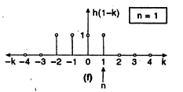 Hence y(1)=(1x1)+(2x1)=1+2=3.
If n=2,then we have to find x(k)h(2-k),
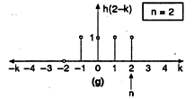Hence y(2)=(1x1)+(2x1)+(3x1)=1+2+3=6.
If n=3,then we have to find x(k)h(3-k),
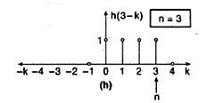Y (3)= (1x1)+(2x1)+(3x1)+(4x1)=1+2+3+4=10
If n=4,then we have to find x(k)h(4-k),
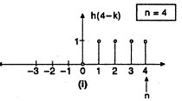y(4)=((1x0)+(2x1)+(3x1)+(4x1)+(0x1)=0+2+3+4+0=9
If n=5,then we have to find x(k)h(5-k),
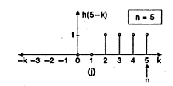 y(5)=(3x1)+(4x1)=3+4=7
If n=6,then we have to find x(k)h(6-k),

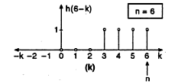y(6)=(4x1)=4
Method:2 Cross-Table Method:

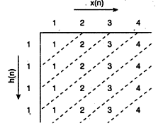
Method:3 Matrix method
X=($N_{1}$+$N_{2}$-1)x$N_{1}$=(4+4-1)x4=7x4 matrix;H=$N_{2}$x1=4x1 matrix
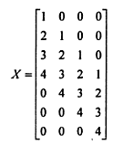
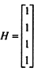
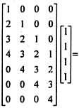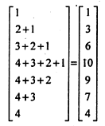
Thus,
1.7 (b) CIRCULAR CONVOLUTION
Let us consider 2 data sequences $x_{1}$(n) of $N_{1}$ samples &$x_{2}$(n) of $N_{2}$ samples.In the case of Linear Convolution the length of the data sample after convolution is $N_{1}$+$N_{2}$-1;But here in Circular Convolution, the length of the data sample after convolution is Maximum ($N_{1}$,$N_{2}$);
Method:1 Circle Method:
Let us consider 2 data sequences $x_{1(n)}$&$x_{2\left(n\right)}$ of length N. If the length of these 2 data sequences are not equal,add zeros at the end of the data whose length is less than the other data sequence,so that both the sequences are of same length.The circular convolution is given by,
That is Maximum ($N_{1}$,$N_{2}$)=4;To find y(0):
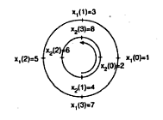
To find y(1):
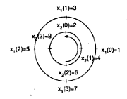
To find y(2):
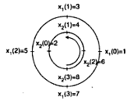
To find y(3):
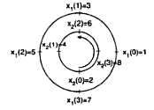
Thus,Thus,
Method:2 Matrix Method:In this method, the sequences are represented as follows:
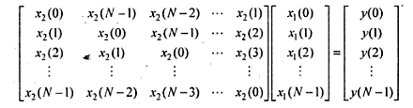
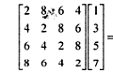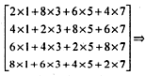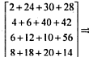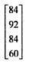
  - Correlation:The correlation is another mathematical operation to measure the degree of similarity of any 2 signals. It is used in RADAR,digital communication,remote sensing etc.,
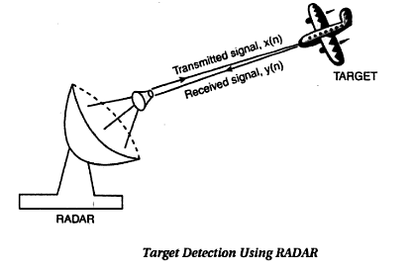
Thus Correlation helps us to extract this important information from y(n).
Cross-Correlation:Cross-correlation refers to the correlation of two different signals.
The cross-correlation of x(n) & y(n) is given by,$γ_{xy}$(m)= $\sum_{n=-∞}^{∞}{x\left(n\right)y(n-m)}, m=0,±1,±2,±3,….$ -(1)
or equivalently$γ_{xy}(m)= \sum_{n=-∞}^{∞}{x\left(n+m\right)y(n)}, m=0,±1,±2,±3,….$(2) where ,m=lag parameter.
Reversing the roll of x(n) & y(n) in equations (1) & (2),we get
$γ_{yx(m)}$ = $\sum_{n=-∞}^{∞}{y\left(n\right)x(n-m)}, m=0,±1,±2,±3,….$- (3)
Or equivalently
$γ_{yx(m)}$ = $\sum_{n=-∞}^{∞}{x\left(n\right)y(n+m)}, m=0,±1,±2,±3,….$- (4) Thus $γ_{xy}$ = $γ_{xy}$(-m)
To find the length of the correlation sequence, $N_{1}$+$N_{2}$-1.In correlation except folding all other process remain the same.Mathematically, the correlation & convolution can be related as,$γ_{xy=x\left(m\right)*y(-m)}$
Method:1 Graphical method:
Determine the cross-correlation of x(n)={1,1,2,2} &y(n)={1,0.5,1}
The x(n) starts at n=0 & has 4 samples.$n_{1}$=0,$N_{1}$=4;The y(n) starts at n=0 & has 3 samples.$n_{2}$=0,$N_{2}$=3;
So total no. of samples=$N_{1+}N_{2}$-1=4+3-1=6 samples.
The initial value of m=$m_{i}$ = $n_{1}$-($n_{2}$+$N_{2}$-1)=0-(0+3-1)=-2
The final value of m=$m_{f}$ = $m_{i}$+($N_{1}$+$N_{2}$-2)=-2-(4+3-2)=3;Hence to find $γ_{xy}$(m) from m=-2 to 3;
The graphical representation of x(n) & y(n) is
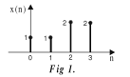
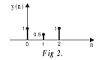$γ_{xy}$(m)= $\sum_{n=-∞}^{∞}{x\left(n\right)y(n-m)}$=$\sum{x(n)y_{m}}$(n);

where $y_{m}\left(n\right)=y(n-m)$
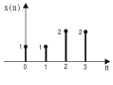
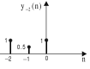which gives,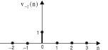
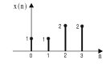
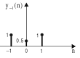which gives,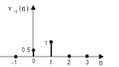
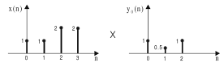--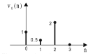
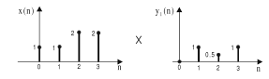--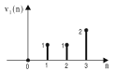
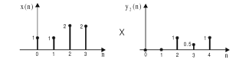-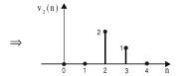

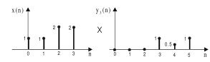-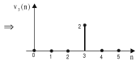
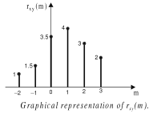
Method:2 Matrix Method:
W.K.T,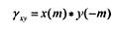
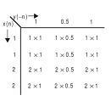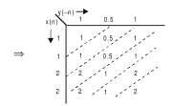
Hence to find cross-correlation from m=-2 to 3;
;;;;;;;
Autocorrelation :Autocorrelation refers to the correlation of two same signals.
When y(n)=x(n),the cross-correlation function becomes the autocorrelation function.y(n) is replaced by x(n);
$γ_{xx}$($l$)= $\sum_{n=-∞}^{∞}{x\left(n\right)x(n-l)}, l=0,±1,±2,±3,….$or equivalently,
$γ_{xx}$($l$)= $\sum_{n=-∞}^{∞}{x\left(n+l\right)x(n)}, l=0,±1,±2,±3,….$
From the above equations,it is clear that the maximum autocorrelation value occurs at $l$=0,because of an in-phase relationship between the 2 sequences.As $l$ increases, the autocorrelation value increases.
Example:Tabular Method:
Determine the autocorrelation of x(n)={1,2,3,4}.
W.K.T $γ_{xx}$($l$)= $\sum_{n=-∞}^{∞}{x\left(n\right)x(n-l)},$The x(n) starts at n=0 & has 4 samples.$n_{x}$ = 0 & N = 4;
Now the total no of samples=2N-1=(2x4)-1=7 samples.The initial value of m=$m_{i=-\left(N-1\right)=-\left(4-1\right)=-3;}$
The final value of m=$m_{f=m_{i}}$+(2N-2)=-3+((2x4)-2)=3;

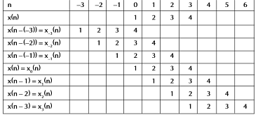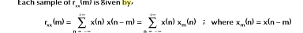
Circular correlation of periodic sequences:If the 2 sequences are periodic with the same period N,then circular correlation is defined as,$γ_{xy}$($l)=\frac{1}{N }\sum_{n=0}^{N-1}{x\left(n\right)y\left(n-l\right),l=0,1…,\left(N-1\right)}$
Method:1 Graphical Method:Perform circular correlation of x(n)={1,1,2,1} & y(n)={2,3,1,1}
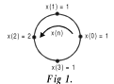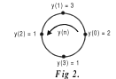
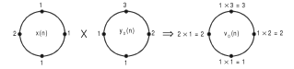
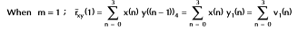
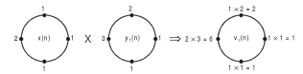
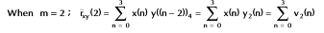
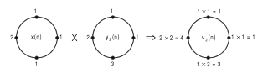
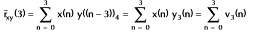
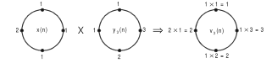
Method: 2 Matrix Method:
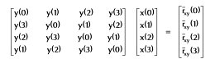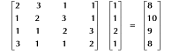
1.6 Z-TRANSFORM:
Z-Transform:The z-Transform of a DT signal x(n) is defined as,
$X\left(z\right)=\sum_{n=-∞}^{∞}{x(n)z^{-n}}$.
This is called Direct Z-Transform ,because it transforms the time-domain signal x(n) into its complex-plane X(z).
For convenience,the Z-T of x(n) is denoted by, X(z) = Z [x(n)],that is $x\left(n\right)\underset{↔}{z}X(z)$
One Sided Z-transform of x(n):$X\left(z\right)=\sum_{n=0}^{∞}{x(n)z^{-n}}$
Two sided Z-Transform of x(n):$X\left(z\right)=\sum_{n=-∞}^{∞}{x(n)z^{-n}}$
Region Of Convergence: (ROC)
Definition: The range of values of Z, for which the Z-Transform sequence converges, is called ROC of Z-Transform.

Inverse Z-Transform:This is to recover the original time domain DT sequence x(n) fromX(z).
ie.,$x\left(n\right)= Z^{-1}$[X(z)] &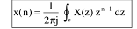where the integral is a contour integral over a closed path C.
Representation of ROC:
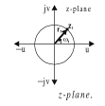
This circle in the Z-Plane is referred to as unit circle & plays a very important role in the discussion of Z-Transform.
Properties of ROC:
- The ROC of X(Z) consists of a ring in the Z-Plane centered at the origin.
- The ROC cannot contain any poles.
- The ROC of finite duration right sided (or causal signal) is in the entire plane except z=0.
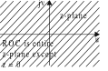
- The ROC of finite duration left sided (anticausal signal)is in the entire plane except z=infinity.
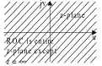
- The ROC of finite duration two sided (noncausal signal is in the entire plane except z=0 & z=infinity.
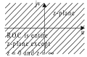
- The ROC of infinite duration right sided (causal) is exterior of the circle of radius r,in Z-Plane.
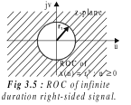
- The ROC of infinite duration left sided (anticausal) is interior of the circle of radius r,in Z-Plane.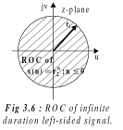
- The ROC of infinite duration two sided (non-causal) is the region between two circles of radius r1 & r2.
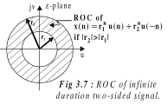
Properties of Z-Transform:
Proof:
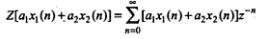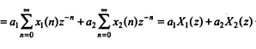
Thus proved.
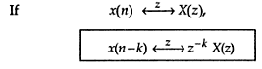
Proof:
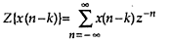
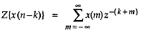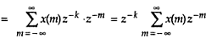
Thus proved.
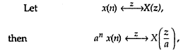
Proof:
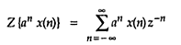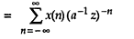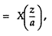
Thus proved.
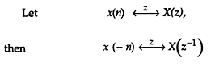
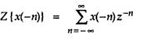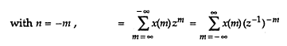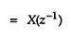
Thus proved.
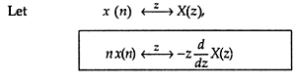
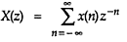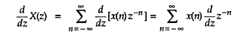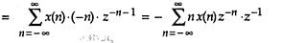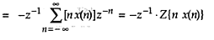
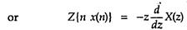
Thus proved.
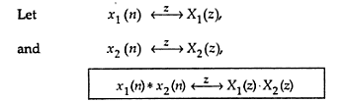
Proof:
Let
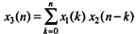
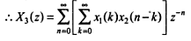Multiply by $Z^{-k}Z^{k}$
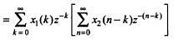
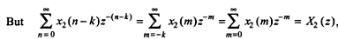
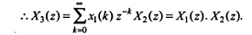
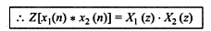
7.
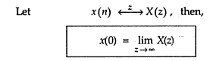
W.K.T
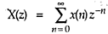
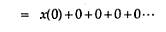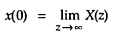
8.Final value theorem:
  - CONCEPTS OF FREQUENCY IN ANALOG & DIGITAL SIGNALS:
#Frequency is closely related to specific type of periodic motion (harmonic oscillation)
# Harmonic oscillation is described by sinusoidal functions.
# The concept of frequency is related to the concept of time by the dimension of inverse time.
- CT Sinusoidal Signals:A simple harmonic oscillation is mathematically described by the following CT sinusoidal signal:
$x_{a}$(t)=Acos($Ω$t + $θ$), - ∞ < t <∞,A is Amplitude,θis phase in rad ,Ω is frequency in rad/s.
Instead of Ω the frequency F in Hz is used, Ω = 2πF, then
$x_{a}$(t)=A cos ($2πF$t + $θ$), - ∞ < t <∞
Analog Sinusoidal Signal Properties:
- For every fixed value of the frequency F, x_{a}(t) is periodic. x_{a}(t+T_{P}) = x_{a}(t) where T_{P} = 1/F is the fundamental period of the sinusoidal signal.
- CT sinusoidal signal with different frequencies are themselves different.cos (20πt) ≠ cos (40πt)
- Increasing the frequency F results in an increase in the rate of oscillation of the signal. (more periods are included in a given time interval)
Analog Sinusoidal Signal Periodicity:If $x_{a}$(t+$T_{p}$) = $x_{a}$(t) then $x_{a}$(t) =periodic.T_{P} is the smallest value to satisfy the above property.Fundamental Period:$T_{p}$ = $\frac{1}{F}$ = $\frac{2π}{Ω}$
Proof:$x_{a}$(t+$T_{p}$)= A cos [Ω (t+T) +$θ$]
= A cos[Ωt+Ω.$\frac{2π}{Ω}$ + ] = A cos (Ω t+$θ$+2π) =A cos (Ωt+$θ$) = $x_{a}$(t)
Complex Exponential Signal:${ x}_{a}$(t) = A $e^{j(Ωt+θ)}$
Euler Manipulations:cos(x) = $\frac{1}{2}$ ($e^{j x}$ + $e^{-j x}$), sin(x) = $\frac{1}{2j }{(e}^{j x}$ - $e^{-j x}$),$e^{j x}$ = cos(x) + j sin (x),
${ e}^{-j x}$ = cos (x) - jsin (x),A cos (Ωt+$θ$) = $\frac{A}{2}e^{j(Ωt+θ)}$ + $\frac{A}{2}e^{-j(Ωt+θ)}$.
Frequency is inherently positive.But for mathematical convenience,negative frequencies are used.
Hence the frequency range for analog sinusoids is -∞< F <∞
(ii) DT Sinusoidal Signals:A discrete-time sinusoidal signal may be expressed as: x(n) = A cos(ωn+$θ$ ), -∞< n <∞. Where n is sample number,ω is frequency in rad/sample,θ is phase in rad.Instead of theω,frequencyf,in cycle per sample is used,ω = 2πf,x(n) = A cos(2πfn+$θ$ ), -∞< n <∞
Discrete-Time Sinusoidal Signal Properties:
- A discrete-time sinusoid signal is periodic, only if its frequency f is a rational number.$f= \frac{N_{1}}{N_{2}},$ where $N_{1}$,$N_{2}$ are rational numbers.
- The period N MUST be an integer > 0 for periodicity.x(n+N) = x(n)
- Discrete Signals whose frequencies are separated by a multiple of 2πk are identical. (k = integer)
Discrete-Time Sinusoidal Signal Periodicity:x(n+N) = x(n) for all n
The highest rate of oscillation in a DT sinusoid is attained when $ω= π(or ω= -π$)
or, equivalently,$f= \frac{1}{2}$ (or $f= - \frac{1}{2}$)
Example:$x\left(n\right)=\cos{ω_{0}}$n where, ω₀ = 0, π/8, π/4, π/2, π corresponding to f = 0, 1/16, 1/8, 1/4, 1/2,which results Periodic sequences having periods N = ∞, 16, 8, 4, 2
Thus, when frequency increases, time period decreases and hence oscillation increases.Here also negative frequencies can be introduced.Thus,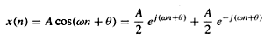
(iii) Harmonically related complex exponential:(Sets of periodic complex exponentials with fundamental frequencies that are multiples of single positive frequency)
Continuous-time exponentials: The basic signals for CT,harmonically related exponentials are
$s_{k}$(t)= $e^{jkΩ_{0}t}$=$e^{j2πkF_{0}t}$ where k=0,$±1,±2…$
For each value of k ,s_{k}(t) is periodic with fundamental period 1/(kF₀) = T_{P}/k or fundamental frequency kF₀ . From the basic signal we can construct a harmonically related complex exponentials by,
$x_{a}\left(t\right)=\sum_{k=-∞}^{∞}{c_{k}}s_{k}\left(t\right)=\sum_{k=-∞}^{∞}{c_{k }}e^{jkΩ_{0}t}$ whereC_{k} is arbitrary complex constant.The signal x_{a}(t) is periodic with fundamental period T_{P}=1/F₀ and its representation in terms of Fourier Series Expansion.
DT Exponentials:A discrete-time complex exponential is periodic if its relative frequency is a rational number,
f₀ = 1/N , then $s_{k}\left(n\right)=e^{j2πkf_{0}n}$, k=0,$±1,±2…$
In Contrast to the CT case, $s_{k+N}\left(n\right)=e^{\frac{j2πn\left(k+N\right)}{N}= e^{j2πn}s_{k \left(n\right)= s_{k}(n)}}$
There are only N distinct periodic complex exponential in the set s_{k}(n)
$s_{k}\left(n\right)=e^{j2πkn}$/ N, k=0,1,2…..N-1 ;$x\left(n\right)= \sum_{k=0}^{N-1}{c_{k }}s_{k}(n)$=$\sum_{k=0}^{N-1}{c_{k }}e^{j2πkn/N}$.
This is Fourier Series Representation.
1.3 SAMPLING THEOREM:Analog to Digital Converter (A/D):Conceptually, the A/D comprise 3 step process as in the following .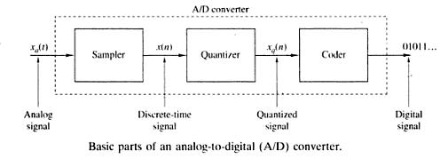
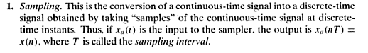
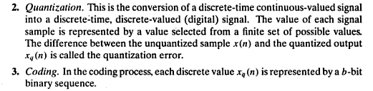
Sampling:It is the conversion of a CT signal into DT signal obtained by taking “Samples” of the CT signal at DT instants.
Periodic or Uniform Sampling:( mapping of infinite frequency of F or Ω into finite frequency range f or ώ.
This type of sampling is used most often in practice, describe by the relation:
$$x\left(n\right)=x_{a}\left(nT\right), -∞<n <∞$$
where x(n) is the DT signal obtained by taking samples of the analog signal x_{a}(t) every T seconds.
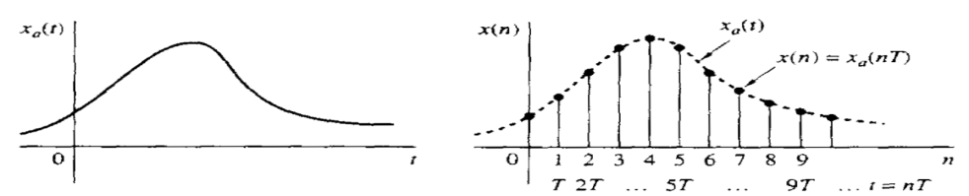
The rate at which the signal is sampled is F_{s}: Sampling rate:F_{s} = 1/T,F_{s} is called the SAMPLING RATE or SAMPLING FREQUENCY (Hz).$t=nT=\frac{n}{F_{S}}$
Sampling:
Consider an analog sinusoidal signal of the form:$x_{a}\left(t\right)=Acos\left(2πFt+θ\right)$
$$x_{a}\left(nT\right)=x\left(n\right)=Acos\left(2πFnT+θ\right)=Acos\left(\frac{2πnF}{F_{s}}+θ\right)$$
We know that x(n)=Acos(2πfn+Ѳ)
By comparing these two equations,$f=\frac{F}{F_{s}}$
And $ω=ΩT$
For CT sinusoids,
$$-∞<F<∞$$
$$-∞<Ω<∞$$
& for DT sinusoids,
$$-\frac{1}{2}<F<\frac{1}{2}$$
$$-π<F<π$$
Substituting CT sinusoids in DT Sinusoids,

$-\frac{1}{2T}=-\frac{F_{s}}{2}≤F≤\frac{F_{s}}{2}$ = $\frac{1}{2T}$
Or equivalently,
$-\frac{π}{T}=-πF_{s}≤Ω≤πF_{s}$ = $\frac{π}{T}$
We observe that the fundamental difference between CT and DT signals in their range of values of the frequency variables F and f or Ω and ω.
Means Sampling from infinite frequency range for F (or Ω) into a finite frequency range for f (or ω).
Since the highest frequency in a DT signal is ω = π or f = 1/2.
With sampling rate F_{s} the corresponding highest values of F and Ω are:
$F_{max}$= $\frac{F_{s}}{2}$ = $\frac{1}{2T}$;
$Ω_{max}$=$πF_{s}$ = $\frac{π}{T}$
THE SAMPLING THEOREM:
To specify $F_{s}$,we should know the maximum frequency content of input signal to be sampled.
We know that,$-\frac{F_{s}}{2}≤F≤\frac{F_{s}}{2}$
To avoid Aliasing,$\frac{F_{S}}{2}>F_{max}$
Thus,
Where is the largest frequency component in analog signal.
And if this condition is satisfied, reconstruction of the analog signal is possible by appropriate interpolation method.This interpolation formula is specified by sampling theorem.
Statement:
Given Band Limited (Frequency Limited Signal) with highest frequency F_{max}:
The signal can be exactly reconstructed provided the following is satisfied:
  - Sampling Frequency:
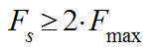
  - The samples are not quantized (analog amplitudes)
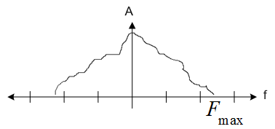
Reconstruction Formula:
- The signal:
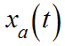
- The samples:
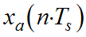
- Formula:
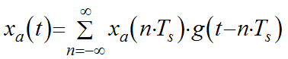
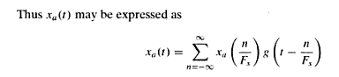
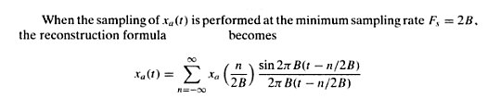
- Interpolation Function:(for recovery)
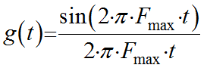
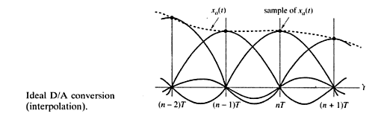
Aliasing
- Aliasing occurs when input frequencies (again greater than half the sampling rate) are folded and superimposed onto other existing frequencies.
- In order to prevent alias
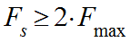
whereF_{max}is the highest input frequency
Nyquist Rate:
Minimum sampling rate to prevent alias.
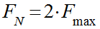
: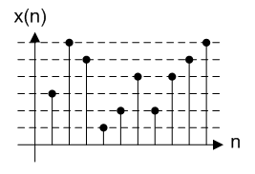
Quantization of Continuous Amplitude Signals
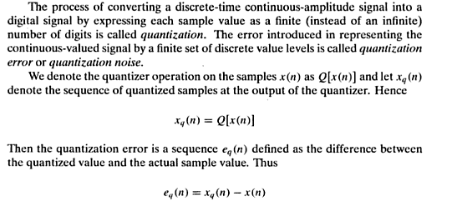
Example:
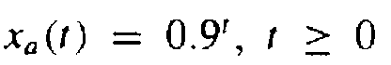
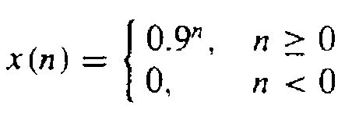
Numerical illustration of quantization with one significant digit using truncation or rounding
Coding:
Coding assigns unique binary number to each quantization level.
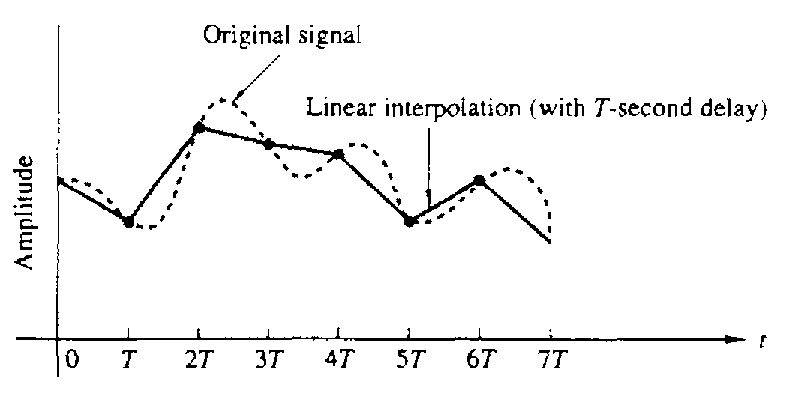

51.Find the Z-Transform of x(n)= $a^{n}$u(n);
W.K.T $X\left(z\right)=\sum_{n=-∞}^{∞}{x\left(n\right)z^{-n}}$
$=\sum_{n=-∞}^{∞}{[a^{n}u(n)]z^{-n}}=\sum_{n=0}^{∞}{a^{n}z^{-n}}$=$\sum_{n=0}^{∞}{{\left(aZ^{-1}\right)}^{n}}$=$\frac{1}{1-\left(aZ^{-1}\right)}$
X(Z)= $\frac{Z}{Z-a}$;
Location of poles: Z=a;Location of zeros: Z=0;
ROC: $\left|Z\right|$> a;
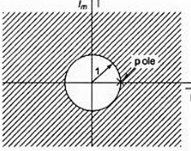
52.Find the Z-T of
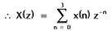
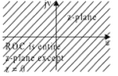
53.Practice: Find the Z-T of x(n)=${0.3}^{n}$u(n)
54.
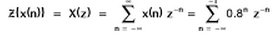
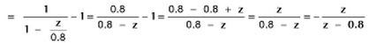

Location of poles: Z=0.8;Location of zeros: Z=0;
ROC: $\left|Z\right|$< 0.8
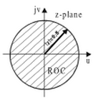;
55.
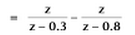
Location of poles: Z=0.3 & 0.8;Location of zeros: Z=0;
ROC:$\left|Z\right|$> 0.3 &$\left|Z\right|$< 0.8
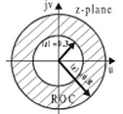
56.Practice: $x\left(n\right)=\{{\left(\frac{1}{2}\right)}^{n}$+${\left(\frac{1}{3}\right)}^{n}$} u(n)
57.Find the initial & final value of
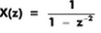
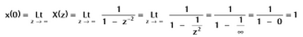
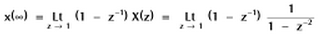

58.
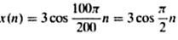
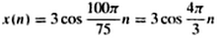
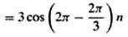
59.Consider the analog signal,
Inverse Z-Transform:
- By Long-Division Method:
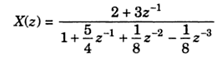
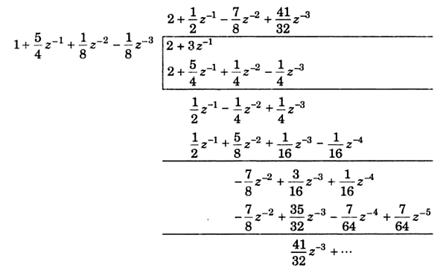
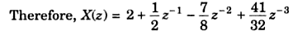
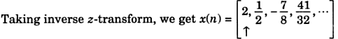
- Partial –Fraction Method:
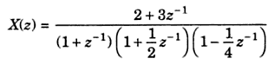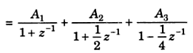
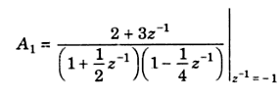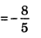
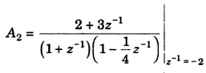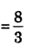
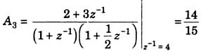
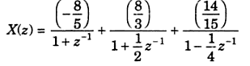
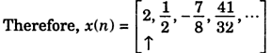
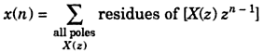
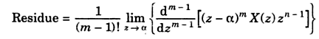
Example:
