Zigzag Array Generation || Bottom-Up DP w/ Prefix Sum Optimization

Java:
class Solution {
private static final int MOD = 1000000007;

public int zigZagArrays(int n, int l, int r) {
int m = r - l + 1;
int[] dp = new int[m];
Arrays.fill(dp, 1);

for (int i = 2; i <= n; i++) {
int sum = 0;
if ((i & 1) == 0)
for (int j = 0; j < m; j++) {
int t = dp[j];
dp[j] = sum;
sum = (sum + t) % MOD;
}
else
for (int j = m - 1; j >= 0; j--) {
int t = dp[j];
dp[j] = sum;
sum = (sum + t) % MOD;
}
}

int res = 0;
for (int j = 0; j < m; j++)
res = (res + dp[j]) % MOD;

return (res << 1) % MOD;
}
}
CPP:
class Solution {
public:
static constexpr int MOD = 1000000007;
int zigZagArrays(int n, int l, int r) {
int m = r - l + 1;
vector<int> dp(m, 1);

for (int i = 2; i <= n; i++) {
reverse(dp.begin(), dp.end());
int sum = 0;
for (auto& d : dp)
sum = (sum + exchange(d, sum)) % MOD;
}

return ((accumulate(dp.begin(), dp.end(), 0LL) % MOD) << 1) % MOD;
}
};
Intuition
Since only the relative ordering matters, the exact values are irrelevant, the range can be transformed into .
Where:
The transformation is with respect to ordering. Hence, all comparisons between elements are preserved.
For example:
Let :
Thus, we only work with relative ranks while keeping the same structure of valid sequences.

Since adjacent elements must be different, the first pair can only form either an increasing or a decreasing relation:
For the element, we cannot have three forming a strictly increasing or strictly decreasing sequence.
Therefore, the direction must switch:
We continue the direction for evey new element as the increases..

Symmetry
- Reversing all values flips every step into a step and vice versa.
- Every valid sequence starting with an increase has a counterpart starting with a decrease.
Hence, the two cases contribute equally, so we only need to process half of the configurations and multiply the result by .

Zigzag Array Generation
Let ,
Observe how the pattern is generated:


DP Construction (Prefix / Suffix Alternation)
Since we only care about the of the Zigzag arrays:
- We initialize a array using the base case for length :
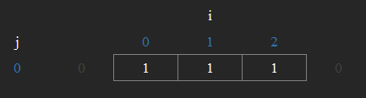
At this point, every value is equally valid as an endpoint.

For the next iteration, we compute using a .
Each position is updated in-place with its :
- This corresponds to transitions where the next relation is
- Each index accumulates contributions from all previous indices.
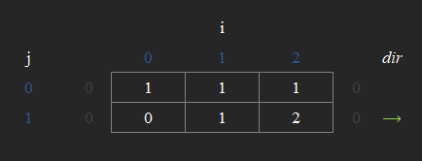

For the following iteration, the direction :
Instead of recomputing a different structure, we perform a and update the array in-place with its suffix sum:
- This corresponds to transitions where the next relation is .
- Each index accumulates contributions from all indices
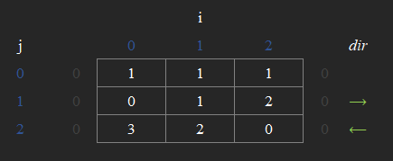

The two operations and alternate at each step, forming the core evolution of the state for constructing zigzag arrays efficiently.
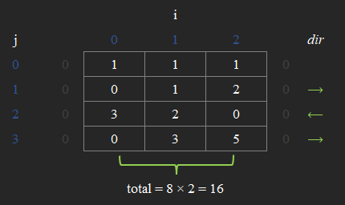

Finally, we sum all values in to get the number of valid sequences for one starting direction.
- Since the structure is , we multiply this result by to account for both increasing-start and decreasing-start cases.

More Example:
Here's for range , and length up to
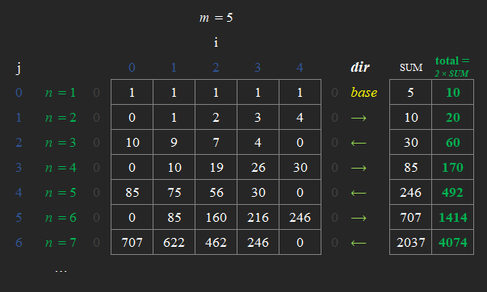

To optimize the runtime, replace with backwards traversal every odd index (see Java).
Time Complexity:
Space Complexity:

