Find Subsets using Frequency count | Simple Explanation
class Solution {
private static final int MAX_BASE = 31622;

public int maximumLength(int[] nums) {
Map<Integer, Integer> freq = new HashMap<>();
for (int n : nums)
freq.merge(n, 1, Integer::sum);

int one = freq.getOrDefault(1, 0);
int res = (one - 1) | 1;
freq.remove(1);

for (int f : freq.keySet()) {
int sq = (int) Math.sqrt(f);
if (sq * sq == f && freq.getOrDefault(sq, 0) > 1) continue;

int n = 0;
int x = f;

while (x <= MAX_BASE && freq.containsKey(x) && freq.get(x) > 1) {
n += 2;
x *= x;
}

res = Math.max(res, n + (freq.containsKey(x) ? 1 : -1));
}

return res;
}
}

Intuition
A must be arranged as
Every value except the appears exactly twice:
- Thus, each non-center value must have at least occurrences.
- The only needs occurrence since it serves as the .

Example:
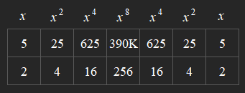

The values form starting from some value :
- We can keep extending the chain as long as the current value has at least .
- Once this is no longer possible, the current value can either serve as the (if it exists) or the chain must end at the previous level.
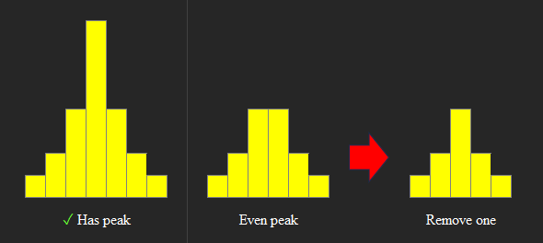

Edge Case
The only special case is , since .
- A valid sequence consisting only of 's must have length.
- Thus, we simply take the number (not exceeding its frequency).
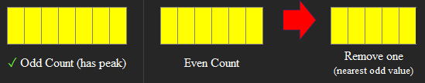

Skip Logic
To avoid processing the same chain multiple times, only process the (smallest possible starting value).
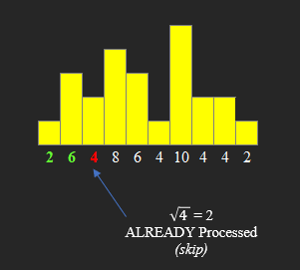
If a value is a and its square root has at least two occurrences:
- Then, any starting from that value can always be extended by starting from its instead.
- Thus, we can safely forming the for that value.
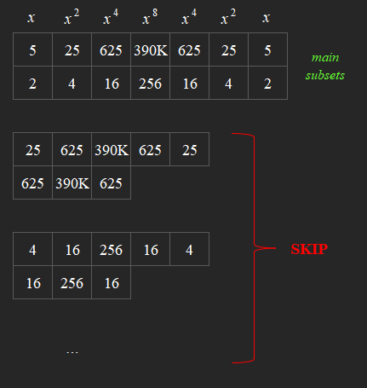

To avoid using - integer types like :
- We can terminate the loop early when exceeds the of the maximum constraint ().

Time Complexity:
Space Complexity:
PLEASE UPVOTE

