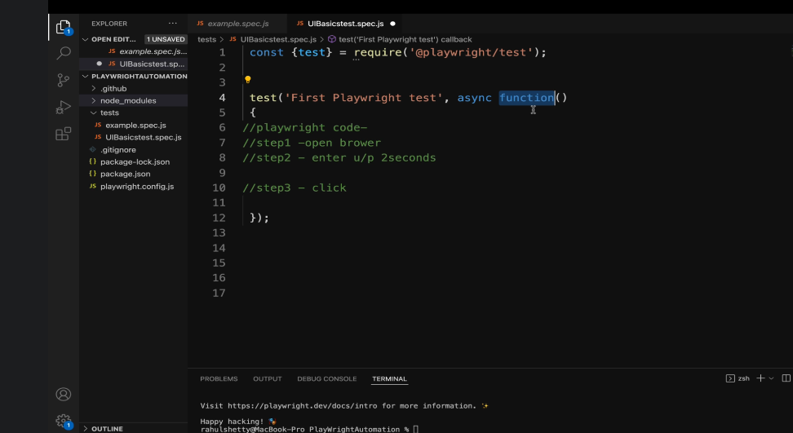

Replace function by 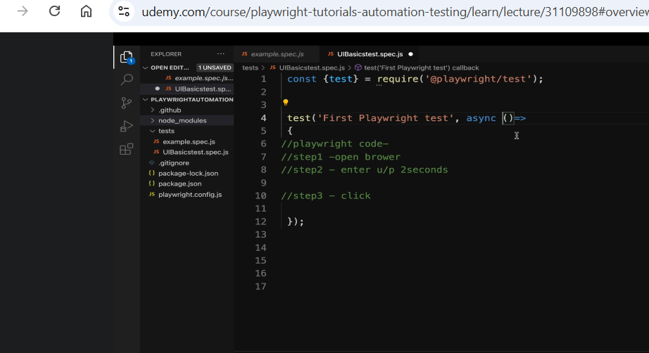

Need to use async keyword as javascript is asynchronous.. the script will fail as lines will execute at once --- hence need to use await and async.

Run specific test only from the test file: 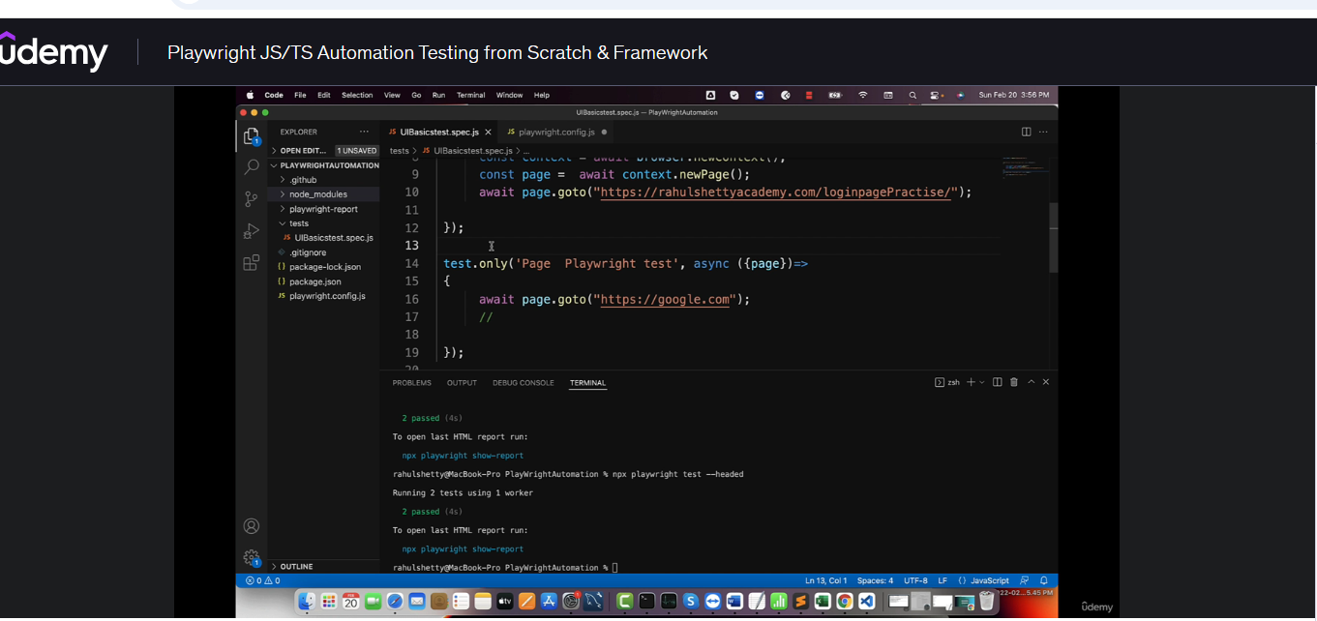
Command to run tests – npx playwright test –headed
Command to view result report – npx playwright show-report
Playwright prefers css selectors over other locator strategies.
1)For id => tagName#idValue or #idValue example input#username
2)For class =>tagName#classvalue or .classValue example input#form-control
3)Using attribute => [attribute=’value’] example [id=’username’]
4)traverse from parent to child. parenttagname childtagname //just space in between

