# Aim:

My aim is to create and maintain the employees’ record of Alex Solutions. Here, I performed all CRUD operations Create, Read, Update and Delete.

To do so, I used Spring MVC with Hibernate framework, maven and Mysql.

I accepted the challenge of the Database systems and Advanced Java programming.

Below I will try to explain each module,

1. Create
   1. - 
   2. After clicking the add employee link, below page will popup
   3. - 
   4. The data will be saved into the db
   5. Like this, the last record was saved with the name of sarah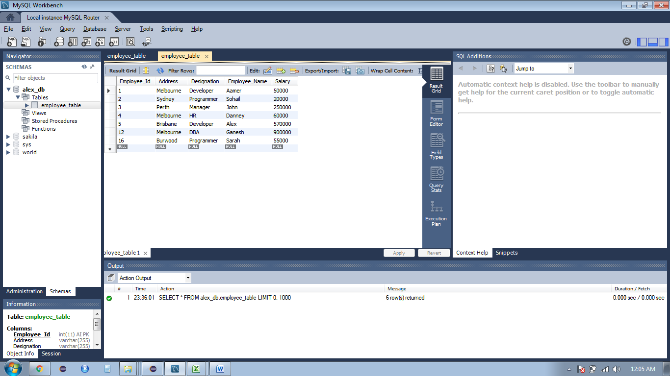
2. Read
   1. After submitting the form, it will read all the records from the database and display it.
   2. – 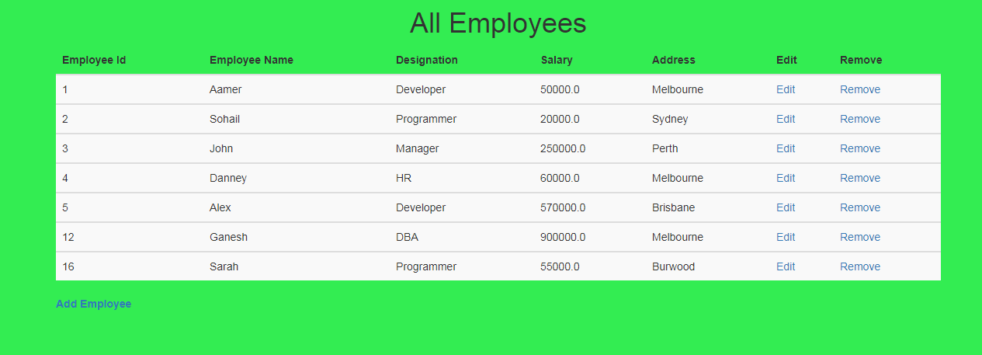
3. Update
   1. The edit link will be used for updating specific record,
   2. Just click on a specific record then it will show a from, where we can update it,
   3. For example, if I want to update the salary of Sarah from 55000 to 88000
   4. So I will click on edit link and it will show the edit form page where we can edit the sarah data.
   5. - 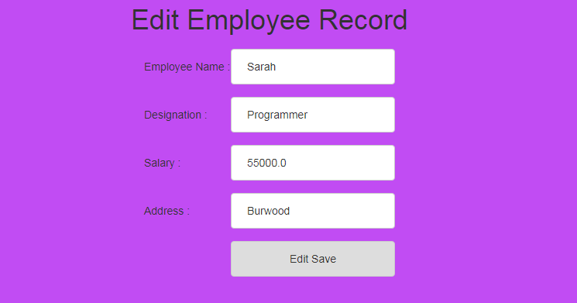
   6. , 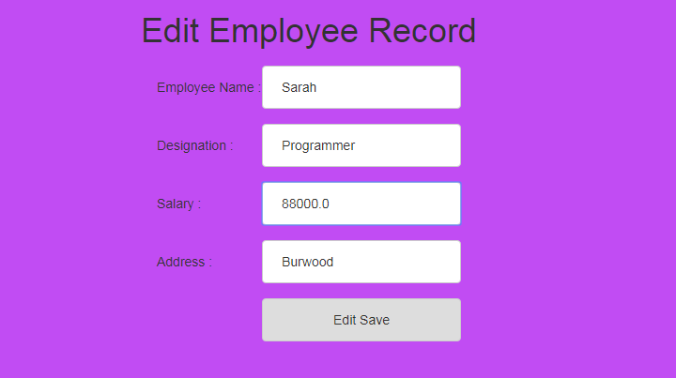
   7. Once I save this the updated data will be displayed like this, 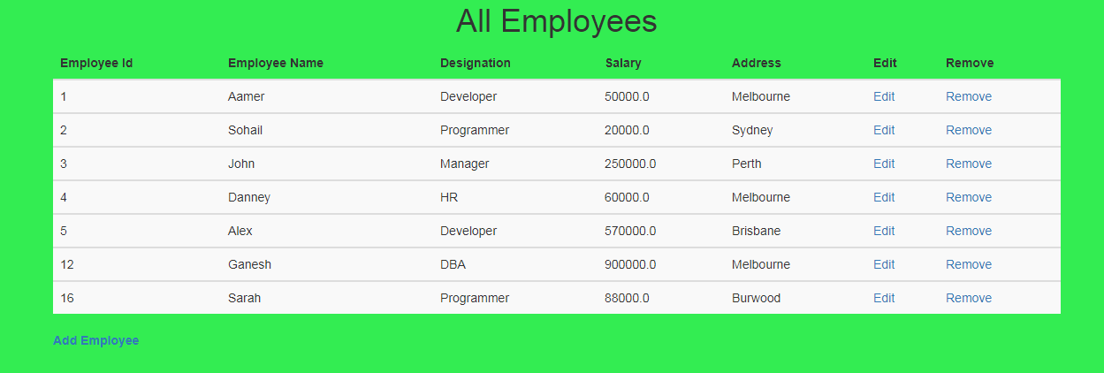
4. Delete
   1. To delete the specific record it will delete the record and display the update page,
   2. Now, I will delete Sarah and Ganesh records, 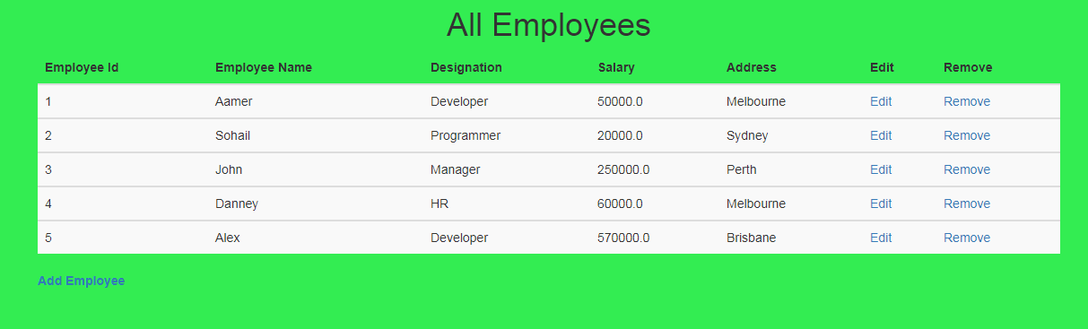

**Note: To run this project on your PC, make sure you have mysql connector java 8 dependencies, mysql username : root and password : root.**

**Just import it to eclipse and it will run very finely.**