# Google Cloud Platform

How to create a VM Instance using Google Cloud Platform

Step 1: The below screenshot showcases the initial page that would open after selecting the link, <https://www.google.com/search?q=google+cloud+platform&oq=google+cloud+platform&aqs=chrome..69i57j69i60l3j69i59l2.4439j0j7&sourceid=chrome&ie=UTF-8>



Step 2: a. Select the “Try free” option

b. $300 credits will be posted to the Gmail account and can be used for a year for free.

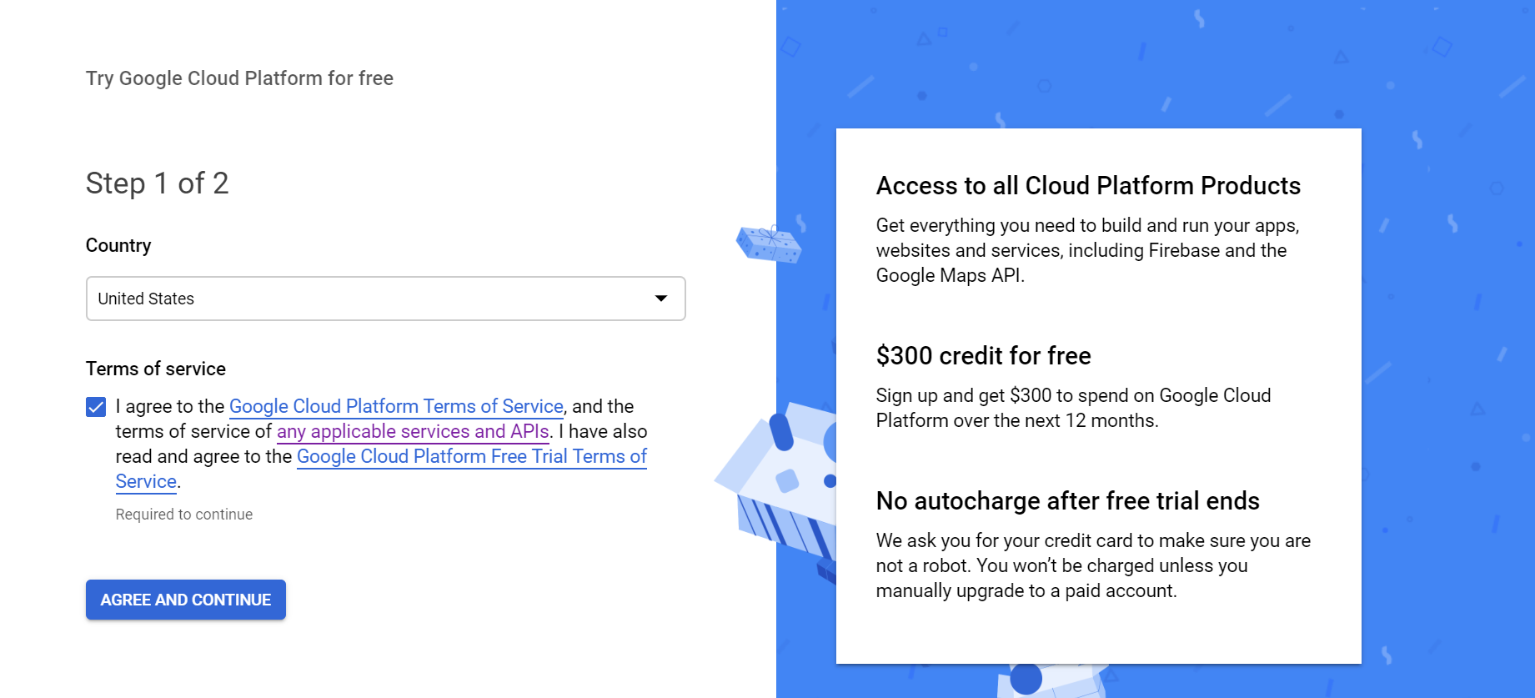

Step 3: Fill in the card details to start and to get access to the console page

The below screenshot showcases the Console Page of Google Cloud Platform:

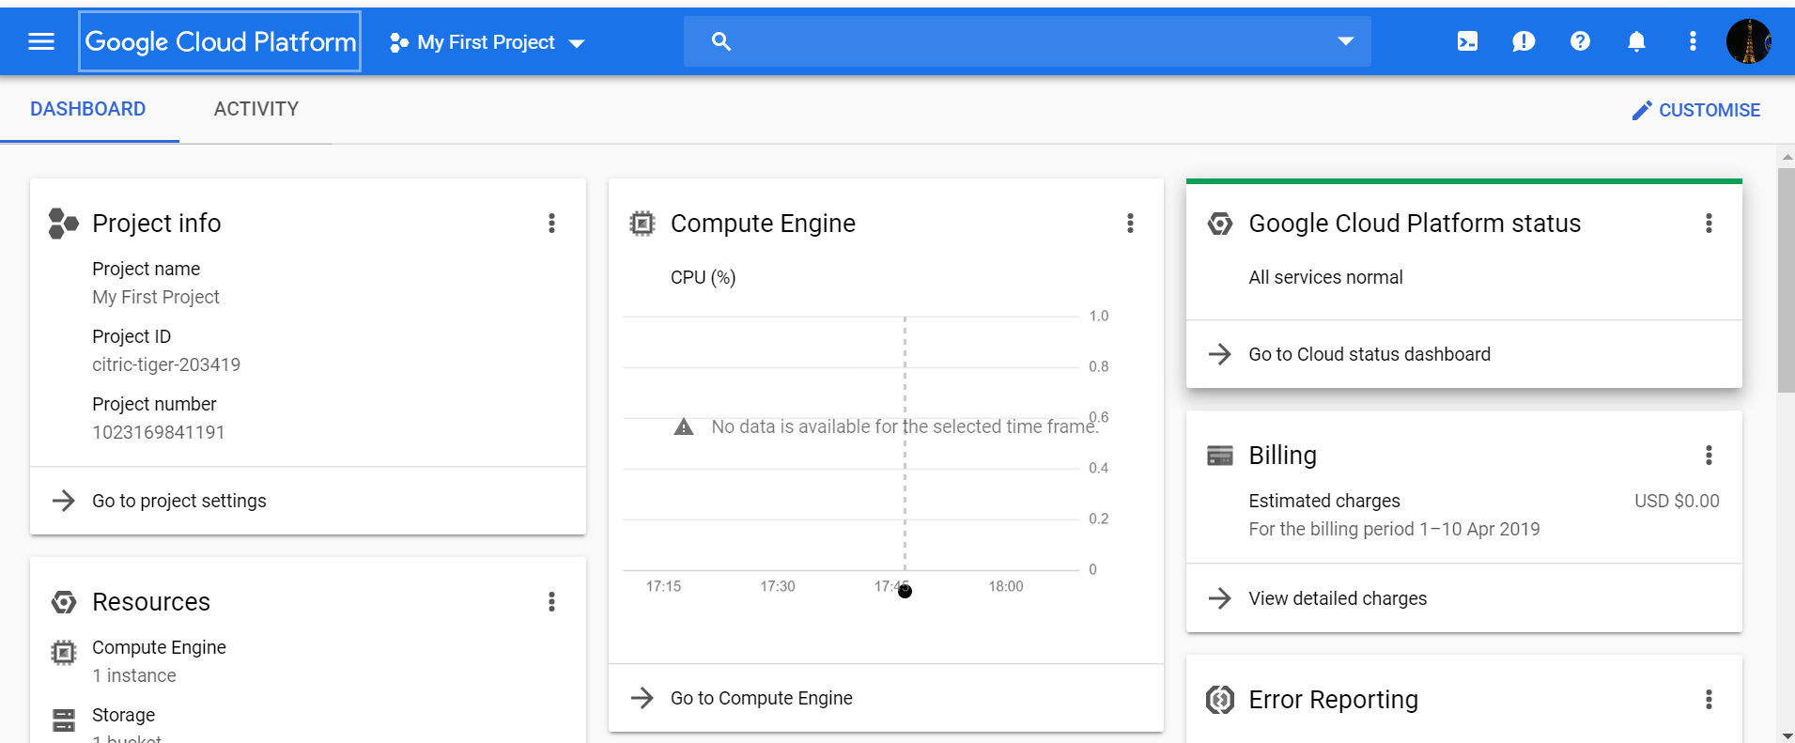

Step 4: Select the highlighted area in red in the below screenshot to view more options:

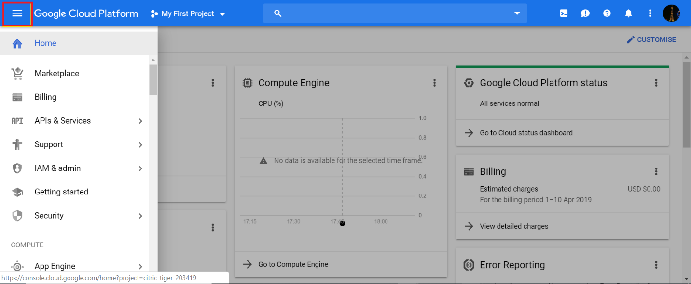

Step 5: To create a VM instance, select “Compute Engine” option -> “VM Instance”

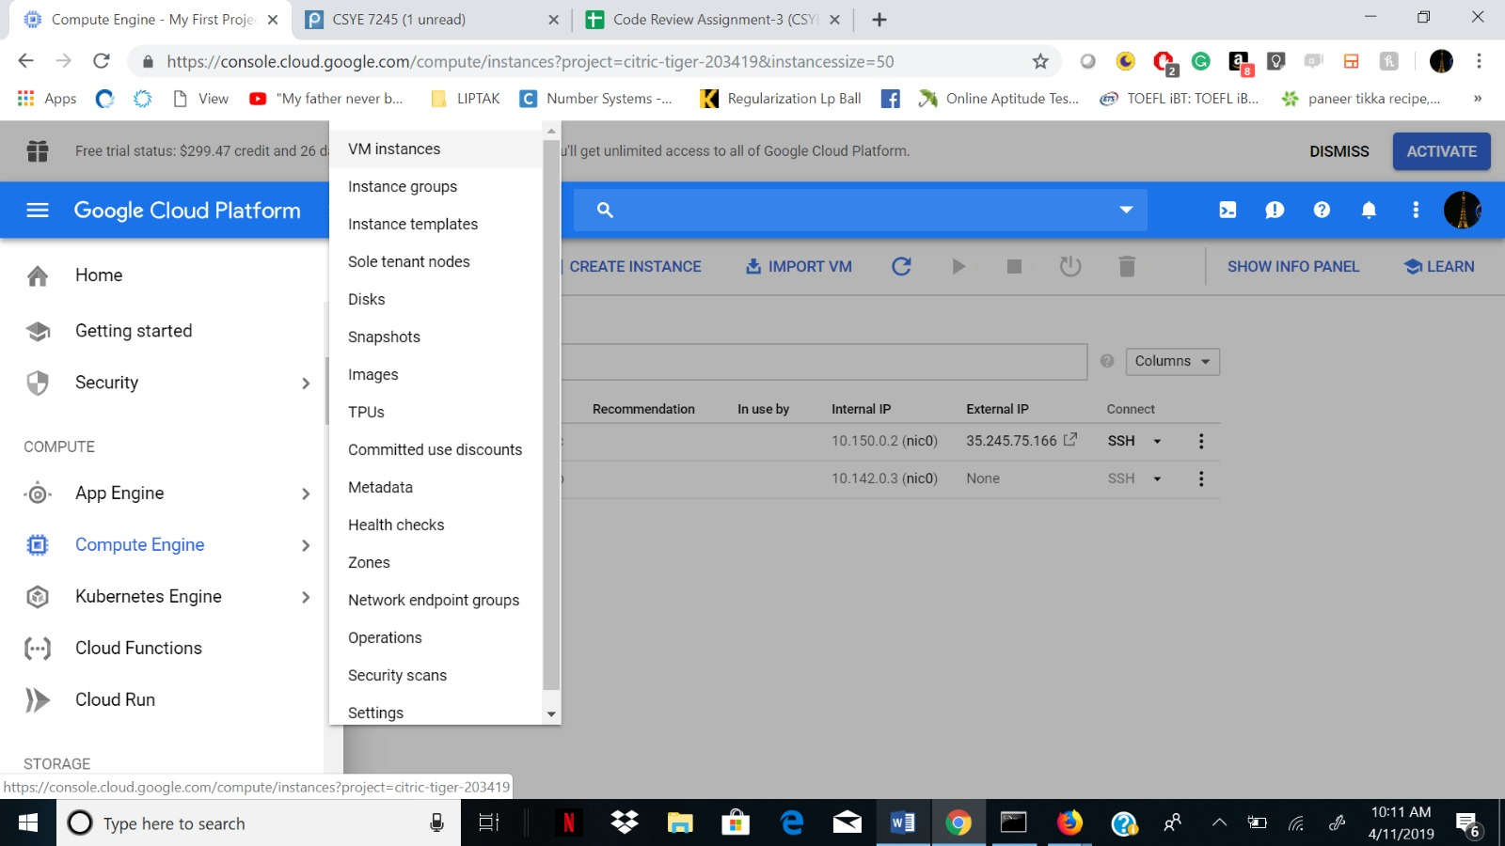

Step 6: Create a New Project and ensure that the billing option is enabled

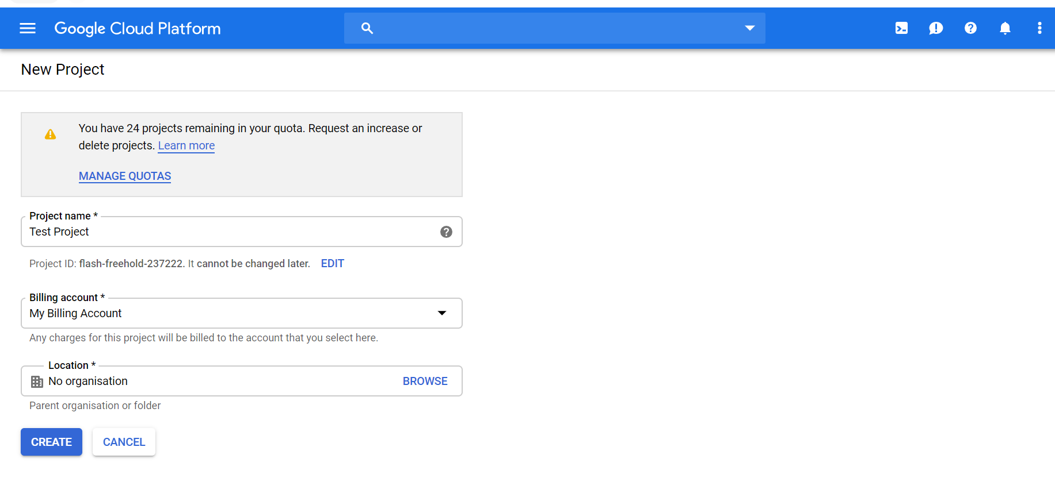

Step 7: Below screenshot shows the console from where VM Instances can be created and the instance name should preferably be in lower case

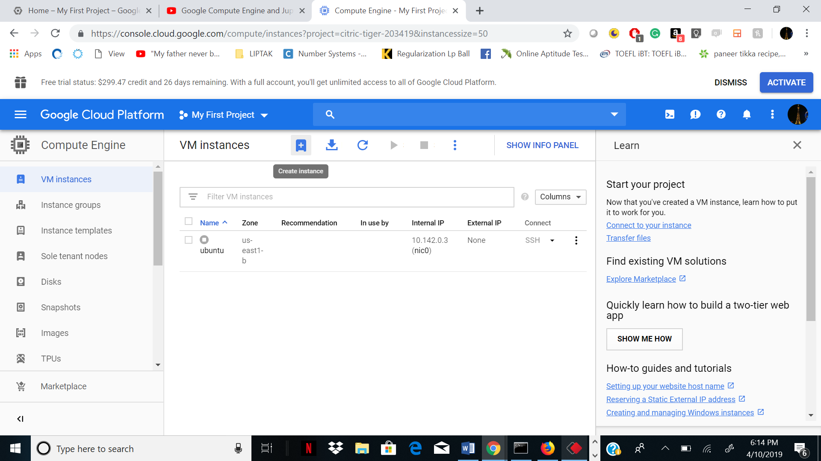

Step 8: Select Create Instance as shown in the below screenshot and fill in the required details:

* Specify Name
* Specify the Region: E.g.: us-east1(South Caroline)
* Select the number of CPU’s

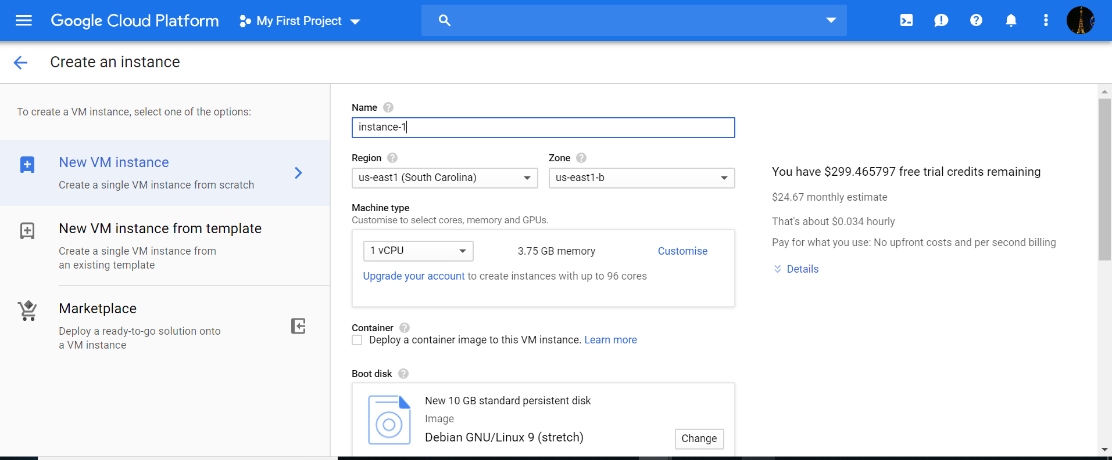

* Change Debian GNU/Linux 9 as per requirement. E.g.: Over here, I have changed Debian GNU/Linux 9 to Ubuntu 16.04LTS
* Specify the size (GB). E.g.: I have selected 50GB.
* Select both the options: Allow HTTP traffic, Allow HTTPS traffic

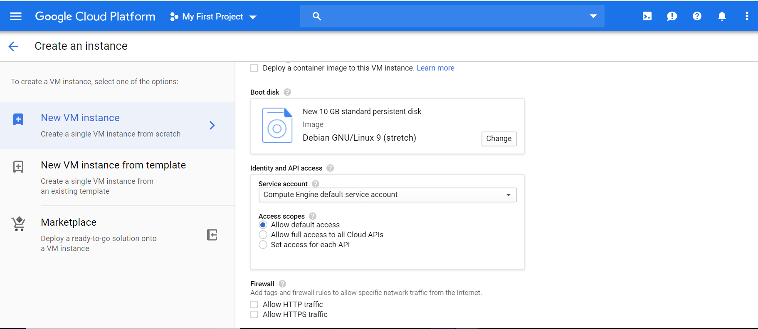

Step 9: Below screenshot shows the VM instance creation:

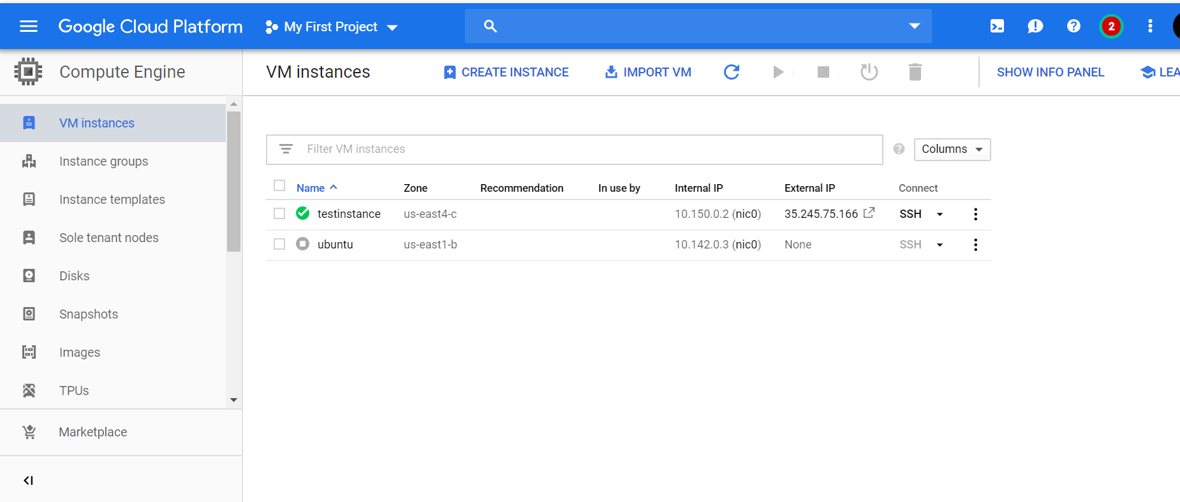

Step 10a: Select SSH, Open in browser window as shown in the below screenshot

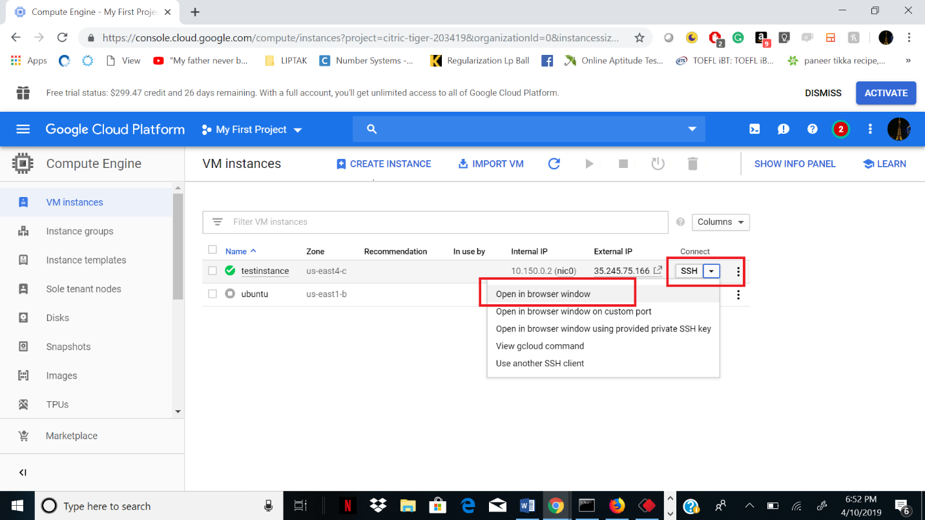

Step 10b: The cmd prompt for the VM instance created, will open as shown in the below screenshot

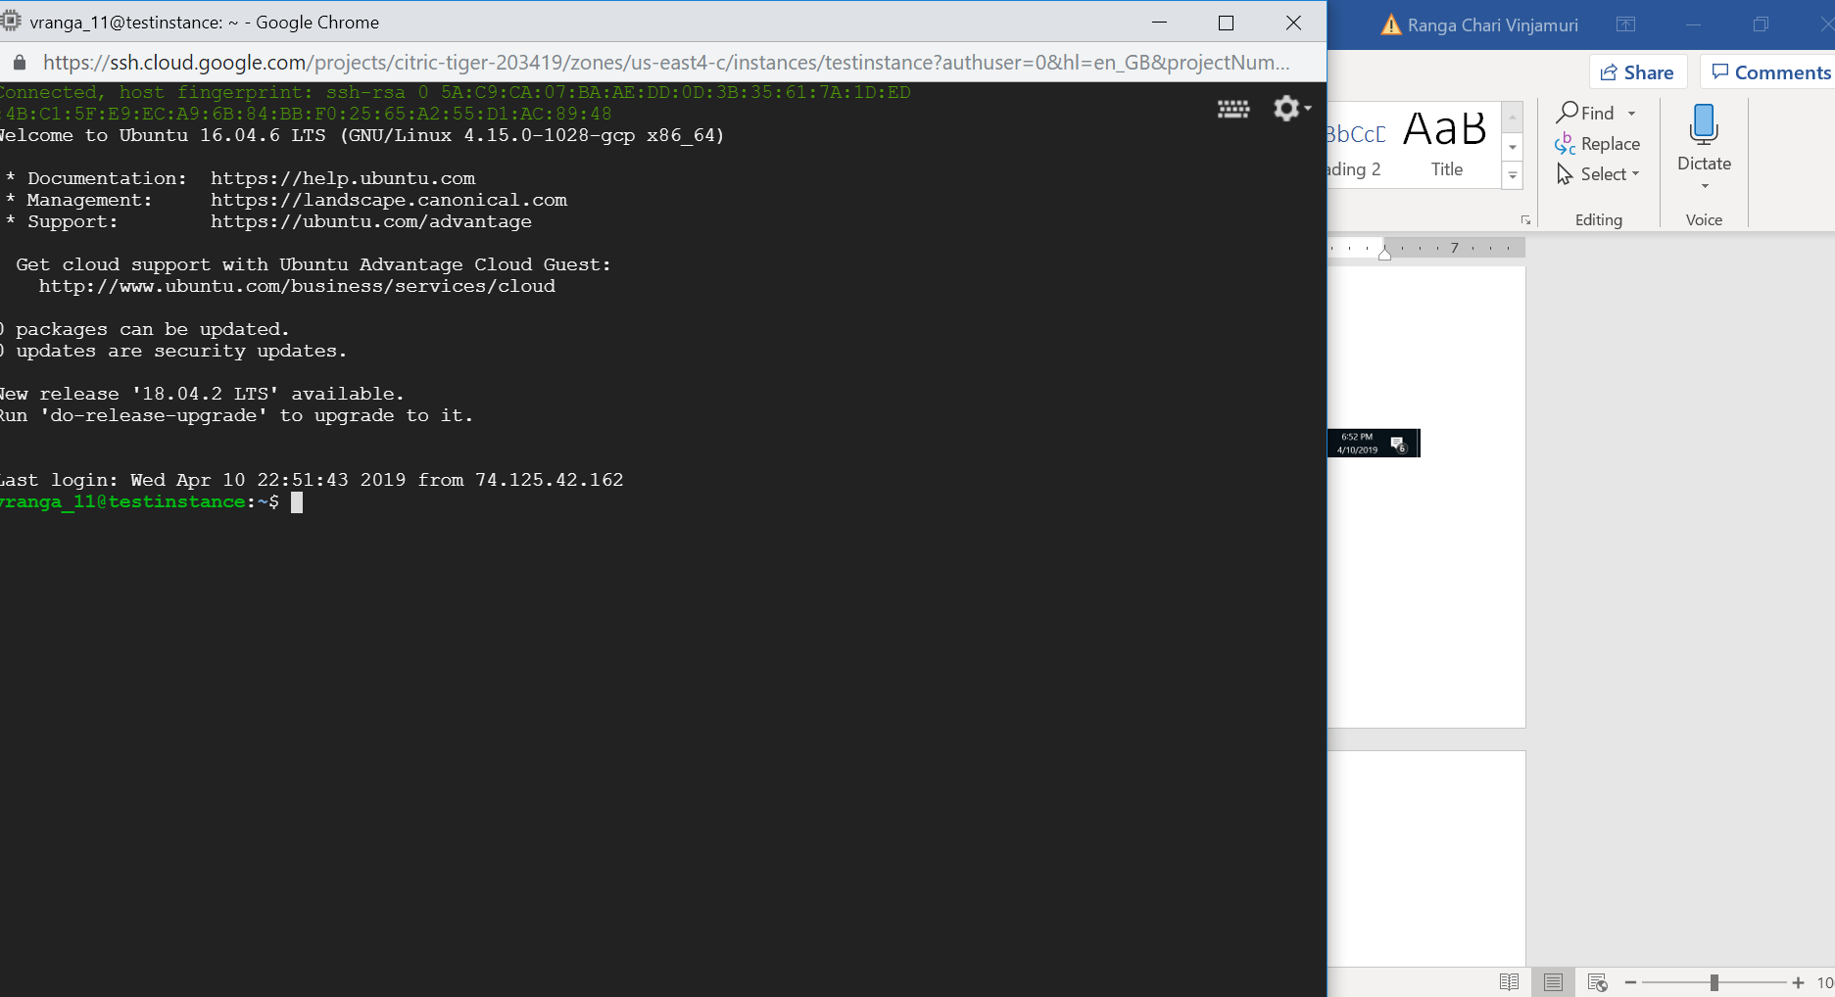

Step 11a: Write the below commands to install and start python and jupyter notebook

sudo apt-get update

sudo apt-get --assume-yes upgrade

sudo apt-get --assume-yes install tmux build-essential gcc g++ make binutils

sudo apt-get --assume-yes install software-properties-common

sudo apt-get --assume-yes install ipython-notebook

pip install --user jupyter

sudo nano ~/.jupyter/jupyter_notebook_config.py

c=get_config()

c.NotebookApp.ip=’*’

c.NotebookApp.open_browser=False

c.NotebookApp.port=5000

ctrl+o

ctrl+x

jupyter notebook password – This is useful to set the password when you access the notebook

jupyter notebook --ip 0.0.0.0 --port 5000

Step 11b: Since the default version installed is 2.7, below are the commands to update python to version 3.6.3

wget <https://www.python.org/ftp/python/3.6.3/Python-3.6.3.tgz>

tar -xvf Python-3.6.3.tgz

cd Python-3.6.3

./configure

sudo apt-get install zlib1g-dev

sudo make

sudo make install

python3 -V

Step 12: Create a new firewall and setup rule to give port access and define the port number

* Select Default option for network
* Select Firewall rules -> “Add a new firewall rule”
* Give a name to the Firewall rule
* Select Source IP ranges as 0.0.0.0/0
* Specify protocols and ports as per requirements E.g.: Over here, I have selected tcp:5000

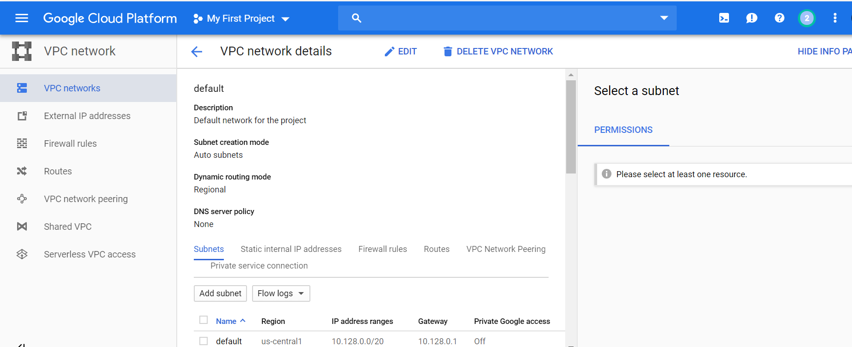

Step 14: Post this, select and copy the external IP address and port number onto the browser as shown in the below screenshot.

For e.g.: 35.245.75.166 is the external IP address and 5000 is the port number to start the jupyter notebook.

