ASSIGNMENT
1. Program to find the GCD of two number.

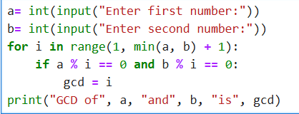

Output :
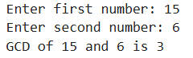

2. Program to find the factorial of a number.

Program:
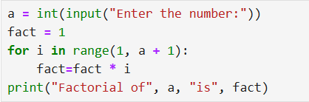
Output:
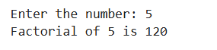

3. Program to generate Fibonacci series of N terms.

Program:

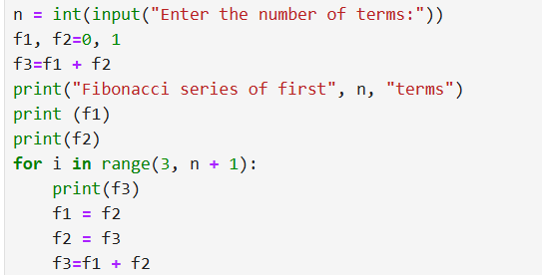

Output:

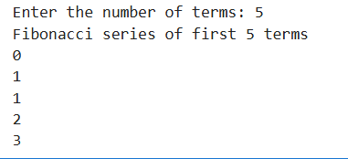

4. Program to count vowels, consonants, digits, and special characters.

Program:

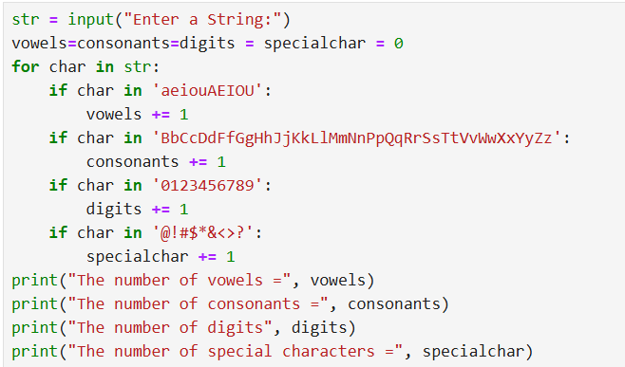

Output:

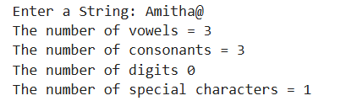

5. Program to find the sum of all items in a list.

Program:
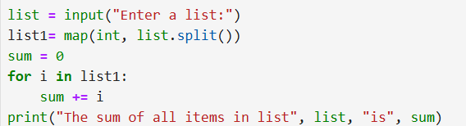

Output:
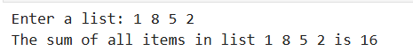
6. Program for the FizzBuzz Test.

Program:
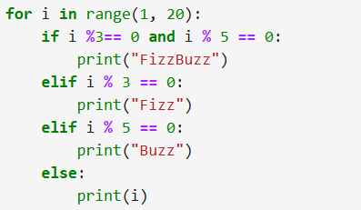

Output:
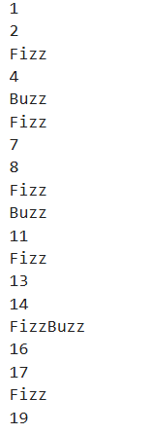
7. Write a program that prints the following pyramid on the screen. The number of lines must be obtained from the user as input.
1
2 2
3 3 3
4 4 4 4

Program:

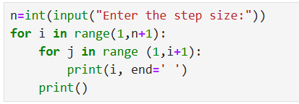

Output:
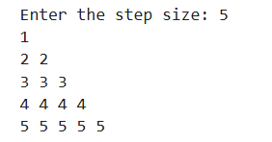

8. Write a program that generates a list of all four digit numbers that have all their digits even and are perfect squares. For example the output should include 6400 but not 8100 (one digit is odd) or 4248 ( not a perfect square).

Program:

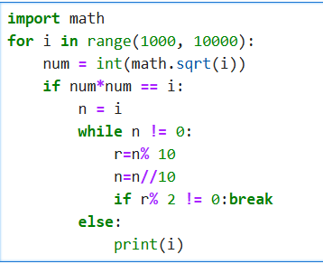

Output:
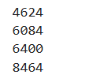
9. Write a program to display the following pyramid. The number of lines has to be a parameter obtained from the user. The pyramid must appear aligned to the left edge of the screen.
1
2 4
3 6 9
4 8 12 16
5 10 15 20 25

Program:
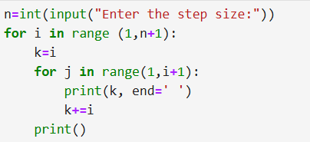

Output:
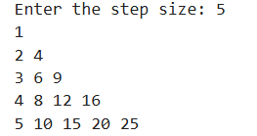

10. Write a Python program which accept the user’s name and print them in reverse order with a space between them.

Program:

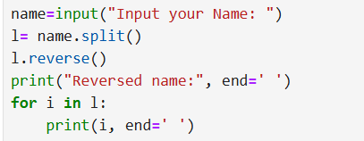

Output:
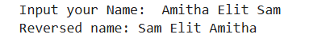
11. Write a Python program to check whether a specified value is contained in a group of values.

Program:

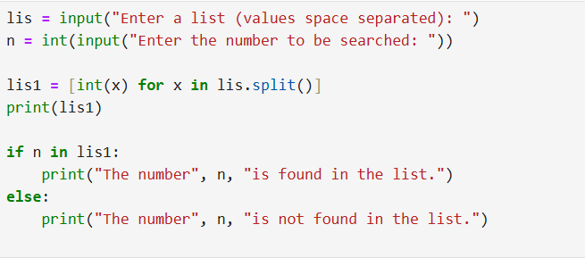

Output:
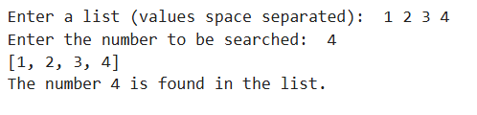
12. Write a Python program to concatenate all elements in a list into a string and return it.

Program:

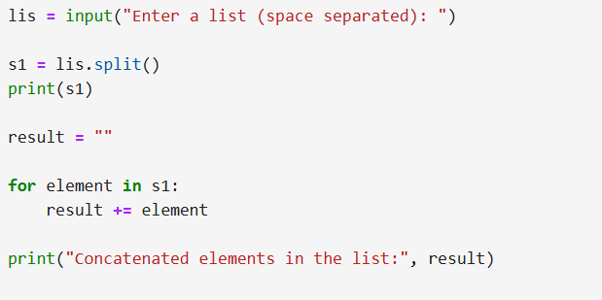

Output:
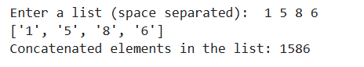

13. Write a Python program to print all even numbers from a given numbers list in the same order and stop the printing if any numbers that come after 237 in the sequence.

Program:
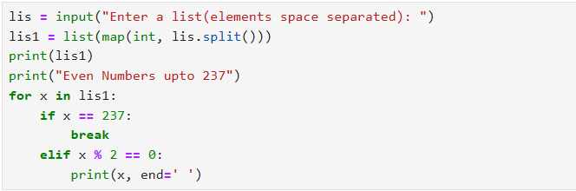
Output:
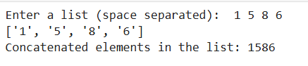

14. Write a Python program to get the least common multiple (LCM) of two positive integers.
Program:
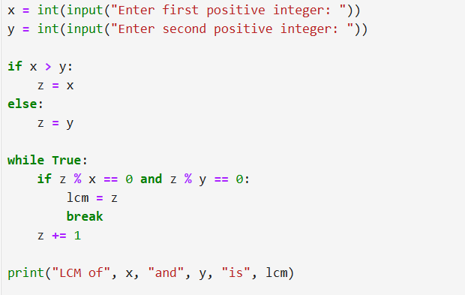
Output:
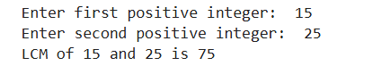

15. Write a Python program to count the number of characters ( character frequency) in a string.

Program:
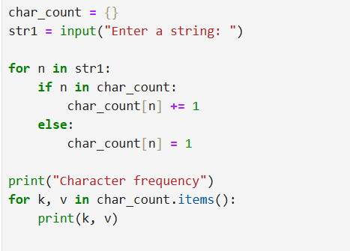
Output:
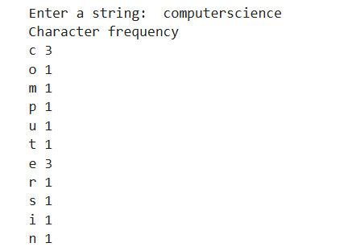
16. Write a Python function that takes a list of words and returns the longest one.

Program:

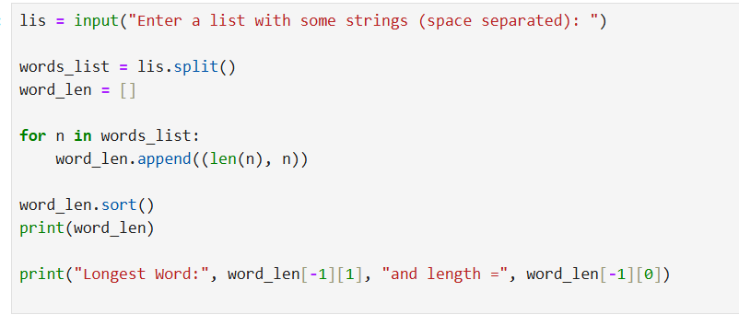

Output:

17. Write a Python program to remove the characters which have odd index values of a given string.

Program:
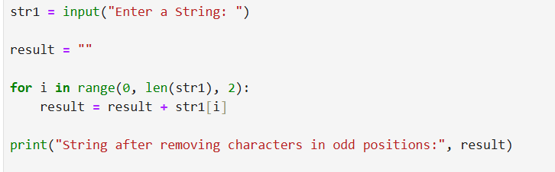
Output:

18. Write a Python program to count the occurrences of each words in a given sentence.

Program:
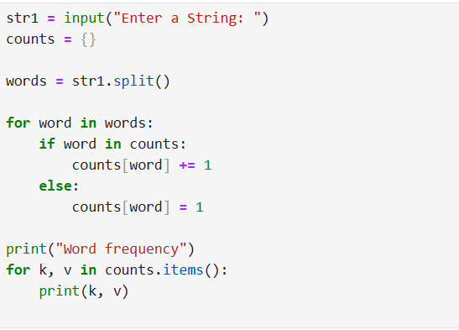

Output:
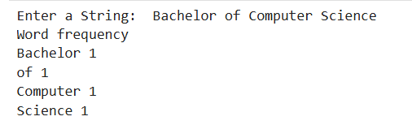

19. Write a Python program to remove duplicates from a list.
Program:
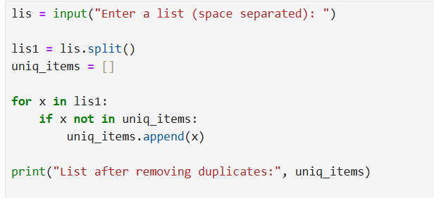

Output:

20. Write a Python program to check a list is empty or not.

Program:
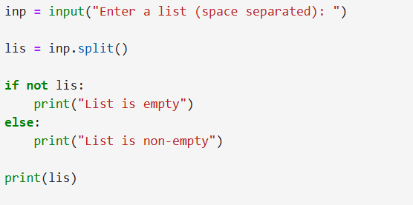

Output:
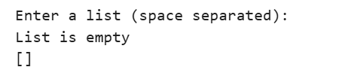

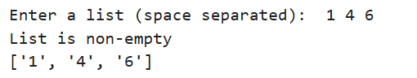

21. Write a Python program to find the list of words that are longer than n from a given list of words.

Program:

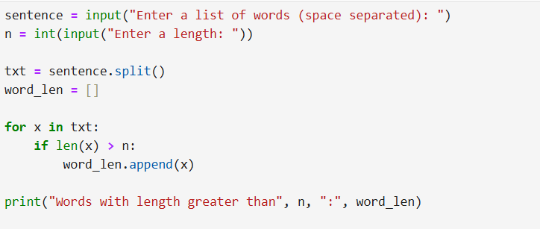

Output:
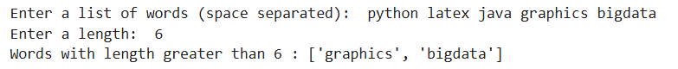
22. Write a Python program to print a specified list after removing the 0th, 2nd, 4th and 5th elements.

Program:

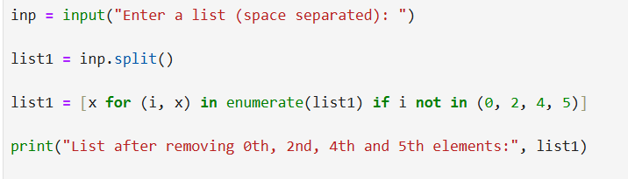

Output:
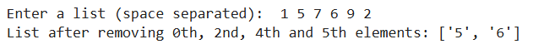

23. Write a Python program to print the numbers of a specified list after removing even numbers from it.

Program:

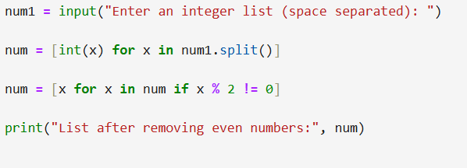

Output:
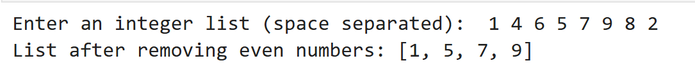

24. Write a Python program to generate and print a list of first and last 5 elements where the values are square of numbers between 1 and 30 ( both include).

Program:
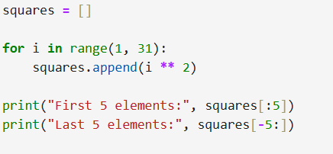

Output:

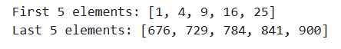

25. Write a Python script to concatenate following dictionaries to create a new one.

Program:
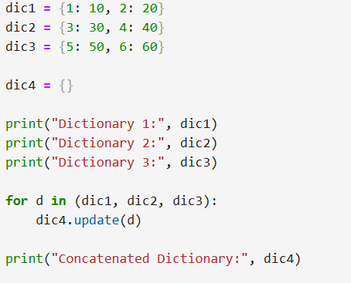

Output:

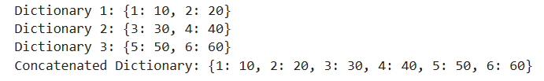

26. Write a Python script to check if a given key already exists in a dictionary.
Program:
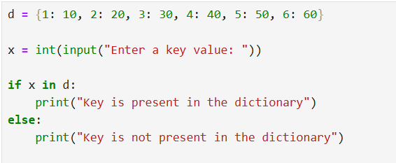

Output:
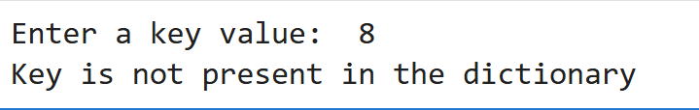

27. Write a Python program to find those numbers which are divisible by 7 and multiple by 5, between 1500 and 2000 (both included).

Program:
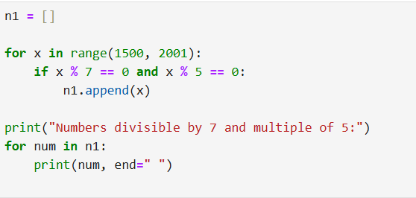

Output:

28.Write a Python program to convert temperatures to and from Celsius, Fahrenheit.

Program:
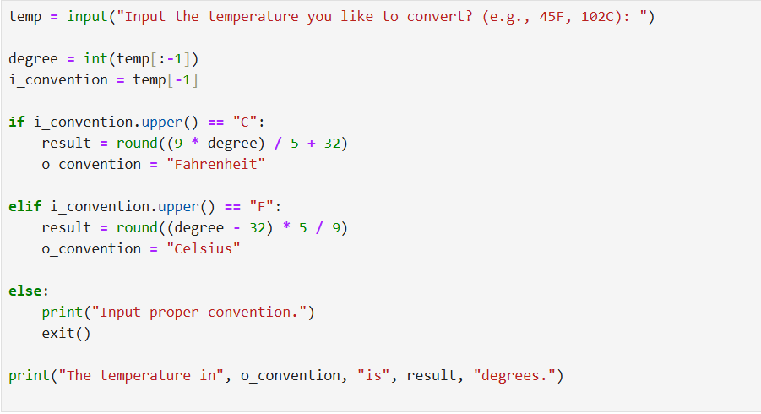

Output:

29. Write a Python program to construct the following pattern using nested for loop.

*
* *
* * *
* * * *
* * * * *
* * * *
* * *
* *
*
Program:
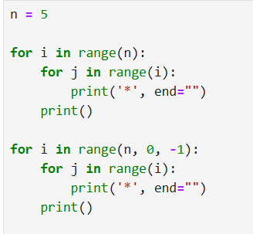
Output:
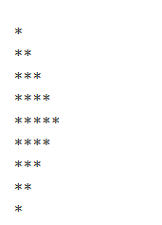
30. Write a Python program that accepts a word from the user and reverse it

Program:
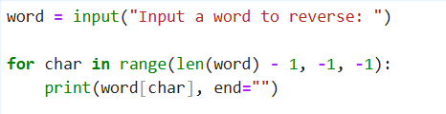

Output:
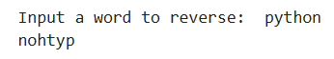

31. Write a Python program that counts odd and even numbers from a list

Program:
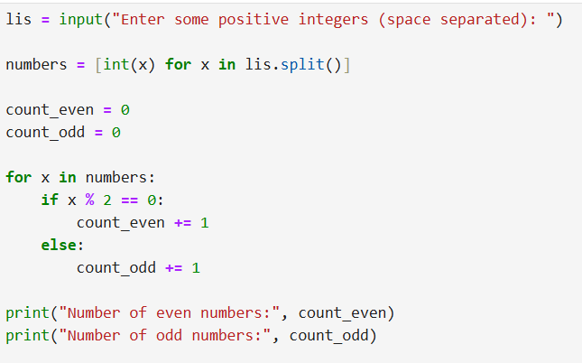

Output:
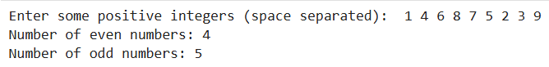

32. Write a Python program which takes two digits m (row) and n (column) as input and generates a two dimensional array. Read the elements and display the array.
Program:
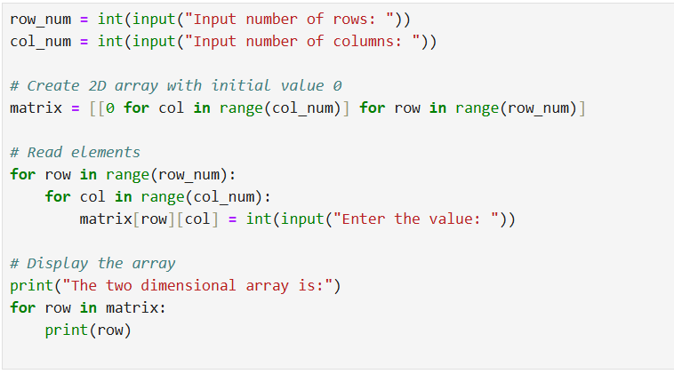
Output:
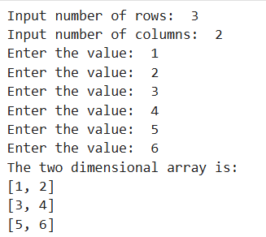

33. Write a Python program that accepts sequence of lines (blank line to terminate) as input and prints the lines as output (all characters in lower case)

Program:

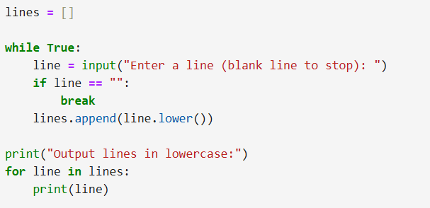

Output:

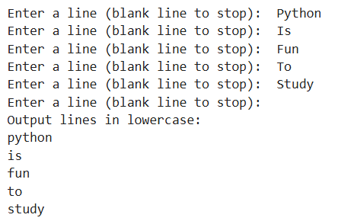

34. Write a Python program which accepts a sequence of comma separated 4-digit binary numbers as its input and print the numbers that are divisible by 5 in a comma separated sequence.

Program:

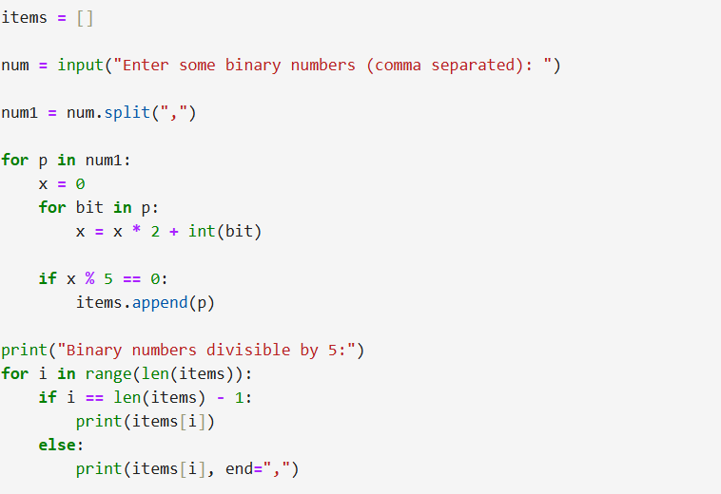

Output:

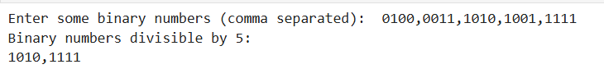

35. Write a Python program to find numbers between 100 and 400 (both included) where each digit of a number is an even number. The numbers obtained should be printed in a comma-separated sequence.
Program:

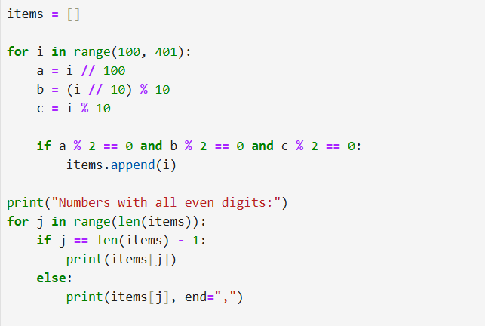

Output:

36. Write a Python program to add two matrices.

Program:

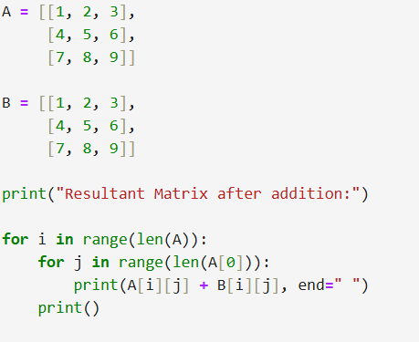

Output:
