DNS Assignment
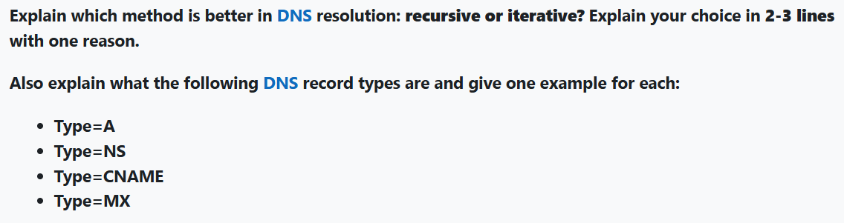
Recursive is better for end-users because the resolver handles all the work, providing a complete answer (reducing load on the client).
DNS Record Types:
- Type=A: Maps a domain to an IPv4 address (e.g., example.com → 192.0.2.1).
- Type=NS: Specifies authoritative name servers for a domain (e.g., example.com → ns1.example.com).
- Type=CNAME: Aliases one domain to another (e.g., www.example.com → example.com).
- Type=MX: Directs email to a mail server (e.g., example.com → mail.example.com).

THE END!

