Creating and Deleting an IAM User in AWS
Step-by-step summary with console screenshots
Item | Detail
Service | AWS Identity and Access Management (IAM)
Scope | Global (IAM is not tied to a single region)
User name | Aamir_choudhary_1
Date performed | 26 September 2026
Objective | Create an IAM user with console access and S3 permissions, verify its permissions, then delete the user
Result | User created with AmazonS3FullAccess and IAMUserChangePassword policies, confirmed on the user's Permissions tab, then successfully deleted

1. Overview
AWS Identity and Access Management (IAM) controls who can sign in to an AWS account and what they are allowed to do. Instead of sharing the root account (which has unrestricted access to everything, including billing), IAM users are created for individual people or applications and are given only the permissions they actually need.
In this exercise, a new IAM user was created with console sign-in access and full access to Amazon S3, so that this user could be used for the earlier S3 labs instead of the root account. Afterwards, the user was deleted to clean up. The steps below follow the order of the screenshots.

2. Steps Performed

Step 1: Open IAM users
Under IAM → Access Management → IAM users, the list shows IAM users (0) and "No resources to display", confirming no IAM users exist yet in this account. Clicking Create user starts the wizard.
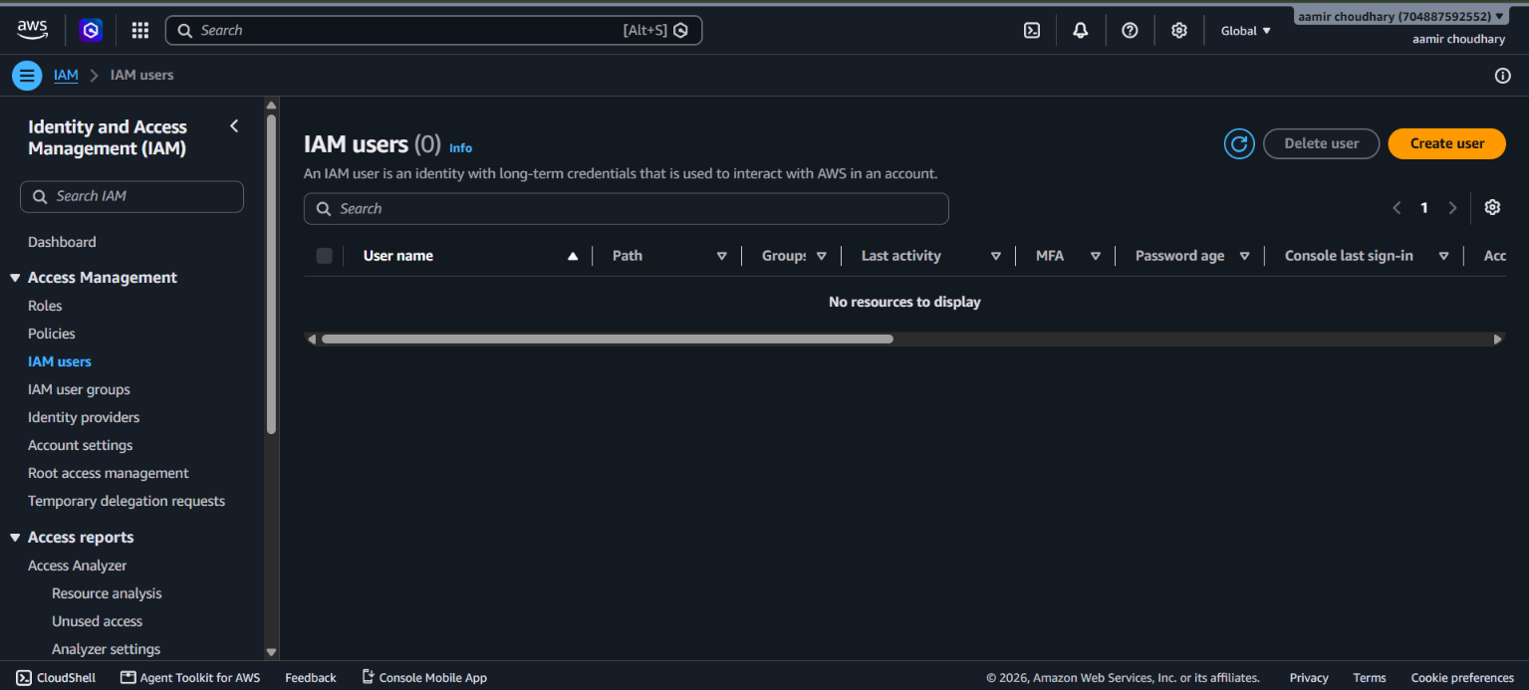
Screenshot 1: IAM users list (empty)

Step 2: Specify user details (Step 1 of the wizard)
The User name entered was Aamir_choudhary_1. "Provide user access to the AWS Management Console – optional" was checked, and Console password was set to Custom password. "Users must create a new password at next sign-in – Recommended" was also checked, so the user must set their own password the first time they log in.
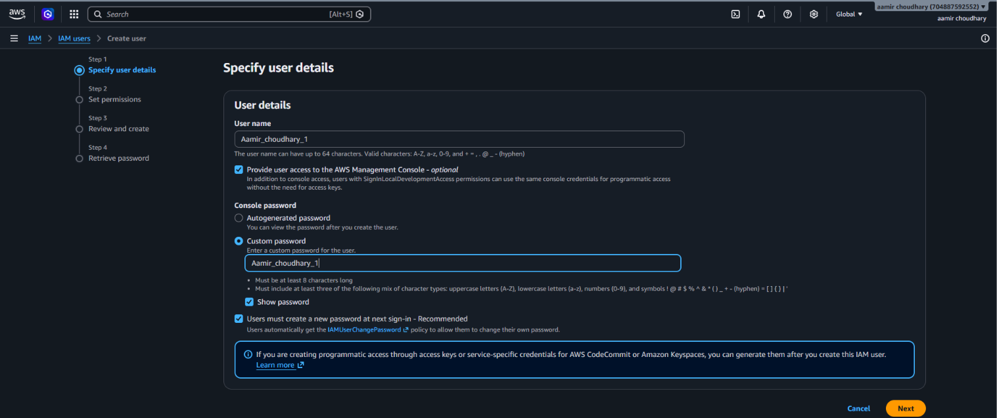
Screenshot 2: Specify user details — console access with a custom password
Important: The custom password shown here matches the user name, which AWS allows but is a weak password in practice. For real accounts, use a strong, unique password — the "Users must create a new password at next sign-in" option helps because the user immediately replaces it with one only they know.

Step 3: Set permissions
On the Set permissions step, three Permissions options are offered: Add user to group, Copy permissions, and Attach policies directly. Attach policies directly was selected, which lets policies be attached straight to this one user (AWS notes that using groups is the best practice for managing multiple users, but attaching directly is simpler for a single test user).
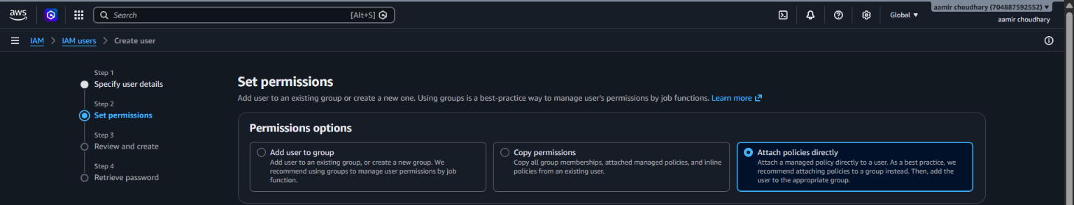
Screenshot 3: Set permissions — Attach policies directly selected

Step 4: Choose a permissions policy
Searching "s3" in Permissions policies (1,584 available policies in total, 25 matching "s3") and selecting the checkbox next to AmazonS3FullAccess (an AWS managed policy) grants this user complete access to all S3 actions and buckets in the account.
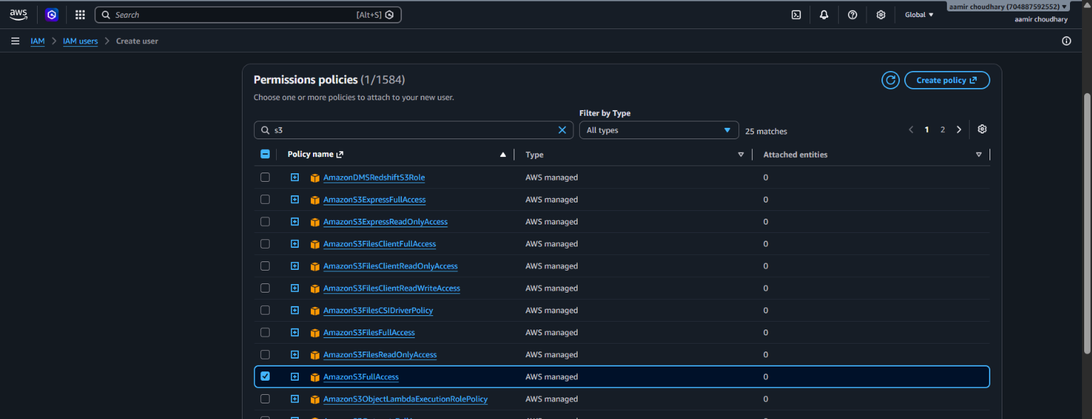
Screenshot 4: Permissions policies — AmazonS3FullAccess selected

Step 5: Review and create
The Review and create step summarizes the choices: User name Aamir_choudhary_1, Console password type Custom password, Require password reset Yes. The Permissions summary lists two policies that will apply: AmazonS3FullAccess (the one chosen) and IAMUserChangePassword (added automatically so the user can change their own password later). No tags were added. Clicking Create user finishes the wizard.
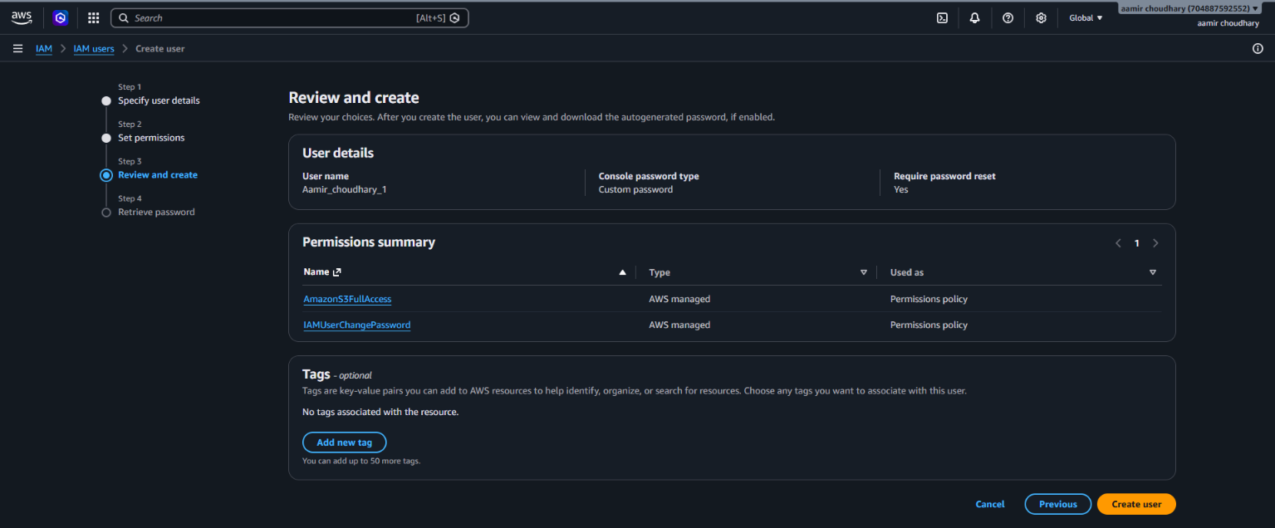
Screenshot 5: Review and create — user details and permissions summary

Step 6: Retrieve the password
A green banner confirms User created successfully. The Retrieve password screen shows the Console sign-in details: the Console sign-in URL (https://704887592552.signin.aws.amazon.com/console), the User name (Aamir_choudhary_1), and the Console password (hidden by default, revealed with Show). AWS states this is the only time the password can be viewed or downloaded, so the .csv file should be downloaded now if it is needed later.
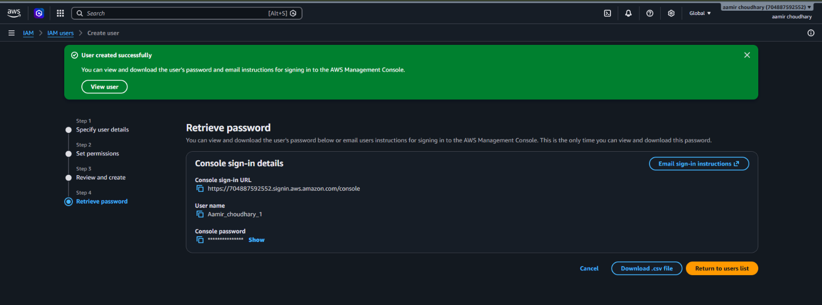
Screenshot 6: Retrieve password — console sign-in URL and credentials
Note: The account ID in the sign-in URL (704887592552) is specific to this AWS account. An IAM user always needs the account ID (or an alias) along with their user name and password to sign in — unlike the root user, who signs in with just an email address.

Step 7: Confirm the user in the list
Back on IAM users, the list now shows IAM users (1) with Aamir_choudhary_1 listed, Password age "Now" (just set) and no MFA, Access key, or console sign-in yet.
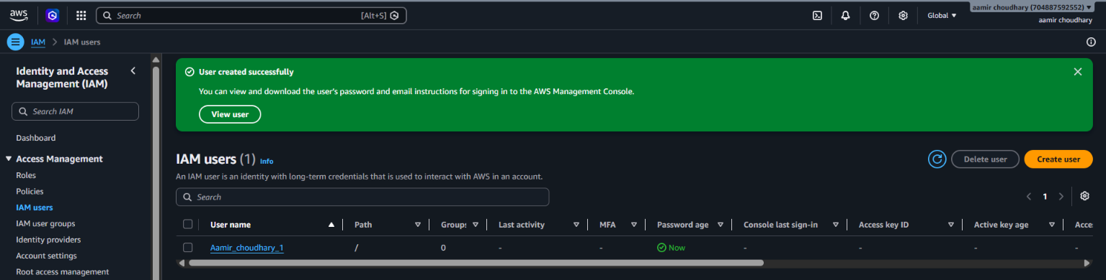
Screenshot 7: IAM users list showing Aamir_choudhary_1

Step 8: Check the user's permissions
Opening the user shows its Summary: ARN arn:aws:iam::704887592552:user/Aamir_choudhary_1, Console access "Enabled without MFA" (a yellow warning, since no multi-factor authentication is set up), Created September 26, 2026, and Last console sign-in "Never". The Permissions tab confirms Permissions policies (2): AmazonS3FullAccess and IAMUserChangePassword, both AWS managed and Attached via Directly — matching the Review and create summary from Step 5.
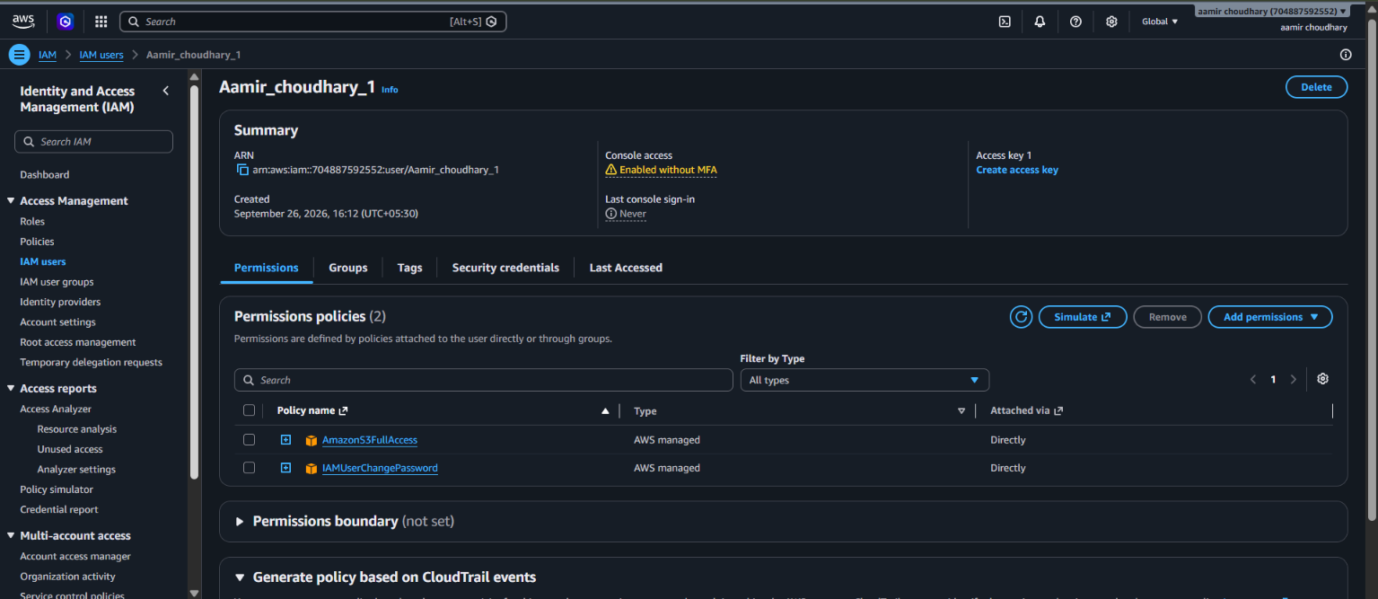
Screenshot 8: User details — Summary and the 2 attached permissions policies
Important: Console access is "Enabled without MFA". For any account with real access to resources, enabling MFA (via the Security credentials tab) adds a critical second layer of protection beyond just the password.

Step 9: Delete the user
Finally, the user was deleted using the Delete button on the user's page. A green banner confirms User "Aamir_choudhary_1" deleted, and IAM users again shows (0) with "No resources to display" — back to the same empty state as Step 1.
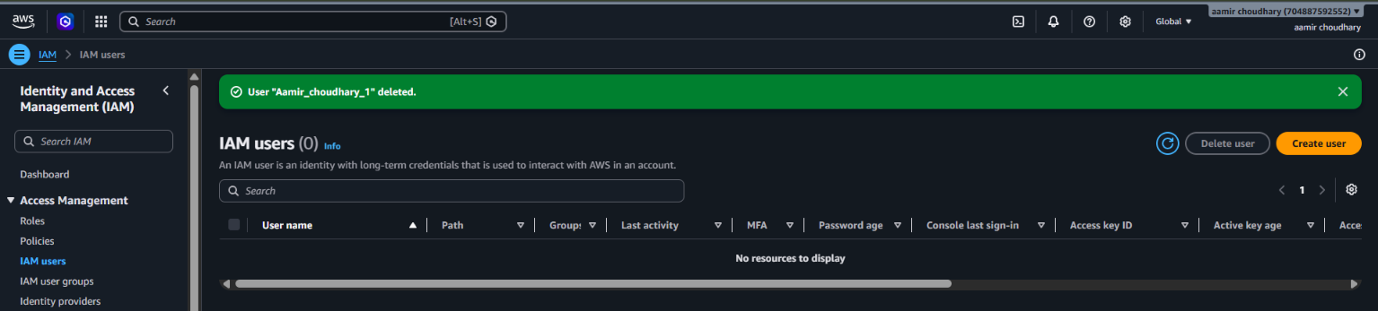
Screenshot 9: IAM users list after the user was deleted

3. Final Configuration Summary
Parameter | Value
User name | Aamir_choudhary_1
Console access | Enabled, custom password, password reset required at first login
MFA | Not enabled
Permissions option used | Attach policies directly
Policies attached | AmazonS3FullAccess, IAMUserChangePassword (both AWS managed)
Access keys | None created
ARN | arn:aws:iam::704887592552:user/Aamir_choudhary_1
Final action | User deleted — IAM users list back to 0

4. Why Use an IAM User Instead of the Root Account
The AWS root user (the email/password used to originally create the account) has unlimited permissions, including the ability to close the account, change billing, and delete every resource. AWS strongly recommends never using the root user for day-to-day work. IAM users solve this by allowing:
- Scoped permissions: a user like Aamir_choudhary_1 can be limited to only S3 (as done here), or only EC2, or read-only access — whatever the task needs.
- Individual accountability: each real person or application gets their own IAM user (or role), so actions in AWS CloudTrail logs can be traced to a specific identity instead of a shared root login.
- Easy revocation: deleting or disabling one IAM user (as done in Step 9) removes access instantly without touching the root account or other users.
- Safer credential practices: IAM users can be forced to reset passwords, required to use MFA, and have their access keys rotated — controls that are harder to enforce on a shared root login.

4.1 Groups vs. attaching policies directly
This lab used Attach policies directly (Step 3) for simplicity with a single user. In a real team setting, the recommended pattern is different:
- Create an IAM user group, for example S3-Admins, and attach AmazonS3FullAccess to the group instead of to individual users.
- Add each user (Aamir_choudhary_1 and any teammates) to that group.
- When permissions need to change, update the group once instead of editing every user separately.

5. Best Practices and Things to Keep in Mind
- Enable MFA: especially for any user with meaningful permissions (like AmazonS3FullAccess here). This lab's user showed "Enabled without MFA", which would be a gap in a real environment.
- Use groups for multiple users: attach policies directly only for quick, one-off testing, as in Step 3 here.
- Avoid FullAccess policies in production: AmazonS3FullAccess grants access to every bucket in the account. A tighter, custom policy scoped to specific buckets and actions (like the public-read policy used in the earlier lab) is safer for real workloads.
- Never reuse the user name as the password: as noted in Step 2, this is fine for a disposable practice user but must be avoided for anything real.
- Download credentials immediately: the console password (Step 6) can only be viewed once. If it is lost before the user signs in, an administrator must reset it.
- Delete unused users: as done in Step 9 — every IAM user with console or programmatic access is a potential entry point, so remove ones that are no longer needed.

6. Clean-up
Clean-up was already performed as the last step of this exercise: the user Aamir_choudhary_1 was deleted in Step 9, which automatically detaches its policies and removes its console access and any access keys. No further action is needed unless a group or custom policy was also created and should be removed separately.

