Creating IAM User Groups (EC2 and S3)
Step-by-step summary with console screenshots
Item | Detail
Service | AWS IAM (user groups)
Scope | Global (IAM is not tied to a single region)
Groups created | EC2-group and S3-Group-001
Users involved | aamir-001, adesh-003, salman-002, vikash-004
Objective | Organise existing IAM users into two groups (one for EC2, one for S3), then sign in as a member and test access
Result | Both groups created with 2 users each, but with Permissions: Not defined — signing in as aamir-001 showed Access denied on EC2 and S3

1. Overview
An IAM user group is a collection of IAM users. Instead of attaching a policy to every user one by one, a policy is attached once to the group, and every member of that group automatically gets those permissions. This is the pattern AWS recommends over attaching policies directly to individual users (as was done in the previous, single-user IAM lab).
In this exercise, two groups were created — EC2-group and S3-Group-001 — and existing IAM users were added to them. The screenshots also capture what happens when signing in as one of those users before any policy was actually attached to the group: every AWS service call returns Access denied, which is a useful demonstration of how IAM permissions really work.

2. Steps Performed

Step 1: Name the new group
From IAM → IAM user groups → Create group, the User group name entered was S3-Group-001. Group names can be up to 128 characters and may include letters, numbers and the characters + = , . @ _ -.
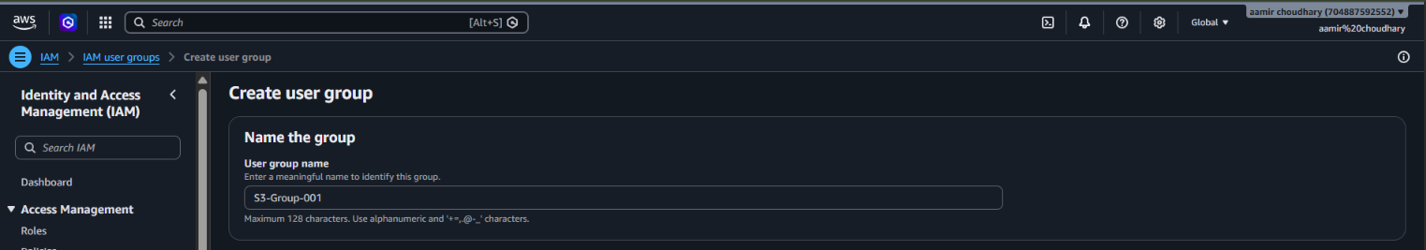
Screenshot 1: Create user group — naming it S3-Group-001

Step 2: Add users to the group
On the Add users to the group step (2 of 4, optional), the existing IAM users aamir-001 and adesh-003 were selected from the list (which also included salman-002 and vikash-004). This step attaches the chosen users to S3-Group-001; permissions/policies are configured separately after the group is created.
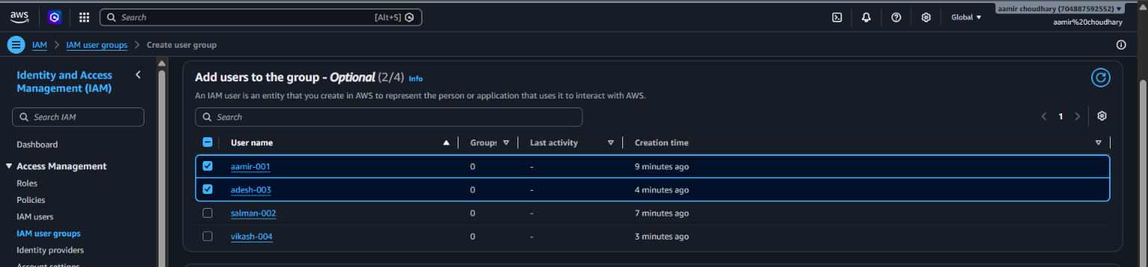
Screenshot 2: Add users to the group — aamir-001 and adesh-003 selected

Step 3: Confirm both groups exist
IAM user groups now lists IAM user groups (2): EC2-group (created earlier, 2 users) and S3-Group-001 (created just now, 2 users, "4 minutes ago"). Both groups show Permissions as a yellow "Not defined" warning, meaning no policy has been attached to either group yet — members currently have no permissions granted through the group.
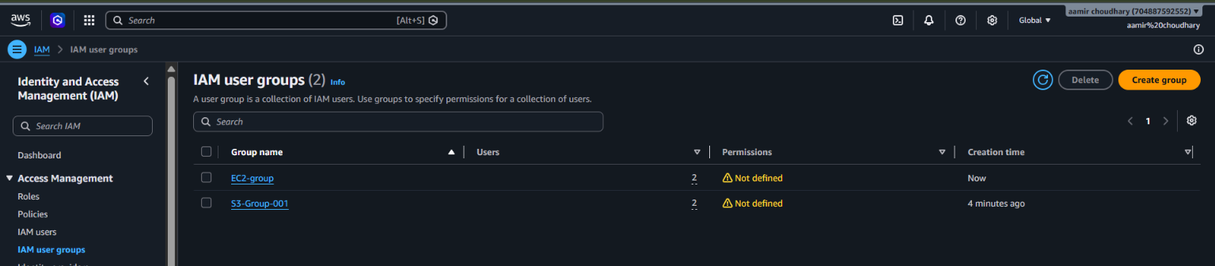
Screenshot 3: IAM user groups list — EC2-group and S3-Group-001, both Permissions: Not defined
Important: Adding a user to a group does not by itself grant any permissions. A policy (such as AmazonEC2FullAccess or AmazonS3FullAccess) must still be attached to the group — the "Not defined" warning here is exactly that missing step, and it is what causes the Access denied results in the next steps.

Step 4: List of IAM users and console sign-in
IAM users shows all 4 users — aamir-001, adesh-003, salman-002, vikash-004 — each already in 1 group. On the IAM user sign-in page, the Account ID (704887592552) and IAM username (aamir-001) were entered along with the password to sign in as that specific user rather than the root account.
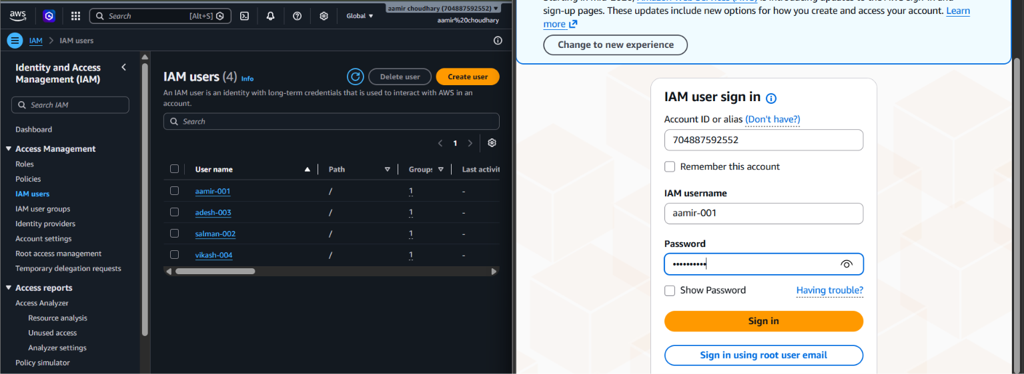
Screenshot 4: IAM users list and the IAM user sign-in page for aamir-001

Step 5: Test EC2 access as aamir-001
After signing in as aamir-001, the EC2 dashboard (region switched to Europe (Stockholm)) loads, but almost every resource panel — Dedicated Hosts, Elastic IPs, Instances, Key pairs, Load balancers, Placement groups, Security groups, Snapshots, Volumes, Auto Scaling Groups, Capacity Reservations — shows Access denied. The Instances (running) counter also could not be read properly. This happens because aamir-001 has no EC2 permissions attached through any group or directly.
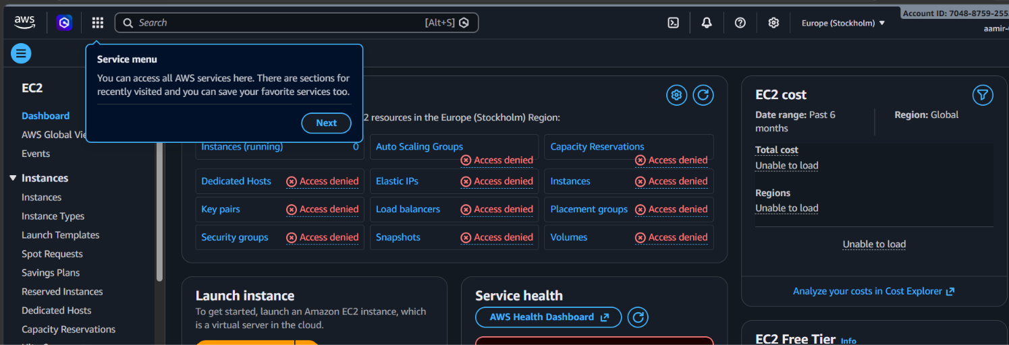
Screenshot 5: EC2 dashboard as aamir-001 — Access denied on almost every panel

Step 6: Test S3 access as aamir-001
Similarly, opening Amazon S3 → Create bucket as aamir-001 (still in Europe (Stockholm)) shows the Create bucket form itself, but attempting to actually create a bucket here would also fail with Access denied, for the same reason: S3-Group-001 (the group aamir-001 was just added to) has no policy attached yet, so S3 permissions have not actually been granted.
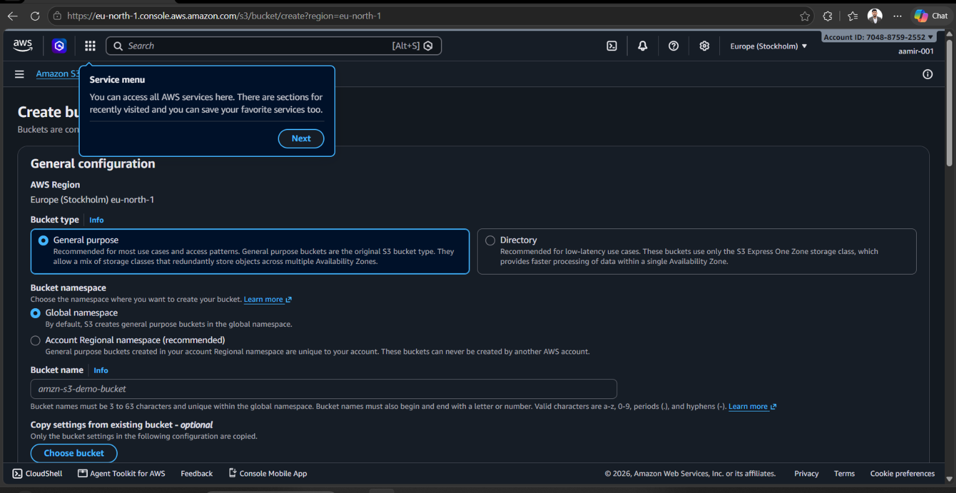
Screenshot 6: S3 Create bucket page as aamir-001 (permissions still not granted)

3. What This Demonstrates
The two groups created here map naturally to two service areas:
Group | Intended purpose | Current status
EC2-group | Users who need to manage EC2 (instances, volumes, security groups, etc.) | Created earlier, 2 users, Permissions: Not defined
S3-Group-001 | Users who need to manage S3 buckets and objects | Created in this lab, 2 users (aamir-001, adesh-003), Permissions: Not defined

Because neither group has a policy attached, every member — including aamir-001 — currently has console sign-in access but effectively no permissions anywhere. This matches exactly what Screenshots 5 and 6 show: the sign-in itself succeeds, but every service call comes back Access denied. This is IAM working correctly: no permission is ever granted "by default", only through an explicitly attached policy.

4. How to Finish This Setup (Next Steps)
To make these groups actually useful, a policy needs to be attached to each one:
- Open IAM user groups → EC2-group → Permissions tab → Add permissions → Attach policies, and attach an AWS managed policy such as AmazonEC2FullAccess (or a narrower custom policy for least privilege).
- Open IAM user groups → S3-Group-001 → Permissions tab → Add permissions → Attach policies, and attach AmazonS3FullAccess (or a scoped S3 policy limited to specific buckets).
- Sign in again as aamir-001 (or refresh the session) and confirm the Access denied messages are gone on the relevant service.
Note: This attach-policy step was not part of the screenshots captured for this lab; it is the logical next action based on the "Not defined" status seen in Screenshot 3.

5. Best Practices and Things to Keep in Mind
- Groups over direct attachment: attaching AmazonEC2FullAccess or AmazonS3FullAccess once to a group (instead of to every user) is exactly the best practice mentioned in the earlier single-user IAM lab — this exercise puts that into action with EC2-group and S3-Group-001.
- One user, multiple groups: an IAM user can belong to more than one group (up to 10), so a person needing both EC2 and S3 access could be added to both EC2-group and S3-Group-001.
- Least privilege over FullAccess: AmazonEC2FullAccess and AmazonS3FullAccess are broad, account-wide policies. For real teams, prefer a custom or scoped policy (for example, limited to specific instance tags or specific S3 buckets).
- "Not defined" is a visible warning, not an error: AWS deliberately flags a group with no attached policy so it cannot be missed on the IAM user groups list.
- Region matters for testing: the access tests here were done in Europe (Stockholm), a different region from the earlier S3 and EC2 labs (Mumbai) — remember that IAM permissions are global, but resources like EC2 instances and volumes are per-region, so "Access denied" here would also happen in any other region for these users.
- Verify by testing as the actual user: signing in as aamir-001 (Step 4) instead of just trusting the admin view is the right way to confirm what a real end-user can and cannot do.

6. Clean-up
If EC2-group and S3-Group-001 were created only for this practice exercise, remove them once done: open IAM user groups, select each group, remove its users (Group details → Users tab → Remove), detach any policies if later added, and then Delete group. Deleting a group does not delete the IAM users themselves, only their membership in that group.

