Creating a Private Amazon S3 Bucket
Step-by-step summary with console screenshots
Item | Detail
Service | Amazon S3 (Simple Storage Service)
Region | Asia Pacific (Mumbai) – ap-south-1
Bucket name | aamir-ch-1
Date performed | 21 September 2026
Objective | Create a private general purpose bucket, upload a file to it, and clean it up afterwards
Result | Bucket created with all public access blocked, one .docx file uploaded, then the bucket was emptied

1. Overview
Amazon S3 is an object storage service. Data is stored as objects (a file plus its metadata) inside containers called buckets. Every object is identified by a key, which is essentially its file name including any folder-like prefix. S3 has no minimum fee and you pay only for the storage and requests you actually use.
In this exercise, a private general purpose bucket was created in the Mumbai region. "Private" means that Block all public access stays turned on, so nobody on the internet can read the bucket or its objects unless they are explicitly granted access through IAM permissions, a bucket policy or a pre-signed URL. The steps below follow the order of the screenshots.

2. Steps Performed

Step 1: Open the Amazon S3 console
Searching for S3 in the AWS console opens the Amazon S3 landing page. It gives a short introduction ("Store and retrieve any amount of data from anywhere"), pricing information and common tasks. The Create bucket button in the top-right card starts the process. The left menu lists Buckets (General purpose, Directory, Table and Vector buckets), Access management and security, and Storage management and insights.
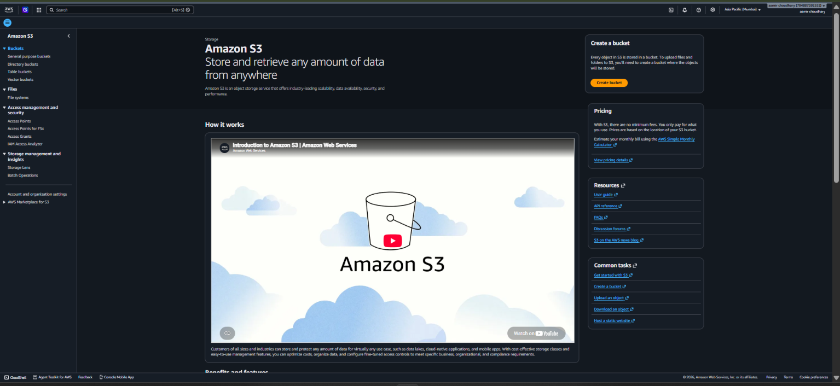
Screenshot 1: Amazon S3 landing page with the Create bucket button

Step 2: Go to General purpose buckets
Under Buckets → General purpose buckets, the list shows "General purpose buckets (0)" and the message "You don't have any buckets". This confirms there are no existing buckets to conflict with. Clicking Create bucket opens the creation form.
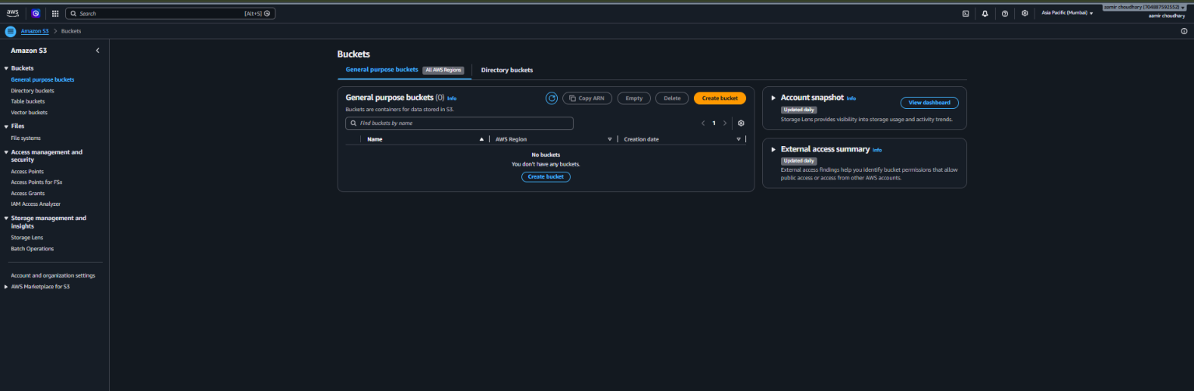
Screenshot 2: General purpose buckets list (empty)

Step 3: General configuration
The first section of the form defines the basic identity of the bucket:
Setting | Value chosen | What it means
AWS Region | Asia Pacific (Mumbai) ap-south-1 | The physical location where the data is stored. Choose a region close to users or compute.
Bucket type | General purpose | Recommended for most use cases; stores objects redundantly across multiple Availability Zones.
Bucket namespace | Global namespace | Bucket name must be unique across all AWS accounts. (The console marks the Account Regional namespace as recommended.)
Bucket name | aamir-ch-1 | 3–63 characters; lowercase letters, numbers, periods and hyphens; must start and end with a letter or number.
Copy settings | Not used | Settings were not copied from another bucket.

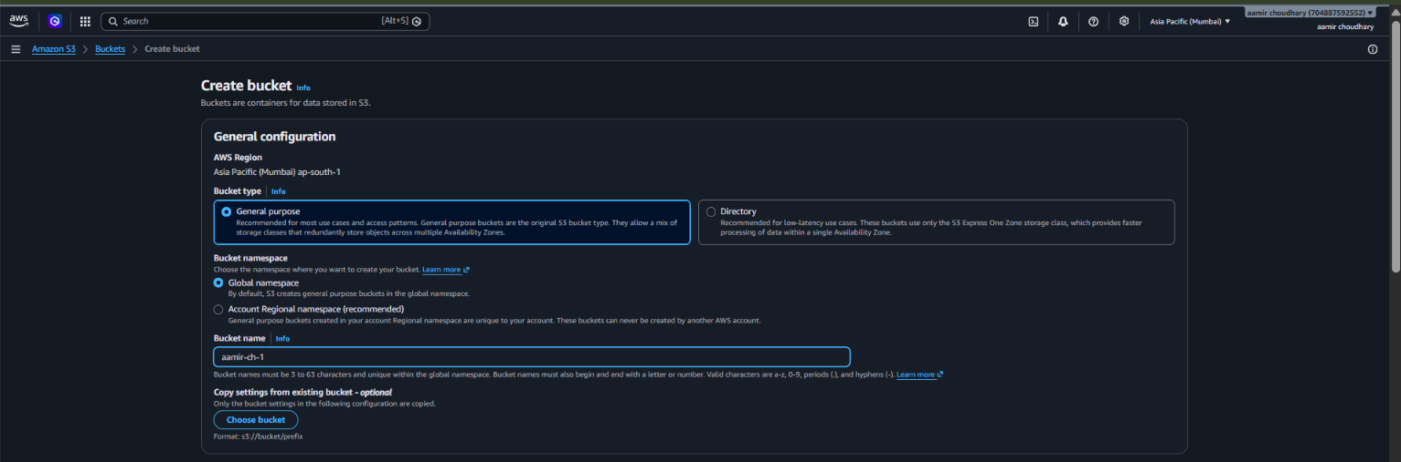
Screenshot 3: Create bucket → General configuration

Step 4: Object Ownership
Object Ownership was set to ACLs disabled (recommended), which the console shows as "Bucket owner enforced". This means every object in the bucket is owned by this account and access is controlled only through policies (IAM and bucket policies), not through legacy access control lists. It is the simpler and safer choice.
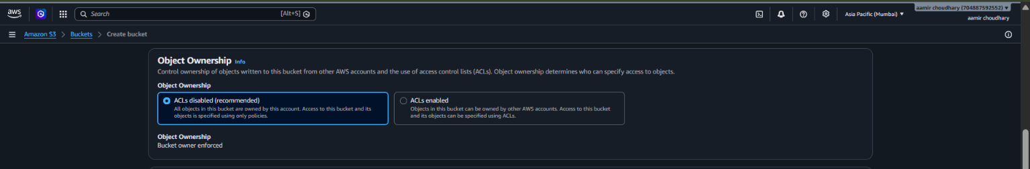
Screenshot 4: Object Ownership set to ACLs disabled

Step 5: Block Public Access (makes the bucket private)
This is the key step for a private bucket. The checkbox Block all public access was left ticked, which automatically turns on all four sub-settings:
- Block public access granted through new access control lists (ACLs).
- Block public access granted through any ACLs.
- Block public access granted through new public bucket or access point policies.
- Block public and cross-account access through any public bucket or access point policies.
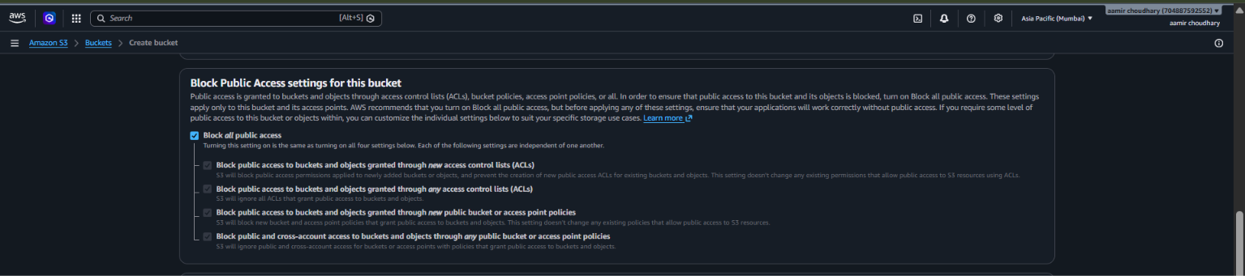
Screenshot 5: Block all public access enabled
Note: AWS recommends keeping Block all public access on unless a specific use case, such as hosting a public website, truly needs otherwise.

Step 6: Bucket Versioning
Bucket Versioning was left on Disable. With versioning off, S3 keeps only the latest copy of an object, so an overwritten or deleted object cannot be recovered. Versioning can be enabled at any time later from the bucket's Properties tab.
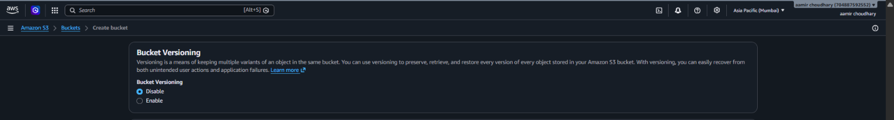
Screenshot 6: Bucket Versioning set to Disable

Step 7: Tags, default encryption and Create bucket
Further down the form:
- Tags (optional): none were added (up to 50 are allowed).
- Default encryption: Server-side encryption with Amazon S3 managed keys (SSE-S3). All new objects are encrypted automatically at rest.
- Bucket Key: shown as Enabled. It only reduces costs for SSE-KMS encryption, so it has no effect with SSE-S3.
- Advanced settings: left collapsed at their defaults.
Clicking the orange Create bucket button creates the bucket.
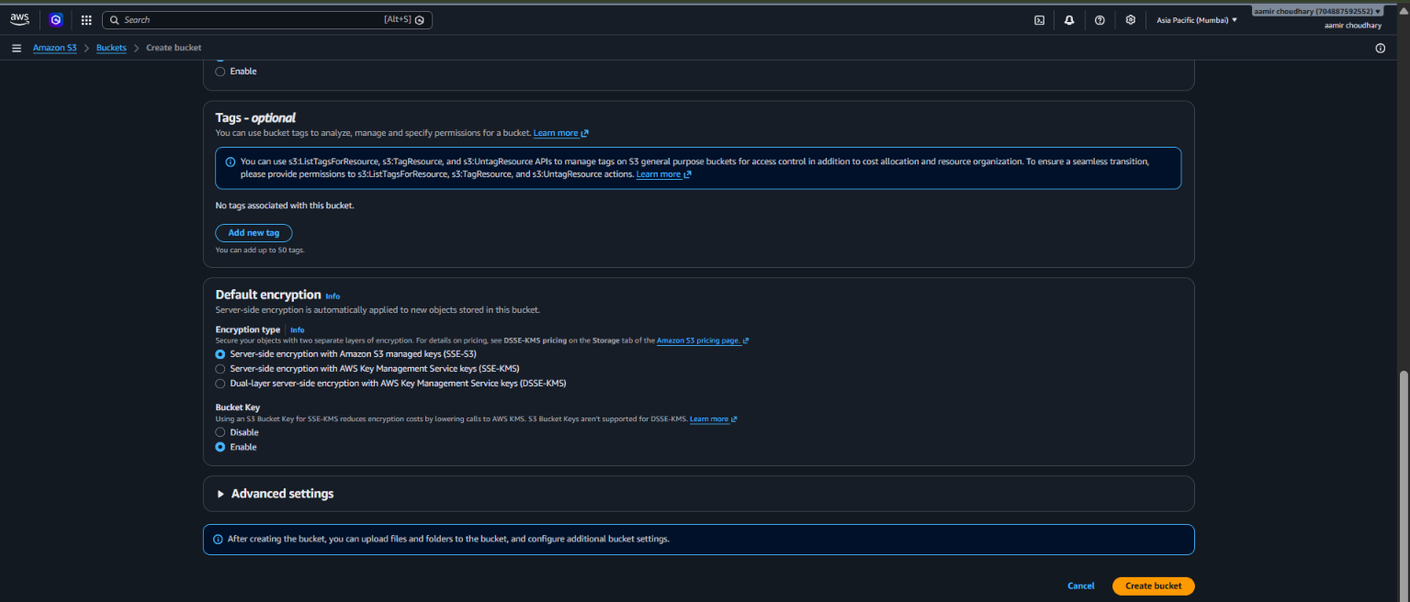
Screenshot 7: Tags, Default encryption and the Create bucket button

Step 8: Bucket created successfully
A green banner confirms Successfully created bucket "aamir-ch-1". The bucket page opens on the Objects tab, which shows Objects (0) and "You don't have any objects in this bucket". The other tabs (Metadata, Properties, Permissions, Metrics, Management, File systems and Access Points) are used to configure the bucket further.
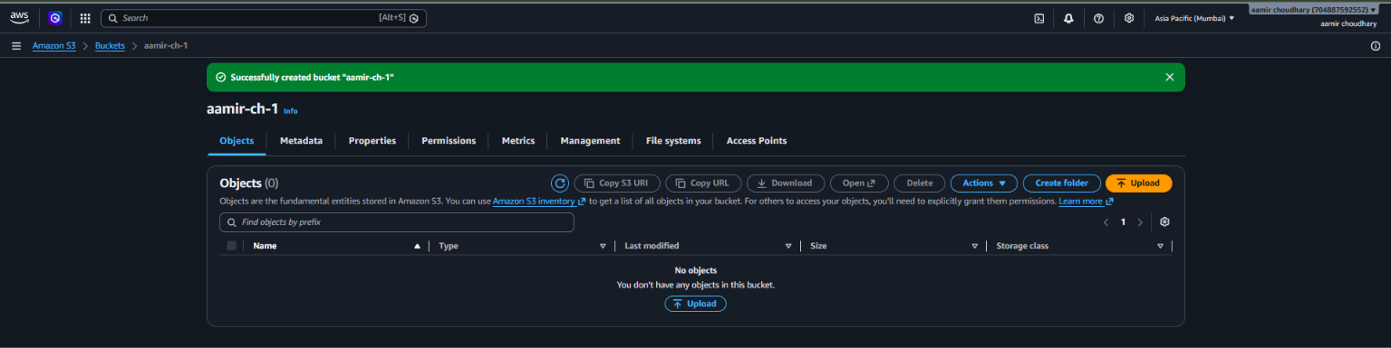
Screenshot 8: New bucket "aamir-ch-1" with no objects

Step 9: Upload a file
Using the Upload button, the file Loan Deliquent Analysis.docx was uploaded. The Upload: status page shows "Upload succeeded". Summary: destination s3://aamir-ch-1, 1 file of 16.3 KB succeeded (100%), and 0 files failed. The file list shows the object with type application/vnd.openxmlformats-… (the Word format) and status Succeeded.
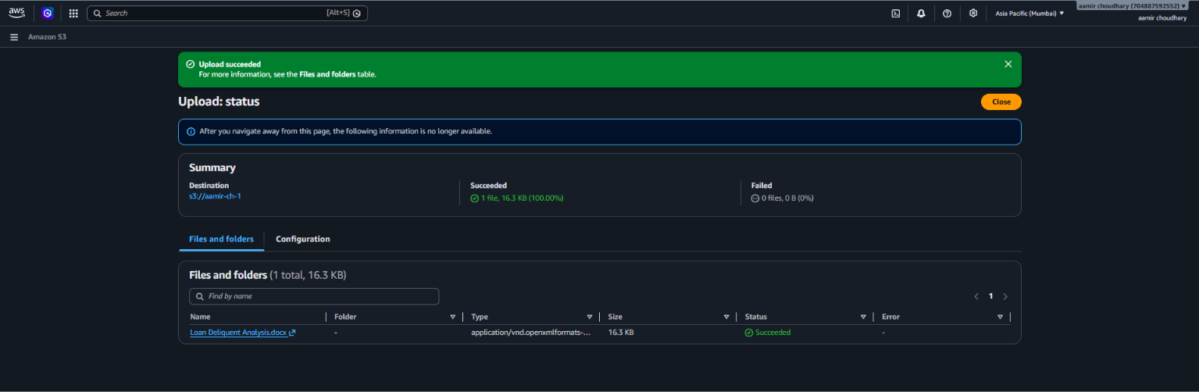
Screenshot 9: Upload status page (Upload succeeded)

Step 10: View the object properties
Opening the uploaded object shows its Properties tab. Important details:
- Key / Type / Size: Loan Deliquent Analysis.docx, docx, 16.3 KB.
- Last modified: September 21, 2026, 10:28:28 (UTC+05:30).
- S3 URI: s3://aamir-ch-1/Loan Deliquent Analysis.docx (used by the AWS CLI and other AWS services).
- ARN and Object URL: the ARN identifies the object in IAM policies; the Object URL is the HTTPS address of the object.
- Bucket Versioning: Disabled. The console shows a yellow recommendation to enable it.
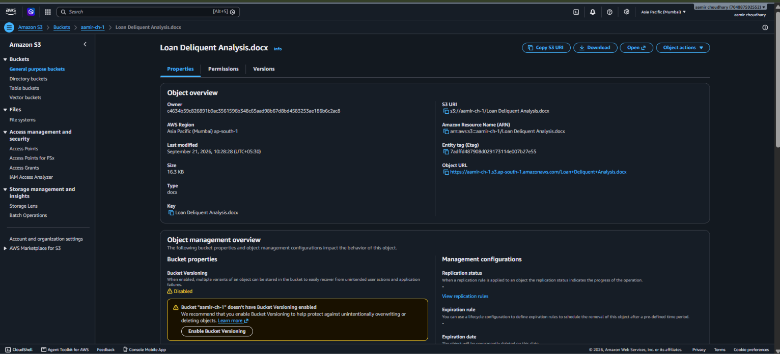
Screenshot 10: Object properties for Loan Deliquent Analysis.docx
Important: Because Block all public access is on, the Object URL will not open for anonymous users. Only authenticated users with permission, or someone using a pre-signed URL, can read the file. This is what makes the bucket private.

Step 11: Empty the bucket
To clean up, the bucket was emptied using the Empty option. The Empty bucket: status page shows Successfully emptied bucket "aamir-ch-1". Summary: source s3://aamir-ch-1, successfully deleted 2 objects (16.3 KB), failed to delete 0 objects. The banner also reminds that emptying does not delete the bucket itself; to remove the bucket, use the separate delete bucket configuration.
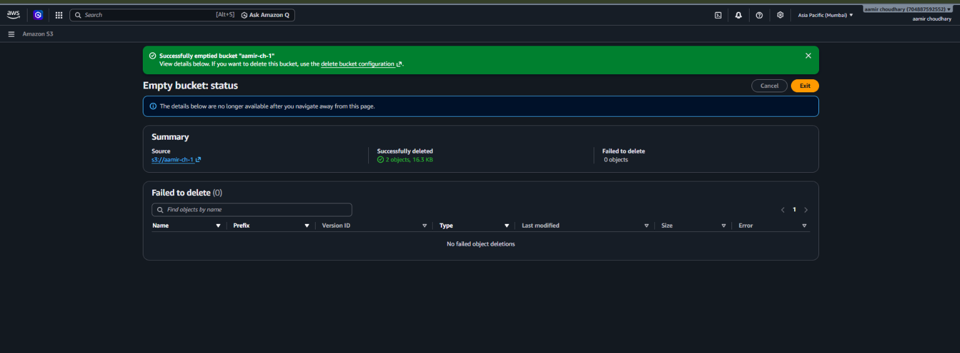
Screenshot 11: Empty bucket status (2 objects deleted, 0 failed)

3. Final Configuration Summary
Parameter | Value
Bucket name | aamir-ch-1
Region | Asia Pacific (Mumbai) ap-south-1
Bucket type / namespace | General purpose / Global namespace
Object Ownership | ACLs disabled (Bucket owner enforced)
Block Public Access | Block all public access: ON (all 4 settings)
Bucket Versioning | Disabled
Default encryption | SSE-S3 (Amazon S3 managed keys)
Tags | None
Object uploaded | Loan Deliquent Analysis.docx (16.3 KB)
Final action | Bucket emptied (bucket itself still exists)

4. How Access Works for a Private Bucket
Since nothing is public, access must be granted deliberately. The common ways are:
- IAM users and roles: attach a policy that allows actions such as s3:GetObject and s3:PutObject on arn:aws:s3:::aamir-ch-1/*. This is the normal way for applications and team members.
- Bucket policy: a resource-based policy on the bucket, useful for granting access to a specific role or another AWS account.
- Pre-signed URL: a temporary link that lets someone download an object without an AWS account. It stops working after the expiry time.
- Console or CLI: the account owner can always use the console, or the AWS CLI with configured credentials.

4.1 Common AWS CLI commands
The same operations done in this exercise can be done from a terminal after running aws configure:
# Create a bucket in Mumbai
aws s3 mb s3://aamir-ch-1 --region ap-south-1

# Upload a file
aws s3 cp "Loan Deliquent Analysis.docx" s3://aamir-ch-1/

# List objects in the bucket
aws s3 ls s3://aamir-ch-1/

# Create a temporary download link (valid for 1 hour)
aws s3 presign "s3://aamir-ch-1/Loan Deliquent Analysis.docx" --expires-in 3600

# Empty the bucket, then delete it
aws s3 rm s3://aamir-ch-1 --recursive
aws s3 rb s3://aamir-ch-1

4.2 How to verify the bucket is really private
- Copy the Object URL from the object's Properties tab and open it in an incognito/private browser window (not logged in to AWS).
- An "Access Denied" XML error means public access is correctly blocked.
- Then open the same file using the Open or Download button in the console, which works because you are authenticated.
Note: This test was not part of the screenshots above; it is an optional check that can be added to the lab report.

5. Best Practices and Things to Keep in Mind
- Keep Block Public Access on: it can also be enforced for the whole account under "Account and organization settings" in the S3 console, which protects against accidental public buckets.
- Enable versioning for important data: it allows recovery from accidental deletes and overwrites. Combine it with a lifecycle rule so that old versions do not pile up and increase cost.
- Naming: bucket names are visible in URLs and must be unique, so avoid putting sensitive information in them. A pattern such as project-purpose-region-number is easier to manage.
- Least privilege: give users and applications access only to the buckets and actions they need, instead of broad s3:* permissions.
- Encryption: SSE-S3 is a good default. Use SSE-KMS when you need audit logs of key usage or control over the encryption key.
- Storage classes: objects use S3 Standard by default. Rarely accessed data can be moved to cheaper classes such as Standard-IA or Glacier using lifecycle rules.
- Tagging: add tags such as Project or Owner to track costs and organise resources.
- File names: spaces in object keys (as in "Loan Deliquent Analysis.docx") work but appear as + or %20 in URLs. Using hyphens or underscores avoids confusion.

6. Clean-up
The bucket was emptied in Step 11. An empty bucket has no storage cost, but it still exists. If it is no longer needed, delete it: select the bucket in General purpose buckets, click Delete, type the bucket name (aamir-ch-1) to confirm, and click Delete bucket. A bucket must be empty before it can be deleted, and deletion cannot be undone.

