Creating a Public S3 Bucket with a Bucket Policy
Step-by-step summary with console screenshots
Item | Detail
Service | Amazon S3 (public bucket + bucket policy)
Region | Asia Pacific (Mumbai) – ap-south-1
Bucket name | public-bucket-assig
Date performed | 25 September 2026
Objective | Create a bucket with public access allowed, attach a public-read bucket policy, upload a file, and confirm it opens over a public URL
Result | Bucket public-bucket-assig created, a PublicReadGetObject policy attached, and AWS_S3_Static_Website_Hosting_Summary.docx (1.7 MB) uploaded and publicly downloadable

1. Overview
This lab explicitly grants public read access using a bucket policy, instead of relying only on Static website hosting. A bucket policy is a JSON document attached to the bucket that says who can perform which S3 actions on it. Here, the policy allows anyone (Principal "*") to run s3:GetObject on every object in the bucket, so any object URL can be opened directly in a browser without signing in to AWS.
This assignment reuses the same account and region as the earlier S3 labs, but is a separate exercise: a new bucket, public-bucket-assig, was created specifically to demonstrate how a public-read bucket policy works.

2. Steps Performed

Step 1: Open the Amazon S3 console
The Amazon S3 landing page was opened again, and Create bucket was clicked to start a new bucket.
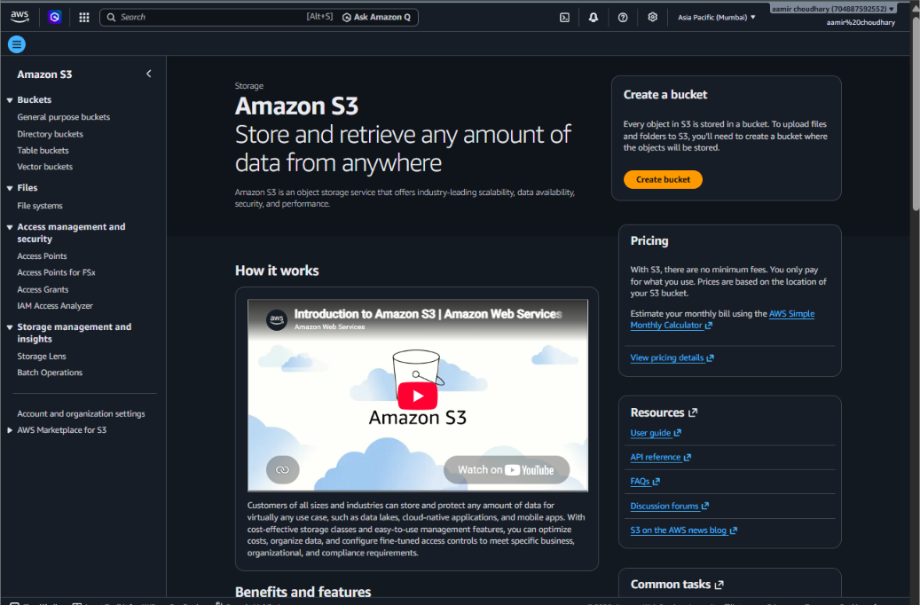
Screenshot 1: Amazon S3 landing page

Step 2: General configuration
On Create bucket: AWS Region was Asia Pacific (Mumbai) ap-south-1, Bucket type was General purpose, Bucket namespace was Global namespace, and the Bucket name entered was public-bucket-assig.
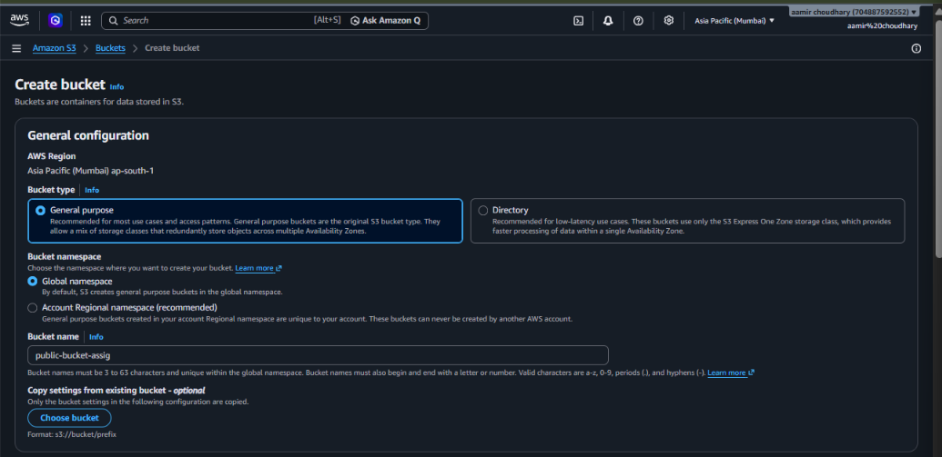
Screenshot 2: Create bucket – General configuration, name public-bucket-assig

Step 3: Block Public Access and Bucket Versioning
Block all public access was unchecked (which un-blocks all four sub-settings), and the acknowledgement "I acknowledge that the current settings might result in this bucket and the objects within becoming public" was ticked. Bucket Versioning was left on Disable.
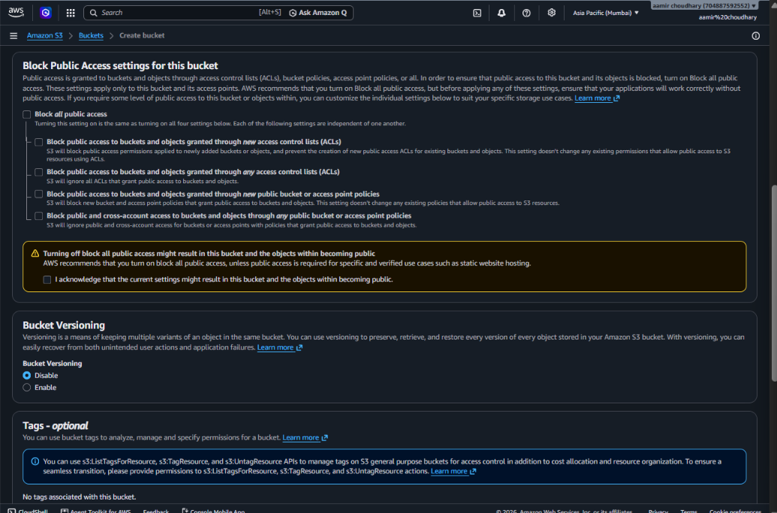
Screenshot 3: Block Public Access turned off, with the acknowledgement checked; Versioning disabled
Important: Turning off Block Public Access only removes the account-level block. The bucket is still not actually public until a policy (or ACL) that grants access is attached — that is done in Step 5.

Step 4: Tags, default encryption and Create bucket
No tags were added. Default encryption stayed at Server-side encryption with Amazon S3 managed keys (SSE-S3), with Bucket Key enabled. Clicking Create bucket created the bucket.
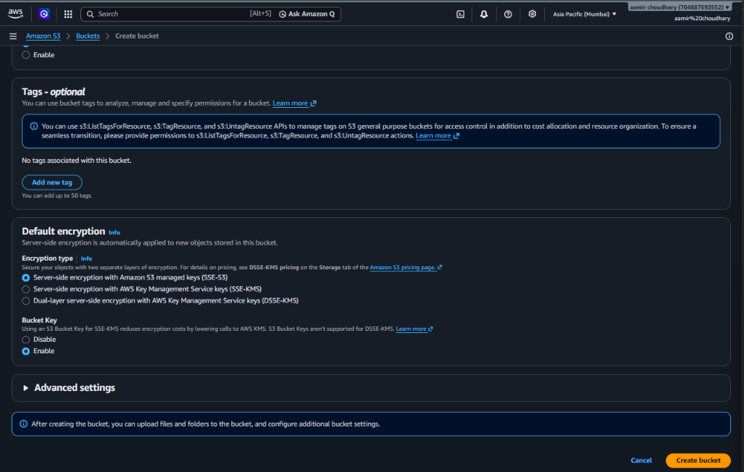
Screenshot 4: Tags, Default encryption and the Create bucket button

Step 5: Attach a public-read bucket policy
From the bucket's Permissions tab → Edit bucket policy, a JSON policy was written directly in the console's Policy editor for Bucket ARN arn:aws:s3:::public-bucket-assig:
{
"Version": "2012-10-17",
"Statement": [
{
"Sid": "PublicReadGetObject",
"Effect": "Allow",
"Principal": "*",
"Action": "s3:GetObject",
"Resource": "arn:aws:s3:::public-bucket-assig/*"
}
]
}

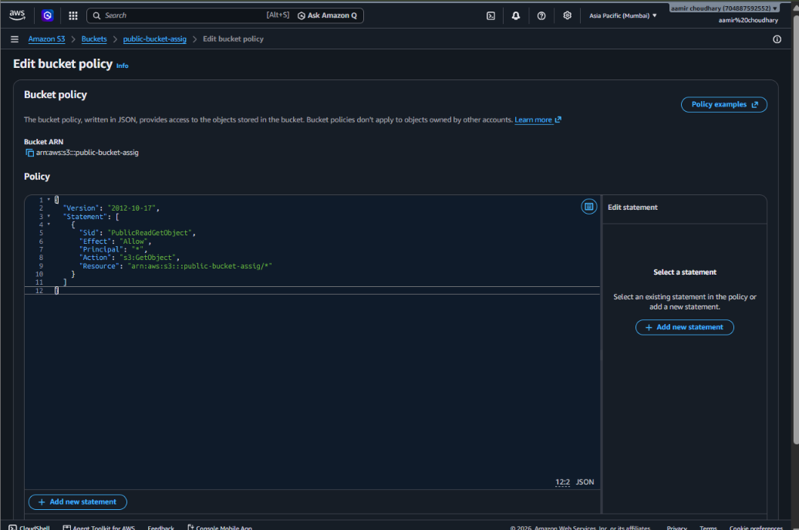
Screenshot 5: Edit bucket policy — PublicReadGetObject statement for public-bucket-assig
This statement means: for the Resource public-bucket-assig/* (every object in the bucket), Allow the Action s3:GetObject to the Principal "*" (absolutely anyone, with or without an AWS account). It grants read-only access — it does not allow uploading, deleting or listing objects.

Step 6: Upload a file
The file AWS_S3_Static_Website_Hosting_Summary.docx (1.7 MB) — the Word document from the previous static-website lab — was uploaded to this bucket to test the new policy. The Upload: status page confirms Upload succeeded — 1 file, 1.7 MB (100.00%), 0 failed, destination s3://public-bucket-assig.
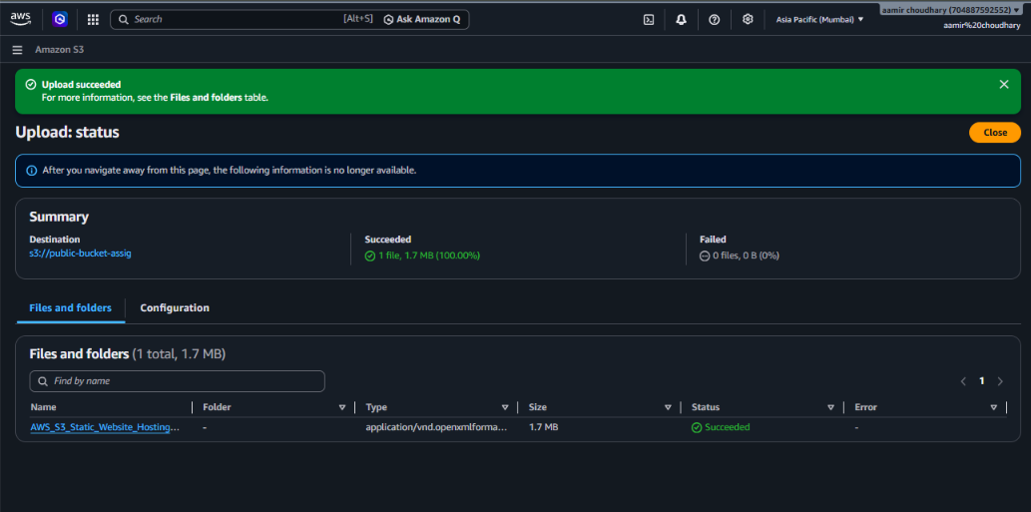
Screenshot 6: Upload status — AWS_S3_Static_Website_Hosting_Summary.docx succeeded (1.7 MB)

Step 7: Check the object's properties
Opening the uploaded object shows its Properties tab. Key details: Size 1.7 MB, Type docx, Last modified September 25, 2026, 21:36:40 (UTC+05:30). The S3 URI is s3://public-bucket-assig/AWS_S3_Static_Website_Hosting_Summary.docx, and the Object URL is https://public-bucket-assig.s3.ap-south-1.amazonaws.com/AWS_S3_Static_Website_Hosting_Summary.docx. Bucket Versioning shows Disabled, with the same recommendation banner seen in the earlier private-bucket lab.
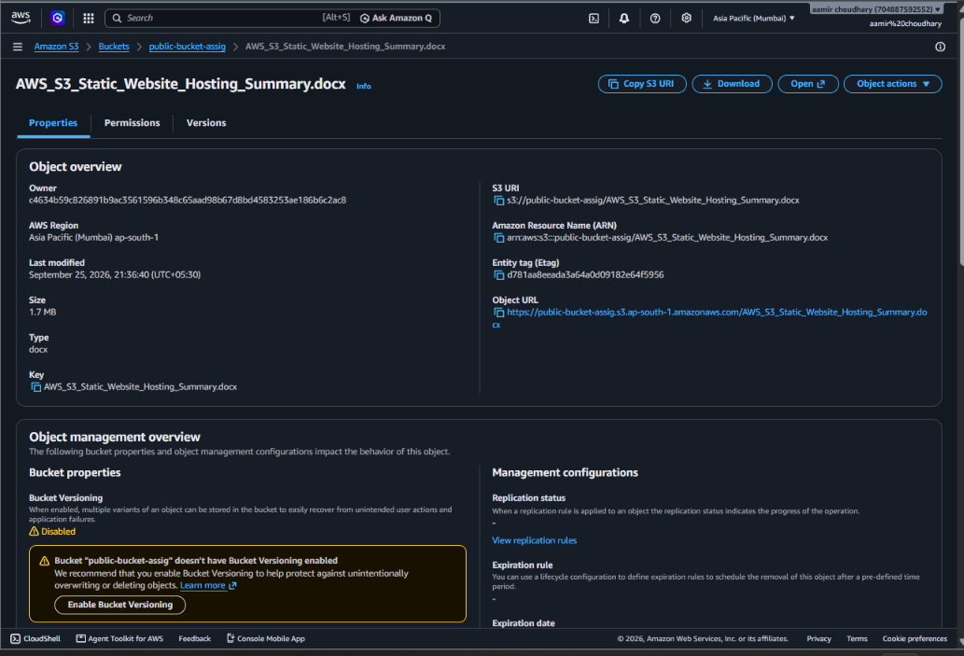
Screenshot 7: Object properties, with the public Object URL and S3 URI

Step 8: Confirm public access by downloading the file
The Object URL was opened directly, and the browser's Save As dialog appeared for AWS_S3_Static_Website_Hosting_Summary.docx, proving the object downloaded successfully without needing to be signed in to AWS. This confirms the bucket policy from Step 5 is working as intended.
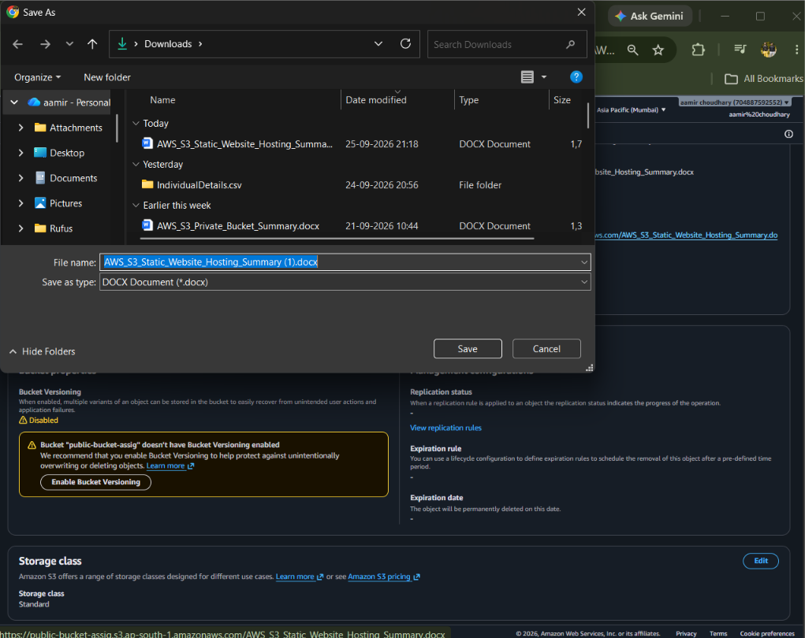
Screenshot 8: Browser Save As dialog after opening the public Object URL

3. Final Configuration Summary
Parameter | Value
Bucket name | public-bucket-assig
Region | Asia Pacific (Mumbai) ap-south-1
Block Public Access | Turned OFF (public access acknowledged)
Bucket policy | PublicReadGetObject — Allow s3:GetObject to Principal "*" on public-bucket-assig/*
Bucket Versioning | Disabled
Default encryption | SSE-S3 (Amazon S3 managed keys)
Object uploaded | AWS_S3_Static_Website_Hosting_Summary.docx (1.7 MB)
Object URL | https://public-bucket-assig.s3.ap-south-1.amazonaws.com/AWS_S3_Static_Website_Hosting_Summary.docx
Verified | File opened/downloaded successfully from a browser with no AWS login

4. Bucket Policy vs. Block Public Access vs. ACLs
This lab used a different mechanism from the earlier static-website bucket, so it is worth comparing the three tools S3 offers for controlling access:
- Block Public Access: an on/off switch at the account or bucket level. When on, it overrides and ignores any public policy or ACL, no matter what they say. It must be off before public access can work at all.
- Bucket policy: a single JSON document per bucket, usually the recommended way to grant public or cross-account access, because it is easy to read, version and audit as one block of text.
- ACLs (Access Control Lists): an older, per-object/per-bucket permission mechanism. AWS recommends keeping ACLs disabled (as was done here and in the earlier labs) and using policies instead.
In short: Block Public Access must be off, and then either a bucket policy or an ACL must actually grant the permission — turning off Block Public Access alone does not make anything public by itself.

5. Best Practices and Things to Keep in Mind
- Least privilege in policies: this policy only grants s3:GetObject (read). Avoid wildcard actions like "s3:*" in a public policy, since that could allow public users to upload or delete objects.
- Scope the Resource carefully: the policy applies to public-bucket-assig/* only, not to other buckets. Double-check the ARN before saving a policy.
- Use Policy examples and the JSON validator: the console's Policy editor (seen in Screenshot 5) checks the JSON syntax and offers ready-made example policies, which helps avoid typos that could accidentally over-expose data.
- Don't mix sensitive files into a public bucket: once a bucket policy allows public reads, every object uploaded to that bucket becomes publicly downloadable, including this project's Word documents. Keep private and public files in separate buckets.
- Monitor public buckets: AWS Trusted Advisor and the S3 console's "Buckets that might be public" indicator on the Buckets page can help catch buckets that are public unintentionally.
- Prefer pre-signed URLs when possible: if only occasional, temporary sharing is needed instead of permanent public access, a pre-signed URL is safer than a public bucket policy.

6. Clean-up
Since this bucket is now public, remove it once the assignment is submitted: empty the bucket (Actions → Empty, or delete the object directly), then delete the bucket policy or the bucket itself from General purpose buckets (select it → Delete → type the bucket name to confirm). Leaving an unused public bucket around is a common source of accidental data exposure and unnecessary cost.

