Hosting a Static Website on Amazon S3
Step-by-step summary with console screenshots
Item | Detail
Service | Amazon S3 (Static Website Hosting)
Region | Asia Pacific (Mumbai) – ap-south-1
Bucket name | aamir-html-website-2026
Date performed | 25 September 2026
Objective | Create a public S3 bucket, upload a static HTML/CSS/JS portfolio site, and host it as a website
Result | Website live at the S3 static website endpoint, showing an "Aamir Akhtar – Data Science & AI Student" portfolio page

1. Overview
Amazon S3 can serve simple websites made only of static files (HTML, CSS, JavaScript, images) directly to the internet, without needing a web server like Apache or Nginx. This is done by turning on Static website hosting on a bucket and making its contents publicly readable.
This is different from the private bucket created earlier: a website bucket must intentionally allow public read access, because visitors are anonymous internet users, not authenticated AWS users. The steps below follow the order of the screenshots, from an empty bucket list to the finished live website.

2. Steps Performed

Step 1: Start from an empty bucket list
Buckets → General purpose buckets shows "General purpose buckets (0)" and "You don't have any buckets", confirming a fresh start before creating the website bucket.
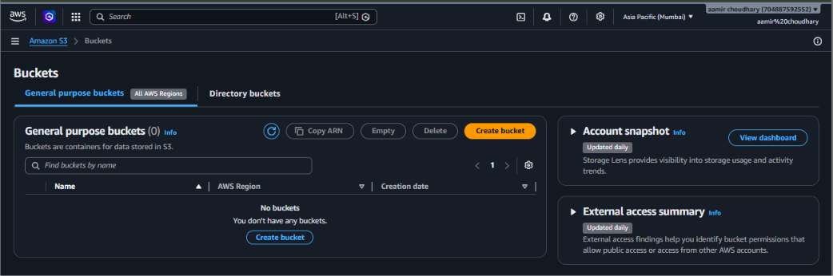
Screenshot 1: General purpose buckets list (empty)

Step 2: General configuration
On Create bucket, the Region was Asia Pacific (Mumbai) ap-south-1, Bucket type was General purpose, and Bucket namespace was Global namespace. The bucket name chosen was aamir-html-website-2026.
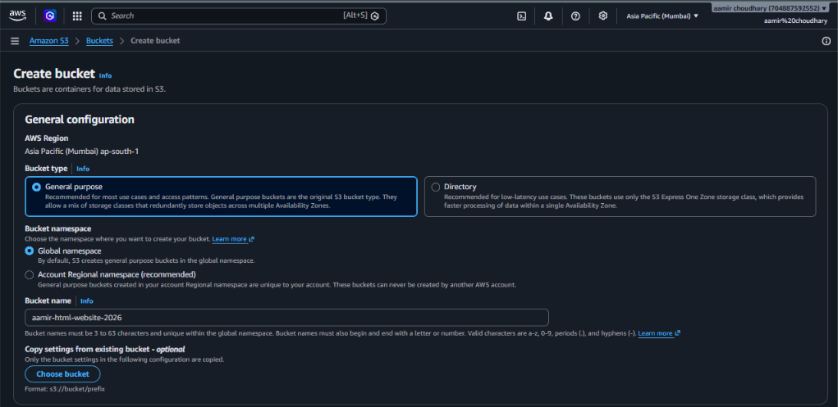
Screenshot 2: Create bucket – General configuration

Step 3: Object Ownership
Object Ownership was left at ACLs disabled (recommended) / Bucket owner enforced, same as the private bucket. Public access for a website is granted later through a bucket policy, not through ACLs.
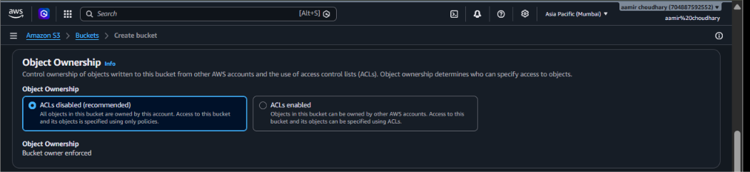
Screenshot 3: Object Ownership – ACLs disabled

Step 4: Turn off Block Public Access
This is the step that makes a website bucket different from a private one. Block all public access was unchecked, which un-blocks all four sub-settings (new/any ACLs, new/any bucket policies). AWS immediately shows a warning that this "might result in this bucket and the objects within becoming public", and the checkbox "I acknowledge that the current settings might result in this bucket and the objects within becoming public" was ticked to confirm the choice.
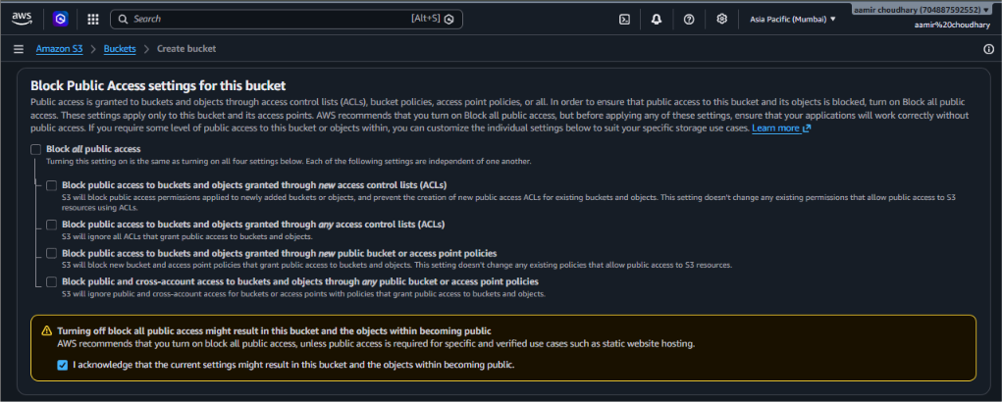
Screenshot 4: Block Public Access turned off, with the public-access acknowledgement checked
Important: Public access should only be turned off for buckets that are meant to be public, like a website. Never disable Block Public Access on a bucket that holds private or sensitive files.

Step 5: Bucket Versioning
Bucket Versioning was left on Disable, so only the latest copy of each file is kept.
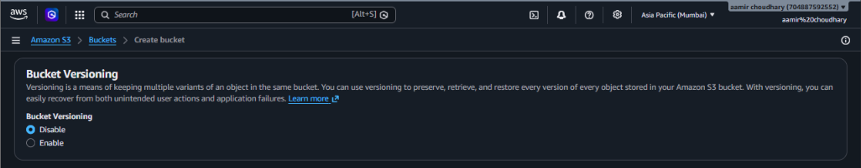
Screenshot 5: Bucket Versioning set to Disable

Step 6: Tags, default encryption and Create bucket
No tags were added. Default encryption was left at Server-side encryption with Amazon S3 managed keys (SSE-S3), with Bucket Key enabled. Clicking Create bucket completed the setup.
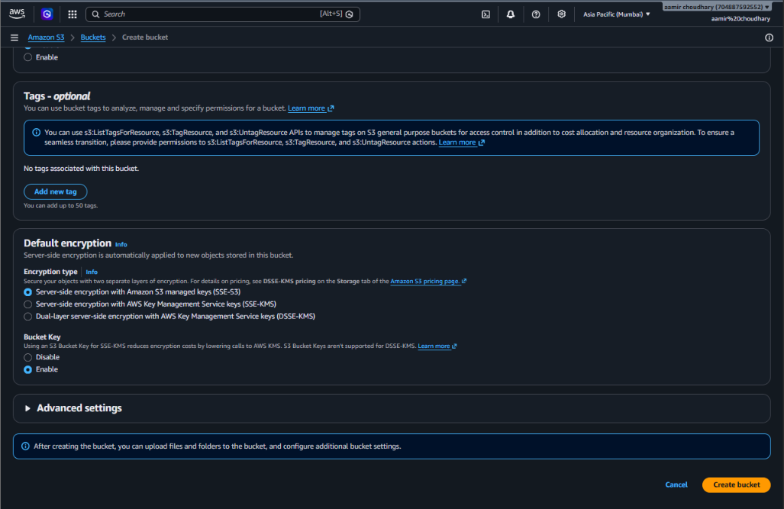
Screenshot 6: Tags, Default encryption and the Create bucket button

Step 7: Bucket created
A green banner confirms Successfully created bucket "aamir-html-website-2026". The Objects tab shows Objects (0), ready for the website files to be uploaded.
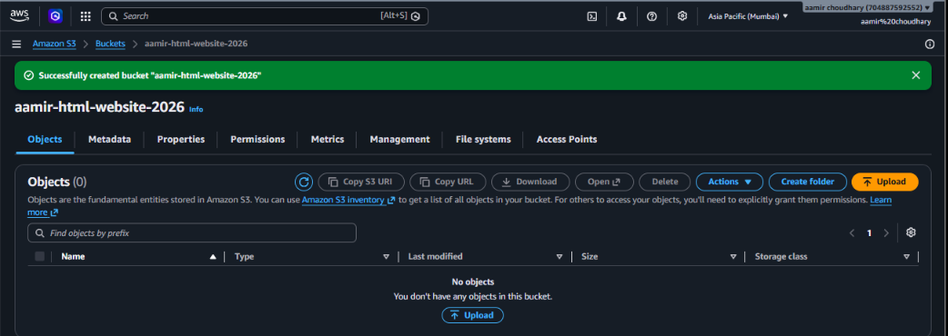
Screenshot 7: New bucket "aamir-html-website-2026" with no objects

Step 8: Upload the website files
Using Upload → Add files, three files were selected: index.html (10.4 KB), scripts.js (506 B) and style.css (8.7 KB) — together 19.7 KB. The destination shown is s3://aamir-html-website-2026.
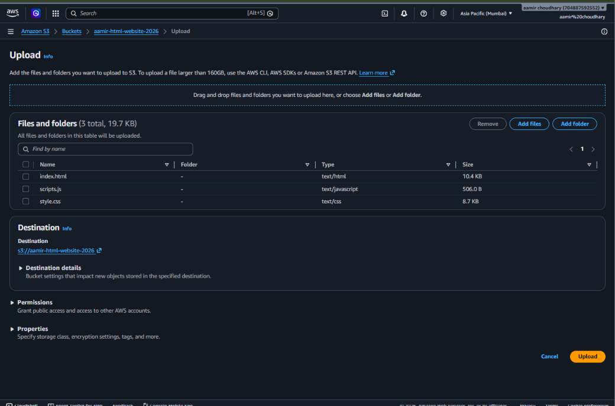
Screenshot 8: Upload page with index.html, scripts.js and style.css queued

Step 9: Upload succeeded
The Upload: status page confirms Upload succeeded — 3 files, 19.7 KB (100.00%), 0 failed. Each file (index.html, scripts.js, style.css) shows status Succeeded.
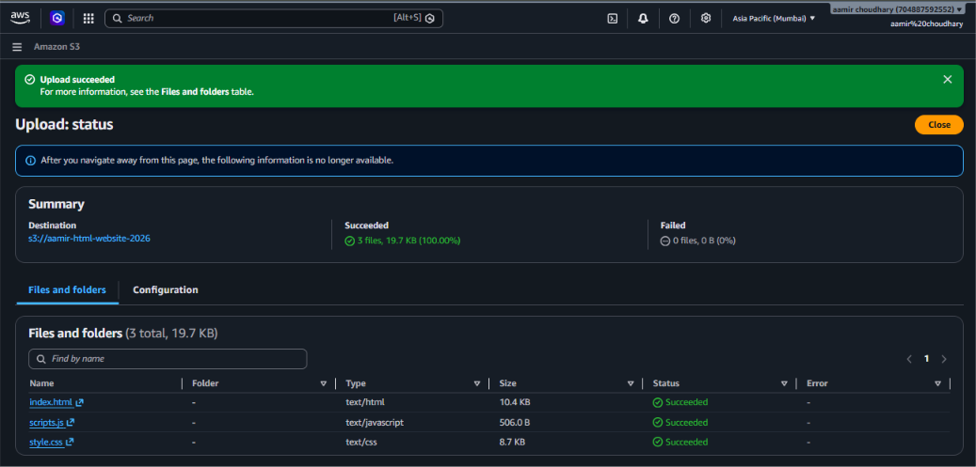
Screenshot 9: Upload status — all 3 files succeeded

Step 10: Object-level permissions and properties
The same upload-status screen also shows the Permissions and Properties that apply to the uploaded objects. The Access control list (ACL) shows the object owner has Read/Write, while Everyone (public access) currently has no explicit grant here — public read for a website is provided by the bucket policy or Block Public Access settings, not by per-object ACLs, since ACLs are disabled on this bucket. Storage class is Standard and no separate encryption key was specified (the bucket default, SSE-S3, applies).
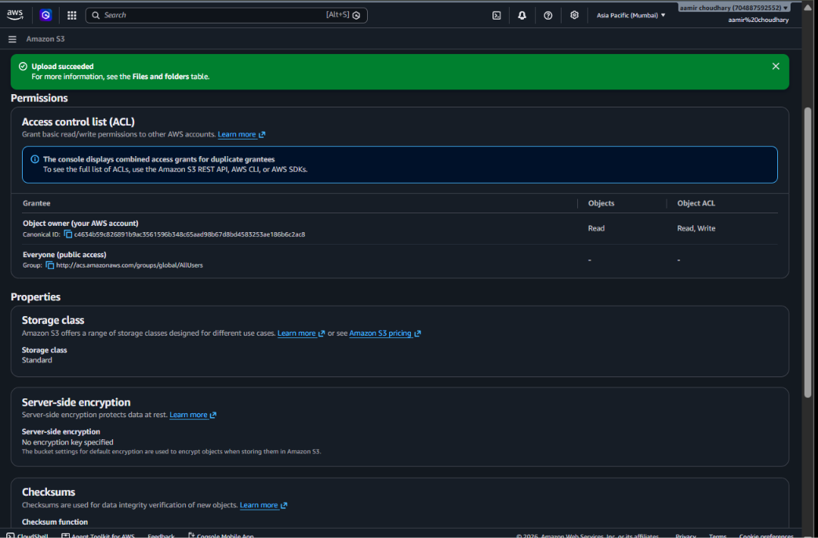
Screenshot 10: Permissions (ACL) and Properties for the uploaded objects

Step 11: Confirm the bucket in the list
Back in General purpose buckets, the list now shows 1 bucket: aamir-html-website-2026, in Asia Pacific (Mumbai) ap-south-1, created on 25 September 2026.
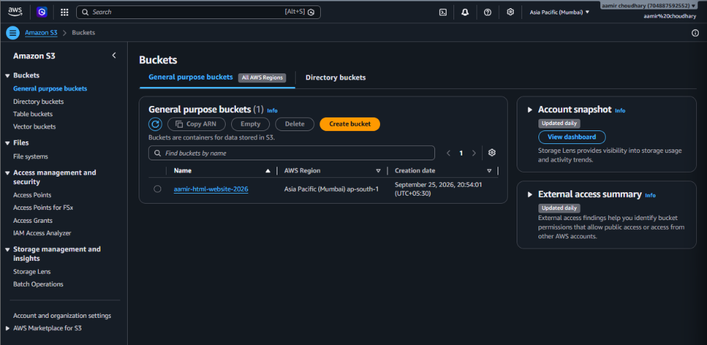
Screenshot 11: Bucket list showing aamir-html-website-2026

Step 12: Enable Static website hosting
From the bucket's Properties tab → Edit static website hosting: Static website hosting was set to Enable, Hosting type to Host a static website, Index document to index.html, and Error document to error.html. A blank Redirection rules box was left empty. AWS reminds that for visitors to access the content, the bucket's Block Public Access settings must allow public reads (already done in Step 4).
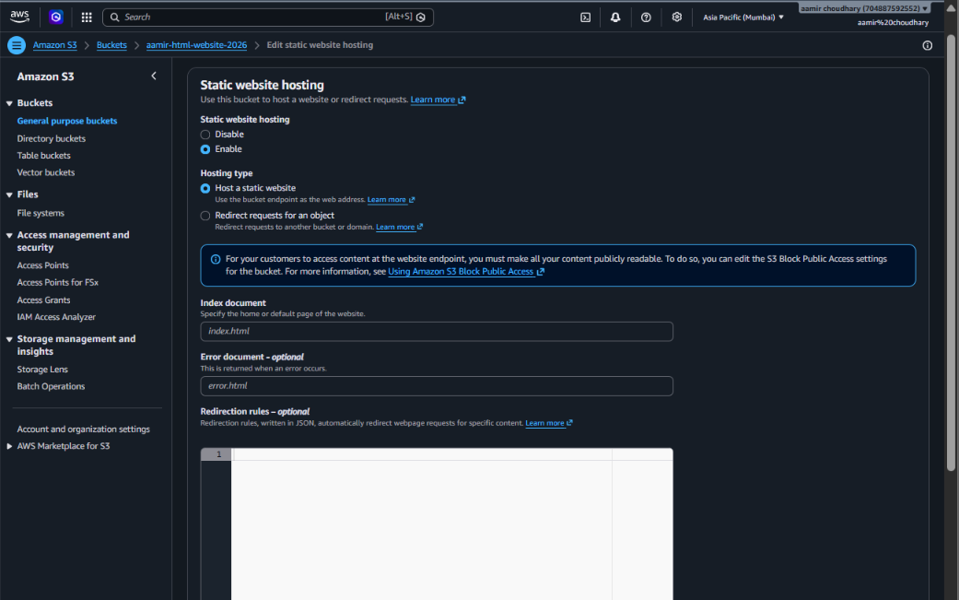
Screenshot 12: Edit static website hosting — Enable, index.html / error.html

Step 13: Get the website endpoint
After saving, the Properties page shows S3 static website hosting: Enabled, Hosting type: Bucket hosting, and the Bucket website endpoint: http://aamir-html-website-2026.s3-website.ap-south-1.amazonaws.com. This URL is the public address of the website. The same Properties tab also confirms Transfer acceleration, Object Lock and Requester pays are all Disabled (left at default).
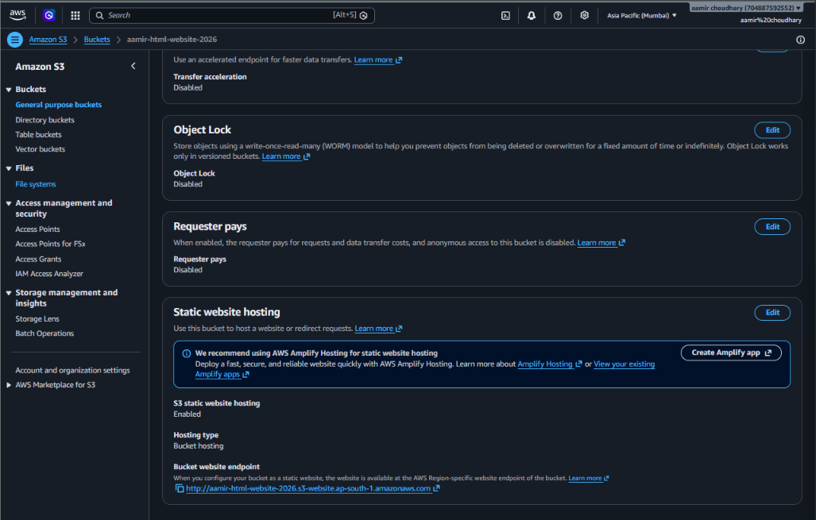
Screenshot 13: Static website hosting enabled, with the bucket website endpoint

Step 14: View the live website
Opening the bucket website endpoint in a browser loads the portfolio page: a dark-themed site titled "AAMIR." in the navbar (Home, About, Skills, Projects, Contact), with a hero section reading "Hello, I'm Aamir Akhtar — Data Science & AI Student" and a "Data Science" badge listing Python, ML, AI, SQL and Analytics. The browser shows "Not secure" because the S3 website endpoint is served over plain HTTP, not HTTPS.
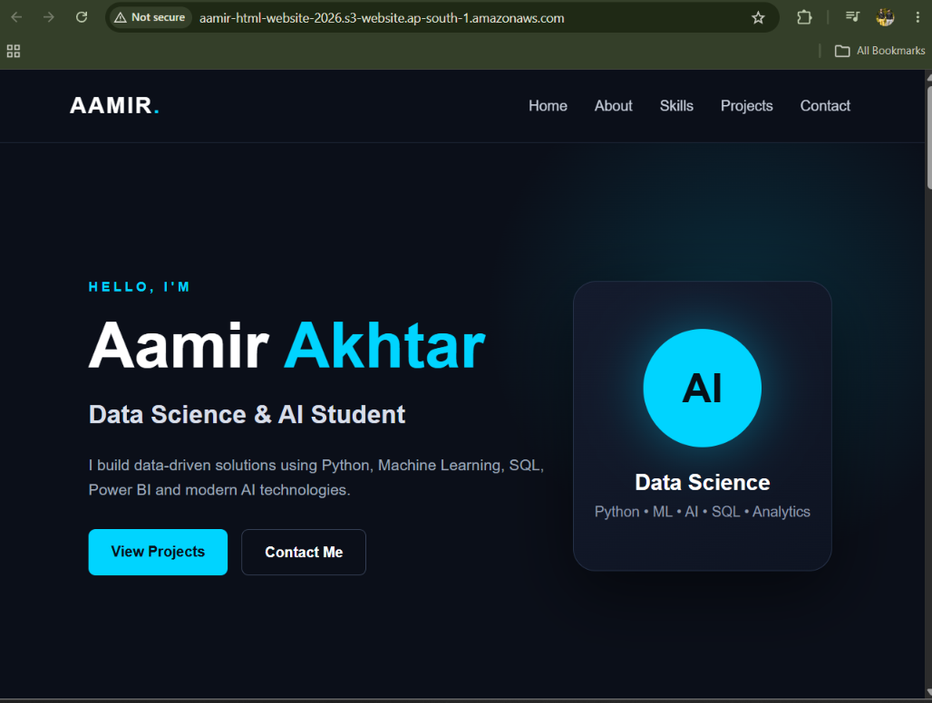
Screenshot 14: Live static website at the S3 website endpoint
Note: A plain S3 website endpoint only supports HTTP and cannot use a custom domain with HTTPS directly. For a production site, put Amazon CloudFront in front of the bucket to get HTTPS, a custom domain and caching.

3. Final Configuration Summary
Parameter | Value
Bucket name | aamir-html-website-2026
Region | Asia Pacific (Mumbai) ap-south-1
Object Ownership | ACLs disabled (Bucket owner enforced)
Block Public Access | Turned OFF (public access acknowledged)
Bucket Versioning | Disabled
Default encryption | SSE-S3 (Amazon S3 managed keys)
Files uploaded | index.html, style.css, scripts.js (19.7 KB total)
Static website hosting | Enabled — Index: index.html, Error: error.html
Website endpoint | http://aamir-html-website-2026.s3-website.ap-south-1.amazonaws.com
Access | Public (read-only, HTTP only)

4. Why a Website Bucket Must Be Public
A normal S3 bucket is private by default so that only authorized AWS identities can read it. A website bucket is different on purpose: every visitor loading the page is an anonymous internet user with no AWS account, so S3 must be told to allow public GetObject requests. Two settings work together to allow this:
- Block Public Access (bucket level): must be turned off, otherwise S3 blocks public policies and ACLs even if you try to add them.
- Bucket policy or ACL granting s3:GetObject to everyone: the actual permission that lets anyone read the objects. In many setups a bucket policy such as the one below is added explicitly.
Even though this bucket did not show a separate bucket-policy screenshot, disabling Block Public Access combined with the site loading successfully in Step 14 confirms public read access is working — S3 static website hosting also relies on it being enabled to serve pages via the website endpoint.

4.1 Example public-read bucket policy
For reference, a typical policy used to make website objects public looks like this (not required here since the site is already loading, shown for understanding):
{
"Version": "2012-10-17",
"Statement": [
{
"Sid": "PublicReadGetObject",
"Effect": "Allow",
"Principal": "*",
"Action": "s3:GetObject",
"Resource": "arn:aws:s3:::aamir-html-website-2026/*"
}
]
}

5. Best Practices and Things to Keep in Mind
- Scope the public access narrowly: only disable Block Public Access on buckets meant to be public, like this website bucket. Keep it enabled on every other bucket.
- index.html and error.html: index.html must exist at the bucket root for the homepage to load; error.html is shown for missing pages or errors — make sure both files were actually uploaded.
- Use CloudFront for production: it adds HTTPS, a custom domain name, caching (faster loads) and can hide the raw S3 endpoint.
- Cache-busting: when style.css or scripts.js are updated and re-uploaded, browsers or CloudFront may keep showing the old cached version — use versioned file names or cache invalidation if this happens.
- Cost: S3 website hosting is billed like normal S3 usage — storage plus data transfer out to visitors — there is no separate "hosting fee".
- No server-side code: S3 can only serve static files. Anything needing a backend (forms that email you, databases, login) needs a separate service such as Lambda, API Gateway, or a traditional server.

6. Clean-up
If the website is no longer needed: first empty the bucket (Actions → Empty, or delete the individual objects), then delete the bucket from General purpose buckets (select it → Delete → type the bucket name to confirm). Deleting the bucket immediately takes the website offline, since the endpoint only works while the bucket and its objects exist.

