AWS EC2 Instance Creation

Screenshot 1 – EC2 Instances Page
Summary:
This screenshot shows the Amazon EC2 Instances page in the AWS Management Console. The selected AWS Region is Asia Pacific (Mumbai) – ap-south-1. Currently, there are no EC2 instances available in this region. The page provides the Launch instances option, which is used to create a new virtual server on AWS.
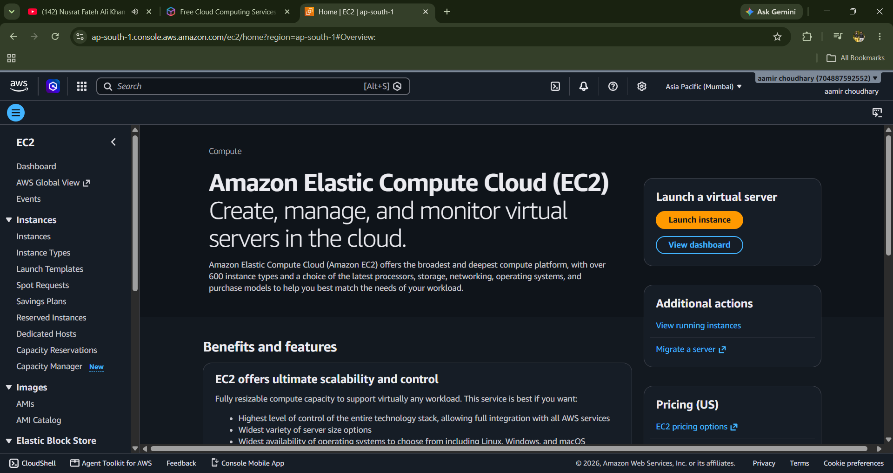

Screenshot 2 – Amazon EC2 Dashboard
Summary:
This screenshot shows the Amazon Elastic Compute Cloud (EC2) dashboard. Amazon EC2 is an AWS service used to create, manage, and monitor virtual servers in the cloud. From this dashboard, a new virtual server can be created using the Launch instance option. It also provides information about EC2 features, scalability, server configurations, and available pricing options.
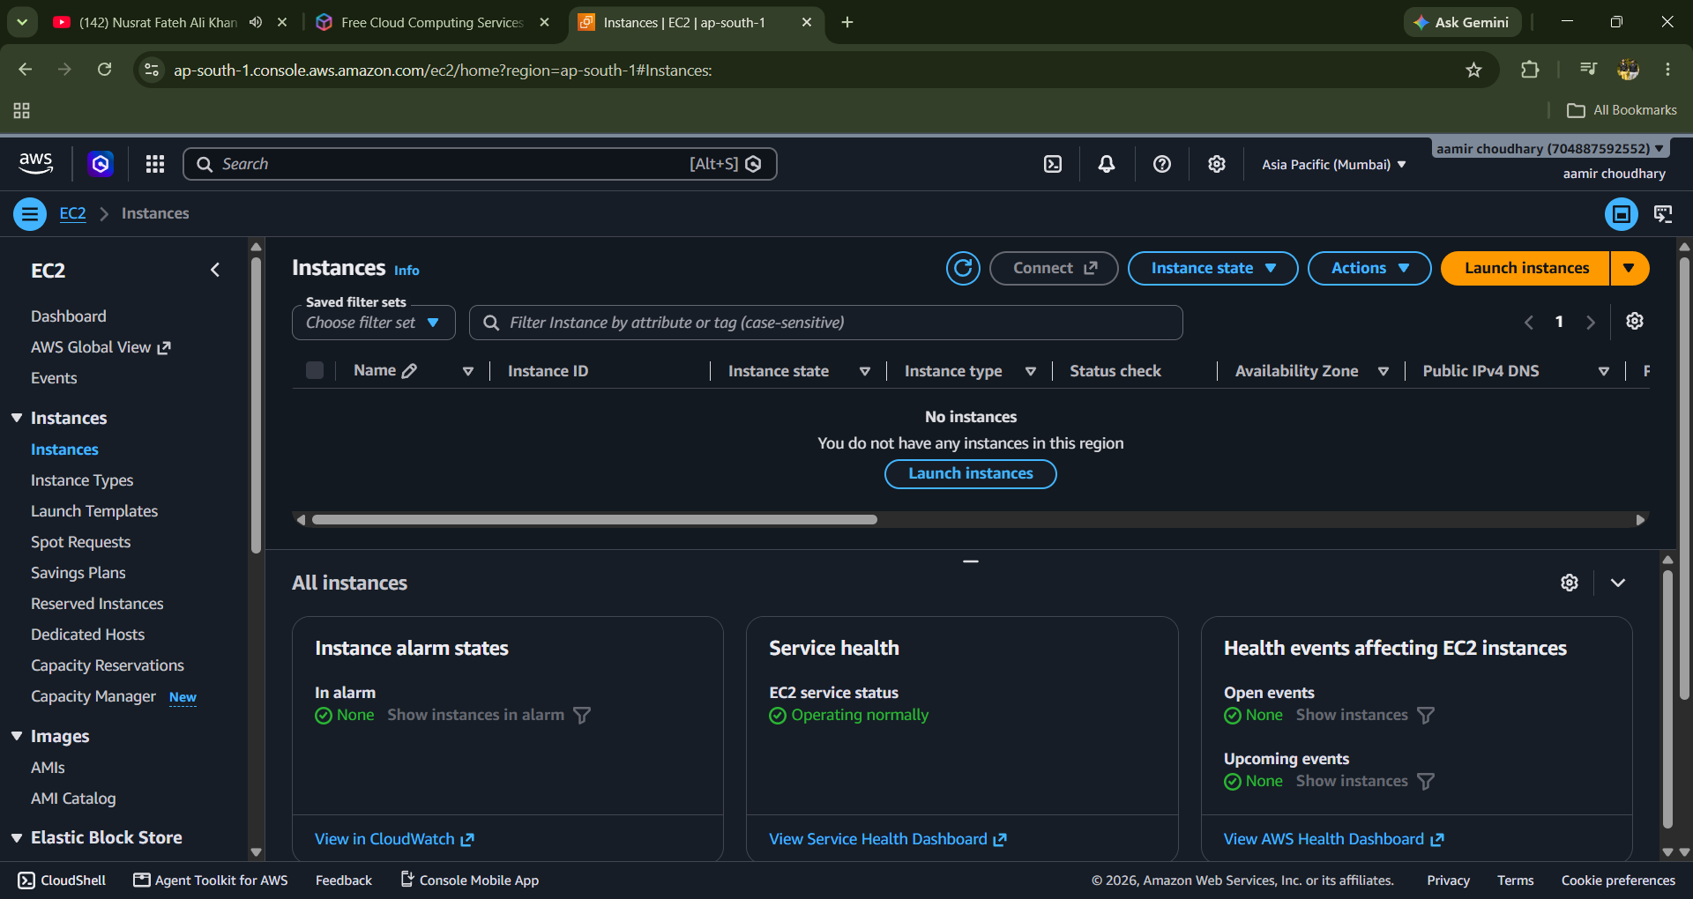

Summary:
In this step, the EC2 instance is given a unique name under the Name and tags section. The name “aamir choudhary” is entered to identify the virtual server easily in the AWS EC2 dashboard.

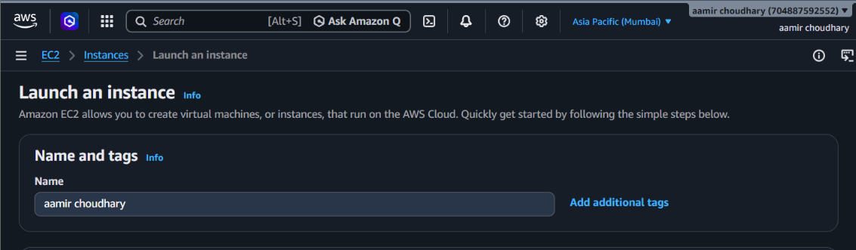

Summary:
In this step, an Amazon Machine Image (AMI) is selected for the EC2 instance. Amazon Linux 2023 (kernel 6.18) is selected as the operating system. It is a Linux-based operating system optimized for AWS and provides a secure and stable environment for developing and running cloud applications. The selected AMI is also marked as Free tier eligible

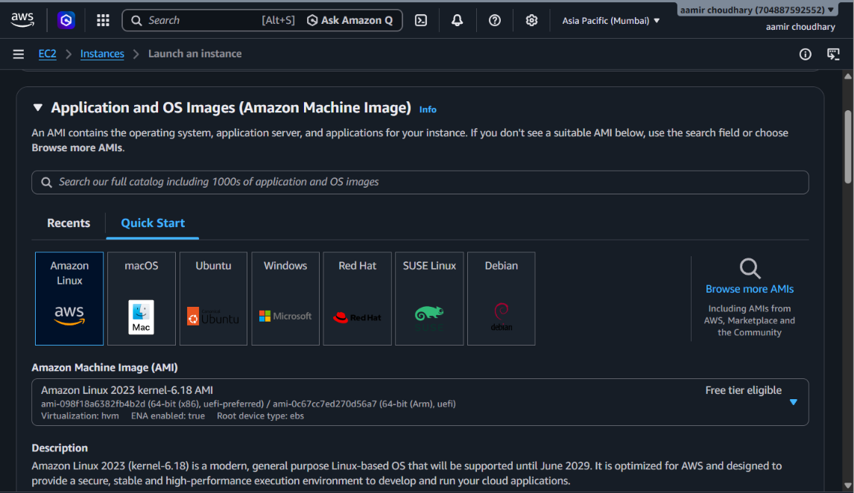

Summary:
In this step, the EC2 instance type is selected according to the required computing resources. The t3.micro instance type is selected, which provides 2 vCPUs and 1 GiB of memory. It is marked as Free tier eligible, making it suitable for basic learning and testing purposes.

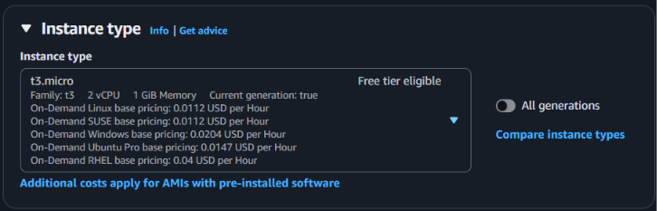

Summary:
In this step, a Key Pair is configured to securely connect to the EC2 instance. AWS recommends using a key pair because it provides secure authentication when accessing the virtual server. The Create new key pair option can be used to generate a new key pair before launching the instance.

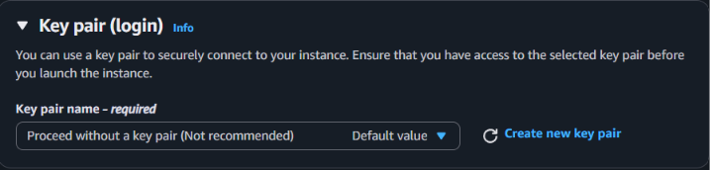

Summary:
In this step, the Network Settings for the EC2 instance are configured. The instance is connected to a VPC, with the default subnet selected. Auto-assign Public IP is enabled so that the instance can be accessed over the internet. A new security group is created, with SSH and HTTPS traffic allowed. These settings control how the EC2 instance communicates with other systems and the internet.

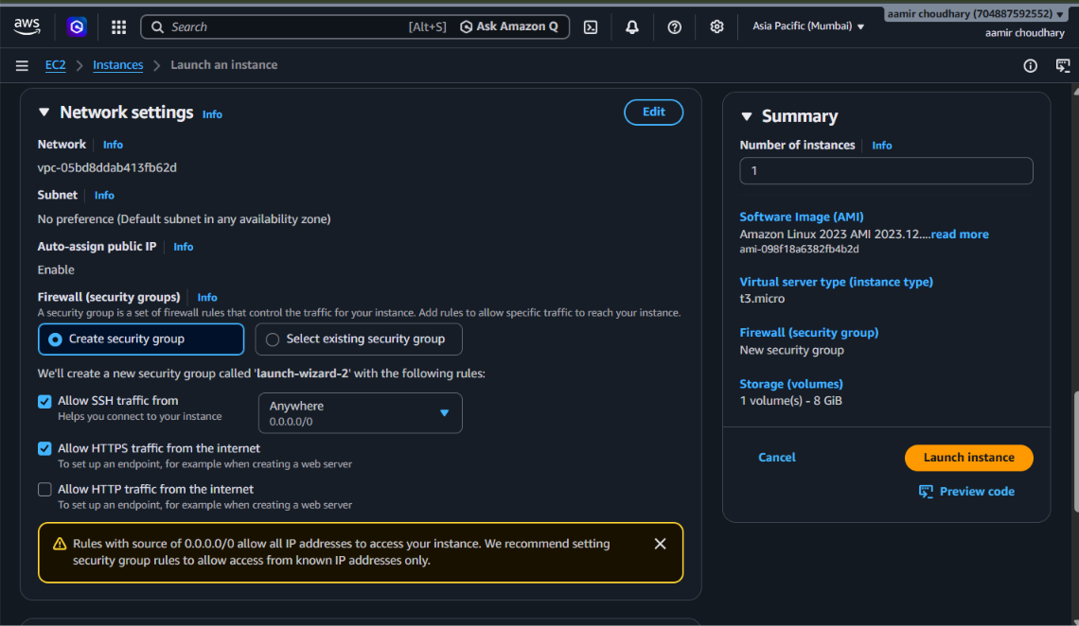

Summary:
In this step, storage is configured for the EC2 instance. An 8 GiB gp3 EBS volume is selected as the root volume, providing storage for the operating system and applications. No additional file system is configured, as the None option is selected. The storage configuration can be modified according to the requirements of the server.

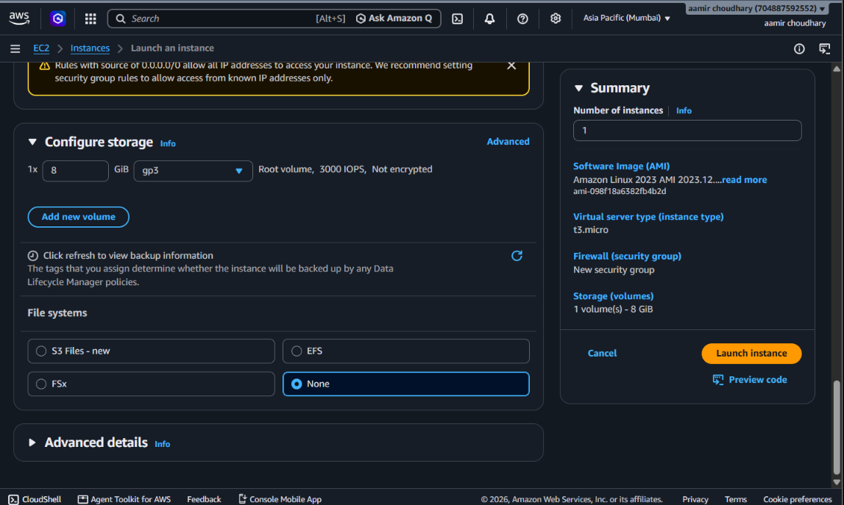

Summary:
After completing the configuration, the EC2 instance is successfully launched and appears on the Instances page. The instance named “aamir choudhary” is in the Running state, with instance type t3.micro. The screenshot also shows that all 3/3 status checks have passed, confirming that the instance is operating normally. A public IPv4 address has also been assigned, allowing the server to be accessed over the internet.

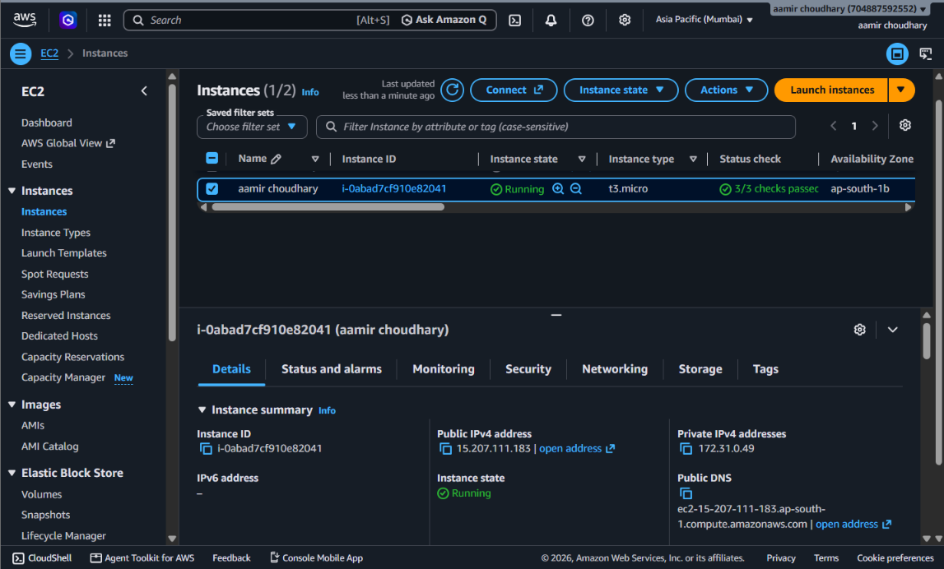
Summary:
In this step, the Connect to Linux instance page is opened to establish a connection with the EC2 server. The instance is confirmed to be Running, and all 3/3 status checks have passed. The EC2 Instance Connect option is selected with Public subnet access, allowing the Linux instance to be accessed directly through a web browser. The public IPv4 address of the instance is also displayed, and the Connect option is available to start the connection.

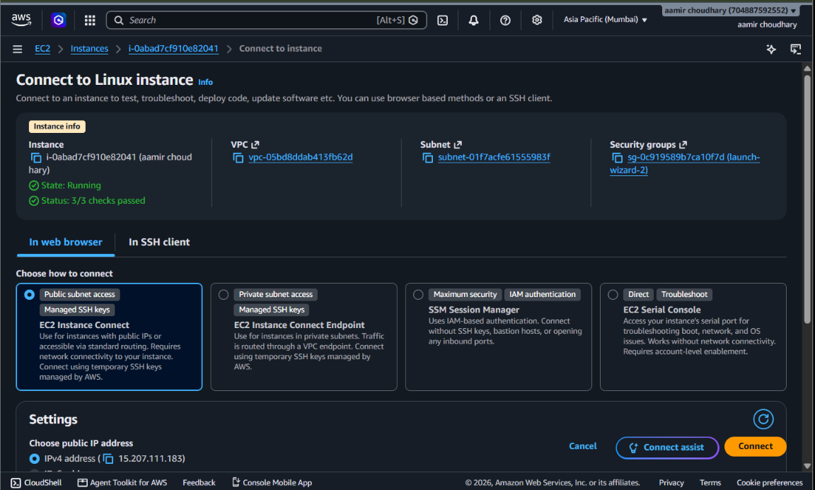

Summary:
After connecting to the Linux EC2 instance, the terminal is used to perform basic file and directory management operations. A data directory is created, and a users_data.txt text file is created inside it. The file is edited using the nano editor, and data is added to the file. The cat command is then used to display and verify the stored content. This confirms that the EC2 Linux server is working correctly and can be used to manage files through the command line.

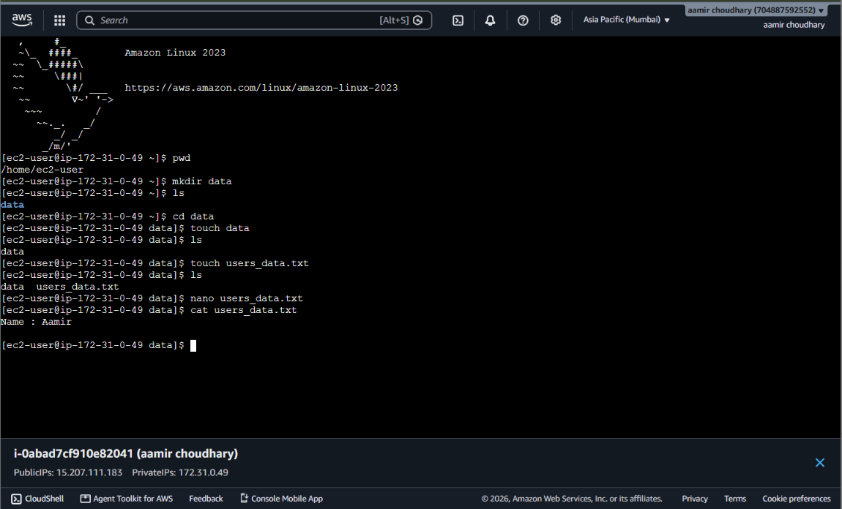

Summary:
In this step, the EC2 instance is prepared for termination after completing the practical. The Terminate (delete) instance confirmation window displays the selected instance and warns that the root EBS volume and its stored data may be deleted. Termination is an irreversible action, and the instance will no longer be available after termination. This step is used to avoid unnecessary AWS resource usage after completing the practical.

