Step – 1: Generate polymer

$ python3 polymer.py

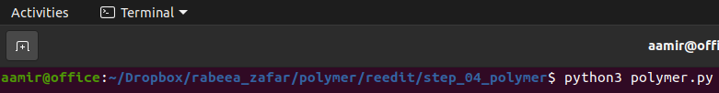

Step – 2: Number of repeat units (monomers)
The program prompts user to enter the number of repeat units (monomers) in the chain. Enter the number of repeat units.

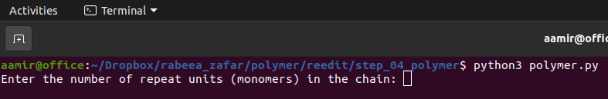
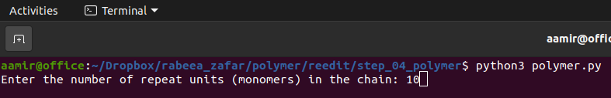

Step – 3: Charge method
The program shows the available charge schemes and prompts user to enter the charge scheme to implement from the shown charge methods. Enter the charge method and two files (polymer.lt and polymer.mol2) will be generated which are the required polymers.

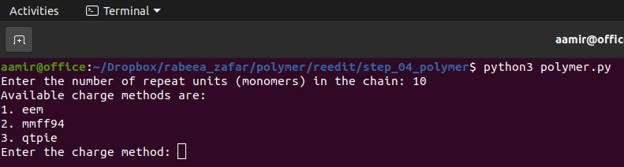
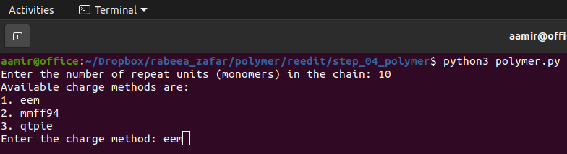

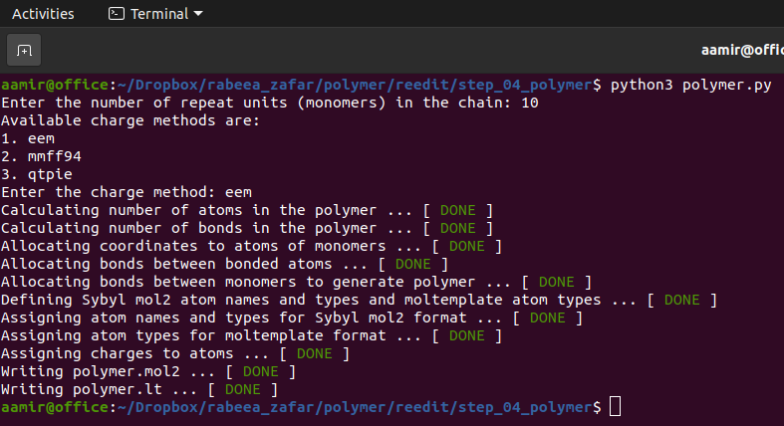
The file polymer.mol2 can be viewed in a visualizer like Pymol.

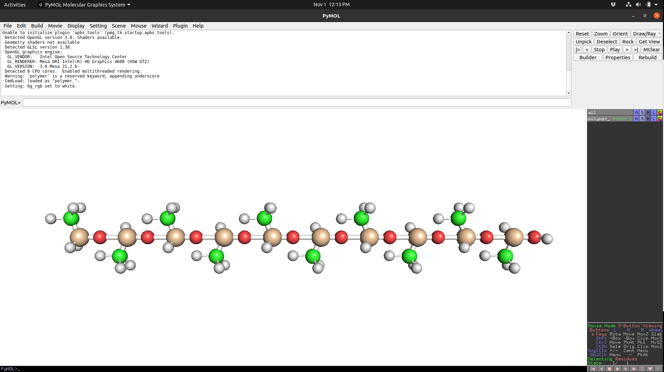

The file polymer.lt can be further processed in moltemplate to generate lammps input data for molecular simulation.

