**Microservices based Sheep Management System:**

The objective is to create a sample application to demonstrate following software concepts

. Microservices

. Message based architecture

. CQRS

. Mediator Pattern

. Command Pattern

. SOLID and Clean Code guidelines

. Cloud Managed Services (Amazon SQS)

. Unit Test

. Integration Test

. Dependency Injection

**Development tools and Technologies:**

. asp.net core 2.2

. visual studio 2019

. Amazon SQS (As Message Queue)

**\*Note:** for Amazon SQS you can create free account and use your own credentials to make this sample work

In appSettings.json file

"AmazonSQSSettings": {

"ApiKey": "",

"ApiSecret": "",

"QueueName": "yourQueue.fifo",

"QueueUrl": "https://sqs.us-east-2.amazonaws.com/381953359561/yourQueue.fifo",

"ServiceUrl": "https://sqs.us-east-2.amazonaws.com"

},

**Application functionality:**

. The current number of sheep can be retrieved by anyone

. A new sheep can be added by anyone

. The total number of sheep is global and may be stored in memory

Example

. A user calls the API to retrieve the number of sheep and receives a response indicating the total number of sheep to be zero

. A user makes a request to the API to add a sheep

. When the API is now called for the number of sheep it returns a response indicating the total number of sheep to be one

. Again, the API is called to add a sheep, this time twice in a row

. When the user calls the API for the number of sheep he receives a response indicating the total number of sheep to be three

**Architecture and Design:**

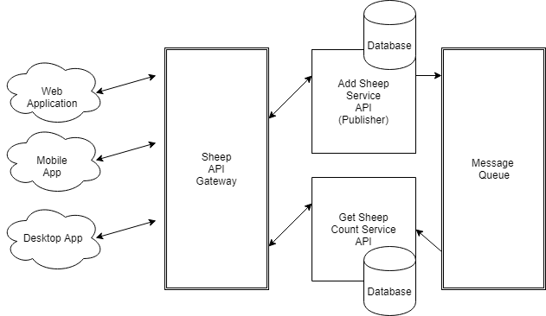

**Solution Structure:**

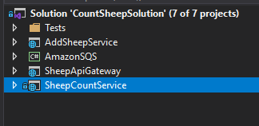

**How to run this solution:**

**To run the Tests:**

You can run each test individually.

However SheepApiGateway test make sure that AddSheepService and SheepCountService are up and running.

**Documentation:**

For this sample, I am using swagger

**How to test the solution using Swagger**

I am using IIS Express, and I assume that for the scope of this sample it should be OK.

I used multiple Startup projects

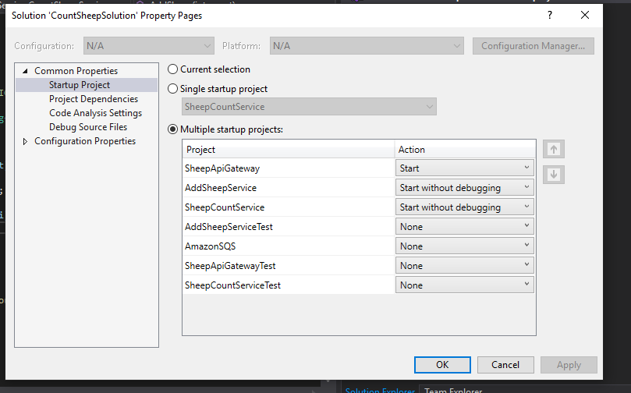

So now when you run the solution, all the api endpoints should work as expected.