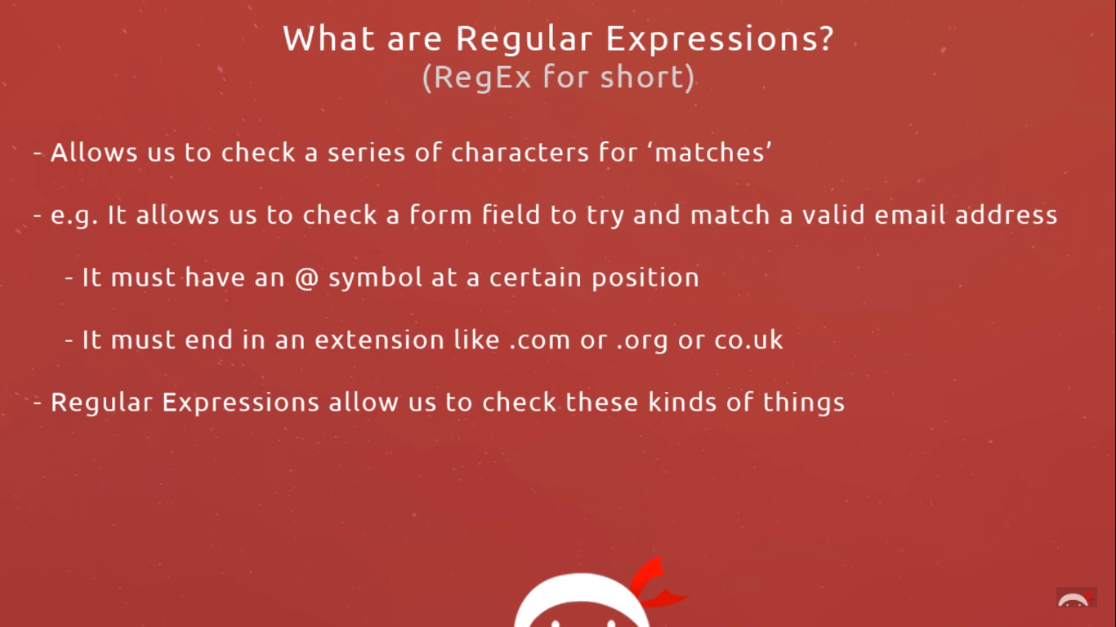

<https://github.com/iamshaunjp/regex-playlist>

<https://regex101.com/>

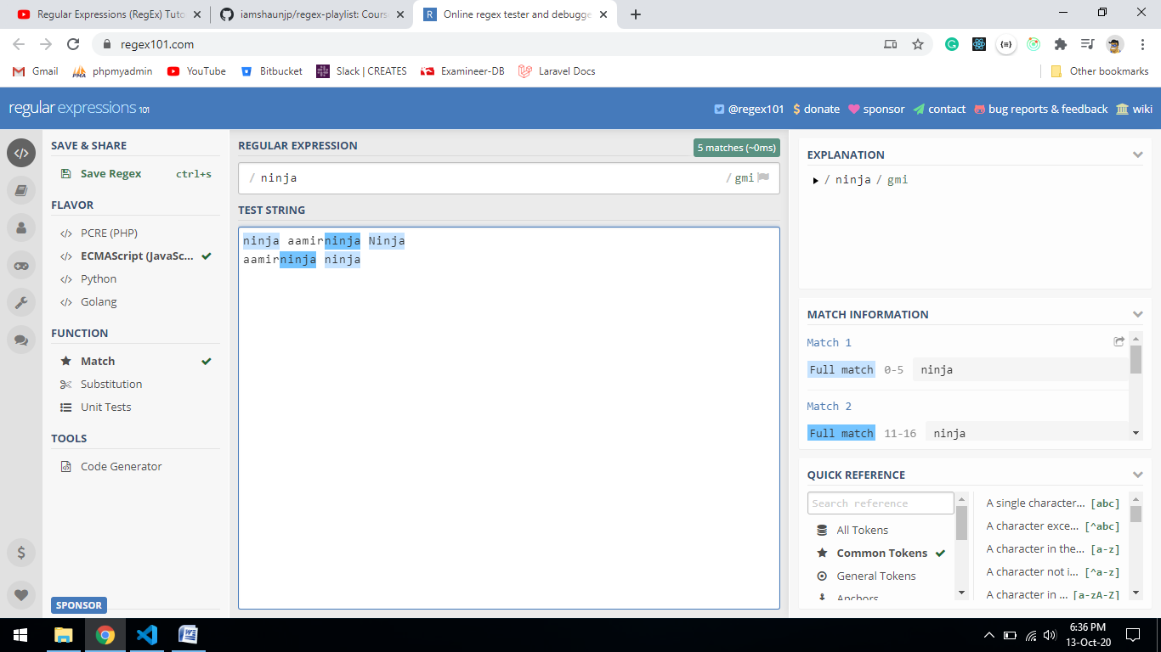

RE: /ninja/gmi

g= global

m= multi line

i= case insensitive

**Character set**

RE: /[abc]ninja/gi

It match first character a or b or c then ninja

Aninja bninja cninja

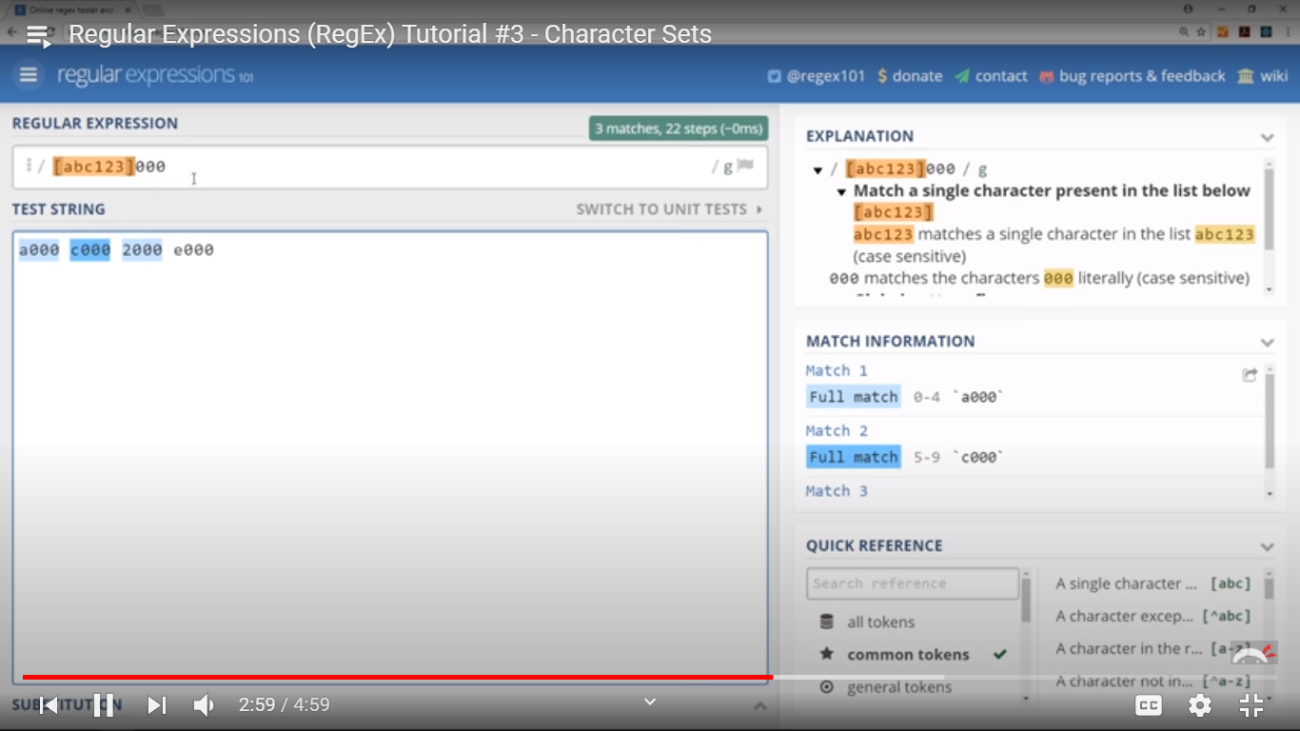

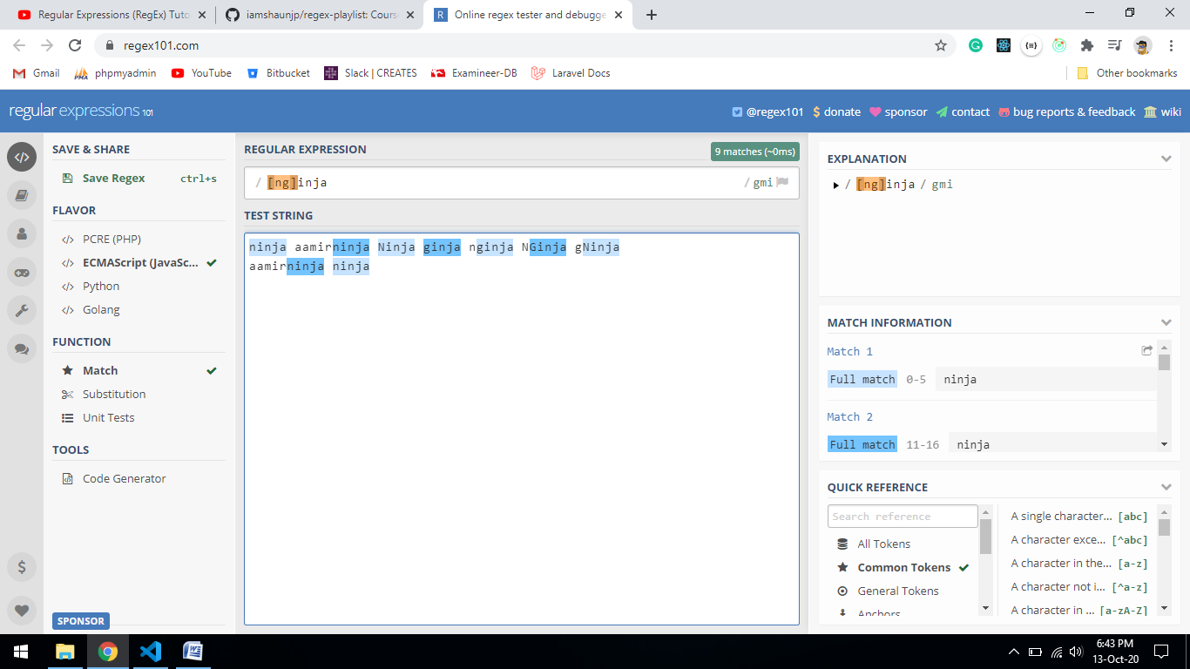

Exclude some characters

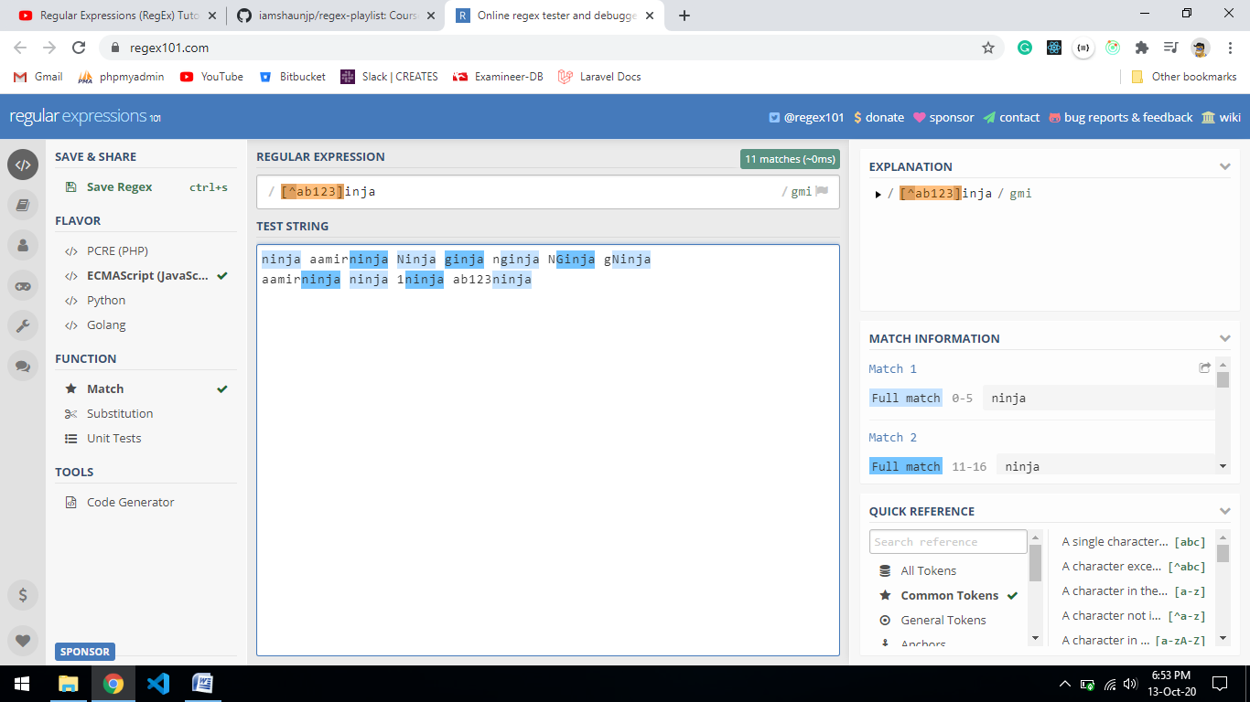

Rage : [a-z] [A-Z] [0-9]

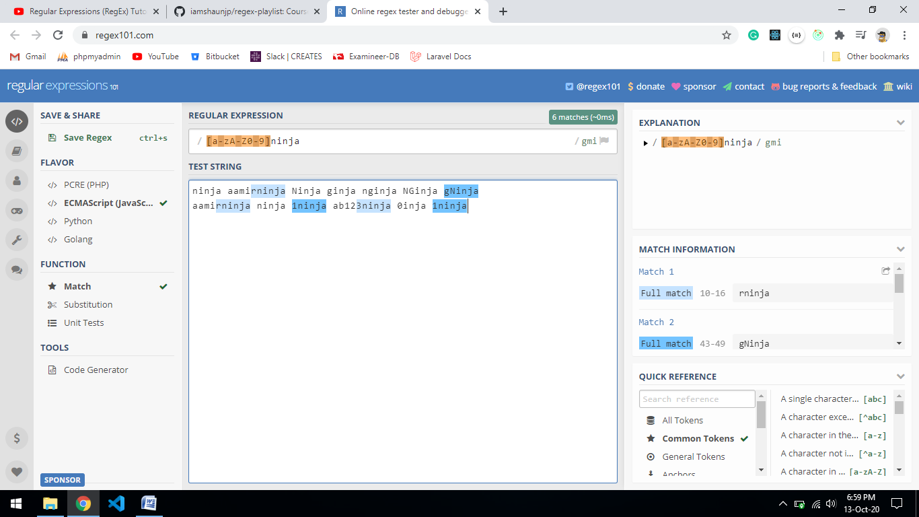

Number of characters

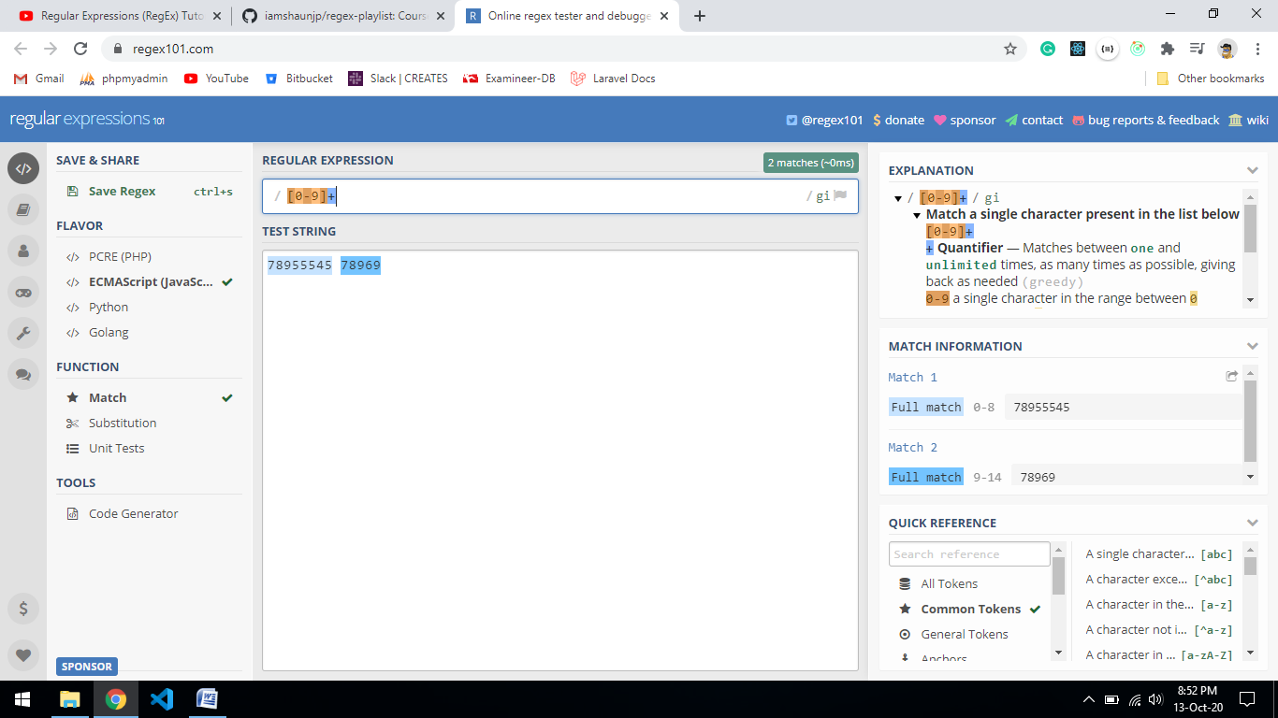

1. /[0-9]+/

+ means 1 to many

2) /[0-9]{5}/

{5} means 5 characters

3) /[0-9]{5,8}/

{5,8} means minimum 5 to maximum 8

4) /[0-9]{5,}/

{5,} means at least 5 characters

5) /[0-9]*test/

* means 0 or more.

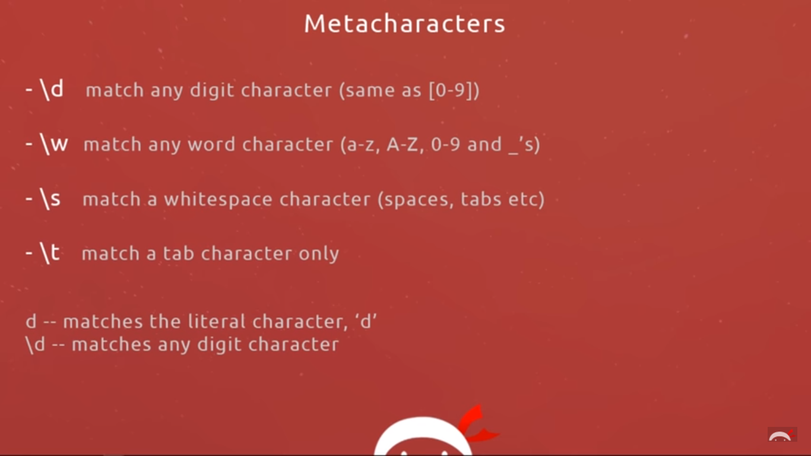

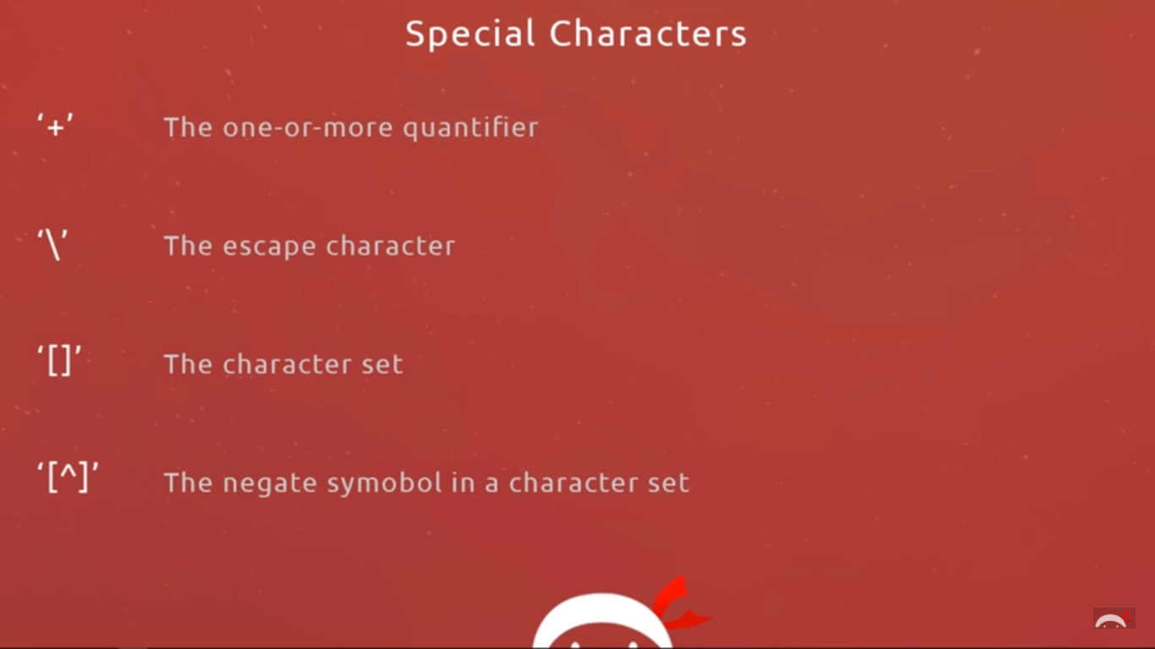

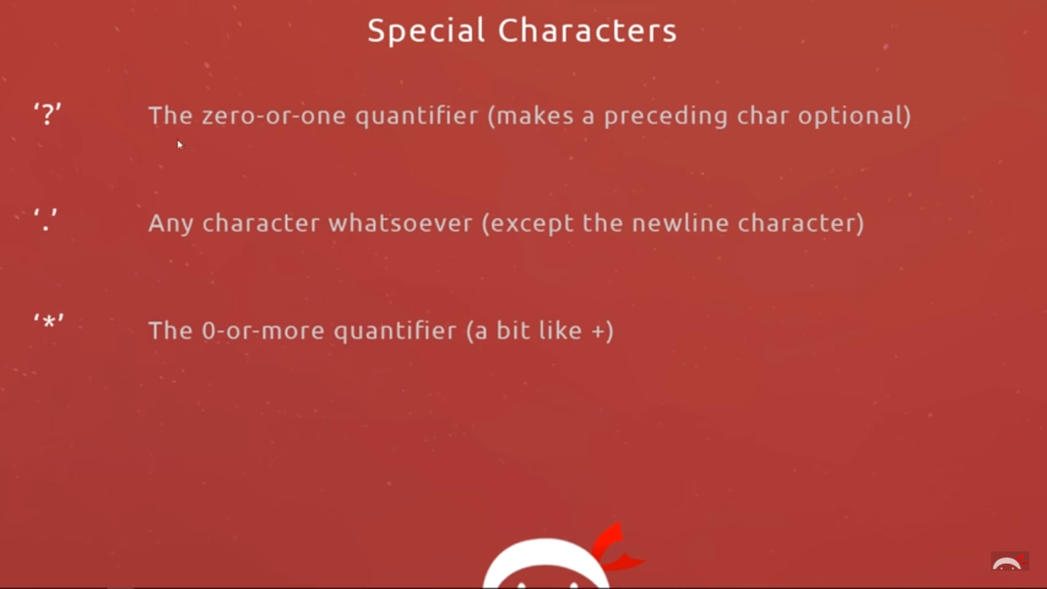

Starting and ending match

/^[0-9]{11}$/

/^ expression $/

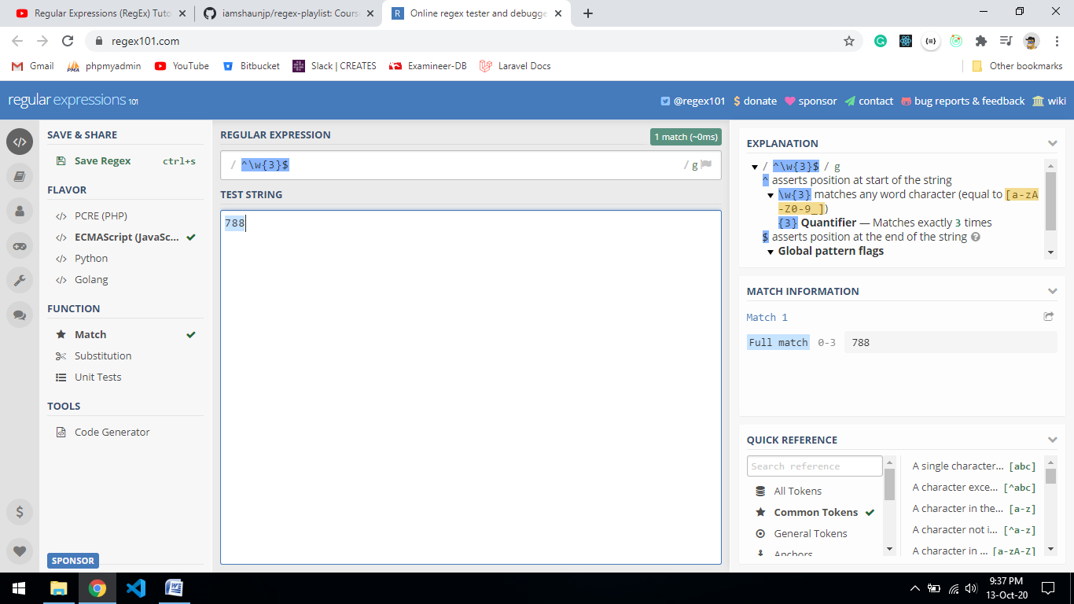

Alternate characters

/P|Tayre/

It select either P or Tayre

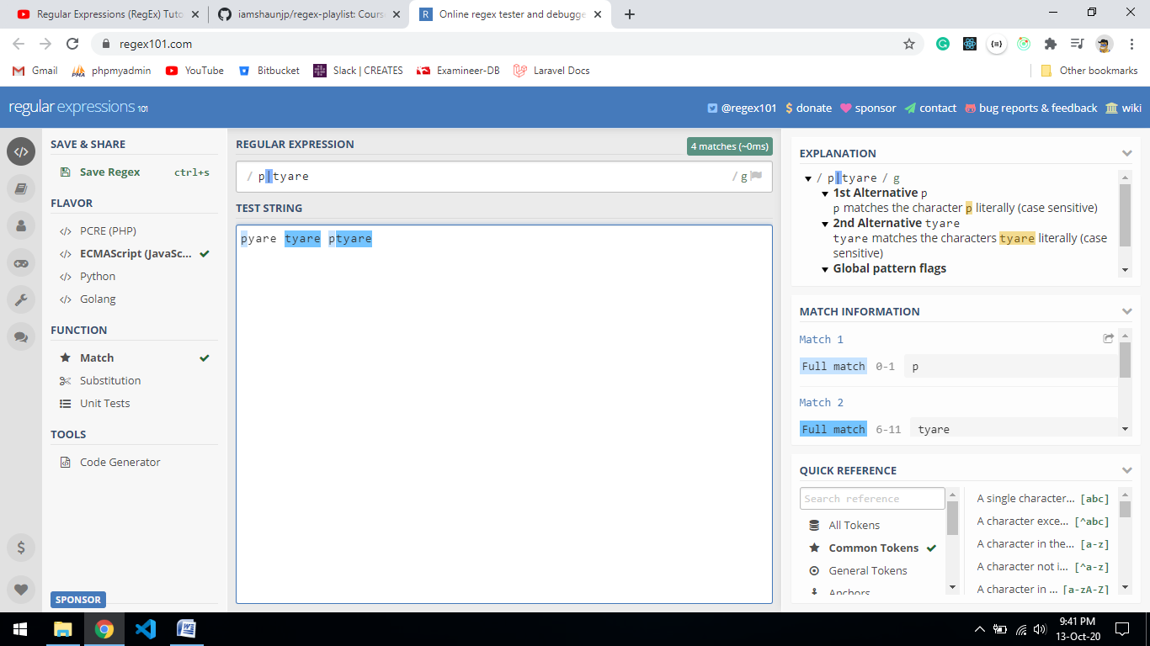

/(p|t)ie/

pie tie

