1. Introduction
1.1 Existing System
The traditional, non-digital system for managing legal cases has several significant drawbacks:
- Physical Document Risks: There is a constant risk of fire, theft, or loss of physical documents.
- Inefficient Retrieval: Finding old case files is a time-consuming process.
- Slow Workflow: Heavy workloads often lead to a slower overall process.
- Manual Information Gathering: Searching for and collecting information physically is a cumbersome task.
- Poor Data Security: The system offers less data security compared to digital alternatives.
- Accessibility Issues: Accessing necessary information from different locations is a problem.
- Record-Keeping Challenges: Maintaining comprehensive records for every file is challenging.
- Risk of Missing Deadlines: There is a high level of stress associated with potentially missing important hearing dates, reports, and evidence deadlines.

1.2 Need for the New System
The new system is needed to address the inefficiencies of the existing manual processes. Its purpose is to:
- Save time in legal case management.
- Accelerate legal processes.
- Eliminate extensive paperwork.
- Remove the need for physical storage of documents.
- Provide timely notifications for hearing dates and case updates.
- Manage cases more smoothly and achieve faster results.
- Enable faster searching and access to information from anywhere at any time.

1.3 Objective of the New System
The primary objectives for developing the eCourt Manager system are to:
- Reduce Manual Work: Minimize the manual effort required in case management.
- Increase Efficiency: Reduce the total time required for various tasks.
- Optimize Manpower: Lower the amount of manpower needed to manage cases.
- Ensure Accuracy: Provide a higher degree of accuracy in data and record-keeping.
- Centralize Data: Create a proper, centralized database for all case-related information.
- Generate Reports: Enable the easy generation of reports.
- Be User-Friendly: Offer a user-friendly interface that is easy to access and navigate.
- Maintain Reliability: Ensure the system is reliable, accurate, and provides non-redundant information.

1.4 Problem Definition
Lawyers often face significant challenges in managing a large volume of cases, clients, and related documentation through traditional, paper-based methods. This manual system is inefficient, prone to errors, and poses security risks such as the loss or theft of critical documents. Key problems include the time-consuming nature of searching for old files, the difficulty in accessing case information remotely, and the high risk of missing important dates for hearings and evidence submission. This overall inefficiency creates a stressful and slow-moving workflow, making it difficult to manage a legal practice effectively. The eCourt Manager project aims to solve these problems by creating a centralized, secure, and accessible digital platform for complete case management.

1.5 Advantage
The implementation of the eCourt Manager system offers several key advantages:
- Efficiency: The online system reduces the inefficiency of slower manual processes.
- Document Security: It mitigates the risk of damage to case information and prevents documents from being stolen or lost.
- Reduced Manual Labor: The system reduces the amount of manual work and the need for extensive manpower.
- Accessibility: Lawyers can easily access information about current or past cases from any location.
- Task Delegation: Junior lawyers or staff can be assigned tasks like setting the next court hearing date.
- Client Access: Clients can view court hearing dates and other case-related information.
- Appointment Scheduling: Clients have the ability to schedule appointments to meet with their lawyer.

2. Requirement Analysis (Literature Review and Survey)

User Requirements
- Lawyers can register, manage client details, manage case documents, and view case notifications from anywhere at any time.
- Clients can create their own accounts, request lawyer changes, view case progress, and provide feedback.
- Staff supports lawyers with case management and timely reminders about hearings.
- Admin manages user registrations, staff allocations, and system-level controls.

Functional Requirements
- Centralized login/authentication ensuring secure access for all users.
- Add, update, and delete cases in the system.
- Store and manage case documents (FIRs, evidence, etc.).
- Manage hearing dates and send notifications about hearings.
- Enable clients to request lawyer changes through the platform.
- Generate various reports for users and admin.
- User and staff management features for the admin role.

Non-Functional Requirements
- Usability: The user interface is intuitive, simple, and designed for effective interaction without training.
- Reliability: The system must have low failure rates and resolve errors quickly. It should prevent unauthorized access.
- Performance: Multiple users can simultaneously use the application (lawyers, clients, staff) without system lag.
- Security: Login modules prevent unauthorized access; strong password requirements for all users.
- Accuracy: Information is correctly processed and displayed, with minimal errors.
- Supportability: The system must be compatible with all major operating systems and browsers.

Stakeholder Survey :
- Lawyers: Need an efficient online platform to manage many clients, cases, documents, and remotely access all critical details. Expressed difficulty with manual paperwork and tracking hearing schedules.
- Clients: Want easy ways to view case status, request lawyer changes if dissatisfied, and provide feedback or ratings. Prefer a transparent, user-friendly interface with notifications about case progression.
- Staff: Require access to client and case data to coordinate supporting activities like document uploads and hearing reminders. Need tools to assist lawyers and keep all case records organized.
- Admin: Responsible for overseeing the system, managing user registrations, allocating staff, handling security, and generating reports. Require robust controls for maintaining data integrity and system-wide configuration.

Key Survey Findings:

- Centralized Management: All parties want a single, streamlined system for managing cases, hearing dates, and notifications instead of fragmented or paper-based workflows.
- Accessibility: Stakeholders emphasize access from any location at any time and compatibility with multiple platforms (desktop, mobile).
- Automation: Notifications, reminders for hearings, and streamlined lawyer/client communication are highly desired.
- Data Security: Secure logins and the ability to control and audit system access are needed to protect sensitive information.
- Reporting: Quick report generation for case statuses, hearing outcomes, and user feedback is essential for admins and lawyers.

3. System Design
3.1 Use Case Diagram
A Use Case Diagram displays the relationship between users (actors) and the various functions (use cases) they can perform within a system. It provides an external view of the system, representing actions a user might take to complete a task.

Symbol | Name | Description
 | Actor | Actor in a use case diagram is any entity that performs a role in one givensystem. This could be a person, organization or an external system andusually drawn  like skeleton shown below.
 | Use case | A use case represents a function or anaction within the system. It’s drawn asan oval and named with  the function.
 | System Boundary | The system is used to define the scopeof the use case and drawn as a rectangle. This an optional element butuseful when you’re visualizing large systems. For example, you can create all the use cases and then use the system object to define the scope covered by your project. Or you can even use it to show the different areascovered in  different releases.
 | Association | Association represents communication between actor anduse case.

Admin:
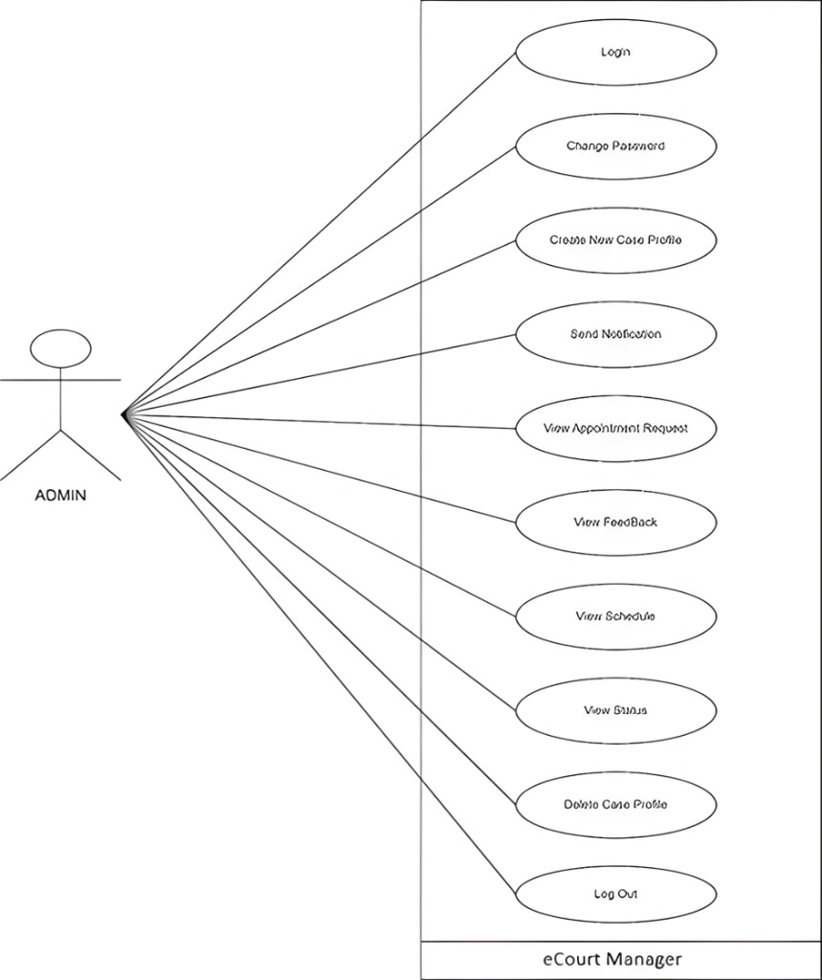

Staff:
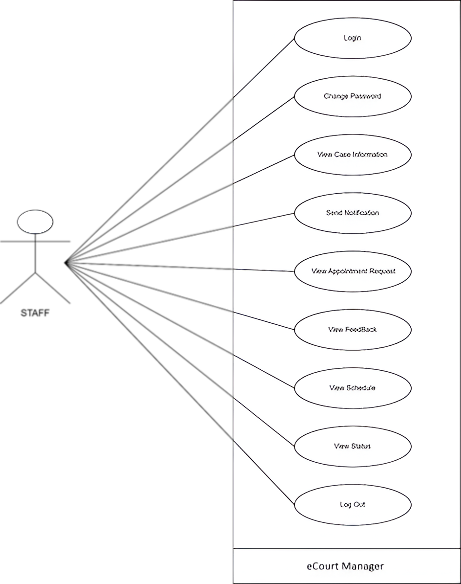

Client:
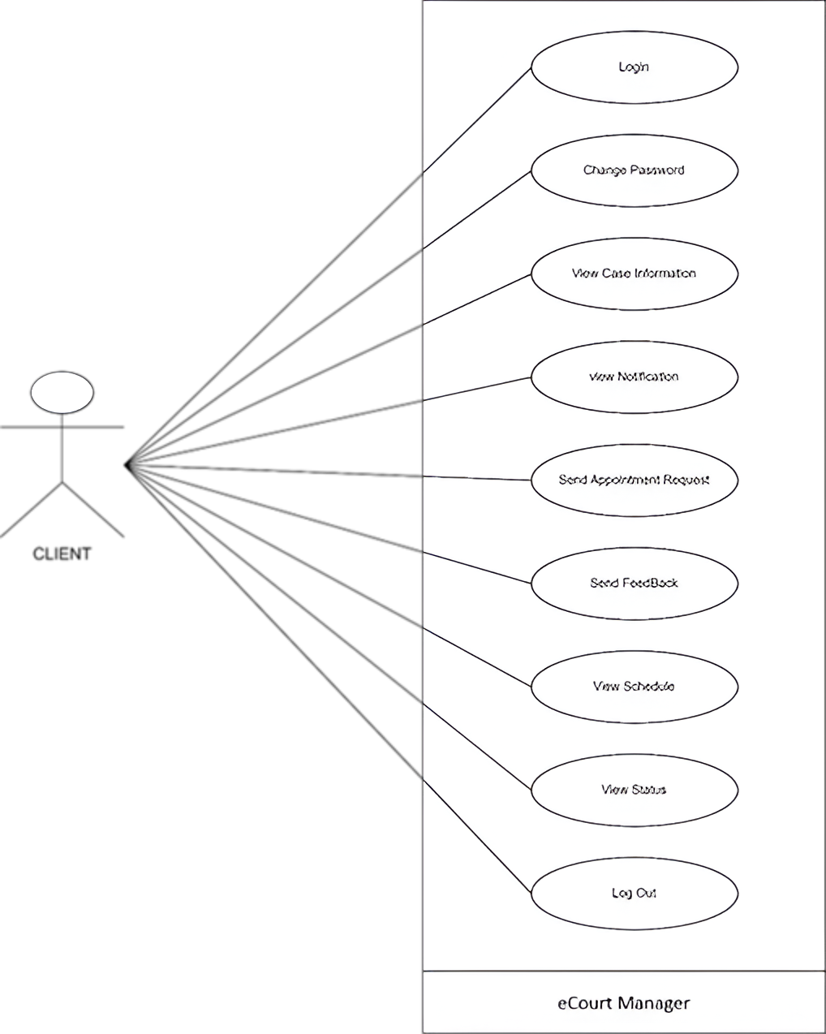

3.2 Flow Diagram
A System Flow Diagram, or flowchart, visually represents how data moves through a system and how decisions are made to control events. It is an effective way to visualize a complex process for a team.

SYMBOL OF SYSTEM FLOW DIAGRAM :-

Symbol | Name | Description
 | Terminator | The terminal or terminator represents the start or end points of a flowchart process.
 | Process | The process symbol is the most common component of a flowchart and indicates a step in the process.
 | Input/ Output | The input/output symbol represents the process of in- or outputting external data.
 | Decision | This symbol represents a decision you or your team need to make to get to the next step of the process.  Typically, it’s a true or false decision or a yes or no question that you need to answer.
 | Flowline | The flowline shows the process’s direction by connecting two blocks with one another.

Flow Diagram:

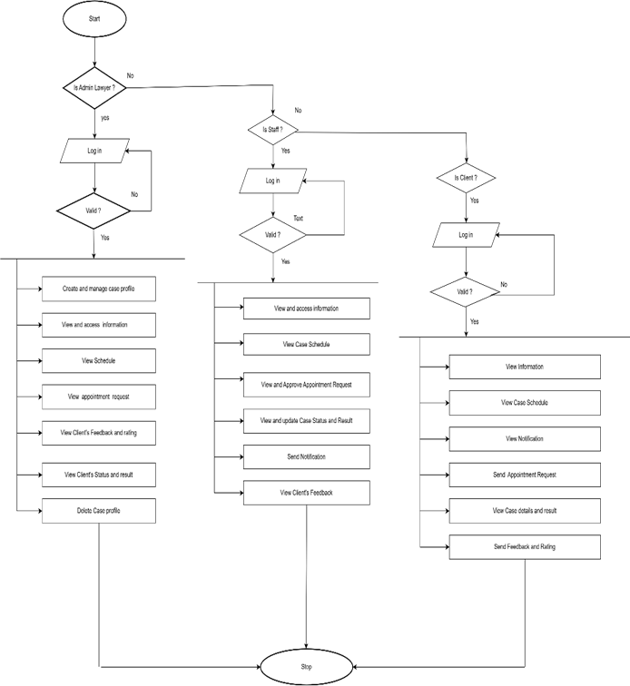

3.3 E-R Diagram
An Entity-Relationship (E-R) Diagram is a type of flowchart used in database design that illustrates how entities like people, objects, or concepts relate to each other within a system.

SYMBOL OF ENTITY ER DIAGRAM:-

Symbol | Name | Description
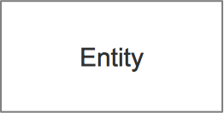 | Entities | Represents real-world objects or concepts in the database.  ExamplesSupplier, Manufacturer, Distributor,Retailer, and Customer.
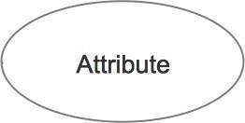 | Attributes | Attributes provide additional information about entities. Examples product attributes (e.g., name, price), customer attributes (e.g., name, address), etc.
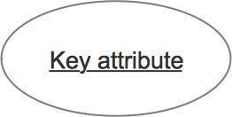 | Primary Key | Denotes the attribute within an entitythat uniquely identify instances of theentity. Typically underlines an attribute to indicate its importance.
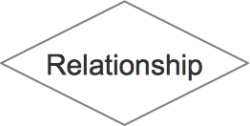 | Strong Relationships | A relationship where entity is existence-independent of other entities, and PK of Child doesn’t contain PK component of ParentEntity. A strong relationship is represented by a single rhombus  Manufacturing.
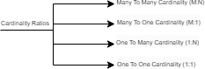 | Cardinality | Specifies the number of instances orrelationships between entities. Common notations include "1" (one), "M" (many), "0" (zero), and "N"  (avariable number).

ER Diagram:
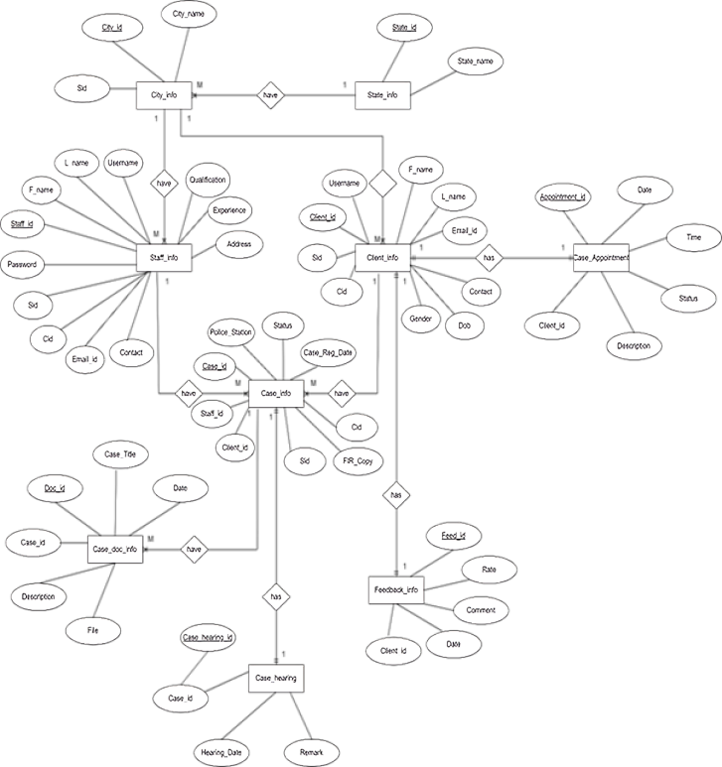
3.4 Class Diagram
A Class Diagram maps out the static structure of a system by modelling its classes, attributes, operations, and the relationships between objects. Since classes are the building blocks of objects, these diagrams are fundamental components of UML.

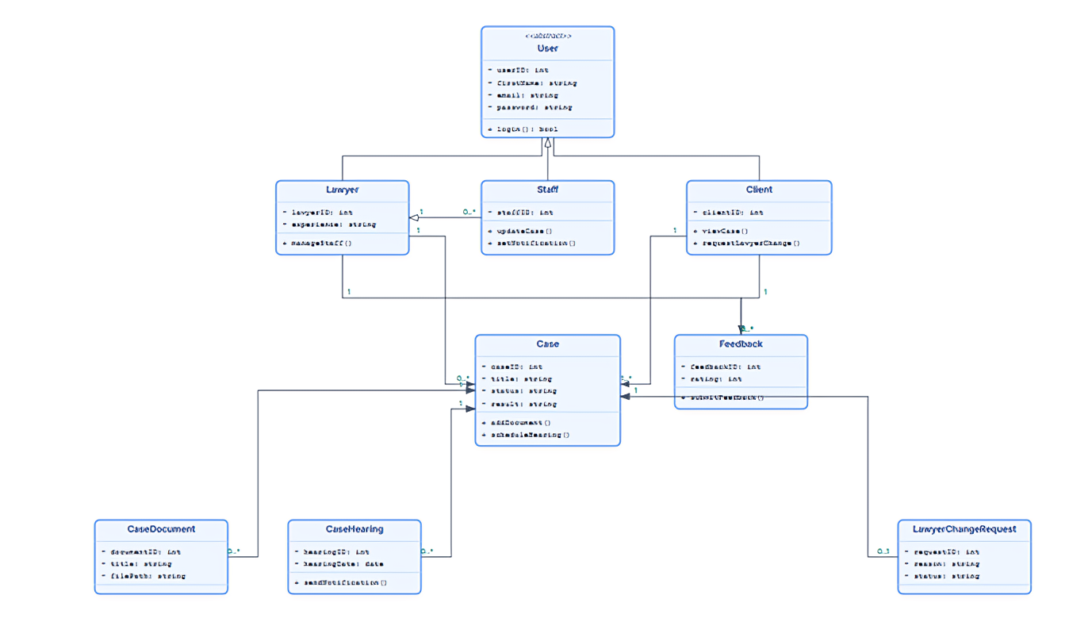
3.5 State Diagram
A State Diagram is a visual model that shows the different conditions, or states, an object can be in throughout its lifecycle. It illustrates how the object transitions from one state to another in response to specific events or triggers. Essentially, it provides a clear map of an object's dynamic behaviour from start to finish, making it ideal for designing event-driven systems.
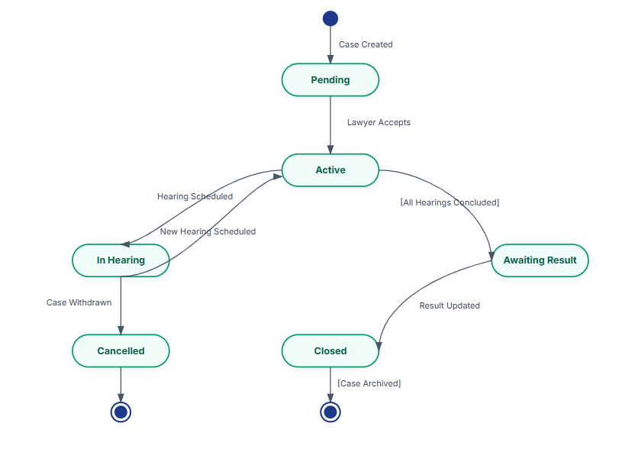
3.6 Sequence Diagram
A Sequence Diagram represents the details of a UML use case by illustrating how objects interact with each other in a sequential order over time. These diagrams can be useful references for businesses to understand interaction flows.

SYMBOL OF SEQUENCE DIAGRAM :-

Symbol | Name | Description
 | Actor Lifeline | Represents an external entity or actor interacting with the system. It typically symbolizes a user or an external system
 | Activation Bar | It indicating the period during which a participant is actively involved in the interaction.
 | Message Arrow | Arrow connecting two participants, indicating the flow of a message or communication between them.
 | Return Message | Represents the return of control or a response message from the receiver back to the sender, typically indicated  by a dashed line with a filled  arrowhead.
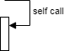 | Self-Message | A message sent from a participant to itself, often used to represent internal processing or method calls within the  same object or entity.
 | Object Destruction | An "X" or similar notation at the end of a lifeline, indicating the termination or destruction of an  object or participant.

Admin:
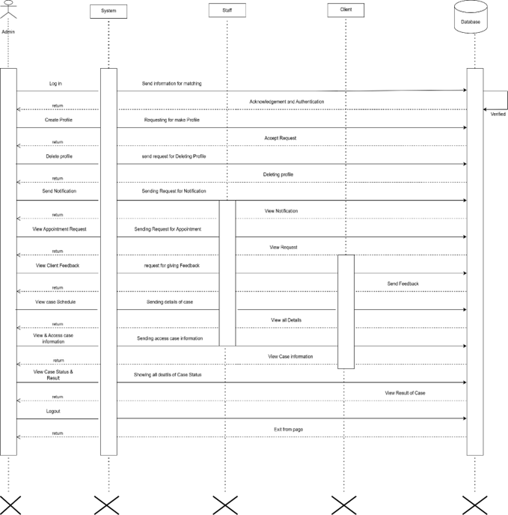

Staff:
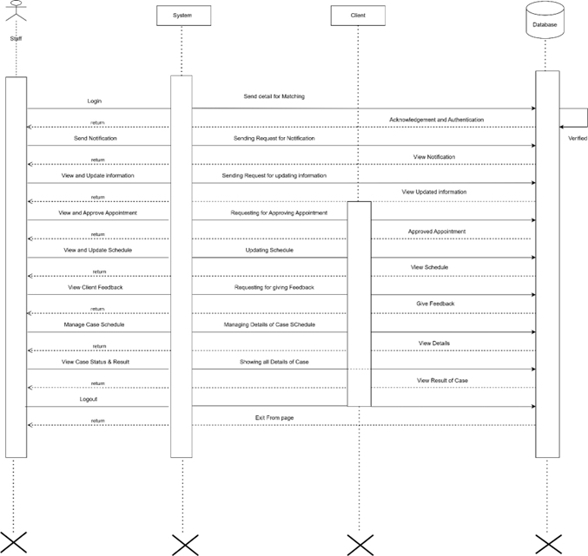

Client:
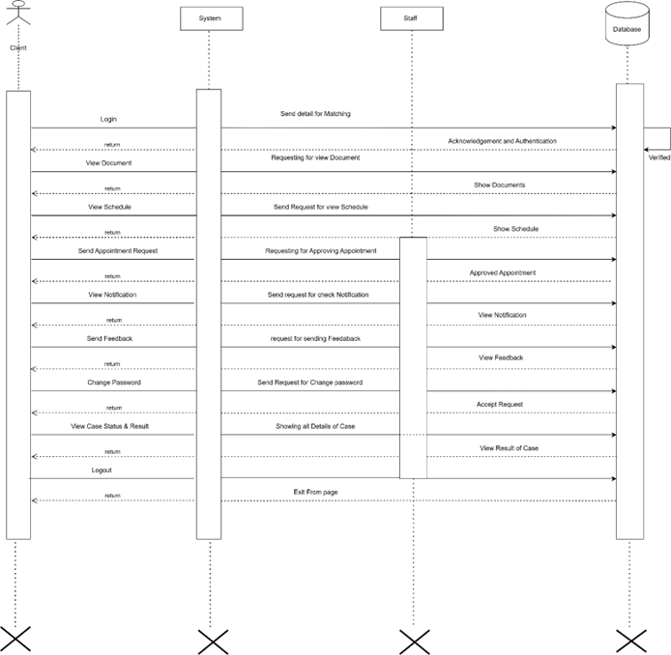

3.7 Activity Diagram
An Activity Diagram is essentially a flowchart that provides a graphical representation of a system's step-by-step activities and actions. It supports choices, iterations, and concurrent processes within a workflow.

SYMBOL OF ACTIVITY DIAGRAM :-

Symbol | Name | Description
 | Start symbol | Represents the beginning of a process or workflow in anactivity diagram. It can be used by itself or with a note symbol that explains the starting point.
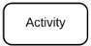 | Activity symbol | Indicates the activities that make up a modeled process.These symbols, which include short descriptions within the shape, are the main building blocks of an activity diagram
 | Connector symbol | Shows the directional flow, or control flow, of the activity. An incoming arrow starts a step of an activity, once the step is completed, the flow continues with theoutgoing arrow
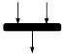 | Joint symbol/ Synchronization bar | Combines two concurrent activities and reintroduces them to a flow where only one activity occurs at a time.  Represented with a thick vertical or horizontal line.
 | Decision symbol | Represents a decision and always has at least two paths branching out with condition text to allow users to view options. This symbol represents the branching or mergingof various flows with the symbol acting as a frame or container
 | End symbol | Marks the end state of an activity and represents thecompletion of all flows of a process.

Admin:
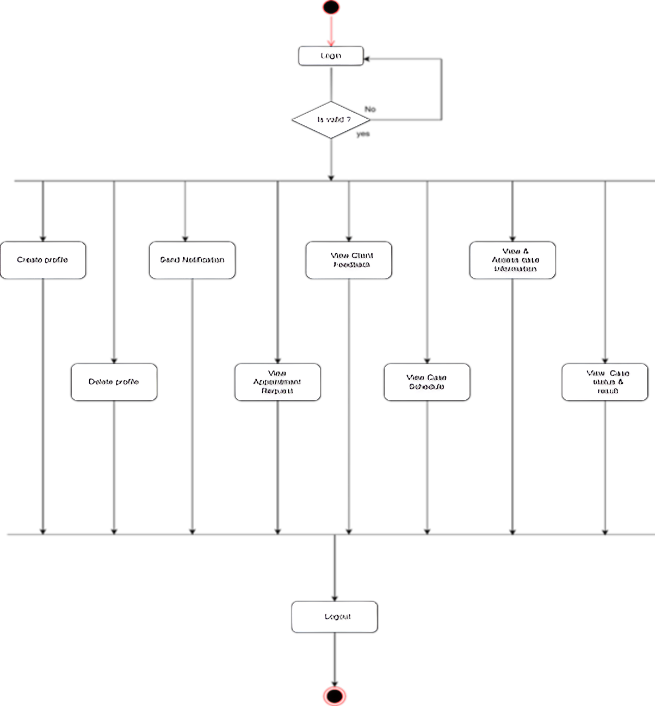

Staff:
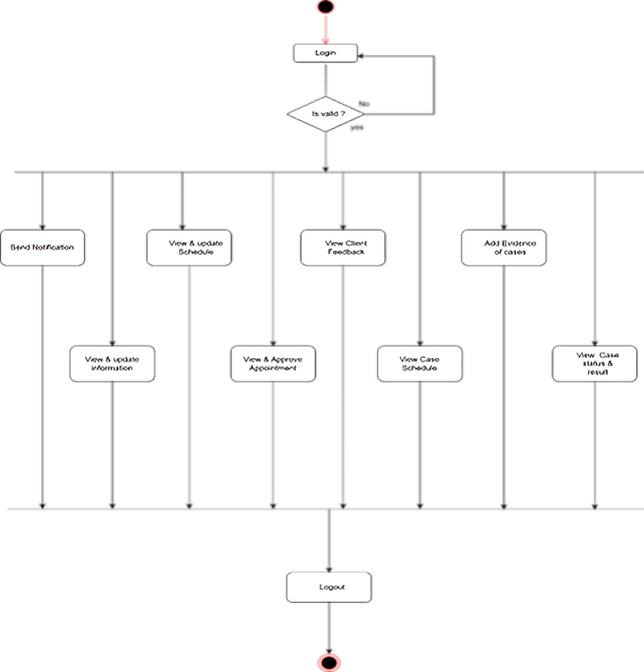

Client:
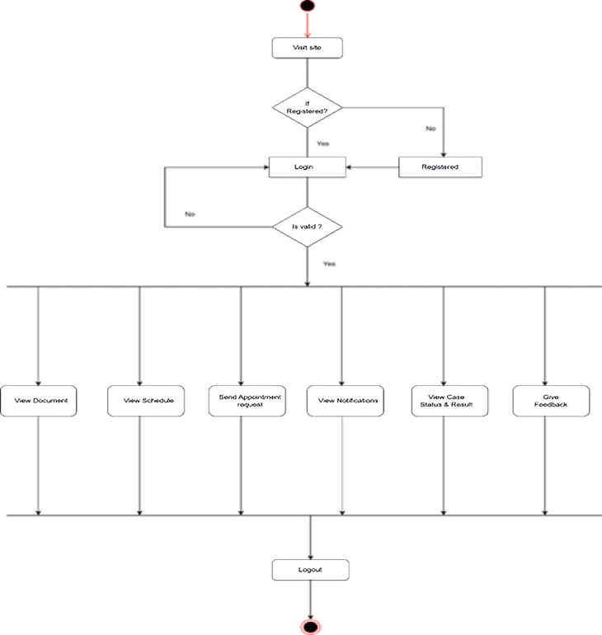
3.8 Data Dictionary
A Data Dictionary is a centralized repository of information about data, such as tables and their fields. It defines the data elements, including their names, data types, constraints, and descriptions, providing a blueprint for the database.

State info:

No | Field_name | Datatype | constraint | Description
1 | State_id | Int(11) | Primary key | State id
2 | State_name | Varchar(30) | Not null | State name

City info:

No | Field_name | datatype | constraint | Description
1 | City_id | Int(11) | Primary key | City id
2 | City_name | Varchar(30) | Not null | City name
3 | sid | int(11) | Foreign key | Foreign key  from state table
Staf f info:

No | Field_Name | DataType | Constraint | Description
1 | Staff_id | Int(11) | Primary key | Staff id
2 | Username | Varchar(30) | Not null | Username
3 | Password | Varchar(30) | Not null | Password
4 | F_name | Varchar(20) | Not null | First name
5 | L_name | Varchar(20) | Not null | Last name
6 | Email | Varchar(30) | Not null | Email
7 | Contact | bigInt | Unique | Contact  number
8 | Qualification | Varchar(20) | Not null | Qualificatio  n
9 | Experience | Varchar(20) | Not null | Experience
10 | Date_of_reg | Date | Not null | Registeratio  n Date
11 | Address | Text | Not null | Address
12 | Sid | Int(11) | Foreign Key | Foreign key from state  table
13 | Cid | Int(11) | Foreign Key | Foreign key from city  table
14 | Gender | Varchar(10) | Not null | Admin  gender
15 | Photo | Varchar(255) | Not null | Photo
16 | Age | Int(3) | Not null | Admin age
17 | Dob | Date | Not null | Birth date
Client info:

No | Field_Name | DataType | Constraint | Description
1 | Client_id | Int(11) | Primary key | client id
2 | Username | Varchar(30) | Not null | Username
3 | Password | Varchar(30) | Not null | Password
4 | F_name | Varchar(20) | Not null | First name
5 | L_name | Varchar(20) | Not null | Last name
6 | Email | Varchar(30) | Not null | Email
7 | Contact | bigInt | Unique | Contact  number
8 | Qualification | Varchar(20) | Not null | Qualificatio  n
9 | Experience | Varchar(20) | Not null | Experience
10 | Date_of_reg | Date | Not null | Registeratio  n Date
11 | Address | Text | Not null | Address
12 | Sid | Int(11) | Foreign Key | Foreign key  from state table
13 | Cid | Int(11) | Foreign Key | Foreign key from city  table
14 | Gender | Varchar(10) | Not null | Admin  gender
15 | Photo | Varchar(255) | Not null | Photo
16 | Age | Int(3) | Not null | Admin age
17 | Dob | Date | Not null | Birth date
Case info:

No | Field_name | Datatype | Constraint | Description
1 | Case_id | Int(11) | Primary key | Case id
2 | Case_title | Varchar(30) | Not null | Case title
3 | description | Text | Not nulll | Case  description
4 | FIR_copy | Varchar(100) | Not null | Fir copy
5 | Police station | Varchar(100) | Not null | Police  station
6 | Staff_id | Int(11) | Foreign key | Staff id
7 | Client_id | Int(11) | Foreign key | Client id
8 | Case_type | Varchar(50) | Not null | Case type
9 | Case_reg_date | Date | Not null | Case  Register date
10 | Status | Varchar(10) | Not null | Status
11 | Result | Varchar(10) | Not null | Result
12 | Sid | Int(11) | Foreign key | Foreign key from state  table
13 | Cid | Int(11) | Foreign key | Foreign key from city  table
Case Documents info:

No. | Field_Name | Data Type | Constraint | Description
1 | Doc_id | Int(11) | Primary Key | Doc id
2 | Case_id | Int(11) | Foreign Key | Case id
3 | Case_title | Varchar(30) | Not Null | Title of case
4 | Description | Text | Not Null | Description of  case
5 | File | Varchar(255) | Not Null | Files
6 | date | date | Not null | Date

Case Hearing info:

No | Field_name | Data_types | Constraint | Description
1 | Case_hearing_id | Int(11) | Primary key | Case_hearing_  id
2 | Case_id | Int(11) | Foreign key | Case_id
3 | Hearing_date | date | Not null | Hearing date
4 | Remarks | Varchar(30) | Not null | Remarks
Case Appointment info:

No | Field_name | Data_types | Constraint | Description
1 | Appointment_  id | Int(11) | Primary key | Appointmen  t id
2 | Date | Date | Not Null | Date
3 | Time | Time | Not Null | Time
4 | Client_id | Int(11) | Foreign key | Client id
5 | Status | Varchar(50) | Not null | Status
6 | Description | Text(50) | Not Null | Description

Inquiry info:

No | Field_name | Data_types | Constraint | Description
1 | Inquiry_id | Int(11) | Primary key | Inquiry id
2 | Inquiry_name | Varchar(30) | Not null | Inquiry name
3 | Email_id | Varchar(30) | Not null | Email id
4 | Contact | Bigint | Not null | Contact
5 | Message | Text | Not null | Message
6 | date | date | Not null | date
Feedback info:

No | Field_name | Data_type | Contraint | Description
1 | Feed_id | Int(11) | Primary Key | Feedback id
2 | Rating | Int(11) | Not Null | Rating
3 | Date | Date | Not Null | Date
4 | comment | Varchar(30) | Not Null | Comment
5 | Client_id | Int(11) | Foreign Key | Client id

4. Development Methodology

The development of the eCourt application follows an Agile, Iterative Software Development methodology tailored to modern web technologies, specifically leveraging the MERN stack (MongoDB, Express.js, React.js, and Node.js). This approach emphasizes rapid delivery of functional software, adaptability to requirement changes, and continuous stakeholder feedback.

Agile Iterative Process:-
The Agile methodology breaks down project development into a series of short iterations (sprints), each encompassing requirements analysis, design, implementation, and testing. At the end of every iteration, a working portion of the eCourt application is delivered, reviewed, and assessed with end-users and stakeholders. Feedback is systematically integrated into subsequent iterations, ensuring the solution evolves in line with real-world legal practice and user needs.

Steps in the Development Lifecycle
- Requirement Gathering & Prioritization:
Stakeholder surveys and interviews are conducted to identify key functionalities. The product backlog is prioritized to ensure the most critical features are addressed first.
- Design & Planning:
Each sprint begins with planning meetings where the team defines the scope and design of upcoming features, ensuring each increment aligns with the overall system architecture and user experience expectations.
- Incremental Development (MERN Stack):
  - Frontend: React.js is used to build a responsive, performant, and intuitive user interface.
  - Backend: Node.js and Express.js provide a robust API layer, connecting seamlessly to the frontend while ensuring scalable business logic and secure endpoints.
  - Database: MongoDB serves as the flexible, high-performance data store, allowing rapid modeling of legal entities such as cases, clients, staff, and notifications.
Sprints focus on discrete features—such as authentication, case management, document uploads, and notification systems—allowing efficient tracking and modular progress.
- Continuous Testing & Integration:
Automated tests and manual reviews are performed at each stage of development. Continuous integration ensures new code merges do not break existing functionality and deployments are rapidly tested in staging environments.
- User Review & Adaptation:
Stakeholders regularly interact with the latest build of eCourt, providing iterative feedback. Developers quickly adapt features, interfaces, and workflows to maximize usability and satisfaction.
- Documentation & Versioning:
Throughout development, thorough documentation of APIs, business logic, and workflows is maintained. Version control with Git ensures full traceability and facilitates streamlined collaboration within the development team.

Advantages of This Methodology
- Flexibility: Responds swiftly to changing requirements.
- Transparency: Stakeholders see ongoing progress with frequent demonstration of working features.
- Risk Reduction: Problems are identified and corrected promptly due to rapid feedback cycles.
- Quality Focus: Regular testing ensures robustness, reliability, and a user-focused product.

Conclusion
By using an Agile, Iterative approach with the MERN stack, the eCourt application can efficiently evolve from a minimum viable product (MVP) to a robust, feature-rich platform, closely aligned with legal professionals’ and clients’ expectations and the dynamic needs of digital court management.

5. Future Scope

The eCourt platform is architected on the MERN stack, prioritizing scalability and adaptability for ongoing innovation in legal technology. The future scope of the project reflects both immediate enhancements and long-term possibilities, ensuring the system remains relevant and impactful for legal professionals, clients, and institutions.

1. Mobile App Integration
Expansion to native Android and iOS applications is planned to provide lawyers, staff, and clients with instant, secure access to case information, documents, and notifications from any location. Mobile apps will allow real-time communication and push notifications, streamlining operational efficiency outside traditional office settings.

2. Digital Transactions and Payments
Development of online payment modules will facilitate secure fee payments, settlements, and other financial transactions directly through the platform. Integration with leading payment gateways will automate billing and receipts, reducing administrative burden and improving transparency.

3. AI and Automation
Introducing artificial intelligence and machine learning features—such as automated scheduling, document categorization, and intelligent reminders—will enhance efficiency and accuracy. Predictive analytics can support case progress forecasting and workload management for lawyers and administrators.

4. Integration with External Legal Systems
The platform’s modular design allows for future integration with government, judicial, and law enforcement databases. This will enable real-time data exchange, automated updates, and streamlined procedures to meet legal and regulatory requirements efficiently.

5. Advanced Reporting and Analytics
eCourt will provide dynamic dashboards, custom reporting tools, and analytics for tracking case performance, workflow optimization, and compliance. Stakeholders will benefit from actionable insights to inform strategic decisions.

6. Enhanced Security and Privacy
Continued investment in security—such as multi-factor authentication, role-based access control, advanced encryption, and audit logs—will ensure sensitive legal data remains protected against emerging threats.

7. Multilingual and Accessibility Features
To serve a broader user base, future versions will support multiple languages and advanced accessibility, ensuring the platform is inclusive for users from diverse regions and abilities.

8. Modular Customizations
Law firms and institutions will be able to customize workflows, notifications, and user roles as per organizational needs, supporting both small practices and large legal enterprises.

6. Conclusion Limitation
Conclusion
The eCourt application, developed using the MERN stack and an iterative Agile methodology, has successfully addressed core challenges in legal case management through robust technical solutions and user-centered design. By centralizing workflows for lawyers, clients, staff, and administrators, the platform offers secure user authentication, streamlined case management, real-time notifications, and intuitive document handling. Regular stakeholder feedback in every development iteration resulted in features that are practical and relevant for real-world usage. The project demonstrates scalability, reliability, and maintainability, positioning eCourt as a valuable asset for legal professionals and institutions committed to digital transformation.
Key Achievements
- Delivered a modular, scalable system that adapts well to changing user needs.
- Ensured secure handling of sensitive legal data and compliant workflows.
- Built with extensibility in mind, allowing for future upgrades and integrations.
- Provided an intuitive, accessible interface for a diverse user base.

Limitations
Despite its strengths, the current version of eCourt has some inherent limitations:
- Partial Automation: Certain workflow steps and notifications still require manual action, limiting full end-to-end automation.
- Feature Gaps: Advanced capabilities such as integrated payment processing, AI-driven analytics, and deep third-party integrations are outlined for future enhancement but are not active in the MVP.
- Device and Platform Support: While the web application is cross-platform, fully optimized mobile experiences and native apps are pending development.
- User Interface Improvements: The present UI is functional but can benefit from further refinement for enhanced usability, aesthetics, and accessibility.
- Limited Real-World Testing: Wider deployment and testing across multiple legal organizations will be required to uncover edge cases and optimize further.

- Bibliography
Books:-
- Chodorow, Kristina. MongoDB: The Definitive Guide. 3rd Edition. O’Reilly Media, 2019.
Comprehensive resource for modeling, storing, and managing data in MERN applications.
- Elliott, Eric. Programming JavaScript Applications: Robust Web Architecture with Node, HTML5, and Modern JS Libraries. O’Reilly Media, 2014.
In-depth practical guide for scalable JavaScript applications using Node.js and React.
- Fowler, Martin. Patterns of Enterprise Application Architecture. Addison-Wesley, 2003.
Frameworks and patterns foundational to designing scalable, maintainable systems.
- Martin, Robert C. Clean Code: A Handbook of Agile Software Craftsmanship. Prentice Hall, 2008.
Principles for writing clear, maintainable, and robust code, crucial for collaborative projects and agile teams.

Academic Papers:-

- Beck, Kent et al. “Manifesto for Agile Software Development.” Agile Alliance, 2001.
Establishes principles for agile, iterative development and continuous delivery.
(https://agilemanifesto.org/)

Official Documentation & Technical References:-
- React Documentation, Meta. https://react.dev/
Official ReactJS reference for component-based web interface development.
- Express.js Documentation. https://expressjs.com/
Core backend framework documentation for RESTful API design in Node.js.
- Mongoose ODM. https://mongoosejs.com/
Standard reference for object data modeling between Node.js and MongoDB.
- MDN Web Docs. Mozilla Foundation. https://developer.mozilla.org/
Definitive guide for JavaScript, HTML, CSS, and modern browser APIs.
- Tailwind CSS Documentation. https://tailwindcss.com/
Official documentation for Tailwind CSS, a utility-first CSS framework
used for modern, responsive UI design.

Legal Technology & Industry Insights
- Ambrogi, Robert. “LawSites Blog.” https://www.lawnext.com/
Tracks the latest trends and developments in legal technology.
- Law Technology Today. https://lawtechnologytoday.org/
Industry articles on the intersection of law and software automation.

Tutorials & Practical Resources
- W3Schools Online Web Tutorials. https://www.w3schools.com/
Practical guides and hands-on examples for core web development skills.

