Phase 1: Wireframes

Ayaz Bhutta, Amir Sayed, and Giovanni Rossi

**Home Page:**

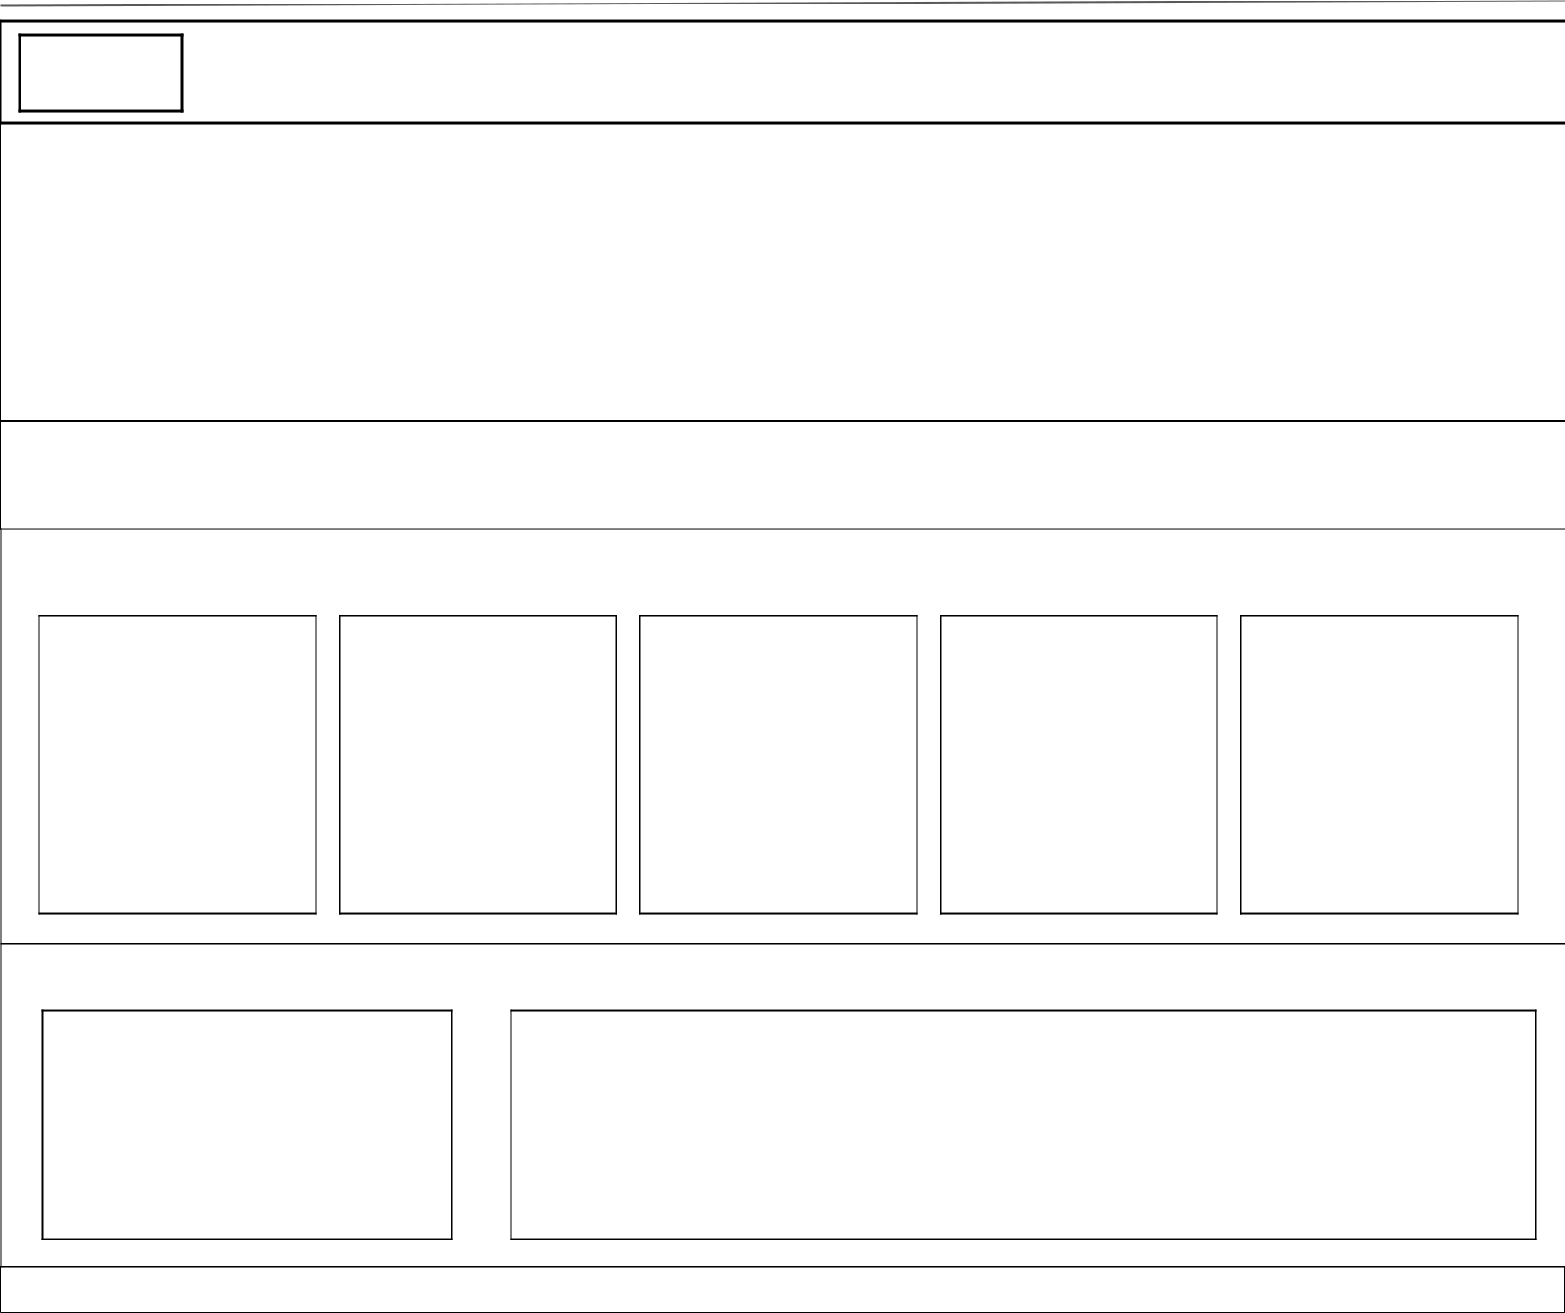

LOGO

|  |  |  |  |  |  |  |  |  |
| --- | --- | --- | --- | --- | --- | --- | --- | --- |
| Page 1 |  | Page 2 |  | Page 3 |  | Page 4 |  | Cart |
|  |  |  |  |  |  |  |  |  |

**Hero Image (Header)**

**Motivational Quote**

**Featured Products:**

#1

#2

#3

#4–

#5

**Featured Video:**

Video

Video Description:

Lorem ipsum dolor sit amet, consectetur adipiscing elit, sed do eiusmod tempor incididunt ut labore et dolore magna aliqua. Ut enim ad minim veniam, quis nostrud exercitation ullamco laboris nisi ut aliquip ex ea commodo consequat.

**Footer**

**Products Page/Marketplace:**

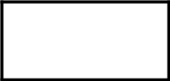

LOGO

Page 1

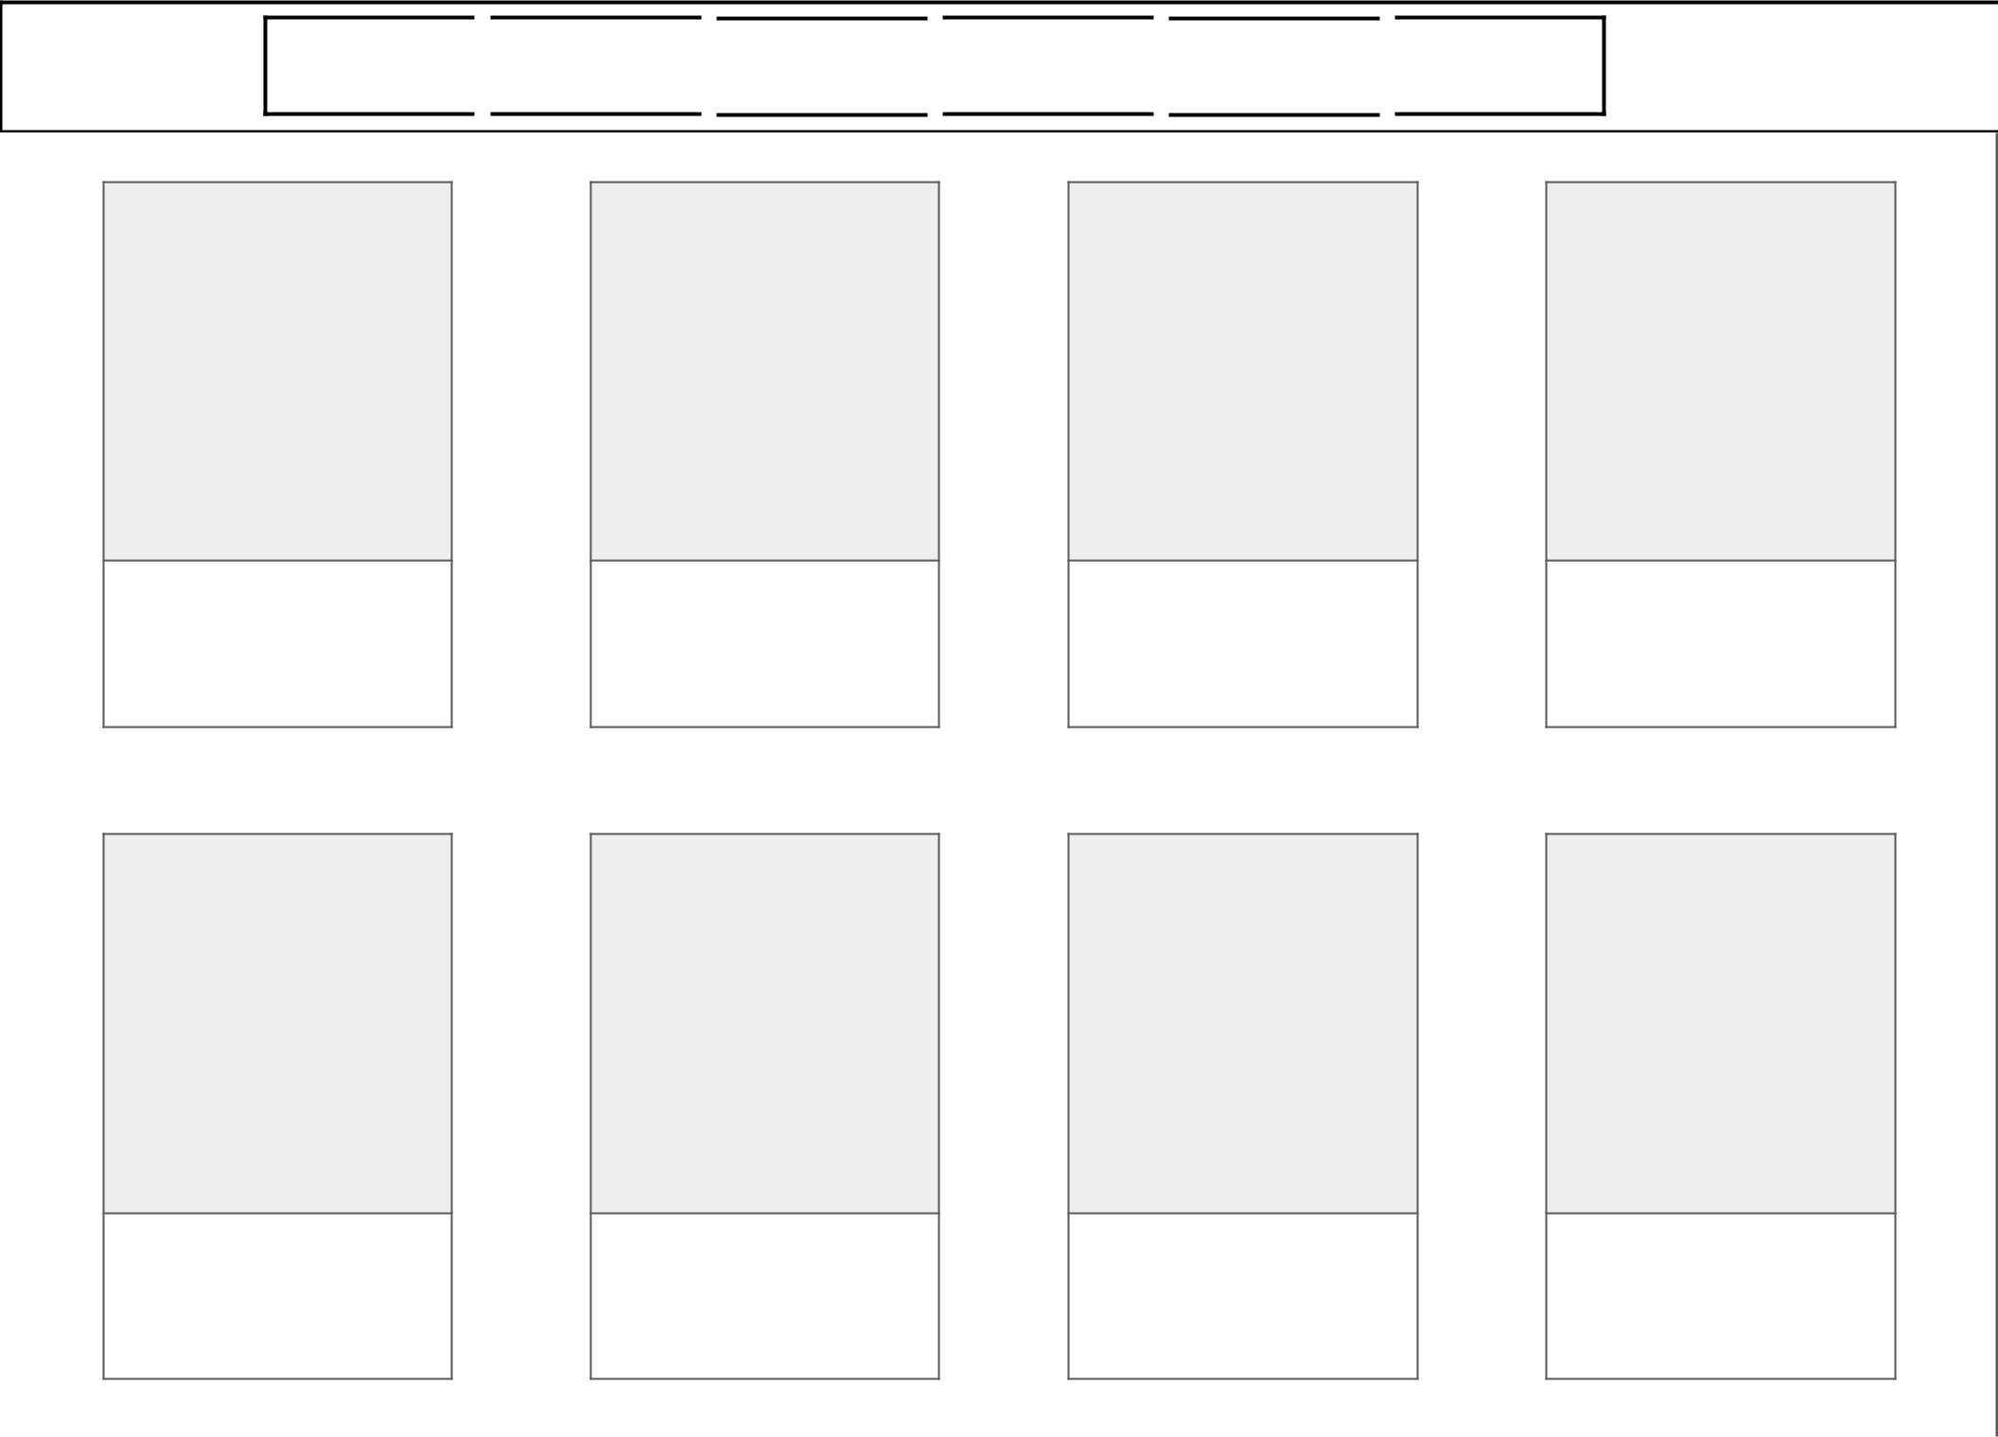

Page 2

Page 3

Page 4

Cart

Category  Category  Category  Category  Category  Category

Product image

Product image

Product image

Product image

Product description

Product description

Product description

Product description

Product image

Product image

Product image

Product image

Product description

Product description

Product description

Product description



**Footer**

**Products Page/Marketplace Category Dropdowns:**

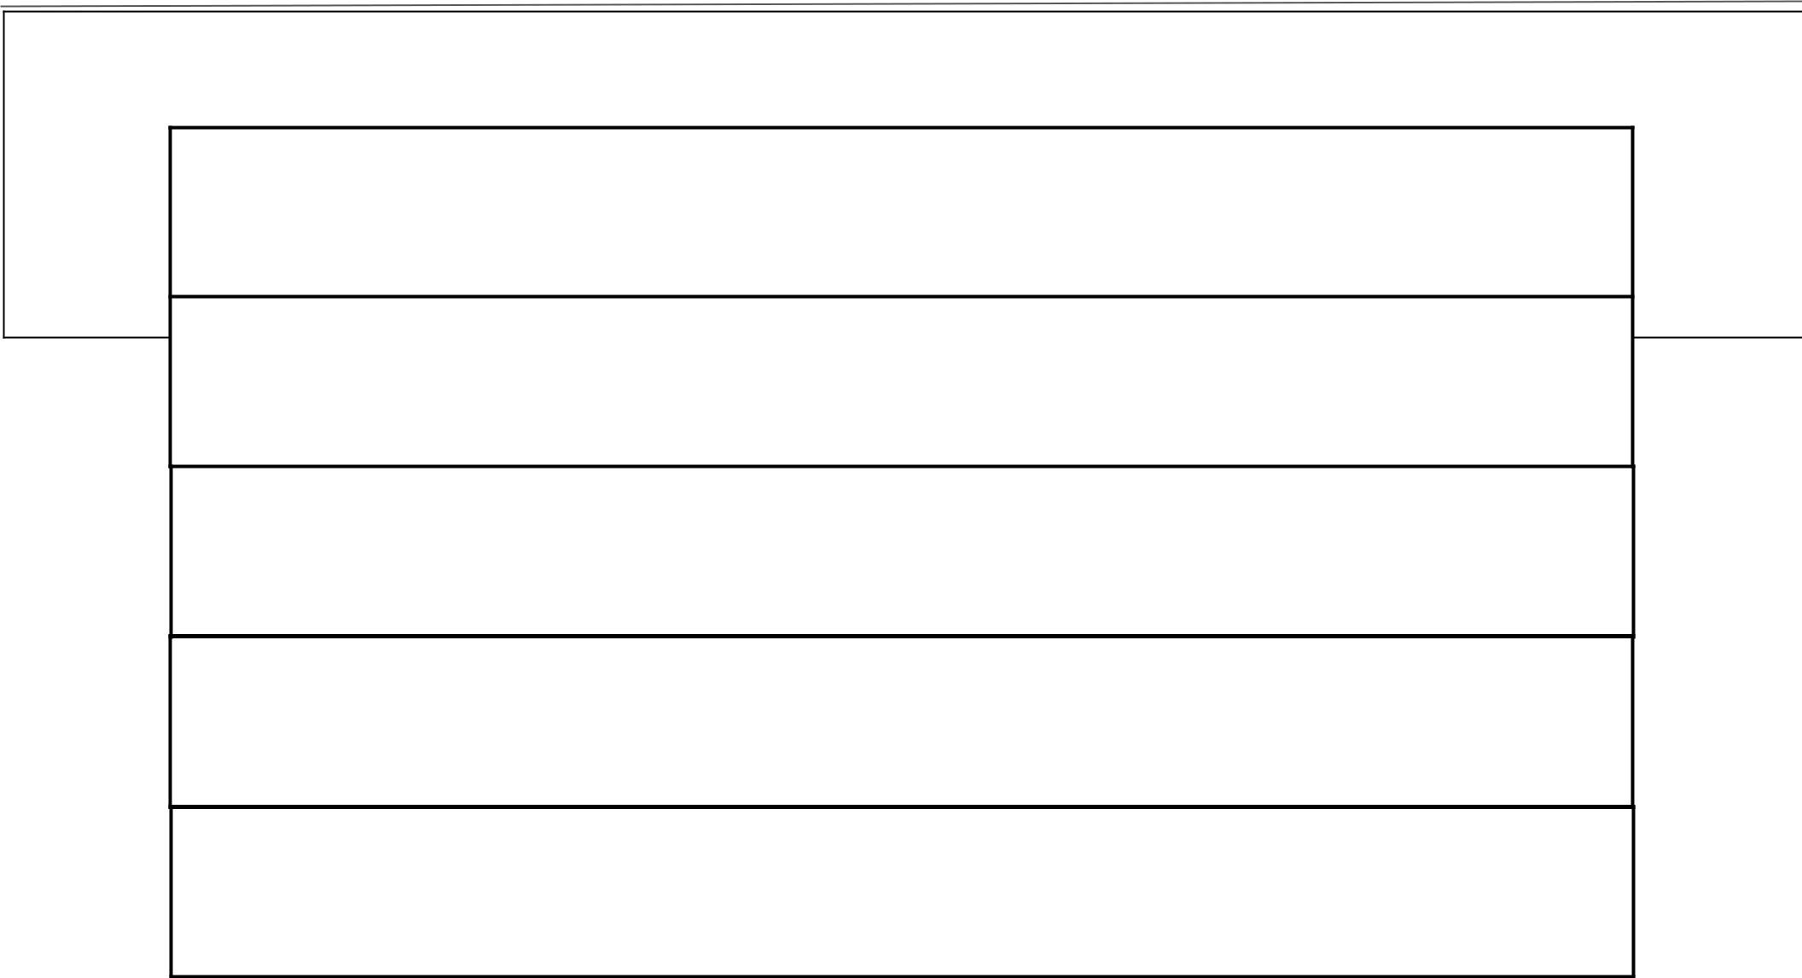

**Category**

**Tennis Rackets**

**Tennis Balls**

**Tennis Bags**

**Water Bottles**

**Apparel**

**Tennis Training/Video Page:**

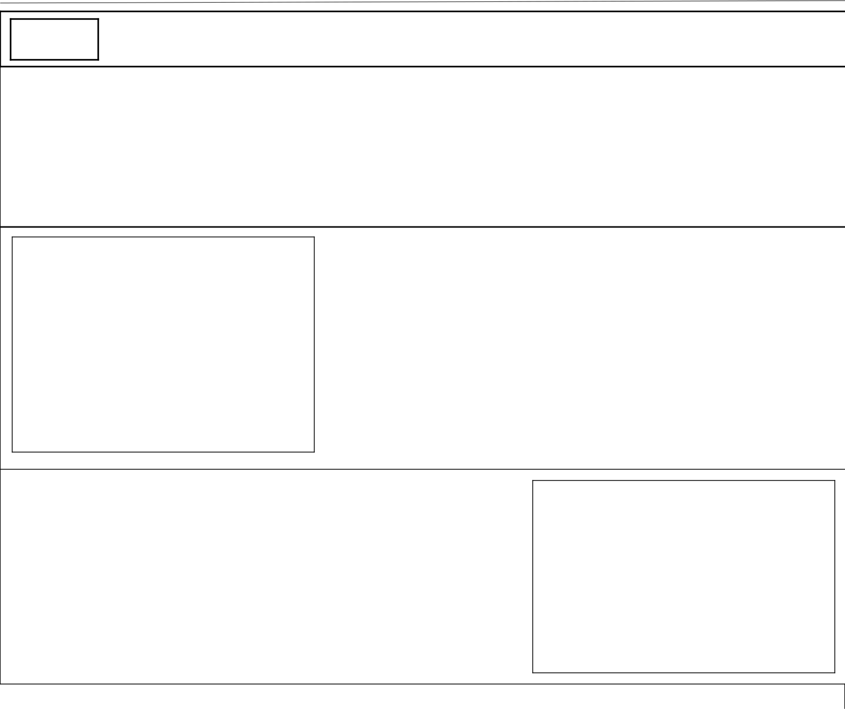

LOGO

|  |  |  |  |  |  |  |  |  |
| --- | --- | --- | --- | --- | --- | --- | --- | --- |
| Page 1 |  | Page 2 |  | Page 3 |  | Page 4 |  | Cart |
|  |  |  |  |  |  |  |  |  |

**Hero Image (Header)**

**Video**

**Video Description**

**Tips and Tricks**

**Video**

**Footer**

**Calculators (Calories Burned):**

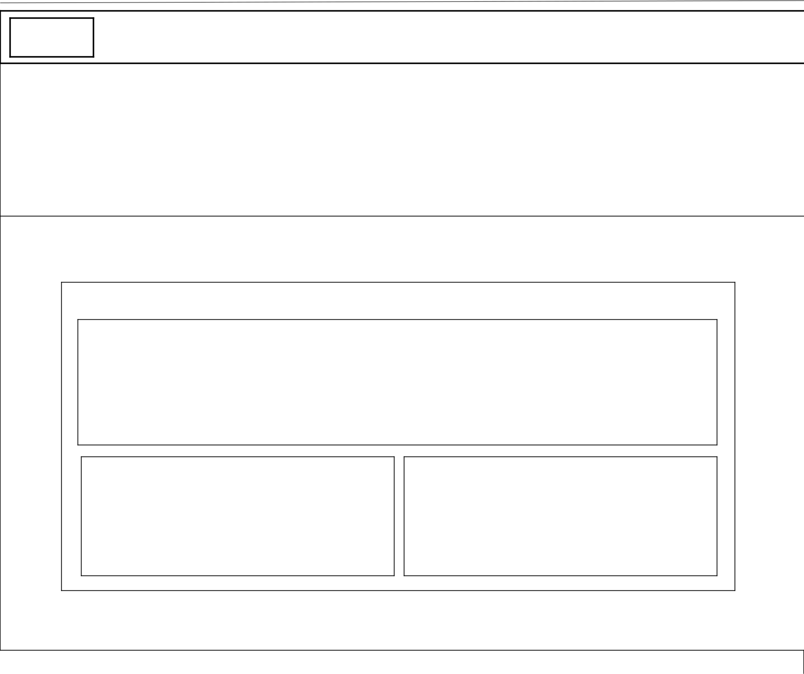

LOGO

|  |  |  |  |  |  |  |  |  |
| --- | --- | --- | --- | --- | --- | --- | --- | --- |
| Page 1 |  | Page 2 |  | Page 3 |  | Page 4 |  | Cart |
|  |  |  |  |  |  |  |  |  |

**Hero Image (Header)**

**Calculator Div**

**Calculator UI**

**Output**

**Inputs**

**Buttons**

**Footer**

**About Page:**

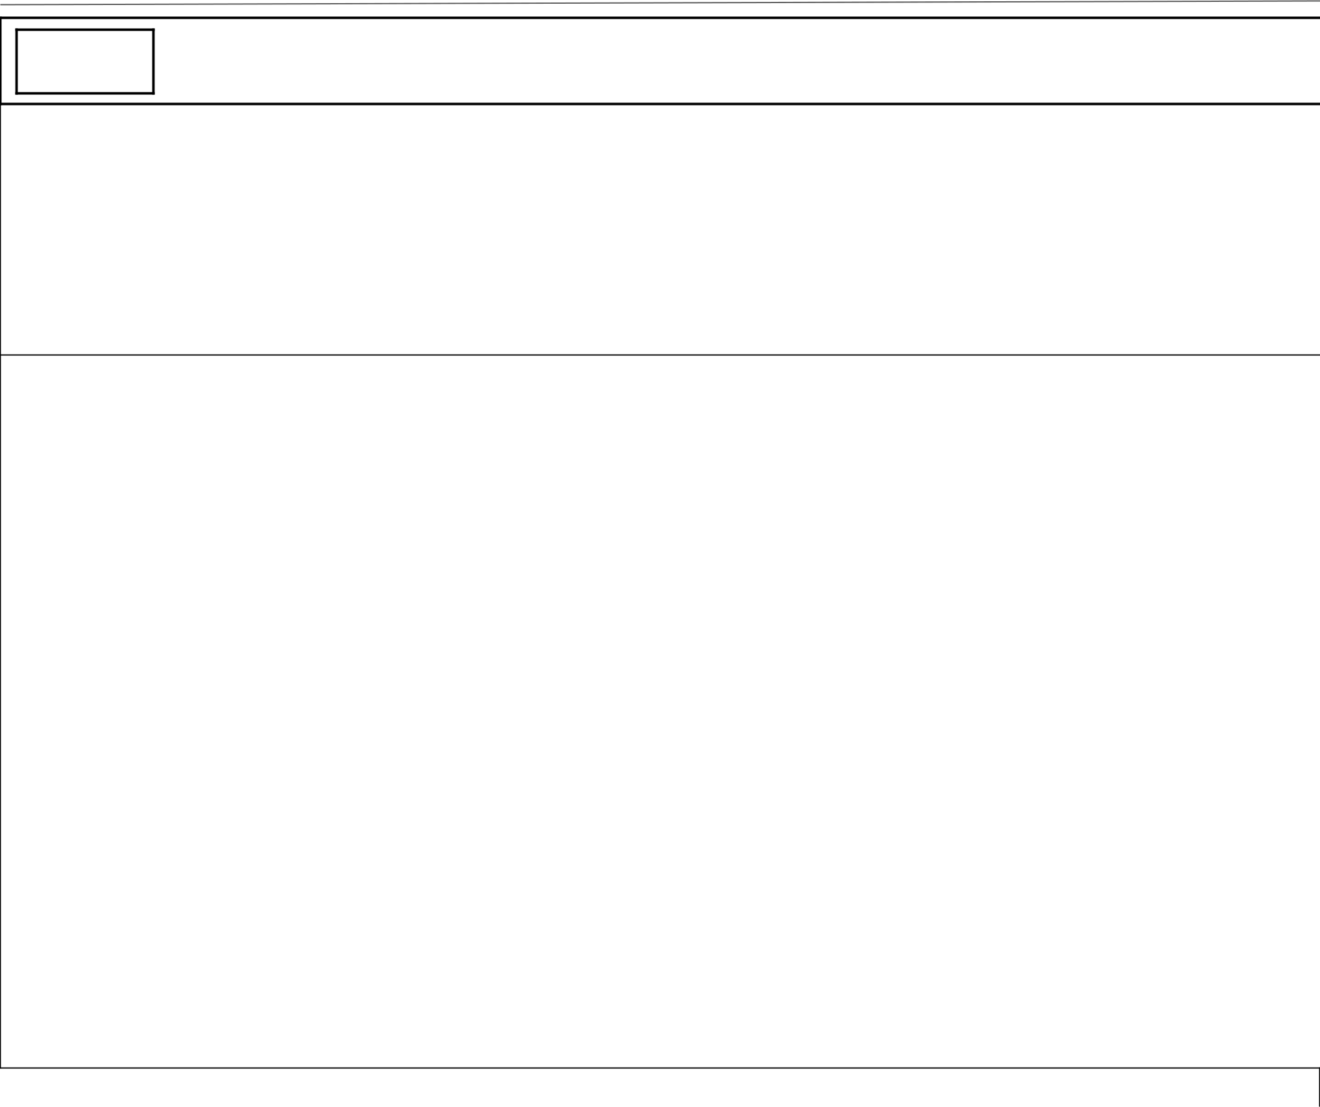

LOGO

|  |  |  |  |  |  |  |  |  |
| --- | --- | --- | --- | --- | --- | --- | --- | --- |
| Page 1 |  | Page 2 |  | Page 3 |  | Page 4 |  | Cart |
|  |  |  |  |  |  |  |  |  |

**Hero Image (Header)**

**About the Company - Description**

Lorem ipsum dolor sit amet, consectetur adipiscing elit, sed do eiusmod tempor incididunt ut labore et dolore magna aliqua. Ut enim ad minim veniam, quis nostrud exercitation ullamco laboris nisi ut aliquip ex ea commodo consequat. Lorem ipsum dolor sit amet,

consectetur adipiscing elit, sed do eiusmod tempor incididunt ut labore et dolore magna aliqua. Ut enim ad minim veniam, quis nostrud exercitation ullamco laboris nisi ut aliquip ex ea commodo consequat. Lorem ipsum dolor sit amet, consectetur adipiscing elit, sed do eiusmod tempor incididunt ut labore et dolore magna aliqua. Ut enim ad minim veniam, quis nostrud exercitation ullamco laboris nisi ut aliquip ex ea commodo consequat. Lorem ipsum dolor sit amet, consectetur adipiscing elit, sed do eiusmod tempor incididunt ut labore et dolore magna aliqua. Ut enim ad minim veniam, quis nostrud exercitation ullamco laboris nisi ut aliquip ex ea commodo consequat.

**Footer**

**Order Summary Page:**



LOGO



Order Summary

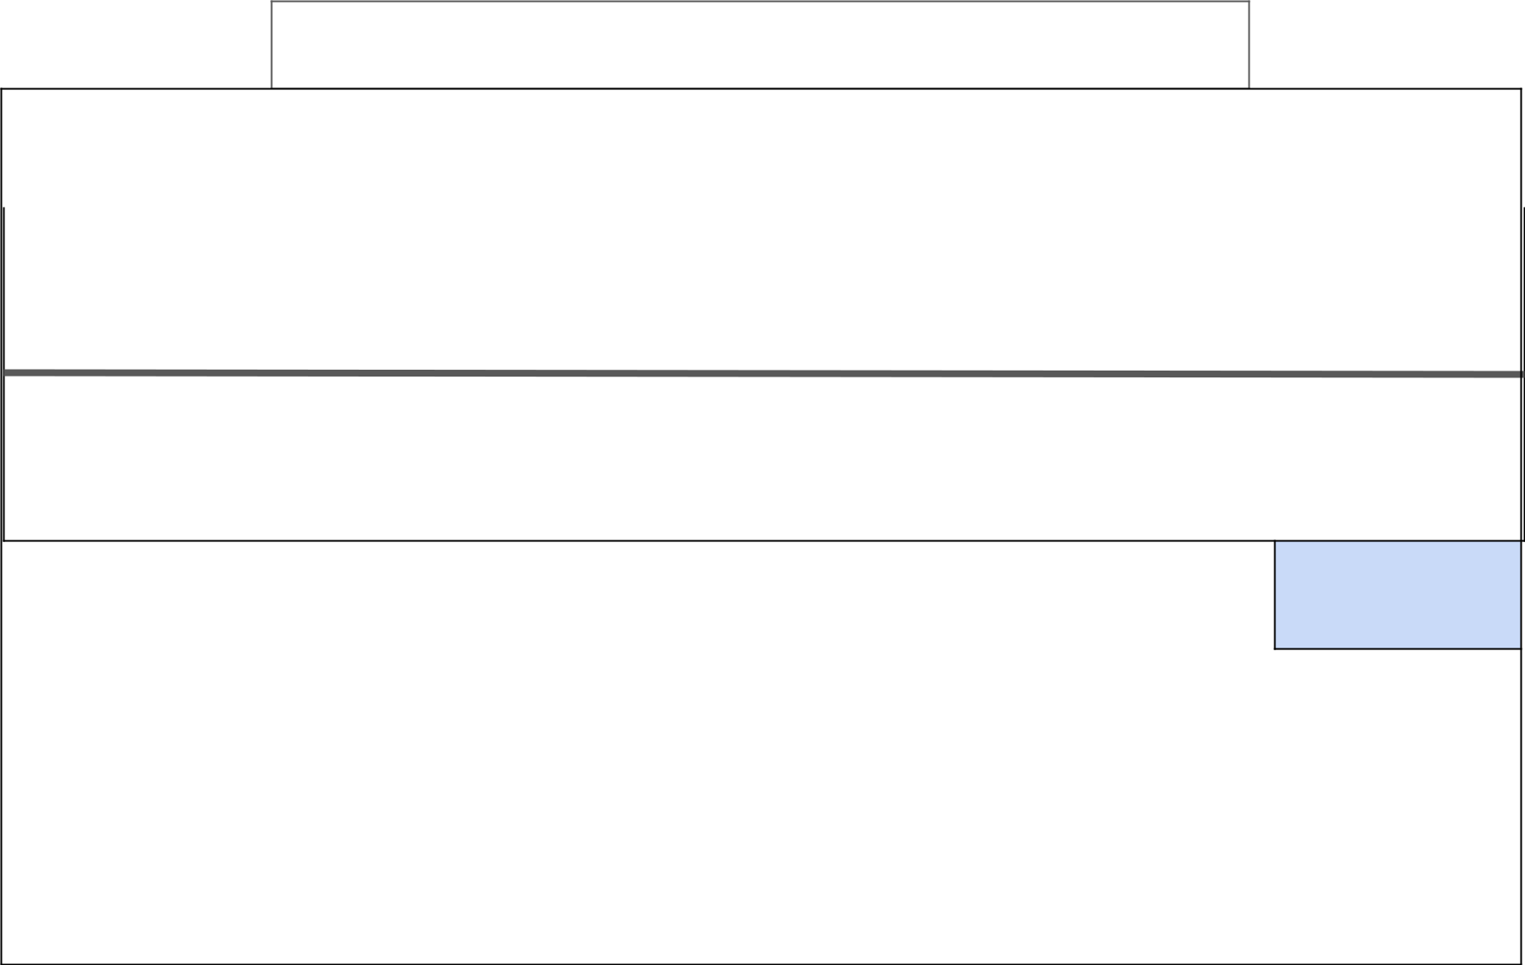

Please take a moment to review your order

|  |  |  |  |
| --- | --- | --- | --- |
| Item Description | Quantity | Price |  |
|  |  |  |  |
| Item A | 1 | $200 |  |
| Item B | 2 | $100 |  |

|  |  |
| --- | --- |
| Order Total | $400 |

Order

**How the Pages Connect:**

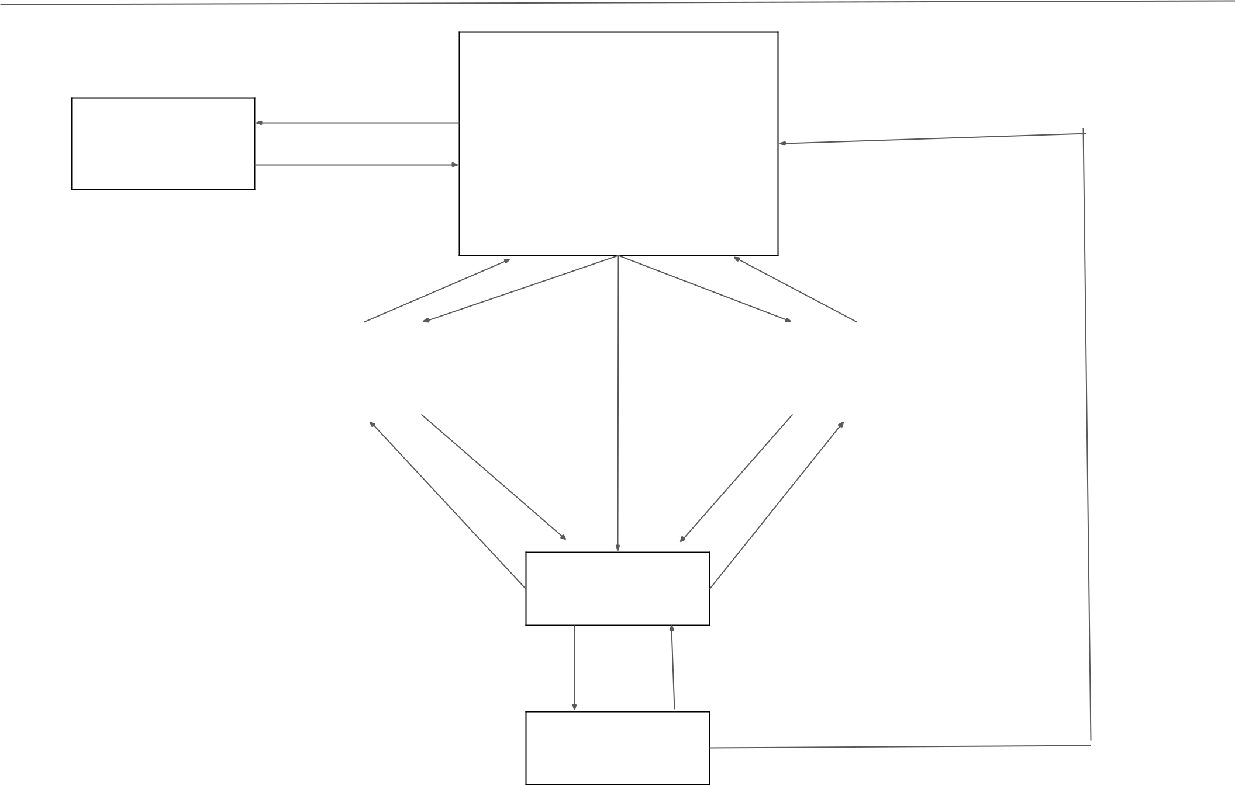

About Page

Home Page

|  |  |  |
| --- | --- | --- |
| Calories |  | Training |
| Calculator |  | Videos |
|  |  |  |

Products

Order

Summary

The idea is that from the home page, users will go to the training video page or the calories calculator page in order for them to visualize and trial our product so that they are enticed to visit the product page and purchase a product. Or they can go directly to the product page.